联合国 | 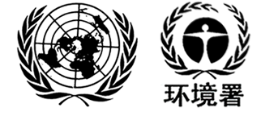 | BC
 |  | UNEP/CHW.15/6/Add.5/Rev.1
 |  | Distr.: General  27 July 2022  Chinese  Original: English

