

*Twin Cities Campus Division of Biostatistics A460 Mayo Building*

*School of Public Health Mayo Mail Code 303*

*420 Delaware Street SE*

*Minneapolis, MN 55455*

*Office: 612-625-1266*

*Fax: 612-626-0660*

*Email: vock@umn.edu*

Mark Glickman, PhD

Department of Statistics

Harvard University

1 Oxford Street

Cambridge, MA 02138

Dear Dr. Glickman,

It is our pleasure to submit “Estimating the Effect of Plate Discipline Using a Causal Inference Framework: An Application of the G-Computation Formula” to the *Journal of Quantitative Analysis in Sports*.

Recently a renewed focus on the effect of plate discipline on batter performance has emerged although there have been few metrics proposed to assess the effect of plate discipline directly on batters' outcomes. In this paper we focus on estimating a batter’s performance (e.g., batting average, slugging percentage, etc.) if he were able to adopt a different place discipline. Because we wish to assess the effect of a counterfactual plate discipline, we use a potential outcome framework and show how the G-computation algorithm can be used to isolate the effect of plate disciple separate from a batter's hitting ability or the types of pitches the batter faces.

We believe that the important and timely baseball questions we address combined with the novel causal methods makes this an important paper for the *Journal of Quantitative Analysis in Sports*.

We look forward to your response.

Kind regards,



David M. Vock, Ph.D.

Assistant Professor of Biostatistics

University of Minnesota

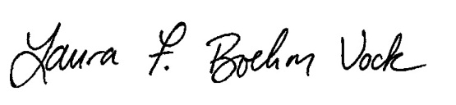

Laura F. Boehm Vock, Ph.D.

Assistant Professor of Statistics

Gustavus Adolphus College