Document containing embedded images that can be OCRed.

The first image:
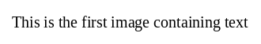

and the second image:
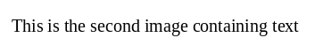

This image cannot be OCRed:


