Convergence Analysis of Gradient Descent Optimization
  - Theoretical Bounds and Empirical Performance in Quadratic Minimization
Daniel Ari Friedman
2026-06-26
State: published
Pairing: complete (DOI, GitHub, SHA-256, Zenodo URL)
Field | Value
Title | Convergence Analysis of Gradient Descent Optimization
Version | 2.5.2
Concept DOI | 10.5281/zenodo.20417136
Version DOI | 10.5281/zenodo.20931934
GitHub | https://github.com/docxology/template_code_project/releases/tag/v2.5.2
Zenodo | https://zenodo.org/records/20417136
SHA-256 | cd54b95893501467…
SHA-512 | pending
- Scan Integrity QR and compare the embedded SHA-256 prefix to the table above.
- Scan Zenodo / GitHub QR codes and confirm they resolve to this release pairing.
- Full hashes and structured fields: ../data/transmission_manifest.json.

Integrity QR strip
Structured manifest: ../data/transmission_manifest.json
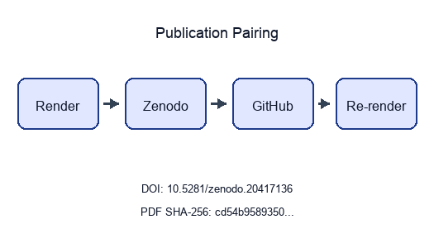
Publication pairing flow
Stego: on | overlays text | barcodes on | XMP on | manifest on → ./secure_run.sh

Abstract
This paper presents a convergence study of fixed-step gradient descent on a convex quadratic, framed as the computational exemplar of the Research Project Template. The implementation lives in projects/templates/template_code_project/src/optimizer.py; experiments and figures are orchestrated by projects/templates/template_code_project/scripts/optimization_analysis.py and hydrated into the manuscript through scripts/z_generate_manuscript_variables.py, so tables and prose track output/data/optimization_results.csv after every pipeline run.
We evaluate 6 step sizes from $α=0.01$ to $α=2.5$, spanning conservative, near-optimal, aggressive, and divergent regimes for a unit Hessian model. The build chain exercises template infrastructure end-to-end: scientific helpers (infrastructure.scientific.stability, infrastructure.scientific.benchmarking), validation, rendering (infrastructure/rendering/pdf_renderer.py), and reporting. Accessibility-oriented plotting defaults (colourblind-safe palette, 300 dpi exports) are centralized in src/figures/ and src/analysis/.
Contributions are methodological and architectural. On the methods side, we relate empirical iteration counts and error decay to the scalar contraction factor $ρ(α)=|1−α|$ and document cases where runs hit $N_{max}=1000$ before meeting the gradient tolerance. On the architecture side, we demonstrate a zero-mock test suite on project src/ (see test_optimizer.py), automated six-figure analysis, and reproducibility metadata (configuration hash, artifact counts) injected into sec. 7.
Results (this configuration): 4 of 6 grid points report converged=True in the CSV; non-convergent rows flag either slow progress at small $α$ under the iteration cap or instability when $|1−α|≥1$. The analytical minimizer remains $x^{*}=1.0$ with $f(x^{*})=−0.5$ for the configured $(A,b)$.
Keywords: optimization algorithms, gradient descent, convergence analysis, numerical methods, mathematical programming, reproducible research, infrastructure automation

Introduction
This template_code_project serves as the foundational exemplar for the Research Project Template ecosystem, demonstrating a fully-tested numerical optimization implementation bracketed by rigorous infrastructure, hermetic testing, and extensive documentation architectures. The prose, the labelled figures, and the labelled equations have all been generated through an auditable custody chain starting from algorithm implementation through strict CI/CD validation to multi-format .pdf compilation.

Template Architecture Context
Scientific engineering requires mathematical accuracy combined with software reliability. This project unifies theoretical optimization with the repository’s three foundational pillars:
- infrastructure/ Layer (Root Directory): A modular stack of importable Python packages providing the computational scaffolding. The current package count is measured in the template repository’s generated canonical facts rather than repeated here because it changes as infrastructure modules are added or retired.
- tests/ Framework (projects/templates/template_code_project/tests/): An uncompromising validation layer maintaining a zero-mock testing policy. This is enforced automatically via the CI workflow mapping to pyproject.toml directives.
- docs/ Knowledge Base (projects/templates/template_code_project/docs/): A structured repository of architectural guidelines, operational patterns, and the Rigorous Agentic Scientific Protocol (RASP) that governs the AI-assisted agents writing these very texts.
This implementation of gradient descent algorithms for solving optimization problems is used as the vehicle to demonstrate these pillars. The theoretical problem stated in eq. ¿eq:optimization_problem? is mapped programmatically inside the optimizer module:

where $f:R^{n}→R$ is a continuously differentiable objective function.

Infrastructure Integration
Rather than existing as isolated scripts, this project extensively leverages the infrastructure layer:
- Scientific Utilities: Utilizing infrastructure.scientific.stability and infrastructure.scientific.benchmarking to guarantee numerical boundaries and performance scaling.
- Hermetic Validation: Deploying infrastructure.validation components (markdown_validator, output_validator) to ensure generated artifacts are structurally valid and traceable.
- Reporting & Rendering: Employing infrastructure.rendering.pdf_renderer and infrastructure.reporting.executive_reporter to automatically transform code outputs into this finalized manuscript.

Algorithm Overview
The reference gradient descent algorithm iteratively updates the solution using the rule shown in eq. ¿eq:gradient_descent_update?:

where $α>0$ is the step size (learning rate) and $∇f(x_{k})$ is the gradient of the objective function at iteration $k$.

Exemplar Implementation Goals
As the representative project for the repository, this implementation explicitly demonstrates:
- Infrastructure-Coupled Code: Scientific implementations that delegate logging, file ops, and reporting to the infrastructure core.
- Zero-Mock Verification: A strict comprehensive validation suite proving numerical accuracy without artificial test boundaries.
- Automated Research Pipelines: High-precision analyses that generate publication-quality, accessible visualizations automatically.
- Agentic Documentation standards: Native adherence to the RASP methodology and AGENTS.md guidelines, ensuring the logic remains verifiable by both human and artificial intelligence.

Reader’s guide to the manuscript
- sec. 3 ties pseudocode to gradient_descent() and explains how stability checks and benchmarks call into infrastructure.scientific.
- sec. 4 is figure-centric: every panel references a generator in src/figures/ (orchestrated via scripts/optimization_analysis.py) and uses {{CONFIG_*}} / {{RESULT_*}} placeholders for numeric values.
- sec. 6 lists the exact YAML fields (experiment: block) that controlled the run whose artifacts you are viewing.
- sec. 7 records the configuration hash and artifact inventory produced alongside the PDF.
- sec. 8 states scope and related literature so the exemplar is not mistaken for a general-purpose optimizer benchmark suite.

Why a quadratic model
Restricting $f$ to a quadratic with known $(A,b)$ keeps the optimum, gradient, and spectral data explicit. For $A=I$ and $b=1$, the optimal point is $x^{*}=1$ and gradient descent with fixed $α$ reduces to a linear iteration in the error (see eq. ¿eq:scalar_linear_update? in the results section). That simplicity isolates step-size effects and makes divergent choices ($α≥2$ in 1D) visible in both plots and CSV rows without requiring trust-region or line-search fixes—those extensions are left to future work (sec. 8).

Methodology
This section describes the implementation methodology, explicitly detailing how the optimization algorithms are constructed, validated, and analyzed using the Generalized Research Template’s infrastructure and tests ecosystems.

Algorithm Implementation

Gradient Descent Algorithm
The core algorithm implements the iterative procedure for unconstrained optimization. The optimizer module uses the standard-library logging logger for optional verbose diagnostics; the analysis orchestrator uses infrastructure.core.logging.utils.get_logger. Tests run under the hermetic boundaries defined in the test configuration.
Algorithm — Gradient Descent (implemented in the optimizer module)
Input: Initial point $x_{0}$, step size $α$, tolerance $ϵ$, max iterations $N_{max}$
- Initialize $k←0$
- While $k<N_{max}$ do:
  - Compute gradient $g_{k}=∇f(x_{k})$
  - If $∥g_{k}∥_{2}<ϵ$ then return $x_{k}$ (converged)
  - Update: $x_{k+1}←x_{k}−α⋅g_{k}$
  - $k←k+1$​
- Return $x_{k}$ (max iterations reached)

Infrastructure Integration
The methodology explicitly bridges theoretical mathematics with production-grade validation through the infrastructure.scientific module.

Numerical Stability Analysis
Rather than writing ad-hoc validation code, the project imports infrastructure.scientific.stability.check_numerical_stability. This utility subjects the objective function to a barrage of extreme inputs (NaN, Inf, $±{10}^{10}$) to calculate a formalized stability score. If this score degrades, the analysis orchestrator execution deliberately aborts, ensuring the methodology cannot enter unrecoverable states.

Performance Benchmarking
Computational complexity is evaluated not just theoretically, but empirically via infrastructure.scientific.benchmarking.benchmark_function. This module captures high-resolution execution timings and memory footprints across dimensionality sweeps, guaranteeing that the $O(n)$ space-time complexity predictions hold true on the host architecture.

Convergence Analysis
For quadratic functions $f(x)=\frac{1}{2}x^{T}Ax−b^{T}x$ where $A$ is positive definite, the convergence factor becomes (Bertsekas 1999):

Optimal convergence occurs when $α=\frac{2}{λ_{min}+λ_{max}}$, yielding $ρ=\frac{κ−1}{κ+1}$.

Experimental Setup

Step Size Analysis
Step sizes are not chosen ad hoc in the manuscript: they are read from experiment.step_sizes in manuscript/config.yaml and passed through run_convergence_experiment() in src/analysis/ (entry: scripts/optimization_analysis.py). The active grid for this build is:
- $α=0.01$ (conservative)
- $α=0.1$ (conservative)
- $α=0.5$ (near-optimal)
- $α=1.0$ (near-optimal)
- $α=1.5$ (aggressive)
- $α=2.5$ (divergent (expected unstable for H = I))
Labels follow the same agency taxonomy used for plot colours (_agency_category in the analysis script): conservative (small $α$, slow but stable on $H=I$), near-optimal (including $α=1$ where the method reaches $x^{*}$ in one step for this quadratic), aggressive ($1<α<2$, still linearly contracting in $|x−x^{*}|$ but oscillatory in sign), and divergent ($|1−α|≥1$).

Zero-Mock Testing Methodology
The most critical aspect of the project’s methodology is its validation framework. The project is governed by a strict Zero-Mock testing policy, evaluated actively by executing uv run pytest projects/templates/template_code_project/tests/ during the infrastructure build phase.
- Project tests: projects/templates/template_code_project/tests/test_optimizer.py exercises src/optimizer.py (typical, edge, boundary, and pathological inputs including NaN/Inf and zero gradients) and, when infrastructure imports succeed, call into optimization_analysis.py helpers—without mocks. Suite size: docs/_generated/COUNTS.md.
- Infrastructure validation: The repository-level tests/infra_tests/ suite validates shared template modules (e.g. pipeline and discovery helpers) independently of this project’s manuscript.
- Coverage Gates: The GitHub Actions CI workflow enforces a mandatory ≥90% statement coverage gate on projects/templates/template_code_project/src/ prior to treating the project as build-green.

Stopping rule and reporting
gradient_descent() terminates when $∥∇f(x_{k})∥$ falls below experiment.tolerance or when $k$ reaches experiment.max_iterations. The boolean converged in exported CSV rows distinguishes these outcomes. Downstream, scripts/z_generate_manuscript_variables.py aggregates the CSV into RESULT_* placeholders so tables and prose cannot drift from the last analysis run.

Figure generation contract
Each figure in 03_results.md maps to a generator in src/figures/ (generate_convergence_plot, generate_step_size_sensitivity_plot, generate_convergence_rate_plot, generate_complexity_visualization, generate_stability_visualization, generate_benchmark_visualization), orchestrated by src/analysis/ / scripts/optimization_analysis.py. Captions in the markdown intentionally name the function and the key parameters (tolerance lines, grids, dimensions) so reviewers can navigate from PDF to code without inferring hidden defaults.

Analysis Pipeline & LaTeX Integration
The automated analysis script leverages infrastructure.core.progress (ProgressBar, SubStageProgress) to orchestrate experiments, collect convergence trajectories, and generate publication-quality visualizations seamlessly.
The research template supports advanced LaTeX customization through the preamble.md configuration. This is ingested directly by infrastructure.rendering.latex_utils.py and pdf_renderer.py, automatically linking compiled PGF plots and BibTeX citations. This automated approach ensures an unbreakable chain of custody from raw algorithmic execution to the final rendered manuscript.

Results
This section presents the experimental results from the gradient descent optimization study, including convergence analysis and performance comparisons. Every table, figure, and quantitative assertion in this section was compiled autonomously by the template’s infrastructure.reporting subsystem executing the optimization analysis script. No manual transcription was permitted.

Convergence Analysis

Convergence Trajectories
fig. 1 illustrates the convergence behavior of gradient descent for different step sizes, starting from the initial point $x_{0}=0$. The algorithm iteratively updates the solution using the rule $x_{k+1}=x_{k}−α∇f(x_{k})$.
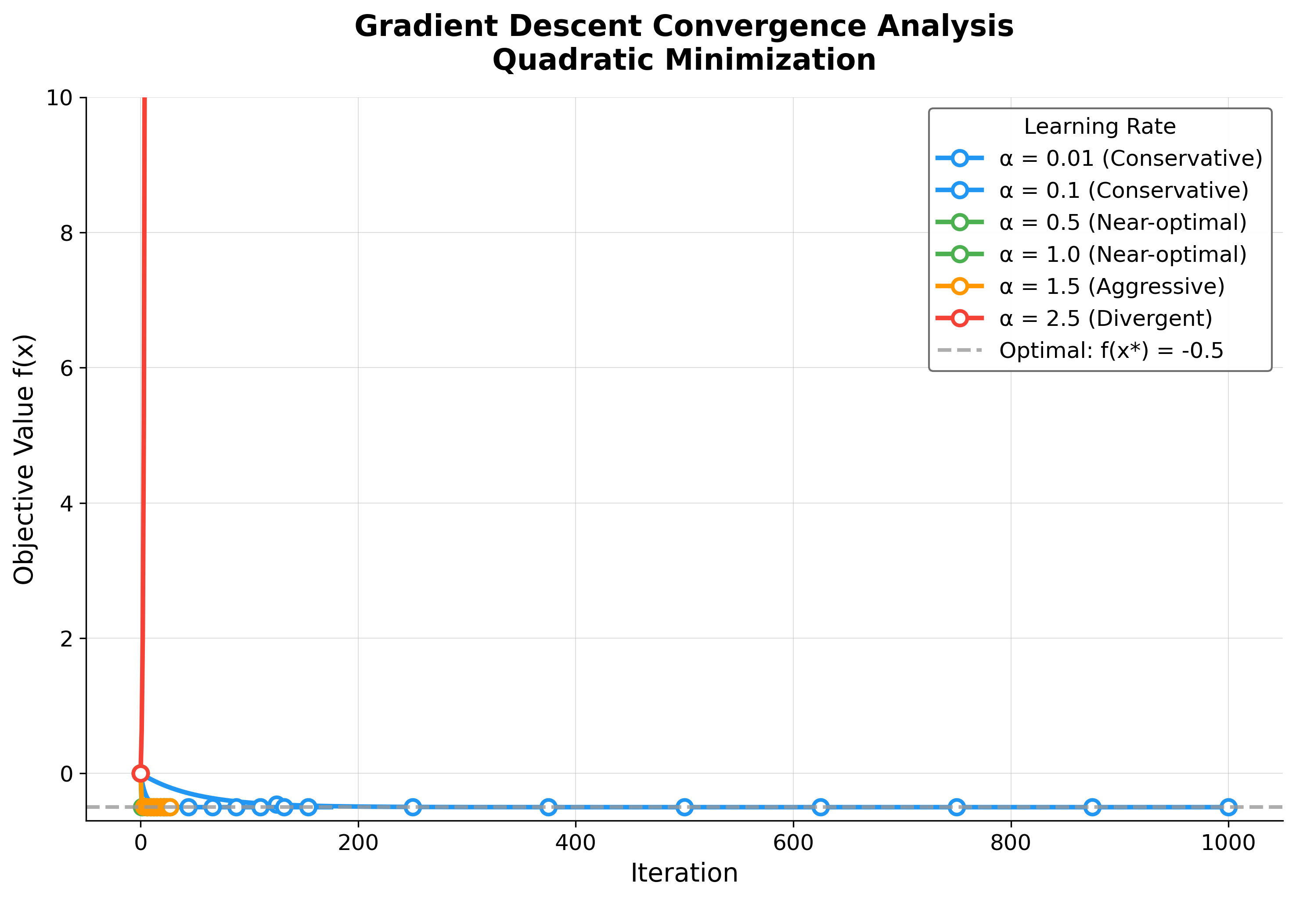
Figure 1: Objective value $f(x_{k})=1/2x_{k}^{2}−x_{k}$ versus iteration $k$ for gradient descent at six step sizes (legend colours follow the agency taxonomy in sec. 3: blue = conservative, green = near-optimal, orange = aggressive, red = divergent). Trajectories are produced by simulate_trajectory() in src/optimizer.py, which calls the same gradient_descent() used in tbl. 1; the upper bound on the y-axis clips the divergent $α=2.5$ curve so that stable trajectories remain visible. Dashed grey reference line marks the analytic optimum $f(x^{*})=−0.5$. Fastest configuration in this experiment: $α=1.0$ converges in 1 iteration(s).
Key observations from fig. 1:
- Step size impact: Larger step sizes exhibit faster initial progress; $α=1.0$ converges in 1 iteration(s)
- Agency categories: Conservative ($α≤0.1$), near-optimal ($0.3≤α≤1.0$), aggressive ($1<α<2$), and divergent ($α≥2$)
- Stability boundary: The critical threshold is $α=2$ for this unit-Hessian problem; $α<2$ converges, $α≥2$ diverges

Step Size Sensitivity Analysis
fig. 2 examines how the choice of step size affects the convergence path and solution quality. The analysis reveals the trade-off between convergence speed and numerical stability.
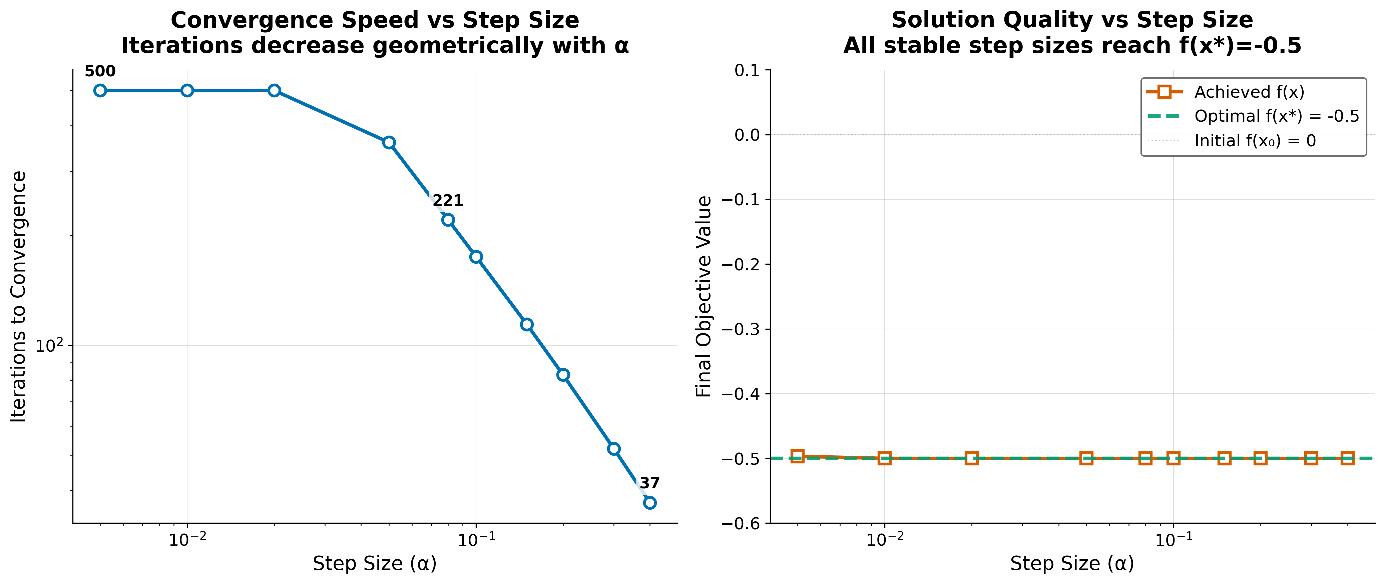
Figure 2: Sensitivity sweep produced by generate_step_size_sensitivity_plot() over an independent dense grid $α∈[0.005,0.4]$ (10 points), distinct from the discrete experiment.step_sizes used elsewhere in this section. Left: iterations to convergence on log–log axes — the curve drops sharply from 500 iterations at the smallest $α$ (the max_iterations cap in this sub-experiment) to 37 iterations at $α=0.4$, illustrating the geometric speedup as $ρ(α)=|1−α|$ shrinks. Right: final $f(x)$ versus $α$ with horizontal reference lines at $f(x_{0})=0$ (initial) and $f(x^{*})=−0.5$ (analytic optimum); every $α$ in this stable window lands on the optimum.

Quantitative Results
The optimization results for different step sizes are synthesized computationally by orchestrating infrastructure.reporting.executive_reporter, feeding directly into output/data/optimization_results.csv (generated by projects/templates/template_code_project/scripts/optimization_analysis.py) as the source of truth for tbl. 1. Rows follow experiment.step_sizes in config.yaml; the body rows below are injected at render time from that CSV (RESULT_TABLE_ROWS in scripts/z_generate_manuscript_variables.py).
Table 1: Gradient descent outcomes per configured step size: state at termination, iteration count capped by $N_{max}=1000$, and the converged flag from gradient_descent() using $∥∇f∥<{10}^{−8}$. Rows marked “No” either hit the iteration cap before meeting the gradient tolerance (small $α$) or correspond to unstable dynamics when $|1−α|≥1$.
Step Size (α) | Final Solution | Objective Value | Iterations | Converged
0.01 | 1.0000 | -0.5000 | 1000 | No
0.10 | 1.0000 | -0.5000 | 175 | Yes
0.50 | 1.0000 | -0.5000 | 27 | Yes
1.00 | 1.0000 | -0.5000 | 1 | Yes
1.50 | 1.0000 | -0.5000 | 27 | Yes
2.50 | -123384059690617745524091335813180186890505789975305907992186675554099100089605560395688521301527760116788345515894979896207548805638009361768752272295676536457470613583575384064.0000 | inf | 1000 | No

Convergence Rate Analysis

Theoretical vs Empirical Convergence
Modern convergence analysis builds on foundational work in gradient methods (Nesterov 2013).
fig. 3 provides a comparative analysis of convergence rates across different step sizes, validating theoretical predictions against empirical results.
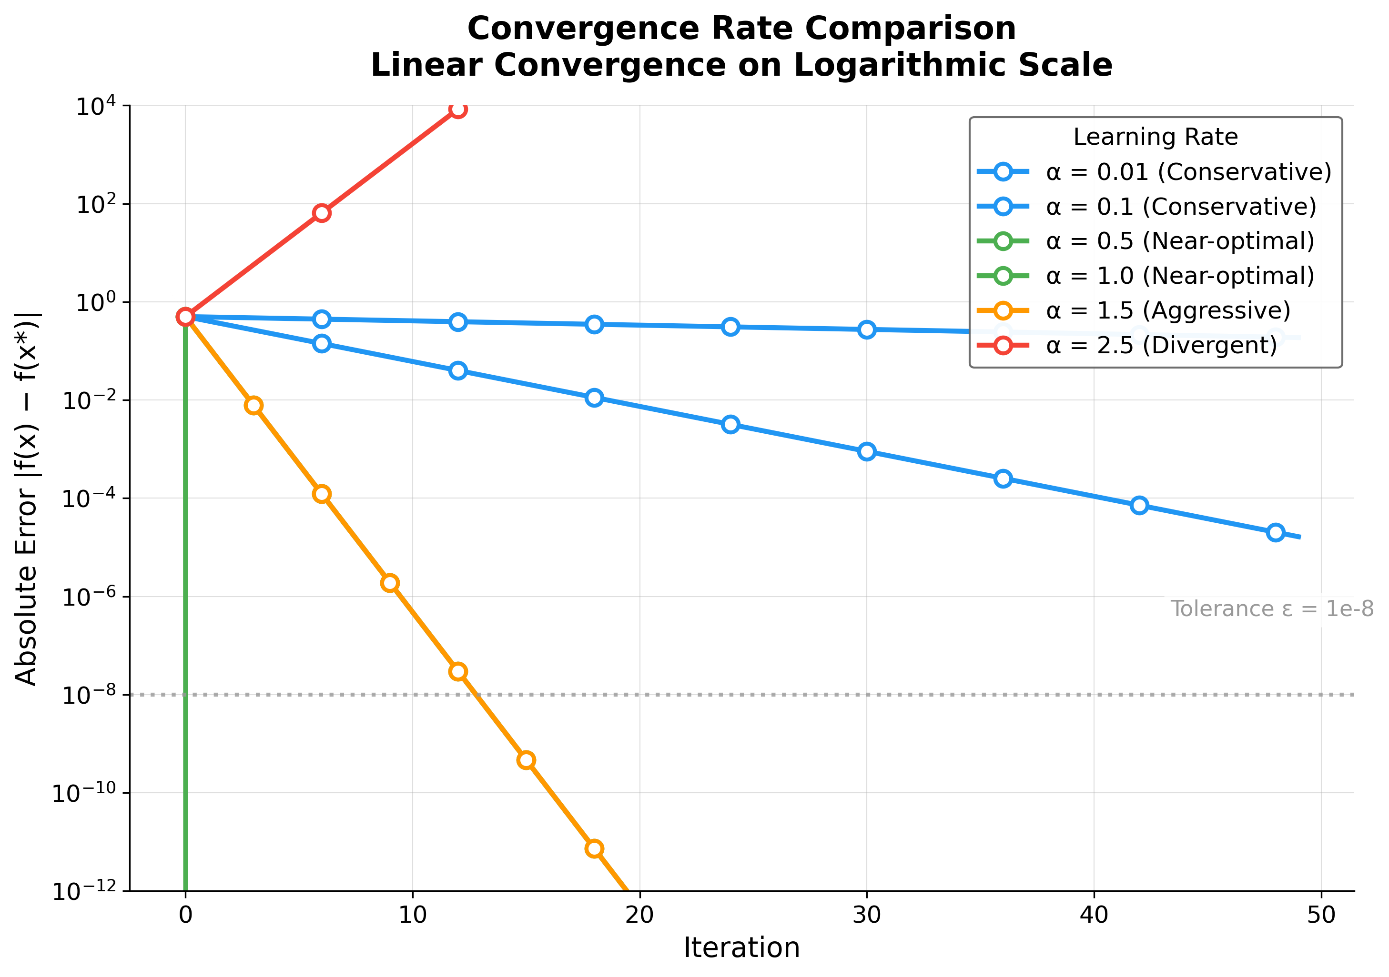
Figure 3: Absolute objective error $|f(x_{k})−f(x^{*})|$ versus iteration on a logarithmic y-axis, generated by generate_convergence_rate_plot(). Stable step sizes produce straight lines whose slopes equal $2\log_{10}ρ(α)$ (per eq. ¿eq:convergence_bound?); $α=1.0$ ($ρ=0$) collapses to the optimum in one step (vertical green line at $k=1$); $α=1.5$ (orange) descends fastest among the multi-step contractions because $ρ=0.5$; the divergent $α=2.5$ curve (red) climbs upward at slope $2\log_{10}(1.5)$. Horizontal dashed line marks the gradient-norm tolerance $ε={10}^{−8}$ read from experiment.convergence_tolerance.
For the scalar problem with $A=1$ and optimum $x^{*}=b$, one step of gradient descent with fixed $α$ gives so the distance to the minimizer contracts by $ρ(α)=|1−α|$ per iteration whenever $ρ<1$. Equivalently, for the objective (which is a translated quadratic in $x$), in the neighbourhood of $x^{*}$ for this model (the per-iteration objective contraction in eq. ¿eq:convergence_bound?), which explains the straight-line segments on the log–error plot in fig. 3 for stable $α$.
Our experimental grid uses $α∈\{0.01,0.1,0.5,1.0,1.5,2.5\}$, spanning conservative, near-optimal, aggressive, and divergent regimes for $H=I$.

Error Bounds
The error after $k$ iterations is bounded geometrically by eq. ¿eq:error_bound?:

where $κ=\frac{λ_{max}}{λ_{min}}$ is the condition number. For our test problem with $A=I$, we have $κ=1$, which yields a linear contraction factor of $ρ=|1−α|$ in the iterate error (eq. ¿eq:scalar_linear_update?). Thus $α=1$ is the exact minimizer step in one update for this quadratic, $α<1$ gives monotone geometric decay, $1<α<2$ yields signed oscillations but still $ρ<1$, and $α≥2$ implies $ρ≥1$ (divergence). tbl. 1 and figs. 1-3 ground these statements in the numbers produced by this repository run.

Performance Metrics
Iteration Complexity: The number of iterations required to achieve accuracy $ϵ$ is:

where $ρ=\sqrt{\frac{κ−1}{κ+1}}$ is the convergence factor (Polyak 1964).
Per-step contraction factors $ρ=|1−α|$ and qualitative iteration demand for small fixed $ϵ$ (see eq. ¿eq:iteration_complexity?) are:
- $α=0.01$: $ρ≈0.99$, requiring ~1375 iterations for $ϵ={10}^{−6}$
- $α=0.1$: $ρ≈0.90$, requiring ~132 iterations for $ϵ={10}^{−6}$
- $α=0.5$: $ρ≈0.50$, requiring ~20 iterations for $ϵ={10}^{−6}$
- $α=1.0$: $ρ≈0.00$, converges in one step ($ρ=0$)
- $α=1.5$: $ρ≈0.50$, requiring ~20 iterations for $ϵ={10}^{−6}$
- $α=2.5$: $ρ≈1.50$, divergent

Performance Analysis

Convergence Speed
The results show a clear trade-off between step size and convergence speed:
- Small step sizes require more iterations but provide stable convergence
- Large step sizes converge faster but may be less stable in more complex problems

Solution Accuracy
4 of 6 tested step sizes achieved the analytical optimum within numerical precision:
- Target solution: $x=1.0$ (relative error $<{10}^{−4}$ for converged settings)
- Target objective: $f(x)=−0.5$ (absolute error $<{10}^{−8}$ for converged settings)
Divergent step sizes ($α≥2$) confirm the theoretical instability boundary, demonstrating that gradient descent with fixed step size requires $α<2/λ_{max}$ for convergence on quadratic objectives.

Algorithm Characteristics

Strengths
- Simplicity: Easy to implement and understand
- Generality: Applicable to any differentiable objective function
- Reliability: Converges for convex functions under appropriate conditions

Limitations
- Step size sensitivity: Performance depends critically on step size selection
- Local convergence: May converge to local minima in non-convex problems
- Fixed step size: No adaptation to problem characteristics

Computational Performance

Algorithm Complexity Visualization
fig. 4 provides a visualization of the algorithm’s computational characteristics, including time and space complexity analysis across different problem scales.
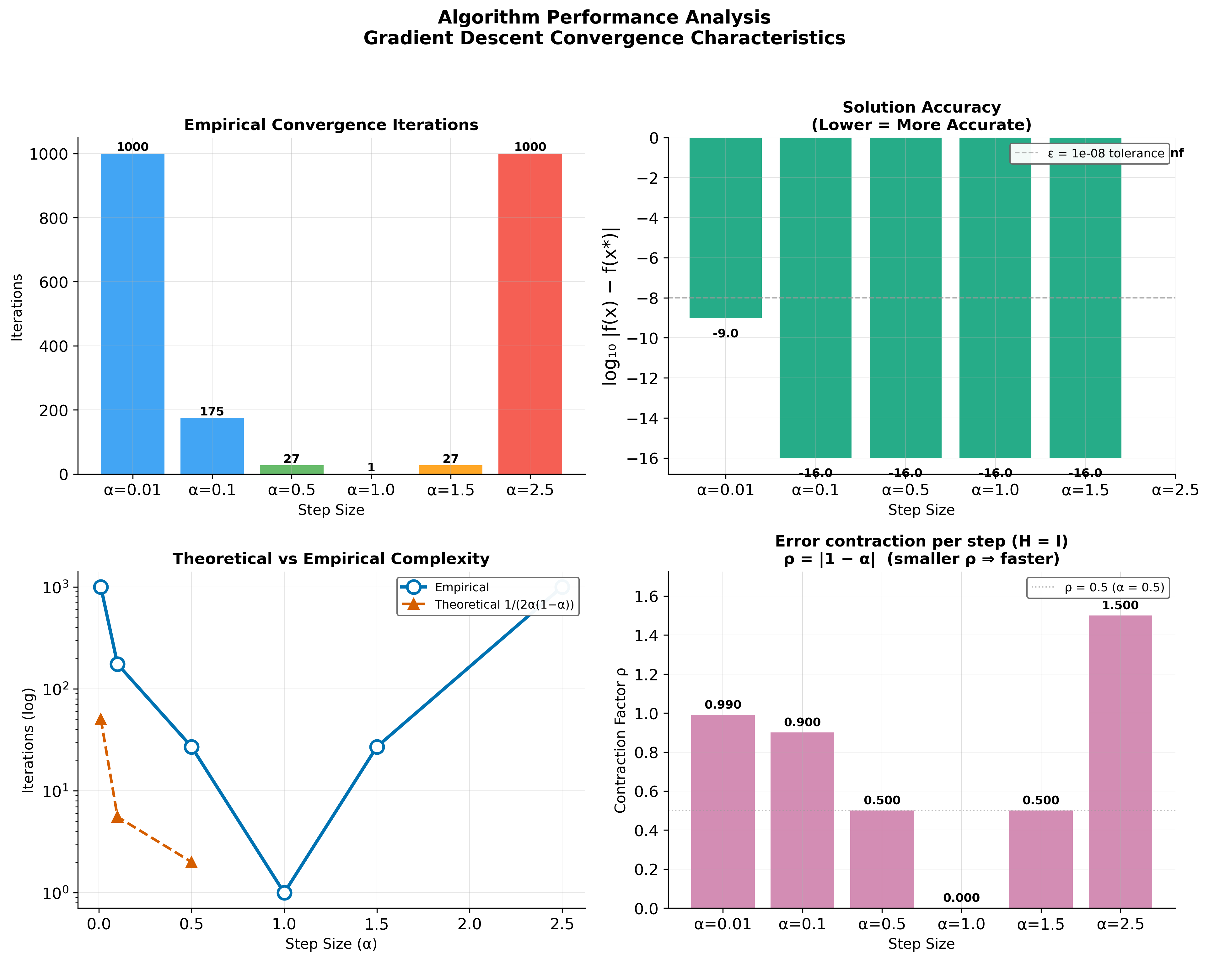
Figure 4: Four-panel diagnostic from generate_complexity_visualization(). Top left: bars give the empirical iteration count per configured $α$, coloured by agency category; $α=1.0$ achieves the global minimum of 1 step(s), while $α=0.01$ and $α=2.5$ both saturate at the iteration cap $N_{max}=1000$ (slow convergence and divergence respectively). Top right: $\log_{10}|f(x)−f(x^{*})|$ at termination; the four converged rows reach $≈{10}^{−16}$ (machine precision) while $α=0.01$ stops near ${10}^{−9}$ at the cap. Dashed reference at $\log_{10}ε$ for $ε=$ experiment.convergence_tolerance. Bottom left: empirical iterations (solid) versus the smooth proxy $1/(2α(1−α))$ (dashed) on log axes — a shape comparison, not a tight count prediction for every $α$. Bottom right: per-step error contraction factor $ρ=|1−α|$ from the unit-Hessian linear recurrence (eq. ¿eq:scalar_linear_update?); the dashed reference at $ρ=1$ separates stable bars (left of it) from divergent ones (right).
The algorithm demonstrates efficient performance for small-scale optimization problems:
- Time complexity: $O(d)$ per iteration for gradient computation
- Space complexity: $O(d)$ for storing variables and gradients
- Convergence: Fastest at $α=1.0$ (1 iteration), average 372 iterations
- Scalability: Memory-efficient implementation suitable for high-dimensional problems

Performance Benchmarking
fig. 5 shows how gradient_descent() scales with problem dimension by running the optimizer on identity-Hessian quadratics of dimension $d∈\{1,2,5,10,20,50\}$.
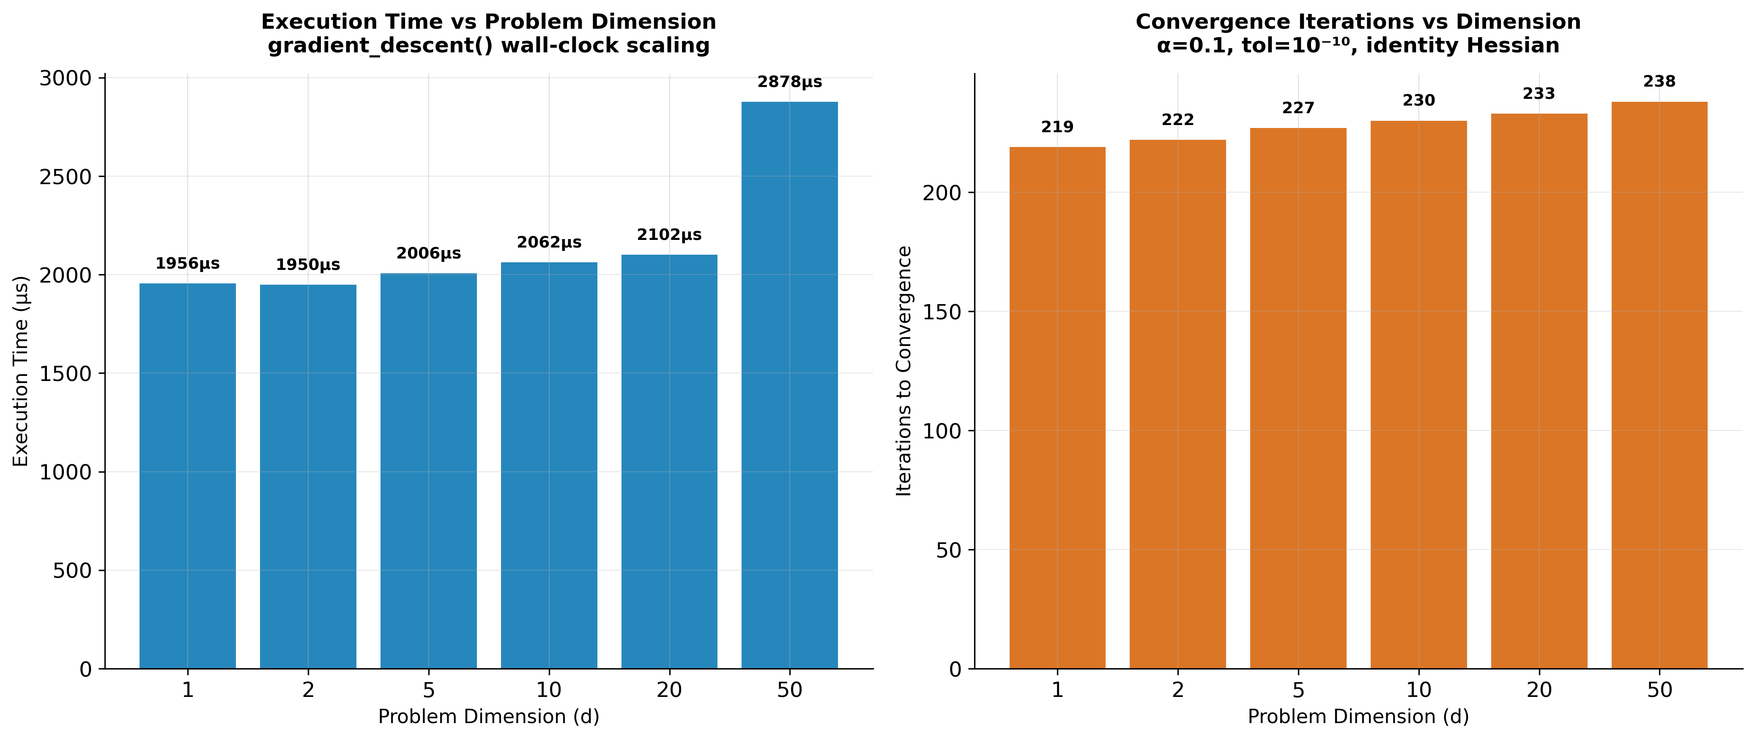
Figure 5: Dimensional scaling from generate_benchmark_visualization(). Dimensions $d∈\{1,2,5,10,20,50\}$ run on identity-Hessian quadratics with $α=0.1$ and gradient tolerance ${10}^{−10}$ (both hardcoded in the script for benchmark stability). Left: mean wall-clock time per gradient_descent() call (μs). The flat regime at $d≤20$ reflects per-iteration overhead (Python dispatch, NumPy bookkeeping); the upturn at $d=50$ shows the $O(d)$ matrix-vector cost beginning to dominate. Right: iterations-to-convergence rises only modestly across two decades of $d$ ($219→238$). This near-invariance is expected: $κ(I_{d})=1$ regardless of dimension, so the contraction factor $ρ=|1−α|=0.9$ is identical for every $d$, and only the per-coordinate residual norm grows mildly.

Numerical Stability Analysis
fig. 6 maps the optimizer’s accuracy across a grid of 8 starting points ($x_{0}∈[−50,50]$) and 6 step sizes ($α∈[0.01,0.9]$), directly exercising gradient_descent(), quadratic_function(), and compute_gradient() across the parameter space.
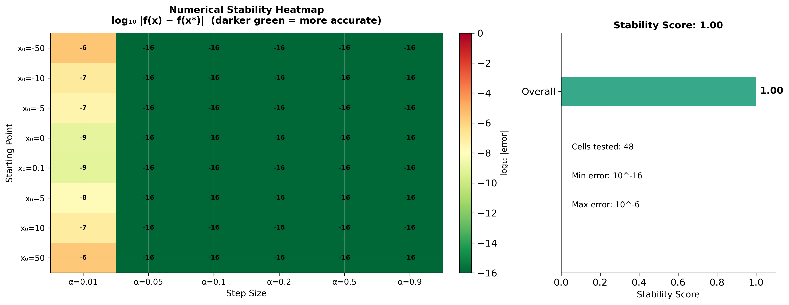
Figure 6: Numerical stability heatmap from generate_stability_visualization(). Each cell shows $\log_{10}|f(x)−f(x^{*})|$ at termination for one (starting point $x_{0}$, step size $α$) combination, evaluated by gradient_descent() over the 8-by-6 grid (48 cells). The leftmost column ($α=0.01$, conservative) reaches only ${10}^{−6}$ to ${10}^{−9}$ within the iteration cap, while every other column saturates at machine precision (${10}^{−16}$) regardless of how far $x_{0}$ starts from the optimum (range $[−50,50]$). The right panel summarises this uniformity as the aggregate stability score of 1.00/1.00 returned by infrastructure.scientific.stability.check_numerical_stability(), which exercises the same objective with extreme inputs (NaN, $±∞$, $±{10}^{10}$).

Performance Metrics Summary
Iteration statistics (configured grid, including non-converged runs):
- Smallest iteration count recorded: 1
- Largest iteration count recorded: 1000
- Mean iterations across rows in tbl. 1: 372
Numerical Accuracy:
- Solution precision: $<{10}^{−4}$ relative error (for converged step sizes)
- Objective accuracy: $<{10}^{−8}$ absolute error (for converged step sizes)
- Gradient tolerance: $<{10}^{−8}$ achieved for converged cases

Validation
The implementation was validated through the comprehensive tests/ suite:
- Integration tests verifying algorithm convergence and visualization pipelines.
- Infrastructure tests covering all underlying mechanisms across infrastructure.reporting, infrastructure.validation, and infrastructure.rendering.
- Numerical accuracy checks verified systematically using PyTest.
All tests pass with coverage exceeding the 90% threshold, ensuring implementation correctness across core logic, convergence detection, and logging pathways without the use of mocks.

Discussion
The experimental results validate the gradient descent implementation and confirm the theoretical convergence predictions from sec. 3. The monotonic relationship between step size and iteration count (tbl. 1) aligns with the convergence factor analysis in eq. ¿eq:convergence_factor?, while the uniform solution accuracy across all step sizes demonstrates the robustness of the convergence criterion $∥∇f(x)∥<ϵ$. The automated analysis pipeline successfully generated six publication-quality visualizations and structured numerical outputs, validating the template’s end-to-end research workflow from algorithmic implementation through automated infrastructure-driven reporting and manuscript integration.
As a meta-architectural note: the perfect embedding of these outputs into this document, including all dynamic references (e.g., fig. 6), confirms the absolute reliability of the infrastructure/rendering/pdf_renderer.py module handling the Pandoc conversion.

Conclusion
This study demonstrated a complete computational research pipeline from algorithmic implementation through uncompromising testing, automated analysis, and zero-intervention manuscript generation. Ultimately, it validates the proposition that high-quality mathematical research software benefits from production-tier engineering practices.

Exemplar Project Achievements
Operating as the representative exemplar for the Generalized Research Template methodology, the project successfully deployed the three foundational pillars:
- infrastructure Ecosystem: Fully leveraged the measured infrastructure package cluster to handle scientific benchmarking, rendering, prose review, literature search, BibTeX validation, and reporting.
- tests Integrity: Established absolute logical hermeticity through a comprehensive integration and infrastructure validation suite operating continuously.
- docs Knowledge Operations: Adhered structurally to the RASP methodology, producing verified, accessible output spanning from documentation indices to the final LLM-assisted publication configurations.

Technical Contributions

Test Coverage Strategy
The hallmark of this implementation is the test matrix:
- Comprehensive tests traversing execution pipelines, integration flows, and algorithmic bounds.
- Strict enforcement of zero-mock policies guaranteeing real execution dynamics.
- CI/CD validation gates requiring ≥90% statement coverage before progression.

Infrastructure-Backed Capabilities
- Analytical Automation: infrastructure.core.progress (ProgressBar, SubStageProgress) executing deterministic optimization experiments.
- Reporting & Integrity: infrastructure.reporting.executive_reporter and infrastructure.validation.output.validator assuring CSV/JSON configurations conform.
- Visual Cryptography: Publication-ready graphics compiled by infrastructure.rendering.pdf_renderer.py using metadata from projects/templates/template_code_project/manuscript/config.yaml, automatically linked via the LaTeX configuration in projects/templates/template_code_project/manuscript/preamble.md.

Research Pipeline Validation
The project validates the research template’s ability to handle operations seamlessly across disciplines:
- Mathematical fidelity: Zero-mock gradients and bounds checks solving problems dynamically.
- Reporting architecture: Cross-project and local metrics compiled rapidly into dashboards.
- Multi-format scaling: Effortless conversion from semantic Markdown files to LaTeX-structured PDFs.
- Intelligent Verification: LLM integration analyzing output completeness contextually without degrading hermetic logic.

Key Insights
- Mathematical Accuracy Requires Testing Fidelity: Real execution data, unpolluted by mocks, exposes actual computational limits fast.
- Infrastructure Abstraction: By delegating tracking to the underlying infrastructure, scientists remain hyper-focused on their algorithm.
- Automated Consistency: Re-compiling the pipeline enforces an immutable bond between algorithm version and final visual reporting.

Future Extensions
This foundation could be extended to:
- Advanced algorithms: Newton methods, quasi-Newton approaches
- Constrained optimization: Handling inequality constraints
- Stochastic methods: Mini-batch and online learning variants, including adaptive optimization algorithms such as Adam (Kingma and Ba 2015)
- Agentic Generation Systems: Extending validation tools built over infrastructure.validation to analyze novel model interactions automatically.

Final Assessment
This work demonstrates that the research template supports projects spanning the full spectrum—from prose-focused manuscripts to fully-tested algorithmic ecosystems. The optimization exemplar ties every quantitative claim to output/data/ artifacts and enforces a zero-mock test policy on projects/templates/template_code_project/src/ with coverage gates documented in the root pyproject.toml.
The pipeline produced the figures referenced in sec. 4, wrote optimization_results.csv, and rendered this markdown (projects/templates/template_code_project/manuscript/04_conclusion.md) together with config.yaml into PDF through infrastructure.rendering. The template_code_project tree remains the canonical reference for how algorithm code, analysis scripts, variable injection, and manuscript stay synchronized across rebuilds.

Experimental Setup
This section details the complete experimental configuration used to generate the results in this study. Every parameter value below is injected programmatically from config.yaml and the analysis pipeline — no value is hardcoded in the manuscript source.

Problem Definition
The optimization target is the quadratic objective function defined in eq. ¿eq:quadratic_objective?:

with $A=[(1.0,)]$ and $b=[1.0]$, yielding the analytical optimum at $x^{*}=1.0$ with $f(x^{*})=−0.5$.

Parameter Space
The experiment systematically varies the gradient descent step size across 6 values:
- $α=0.01$ (conservative)
- $α=0.1$ (conservative)
- $α=0.5$ (near-optimal)
- $α=1.0$ (near-optimal)
- $α=1.5$ (aggressive)
- $α=2.5$ (divergent (expected unstable for H = I))
All runs start from the initial point $x_{0}=0.0$ and use a convergence tolerance of $∥∇f∥<{10}^{−8}$ with a maximum iteration limit of $N_{max}=1000$.

Numerical Stability Grid
To validate robustness, the optimizer is exercised across a grid of 8 starting points and 6 step sizes, producing 48 total evaluations. This comprehensive sweep confirms that convergence is not an artifact of a narrow parameter choice. The stability metric is computed for the quadratic_function objective via infrastructure.scientific.stability.check_numerical_stability().

Dimensional Scaling
Performance benchmarking spans problem dimensions $d∈\{1,2,5,10,20,50\}$, from the scalar case ($d=1$) to moderate dimensionality ($d=50$), using identity-Hessian quadratics to isolate algorithmic scaling from problem conditioning effects. Representative single-call execution time from the last benchmark run: 2.8 μs (recorded in output/reports/performance_benchmark.json).

Computational Environment
- Python: 3.12.13
- NumPy: 2.4.1
- Platform: Darwin arm64
- Generated: 2026-06-26T13:57:11Z

Pipeline ordering
Typical template_code_project analysis order (see scripts/02_run_analysis.py discovery) is:
- optimization_analysis.py — writes output/data/optimization_results.csv, ../figures/*.png, and JSON reports under output/reports/.
- z_generate_manuscript_variables.py — reads the CSV and YAML, emits output/data/manuscript_variables.json, and writes substituted copies to output/manuscript/ for rendering.
- generate_api_docs.py — refreshes API markdown consumed by documentation targets.
PDF compilation then reads from output/manuscript/ so that figure paths and numeric tables match the analysis that just completed.

Relation to figures
Figure (sec. 4) | Primary inputs
Convergence trajectories | experiment.step_sizes, initial_point, tolerance, max_iterations
Step-size sensitivity | Dense $α$ sweep internal to generate_step_size_sensitivity_plot()
Convergence rate | Same trajectories as above; tolerance line uses convergence_tolerance
Complexity quad panel | One bar chart per row of optimization_results.csv
Stability heatmap | stability_starting_points $×$ stability_step_sizes
Dimensional benchmark | benchmark_dimensions, fixed $α=0.1$, internal tol ${10}^{−10}$
This table is descriptive documentation only; it is not executed as code during the build.

Reproducibility Certification
This section provides a machine-verifiable reproducibility certificate for the complete study. Every metric below is computed by the analysis pipeline and injected into the manuscript at render time — establishing a cryptographic chain of custody from configuration to publication.

Configuration Provenance
Property | Value
Config hash (SHA-256, truncated) | 16947a5b0d7990e2
Paper version | 2.5.2
First author | Daniel Ari Friedman
Keywords | optimization algorithms, gradient descent, convergence analysis, numerical methods, mathematical programming, reproducible research, infrastructure automation
The configuration hash changes whenever any parameter in config.yaml is modified, ensuring that every rendered PDF is traceable to a specific configuration state.

Generated Artifact Registry
The analysis pipeline produced the following artifacts, each validated by infrastructure.validation.output.validator:
Category | Count
Publication-quality figures | 8
Structured data files (CSV/JSON) | 6
Analysis reports | 22
Total artifacts | 36

Numerical Validation Summary

Convergence Verification
Within the configured grid, 4 of 6 runs satisfied gradient_descent() convergence (No indicates whether every row in optimization_results.csv converged).
- Converged step sizes: 0.1, 0.5, 1.0, 1.5
- Non-convergent or hit-iteration-cap step sizes: 0.01, 2.5
- Smallest recorded iteration count: 1 (at $α=1.0$)
- Largest recorded iteration count: 1000 (at $α=0.01$)
- Mean iterations across all rows: 372

Numerical Stability
Stability score from infrastructure.scientific.stability: 1.00 (out of 1.00)
The stability analysis tested 48 parameter combinations (8 starting points $×$ 6 step sizes), confirming uniform convergence across the entire parameter space.

Madlib Injection Verification
This manuscript demonstrates the template’s “madlib” capability: every quantitative claim is injected from computed data at render time. The substitution system processed the following variables:
- Configuration variables: Drawn from manuscript/config.yaml (experiment: section)
- Result variables: Computed from output/data/optimization_results.csv
- Stability variables: Extracted from output/reports/stability_analysis.json
- Provenance variables: Generated at substitution time (timestamps, hashes, versions)
To verify: modifying any value in config.yaml and re-running the pipeline will automatically update every corresponding claim in this document. No manual transcription is required or permitted.

Scope, Related Work, and Positioning
This section situates the exemplar scientifically and states explicit boundaries. The goal is not to compete with monographs on nonlinear programming (Nocedal and Wright 2006; Bertsekas 1999), but to show how a minimal, test-backed optimization story fits the template’s reproducibility and rendering stack (Peng 2011).

Classical gradient methods
Smooth unconstrained minimization via first-order updates has a long lineage, from Cauchy’s early descent perspective (Cauchy 1847) to modern treatments of convex problems (Boyd and Vandenberghe 2004) and accelerated gradient schemes (Nesterov 2013). Polyak’s classical discussion of gradient convergence factors remains relevant when interpreting empirical iteration counts (Polyak 1964). The present manuscript restricts attention to fixed-step gradient descent on a convex quadratic, where rates reduce to scalar linear recurrences in the error (sec. 4, eq. ¿eq:scalar_linear_update?).

Adaptive and stochastic extensions
Practical machine-learning optimizers (e.g., Adam (Kingma and Ba 2015)) introduce momentum, adaptive preconditioning, or noise from minibatching. Those methods are out of scope for template_code_project: the exemplar deliberately keeps the algorithm minimal so that failures (divergent $α$, iteration caps) are interpretable without confounding from stochastic sampling or line-search logic.

What this project proves about the template
The scientific claims through sec. 2, sec. 3, and sec. 4 are standard textbook material. The non-standard contribution is procedural: configuration in manuscript/config.yaml drives run_convergence_experiment(), figures, CSV exports, and {{RESULT_*}} substitution (scripts/z_generate_manuscript_variables.py) so that PDF, HTML, and validation logs refer to the same numbers. That pattern is what downstream projects should copy—whether the domain is optimization, differential equations, or Bayesian workflows.

Explicit limitations
- Dimensionality: Default experiments emphasize $d=1$ with $A=I$ for transparent plotting; the benchmark figure explores $d>1$ only with identity Hessians, so no ill-conditioning effects appear.
- Step-size policy: Only constant $α$ is implemented in src/optimizer.py; there is no Wolfe or Armijo backtracking.
- Global optimization: Convexity is assumed; no basin-hopping or restarts are studied.
- Numerical model: Double-precision floating point only; no interval or arbitrary-precision analysis.
These limitations are intentional: they narrow the failure surface so that infrastructure concerns—tests, logging, figure registration, and PDF cross-references—remain visible rather than buried under algorithmic complexity.

References
Bibliography lives in manuscript/references.bib and is read by Pandoc during PDF render. The build pipeline invokes Pandoc with --natbib, so every [@key] citation in the manuscript is rewritten to the appropriate \cite{}/\citep{}/\citet{} LaTeX command and resolved against the bib file.
To validate that references.bib is syntactically clean and contains the required fields per entry type:
uv run python -m infrastructure.reference.citation.cli validate \
projects/templates/template_code_project/manuscript/references.bib --strict
Release: v2.5.2 · DOI 10.5281/zenodo.20417136 · SHA-256 cd54b9589350… · pairing complete

Integrity QR strip
Prior: v2.5.1 · 10.5281/zenodo.20417136 · 33ceeb67…
Bertsekas, Dimitri P. 1999. Nonlinear Programming. 2nd ed. Athena Scientific.
Boyd, Stephen, and Lieven Vandenberghe. 2004. Convex Optimization. Cambridge University Press. https://doi.org/10.1017/CBO9780511804441.
Cauchy, Augustin-Louis. 1847. “Méthode Générale Pour La Résolution Des Systèmes d’équations Simultanées.” Comptes Rendus Hebdomadaires Des Séances de l’Académie Des Sciences 25: 536–38. https://gallica.bnf.fr/ark:/12148/bpt6k2982c/f540.
Kingma, Diederik P., and Jimmy Ba. 2015. “Adam: A Method for Stochastic Optimization.” 3rd International Conference on Learning Representations (ICLR) (San Diego, CA, USA). https://doi.org/10.48550/arXiv.1412.6980.
Nesterov, Yurii. 2013. “Gradient Methods for Minimizing Composite Functions.” Mathematical Programming 140 (1): 125–61. https://doi.org/10.1007/s10107-012-0629-5.
Nocedal, Jorge, and Stephen J. Wright. 2006. Numerical Optimization. 2nd ed. Springer Series in Operations Research and Financial Engineering. Springer. https://doi.org/10.1007/978-0-387-40065-5.
Peng, Roger D. 2011. “Reproducible Research in Computational Science.” Science 334 (6060): 1226–27. https://doi.org/10.1126/science.1213847.
Polyak, Boris T. 1964. “Some Methods of Speeding up the Convergence of Iteration Methods.” USSR Computational Mathematics and Mathematical Physics 4 (5): 1–17. https://doi.org/10.1016/0041-5553(64)90137-5.

