Daniel Ari Friedman

Front Matter

Dedication
TKTK — dedicate this book to whom you choose. One or two lines is conventional. Delete this comment and the placeholder once written.

About This Template
This is not a finished book. It is a scaffold — a complete, internally consistent skeleton for a book-length technical work, with every structural element in place and every author-specific passage left as a marked stub for you to fill.
The whole book is data-driven from a single source of truth, config.yaml. That file declares the parts, the chapters inside each part, the front matter, the appendices, and the labs and question banks. The table of contents, chapter numbering, figure numbering, and the manuscript-integrity tests all read from it. You grow the book by editing config.yaml and then materialising any missing files — you never hand-number a chapter, figure, equation, or table.
What is already provided for you:
- Twelve chapters across four parts, each a valid chapter shell with a labelled heading, a figure, a metadata badge, a Study Blueprint, Learning Objectives, a worked formalism (equation + parameter table), an inline Mermaid diagram, and Summary / Key Terms / Further Reading / Practice sections.
- A matching lab and question bank for every chapter, under labs/ and questions/.
- A tested computational backbone in src/ — the worked equations are real, tested Python functions (textbook.models), and figures are generated deterministically. Chapter prose calls these functions rather than retyping the mathematics.
- A test gate (tests/test_manuscript_integrity.py plus scripts/audit_textbook_quality.py) that checks the structural contract holds as you write.
Everywhere author-specific content belongs, you will find a stub marker: <!-- STUB -->, TODO:, or TKTK. The quality audit counts these, so your progress toward a finished book is measurable. See Appendix A — Authoring Guide and AGENTS.md for the full filling workflow.

How to Read This Book
The book is organised into four parts that build on one another. A first-time reader should move through them in order; an instructor can assign parts independently.
- Part 0 — Orientation and Methods. Where the field sits, the core methods and tools, and the quantitative foundations the rest of the book assumes. Start here even if you are experienced; it fixes notation and conventions.
- Part I — Fundamentals. First principles, the building blocks, and how structure and form arise. The conceptual bedrock.
- Part II — Core Systems. A systems overview, dynamics and change, and regulation and control. The working theory.
- Part III — Applications and Synthesis. Applied models, case studies, and frontiers with open problems. Where the ideas meet practice and the edge of what is known.
Each chapter ends with a Practice section pointing to its lab (a guided, hands-on exercise) and its question bank (self-check questions). Work the lab after reading; use the question bank to confirm you can recall and apply the material. New terms are linked to the Master Glossary the first time they appear.

Methodology: How This Book Is Generated
This manuscript is rendered, not typeset by hand. The pipeline reads config.yaml, runs the analysis scripts that produce figures and diagrams, assembles the Markdown sections in declared order, and renders a PDF through Pandoc with pandoc-crossref resolving every cross-reference and citation.
To build the book from the repository root:
uv run python scripts/pipeline/stage_02_analysis.py --project templates/template_textbook
uv run python scripts/pipeline/stage_03_render.py --project templates/template_textbook
or run the full pipeline with ./run.sh. See README.md for the manuscript directory layout and SYNTAX.md for the exact authoring syntax.

Preface

Why This Book Exists
TKTK — state, in two or three paragraphs, the problem this book solves and why it is worth a reader’s time. What gap in the existing literature does it fill? What will a reader be able to do after finishing it that they could not do before?
This template is domain-neutral by design. Wherever the sample chapters speak of “systems”, “dynamics”, or “regulation”, substitute the concepts of your own field. The structure — orientation, fundamentals, core systems, applications — generalises across most technical subjects; the content is yours to supply.

Who This Book Is For
TKTK — describe the intended reader. Assumed background? A prerequisite course or a specific level of mathematical maturity? Whether the book suits self-study, a one-semester course, or a reference shelf.
The book assumes the quantitative foundations laid out in Part 0 and nothing more. A reader comfortable with that material can follow every chapter.

How to Use the Labs and Question Banks
Each chapter is paired with two companion documents:
- A lab (under labs/) — a guided, hands-on exercise that puts the chapter’s worked formalism to work. Labs are meant to be done, not just read: run the tested functions in textbook.models, vary the parameters, and observe how the predictions change. Work the lab immediately after reading the chapter, while the ideas are fresh.
- A question bank (under questions/) — self-check questions that confirm you can recall and apply the chapter’s load-bearing claims. Use it as a diagnostic: a question you cannot answer points you back to a specific section.
Instructors can assign the lab as homework and draw exam or quiz items from the question bank. Because both are generated from the same config.yaml as the chapters, they stay in lockstep with the manuscript as it grows.

A Note on Reproducibility
Every equation in this book is implemented as a tested function and every figure is generated deterministically from code. Nothing in the prose is computed by hand. If you build the book yourself you will get byte-identical figures and numbers — see README.md for the build commands.
— The Author, TKTK (place), TKTK (date)

Part 0: Orientation and Methods
This part covers orientation and methods. It contains the following chapters:
- Orientation to the Field — sec. 4
- Core Methods and Tools — sec. 5
- Quantitative Foundations — sec. 6
How to use this part.

Orientation to the Field

Figure 1: Overview schematic for “Orientation to the Field”. Replace this generated placeholder with a real figure produced by src/visualization/plots.py.
Level 1/3 · 30 min read · 45 min lecture · Prerequisites: none

Learning Objectives
By the end of this chapter you should be able to:
- TODO: state the first measurable learning objective.
- TODO: state the second learning objective.
- TODO: state the third learning objective.

Study Blueprint
- Big idea:
- Core concepts: regulation, boundary, state.
- Quantitative lens: the worked formalism in eq. 1.
- Data skill:
- Common misconception to repair:
- Primary lab: sec. 19.
- Question bank: sec. 31.
- Bridge to computation: textbook.models.

Opening Vignette: TKTK — a motivating story

Orientation
This section introduces the central ideas of Orientation to the Field. Foundational treatments include (Kim 2020; Brown 2017). Key terms such as regulation, boundary, state are defined in the glossary.

A Worked Formalism
The recurring quantitative model for this chapter is shown in eq. 1:
$$N(t)=\frac{K}{1+\left(\frac{K−N_{0}}{N_{0}}\right)e^{−rt}} (1)$$
It is implemented and tested in textbook.models.logistic_growth; never retype the maths in prose or scripts — call the tested function. The parameters appear in tbl. 1.
Table 1: Parameters of the worked model for this chapter.
Symbol | Meaning | Units
$r$​ | intrinsic rate | 1/time
$K$​ | carrying capacity | quantity
$N_{0}$​ | initial value | quantity
A concept map of how the pieces fit together:
Note

Going Deeper
See the overview in fig. 1 and revisit the objectives above as you read. Further evidence: (Kim 2020; Brown 2017).

Summary

Key Terms
feedback, gradient, threshold, network.

Further Reading
- TODO: one-line annotation (Wilson 2021).

Practice
- Lab: sec. 19
- Question bank: sec. 31

Core Methods and Tools
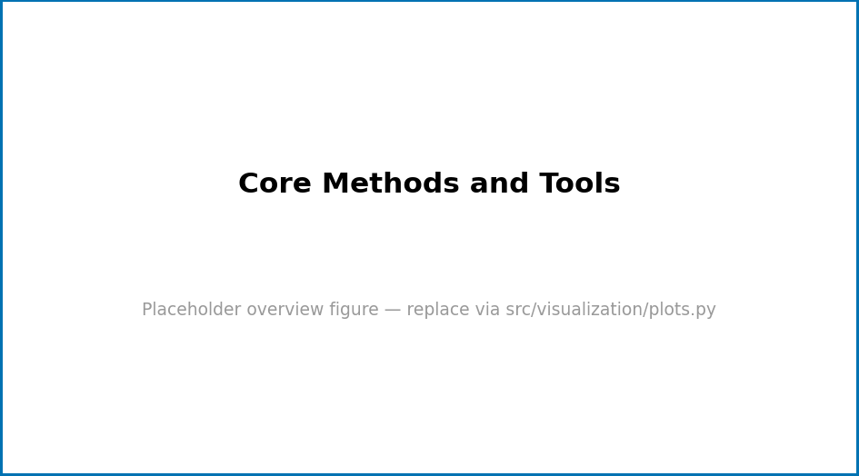
Figure 2: Overview schematic for “Core Methods and Tools”. Replace this generated placeholder with a real figure produced by src/visualization/plots.py.
Level 1/3 · 30 min read · 45 min lecture · Prerequisites: none

Learning Objectives
By the end of this chapter you should be able to:
- TODO: state the first measurable learning objective.
- TODO: state the second learning objective.
- TODO: state the third learning objective.

Study Blueprint
- Big idea:
- Core concepts: model, parameter, variable.
- Quantitative lens: the worked formalism in eq. 2.
- Data skill:
- Common misconception to repair:
- Primary lab: sec. 20.
- Question bank: sec. 32.
- Bridge to computation: textbook.models.

Opening Vignette: TKTK — a motivating story

Orientation
This section introduces the central ideas of Core Methods and Tools. Foundational treatments include (Kim 2020; Brown 2017). Key terms such as model, parameter, variable are defined in the glossary.

A Worked Formalism
The recurring quantitative model for this chapter is shown in eq. 2:
$$N(t)=\frac{K}{1+\left(\frac{K−N_{0}}{N_{0}}\right)e^{−rt}} (2)$$
It is implemented and tested in textbook.models.logistic_growth; never retype the maths in prose or scripts — call the tested function. The parameters appear in tbl. 2.
Table 2: Parameters of the worked model for this chapter.
Symbol | Meaning | Units
$r$​ | intrinsic rate | 1/time
$K$​ | carrying capacity | quantity
$N_{0}$​ | initial value | quantity
A concept map of how the pieces fit together:
Note

Going Deeper
See the overview in fig. 2 and revisit the objectives above as you read. Further evidence: (Kim 2020; Brown 2017).

Summary

Key Terms
emergence, regulation, boundary, state.

Further Reading
- TODO: one-line annotation (Wilson 2021).

Practice
- Lab: sec. 20
- Question bank: sec. 32

Quantitative Foundations

Figure 3: Overview schematic for “Quantitative Foundations”. Replace this generated placeholder with a real figure produced by src/visualization/plots.py.
Level 1/3 · 30 min read · 45 min lecture · Prerequisites: none

Learning Objectives
By the end of this chapter you should be able to:
- TODO: state the first measurable learning objective.
- TODO: state the second learning objective.
- TODO: state the third learning objective.

Study Blueprint
- Big idea:
- Core concepts: feedback, gradient, threshold.
- Quantitative lens: the worked formalism in eq. 3.
- Data skill:
- Common misconception to repair:
- Primary lab: sec. 21.
- Question bank: sec. 33.
- Bridge to computation: textbook.models.

Opening Vignette: TKTK — a motivating story

Orientation
This section introduces the central ideas of Quantitative Foundations. Foundational treatments include (Smith 2020; Doe 2019). Key terms such as feedback, gradient, threshold are defined in the glossary.

A Worked Formalism
The recurring quantitative model for this chapter is shown in eq. 3:
$$N(t)=\frac{K}{1+\left(\frac{K−N_{0}}{N_{0}}\right)e^{−rt}} (3)$$
It is implemented and tested in textbook.models.logistic_growth; never retype the maths in prose or scripts — call the tested function. The parameters appear in tbl. 3.
Table 3: Parameters of the worked model for this chapter.
Symbol | Meaning | Units
$r$​ | intrinsic rate | 1/time
$K$​ | carrying capacity | quantity
$N_{0}$​ | initial value | quantity
A concept map of how the pieces fit together:
Note

Going Deeper
See the overview in fig. 3 and revisit the objectives above as you read. Further evidence: (Smith 2020; Doe 2019).

Summary

Key Terms
observable, system, model, parameter.

Further Reading
- TODO: one-line annotation (Lee 2021).

Practice
- Lab: sec. 21
- Question bank: sec. 33

Part I: Fundamentals
This part covers fundamentals. It contains the following chapters:
- First Principles — sec. 8
- Building Blocks — sec. 9
- Structure and Form — sec. 10
How to use this part.

First Principles
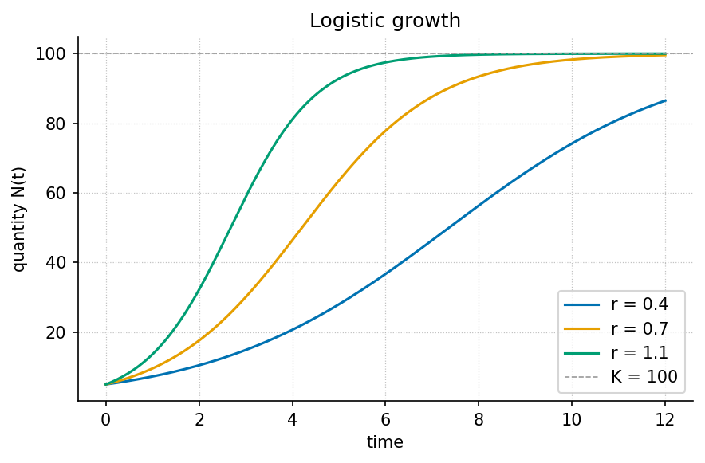
Figure 4: A logistic growth curve for three growth rates, approaching the carrying capacity $K=100$. Produced deterministically by visualization.plots.plot_logistic_growth.
Level 1/3 · 25 min read · 40 min lecture · Prerequisites: none
This chapter is a worked reference. It is filled to completion to show what a finished chapter looks like. The other chapters in this template ship as structurally-complete stubs (marked with stub comments and TODO notes); fill them the same way.

Learning Objectives
By the end of this chapter you should be able to:
- Explain what it means to model a system as a small set of state variables and a rule for how they change.
- Distinguish a parameter from a variable, and identify each in a worked model.
- Derive and interpret the logistic growth law and predict its long-run behaviour toward an equilibrium.
- Compute model values with the tested function textbook.models.logistic_growth rather than re-deriving arithmetic by hand.

Study Blueprint
- Big idea: A great deal of change in the world is captured by a handful of variables and a single rule relating their rates — the first principle of quantitative modelling.
- Core concepts: system, state, parameter, equilibrium.
- Quantitative lens: the logistic law in eq. 5.
- Data skill: read an S-curve and estimate its carrying capacity by eye, then confirm numerically.
- Common misconception to repair: “exponential” and “logistic” are not the same — unbounded growth is an early-time approximation, not the rule.
- Primary lab: sec. 22.
- Question bank: sec. 34.
- Bridge to computation: textbook.models.logistic_growth.

Opening Vignette: Counting before you explain.
A population biologist watches a colony double, then double again, then — unexpectedly — slow. A start-up tracks users that grow the same way before the market saturates. A chemist measures a reaction that races, then crawls as substrate runs low. Three unrelated fields, one shape. The job of a first model is not to capture everything; it is to capture that shape with as few moving parts as possible.

From a system to a model
A model is a deliberate simplification. We choose a small number of state variables — here, a single quantity $N(t)$ — and write a rule for how the state changes. The art is leaving things out: a first model that fits on one line teaches more than a faithful one that fills a page.
The variables are what change; the parameters are what we hold fixed while we reason. In the growth model below, $N$ is the variable, while the rate $r$ and the carrying capacity $K$ are parameters. Confusing the two is the most common beginner error: if you find yourself “solving for $K$ over time,” you have mislabelled a parameter as a variable.

A first quantitative law
Unbounded (exponential) growth assumes nothing ever pushes back. Real systems saturate. The simplest law that grows fast when small and levels off when large is the logistic equation, written as a rate of change in eq. 4 and in closed form in eq. 5:
$$\frac{dN}{dt}=rN\left(1−\frac{N}{K}\right) (4)$$
$$N(t)=\frac{K}{1+\left(\frac{K−N_{0}}{N_{0}}\right)e^{−rt}} (5)$$
Read eq. 4 aloud: the rate of change is proportional to how much there is ($rN$) times how much room remains ($1−N/K$). When $N$ is small the second factor is near $1$ and growth is nearly exponential; as $N$ approaches $K$ the factor approaches $0$ and growth stalls. The parameters are collected in tbl. 4.
Table 4: Parameters of the logistic model. Variables change over time; parameters are held fixed while reasoning.
Symbol | Name | Role | Example value
$N(t)$​ | quantity | variable | computed
$r$​ | intrinsic rate | parameter | $0.8 s^{−1}$​
$K$​ | carrying capacity | parameter | $100$ units
$N_{0}$​ | initial value | parameter | $5$ units

Worked example
Take $r=0.8$, $K=100$, and $N_{0}=5$. Rather than evaluate the exponential by hand, call the tested backbone:
import numpy as np
from textbook import models
t = np.array([0.0, 2.0, 5.0, 10.0])
N = models.logistic_growth(t, r=0.8, carrying_capacity=100.0, initial=5.0)
# N -> [ 5.00, 20.68, 74.18, 99.37 ]
The trajectory starts at $N(0)=5.00$, reaches $N(2)=20.68$, passes the steep middle near $t=5$ with $N(5)=74.18$, and by $t=10$ has all but arrived at $N(10)=99.37$ — within one part in a hundred of the carrying capacity. This is the S-curve plotted in fig. 4: an early near-exponential rise, an inflection, and a long approach to the asymptote.
The long-run behaviour is exact, not approximate. Because $r>0$, the term $e^{−rt}→0$, so $N(t)→K$. The proof is one line and is recorded as Theorem 1 in sec. 46; the same fact is asserted numerically by the test suite, so the prose and the code cannot silently disagree.

How the pieces connect
This loop — choose, write, solve, predict, compare — is the first principle the rest of the book elaborates. Foundational treatments of model-building include (Brown 2017) and (Patel 2018).

Summary
A model trades completeness for clarity: a few state variables and one rule. The logistic law adds a single idea — finite room — to exponential growth, and that idea changes the long-run behaviour from unbounded increase to a stable equilibrium at the carrying capacity $K$. Compute with the tested logistic_growth function so your worked numbers are reproducible and correct by construction.

Key Terms
system, model, state, parameter, equilibrium.

Further Reading
- Brown (2017) — a readable introduction to reasoning from first principles; start with its opening chapter on what a model is for.
- Patel (2018) — a broader survey of model families; use it to see where the logistic law sits among alternatives.

Practice
- Lab: sec. 22 — measure an S-curve and estimate its parameters.
- Question bank: sec. 34 — recall through synthesis.

Building Blocks
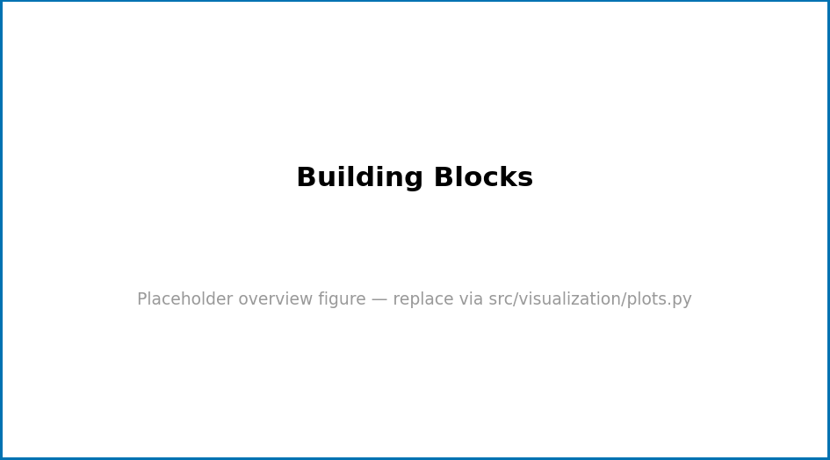
Figure 5: Overview schematic for “Building Blocks”. Replace this generated placeholder with a real figure produced by src/visualization/plots.py.
Level 1/3 · 30 min read · 45 min lecture · Prerequisites: none

Learning Objectives
By the end of this chapter you should be able to:
- TODO: state the first measurable learning objective.
- TODO: state the second learning objective.
- TODO: state the third learning objective.

Study Blueprint
- Big idea:
- Core concepts: equilibrium, feedback, gradient.
- Quantitative lens: the worked formalism in eq. 6.
- Data skill:
- Common misconception to repair:
- Primary lab: sec. 23.
- Question bank: sec. 35.
- Bridge to computation: textbook.models.

Opening Vignette: TKTK — a motivating story

Orientation
This section introduces the central ideas of Building Blocks. Foundational treatments include (Taylor 2019; Smith 2020). Key terms such as equilibrium, feedback, gradient are defined in the glossary.

A Worked Formalism
The recurring quantitative model for this chapter is shown in eq. 6:
$$N(t)=\frac{K}{1+\left(\frac{K−N_{0}}{N_{0}}\right)e^{−rt}} (6)$$
It is implemented and tested in textbook.models.logistic_growth; never retype the maths in prose or scripts — call the tested function. The parameters appear in tbl. 5.
Table 5: Parameters of the worked model for this chapter.
Symbol | Meaning | Units
$r$​ | intrinsic rate | 1/time
$K$​ | carrying capacity | quantity
$N_{0}$​ | initial value | quantity
A concept map of how the pieces fit together:
Note

Going Deeper
See the overview in fig. 5 and revisit the objectives above as you read. Further evidence: (Taylor 2019; Smith 2020).

Summary

Key Terms
state, observable, system, model.

Further Reading
- TODO: one-line annotation (Doe 2019).

Practice
- Lab: sec. 23
- Question bank: sec. 35

Structure and Form
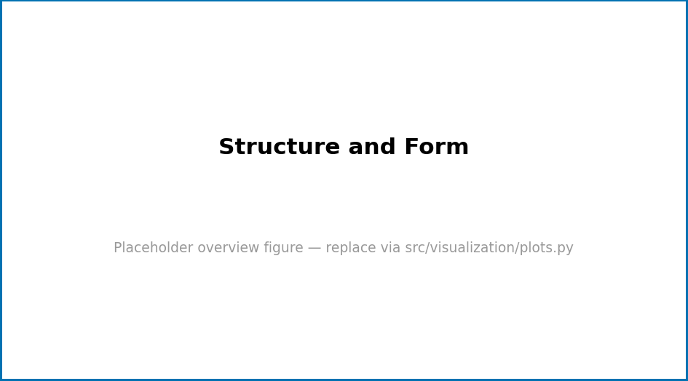
Figure 6: Overview schematic for “Structure and Form”. Replace this generated placeholder with a real figure produced by src/visualization/plots.py.
Level 1/3 · 30 min read · 45 min lecture · Prerequisites: none

Learning Objectives
By the end of this chapter you should be able to:
- TODO: state the first measurable learning objective.
- TODO: state the second learning objective.
- TODO: state the third learning objective.

Study Blueprint
- Big idea:
- Core concepts: threshold, network, dynamics.
- Quantitative lens: the worked formalism in eq. 7.
- Data skill:
- Common misconception to repair:
- Primary lab: sec. 24.
- Question bank: sec. 36.
- Bridge to computation: textbook.models.

Opening Vignette: TKTK — a motivating story

Orientation
This section introduces the central ideas of Structure and Form. Foundational treatments include (Lee 2021; Garcia 2022). Key terms such as threshold, network, dynamics are defined in the glossary.

A Worked Formalism
The recurring quantitative model for this chapter is shown in eq. 7:
$$N(t)=\frac{K}{1+\left(\frac{K−N_{0}}{N_{0}}\right)e^{−rt}} (7)$$
It is implemented and tested in textbook.models.logistic_growth; never retype the maths in prose or scripts — call the tested function. The parameters appear in tbl. 6.
Table 6: Parameters of the worked model for this chapter.
Symbol | Meaning | Units
$r$​ | intrinsic rate | 1/time
$K$​ | carrying capacity | quantity
$N_{0}$​ | initial value | quantity
A concept map of how the pieces fit together:
Note

Going Deeper
See the overview in fig. 6 and revisit the objectives above as you read. Further evidence: (Lee 2021; Garcia 2022).

Summary

Key Terms
model, parameter, variable, equilibrium.

Further Reading
- TODO: one-line annotation (Patel 2018).

Practice
- Lab: sec. 24
- Question bank: sec. 36

Part II: Core Systems
This part covers core systems. It contains the following chapters:
- Systems Overview — sec. 12
- Dynamics and Change — sec. 13
- Regulation and Control — sec. 14
How to use this part.

Systems Overview
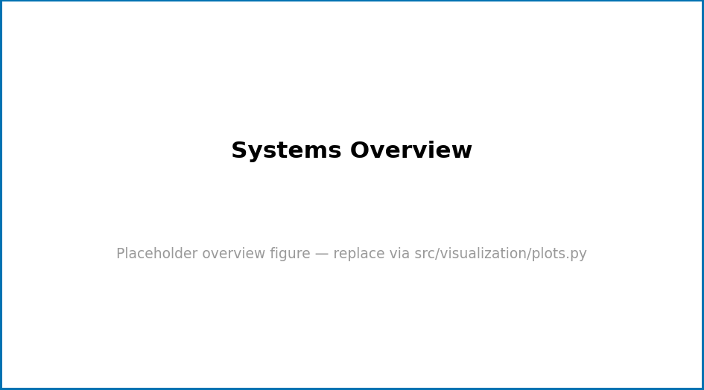
Figure 7: Overview schematic for “Systems Overview”. Replace this generated placeholder with a real figure produced by src/visualization/plots.py.
Level 1/3 · 30 min read · 45 min lecture · Prerequisites: none

Learning Objectives
By the end of this chapter you should be able to:
- TODO: state the first measurable learning objective.
- TODO: state the second learning objective.
- TODO: state the third learning objective.

Study Blueprint
- Big idea:
- Core concepts: equilibrium, feedback, gradient.
- Quantitative lens: the worked formalism in eq. 8.
- Data skill:
- Common misconception to repair:
- Primary lab: sec. 25.
- Question bank: sec. 37.
- Bridge to computation: textbook.models.

Opening Vignette: TKTK — a motivating story

Orientation
This section introduces the central ideas of Systems Overview. Foundational treatments include (Patel 2018; Nguyen 2023). Key terms such as equilibrium, feedback, gradient are defined in the glossary.

A Worked Formalism
The recurring quantitative model for this chapter is shown in eq. 8:
$$N(t)=\frac{K}{1+\left(\frac{K−N_{0}}{N_{0}}\right)e^{−rt}} (8)$$
It is implemented and tested in textbook.models.logistic_growth; never retype the maths in prose or scripts — call the tested function. The parameters appear in tbl. 7.
Table 7: Parameters of the worked model for this chapter.
Symbol | Meaning | Units
$r$​ | intrinsic rate | 1/time
$K$​ | carrying capacity | quantity
$N_{0}$​ | initial value | quantity
A concept map of how the pieces fit together:
Note

Going Deeper
See the overview in fig. 7 and revisit the objectives above as you read. Further evidence: (Patel 2018; Nguyen 2023).

Summary

Key Terms
state, observable, system, model.

Further Reading
- TODO: one-line annotation (Kim 2020).

Practice
- Lab: sec. 25
- Question bank: sec. 37

Dynamics and Change

Figure 8: Overview schematic for “Dynamics and Change”. Replace this generated placeholder with a real figure produced by src/visualization/plots.py.
Level 1/3 · 30 min read · 45 min lecture · Prerequisites: none

Learning Objectives
By the end of this chapter you should be able to:
- TODO: state the first measurable learning objective.
- TODO: state the second learning objective.
- TODO: state the third learning objective.

Study Blueprint
- Big idea:
- Core concepts: parameter, variable, equilibrium.
- Quantitative lens: the worked formalism in eq. 9.
- Data skill:
- Common misconception to repair:
- Primary lab: sec. 26.
- Question bank: sec. 38.
- Bridge to computation: textbook.models.

Opening Vignette: TKTK — a motivating story

Orientation
This section introduces the central ideas of Dynamics and Change. Foundational treatments include (Brown 2017; Wilson 2021). Key terms such as parameter, variable, equilibrium are defined in the glossary.

A Worked Formalism
The recurring quantitative model for this chapter is shown in eq. 9:
$$N(t)=\frac{K}{1+\left(\frac{K−N_{0}}{N_{0}}\right)e^{−rt}} (9)$$
It is implemented and tested in textbook.models.logistic_growth; never retype the maths in prose or scripts — call the tested function. The parameters appear in tbl. 8.
Table 8: Parameters of the worked model for this chapter.
Symbol | Meaning | Units
$r$​ | intrinsic rate | 1/time
$K$​ | carrying capacity | quantity
$N_{0}$​ | initial value | quantity
A concept map of how the pieces fit together:
Note

Going Deeper
See the overview in fig. 8 and revisit the objectives above as you read. Further evidence: (Brown 2017; Wilson 2021).

Summary

Key Terms
regulation, boundary, state, observable.

Further Reading
- TODO: one-line annotation (Taylor 2019).

Practice
- Lab: sec. 26
- Question bank: sec. 38

Regulation and Control
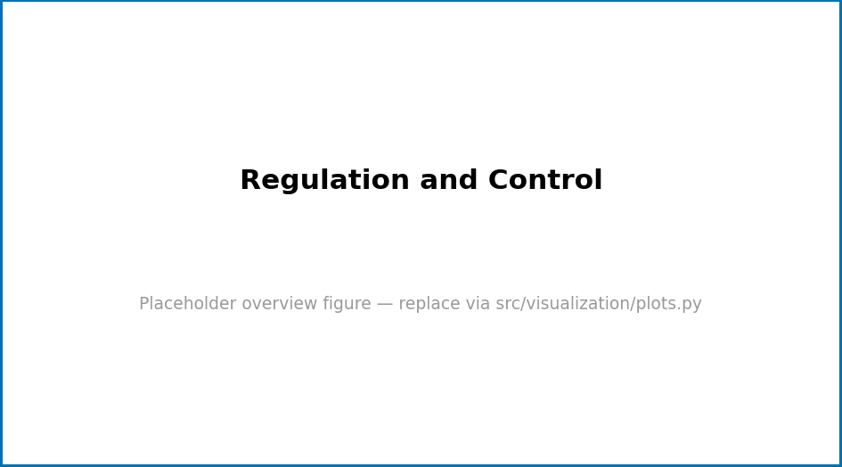
Figure 9: Overview schematic for “Regulation and Control”. Replace this generated placeholder with a real figure produced by src/visualization/plots.py.
Level 1/3 · 30 min read · 45 min lecture · Prerequisites: none

Learning Objectives
By the end of this chapter you should be able to:
- TODO: state the first measurable learning objective.
- TODO: state the second learning objective.
- TODO: state the third learning objective.

Study Blueprint
- Big idea:
- Core concepts: network, dynamics, emergence.
- Quantitative lens: the worked formalism in eq. 10.
- Data skill:
- Common misconception to repair:
- Primary lab: sec. 27.
- Question bank: sec. 39.
- Bridge to computation: textbook.models.

Opening Vignette: TKTK — a motivating story

Orientation
This section introduces the central ideas of Regulation and Control. Foundational treatments include (Wilson 2021; Taylor 2019). Key terms such as network, dynamics, emergence are defined in the glossary.

A Worked Formalism
The recurring quantitative model for this chapter is shown in eq. 10:
$$N(t)=\frac{K}{1+\left(\frac{K−N_{0}}{N_{0}}\right)e^{−rt}} (10)$$
It is implemented and tested in textbook.models.logistic_growth; never retype the maths in prose or scripts — call the tested function. The parameters appear in tbl. 9.
Table 9: Parameters of the worked model for this chapter.
Symbol | Meaning | Units
$r$​ | intrinsic rate | 1/time
$K$​ | carrying capacity | quantity
$N_{0}$​ | initial value | quantity
A concept map of how the pieces fit together:
Note

Going Deeper
See the overview in fig. 9 and revisit the objectives above as you read. Further evidence: (Wilson 2021; Taylor 2019).

Summary

Key Terms
parameter, variable, equilibrium, feedback.

Further Reading
- TODO: one-line annotation (Smith 2020).

Practice
- Lab: sec. 27
- Question bank: sec. 39

Part III: Applications and Synthesis
This part covers applications and synthesis. It contains the following chapters:
- Applied Models — sec. 16
- Case Studies — sec. 17
- Frontiers and Open Problems — sec. 18
How to use this part.

Applied Models

Figure 10: Overview schematic for “Applied Models”. Replace this generated placeholder with a real figure produced by src/visualization/plots.py.
Level 1/3 · 30 min read · 45 min lecture · Prerequisites: none

Learning Objectives
By the end of this chapter you should be able to:
- TODO: state the first measurable learning objective.
- TODO: state the second learning objective.
- TODO: state the third learning objective.

Study Blueprint
- Big idea:
- Core concepts: equilibrium, feedback, gradient.
- Quantitative lens: the worked formalism in eq. 11.
- Data skill:
- Common misconception to repair:
- Primary lab: sec. 28.
- Question bank: sec. 40.
- Bridge to computation: textbook.models.

Opening Vignette: TKTK — a motivating story

Orientation
This section introduces the central ideas of Applied Models. Foundational treatments include (Patel 2018; Nguyen 2023). Key terms such as equilibrium, feedback, gradient are defined in the glossary.

A Worked Formalism
The recurring quantitative model for this chapter is shown in eq. 11:
$$N(t)=\frac{K}{1+\left(\frac{K−N_{0}}{N_{0}}\right)e^{−rt}} (11)$$
It is implemented and tested in textbook.models.logistic_growth; never retype the maths in prose or scripts — call the tested function. The parameters appear in tbl. 10.
Table 10: Parameters of the worked model for this chapter.
Symbol | Meaning | Units
$r$​ | intrinsic rate | 1/time
$K$​ | carrying capacity | quantity
$N_{0}$​ | initial value | quantity
A concept map of how the pieces fit together:
Note

Going Deeper
See the overview in fig. 10 and revisit the objectives above as you read. Further evidence: (Patel 2018; Nguyen 2023).

Summary

Key Terms
state, observable, system, model.

Further Reading
- TODO: one-line annotation (Kim 2020).

Practice
- Lab: sec. 28
- Question bank: sec. 40

Case Studies
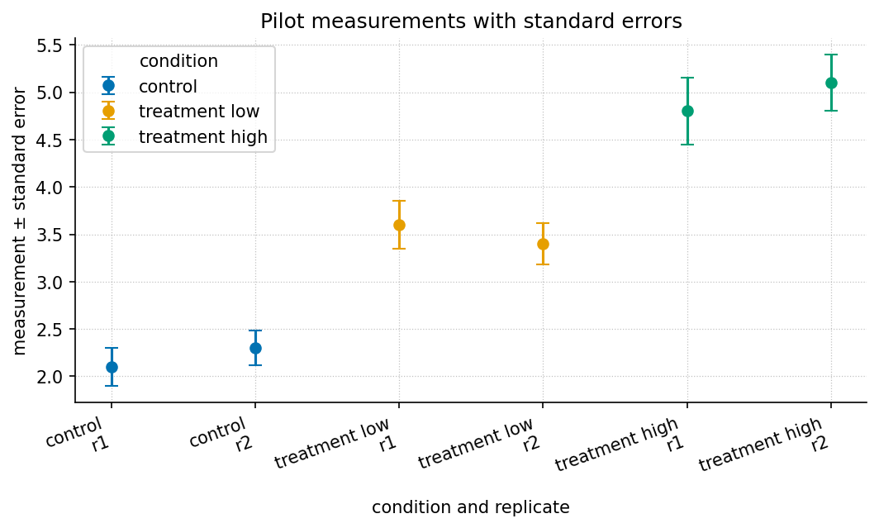
Figure 11: Pilot measurements with standard-error bars across the control, low-treatment, and high-treatment conditions, generated directly from manuscript/assets/data/sample_dataset.csv.
Level 2/3 · 30 min read · 45 min lecture · Prerequisites: First Principles
This chapter is a worked reference in a different style from sec. 8: where that chapter derives a model, this one applies one to a small dataset. The remaining chapters ship as stubs.

Learning Objectives
By the end of this chapter you should be able to:
- Frame a real question as a comparison between a system under control and treatment conditions.
- Summarise grouped observable data with means and a measure of spread, and read an error-bar figure.
- Fit a simple dose–response trend with textbook.models.linear_fit and state what its slope and $R^{2}$ mean.
- Distinguish a defensible interpolation from an unjustified extrapolation.

Study Blueprint
- Big idea: A case study turns a general model into a decision about a specific dataset — and into an honest statement of its limits.
- Core concepts: observable, gradient, threshold.
- Quantitative lens: a linear dose–response fit, eq. 12.
- Data skill: group, average, and fit; then sanity-check the fit against the raw numbers in tbl. 11.
- Common misconception to repair: a high $R^{2}$ on three points is not strong evidence — it is an invitation to collect more.
- Primary lab: sec. 29.
- Question bank: sec. 41.
- Bridge to computation: textbook.models.linear_fit, descriptive_statistics.

Opening Vignette: From a spreadsheet to a decision.
A team runs a small pilot: a control condition and two treatment levels, two replicates each. The numbers land in a spreadsheet. The question is not “are they different?” — they obviously are — but “by how much, how confidently, and what should we predict next?” A case study is the discipline of answering those three questions without overreaching.

The data
The pilot produced six measurements across three conditions, recorded in assets/data/sample_dataset.csv and reproduced in tbl. 11.
Table 11: The pilot dataset: two replicates per condition.
Condition | Replicate | Measurement | Standard error
control | 1 | 2.10 | 0.20
control | 2 | 2.30 | 0.18
treatment (low) | 1 | 3.60 | 0.25
treatment (low) | 2 | 3.40 | 0.22
treatment (high) | 1 | 4.80 | 0.35
treatment (high) | 2 | 5.10 | 0.30
Grouping and averaging — the first move in almost every case study — gives means of $2.20$ (control), $3.50$ (low), and $4.95$ (high). Across all six points the mean is $3.55$ with a standard deviation of $1.13$ (textbook.models.descriptive_statistics). The error-bar view is fig. 11.

Fitting a trend
Encode the dose as $0,1,2$ for control, low, and high, and fit a line with textbook.models.linear_fit:
import numpy as np
from textbook import models
dose = np.array([0.0, 1.0, 2.0])
response = np.array([2.20, 3.50, 4.95]) # condition means
fit = models.linear_fit(dose, response)
# fit.slope ≈ 1.375, fit.intercept ≈ 2.175, fit.r_squared ≈ 0.999
The fitted relationship in eq. 12 is
$$\hat{y}(d)=1.375 d+2.175 (12)$$
with $R^{2}=0.999$. The slope says each dose step adds about $1.4$ units of response; the intercept, $2.175$, is close to the measured control mean of $2.20$, a reassuring internal check.

Interpolation versus extrapolation
Using eq. 12 to estimate the response at an intermediate dose is reasonable: the model interpolates within the range it was fit on. Using it to predict a much higher dose — say $d=3$, giving $\hat{y}=6.3$ — is an extrapolation the data cannot support. Real dose–response curves usually saturate (recall the threshold behaviour of the saturating response in sec. 45); a straight line will overpredict once the system approaches its ceiling.
Warning. A linear fit through three averaged points reports $R^{2}=0.999$, but that number describes how well the line passes through three dots — not how well it predicts the next experiment. Treat it as a reason to collect more data, not as a conclusion. Foundational guidance on this trap appears in (Kim 2020) and (Wilson 2021).

Summary
A case study moves from raw observables to a summary, a fitted trend, and — crucially — an honest boundary around what the trend can claim. Here, averaging and a linear_fit recovered a clean dose–response slope of about $1.4$ units per step with an intercept that matched the control, but the same fit must not be pushed beyond the measured range. The reusable move is: summarise, fit, then state the limits.

Key Terms
observable, gradient, threshold, model.

Further Reading
- Kim (2020) — practical guidance on summarising and visualising small datasets before fitting anything.
- Wilson (2021) — on the difference between a good fit and a good prediction.

Practice
- Lab: sec. 29 — re-run the grouping and fit, then add a fourth condition and watch the fit change.
- Question bank: sec. 41 — recall through synthesis.

Frontiers and Open Problems
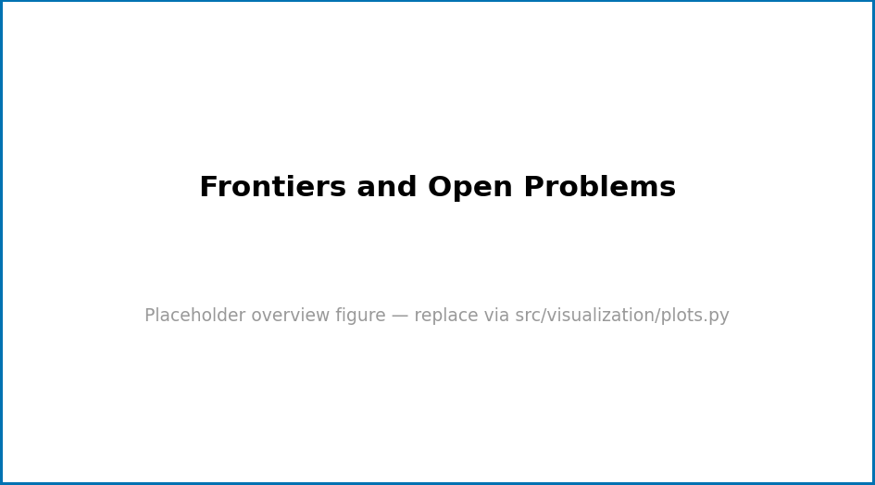
Figure 12: Overview schematic for “Frontiers and Open Problems”. Replace this generated placeholder with a real figure produced by src/visualization/plots.py.
Level 1/3 · 30 min read · 45 min lecture · Prerequisites: none

Learning Objectives
By the end of this chapter you should be able to:
- TODO: state the first measurable learning objective.
- TODO: state the second learning objective.
- TODO: state the third learning objective.

Study Blueprint
- Big idea:
- Core concepts: state, observable, system.
- Quantitative lens: the worked formalism in eq. 13.
- Data skill:
- Common misconception to repair:
- Primary lab: sec. 30.
- Question bank: sec. 42.
- Bridge to computation: textbook.models.

Opening Vignette: TKTK — a motivating story

Orientation
This section introduces the central ideas of Frontiers and Open Problems. Foundational treatments include (Wilson 2021; Taylor 2019). Key terms such as state, observable, system are defined in the glossary.

A Worked Formalism
The recurring quantitative model for this chapter is shown in eq. 13:
$$N(t)=\frac{K}{1+\left(\frac{K−N_{0}}{N_{0}}\right)e^{−rt}} (13)$$
It is implemented and tested in textbook.models.logistic_growth; never retype the maths in prose or scripts — call the tested function. The parameters appear in tbl. 12.
Table 12: Parameters of the worked model for this chapter.
Symbol | Meaning | Units
$r$​ | intrinsic rate | 1/time
$K$​ | carrying capacity | quantity
$N_{0}$​ | initial value | quantity
A concept map of how the pieces fit together:
Note

Going Deeper
See the overview in fig. 12 and revisit the objectives above as you read. Further evidence: (Wilson 2021; Taylor 2019).

Summary

Key Terms
threshold, network, dynamics, emergence.

Further Reading
- TODO: one-line annotation (Smith 2020).

Practice
- Lab: sec. 30
- Question bank: sec. 42

Lab — Orientation to the Field
Lab · 60 min · Materials: notebook, calculator (or textbook.models)

Objectives

Background
Linked chapter: sec. 4.

Procedure
- TODO: first step.
- TODO: second step.

Analysis
Summarise results with textbook.models.descriptive_statistics.

Computational Workflow
from textbook.models import logistic_growth
# TODO: parameterise and plot the model for this lab's scenario.

Reflection

Lab — Core Methods and Tools
Lab · 60 min · Materials: notebook, calculator (or textbook.models)

Objectives

Background
Linked chapter: sec. 5.

Procedure
- TODO: first step.
- TODO: second step.

Analysis
Summarise results with textbook.models.descriptive_statistics.

Computational Workflow
from textbook.models import logistic_growth
# TODO: parameterise and plot the model for this lab's scenario.

Reflection

Lab — Quantitative Foundations
Lab · 60 min · Materials: notebook, calculator (or textbook.models)

Objectives

Background
Linked chapter: sec. 6.

Procedure
- TODO: first step.
- TODO: second step.

Analysis
Summarise results with textbook.models.descriptive_statistics.

Computational Workflow
from textbook.models import logistic_growth
# TODO: parameterise and plot the model for this lab's scenario.

Reflection

Lab — First Principles
Lab · 60 min · Materials: a computer with the project installed (uv sync), or graph paper and a calculator

Objectives
After this lab you will be able to (1) generate a logistic trajectory for chosen parameters, (2) read its carrying capacity and half-rise time from a plot, and (3) recover the growth rate from data with a simple fit.

Background
This lab makes the chapter concrete: see sec. 8 for the logistic law and the meaning of $r$, $K$, and $N_{0}$. You will produce the same S-curve shown in fig. 4 and then work backwards from numbers to parameters.

Procedure
- Install the project: uv sync. Confirm the tests pass: uv run --extra dev python -m pytest tests/test_models.py -q.
- Generate a trajectory for $r=0.8$, $K=100$, $N_{0}=5$ at $t=0,1,2,…,12$ using the computational workflow below.
- Plot $N$ against $t$. Mark the value the curve approaches and the time at which $N$ first exceeds $K/2=50$.
- Repeat for $r=0.4$ and $r=1.2$, keeping $K$ and $N_{0}$ fixed. Overlay the three curves.

Analysis
Summarise each trajectory with textbook.models.descriptive_statistics(N) and tabulate the maximum value and the time-to-half-capacity for each $r$. Describe, in one sentence, how increasing $r$ changes the curve without changing where it ends.

Computational Workflow
import numpy as np
from textbook import models
t = np.arange(0, 13, 1.0)
for r in (0.4, 0.8, 1.2):
N = models.logistic_growth(t, r=r, carrying_capacity=100.0, initial=5.0)
t_half = t[np.argmax(N > 50)]
print(f"r={r}: N(12)={N[-1]:.1f}, first t with N>50 is t={t_half:.0f}")
print(" stats:", models.descriptive_statistics(N))

Reflection
- Two of your three curves end at almost the same value. Which parameter sets that value, and why is it independent of $r$?
- A colleague claims the population “will keep growing forever.” Using eq. 5, explain in one sentence why it will not.
- If your measured data rose past $K$ and then fell back, what would that tell you about the adequacy of the logistic model for that system?

Lab — Building Blocks
Lab · 60 min · Materials: notebook, calculator (or textbook.models)

Objectives

Background
Linked chapter: sec. 9.

Procedure
- TODO: first step.
- TODO: second step.

Analysis
Summarise results with textbook.models.descriptive_statistics.

Computational Workflow
from textbook.models import logistic_growth
# TODO: parameterise and plot the model for this lab's scenario.

Reflection

Lab — Structure and Form
Lab · 60 min · Materials: notebook, calculator (or textbook.models)

Objectives

Background
Linked chapter: sec. 10.

Procedure
- TODO: first step.
- TODO: second step.

Analysis
Summarise results with textbook.models.descriptive_statistics.

Computational Workflow
from textbook.models import logistic_growth
# TODO: parameterise and plot the model for this lab's scenario.

Reflection

Lab — Systems Overview
Lab · 60 min · Materials: notebook, calculator (or textbook.models)

Objectives

Background
Linked chapter: sec. 12.

Procedure
- TODO: first step.
- TODO: second step.

Analysis
Summarise results with textbook.models.descriptive_statistics.

Computational Workflow
from textbook.models import logistic_growth
# TODO: parameterise and plot the model for this lab's scenario.

Reflection

Lab — Dynamics and Change
Lab · 60 min · Materials: notebook, calculator (or textbook.models)

Objectives

Background
Linked chapter: sec. 13.

Procedure
- TODO: first step.
- TODO: second step.

Analysis
Summarise results with textbook.models.descriptive_statistics.

Computational Workflow
from textbook.models import logistic_growth
# TODO: parameterise and plot the model for this lab's scenario.

Reflection

Lab — Regulation and Control
Lab · 60 min · Materials: notebook, calculator (or textbook.models)

Objectives

Background
Linked chapter: sec. 14.

Procedure
- TODO: first step.
- TODO: second step.

Analysis
Summarise results with textbook.models.descriptive_statistics.

Computational Workflow
from textbook.models import logistic_growth
# TODO: parameterise and plot the model for this lab's scenario.

Reflection

Lab — Applied Models
Lab · 60 min · Materials: notebook, calculator (or textbook.models)

Objectives

Background
Linked chapter: sec. 16.

Procedure
- TODO: first step.
- TODO: second step.

Analysis
Summarise results with textbook.models.descriptive_statistics.

Computational Workflow
from textbook.models import logistic_growth
# TODO: parameterise and plot the model for this lab's scenario.

Reflection

Lab — Case Studies
Lab · 75 min · Materials: the project installed (uv sync), assets/data/sample_dataset.csv

Objectives
After this lab you will be able to (1) load grouped data, (2) compute per-group means and an overall summary, (3) fit a dose–response trend, and (4) state where the fit may and may not be trusted.

Background
This lab operationalises sec. 17. You will reproduce the chapter’s numbers (group means $2.20$, $3.50$, $4.95$; fitted slope $≈1.375$) and then probe the fit’s limits by adding a condition.

Procedure
- Read assets/data/sample_dataset.csv into three groups (control, low, high).
- Compute each group’s mean and the overall summary with textbook.models.descriptive_statistics.
- Encode dose as $0,1,2$ and fit a line with textbook.models.linear_fit. Confirm slope $≈1.375$, intercept $≈2.175$, $R^{2}≈0.999$.
- Add a hypothetical fourth condition (dose 3) with a saturating response — use the fixture value 5.3 rather than the line’s 6.3 prediction — refit, and compare the new slope and $R^{2}$.

Analysis
Tabulate the slope, intercept, and $R^{2}$ for the three-point and four-point fits. In two sentences, explain why the four-point fit’s slope falls and what that implies about extrapolating the original line.

Computational Workflow
import csv
import numpy as np
from textbook import models
rows = list(csv.DictReader(open("manuscript/assets/data/sample_dataset.csv")))
groups: dict[str, list[float]] = {}
for r in rows:
groups.setdefault(r["condition"], []).append(float(r["measurement"]))
means = {k: float(np.mean(v)) for k, v in groups.items()}
dose = np.array([0.0, 1.0, 2.0])
response = np.array([means["control"], means["treatment_low"], means["treatment_high"]])
print(models.linear_fit(dose, response))

Reflection
- The intercept of the fit was close to the control mean. Why is that a useful internal consistency check?
- Your four-point fit changed the slope. Which is the more honest summary of the system, and what would you measure next to decide?
- When is a straight-line dose–response model adequate, and when does the saturating model from sec. 45 become necessary?

Lab — Frontiers and Open Problems
Lab · 60 min · Materials: notebook, calculator (or textbook.models)

Objectives

Background
Linked chapter: sec. 18.

Procedure
- TODO: first step.
- TODO: second step.

Analysis
Summarise results with textbook.models.descriptive_statistics.

Computational Workflow
from textbook.models import logistic_growth
# TODO: parameterise and plot the model for this lab's scenario.

Reflection

Question Bank — Orientation to the Field
Linked chapter: sec. 4.

Recall
- TODO. (Answer: )
- TODO. (Answer: )

Application
- TODO. (Answer: )
- TODO. (Answer: )

Synthesis
- TODO. (Answer: )

Question Bank — Core Methods and Tools
Linked chapter: sec. 5.

Recall
- TODO. (Answer: )
- TODO. (Answer: )

Application
- TODO. (Answer: )
- TODO. (Answer: )

Synthesis
- TODO. (Answer: )

Question Bank — Quantitative Foundations
Linked chapter: sec. 6.

Recall
- TODO. (Answer: )
- TODO. (Answer: )

Application
- TODO. (Answer: )
- TODO. (Answer: )

Synthesis
- TODO. (Answer: )

Question Bank — First Principles
Linked chapter: sec. 8. Answers follow each question in italics; in a print build, move them to an answer key if you prefer.

Recall
- In the logistic model $N(t)$, which symbols are parameters and which is the variable? (Answer: $r$, $K$, and $N_{0}$ are parameters held fixed; $N(t)$ is the variable that changes with time $t$.)
- What value does a logistic trajectory approach as $t→∞$ when $r>0$? (Answer: the carrying capacity $K$.)

Application
- With $r=0.8$, $K=100$, $N_{0}=5$, the chapter reports $N(5)=74.18$ and $N(10)=99.37$. Roughly what fraction of the carrying capacity remains unfilled at $t=10$? (Answer: about $0.63\%$ — $N(10)$ is within one part in a hundred of $K$.)
- Doubling $r$ from $0.4$ to $0.8$ changes the curve in what way, and what does it leave unchanged? (Answer: the curve rises and reaches the neighbourhood of $K$ sooner — a steeper S — but the final level $K$ is unchanged because $K$ is a separate parameter.)

Synthesis
- A dataset grows nearly exponentially at first, then levels off, but the plateau sits well below the resources you believe are available. Propose one modification to the logistic model that could explain a lower-than-expected plateau, and name the parameter it would change. (Answer: any mechanism that effectively lowers the carrying capacity — competition, a toxin, or a resource cap — would reduce $K$; the plateau tracks $K$, not the nominal resource supply. Accept reasoned alternatives.)

Question Bank — Building Blocks
Linked chapter: sec. 9.

Recall
- TODO. (Answer: )
- TODO. (Answer: )

Application
- TODO. (Answer: )
- TODO. (Answer: )

Synthesis
- TODO. (Answer: )

Question Bank — Structure and Form
Linked chapter: sec. 10.

Recall
- TODO. (Answer: )
- TODO. (Answer: )

Application
- TODO. (Answer: )
- TODO. (Answer: )

Synthesis
- TODO. (Answer: )

Question Bank — Systems Overview
Linked chapter: sec. 12.

Recall
- TODO. (Answer: )
- TODO. (Answer: )

Application
- TODO. (Answer: )
- TODO. (Answer: )

Synthesis
- TODO. (Answer: )

Question Bank — Dynamics and Change
Linked chapter: sec. 13.

Recall
- TODO. (Answer: )
- TODO. (Answer: )

Application
- TODO. (Answer: )
- TODO. (Answer: )

Synthesis
- TODO. (Answer: )

Question Bank — Regulation and Control
Linked chapter: sec. 14.

Recall
- TODO. (Answer: )
- TODO. (Answer: )

Application
- TODO. (Answer: )
- TODO. (Answer: )

Synthesis
- TODO. (Answer: )

Question Bank — Applied Models
Linked chapter: sec. 16.

Recall
- TODO. (Answer: )
- TODO. (Answer: )

Application
- TODO. (Answer: )
- TODO. (Answer: )

Synthesis
- TODO. (Answer: )

Question Bank — Case Studies
Linked chapter: sec. 17. Answers follow each question in italics.

Recall
- What two summary numbers does the chapter report for each condition group, and which function computes them? (Answer: the per-group mean — e.g. $2.20$, $3.50$, $4.95$ — plus an overall spread from textbook.models.descriptive_statistics, which returns mean, std, min, max, and count.)
- What do the slope and intercept of the fitted line eq. 12 represent? (Answer: the slope ($≈1.375$) is the response added per dose step; the intercept ($≈2.175$) is the predicted response at dose $0$, which should match the control mean.)

Application
- The intercept ($2.175$) is close to the control mean ($2.20$). Why is this a useful check rather than a coincidence to ignore? (Answer: a fit whose dose-$0$ prediction matches the measured control is internally consistent; a large mismatch would signal a coding error or a poor model.)
- The line predicts $\hat{y}(3)=6.3$. Why should this prediction be flagged? (Answer: dose $3$ is outside the measured range $[0,2]$ — it is an extrapolation, and real dose–response curves usually saturate, so a line will overpredict.)

Synthesis
- With only three averaged points the fit reports $R^{2}=0.999$. Explain why this is weak evidence and describe one experiment that would strengthen — or overturn — the linear conclusion. (Answer: $R^{2}$ near $1$ on three points mostly reflects that a line can pass through three dots; it says little about prediction. Collecting more doses, especially higher ones, would reveal curvature/saturation and test whether the linear model generalises. Accept reasoned alternatives.)

Question Bank — Frontiers and Open Problems
Linked chapter: sec. 18.

Recall
- TODO. (Answer: )
- TODO. (Answer: )

Application
- TODO. (Answer: )
- TODO. (Answer: )

Synthesis
- TODO. (Answer: )

Appendix A — Authoring Guide: Filling the Stubs
Reference appendix · For authors and contributors · Read this first.
This is the most important file in the template. It explains how to turn the empty scaffold into a finished book by filling stubs and growing structure from a single source of truth. Read it once end-to-end, then keep it open while you work.

The Big Idea: One Source of Truth
The book is data-driven from config.yaml. The list of parts, chapters, labs, question banks, and reference appendices lives there and nowhere else. The Python engine in src/textbook/ reads that file and the scaffolding scripts in scripts/ materialise the matching markdown files. You never hand-number a chapter, figure, equation, or section — pandoc-crossref does that at render time from the labels you write.
The flow is always the same:
edit config.yaml -> scaffold_chapter.py -> fill <!-- STUB --> blocks
-> add figures / glossary terms / references -> audit + tests

Step 1 — Decide the Structure in config.yaml
Open config.yaml. To add or rename a chapter, edit the parts: tree (each chapter has a stem and a title); to add a lab or question bank, add an entry under appendices.labs / appendices.questions for the matching part. The stem drives every downstream name:
- chapter file → manuscript/<part>/<NN>_<stem>.md, label {#sec:<part>_<stem>}
- lab file → manuscript/labs/<part>/lab_<stem>.md, label {#sec:lab_<part>_<stem>}
- question bank → manuscript/questions/<part>/q_<stem>.md, label {#sec:q_<part>_<stem>}
Keep stems short, lowercase, and snake_case. Do not invent a numbering scheme; the table of contents and labels are derived in src/textbook/toc.py.

Step 2 — Materialise the Stubs
Run the scaffolder. It only creates files that are missing, so it is safe to re-run after every config change:
uv run python scripts/scaffold_chapter.py
This writes a chapter (or lab, or question bank) pre-populated with every required structural element as <!-- STUB --> markers. Your job is to replace the stubs with real prose, never to delete the structure.

Step 3 — Fill the Content Contract
Every chapter must carry these elements (enforced by validate_chapter in src/textbook/content.py and by the integrity tests). Fill each, keep the markers’ surrounding structure:
- a labelled H1: # Title {#sec:<part>_<stem>}
- a metadata badge line: <!-- chapter-metadata-badge -->
- a Study Blueprint: <!-- curriculum-scaffold-start -->
- Learning Objectives
- one figure with alt text and a crossref label {#fig:...}
- a worked formalism: an equation {#eq:...} plus a parameter table {#tbl:...}
- an inline ```mermaid diagram
- Summary, Key Terms, Further Reading, Practice sections
Cross-reference syntax is pandoc-crossref: [@fig:..], [@tbl:..], [@eq:..], [@sec:..]. Stub markers the audit counts are <!-- STUB -->, TODO:, and TKTK — drive these to zero as the chapter matures.

Step 4 — Add a Figure
Figures are deterministic matplotlib output. Each chapter expects a placeholder named <part_id>_<stem>.png. To make it real, add or edit a function in src/visualization/plots.py (the four worked figures show the pattern), then regenerate:
uv run python scripts/generate_figures.py
For diagrams, edit src/mermaid/diagram_specs.yaml and run scripts/generate_diagrams.py (PNG, or .mmd fallback). Reference the figure in prose with [@fig:<part>_<stem>] and give it alt text.

Step 5 — Add a Glossary Term
Glossary anchors are a closed contract. To add a term you must update both:
- GLOSSARY_ANCHORS in src/textbook/constants.py
- the matching entry in glossary.md
Link a term in prose as [**term**](#gl:<anchor>). The current anchors are system, model, parameter, variable, equilibrium, feedback, gradient, threshold, network, dynamics, emergence, regulation, boundary, state, observable.

Step 6 — Add a Reference
Citations are [@key] and must resolve in references.bib. Add a BibTeX entry, then cite it. Keep CITATION_KEYS in constants.py in sync if you add a key that the structural contract should track.

Step 7 — Audit and Test
Two gates decide whether the book is healthy:
# Quality gate: counts stubs, checks the content contract per file
uv run python scripts/audit_textbook_quality.py
# Full test suite (engine + manuscript integrity)
uv run --extra dev python -m pytest
tests/test_manuscript_integrity.py verifies that every chapter satisfies the content contract, that labels are unique, that citations resolve, and that glossary links point at real anchors. Green tests with remaining stubs mean the structure is correct but the content is unfinished — that is the normal state of a freshly scaffolded chapter.

Growing the Book
To add a whole new chapter end-to-end:
- add its stem/title under the right part in config.yaml;
- add matching lab and question-bank entries under appendices;
- run scripts/scaffold_chapter.py;
- fill the stubs (Steps 3–6);
- run the audit and tests until the contract passes.
See also: Appendix B — Notation, Appendix C — Mathematical Review, and the appendices README.

Appendix B — Notation and Symbols
Reference appendix · Symbol glossary for the worked models.
This appendix lists the symbols used by the worked formalisms in src/textbook/models.py. Keep it in sync with the parameter tables ({#tbl:...}) in the chapters: every symbol that appears in an equation {#eq:...} should have a row here.

Conventions
- Scalars are italic lowercase (e.g. r, t); sets and spaces are uppercase.
- Subscript 0 denotes an initial value (e.g. N₀ at t = 0).
- Units are stated in SI / metric unless a chapter declares otherwise.

Symbol Table
Symbol | Name | Appears in | Units | Notes
t | time / independent variable | all dynamic models | s (or chapter unit)
N | state quantity / population | logistic_growth | dimensionless
N₀ | initial state | logistic_growth, exponential_decay | dimensionless
r | intrinsic growth rate | logistic_growth | 1/time
K | carrying capacity | logistic_growth | dimensionless
λ (lambda) | decay constant | exponential_decay, half_life | 1/time
t½ | half-life | half_life | time
Vmax | maximum response | saturating_response | response unit
Kₘ | half-saturation constant | saturating_response | input unit
x, y | paired observations | linear_fit | data unit
m, b | slope, intercept | linear_fit | derived
μ, σ | mean, standard deviation | descriptive_statistics | data unit
See also: Appendix C — Mathematical Review.

Appendix C — Mathematical Review
Reference appendix · Just-enough mathematics for the worked models.
A brief refresher on the mathematics the book relies on. Each section ties directly to a function in src/textbook/models.py so you can move from formula to tested code without a gap. Replace the stubs with the depth your audience needs.

Functions and Variables
A function maps an input to an output; here state quantities depend on a variable such as time, tuned by parameters. See normalize_unit_interval for rescaling inputs to [0, 1].

Growth and Decay
Logistic growth (logistic_growth) rises then saturates at the carrying capacity K; exponential decay (exponential_decay) falls by a fixed fraction per unit time, summarised by the half-life t½ (half_life). These are the canonical examples of dynamics.

Saturating Responses
The saturating (Michaelis–Menten-style) response (saturating_response) climbs toward Vmax with half-maximum at Kₘ — a recurring shape whenever a resource or signal becomes limiting near a threshold.

Linear Fits
Least-squares fitting (linear_fit) returns a slope m and intercept b for paired data, the simplest way to summarise a trend before reaching for a richer model.

Basic Statistics
Descriptive statistics (descriptive_statistics) report the mean μ and standard deviation σ — the first numbers to compute on any observable before inference.
See also: Appendix B — Notation and the Authoring Guide.

Appendix — Formalisms
A worked example of every formal element a technical book uses: definitions, theorems with proofs, lemmas, algorithms in pseudocode, step-by-step derivations, systems of numbered equations, and dimensioned quantities. Each maps to a tested function in src/textbook/models.py, so the prose and the code stay in agreement.
Convention. Theorem-like environments below use a portable bold-label block-quote form that renders in every target. If your render profile loads amsthm (the preamble does), you may instead use native LaTeX theorem, lemma, definition, and proof environments.

1. Definitions
Definition 1 (Equilibrium). A state $N^{*}$ of a dynamical system $\dot{N}=f(N)$ is an equilibrium if $f(N^{*})=0$. See equilibrium.
Definition 2 (Carrying capacity). For logistic dynamics, the carrying capacity $K$ is the non-zero equilibrium toward which trajectories converge.

2. A theorem with proof
Theorem 1 (Logistic limit). For the logistic model in eq. 14 with $r>0$ and $0<N_{0}≤K$, the trajectory satisfies $\lim_{t→∞}N(t)=K$.
$$N(t)=\frac{K}{1+Ae^{−rt}}, A=\frac{K−N_{0}}{N_{0}}. (14)$$
Proof. Because $r>0$, the term $e^{−rt}→0$ as $t→∞$. Hence the denominator $1+Ae^{−rt}→1$, and therefore $N(t)→K/1=K$. The constant $A≥0$ follows from $0<N_{0}≤K$, so $N(t)$ is increasing and the limit is approached from below. $◼$
This is exactly the asymptotic behaviour the test tests/test_models.py::test_logistic_growth_starts_at_initial_and_approaches_capacity verifies numerically — the proof and the test assert the same fact.

3. A lemma
Lemma 1 (Half-life). For exponential decay $y(t)=y_{0}e^{−λt}$ with $λ>0$, the time at which $y$ falls to half its initial value is $t_{1/2}=ln2/λ$, independent of $y_{0}$.
Proof. Set $y(t_{1/2})=y_{0}/2$. Then $e^{−λt_{1/2}}=1/2$, so $−λt_{1/2}=−ln2$, giving $t_{1/2}=ln2/λ$. The result does not depend on $y_{0}$. $◼$
Implemented as textbook.models.half_life.

4. Algorithms (pseudocode)
Where the preamble provides an algorithm package, use it; otherwise this fenced form renders everywhere.
Algorithm 1: Ordinary least-squares line fit
Input : points (x_i, y_i), i = 1..n, n >= 2
Output: slope m, intercept b, coefficient of determination R^2
1 x_bar <- mean(x); y_bar <- mean(y)
2 m <- sum((x_i - x_bar)(y_i - y_bar)) / sum((x_i - x_bar)^2)
3 b <- y_bar - m * x_bar
4 SS_res <- sum((y_i - (m x_i + b))^2)
5 SS_tot <- sum((y_i - y_bar)^2)
6 R^2 <- 1 - SS_res / SS_tot (define R^2 = 1 when SS_tot = 0)
7 return (m, b, R^2)
This is textbook.models.linear_fit; Step 6’s degenerate case is covered by tests/test_models.py::test_linear_fit_constant_y_gives_r_squared_one.

5. A step-by-step derivation
Starting from the logistic differential equation and separating variables:
$$\begin{aligned}\frac{dN}{dt}&=rN\left(1−\frac{N}{K}\right) \\ ∫\frac{dN}{N(1−N/K)}&=∫r dt \\ ln​\left(\frac{N}{K−N}\right)&=rt+C \\ N(t)&=\frac{K}{1+Ae^{−rt}}, A=e^{−C},\end{aligned}$$
which recovers eq. 14. Each line is one algebraic move; show your work at this granularity so readers can follow without gaps.

6. A system of numbered equations
A simple predator–prey system, with each equation individually referenceable (eq. 15, eq. 16):
$$\frac{dx}{dt}=αx−βxy (15)$$
$$\frac{dy}{dt}=δxy−γy (16)$$
The vector-field figure style for such systems is demonstrated by the quiver plot in the format gallery (sec. 47).

7. Dimensioned quantities
State parameters with units explicitly, in math mode so they render in every target:
Table 13: Worked-model parameters with representative dimensioned values.
Symbol | Quantity | Example value
$r$​ | intrinsic rate | $0.8 s^{−1}$​
$λ$​ | decay constant | $0.5 s^{−1}$​
$t_{1/2}$​ | half-life | $1.386 s$​
$K$​ | carrying capacity | $100$ individuals

8. Notation summary
Symbols used throughout are collected in the notation appendix (sec. 44); glossary definitions for narrative terms such as gradient and threshold are in the master glossary.

Appendix — Format Gallery
This appendix is a kitchen-sink demonstration: a working example of every content primitive this template supports. Copy any block into a chapter and adapt it. Each example is real and renders through the standard pipeline; figures are produced deterministically by src/visualization/ and embedded from ../figures/.
How to read this appendix. Headings group primitives by kind: text, lists, callouts, tables, math, figures, diagrams, code, cross-references, media, and pedagogy blocks. The Markdown source is the example — view it next to the rendered output.

1. Text and inline formatting
Plain paragraph text wraps and flows normally. Inline styles: bold, italic, bold italic, inline code, strikethrough, H₂O with a subscript, E = mc² with a superscript, and a footnote.
You can hard-break a line with a backslash at the line end.
The next line begins after that break; separate paragraphs with a blank line. Escape literal Markdown with a backslash: *not italic*.

2. Lists
Unordered, with nesting:
- First item
- Second item
  - Nested item
  - Another nested item
    - Third level
- Third item
Ordered:
- Step one
- Step two
  - Sub-step a
  - Sub-step b
- Step three
Task list (renders as checkboxes in many targets):
- Scaffold the chapter
- Generate figures
- Fill the prose
- Write the assessment answers
Definition list:
Parameter
A fixed quantity that configures a model (see parameter).
Variable
A quantity that changes across states (see variable).

3. Block quotes and callouts
A plain block quote:
“Form follows function.” Use quotes for epigraphs and primary-source extracts.
Portable callouts (a bold label inside a block quote — renders in every target):
Note. A neutral aside that adds context.
Tip. A practical suggestion the reader can act on.
Warning. A caveat, common error, or safety note.
Example. A short worked illustration inline in the text.
Definition. A precise statement of a term, often paired with a glossary entry such as equilibrium.
Pandoc fenced-div callout (richer styling where supported; falls back gracefully):
This is a Pandoc fenced div. If your render profile styles .callout-note, it appears as a boxed admonition; otherwise it renders as a normal block.

4. Tables
A simple table with column alignment and a cross-referencable caption (tbl. 14):
Table 14: Column alignment — left, centre, right.
Left | Centre | Right
alpha | 1 | 10.0
beta | 22 | 2.5
gamma | 333 | 0.125
The values above are mirrored in manuscript/assets/data/format_gallery.csv so rendering examples remain evidence-addressable fixtures rather than anonymous literals.
A multi-line / grid table (cells may contain longer wrapped text):
Symbol | Meaning | Typical range
$r$​ | intrinsic rate of change | 0.1 – 2.0
$K$​ | carrying capacity / saturation level the system approaches | problem- dependent

5. Mathematics and units
Inline math: the half-life is $t_{1/2}=ln2/λ$.
A numbered display equation, cross-referenced as eq. 17:
$$N(t)=\frac{K}{1+\left(\frac{K−N_{0}}{N_{0}}\right)e^{−rt}} (17)$$
Multi-line aligned derivation:
$$\begin{aligned}\frac{dN}{dt}&=rN\left(1−\frac{N}{K}\right) \\ &=rN−\frac{r}{K}N^{2}.\end{aligned}$$
A matrix and a piecewise definition:
$$A=\left[\begin{matrix}a_{11} & a_{12} \\ a_{21} & a_{22}\end{matrix}\right], f(x)=\left\{\begin{matrix}0 & x<0 \\ 1 & x≥0.\end{matrix}\right.$$
Physical quantities with units, written in math mode so they render in every target (PDF, HTML, slides): a rate of $0.5 s^{−1}$, a length of $2.0 m$, and a concentration of $1.5 mol L^{−1}$. (For PDF-only builds you may instead use siunitx macros such as \SI{0.5}{\per\second}, which the preamble loads — but math-mode units are the portable choice.)

6. Figures
A single figure with caption, label, and alt text, cross-referenced as fig. 13:
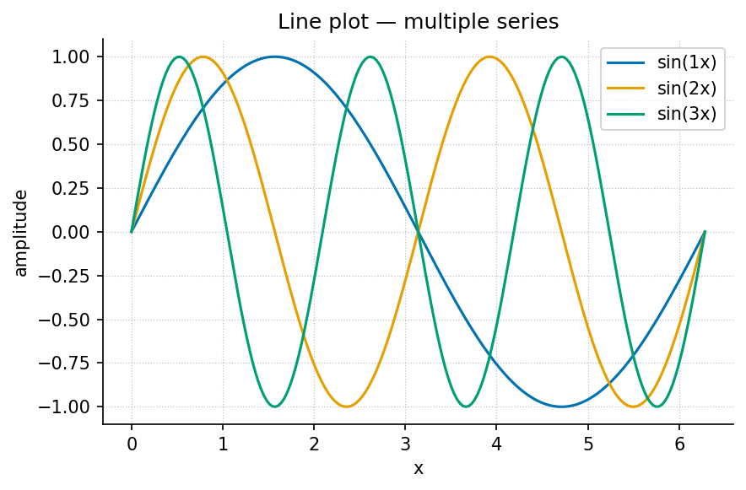
Figure 13: A multi-series line plot of three sine waves, produced by visualization.gallery.line_plot.
Two figures side by side (Pandoc fenced div; falls back to stacked):
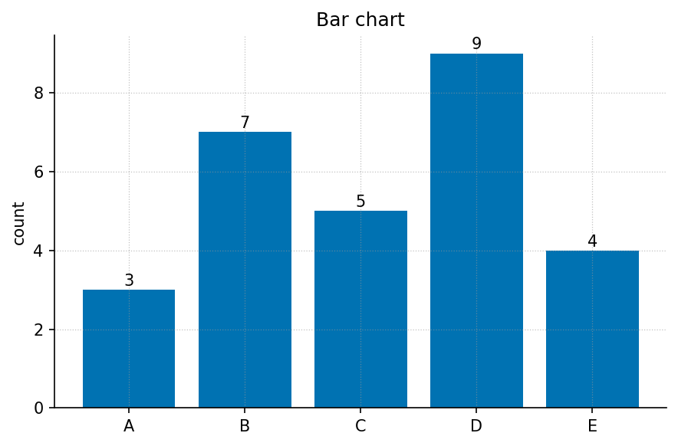
Figure 14: Bar chart.
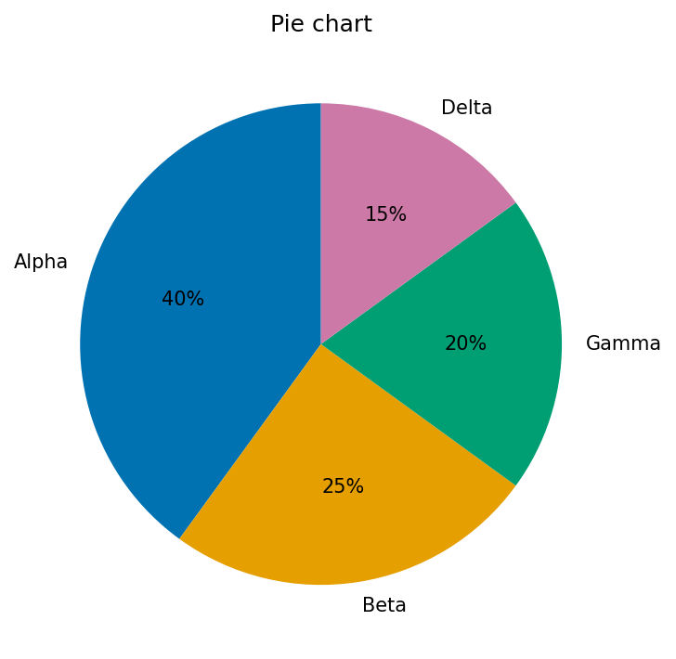
Figure 15: Pie chart.
A multi-panel composite (fig. 16):
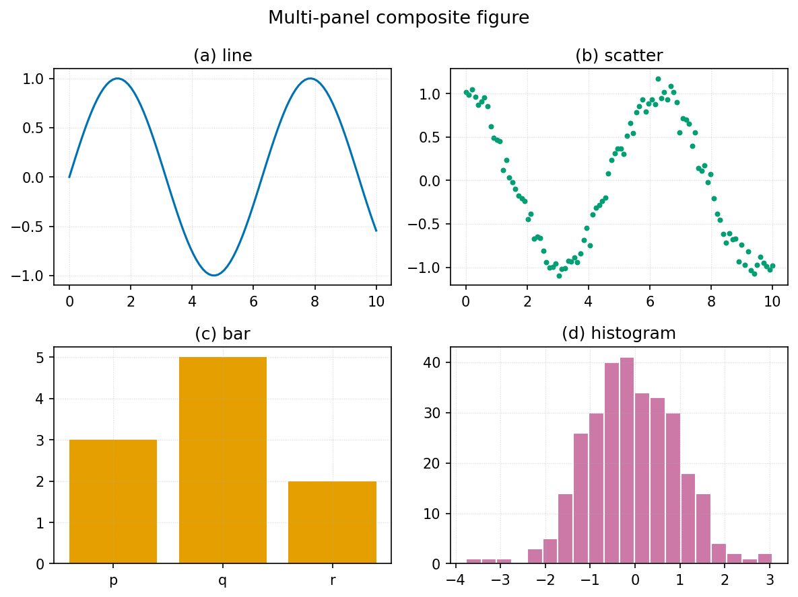
Figure 16: A 2×2 composite: line, scatter, bar, and histogram panels.
The full plot-type gallery lives in ../figures/gallery/ and includes: line, scatter-with-fit, bar, grouped bar, horizontal bar, histogram, box, violin, heatmap, contour, quiver field, step, stacked area, error bars, log-log, pie, annotated, and multi-panel.

7. Diagrams (Mermaid)
The pipeline renders fenced mermaid blocks to figures (and falls back to the .mmd source if the Mermaid CLI is absent). One worked example of each kind the builders in src/mermaid/diagrams.py support:
Flowchart:
Sequence:
State:
Class:
Entity-relationship:
Pie, Gantt, mindmap, timeline, quadrant, and user-journey diagrams are also supported — see src/mermaid/diagram_specs.yaml for a worked spec of each.

8. Code
Inline code: call textbook.models.logistic_growth(t, r=..., ...).
A fenced code block with a language (syntax-highlighted) and a caption (lst. 1):
Listing 1: Calling the tested computational backbone.
from textbook import models
import numpy as np
t = np.linspace(0, 10, 100)
n = models.logistic_growth(t, r=0.8, carrying_capacity=100.0, initial=5.0)
print(n[-1]) # -> approaches the carrying capacity
A shell example:
uv run python scripts/generate_figures.py
uv run --extra dev python -m pytest tests/ --cov=src

9. Cross-references and citations
Cross-references resolve by label: figure fig. 13, table tbl. 14, equation eq. 17, and section sec. 46. Never hand-number — Pandoc fills these in.
Citations resolve against references.bib: a single source (Smith 2020), multiple sources (Doe 2019; Lee 2021), and an in-text form — Garcia (2022) showed the effect first. A locator narrows the reference (Patel 2018, 12–14).

10. Media and data
Embedded raster image (any PNG/JPG works the same way as a figure):
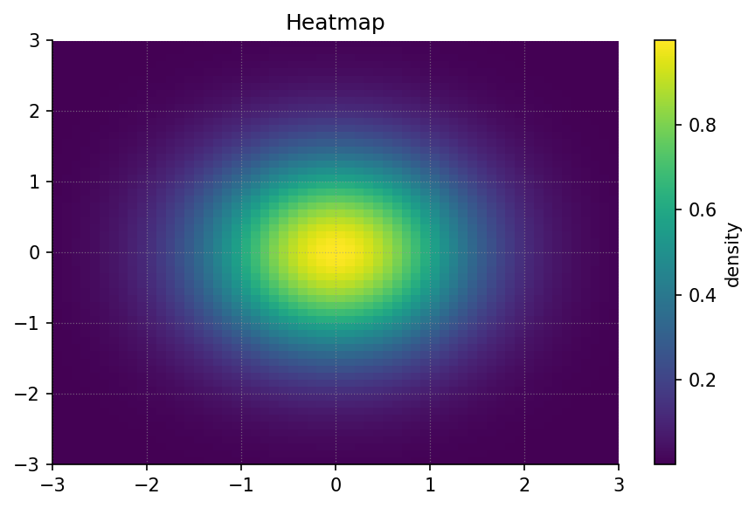
Figure 17: A generated heatmap embedded as a raster image.
Audio and video embed in HTML targets (PDF shows the caption + link). Syntax:
![Caption for an audio clip.](../assets/media/clip.mp3)
![Caption for a video.](../assets/media/demo.mp4){width=70%}
A downloadable data file lives at assets/data/sample_dataset.csv; its contents as a table:
Table 15: Sample dataset (mirrors assets/data/sample_dataset.csv).
condition | replicate | measurement | standard_error
control | 1 | 2.10 | 0.20
control | 2 | 2.30 | 0.18
treatment_low | 1 | 3.60 | 0.25
treatment_high | 1 | 4.80 | 0.35
The error-bar figure fig. 18 visualises this kind of data:
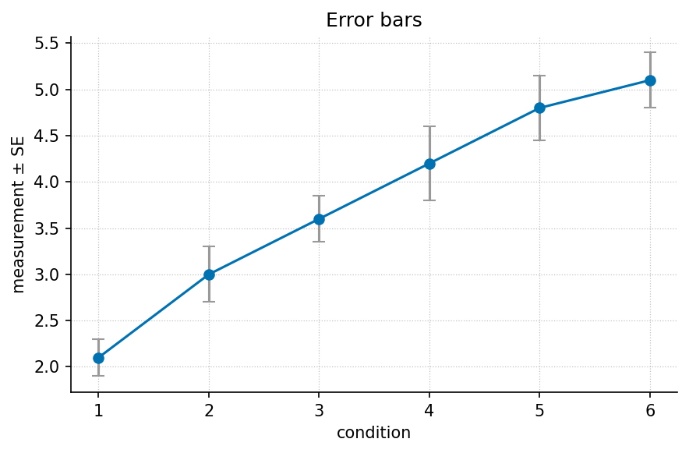
Figure 18: Means with standard-error bars.

11. Pedagogical blocks
These are the reusable teaching elements chapters draw on.
Learning objective. After this section a reader can identify which Markdown primitive to use for a given purpose.
Worked example. Given $r=0.8$, $K=100$, $N_{0}=5$, evaluate $N(10)$ via eq. 17 using textbook.models.logistic_growth. The result approaches $K$.
Try it. Change $r$ to $1.5$ and predict, then check, how the curve shifts.
Key terms. model, parameter, state.
Summary. This appendix demonstrated text, lists, callouts, tables, math and units, figures, diagrams, code, cross-references, media, and pedagogy blocks — the complete primitive set.

12. Miscellany
A horizontal rule separates major shifts in topic (three or more dashes):

Raw inline HTML is supported only inside <details>, <aside>, or <callout> per project style; everything else uses Markdown. Unicode renders directly: α, β, γ, Δ, ∑, ∞, ≈, →. For PDF math, prefer LaTeX ($\alpha$) over raw Unicode in equations.

Master Glossary

Boundary
The interface separating a system from its environment.

Dynamics
How the state of a system changes over time.

Emergence
System-level behaviour not present in the parts taken alone.

Equilibrium
A state in which opposing influences balance and net change is zero.

Feedback
A loop in which a system’s output influences its own input.

Gradient
A spatial or quantitative difference that drives flow or change.

Model
A simplified, often quantitative, representation of a system.

Network
A set of elements (nodes) connected by relationships (edges).

Observable
A quantity that can be measured or recorded.

Parameter
A fixed quantity that configures a model’s behaviour.

Regulation
The control of a system variable toward a target range.

State
The configuration of a system at a moment in time.

System
A set of interacting parts forming an integrated whole.

Threshold
A critical value at which a qualitative change occurs.

Variable
A quantity that can take different values across states or observations.

Appendix E — Index of Key Terms
Reference appendix · Generated index — do not hand-maintain.
This index is intended to be generated at build time, not edited by hand. A future indexing pass will scan the chapters for glossary links ([**term**](#gl:<anchor>)) and crossref labels ({#sec:...}, {#fig:...}, {#tbl:...}, {#eq:...}) and collate page/section references from the rendered PDF. Until that pass runs, the entries below are placeholders.
The authoritative term definitions live in Appendix D — Glossary; the closed list of anchors is GLOSSARY_ANCHORS in src/textbook/constants.py.

Placeholder Entries
- dynamics — see sec. 13
- equilibrium — see sec. 14
- feedback — see sec. 14
- model — see sec. 6
- network — see sec. 10
- system — see sec. 12
See also: Appendix D — Glossary.
Brown, Casey. 2017. First Principles: A Placeholder Reference. Placeholder Press.
Doe, Jordan. 2019. “Core Methods: A Placeholder Reference.” Journal of Placeholders 1: 1–20.
Garcia, Robin. 2022. “Dynamics and Change: A Placeholder Reference.” Journal of Placeholders 4: 88–110.
Kim, Dana. 2020. “Working with Data: A Placeholder Reference.” Journal of Placeholders 2: 200–225.
Lee, Sam. 2021. “Systems Thinking: A Placeholder Reference.” Journal of Placeholders 3: 44–67.
Nguyen, Minh. 2023. “Synthesis Across Scales: A Placeholder Reference.” Journal of Placeholders 5: 12–34.
Patel, Riya. 2018. Modelling Practice: A Placeholder Reference. Placeholder Press.
Smith, Alex. 2020. Foundations of the Field: A Placeholder Reference. Placeholder Press.
Taylor, Quinn. 2019. “Toward a Theory: A Placeholder Reference.” Journal of Placeholders 1: 300–330.
Wilson, Drew. 2021. “Methods of Analysis: A Placeholder Reference.” Journal of Placeholders 3: 130–58.

Footnotes collect at the end of the document (or page, in PDF). Use them for asides that would interrupt the sentence.

