Step 1: Clone code
git clone https://vinhtdq@bitbucket.org/vinhtdq/licensemanagement.git

Requirement:
nodejs version v10.16.2
PHP 7.2.26
https://getcomposer.org/download/

Step 2: Build frontend
cd licensemanagement\frontend
cmd run: npm install
Change domain: API_URL
Path: frontend\config\prod.env.js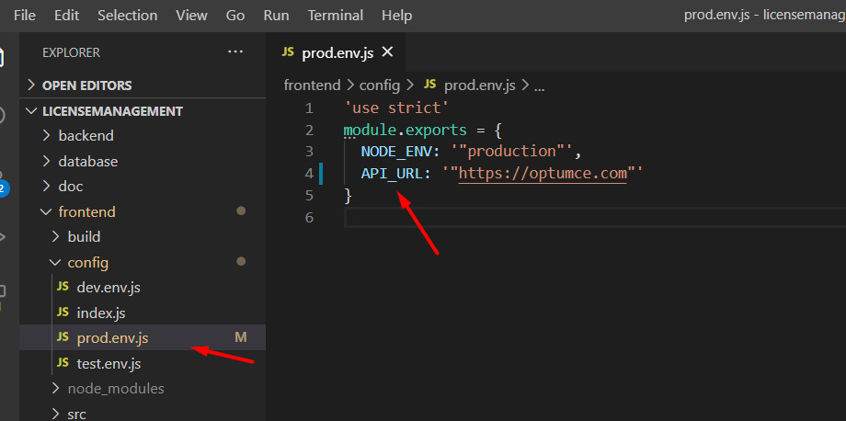

cmd run: npm run build
Output:
\frontend\dist
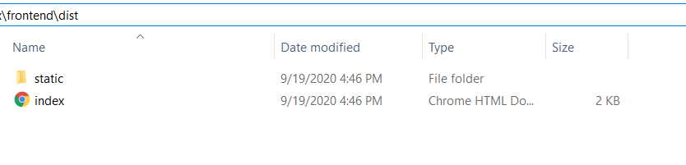
copy static folder paste
backend\licensemanagement\public
and open file index.html copy all content paste to app.blade.php file

path: backend\licensemanagement\resources\views\app.blade.php

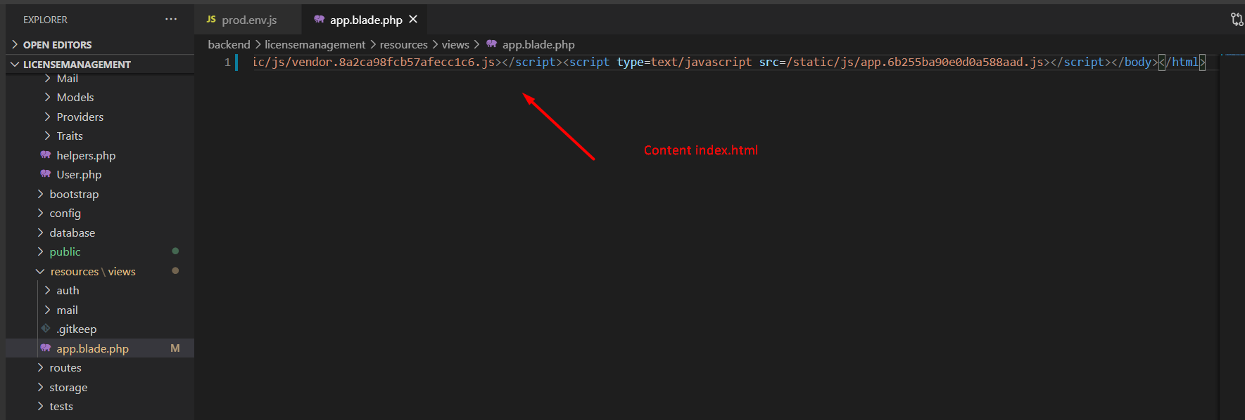

Step 3: Build backend api
cd backend\licensemanagement
cmd run: composer install

backend\licensemanagement\.env.example
rename .env.example to .env
Need change:
APP_URL => domain.com
APP_DEBUG => false
email settings

Step 4: Deploy
After deploy to server, please repleace BcryptHasher.php by Md5 hash file.
In demo server, that file is in below location:
~\vendor\illuminate\hashing\BcryptHasher.php

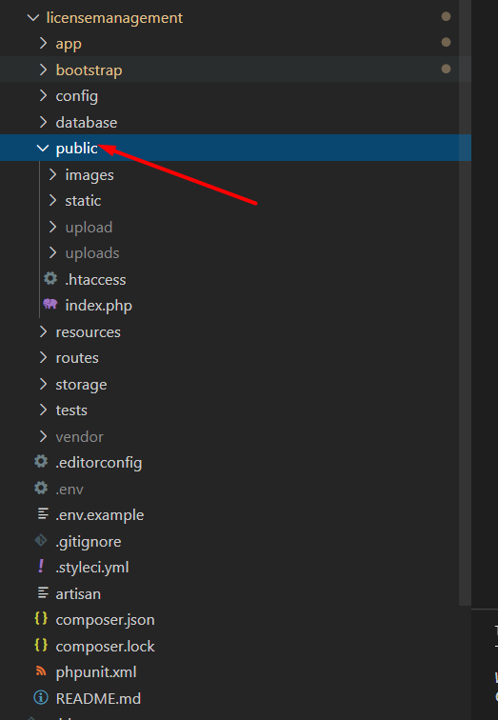
The root directive specifies where application files are stored. The Laravel application is stored in /var/www/html/licensemanagement, but only the /public subdirectory should be exposed to the internet; all other application files should not be accessible via the browser at all. To comply with these best practices, we set the web root to /var/www/html/licensemanagement/public.

Step 5: Import database
database/optumce_com_db_license.sql

Code on base:
https://lumen.laravel.com/docs/7.x

More info deploy

https://www.digitalocean.com/community/tutorials/how-to-deploy-a-laravel-application-with-nginx-on-ubuntu-16-04

https://www.hostinger.com/tutorials/how-to-install-laravel-on-ubuntu-18-04-with-apache-and-php/

