**Jenkins**

(jenkins download and unzip we get a .war

make sure java is installed in the system

C:\> java –version)

<https://www.quora.com/What-is-Jenkins-When-and-why-is-it-used> -> introduction

<https://jenkins-le-guide-complet.github.io/html/sect-first-steps-first-job.html> -> jobs

**Jenkins:**

Jenkins is a powerful application that allows **continuous integration** and **continuous delivery** of projects written in java.

Jenkins is nothing but a middle man between your code repo and your build server. It checks for changes on your server every few minutes. If it found them, it gathers them and sends them to your build server. That's what Jenkins is.

You can integrate Jenkins with a number of testing and deployment technologies.

**Simple work flow of Jenkins:**

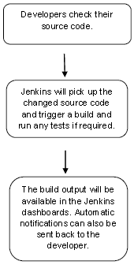

**Why Jenkins and advantages of Jenkins:**

1. It is open source and it is user-friendly, easy to install and does not require additional installations or components.
2. It is free of cost.
3. Easily Configurable. Jenkins can be easily modified and extended. It deploys code instantly, generates test reports. Jenkins can be configured according to the requirements for continuous integrations and continuous delivery.
4. Platform Independent. Jenkins is available for all platforms and different operating systems, whether OS X, Windows or Linux.
5. Rich Plugin ecosystem. The extensive pool of plugins makes Jenkins flexible and allows building, deploying and automating across various platforms.
6. Easy support. Because it is open source and widely used, there is no shortage of support from large online communities of agile teams.
7. Developers write the tests to detect the errors of their code as soon as possible. So the developers don’t waste time on large-scale error-ridden integrations.
8. Issues are detected and resolved almost right away which keeps the software in a state where it can be released at any time safely.
9. Most of the integration work is automated. Hence fewer integration issues. This saves both time and money over the lifespan of a project.

(Simply to say, open source tool->easy to install->has more than 1000 plug-in to make the work easier->easy to create new Jenkins plugin if one is not available->a tool which is written in Java, hence it can be portable to almost all major platforms)

**What is Continuous Integration?**

Continuous Integration is a development practice that requires developers to integrate code into a shared repository at regular intervals.

This concept was meant to remove the problem of finding later occurrence of issues in the build lifecycle.

Continuous integration requires the developers to have frequent builds. The common practice is that whenever a code commit occurs, a build should be triggered.

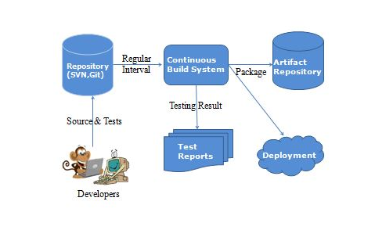

**Jenkins Installation:**

Download Jenkins from the official website

https://jenkins.io/

Click the link “Older but stable version” to download the Jenkins war file.

## Starting Jenkins

Open the command prompt. From the command prompt, browse to the directory where the jenkins.war file is present. Run the following command

**E:\>java –jar jenkins.war**

After the command is run, various tasks will run, one of which is the extraction of the war file which is done by an embedded webserver called winstone.

**E:\>java –jar jenkins.war**

Running from: C:\jenkins.war

Webroot: $user.home/ .jenkins

Sep 29, 2015 4:10:46 PM winstone.Logger logInternal

INFO: Beginning extraction from war file

Once the processing is complete without major errors, the following line will come in the output of the command prompt.

INFO: Jenkins is fully up and running

## Accessing Jenkins:

## Once Jenkins is up and running it can be accessed from the link,

−> **http://localhost:8080**

This link will bring up the Jenkins dashboard.

**User name**: provide user name (admin)

**Pwd:** will be available in C:\Users\mdodda\.jenkins\secrets\initialAdminPassword (09b10f8570144e729c8fe64d8beaeec2)

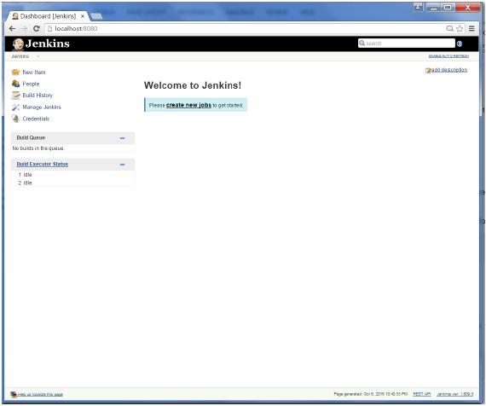

By default, Jenkins is accessed on port 8080. Using the below command, port can be changed if any conflicts occur.

**E:\>java –jar jenkins.war –httpPort=8088**

**Scenario-1:** -> ***Jenkins - Git Setup***

For setting up Git in Jenkins,

1. Go to Jenkins dashboard
2. Click manage Jenkins (on left side)
3. Click manage plugins
4. Click on Available tab -> show list of plugins -> which are available for downloading -> Search for Git Plugin in Filter tab
5. Check the Git Plugin Option and click on the button “Install without restart”
6. Installation will be done in Jenkins
7. Once done with installation restart Jenkins with the link [**http://localhost:8080/jenkins/restart**](http://localhost:8080/jenkins/restart)
8. To verify, click on New Item in the menu options, then enter a name for a job, like Demo. Select Freestyle project as item type and click ok button.
9. If you browse to the Source code management section, you will now see “Git” as an option.
10. If once “Git” option is seen Git setup is done successfully in Jenkins.

Check the following screenshots,

Click the ‘Manage Plugins’ option. 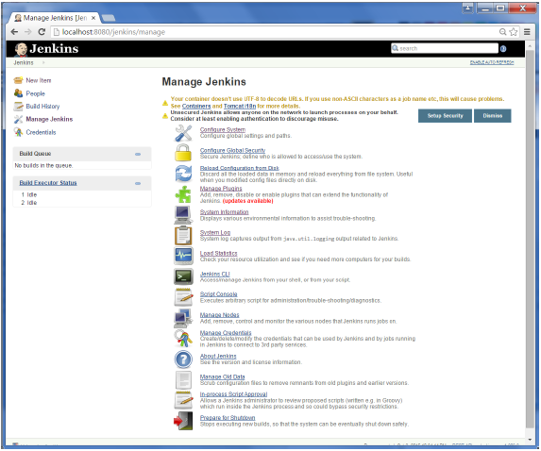

Click the Available tab. This tab will give a list of plugins which are available for downloading. In the ‘Filter’ tab type ‘Git plugin’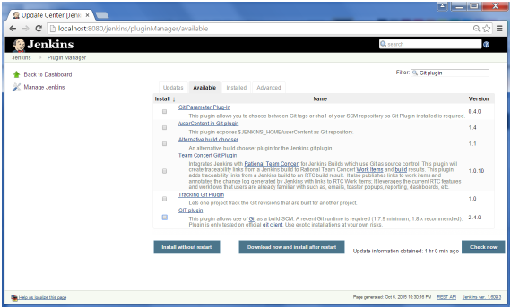

The list will then be filtered. Check the Git Plugin option and click on the button ‘Install without restart’

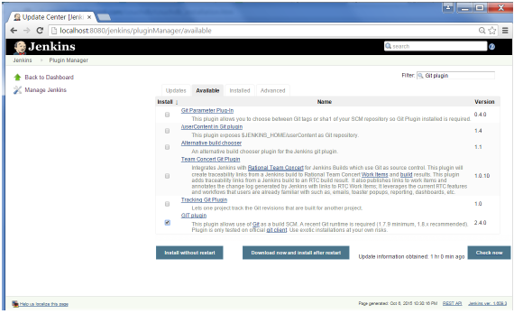

The installation will then begin and the screen will be refreshed to show the status of the download as shown in the below screenshot.

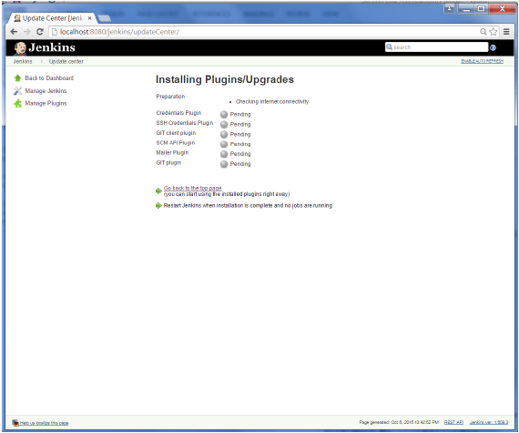

Once all installations are complete, restart Jenkins by issuing the following command in the browser -> **http://localhost:8080/jenkins/restart**

After Jenkins is restarted, Git will be available as an option whilst configuring jobs. To verify, click on New Item in the menu options for Jenkins. Then enter a name for a job, in the following case, the name entered is ‘Demo’. Select ‘Freestyle project’ as the item type. Click the Ok button.

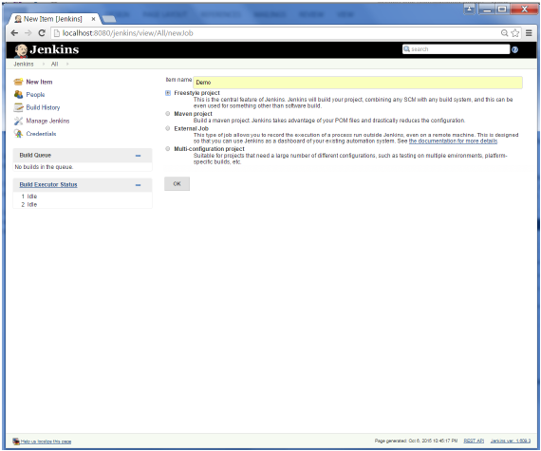

If you browse to the Source code Management section, you will now see ‘Git’ as an option.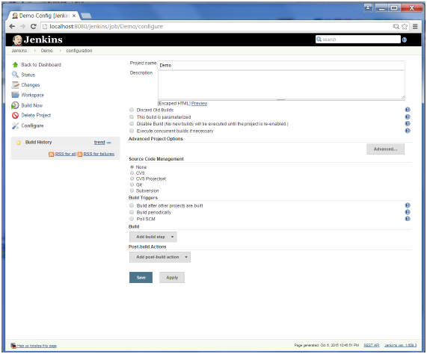

**Scenario-2:** -> ***Integrating Jenkins & GitHub***

( i.e., Compiling and running a java application in jenkins on Windows by cloning code from git repository)

**Jenkins** is a continuous integration server and this means it needs to check out source code from a source code repository and build code.

Jenkins has excellent support for various source code management systems like CVS, Subversion, etc.

**Git** is fast becoming one of the most popular source code management systems. Jenkins works with Git through the Git plugin. In above scenario, already we have seen how to set up a git plugin.

**Accessing Git Repository:**

Created an account in github -> https://github.com/

Created my repository by clicking "+" which is present on top left -> My Repository -> Repo_name (myRepo)

**Uploading fles:**

To upload files into repo-> go to particular repository ( myRepo ) -> Upload files -> choose your files -> add comment/or description -> commit (to save the changes done)

To check the files present in the repo have to click on the particular repo name.

**Modifying files:**

We can modify files which are already uploaded in the repository -> select a file to be changed -> select edit on top left -> make necessary changes -> commit

**Deleting files:**

To delete files from the repository -> select file to be deleted -> select delete icon on top left -> commit

I have pushed java code into the git repository and committed the changes.

Let’s start the scenario, first create a job in Jenkins which picks up a simple HelloWorld application, builds and runs the java program.

**Step-1:** Create a new job in Jenkins dashboard by clicking on NewItem in the leftside of dashboard.

Build jobs are at the heart of the Jenkins build process. Simply put, you can think of a Jenkins build job as a particular task or step in your build process. This may involve simply compiling your source code and running your unit tests. Or you might want a build job to do other related tasks, such as running your integration tests, measuring code coverage or code quality metrics, generating technical documentation, or even deploying your application to a web server. A real project usually requires many separate but related build jobs.

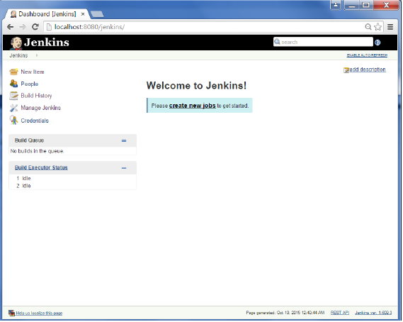

**Step-2:** Enter the Item name, in this case I have named it as “Helloworld”. Choose the ‘Freestyle project option’

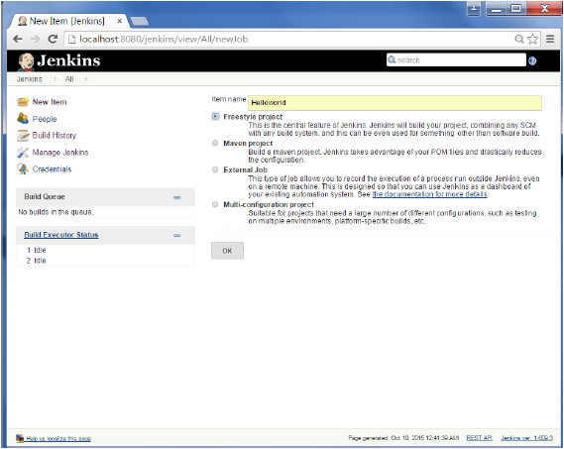

**Step-3:**  The following screen will come up in which you can specify the details of the job.

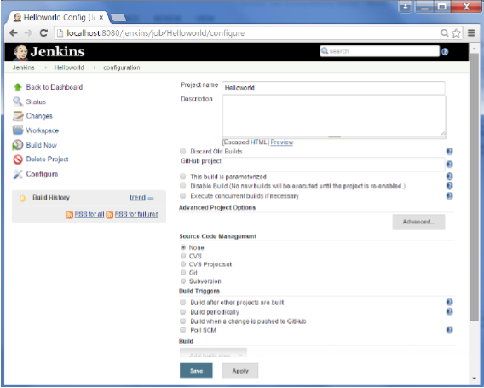

**Step-4:**

As my repository is hosted on Github, I entered the url of that repository here.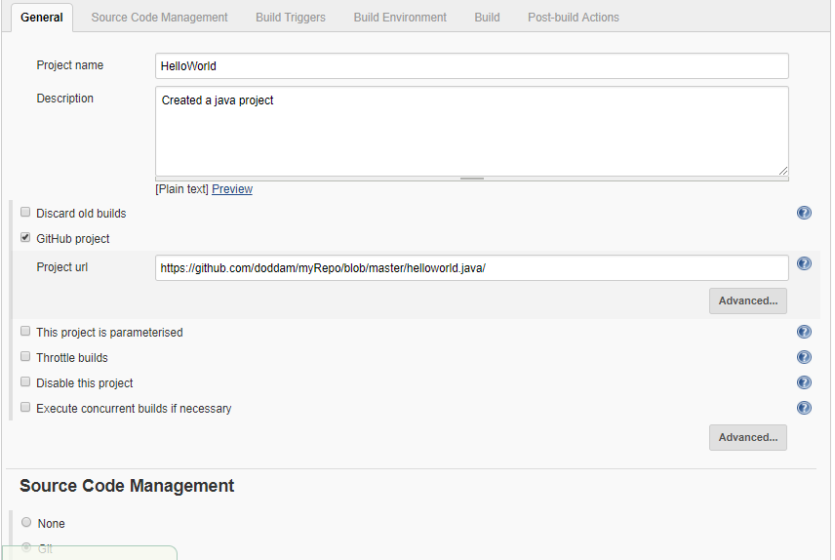

**Step-5:**

We need to specify the location of files which need to be built. In this example, we will assume, a git repository has been setup which contains a ‘HelloWorld.java’ file. Hence scroll down and click on the Git option and enter the URL of the local git repository.

In addition to this, you would need to click on the Add button for the credentials to add a user name and password to the github repository so that the code can be picked up from the remote repository.

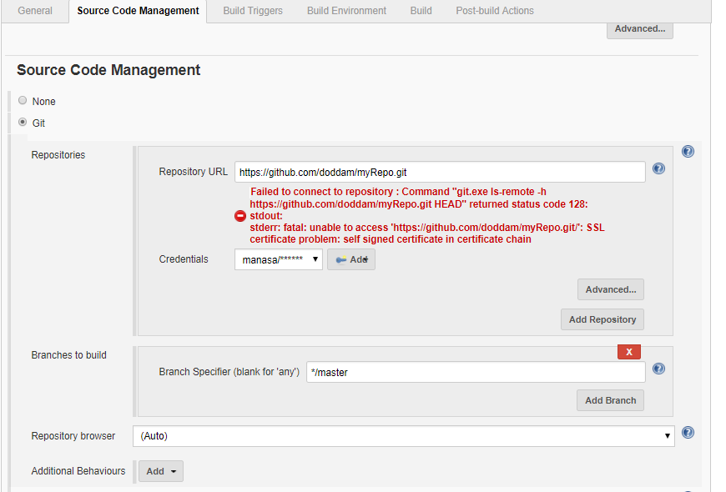

**Step-6:** Now go to the Build section and click on Add build step → Execute Windows batch command

**Step-7:** In the command window, enter the following commands and then click on the Save button.

javac HelloWorld.java

java HelloWorld

**Step-8:** Once saved, you can click on the Build Now option to see if you have successfully defined the job.

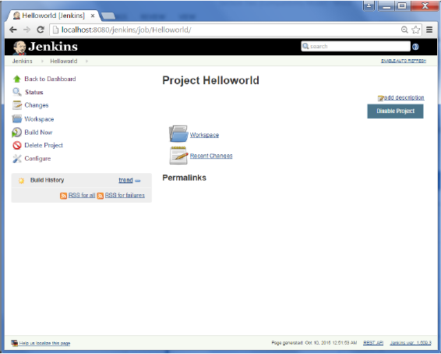

**Step-9:** Once the build is scheduled, it will run. The following Build history section shows that a build is in progress.

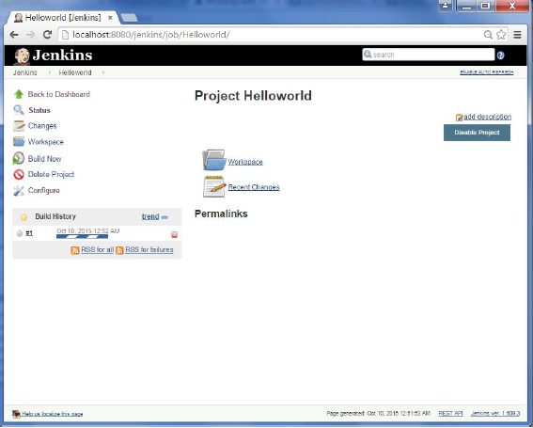

**Step-10:** Once the build is completed, a status of the build will show if the build was successful or not. In our case, the following build has been executed successfully. Click on the #1 in the Build history to bring up the details of the build.

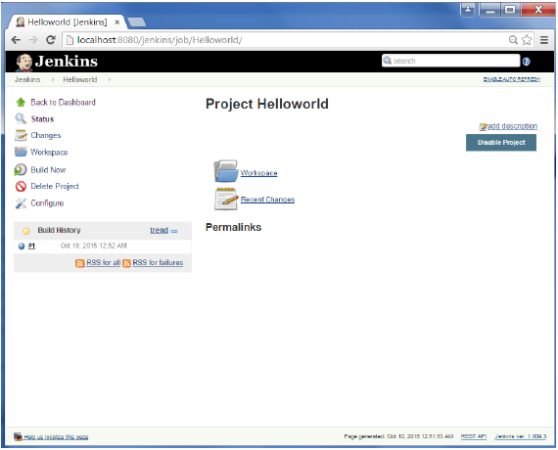

**Step-11:** Click on the Console Output link to see the details of the build.

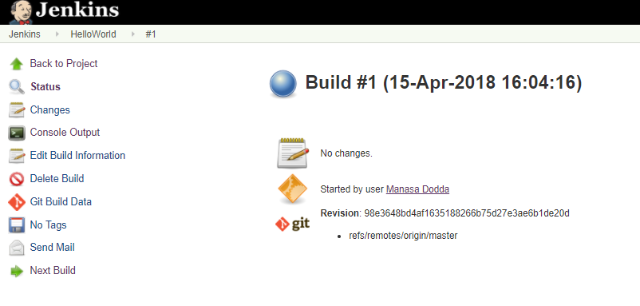

**Step-12:** You can see output by clicking Console output on the left side of dashboard.

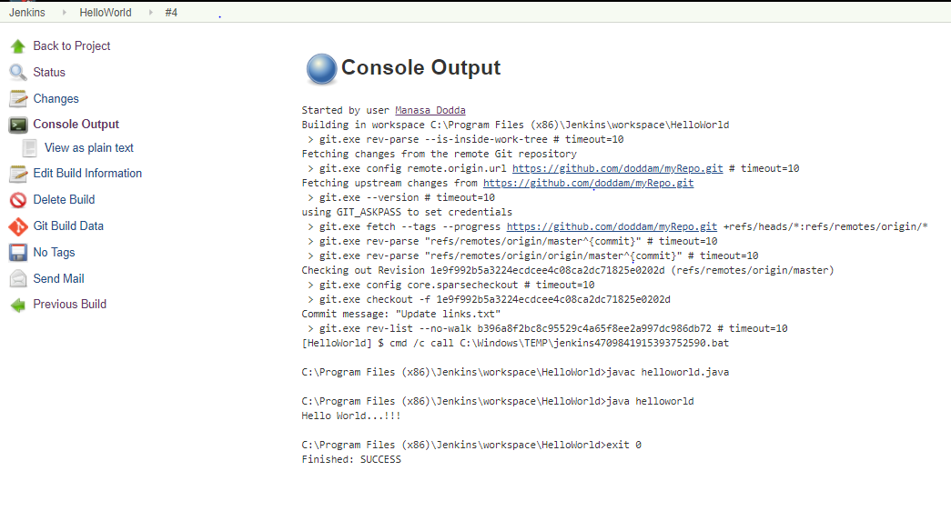

**Scenario-3:** -> ***Jenkins - Tomcat Setup***

Why?

Jenkins – standalone server (owns a servlet container - Jetty/winstone)

Start all web applications on a single server tomcat

Deploy Jenkins in tomcat servlet container

Need java 7 or above in system, tomcat 5 or above

**Step-1:** Download and Install tomcat

1. Go to [http://tomcat.apache.org](http://tomcat.apache.org/) ⇒ Under "Tomcat 9.0.{xx} Released" (where {*xx*} is the latest upgrade number) ⇒ Click "Download" ⇒ Under "9.0.{xx}" ⇒ Binary Distributions ⇒ Core ⇒ "**ZIP**" package (e.g., "apache-tomcat-9.0.{*xx*}.**zip**", about 9.8 MB).
2. UNZIP the downloaded file into your project directory "C:\Tomcat". Tomcat will be unzipped into directory "C:\Tomcat\apache-tomcat-9.0.7".
3. For ease of use, I shall shorten and rename this directory to "C:\Tomcat\tomcat" or leave it.
4. I have already tomcat in my system, so I will use that “C:\Tomcat\apache-tomee-plume-7.0.1”

**Step-2:** Start tomcat

Open windows command prompt -> navigate to your bin directory where tomcat is present C:\Tomcat\apache-tomee-plume-7.0.1\bin -> type the following command

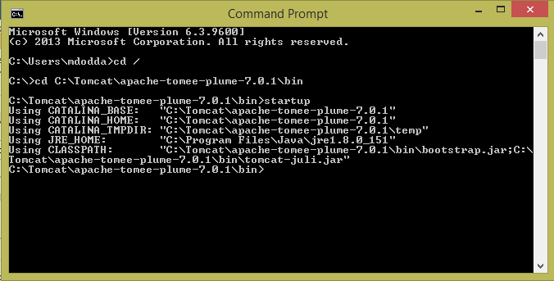

When you type the above command, a separate window will open and a series of messages will appear, followed by the message indicating the server is started

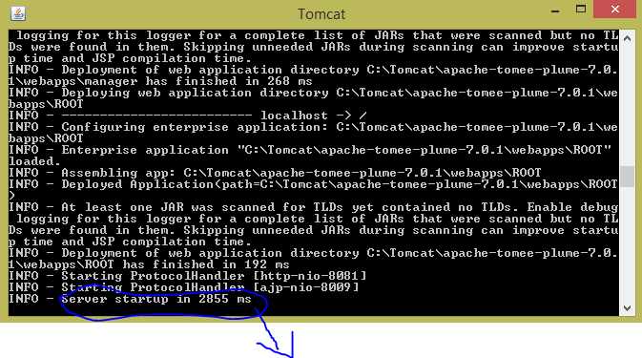

Indicates tomcat server has been started and the exact number of milliseconds will vary based on the number of web applications that are deployed, among other factors

**Step-3:** How to know that tomcat is running….!?

The default port for Tomcat is 8080. After starting Tomcat on your local machine, you can validate if Tomcat is running the URL:

Type the URL http://localhost:8080 from a Web browser

**Note:**

Choosing a Different Port (Optional) by default, Tomcat runs on part 8080. You can change it to a different port. To do so, open C:\Tomcat\apache-tomee-plume-7.0.1\conf\server.xml using a text editor such as NotePad. Search for 8080 and change it to a desired port number such as 8081 in the following context.

<Connector className="org.apache.coyote.tomcat4.CoyoteConnector"

port="8080" minProcessors="5" maxProcessors="75"

enableLookups="true" redirectPort="8443"

acceptCount="100" debug="0" connectionTimeout="20000"

useURIValidationHack="false" disableUploadTimeout="true" />

Now, I run tomcat by the url URL http://localhost:8081 from a Web browser as shown below

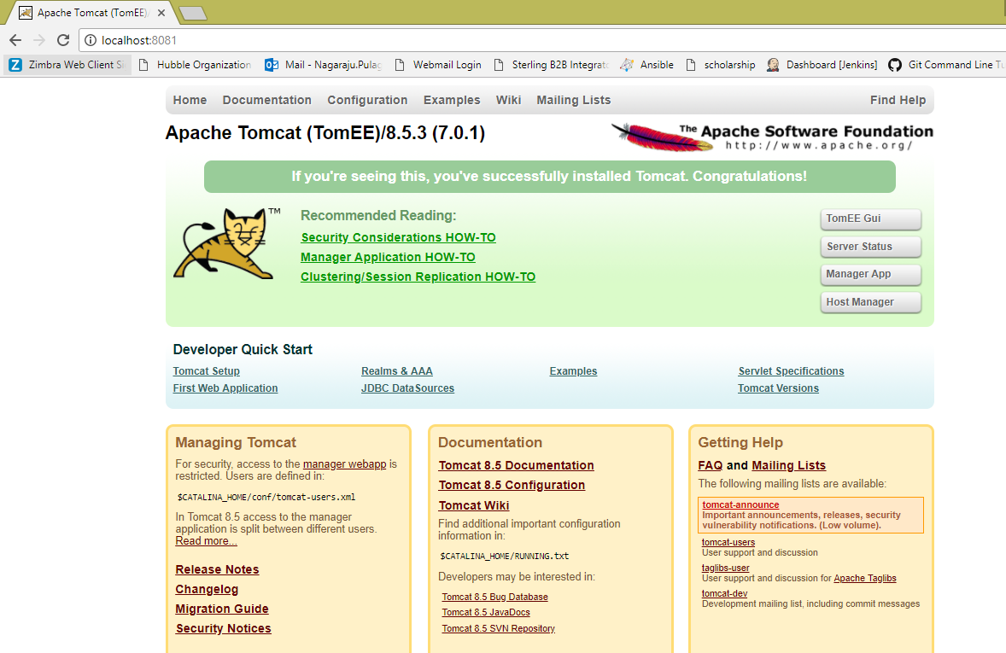

**Step-4:**

Now in the browser open manager app in gui, give user name and password > these will be in your conf/tomcat-users.xml > click login

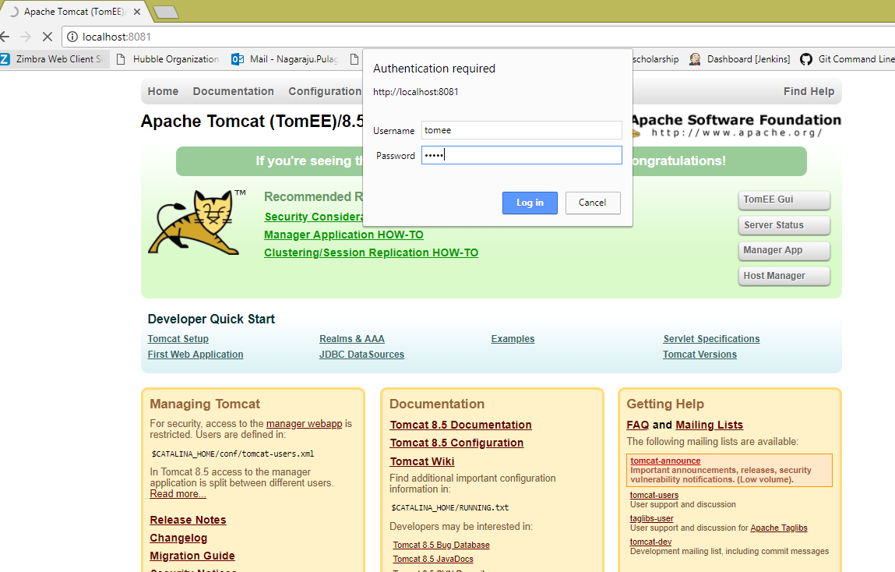

Check in the below screenshot, tomcat web application manager is opened which contains all the applications.

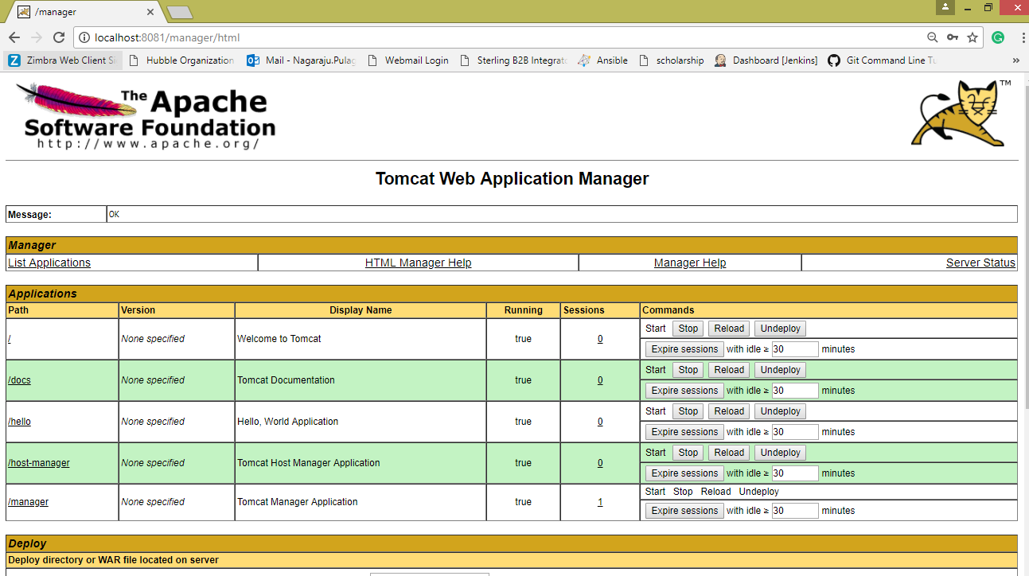

Stop the tomcat server from the command prompt by typing shutdown

Now navigate to the path C:\Tomcat\apache-tomee-plume-7.0.1\webapps -> copy the jenkins.war file

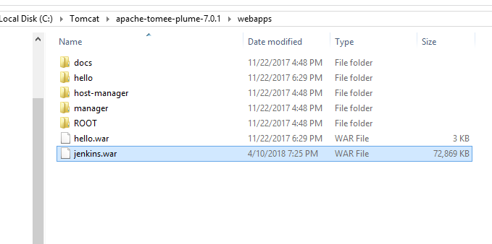

Start tomcat server -> open browser -> run tomcat -> you can see Jenkins application

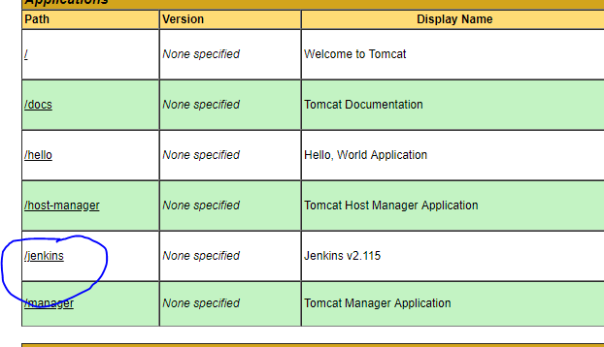

You can access Jenkins application by giving the url > http://localhost:8081/jenkins

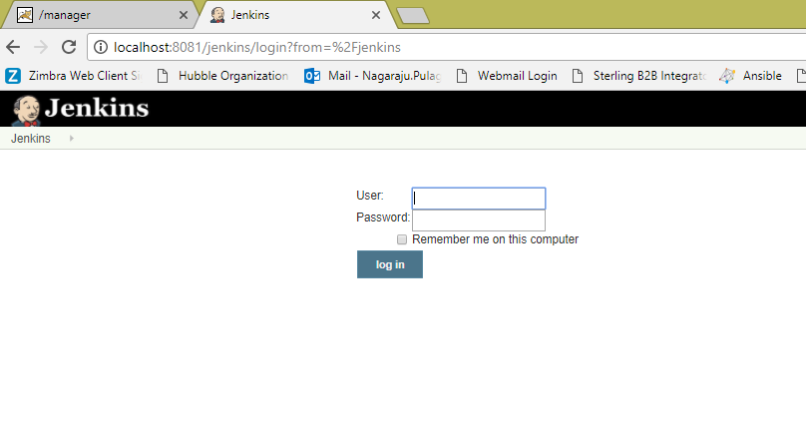

**Scenario - 4:** -> ***Jenkins accessing an application from local system (on windows)***

Simply say as a basic scenario, Jenkins picks up a java application from local system which is placed in the Jenkins workplace.

[i.e., compile and run a simple java file in jenkins on Windows]

Hello.java

public class Hello {

public static void main(String args[]){n

System.out.println("I'm dancing");

}

}

**Steps:**

1. Create a new job/project in jenkins dashboard -> say “JavaProject”
2. Go to configuration page of your job/project
3. Select "Execute Windows batch command" from "Add build step"
4. Type the following commands:
   1. **javac Hello.java**
   2. **java Hello**
5. Save configuration.
6. Now place the file **Hello.java** in the path -> /Jenkins/workspace/ jobname/

Eg: /Jenkins/workspace/ JavaProject/

1. Build the project/job by clicking "Build Now" link and see the Console Output

**Troublshooting:** *“*[***ERROR: Error cloning remote repo 'origin'***](https://stackoverflow.com/questions/37155321/error-error-cloning-remote-repo-origin) *”*

After building the project (integrating Jenkins and Git), I received the above error on the console output section.

Apparently the Jenkins Git Plugin executes ** before ** the environment is inherited.

1. Go to Manage Jenkins > Global Tool Configurations
2. Under Git configuration > Git installations
3. Enter complete path to git executable including git.exe > Save > Again build the project

Check the below screenshot:

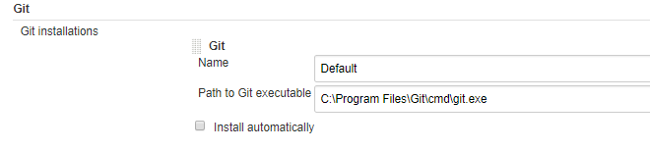

1. Sometimes this error occurs when disk space is less. So, do check the space of your machine where Jenkins is hosted.

**Scenario - 5:** -> ***Configured & Build a job using the feature Poll SCM in build triggers***

**Step-1:** Created a job namely PollSCMEx

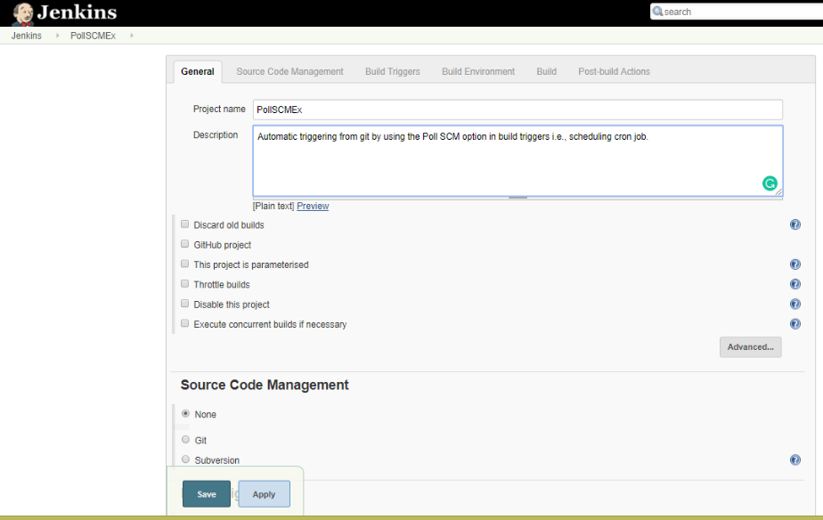

**Step-2:**

Configured source code management tab by giving git credentials > give Jenkins credentials

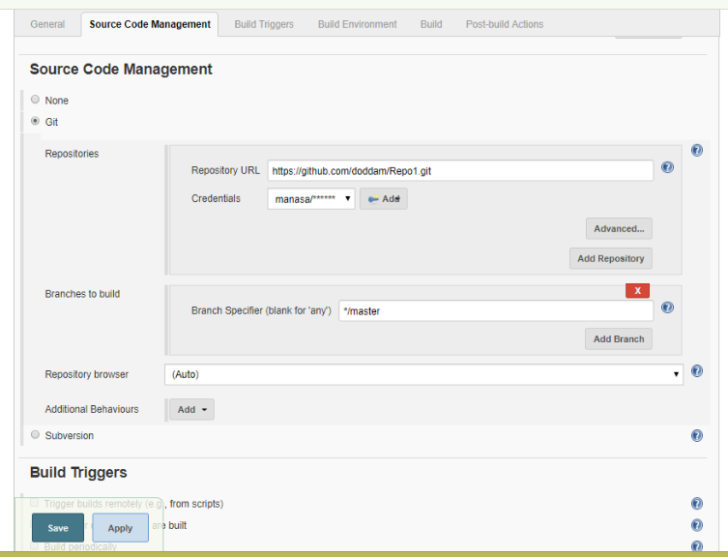

**Step-3:**

Check the below screenshot in Build Triggers tab, selected Poll SCM option.

Here comes the scenario, how the cron job is scheduled in the same way the job is built by polling SCM.

I have set cron job as below,

* * * * *

So, for every minute the git repository is checked for any changes, if so then a new build is made in Jenkins automatically.

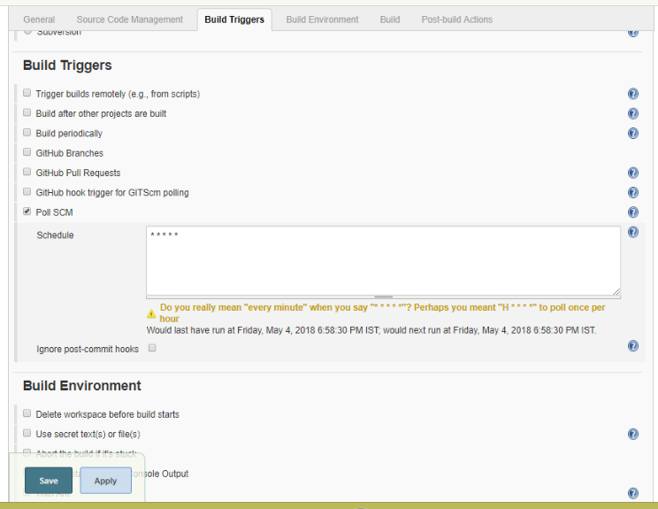

**Step-4:**

* I have created a Java application in a notepad and save as **Prog.java**

public class Prog

{

public static void main(String[] args)

{

for(int i=1;i<=5;i++)

{

System.out.println("Hiiii ... "+i);

}

}

}

* Select execute windows batch command as we are working on windows
* Give the commands that are required to run an application.
* Save the configuration.

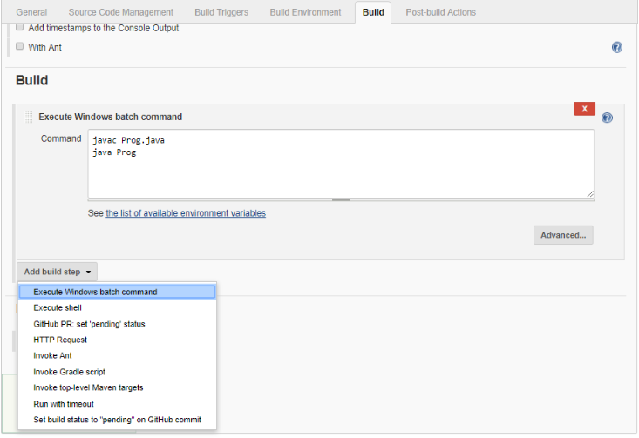

Now check the output:

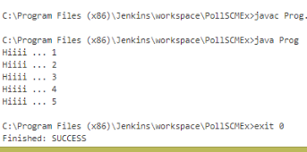

**Step-5:**

Go to the path where you have added git remote repository to the local system> right click > select Git Bash here

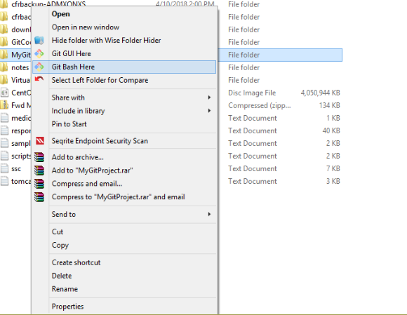

**Step-6:** Here a new file is added and pushed to git repo through git bash.

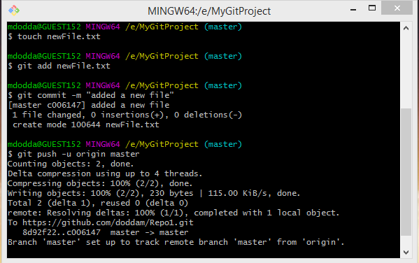

**Step-7:**  Now check in the git repository “newFile” is added.

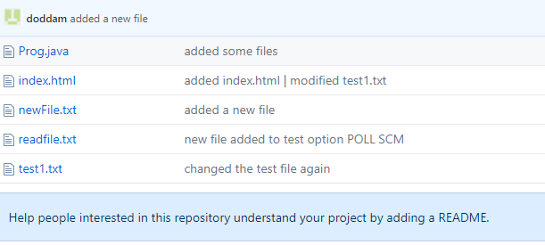

**Step-8:** Check the below screenshot, the file is added in the jenkins project dashboard.

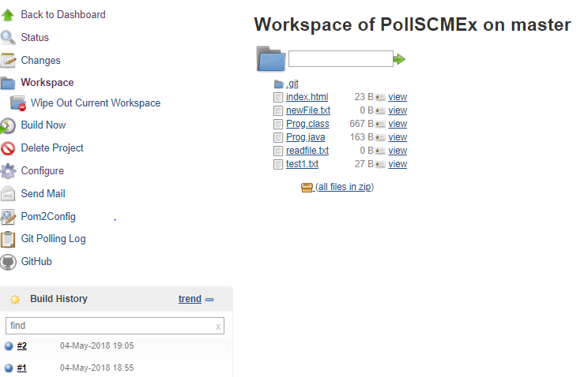

**Step-9:**

Job is built automatically as some changes are made to the git repository and can check in console output “Started by an SCM change”.

