BANKING MANAGEMENT SYSTEM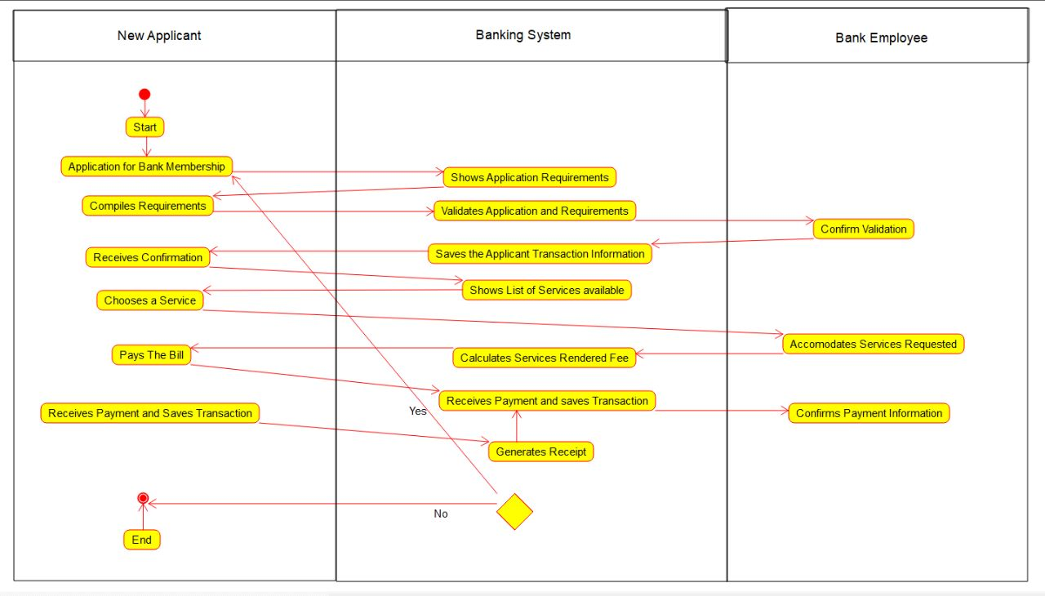RAILWAY MANAGEMENT SYSTEM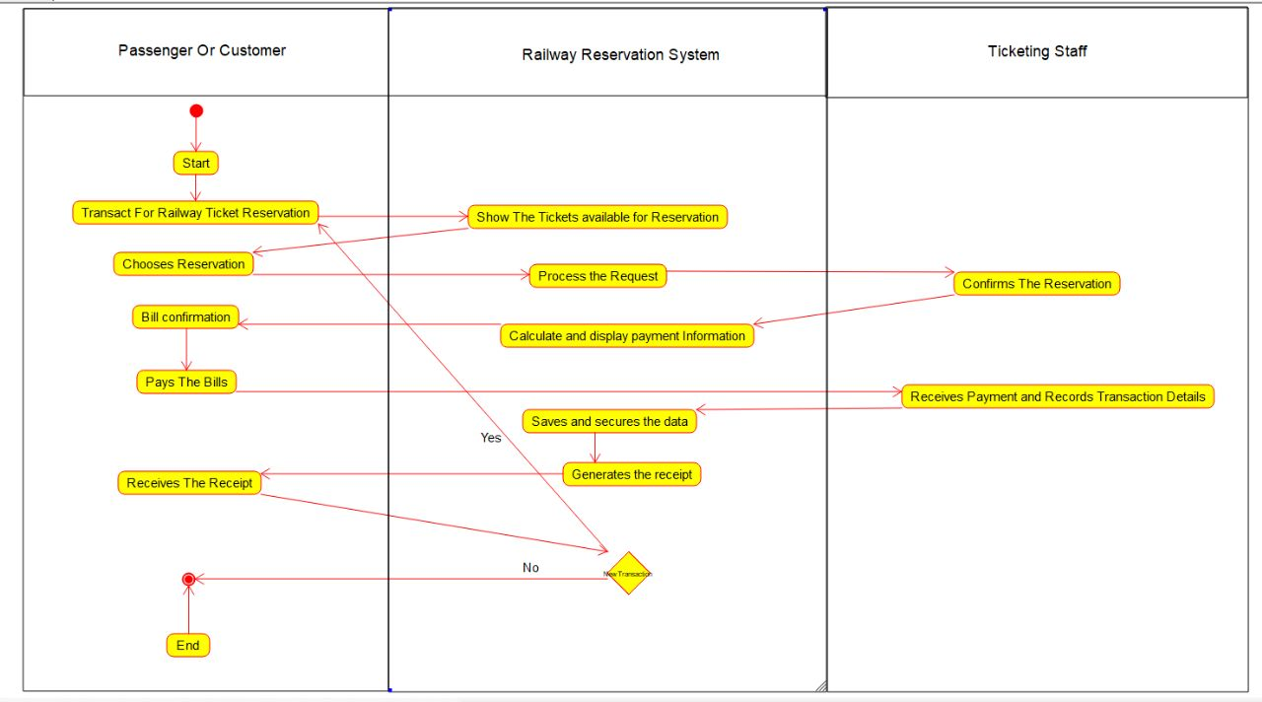 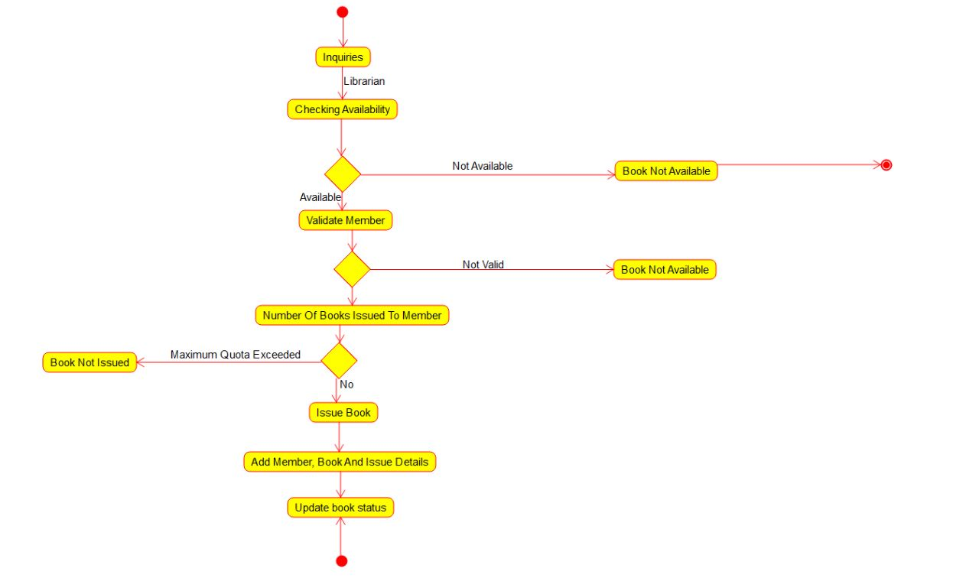LIBRARY MANAGEMENT SYSTEM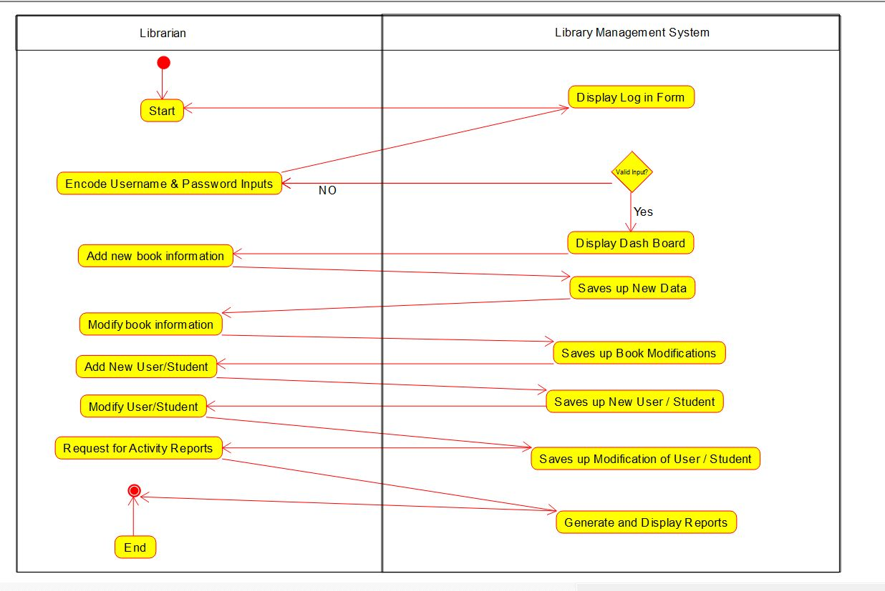 ONLINE MANAGEMENT SYSTEM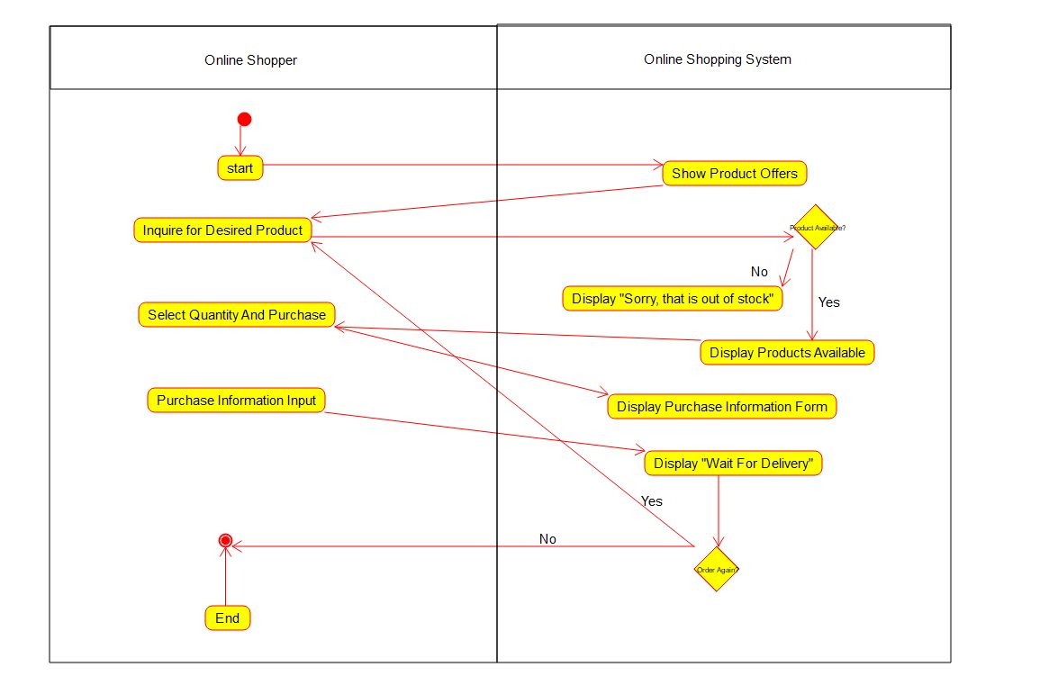ONLINE VOTING SYSTEM