Steps to post and upgrade to Apple

Switch over to the QA repository

In TERMINAL: VERY VERY IMPORTANT – we don’t want to sync the wrong direction.

git checkout qa

git merge dev

Resolve conflicts if any.

git status

git log --oneline --decorate -n 10

git diff dev..qa

In Xcode:

open the qa version, test to be sure it’s right.
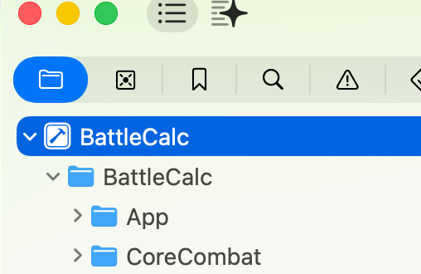
Go to

Tap ‘General”

Bump up the Build number:

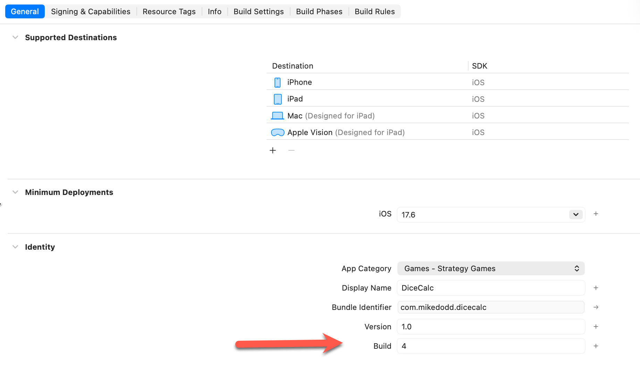
Go to Menu Product
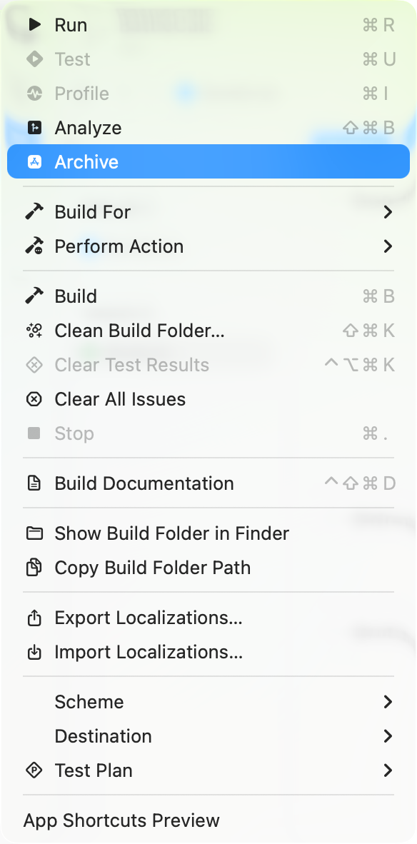

I

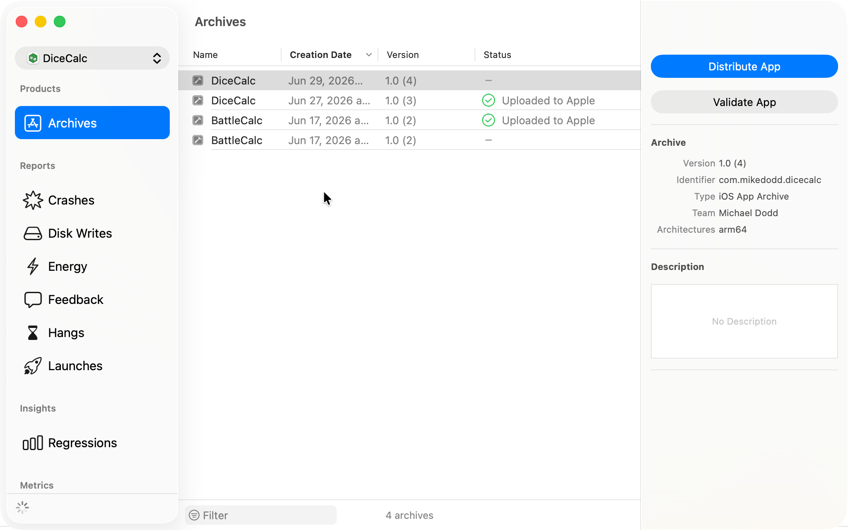

In the Organizer:

Distribute App > App Store Connect > Upload

Go to browser:
appstoreconnect.apple.com

Open TestFlight tab

Select the new build you uploaded in the previous step and assign to the tester groups

Tell the users what needs testing.

