|  |  |
| --- | --- |
| **Networking Infrastructure**  Diploma in CSF/IT  Year 2 (2020/21) Semester 3 | Week 13 |
| **1** hour |
| **CA2 (Group 5%) – Answer Document** | |

**Answers for E to G: Creating OUs and User Accounts**

**Task 1 - Are all OUs created correctly?**

After you have created all OUs and user accounts with the stated restrictions, replace the provided sample screen capture shown in Figure H1, H2 and H3 with your captured screens.

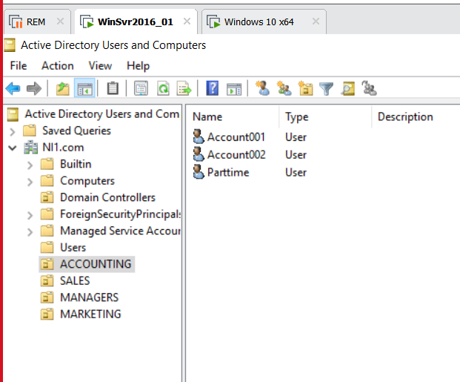

Figure H1: Creation of OUs

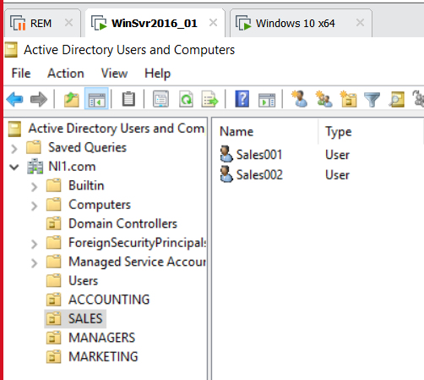

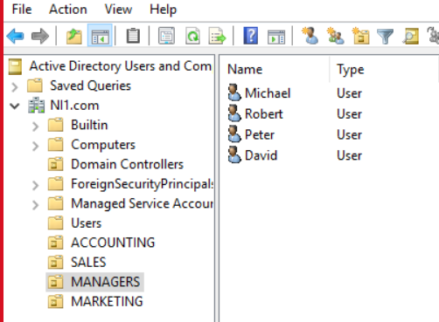

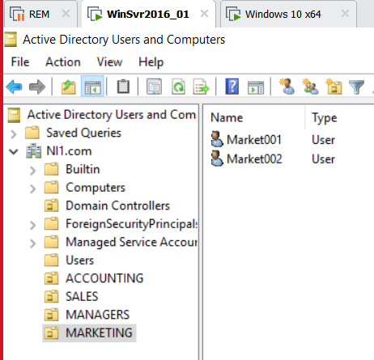

**Task 2 - Are all user account(s) with restrictions (if any) created correctly in their respective OU?**

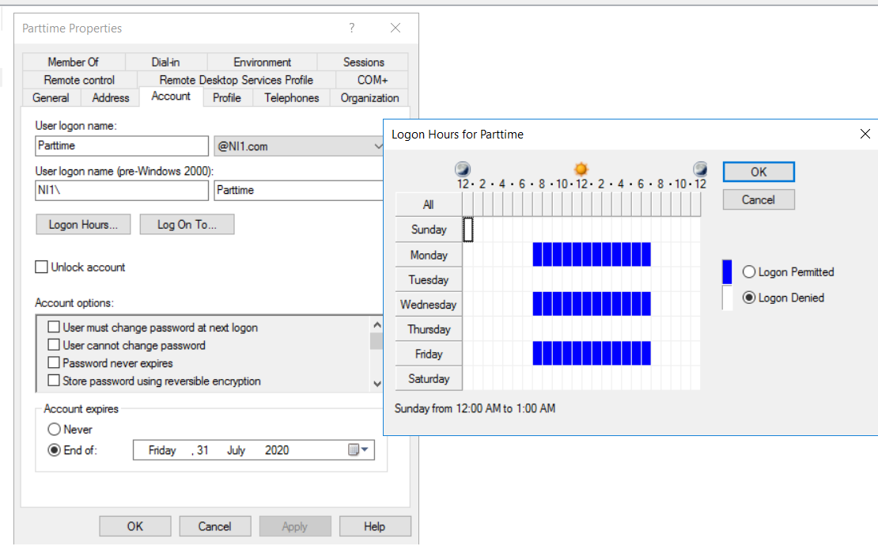

Figure H2 – user account with restrictions

**Task 3 – How Michael is assigned administrator’s rights?**

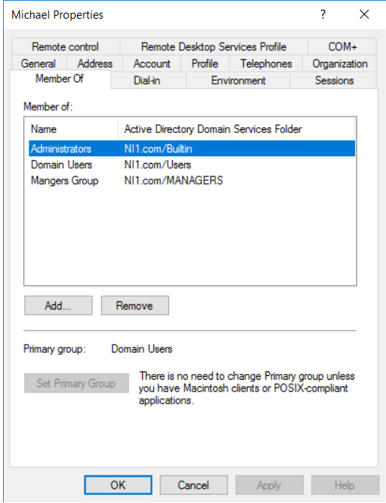

Figure H3 – Properties of Michael

|  |  |  |
| --- | --- | --- |
| **Tasks** | **Picture** | **Tutor’s remarks** |
| 1. Are all OUs created correctly? | Figure H1 |  |
| 2. Are all user account(s) with restrictions (if any) created correctly in their respective OU? | Figure H2 |  |
| 3. Show the membership of Michael | Figure H3 |  |

(3 marks)

**Answers for I. Testing User Accounts**

**Task 1 - Creation and testing on the user account. Is your user, “Market001” able to** **to log in to domain?**

Test the created user accounts by using the Windows 10 client to log into the Windows domain using the created accounts. Open a PowerShell and type the command “whoami” to indicate who is the user as shown in Figure I1. Replace Figure I1 with your captured screen.

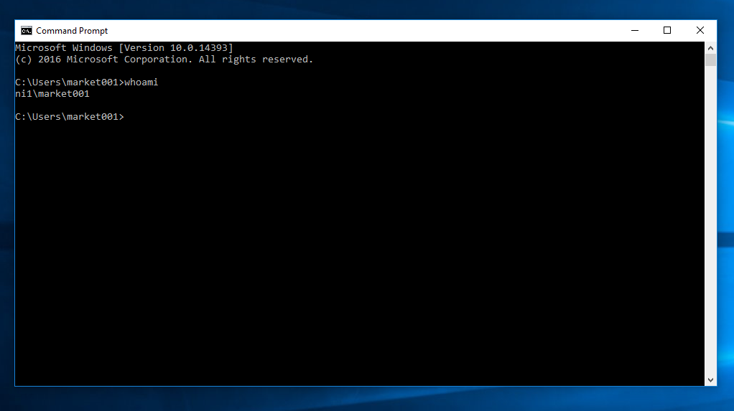

Figure I1 – Successful logon of user account

**Task 2 - Testing on the user’s configured log-on hours.**

To test on the configured log-on hours:

Change the computer time on the Windows 2016 domain controller to an invalid logon time and try to log in with the Windows 10 client using a suitable user account as shown in Figure I2. Replace Figure I2 with your captured screen.

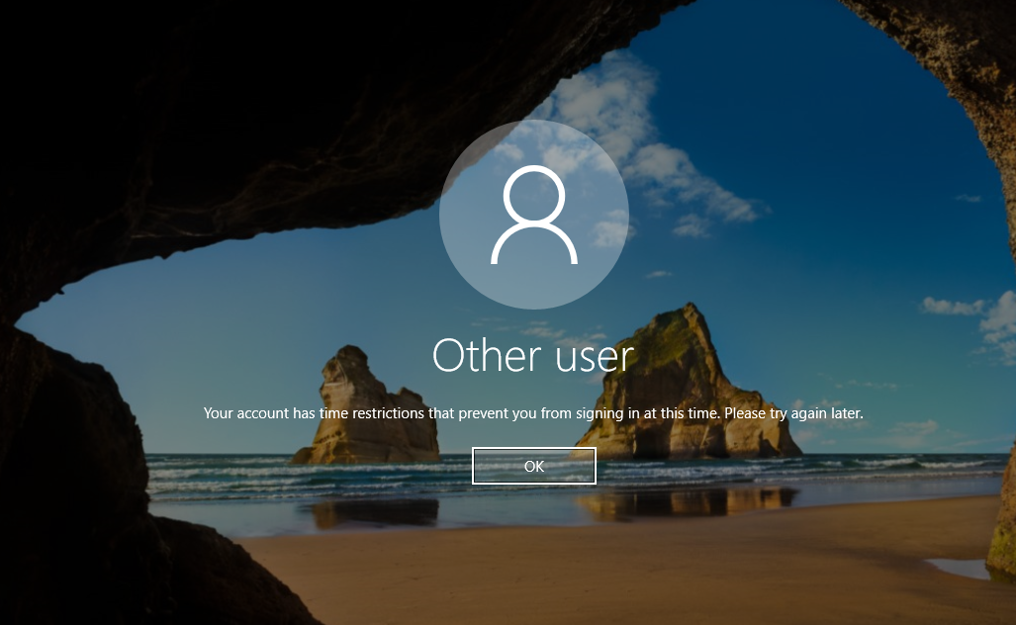

**Figure I2 – Account restriction**

**Task 3 - Testing on the configured parttime’s account expiration.**

To test on the configured parttime’s account expiration:

Set the computer time on the Windows 2016 domain controller to a date that is beyond the expiry date and try to log in as shown in Figure I3. Replace Figure I3 with your captured screen.

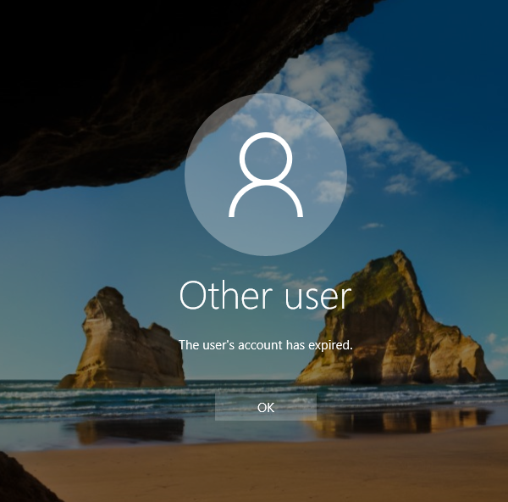

|  |  |  |
| --- | --- | --- |
| **Tasks** | **Picture** | **Tutor’s remarks** |
| 1. Creation and testing on the user accounts. User able to log in to domain. | Figure I1 |  |
| 1. Testing on the user’s configured log-on hours. | Figure I2 |  |
| 1. Testing on the configured parttime’s account expiration. | Figure I3 |  |

(3 marks)

**Answer for J. Testing the Delegation**

**Task 1 - Is Robert able to perform certain tasks for Sales users (as delegated)?**

In Active Directory Users and Computer Tool:

Assuming a Sales user (i.e Sales001) has forgotten his password, **right click** this user account under **SALES** OU and reset the password to **Password123**.

Open a PowerShell and type the command “whoami” to indicate who is the user. The result is shown in Figure J1. Replace Figure J1 with your captured screen.

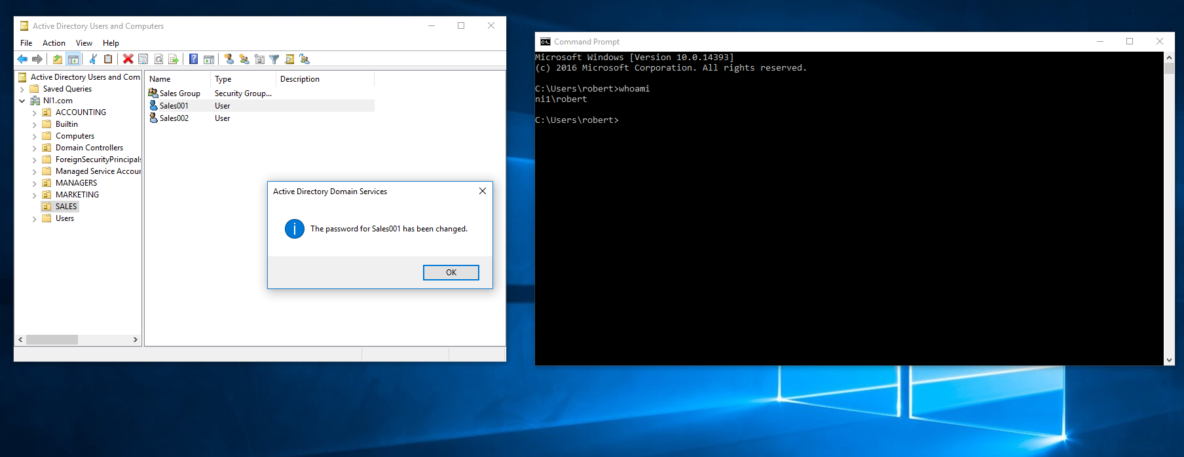

Figure J1 – Resetting password for user in SALES OU

**Task 2 - Is Robert able to perform certain tasks for Accounting users?**

Using **Robert’s account**, are you able to reset password for user accounts in other OU such as **ACCOUNTING**? Open a PowerShell and type the command “whoami” to indicate who is the user. Replace Figure J2 with your captured screen.

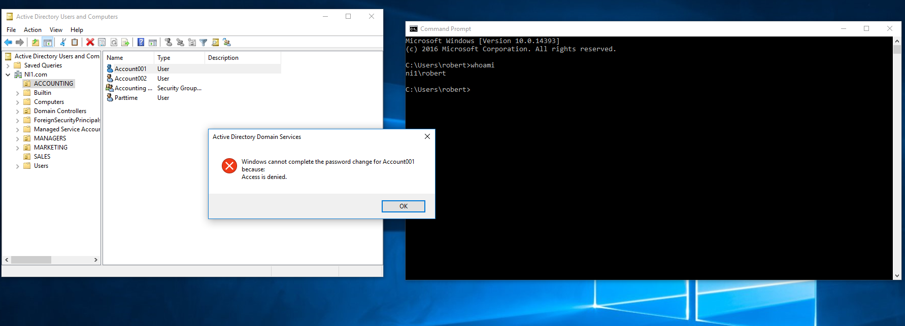

Figure J2 – Resetting password for user in ACCOUNTING OU

|  |  |  |
| --- | --- | --- |
| **Tasks** | **Picture** | **Tutor’s Remarks** |
| 1. Configuration and Testing on the OU delegation task. Is Robert able to perform certain tasks for Sales users (as delegated)? | Figure J1 |  |
| 1. Is Robert able to perform certain tasks for Accounting users? | Figure J2 |  |

(2 marks)

Q1. Can Robert create a new Sales user account (e.g. Sales004) in the **SALES** OU?

Yes

______________________________________________________________

(1 mark)

Q2. Name a user that can reset **Robert password** apart from **Administrator**.

Michael

______________________________________________________________

(1 mark)

**** End of Practical ****