Detail hardness report 3

Task description 2
Simulation results (uncommon data) 3
Cascade network 4
Simulation 1(cascade 15) 4
Simulation 2 (cascade 15) 5
Simulation 3 (cascade 20) 6
Simulation 4 (cascade 30) 7
Feedforward network 8
Simulation 1 (2-30-10) 8
Simulation 2 (2-20-10) 9
Simulation 3 (2-60-10) 10
Simulation 4 (2-50-10) 11
Cascade forward network (newcf) 12
Simulation 1 (2-30-10-10) 12
Simulation 2 (2-20-20-10) 13
Simulation 3 (2-10-10-10-10) 14
Simulation 4 (2-25-10-5-10) 15
Simulation results (common data) 16
Cascade network 17
Simulation 1 (cascade 15) 17
Simulation 2 (cascade 20) 18
Simulation 3 (cascade 25) 19
Feedforward network 20
Simulation 1 (2-30-10) 20
Simulation 2 (2-20-10) 21
Simulation 3(2-50-10) 22
Simulation 4(2-60-10) 23
Cascade forward network (newcf) 24
Simulation 1 (2-30-10-10) 24
Simulation 2 (2-20-20-10) 25
Simulation 3 (2-25-10-5-10) 26
Simulation 4(2-20-10-10-10) 27

Task description

The data, provided by the user, consists of a set of the experiments. Each experiment results are obtained by cooling the detail by air and water under pressure. The cooling process consists of three phases (Figure 1) :
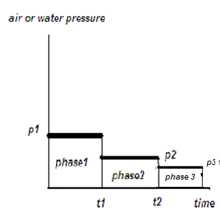
Figure 1 : Cooling process phases
The temperature of the metal heating also matters. Hence, there are 10 conditions describing the production process. (Figure 2)
The hardness of the received gear is measured in the different points. The points have different polar coordinates (the radius and the angle). As the gear is a symmetrical object, the angle parameter is out of the scope. Hence, we have two parameters, defining the point. They are radius and hardness.
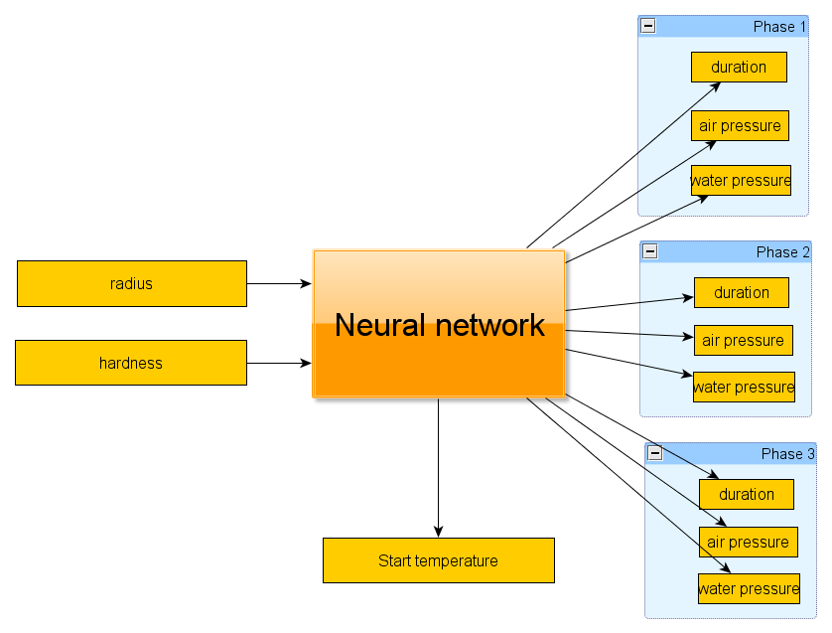
Figure 2 : Neural net inputs-outputs

Simulation results (uncommon data)

The constructed neural network uses the tansig activation function, which produces values in the range of [-1; +1]. That's why before the data is passed to the network it is normalized. The response, produced by the network is denormalized during the demonstration. The error values, obtained during the learning process, are computed on the normalized values (from the [-1; +1] range).
So, we have 10 experiments involved in the training process. 1 experiment is not involved and is used for the demonstration.
The demonstration for each experiment was performed on the full data and the average values of the last experiment (#121). This experiment is pretty much different from the others as it has a lower start temperature and only 2 cooling phases. Hence, it is uncommon.
So, we have 2 evaluation sets. The first of them (large data) contains 180 items of the original data. The other one (small data) contains only items which are the average values of the previous one.

Cascade network
The first approach was trying the cascade network, described by (Fahlman S. E., Lebiere C., “The Cascaded-correlation learning architecture”, 1990)

Simulation 1(cascade 15)
 | Feature | Value
General information
 | Neurons count | 2-c15-10
 | Training error | 0.565937
Large exam
 | error | 1.448319
 | Received emperature | 929.712124
 | Expected temperature | 850.000000
Small exam
 | error
 | Received emperature | 943.763180
 | Expected temperature | 850.000000
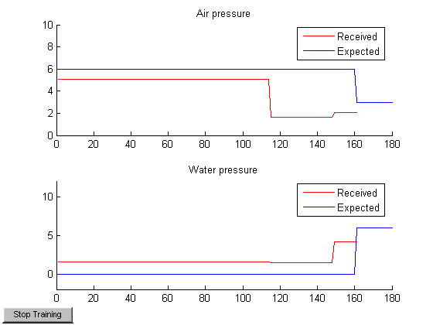
Figure 3 : Large exam
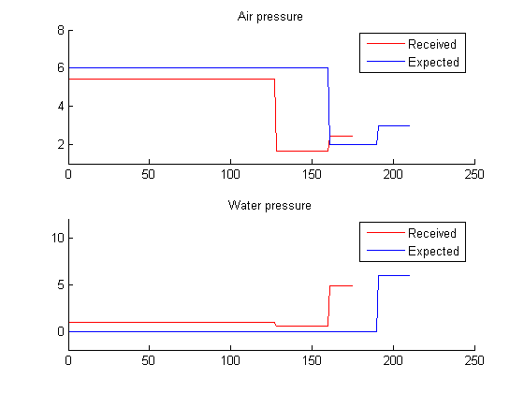
Figure 4 : small exam

Simulation 2 (cascade 15)
 | Feature | Value
General information
 | Neurons count | 2-c15-10
 | Training error | 1.457640
Large exam
 | error | 1.457640
 | Received emperature | 930.026955
 | Expected temperature | 850.000000
Small exam
 | error | 1.410002
 | Received emperature | 945.063811
 | Expected temperature | 850.000000

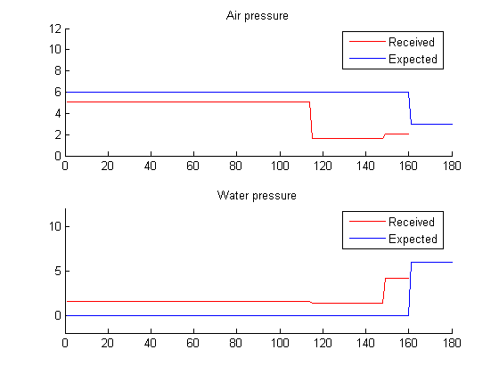
Figure 5 : Large exam
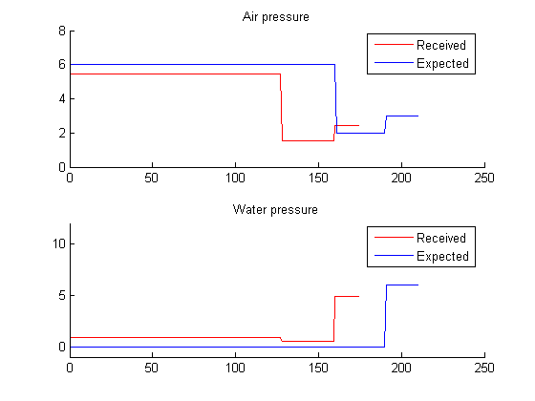
Figure 6 : small exam

Simulation 3 (cascade 20)
 | Feature | Value
General information
 | Neurons count | 2-c20-10
 | Training error | 0.548298
Large exam
 | error | 1.467110
 | Received emperature | 929.732569
 | Expected temperature | 850.000000
Small exam
 | error | 1.402958
 | Received emperature | 944.890952
 | Expected temperature | 850.000000

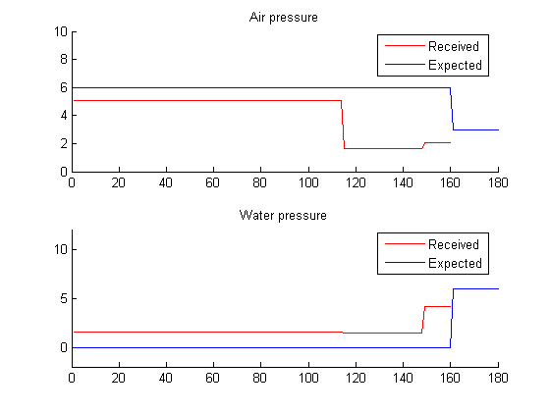
Figure 7 : Large exam
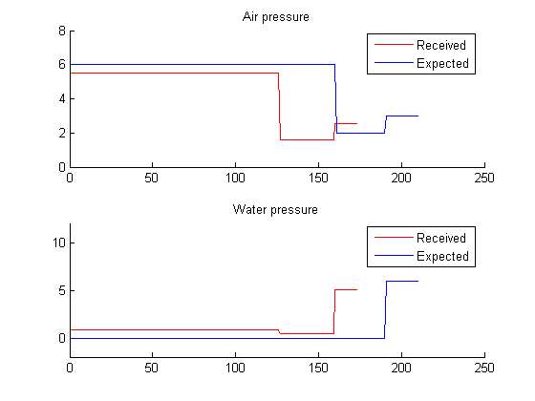
Figure 8 : small exam

Simulation 4 (cascade 30)
 | Feature | Value
General information
 | Neurons count | 2-c30-10
 | Training error | 0.550165
Large exam
 | error | 1.467339
 | Received emperature | 929.198024
 | Expected temperature | 850.000000
Small exam
 | error | 1.425729
 | Received emperature | 943.967807
 | Expected temperature | 850.000000

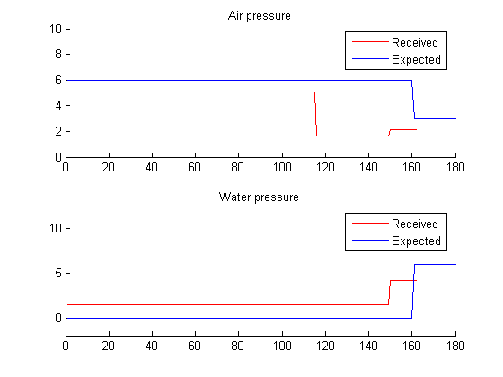
Figure 9 : Large exam
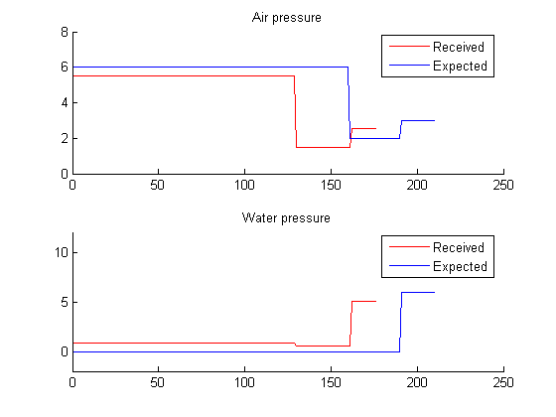
Figure 10 : small exam

Feedforward network

Simulation 1 (2-30-10)
 | Feature | Value
General information
 | Neurons count | 2-30-10
 | Training error | 0.740108
Large exam
 | error | 1.856814
 | Received emperature | 910.666667
 | Expected temperature | 850.000000
Small exam
 | error | 1.521312
 | Received emperature | 910.000000
 | Expected temperature | 850.000000
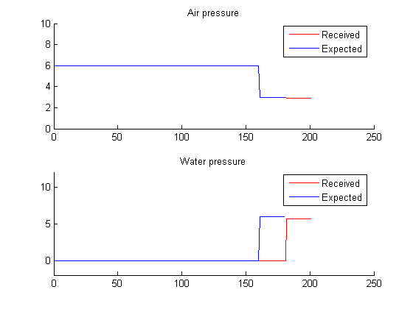
Figure 11 : fnn 2-30-10 large exam
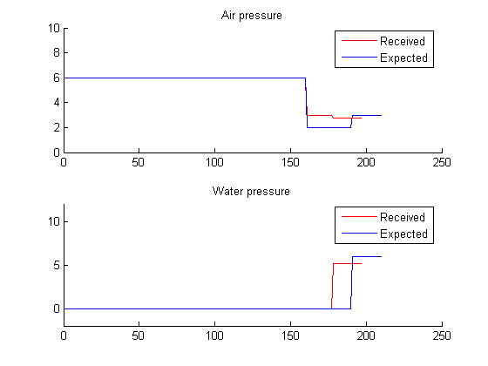
Figure 12 : fnn 2-30-10 small exam

Simulation 2 (2-20-10)
 | Feature | Value
General information
 | Neurons count | 2-20-10
 | Training error | 0.197484
Large exam
 | error | 1.961429
 | Received emperature | 953.013868
 | Expected temperature | 850.000000
Small exam
 | error | 1.628976
 | Received emperature | 910.000000
 | Expected temperature | 953.024504
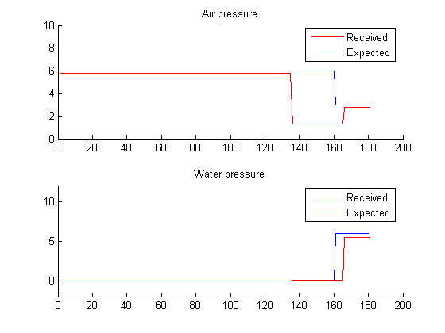
Figure 13 : fnn 2-20-10 large exam
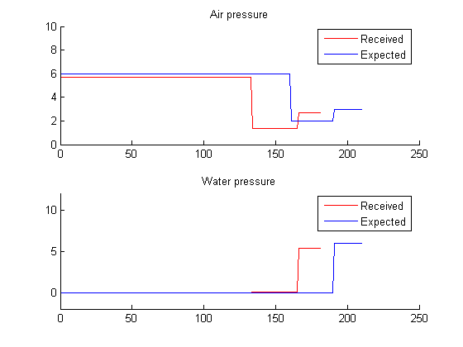
Figure 14 : fnn 2-20-10 small exam

Simulation 3 (2-60-10)
 | Feature | Value
General information
 | Neurons count | 2-60-10
 | Training error | 0.267974
Large exam
 | error | 1.970630
 | Received emperature | 953.101348
 | Expected temperature | 850.000000
Small exam
 | error | 1.649925
 | Received emperature | 910.000000
 | Expected temperature | 952.911051
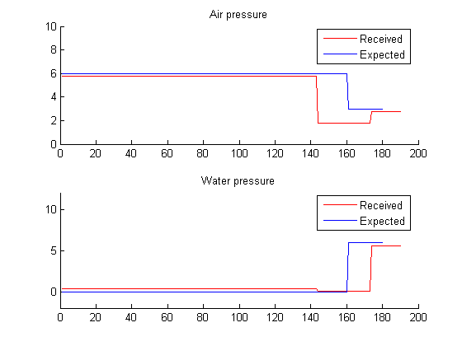
Figure 15 : fnn 2-60-10 large exam
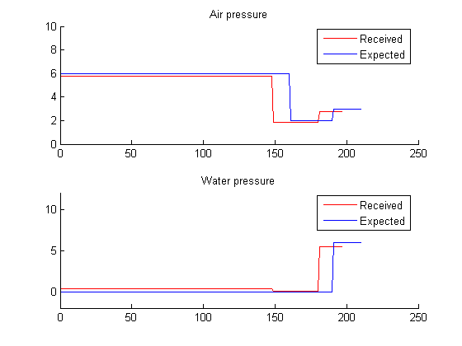
Figure 16 : fnn 2-60-10 small exam

Simulation 4 (2-50-10)
 | Feature | Value
General information
 | Neurons count | 2-50-10
 | Training error | 0.281693
Large exam
 | error | 1.995317
 | Received emperature | 954.338378
 | Expected temperature | 850.000000
Small exam
 | error | 1.701537
 | Received emperature | 910.000000
 | Expected temperature | 954.027954
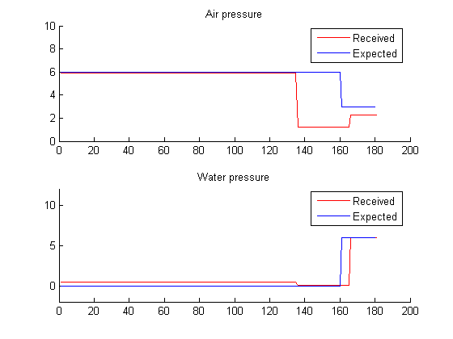
Figure 17 : fnn 2-50-10 large exam
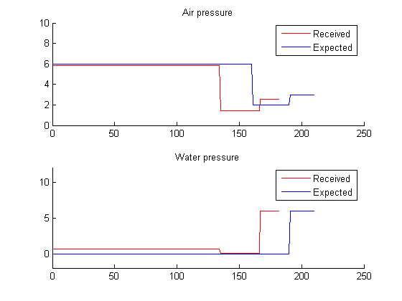
Figure 18 : fnn 2-50-10 small exam

Cascade forward network (newcf)

Simulation 1 (2-30-10-10)
 | Feature | Value
General information
 | Neurons count | 2-30-10-10  (with cascade)
 | Training error | 0.498051
Large exam
 | error | 2.023548
 | Received emperature | 929.894039
 | Expected temperature | 850.000000
Small exam
 | error | 1.700884
 | Received emperature | 910.000000
 | Expected temperature | 850.000000
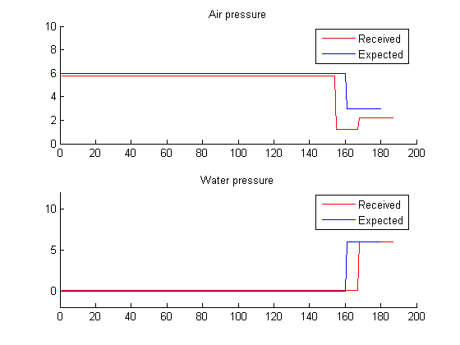
Figure 19 : cascade 2-30-10-10 large exam
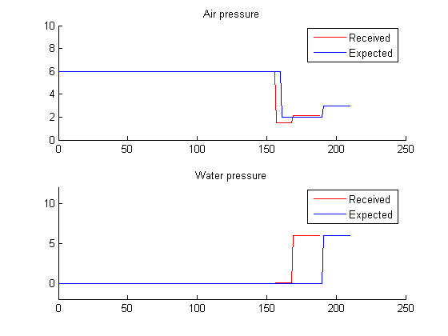
Figure 20 : cascade 2-30-10-10 small exam

Simulation 2 (2-20-20-10)
 | Feature | Value
General information
 | Neurons count | 2-20-20-10  (with cascade)
 | Training error | 0.173909
Large exam
 | error | 1.993128
 | Received emperature | 954.999999
 | Expected temperature | 850.000000
Small exam
 | error | 1.676904
 | Received emperature | 955.000000
 | Expected temperature | 850.000000
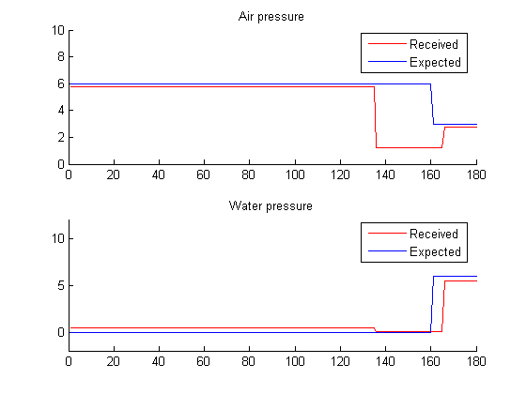
Figure 21 : cascade 2-20-20-10 large exam
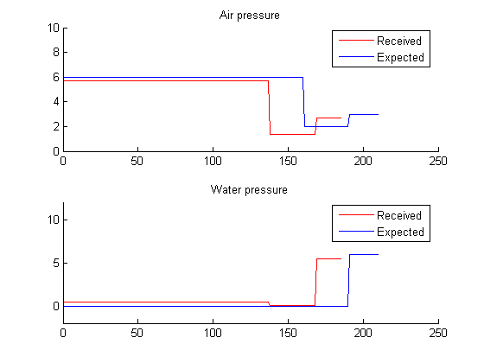
Figure 22 : cascade 2-20-20-10 small exam

Simulation 3 (2-10-10-10-10)
 | Feature | Value
General information
 | Neurons count | 2-20-10-10-10  (with cascade)
 | Training error | 0.210370
Large exam
 | error | 2.154339
 | Received emperature | 952.385225
 | Expected temperature | 850.000000
Small exam
 | error | 1.812939
 | Received emperature | 955.000000
 | Expected temperature | 952.454654
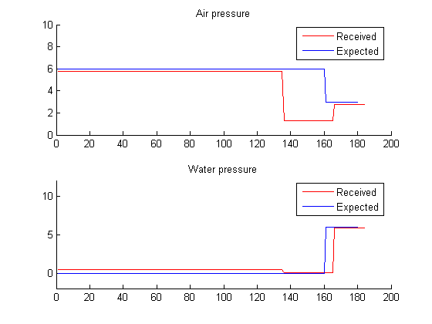
Figure 23 : cascade 2-20-10-10-10 large exam
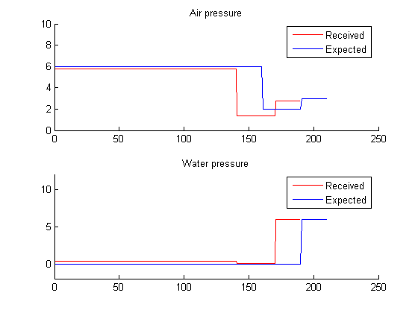
Figure 24 : cascade 2-20-10-10-10 small exam

Simulation 4 (2-25-10-5-10)
 | Feature | Value
General information
 | Neurons count | 2-25-10-5-10  (with cascade)
 | Training error | 0.340586
Large exam
 | error | 2.194925
 | Received emperature | 954.625447
 | Expected temperature | 850.000000
Small exam
 | error | 1.844304
 | Received emperature | 955.000000
 | Expected temperature | 954.697277
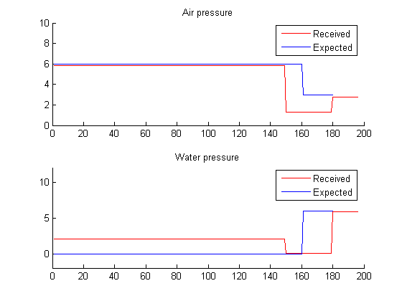
Figure 25 : cascade 2-25-10-5-10 large exam
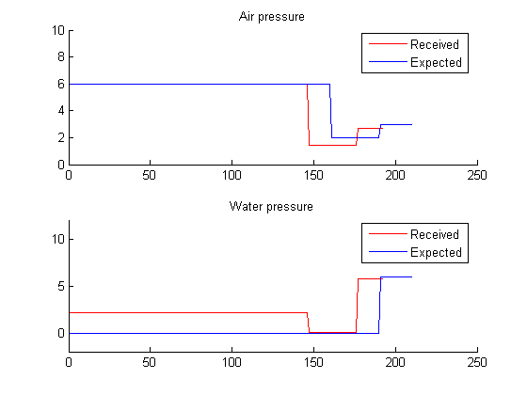
Figure 26 : cascade 2-25-10-5-10 small exam

Simulation results (common data)

The constructed neural network uses the tansig activation function, which produces values in the range of [-1; +1]. That's why before the data is passed to the network it is normalized. The response, produced by the network is denormalized during the demonstration. The error values, obtained during the learning process, are computed on the normalized values (from the [-1; +1] range).
So, we have 10 experiments involved in the training process. 1 experiment is not involved and is used for the demonstration.
The demonstration for each experiment was performed on the full data and the average valuesof the second experiment (#67). This experiment is not much different from the others. Hence, it is common.
So, we have 2 evaluation sets. The first of them (large data) contains 180 items of the original data. The other one (small data) contains only items which are the average values of the previous one.

Cascade network
The first approach was trying the cascade network, described by (Fahlman S. E., Lebiere C., “The Cascaded-correlation learning architecture”, 1990)

Simulation 1 (cascade 15)
 | Feature | Value
General information
 | Neurons count | 2-c15-10
 | Training error | 0.633863
Large exam
 | error | 0.584001
 | Received emperature | 918.849759
 | Expected temperature | 950.000000
Small exam
 | error | 0.940040
 | Received emperature | 909.717408
 | Expected temperature | 950.000000

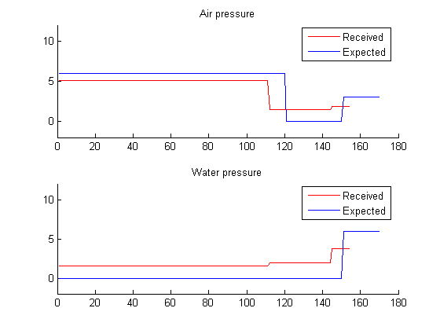
Figure 27 : Large exam

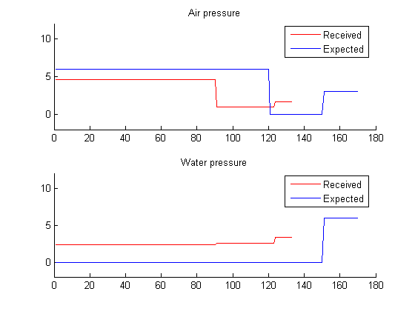
Figure 28 : small exam

Simulation 2 (cascade 20)
 | Feature | Value
General information
 | Neurons count | 2-c20-10
 | Training error | 0.648555
Large exam
 | error | 0.571265
 | Received emperature | 918.845660
 | Expected temperature | 950.000000
Small exam
 | error | 1.137731
 | Received emperature | 896.583356
 | Expected temperature | 950.000000

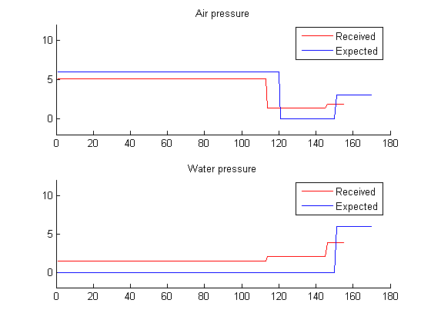
Figure 29 : Large exam

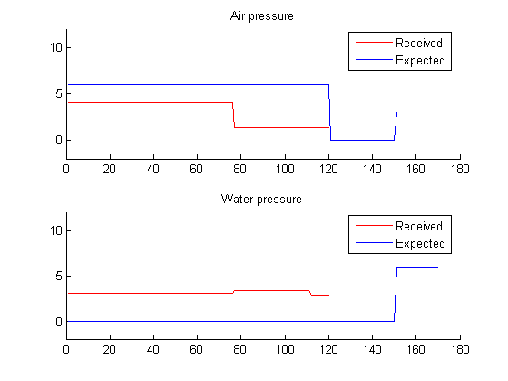
Figure 30 : small exam

Simulation 3 (cascade 25)
 | Feature | Value
General information
 | Neurons count | 2-c25-10
 | Training error | 0.650020
Large exam
 | error | 0.558844
 | Received emperature | 918.651613
 | Expected temperature | 950.000000
Small exam
 | error | 1.040822
 | Received emperature | 903.474734
 | Expected temperature | 950.000000

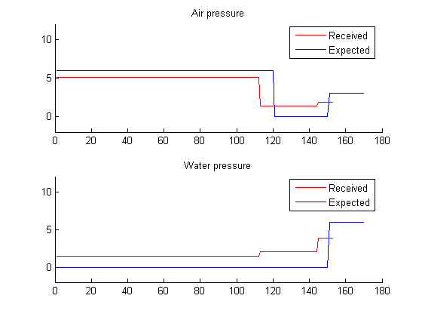
Figure 31 : Large exam

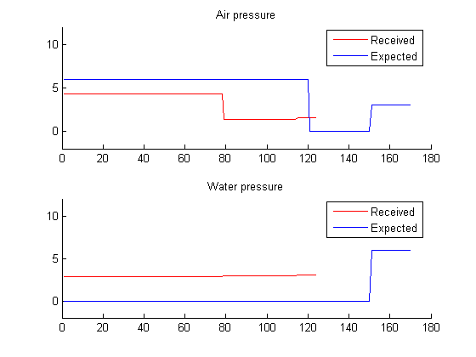
Figure 32 : small exam

Feedforward network

Simulation 1 (2-30-10)
 | Feature | Value
General information
 | Neurons count | 2-30-10
 | Training error | 0.793595
Large exam
 | error | 0.460462
 | Received emperature | 955.000000
 | Expected temperature | 950.000000
Small exam
 | error | 0.373598
 | Received emperature | 955.000000
 | Expected temperature | 950.000000
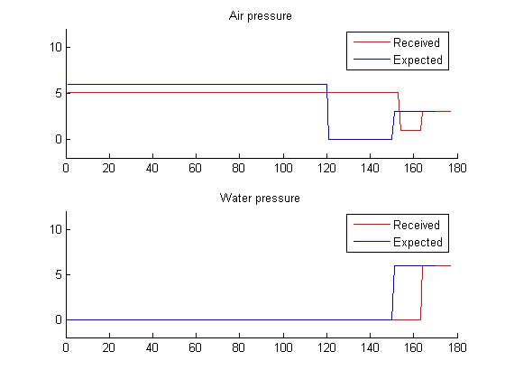
Figure 33 : fnn 2-30-10 large exam

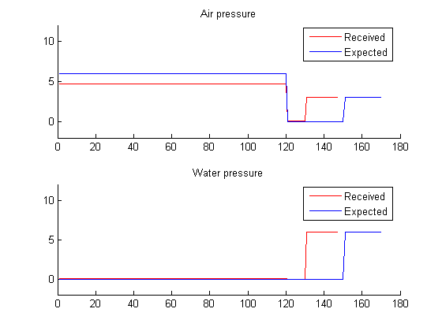
Figure 34 : fnn 2-30-10 small exam

Simulation 2 (2-20-10)
 | Feature | Value
General information
 | Neurons count | 2-20-10
 | Training error | 0.370675
Large exam
 | error | 0.166449
 | Received emperature | 939.675560
 | Expected temperature | 950.000000
Small exam
 | error | 0.155943
 | Received emperature | 938.232568
 | Expected temperature | 950.000000
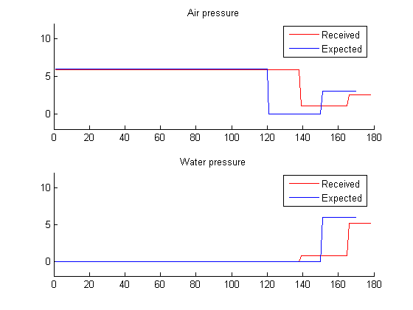
Figure 35 : fnn 2-20-10 large exam

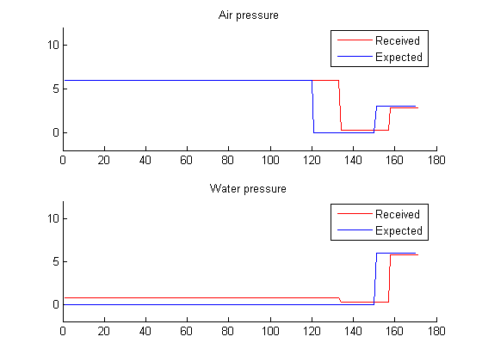
Figure 36 : fnn 2-20-10 small exam

Simulation 3(2-50-10)
 | Feature | Value
General information
 | Neurons count | 2-50-10
 | Training error | 0.806195
Large exam
 | error | 0.334069
 | Received emperature | 955.000000
 | Expected temperature | 950.000000
Small exam
 | error | 0.301502
 | Received emperature | 955.000000
 | Expected temperature | 950.000000
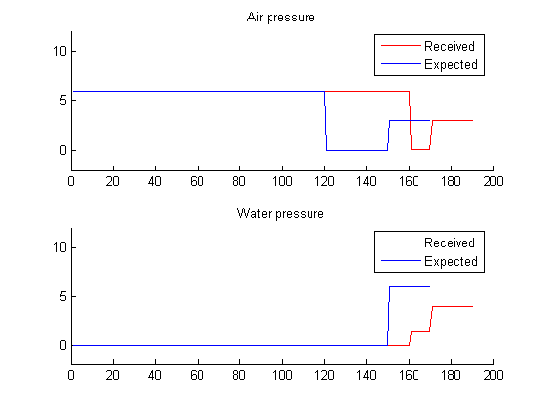
Figure 37 : fnn 2-50-10 large exam

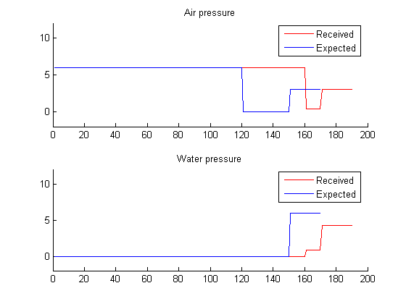
Figure 38 : fnn 2-50-10 small exam

Simulation 4(2-60-10)
 | Feature | Value
General information
 | Neurons count | 2-60-10
 | Training error | 0.357855
Large exam
 | error | 0.179362
 | Received emperature | 940.140570
 | Expected temperature | 950.000000
Small exam
 | error | 0.226389
 | Received emperature | 947.700990
 | Expected temperature | 950.000000
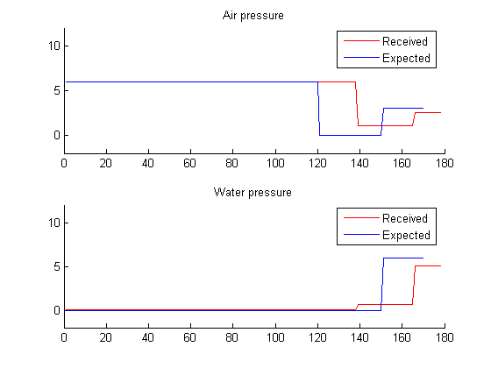
Figure 39 : fnn 2-60-10 large exam

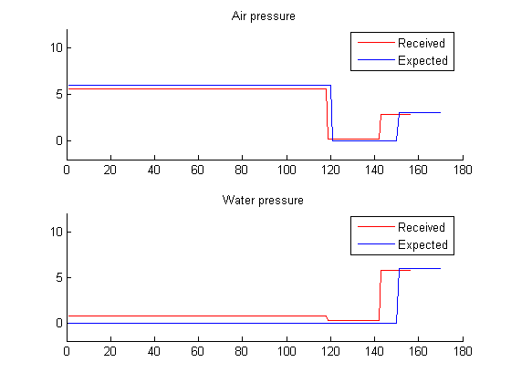
Figure 40 : fnn 2-60-10 small exam

Cascade forward network (newcf)

Simulation 1 (2-30-10-10)
 | Feature | Value
General information
 | Neurons count | 2-30-10-10
 | Training error | 0.334907
Large exam
 | error | 0.192305
 | Received emperature | 940.846834
 | Expected temperature | 950.000000
Small exam
 | error | 0.266779
 | Received emperature | 947.723839
 | Expected temperature | 950.000000

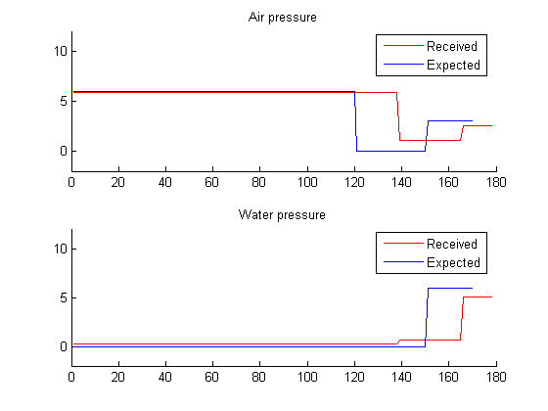
Figure 41 : fnn 2-30-10-10 large exam

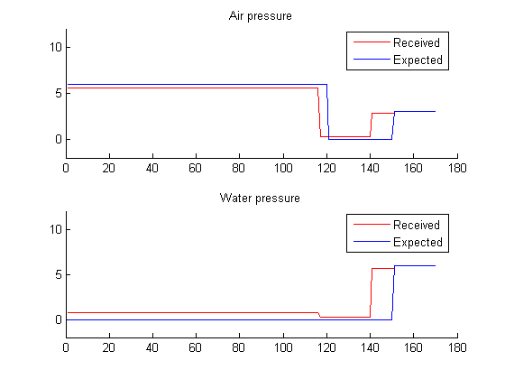
Figure 42 : fnn 2-30-10-10 small exam

Simulation 2 (2-20-20-10)
 | Feature | Value
General information
 | Neurons count | 2-20-20-10
 | Training error | 0.325460
Large exam
 | error | 0.208955
 | Received emperature | 941.111594
 | Expected temperature | 950.000000
Small exam
 | error | 0.212079
 | Received emperature | 948.037857
 | Expected temperature | 950.000000

Figure 43 : fnn 2-20-20-10 large exam

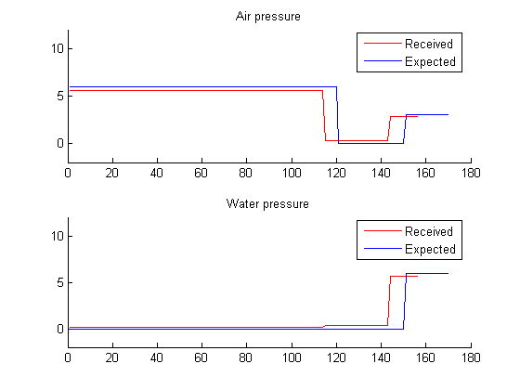
Figure 44 : fnn 2-20-20-10 small exam

Simulation 3 (2-25-10-5-10)
 | Feature | Value
General information
 | Neurons count | 2-25-10-5-10
 | Training error | 0.450364
Large exam
 | error | 0.220565
 | Received emperature | 955.000000
 | Expected temperature | 950.000000
Small exam
 | error | 0.189440
 | Received emperature | 955.000000
 | Expected temperature | 950.000000

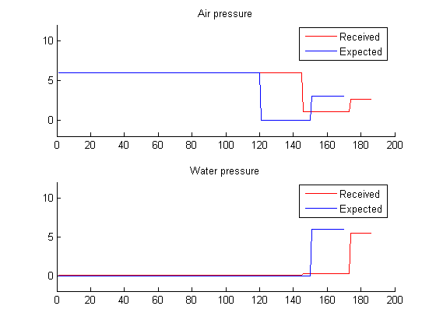
Figure 45 : fnn 2-25-10-5-10 large exam

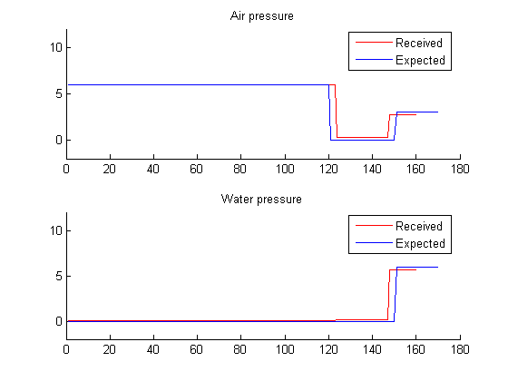
Figure 46 : fnn 2-25-10-5-10small exam

Simulation 4(2-20-10-10-10)
 | Feature | Value
General information
 | Neurons count | 2-20-10-10-10
 | Training error | 0.348942
Large exam
 | error | 0.180575
 | Received emperature | 940.096189
 | Expected temperature | 950.000000
Small exam
 | error | 0.327287
 | Received emperature | 933.740083
 | Expected temperature | 950.000000

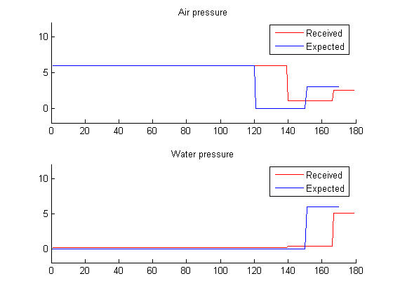
Figure 47 : fnn 2-20-10-10-10 large exam

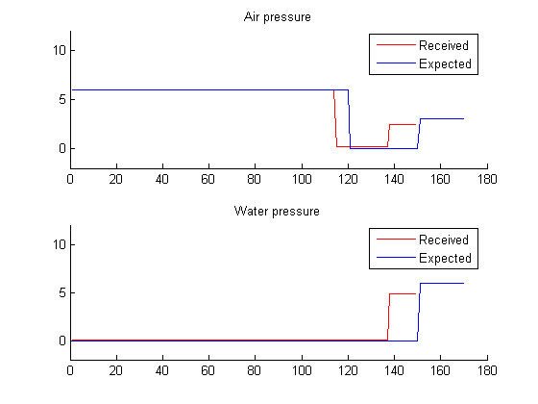
Figure 48 : fnn 2-20-10-10-10 small exam

