Detail hardness report 3

Task description 2

Simulation results (uncommon data) 3

Cascade network 4

Simulation 1(cascade 15) 4

Simulation 2 (cascade 15) 5

Simulation 3 (cascade 20) 6

Simulation 4 (cascade 30) 7

Feedforward network 8

Simulation 1 (2-30-10) 8

Simulation 2 (2-20-10) 9

Simulation 3 (2-60-10) 10

Simulation 4 (2-50-10) 11

Cascade forward network (newcf) 12

Simulation 1 (2-30-10-10) 12

Simulation 2 (2-20-20-10) 13

Simulation 3 (2-10-10-10-10) 14

Simulation 4 (2-25-10-5-10) 15

Simulation results (common data) 16

Cascade network 17

Simulation 1 (cascade 15) 17

Simulation 2 (cascade 20) 18

Simulation 3 (cascade 25) 19

Feedforward network 20

Simulation 1 (2-30-10) 20

Simulation 2 (2-20-10) 21

Simulation 3(2-50-10) 22

Simulation 4(2-60-10) 23

Cascade forward network (newcf) 24

Simulation 1 (2-30-10-10) 24

Simulation 2 (2-20-20-10) 25

Simulation 3 (2-25-10-5-10) 26

Simulation 4(2-20-10-10-10) 27

# Task description

The data, provided by the user, consists of a set of the ***experiments***. Each experiment results are obtained by cooling the detail by air and water under pressure. The cooling process consists of three **phases (**Figure 1**) :**

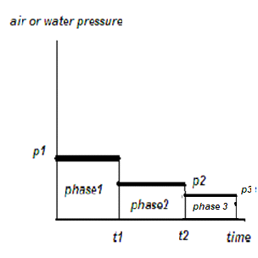

Figure 1 : Cooling process phases

The temperature of the metal heating also matters. Hence, there are 10 conditions describing the production process. (Figure 2)

The **hardness** of the received gear is measured in the different **points**. The points have different polar coordinates (the **radius** and the **angle**). As the gear is a symmetrical object, the angle parameter is out of the scope. Hence, we have two parameters, defining the point. They are **radius** and **hardness**.

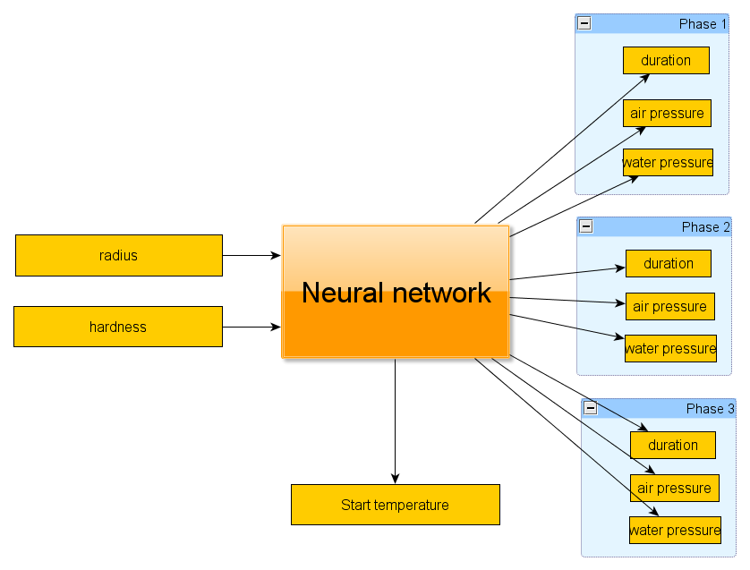

Figure 2 : Neural net inputs-outputs

# Simulation results (uncommon data)

The constructed neural network uses the ***tansig*** activation function, which produces values in the range of [-1; +1]. That's why before the data is passed to the network it is ***normalized***. The response, produced by the network is ***denormalized*** during the demonstration. The error values, obtained during the learning process, are computed on the normalized values (from the [-1; +1] range).

So, we have 10 experiments involved in the training process. 1 experiment is not involved and is used for the demonstration.

The demonstration for each experiment was performed on the **full data** and the **average** **values** of the *last* experiment (#121). This experiment is pretty much different from the others as it has a lower start temperature and only 2 cooling phases. Hence, it is uncommon.

So, we have 2 evaluation sets. The first of them (**large data**) contains 180 items of the original data. The other one (**small data**) contains only items which are the average values of the previous one.

## Cascade network

The first approach was trying the cascade network, described by (***Fahlman S. E.,  Lebiere C., “The Cascaded-correlation learning architecture”, 1990***)

### Simulation 1(cascade 15)

|  |  |  |
| --- | --- | --- |
|  | Feature | Value |
| General information |  |  |
|  | Neurons count | 2-c15-10 |
|  | Training error | 0.565937 |
| Large exam |  |  |
|  | error | 1.448319 |
|  | Received emperature | 929.712124 |
|  | Expected temperature | 850.000000 |
| Small exam |  |  |
|  | error |  |
|  | Received emperature | 943.763180 |
|  | Expected temperature | 850.000000 |

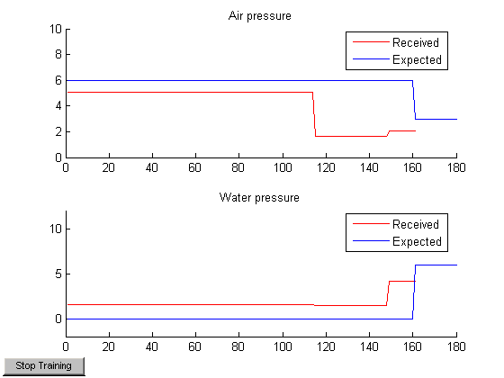

Figure : Large exam

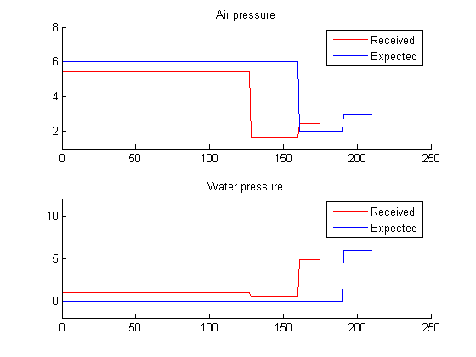

Figure 4 : small exam

### Simulation 2 (cascade 15)

|  |  |  |
| --- | --- | --- |
|  | Feature | Value |
| General information |  |  |
|  | Neurons count | 2-c15-10 |
|  | Training error | 1.457640 |
| Large exam |  |  |
|  | error | 1.457640 |
|  | Received emperature | 930.026955 |
|  | Expected temperature | 850.000000 |
| Small exam |  |  |
|  | error | 1.410002 |
|  | Received emperature | 945.063811 |
|  | Expected temperature | 850.000000 |

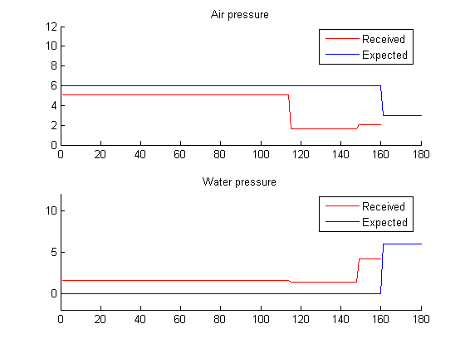

Figure : Large exam

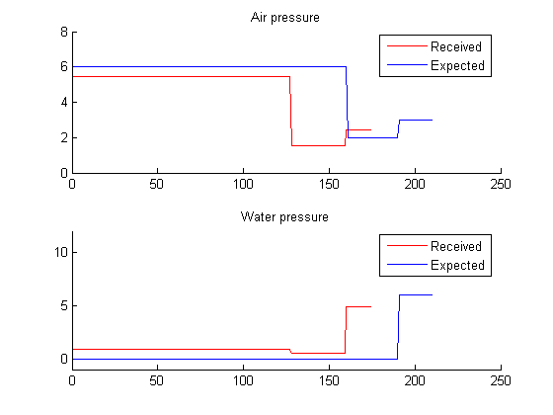

Figure 6 : small exam

### Simulation 3 (cascade 20)

|  |  |  |
| --- | --- | --- |
|  | Feature | Value |
| General information |  |  |
|  | Neurons count | 2-c20-10 |
|  | Training error | 0.548298 |
| Large exam |  |  |
|  | error | 1.467110 |
|  | Received emperature | 929.732569 |
|  | Expected temperature | 850.000000 |
| Small exam |  |  |
|  | error | 1.402958 |
|  | Received emperature | 944.890952 |
|  | Expected temperature | 850.000000 |

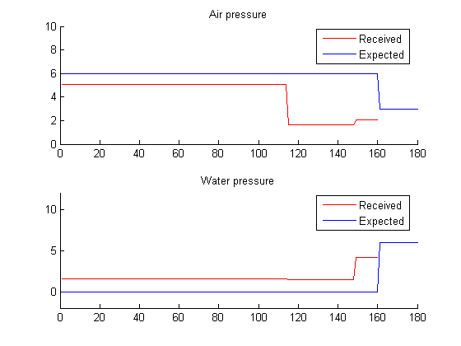

Figure : Large exam

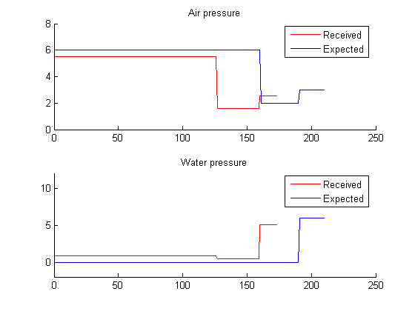

Figure 8 : small exam

### Simulation 4 (cascade 30)

|  |  |  |
| --- | --- | --- |
|  | Feature | Value |
| General information |  |  |
|  | Neurons count | 2-c30-10 |
|  | Training error | 0.550165 |
| Large exam |  |  |
|  | error | 1.467339 |
|  | Received emperature | 929.198024 |
|  | Expected temperature | 850.000000 |
| Small exam |  |  |
|  | error | 1.425729 |
|  | Received emperature | 943.967807 |
|  | Expected temperature | 850.000000 |

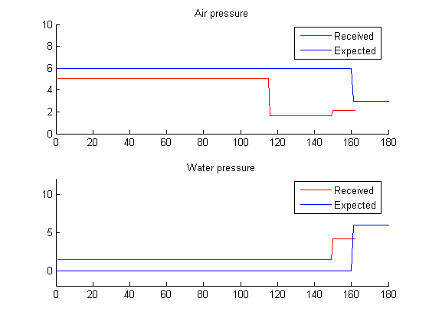

Figure : Large exam

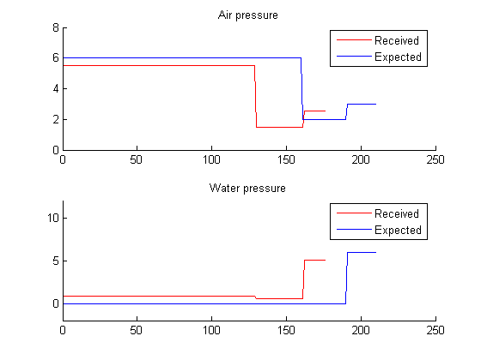

Figure 10 : small exam

## Feedforward network

### Simulation 1 (2-30-10)

|  |  |  |
| --- | --- | --- |
|  | Feature | Value |
| General information |  |  |
|  | Neurons count | 2-30-10 |
|  | Training error | 0.740108 |
| Large exam |  |  |
|  | error | 1.856814 |
|  | Received emperature | 910.666667 |
|  | Expected temperature | 850.000000 |
| Small exam |  |  |
|  | error | 1.521312 |
|  | Received emperature | 910.000000 |
|  | Expected temperature | 850.000000 |

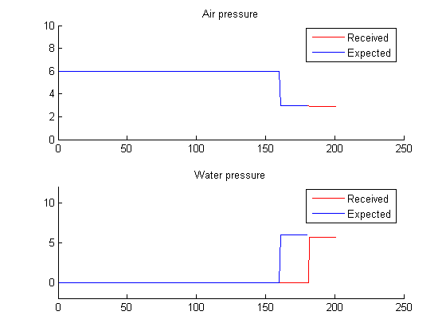

Figure : fnn 2-30-10 large exam

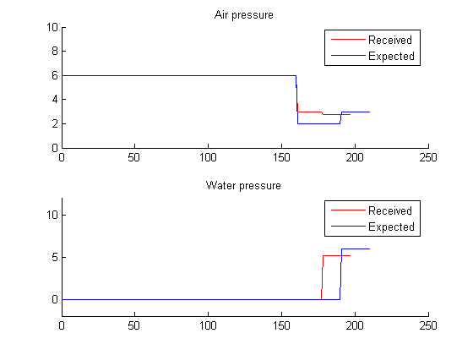

Figure 12 : fnn 2-30-10 small exam

### Simulation 2 (2-20-10)

|  |  |  |
| --- | --- | --- |
|  | Feature | Value |
| General information |  |  |
|  | Neurons count | 2-20-10 |
|  | Training error | 0.197484 |
| Large exam |  |  |
|  | error | 1.961429 |
|  | Received emperature | 953.013868 |
|  | Expected temperature | 850.000000 |
| Small exam |  |  |
|  | error | 1.628976 |
|  | Received emperature | 910.000000 |
|  | Expected temperature | 953.024504 |

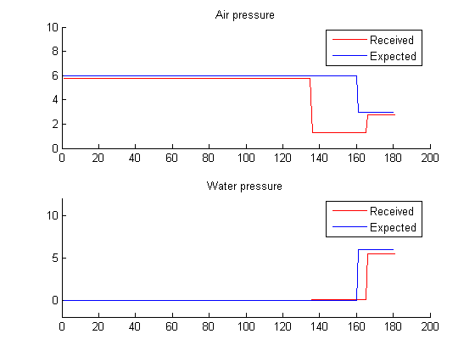

Figure : fnn 2-20-10 large exam

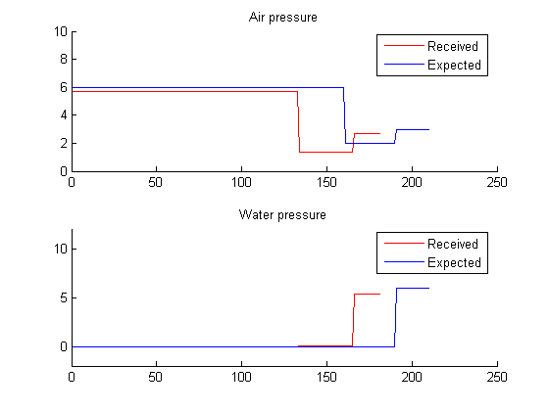

Figure 14 : fnn 2-20-10 small exam

### Simulation 3 (2-60-10)

|  |  |  |
| --- | --- | --- |
|  | Feature | Value |
| General information |  |  |
|  | Neurons count | 2-60-10 |
|  | Training error | 0.267974 |
| Large exam |  |  |
|  | error | 1.970630 |
|  | Received emperature | 953.101348 |
|  | Expected temperature | 850.000000 |
| Small exam |  |  |
|  | error | 1.649925 |
|  | Received emperature | 910.000000 |
|  | Expected temperature | 952.911051 |

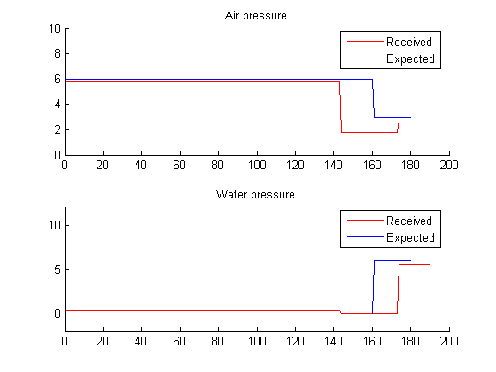

Figure : fnn 2-60-10 large exam

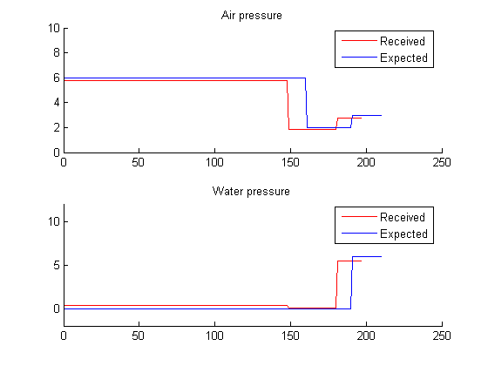

Figure 16 : fnn 2-60-10 small exam

### Simulation 4 (2-50-10)

|  |  |  |
| --- | --- | --- |
|  | Feature | Value |
| General information |  |  |
|  | Neurons count | 2-50-10 |
|  | Training error | 0.281693 |
| Large exam |  |  |
|  | error | 1.995317 |
|  | Received emperature | 954.338378 |
|  | Expected temperature | 850.000000 |
| Small exam |  |  |
|  | error | 1.701537 |
|  | Received emperature | 910.000000 |
|  | Expected temperature | 954.027954 |

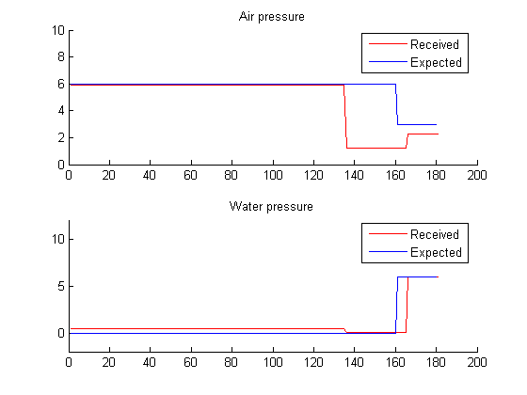

Figure : fnn 2-50-10 large exam

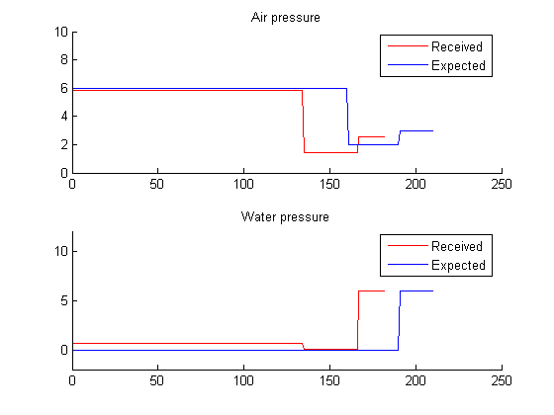

Figure 18 : fnn 2-50-10 small exam

## Cascade forward network (newcf)

### Simulation 1 (2-30-10-10)

|  |  |  |
| --- | --- | --- |
|  | Feature | Value |
| General information |  |  |
|  | Neurons count | 2-30-10-10  (with cascade) |
|  | Training error | 0.498051 |
| Large exam |  |  |
|  | error | 2.023548 |
|  | Received emperature | 929.894039 |
|  | Expected temperature | 850.000000 |
| Small exam |  |  |
|  | error | 1.700884 |
|  | Received emperature | 910.000000 |
|  | Expected temperature | 850.000000 |

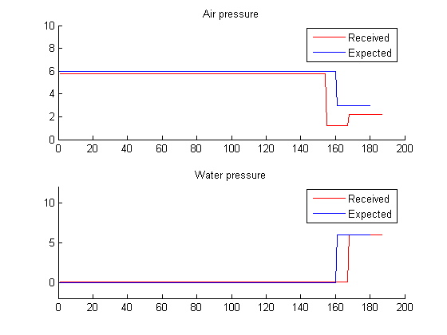

Figure : cascade 2-30-10-10 large exam

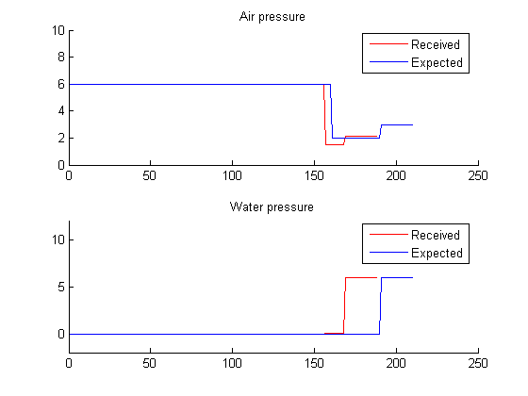

Figure 20 : cascade 2-30-10-10 small exam

### Simulation 2 (2-20-20-10)

|  |  |  |
| --- | --- | --- |
|  | Feature | Value |
| General information |  |  |
|  | Neurons count | 2-20-20-10  (with cascade) |
|  | Training error | 0.173909 |
| Large exam |  |  |
|  | error | 1.993128 |
|  | Received emperature | 954.999999 |
|  | Expected temperature | 850.000000 |
| Small exam |  |  |
|  | error | 1.676904 |
|  | Received emperature | 955.000000 |
|  | Expected temperature | 850.000000 |

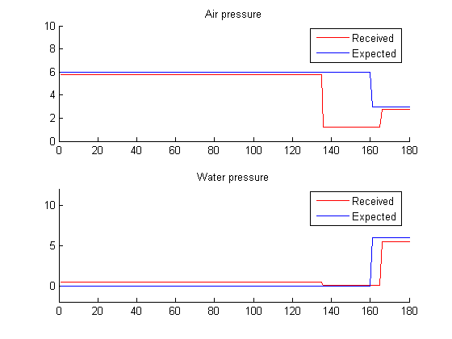

Figure : cascade 2-20-20-10 large exam

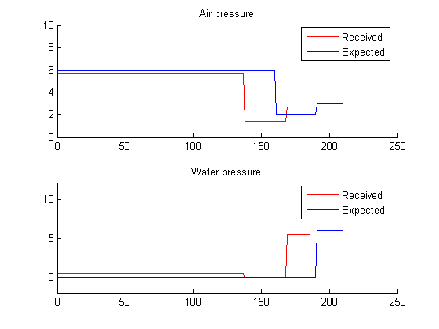

Figure 22 : cascade 2-20-20-10 small exam

### Simulation 3 (2-10-10-10-10)

|  |  |  |
| --- | --- | --- |
|  | Feature | Value |
| General information |  |  |
|  | Neurons count | 2-20-10-10-10  (with cascade) |
|  | Training error | 0.210370 |
| Large exam |  |  |
|  | error | 2.154339 |
|  | Received emperature | 952.385225 |
|  | Expected temperature | 850.000000 |
| Small exam |  |  |
|  | error | 1.812939 |
|  | Received emperature | 955.000000 |
|  | Expected temperature | 952.454654 |

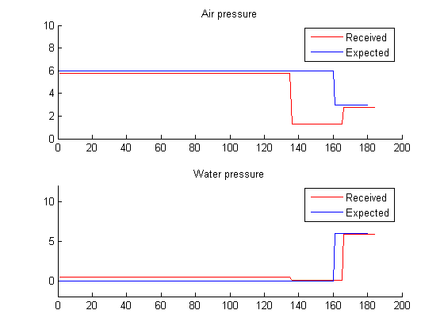

Figure : cascade 2-20-10-10-10 large exam

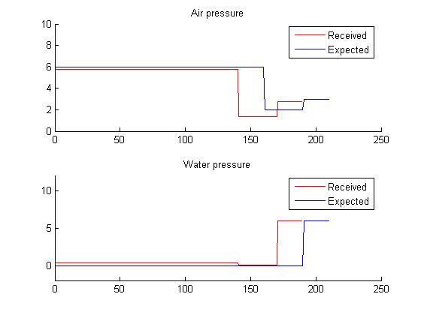

Figure 24 : cascade 2-20-10-10-10 small exam

### Simulation 4 (2-25-10-5-10)

|  |  |  |
| --- | --- | --- |
|  | Feature | Value |
| General information |  |  |
|  | Neurons count | 2-25-10-5-10  (with cascade) |
|  | Training error | 0.340586 |
| Large exam |  |  |
|  | error | 2.194925 |
|  | Received emperature | 954.625447 |
|  | Expected temperature | 850.000000 |
| Small exam |  |  |
|  | error | 1.844304 |
|  | Received emperature | 955.000000 |
|  | Expected temperature | 954.697277 |

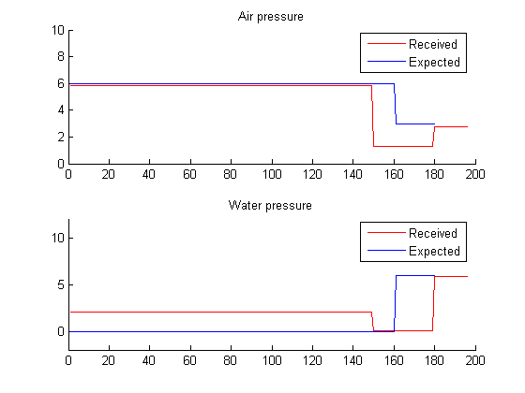

Figure : cascade 2-25-10-5-10 large exam

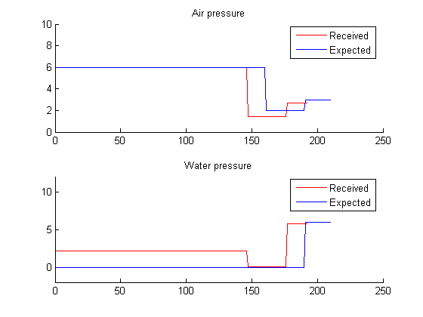

Figure 26 : cascade 2-25-10-5-10 small exam

# Simulation results (common data)

The constructed neural network uses the ***tansig*** activation function, which produces values in the range of [-1; +1]. That's why before the data is passed to the network it is ***normalized***. The response, produced by the network is ***denormalized*** during the demonstration. The error values, obtained during the learning process, are computed on the normalized values (from the [-1; +1] range).

So, we have 10 experiments involved in the training process. 1 experiment is not involved and is used for the demonstration.

The demonstration for each experiment was performed on the **full data** and the **average** **values**of the *second* experiment (#67). This experiment is not much different from the others. Hence, it is common.

So, we have 2 evaluation sets. The first of them (**large data**) contains 180 items of the original data. The other one (**small data**) contains only items which are the average values of the previous one.

## Cascade network

The first approach was trying the cascade network, described by (***Fahlman S. E.,  Lebiere C., “The Cascaded-correlation learning architecture”, 1990***)

### Simulation 1 (cascade 15)

|  |  |  |
| --- | --- | --- |
|  | Feature | Value |
| General information |  |  |
|  | Neurons count | 2-c15-10 |
|  | Training error | 0.633863 |
| Large exam |  |  |
|  | error | 0.584001 |
|  | Received emperature | 918.849759 |
|  | Expected temperature | 950.000000 |
| Small exam |  |  |
|  | error | 0.940040 |
|  | Received emperature | 909.717408 |
|  | Expected temperature | 950.000000 |

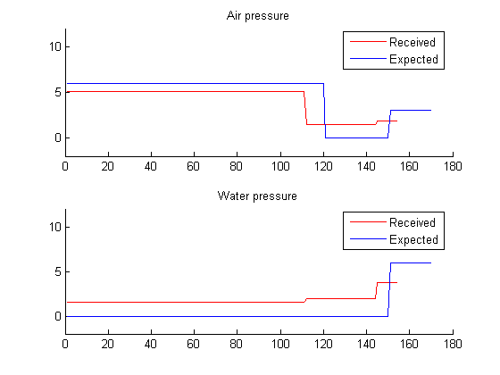

Figure : Large exam

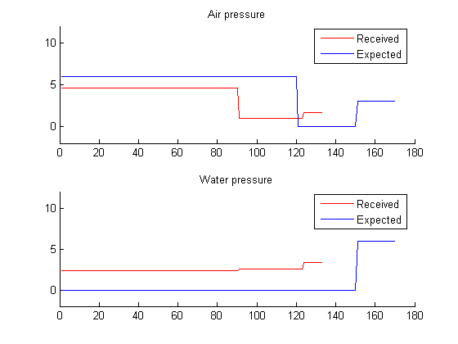

Figure 28 : small exam

### Simulation 2 (cascade 20)

|  |  |  |
| --- | --- | --- |
|  | Feature | Value |
| General information |  |  |
|  | Neurons count | 2-c20-10 |
|  | Training error | 0.648555 |
| Large exam |  |  |
|  | error | 0.571265 |
|  | Received emperature | 918.845660 |
|  | Expected temperature | 950.000000 |
| Small exam |  |  |
|  | error | 1.137731 |
|  | Received emperature | 896.583356 |
|  | Expected temperature | 950.000000 |

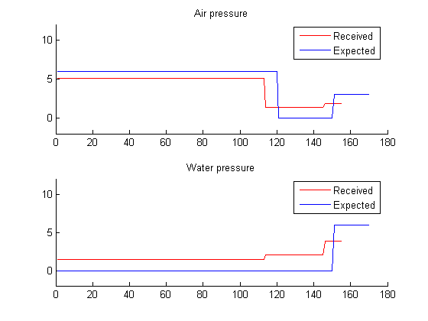

Figure : Large exam

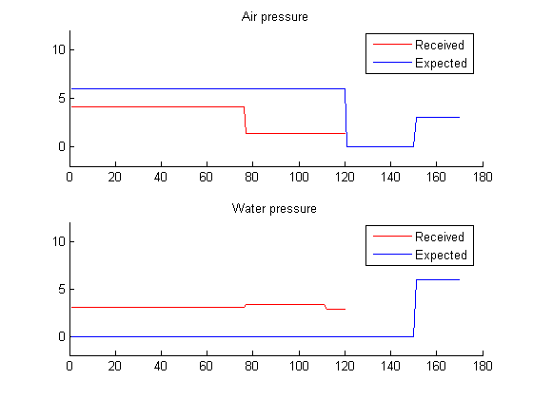

Figure 30 : small exam

### Simulation 3 (cascade 25)

|  |  |  |
| --- | --- | --- |
|  | Feature | Value |
| General information |  |  |
|  | Neurons count | 2-c25-10 |
|  | Training error | 0.650020 |
| Large exam |  |  |
|  | error | 0.558844 |
|  | Received emperature | 918.651613 |
|  | Expected temperature | 950.000000 |
| Small exam |  |  |
|  | error | 1.040822 |
|  | Received emperature | 903.474734 |
|  | Expected temperature | 950.000000 |

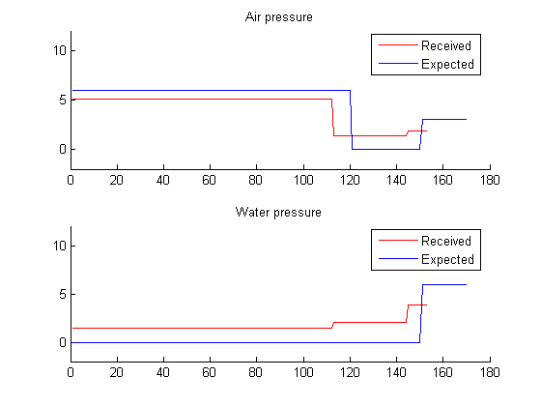

Figure : Large exam

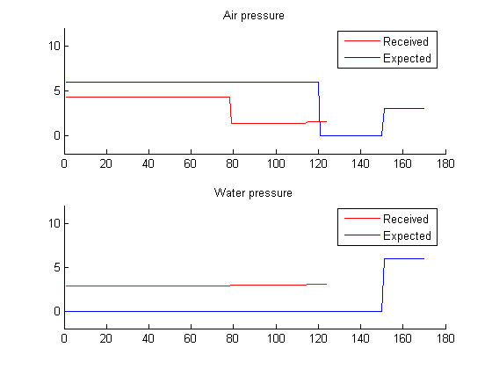

Figure 32 : small exam

## Feedforward network

### Simulation 1 (2-30-10)

|  |  |  |
| --- | --- | --- |
|  | Feature | Value |
| General information |  |  |
|  | Neurons count | 2-30-10 |
|  | Training error | 0.793595 |
| Large exam |  |  |
|  | error | 0.460462 |
|  | Received emperature | 955.000000 |
|  | Expected temperature | 950.000000 |
| Small exam |  |  |
|  | error | 0.373598 |
|  | Received emperature | 955.000000 |
|  | Expected temperature | 950.000000 |

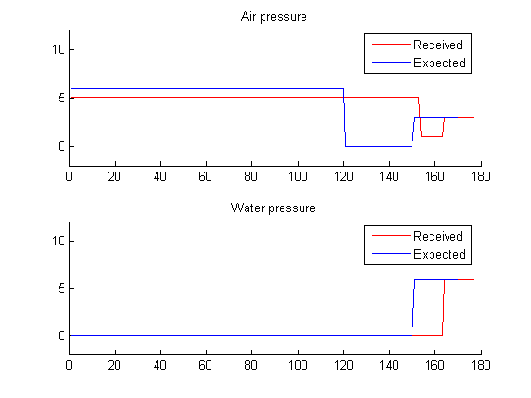

Figure : fnn 2-30-10 large exam

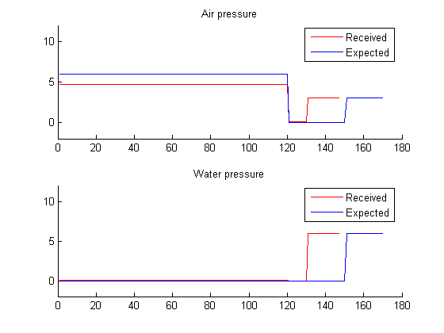

Figure 34 : fnn 2-30-10 small exam

### Simulation 2 (2-20-10)

|  |  |  |
| --- | --- | --- |
|  | Feature | Value |
| General information |  |  |
|  | Neurons count | 2-20-10 |
|  | Training error | 0.370675 |
| Large exam |  |  |
|  | error | 0.166449 |
|  | Received emperature | 939.675560 |
|  | Expected temperature | 950.000000 |
| Small exam |  |  |
|  | error | 0.155943 |
|  | Received emperature | 938.232568 |
|  | Expected temperature | 950.000000 |

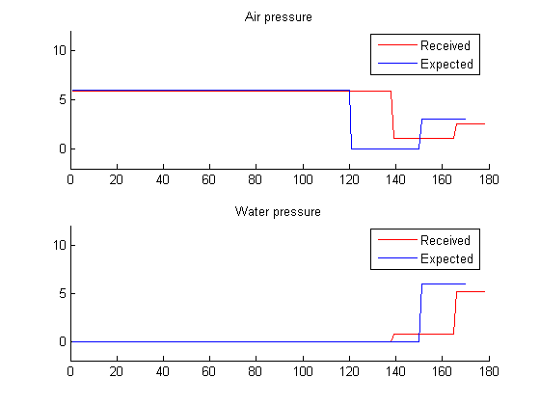

Figure : fnn 2-20-10 large exam

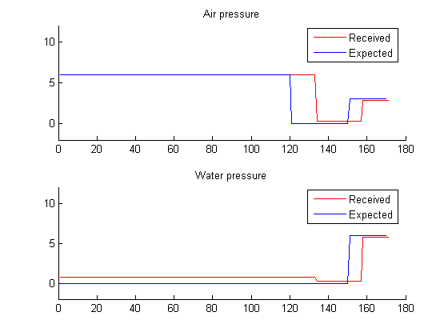

Figure 36 : fnn 2-20-10 small exam

### Simulation 3(2-50-10)

|  |  |  |
| --- | --- | --- |
|  | Feature | Value |
| General information |  |  |
|  | Neurons count | 2-50-10 |
|  | Training error | 0.806195 |
| Large exam |  |  |
|  | error | 0.334069 |
|  | Received emperature | 955.000000 |
|  | Expected temperature | 950.000000 |
| Small exam |  |  |
|  | error | 0.301502 |
|  | Received emperature | 955.000000 |
|  | Expected temperature | 950.000000 |

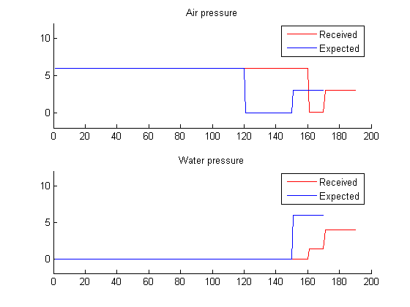

Figure 37 : fnn 2-50-10 large exam

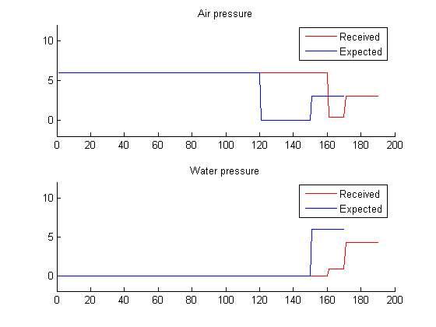

Figure 38 : fnn 2-50-10 small exam

### Simulation 4(2-60-10)

|  |  |  |
| --- | --- | --- |
|  | Feature | Value |
| General information |  |  |
|  | Neurons count | 2-60-10 |
|  | Training error | 0.357855 |
| Large exam |  |  |
|  | error | 0.179362 |
|  | Received emperature | 940.140570 |
|  | Expected temperature | 950.000000 |
| Small exam |  |  |
|  | error | 0.226389 |
|  | Received emperature | 947.700990 |
|  | Expected temperature | 950.000000 |

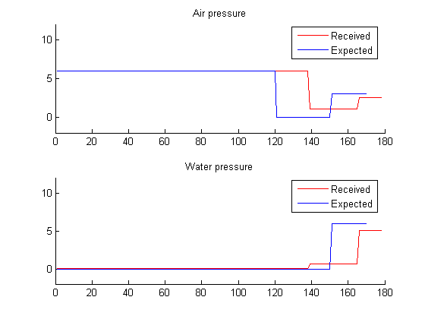

Figure 39 : fnn 2-60-10 large exam

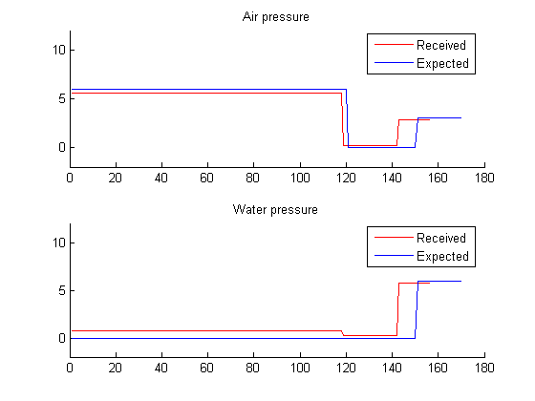

Figure 40 : fnn 2-60-10 small exam

## Cascade forward network (newcf)

### Simulation 1 (2-30-10-10)

|  |  |  |
| --- | --- | --- |
|  | Feature | Value |
| General information |  |  |
|  | Neurons count | 2-30-10-10 |
|  | Training error | 0.334907 |
| Large exam |  |  |
|  | error | 0.192305 |
|  | Received emperature | 940.846834 |
|  | Expected temperature | 950.000000 |
| Small exam |  |  |
|  | error | 0.266779 |
|  | Received emperature | 947.723839 |
|  | Expected temperature | 950.000000 |

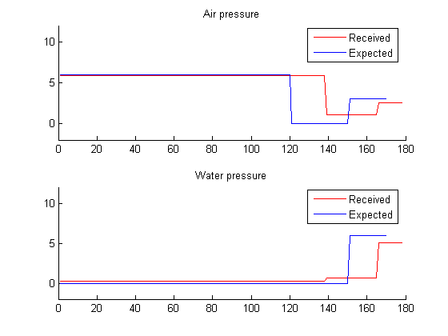

Figure 41 : fnn 2-30-10-10 large exam

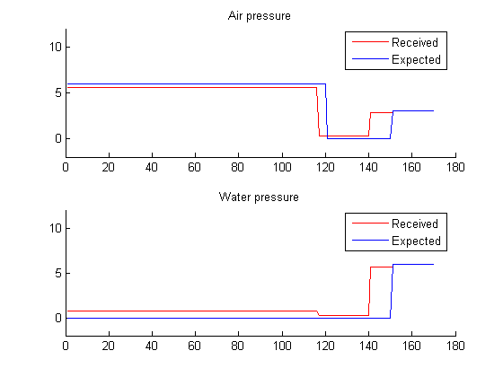

Figure 42 : fnn 2-30-10-10 small exam

### Simulation 2 (2-20-20-10)

|  |  |  |
| --- | --- | --- |
|  | Feature | Value |
| General information |  |  |
|  | Neurons count | 2-20-20-10 |
|  | Training error | 0.325460 |
| Large exam |  |  |
|  | error | 0.208955 |
|  | Received emperature | 941.111594 |
|  | Expected temperature | 950.000000 |
| Small exam |  |  |
|  | error | 0.212079 |
|  | Received emperature | 948.037857 |
|  | Expected temperature | 950.000000 |

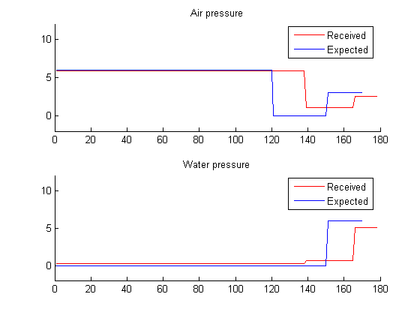

Figure 43 : fnn 2-20-20-10 large exam

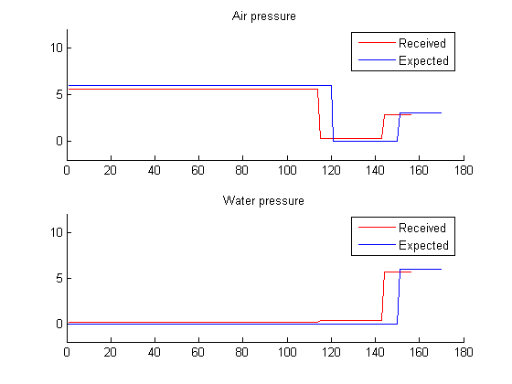

Figure 44 : fnn 2-20-20-10 small exam

### Simulation 3 (2-25-10-5-10)

|  |  |  |
| --- | --- | --- |
|  | Feature | Value |
| General information |  |  |
|  | Neurons count | 2-25-10-5-10 |
|  | Training error | 0.450364 |
| Large exam |  |  |
|  | error | 0.220565 |
|  | Received emperature | 955.000000 |
|  | Expected temperature | 950.000000 |
| Small exam |  |  |
|  | error | 0.189440 |
|  | Received emperature | 955.000000 |
|  | Expected temperature | 950.000000 |

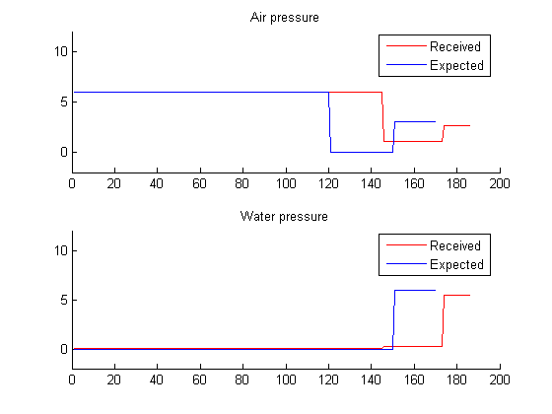

Figure 45 : fnn 2-25-10-5-10 large exam

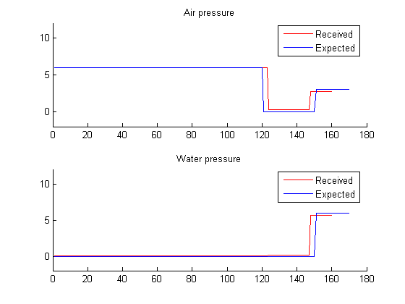

Figure 46 : fnn 2-25-10-5-10small exam

### Simulation 4(2-20-10-10-10)

|  |  |  |
| --- | --- | --- |
|  | Feature | Value |
| General information |  |  |
|  | Neurons count | 2-20-10-10-10 |
|  | Training error | 0.348942 |
| Large exam |  |  |
|  | error | 0.180575 |
|  | Received emperature | 940.096189 |
|  | Expected temperature | 950.000000 |
| Small exam |  |  |
|  | error | 0.327287 |
|  | Received emperature | 933.740083 |
|  | Expected temperature | 950.000000 |

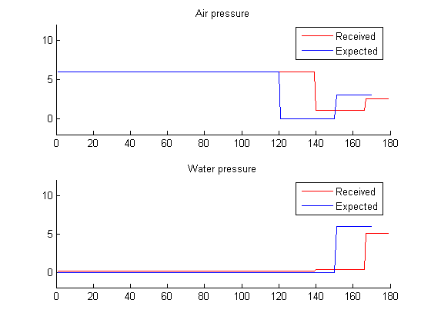

Figure 47 : fnn 2-20-10-10-10 large exam

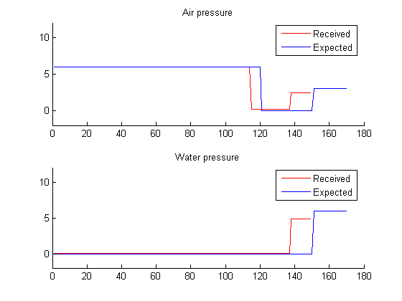

Figure 48 : fnn 2-20-10-10-10 small exam