**Admin Dashboard:**

- Under "Aufträge", admin should not see the amount (€) of the order (order you built in best way, like for user vie under "Aufträge" the "Tabelle anpassen" possibilit, that admin can select what he wants to see). But admin should have possibility, to click in this order and see then the "sub-status" how the current process is (like a progress where all things which happened in this order are shown).

Admin should also see here in overview, the advertiser name and the customer name. This should be work with the freetext-filter, that admin can search herefore, too.

The data format should be e.g. 18.01.2024 on whole platform. Bug here in overview: If we click on date filter on top, nothing opens.

- If you click on FairLink Logo, you get logged out

- If a customer has any problem with an advertiser, or if advertiser has any problem with customer, that there is a possibility, to send this problem to admin (e.g. with a button everywhere, which means "Any problem? Send to admin"), that admin receives this via backend notice or per e-mail with this specific case (something similar like in the user dashboard under "Projekte" if we go to an project, there we see the help button on right sidebar, too).

- Translations: "Planen" => "Pläne",

- If we are in "Benutzer" and hover over Typ "Publisher" or "User", the font color gets white.

- If we want to edit an user, we can not change his e-mail address or the type of the user. And there is the button "Erstellen" in user edit form, please rename this button to "Aktualisieren".

- Under "Backlinks", Admin should see the publishers name for each backlink

- Under "Besucher", there should be a filter bar to search for user name or e-mail address

- Under "Backlinks", if we click on a backlink, and scroll down to orders, admin should see the name and e-mail address of the specific customers, which ordered this backlink. Here is a bug, if we click on the order here, for a millisecond comes the error "Not found" and disappears then and shows the order.

- Bug: If we click on top right admin dropdown, and click on "Zahlungen", we get logged out.

- Where can admin edit some details, like e.g. "Platzierung in "Blog, Zeitschriften, Zeitungen"" or under "Backlinks" in the filter "Produktart" the three options or the .tld's?

- If admin is in any order, under "Linkziel" it means "Gehe zu" and then we come to a bootstrap demo site, so the "Linkziel" is not shown there. (Ans. The link has been added by the customer for their target URL site)

- Admin does not need a cart (on top) I think..

**User Dashboard:**

- How are the daily deals defined - with which logic or how to pick those as admin or from system?.

**Ans:** **Currently, we are showing the lowest-priced 5 links in daily deals.**

- For his own project, the user should have possibilty to define categories for this project. And based on this, he should see then some dynamic (!) daily deals from those categories. If he has more than 1 project, then regarding to all categories of all his projects, the daily deals can be mixed within those all categories.

- If we are in "Aufträge" in any order, the chat function does not work on bottom. We can not send any text.

- Rename "Armaturenbrett" and "Armaturenbrett (U)" to => "Übersicht"

- Under "Marktplatz" => "Link Bundles" where can admin edit this text?(Now In the admin section's plan menu, include options to add a heading and description for the Link Bundle page. This text will be displayed on the Link Bundles page.) And Bug: The three linkbundle tables have padding 0 to the left and right side, so they are at the edge of the main container.

- Can we let the submenu for "Marktplatz" from basicly stay open?

- On all amounts, please do it this format, e.g. => "439,39 €", not $1400 or 2000 ( all done (except the Stripe payment system and, in some cases, in the backend))

- Under "Aufträge" if we click in search field, the orange outline stops on left edge

- Same bug like in admin, if we click on date filter, nothing opens.

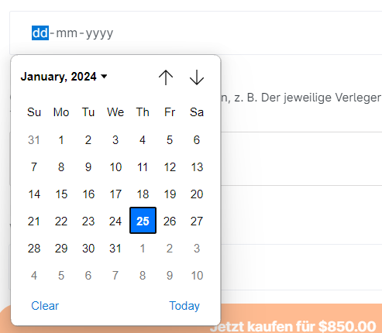

- Same bug like before for "Linkziel" - "Gehe zu"

- Same bug like before, we can not add text in messages on bottom. And question here: who gets then this messages? In this case, the advertiser? Such functions like that, I did not reviewed till now.

**Ans : The customer's message sent to the publisher of purchased backlinks(owner).**

- Under Marktplatz - "Backlinks" menu item, what means "Qualiti filter"? If we select or unselect, nothing changes(). Bug: "Tabelle anpassen" items does not work. "weitere Filter" seems not to work, too.

- Question: From where comes the "Bewertung" in each Domain (the star rating)?

**Ans - Currently, we do not have a third-party API to retrieve 'Bewertung' for each domain.**

- To buy more domain reveals, there is missing this function. For user, as for admin to set there the price and packages for the reveals. I did not test if the function of reveal works, because we have not as much domains in it for demo. Can you test this please or create this situation?

- In this: https://p1.2024web.com/app/content/36weorau, the right side is scrollable to right (in the order form)

- If user clicks on top right user dropdown, under "Zahlungen", where can he see the invoice to each paiment? So, that there are two options: If customer buis a credit via stripe, this monei goes to admin. So there should automaticalli come the stripe invoice in it. But if customer buis a link from a publisher, then if the publisher uploads the invoice, the invoice should come there AND in the order (in summari). If publisher did not upload an invoice, so if the field is empti, then should there be a button with "Rechnung anfordern" (Ask for invoice) and publisher should receive a message (where?) that he gets notified to upload an invoice.

**Currently, invoices can be downloaded as PDFs for both Stripe credit and purchase links.**

- In germani there exists "VAT" (19%) - here maibe we need to talk about, how to integrate the VAT for everithing (cart, order, and so on).

- If user has a backlink in cart, and expand for more options in cart, and adds the "Textgenehmigung", there comes a price but without the currenci simbol. Question here too: where to setup such prices? But maibe i will see it in advertiser login then. :)

- If we select "write own text", onli then should be the "Ankertext" text box visible, but if we select "Redaktioneller Text" (what means, that advertiser writes it, then should the textbox for own text be hided.

**Ans: We implemented its functionality with reference to backlinked.com.**

Bug: If we click the checkbox "Ankertext von Fairlinked wählen lassen", nothing happens. It is without function.

**Ans: If you click on 'Ankertext von Fairlinked wählen lassen,' the Ankertext textbox is disabled**

Bug: If we click on date filter (or date icon which is on right side, should be directli after date field right), calendar does not open.( I checked it live, and it worked.)



- Question: If customer checks "Text for Veröffentlichung genehmigen", where does advertiser see then such important details in the order?

- If we select "write our own text" then an upload field opens below "Ankertext von FairLinked wählen lassen" - for what is this upload field?

**Ans:** The anchor text selection by FairLinked is not related to writing our own text in this field; it is related to the anchor text.

- If we select "advertiser writes text" and want to place order, it is not allowed, because or required field (which i spoke about, that this should go then awai this field).

- Bug: we can set for placing the link date a date e.g. from 2010 - which is in past, so this should be allowed of course onli dates in future.

- After buing, nothing happens. Then the cart is onli empti. But here we need something other, like a short summari what was bought, and maibe a link to the chat to the advertiser or something else.

**Publisher Dashboard:**

- For Domain Overview, the domain boxes have a high height. Can we fix this or will there come ani image like e.g. domain preview from website? (Domain preview image is already displayed.).

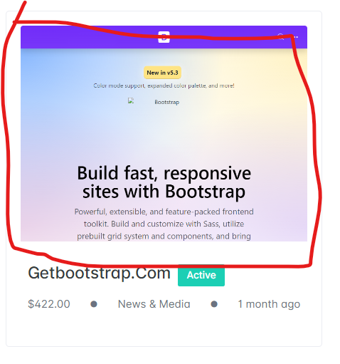

- Same bugs with date filter like before (in "Aufträge")

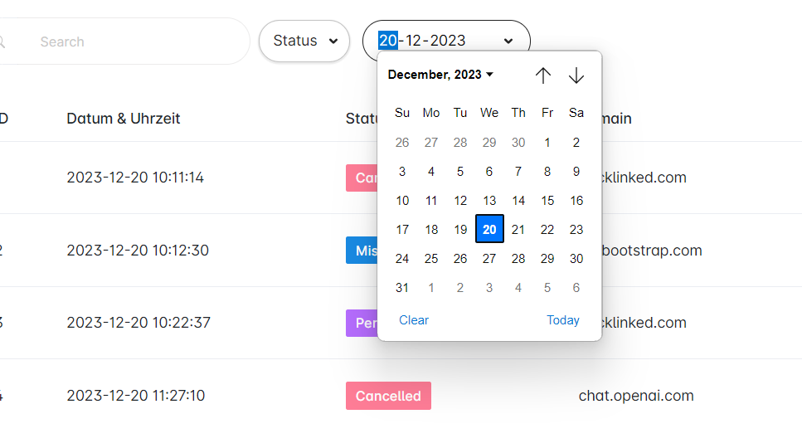

- Under "Aufträge" the export button does not work (Now export publisher order data as a CSV file.)

- In order chat, can we remove the images avatars and write instead, there the names?

- In order chat, it should not be possible to delete written messages

- In order, under "Textdatei herunterladen" (Download text) - it does not work, there comes a blank site then. And are these backend links created with SALT or ani securiti? Otherwise, anibodi could tri with other numbers after last slash and have insights to not-own-information.

*Solution*

*1. I have checked that text downloads are working and file download is working.*

*2. Now text file only access admin, buyer and seller*

- If we set a new status to an order, is the buier then informed about it in email and in plattform?

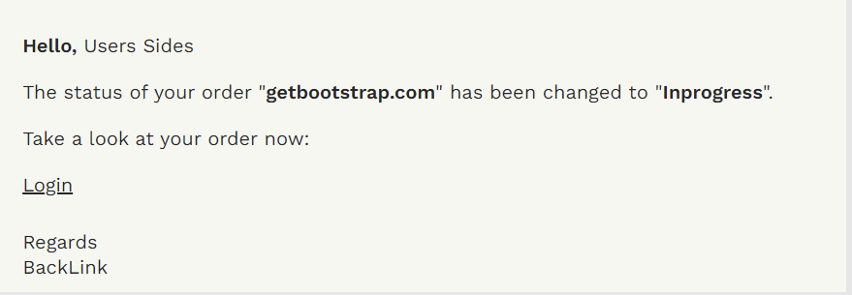

- The "Mitteilungen" - can we do this better and more clearli to see, which order, and e.g. for new messages with an "!" in "Mitteilungen" Menu item, and on the message itself which is new? So that those all messages are ordered in "in-order-messages"?

- Bug: If we click on menu avatar dropdown on top, under "Zahlungen" we get logged out.

- Publisher needs to have possibiliti to upload an invoice to each order in an extra box. And this should be clearli visible, even in overview, for each order, where is a tag or something else with "Rechnung gesendet" (Invoice sent) or "Rechnung ausstehend" (Invoice awaiting). Even in "Zahlungen" Tab should be possible to upload and see the invoice regarding to each paiment, which a customer did. would be great, even, if publisher set status to completed, that then opens the message or upload for invoice, too.

- All in all for invoices thing: we need here then different stati (see explanaition before). Even for customer and publisher both, own more status like "Invoice paid" or "Invoice not paid".

OTHERwISE (would be better wai): That we do not store invoices and those invoice uploads on server. Better: Customer should insert for each order an invoice e-Mail with invoice data. This should be shown then for publisher. That publisher send the invoice via e-Mail to customer, which then has nothing to do with our plattform. But the all status for this too, is neccessari.

# Currency Format Change Page:

**User side**

1. Cart page
2. Place order modal
3. Link view page
4. Dashboard page
5. Project page
6. Order page
7. Order view page
8. Backlink list page
9. Backlink view page
10. Link bundle page
11. Transaction page

**Publisher side**

1. Domain list page
2. Domain view page
3. Order list page
4. Order view page

**Admin side**

1. Order list page
2. Order view page
3. Backlinks list page
4. Backlink view page
5. Project list page
6. Project view page
7. Plan page