LAB ASSIGNMENT V : HUERISTIC EVALUATION
SYSTEM EVALUATED : FamApp Redesign
Groups members NAME : ………………………………………………….
Evaluation to be done by other Group
PART I : HUERISTIC EVALUATION BASED ON NIELSEN'S 10 GENERAL PRINCIPLES FOR INTERACTION DESIGN. (0 is lowest and 5 is highest)
S.No. | Heuristic Evaluation Parameter | Mention Violation if any | Severity 0-5 (0- minimum and 5 is maximium) | Ways to improve
1 | User Control: Interface will allow the user to perceive that they are in control | Back arrows are present on most secondary screens and the bottom bar is always visible, so users can move around freely. Gaps: the bottom sheets (Confirm payment, PIN, Add money, Card details, Split bill) show only a drag handle and no visible Close or Cancel button, and the PIN sheet has no cancel option. The success screen has both a back arrow and a Done button, so it is unclear whether back would return to the payment. The bottom bar also stays on the 'Processing payment' screen while the text says not to close the app. Whether sheets can be swiped away, and what back does after a payment, needs testing in the prototype. | 2 | Add a visible close (X) or Cancel on every bottom sheet, especially the PIN sheet. Remove the back arrow from the success screen and keep Done as the only exit. Hide the bottom bar on the processing screen, or let users leave it and check the result later in History.
2 | Human Limitations: Interface will not overload the users cognitive, auditory and motor skills | Most screens keep a limited number of actions, but several controls look small for thumb use: the Lunch/Snacks/Fees tags, the Completed/Failed/Pending filter chips, the ₹100/₹500/₹1,000 chips, the Copy buttons and the bottom-bar labels. Home also stacks a lot in one scroll (balance card, two buttons, five quick actions, spending breakdown, recent activity), which adds to what the user has to scan. Exact sizes need to be checked in Figma; at the scale of the screenshots the chips look well under the usual 44 px touch size. | 3 | Make chips and Copy buttons at least 44 px tall with enough spacing, and increase the bottom-bar label size. On Home, turn the spending breakdown into a short summary that opens the full view, so the first screen shows the balance, main actions and a few recent items.
3 | Accommodation: The interface will fit the way each user group works and thinks (personas) | No persona or user brief was provided, so this is judged from content only. Examples such as Canteen, Art Supplies, Game top-up, a savings streak and Safety Tips suggest a young, student-type user, and the Keeper and Rewards tabs fit that. However, nothing in the screens shows how guardians, spending limits, other languages or larger-text needs are supported. 'Limits & Fees' is listed in Profile but its screen was not provided. The evidence is not enough to rate the fit for every user group. | 2 | State the target personas in the report and check each flow against them. If the app is meant for younger users, show where limits and any guardian visibility appear, and consider language options and larger-text support. Provide the Limits & Fees screen for review.
4 | Linguistic Clarity: Interface will communicate as efficiently as possible | Most microcopy is clear and direct, for example 'Why this happened', 'Money status: Not deducted' and 'Expected refund: Within 2 hours'. Some labels are weaker: 'Keeper' does not say it is a savings-goals feature; 'Add Money' means adding to the wallet on Wallet but adding to a goal inside Keeper; 'Redeem / Use Offer' puts two verbs on one button; 'Fees' appears as a payment tag next to Lunch and Snacks; and help is called 'Get Help', 'Help' and 'Chat with Us' on different screens. | 2 | Add a sub-label to Keeper (for example 'Keeper · Savings goals'). Use 'Add to goal' inside Keeper. Use one button label such as 'Use offer'. Use one name for help across the app. Check whether the 'Fees' tag is needed.
5 | Aesthetic Integrity: The interface will have an attractive and appropriate design | No significant violation. The black, orange and warm grey palette, rounded cards and the clear size difference between large amounts and small labels give a coherent, fintech-appropriate look and a clear visual hierarchy. Minor: the Rewards screens are text-only with placeholder names (Brand A to F) and no logos or imagery. | 1 | Add brand logos or imagery to reward cards once real content is available. No other major improvement required based on the available screenshots.
6 | Simplicity: The interface will have a simple design | Layouts are clean with good spacing, and the payment flow is short. However, Home repeats actions: Scan & Pay and Pay on the balance card, and Pay and Scan again in the quick-action row, giving four entry points to two actions. Keeper has two ways to create a goal ('+ New goal' at the top and the 'New Goal' card). Goal Details shows progress twice (ring and bar). | 2 | Remove the duplicate entry points on Home (keep the two buttons on the card and use the row for Your QR, Add Money, History and similar). Keep one 'New goal' entry in Keeper. Show progress once on Goal Details.
7 | Predictability: The interface will behave in such a manner that the user can accurately predict what will happen next | Standard patterns (back arrows, bottom tabs, Confirm, PIN, result) make most outcomes predictable, and the Confirm sheet clearly states recipient, source and note. Less predictable: 'Pay ₹450' is followed by another 'Confirm & Pay' step with similar wording; the Pay screen shows the amount but no visible way to change it, so it is unclear what tapping the amount does; 'Split' gives no hint of its result; and the orange-filled 'Pay' quick action on Home looks selected next to the outlined ones. The actual results of taps cannot be confirmed from static screens and need prototype testing. | 2 | Show an edit cue or keypad on the amount field. Label the first button 'Continue' or 'Review' so the final 'Confirm & Pay' is clearly the last step. Give the quick actions equal styling or explain why Pay is emphasised. Test the amount and Split interactions in the prototype.
8 | Accuracy: Interface will be free from errors | The sample content conflicts across the payment-failure flow. The Failed screen (3b) says 'No money was deducted' and 'Balance unchanged', while Payment Reversing (3c) for the same ₹450 at 10:42 says the money was temporarily deducted. If these are meant as two separate scenarios, nothing says so. The reversal timeline lists 'Payment failed' before '₹450 deducted', which reads out of order. In History, the failed item is Canteen ₹250 and Riya Sharma appears as +₹450 received, although the Pay flow sends ₹450 to Riya. Failed items are also shown as '-₹250', as if the money had left. In Keeper, '₹200 saved this week' does not match the deposit list, where the latest deposit is 28 Sep. | 3 | Keep one story per flow (same recipient, amount and time across Pay, Success/Failed, History and Chat). Order the reversal timeline as Payment started, ₹450 deducted, Payment failed, Refund processing. Show failed items without a minus sign (for example grey with a 'Not deducted' note). Keep the Keeper weekly figure consistent with the deposit list.
9 | Technical Clarity: Interface will have the highest possible fidelity. | The screens are high-fidelity: crisp text, realistic device frames, consistent icons and believable data. Small issues: placeholder content (Brand A to F, a blocky stand-in QR code); in the Split bill sheet the 'Request Money' button and the list rows appear to overlap at the left edge, which looks like a layout glitch; and 'S-Processing' and 'S-Processing Fail' look identical in the screenshots, so the failure state is not visible. | 1 | Fix the overlap in the Split bill sheet. Make 'S-Processing Fail' visibly different, or remove it if the Failed screen already covers that state. Replace placeholders with realistic content in the final submission.
10 | Fulfillment: The interface will provide a satisfying user experience | No significant violation. Keeper (goal progress, weekly savings bars, a 3-week streak, 'You're saving faster than last week') and Rewards (FamCoins, offers) give a sense of progress and benefit, and the clear success and failure screens add reassurance. Minor: FamCoins have no explanation of how they are earned or spent. | 1 | Add a short line or info link on Rewards explaining how FamCoins are earned and used. No other major improvement required based on the available screenshots.
11 | Consistency: Interface will be consistent | Layout, cards, buttons and typography are consistent across screens. Inconsistencies: the same action is 'Pay' on Home and 'Send' on Wallet; the quick-action rows differ in content and order between Home (Pay, Scan, Your QR, Add Money, History) and Wallet (Add Money, Send, Request, Scan); the balance has a hide/show eye icon on Home but not on Wallet; the Profile icon appears on Home only; and the active tab is highlighted on some screens (Wallet, Rewards, Keeper) but not on others (Pay, Success/Failed, Scan QR, Profile). | 2 | Use one name per action (Pay or Send, not both) and one order for shared actions. Add the hide-balance toggle to the Wallet card. Choose one rule for the active tab on sub-screens and apply it everywhere. Make Profile reachable from the same place on all main tabs.
12 | User Support: Interface will provide additional assistance as needed or requested | Support exists: Chat with Us, 'Get Help' on the failed and reversing screens, a Help button on the card screen, and a Safety Tips screen. The chat is pre-filled with the failed ₹450 payment, which is helpful. Gaps: support and safety tips are reachable only from Profile or error screens; there is no FAQ, no explanation of what 'Pending' means, no help on the PIN sheet (for example forgot PIN), and no onboarding or tooltips. Whether 'Get Help' opens the chat with context needs prototype testing. | 2 | Add a small help link on the Pay, PIN and Add Money sheets and next to 'Pending' status. Consider a short FAQ inside Chat with Us. Show Safety Tips at first use or as a tip on the Pay screen.
13 | Precision: The interface will allow the users to perform a task exactly | Amount entry is the main concern. On Pay the amount is a large number with no keypad or visible edit control, so it is unclear how users type or correct an exact amount. Add Money shows only ₹100/₹500/₹1,000 chips, with no visible custom-amount field. Split bill shows an equal split (₹225 each) and does not show whether uneven shares are possible. Small chips and Copy buttons also reduce tap accuracy. On the positive side, the QR confirm screen shows recipient, Verified tag and amount clearly. | 2 | Show a keypad or a clearly editable amount field on Pay and Add Money, and add an 'Other amount' option. Let users edit individual shares in Split bill, or state that splits are equal. Verify these interactions in the prototype.
14 | Forgiveness: Interface will make action recoverable | Good error prevention before payment: the Confirm sheet shows recipient, source and note, recipients carry a 'Verified' tag, and the PIN pad has a backspace key. The Failed and Reversing screens give Retry, Get Help and a refund timeline, so recovery is clear. Gaps: no visible Cancel on the Processing screen or PIN sheet; Keeper shows no way to edit, delete or withdraw from a goal; the card toggles (Online Payments, Subscriptions) show no confirmation or undo. Wrong-PIN and insufficient-balance states are not in the screenshots. | 2 | Add edit/delete or withdraw options on Goal Details, and a short confirmation or 'Undo' message after turning a card control off. Design wrong-PIN and insufficient-balance states with a clear next step. Add a Cancel option on the PIN sheet.
15 | Responsiveness: The interface will inform users about the results of their actions and their interface status | Payment status feedback is strong: Processing, Success, Failed and Reversing screens each say what happened, the money status and the next step, with timestamps and an expected refund time. Not shown: feedback after Copy (card number, UPI ID), Add Money, creating a goal, linking a bank account or changing card controls; loading and empty states for Wallet, History and Rewards; and how long Processing may take. Tap feedback, animation and transitions cannot be judged from static screenshots and need prototype testing. | 2 | Add small confirmations (a 'Copied' toast) and success states for Add Money, Create goal and Link account. Add loading and empty states for lists. Show a time-out message on Processing, for example 'Taking longer than usual. We'll update you in History.'
 | Total Score (sum of the 15 severity scores, maximum 75) |  | 29 / 75
Attach Screenshots (see the screenshots attached at the end of this document)

PART II : List out any other points that you may have missed out . (Other than Nielsen’s Principles)
S.NO | OBSERVATIONS | COMMENTS
1 | Card details sheet shows the full card number, expiry and CVV with Copy buttons on a single screen. No re-authentication or reveal step is visible. | Trust and safety. If the real flow has no verification, this is a high-risk screen. Suggest showing details masked, revealing them after PIN or biometric check, hiding them again after a few seconds, and adding a short warning about copying the CVV. Check in the prototype whether a verification step comes before this sheet.
2 | Status colours are not used consistently. 'Failed' is orange, 'Pending' is grey, credits such as +₹450 and +₹1,000 are orange, and orange is also the main button, progress and offer colour. Green appears only for Verified, Paid and KYC tags. | Accessibility and clarity. Users have to read the word to know the status. Use distinct colours for success, failure and pending (for example green, red, amber) and pair them with an icon or text so meaning does not depend on colour alone.
3 | Small grey text on beige or black (section labels like AVAILABLE BALANCE, captions on the processing screen, bottom-bar labels, chart day labels) looks low in contrast, and white text on the orange buttons appears to be around 3:1. | Accessibility. This is an estimate from screenshots and should be checked with a contrast tool; WCAG AA asks for 4.5:1 for normal-size text. Consider a darker orange for button fills (or dark text on orange) and slightly larger captions.
4 | No sign-up, login, OTP, onboarding or camera-permission screens were provided. | The first-use experience and trust-building steps cannot be evaluated. The camera permission prompt matters especially for Scan QR.
5 | Edge cases are not shown: empty states (no transactions, no goals), no internet, insufficient balance, wrong PIN, invalid or expired QR, and spending limit reached. | For a payments app these are common situations. Design at least the insufficient-balance, wrong-PIN and invalid-QR states, or note them as planned work.
6 | Wallet shows the UPI ID as a full phone number (7878968636@fam), and the hide-balance toggle exists only on Home. Privacy Settings is listed in Profile but its screen was not provided. | Privacy. Consider masking part of the ID by default and adding the hide toggle to Wallet. Provide the Privacy Settings screen for review.
7 | Profile shows Account, Support, Safety & Privacy and Legal sections, but no log out, notification settings, language or accessibility settings are visible. | These may exist elsewhere; they were not in the submitted screens. Confirm and add them if they are part of the scope.
8 | Evaluation limits: the screenshots are static, and several frames (Home, Wallet, Card, Rewards, Profile) are cropped at the bottom, so content below the fold was not reviewed. | Needs testing in the working prototype: tap feedback and transitions, how the Pay amount is edited, sheet dismissal, back behaviour after payment, Processing to Failed transition, Split bill behaviour, and whether any verification precedes the Card details sheet.
Overall assessment: The redesign has a clear visual identity and a thorough payment-status flow (processing, success, failed, reversing with a refund timeline), which are its main strengths. The total severity score is 29 out of 75 (average 1.9 per parameter); no parameter was rated 4 or 5. The most important problems are the conflicting failure messages and sample data (Accuracy), small tap targets and a dense Home screen (Human Limitations), unclear amount editing (Precision), and card details shown without a visible verification step (Part II). Several items could not be verified from static screenshots and should be tested in the working prototype.
Students Evaluation Team : group that is evaluation ………………………………………………………………………………..
Screenshot 1: Home, Pay, Payment Successful, Payment Failed, Payment Reversing, Wallet, FamX Card and Rewards (top rows)
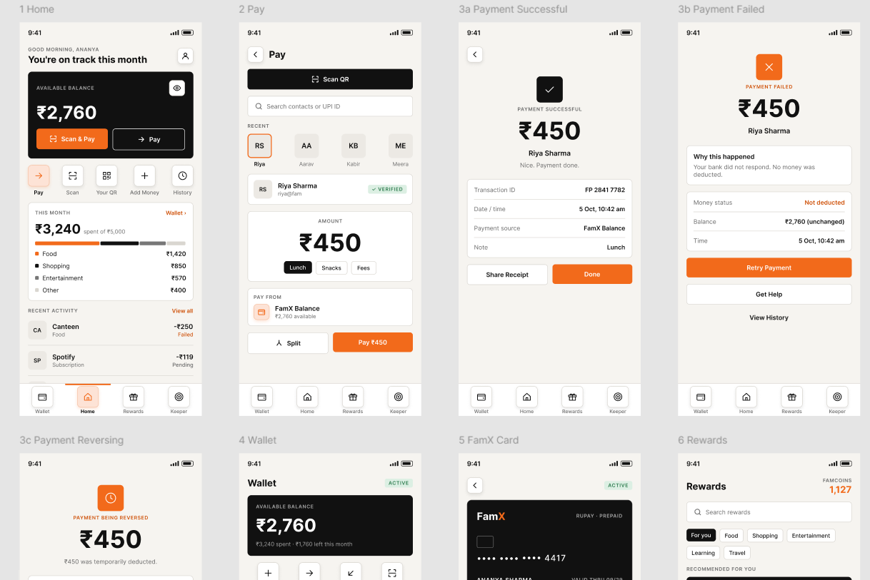
Screenshot 2: Payment Reversing, Wallet, FamX Card, Rewards, Reward Details, Keeper and Profile
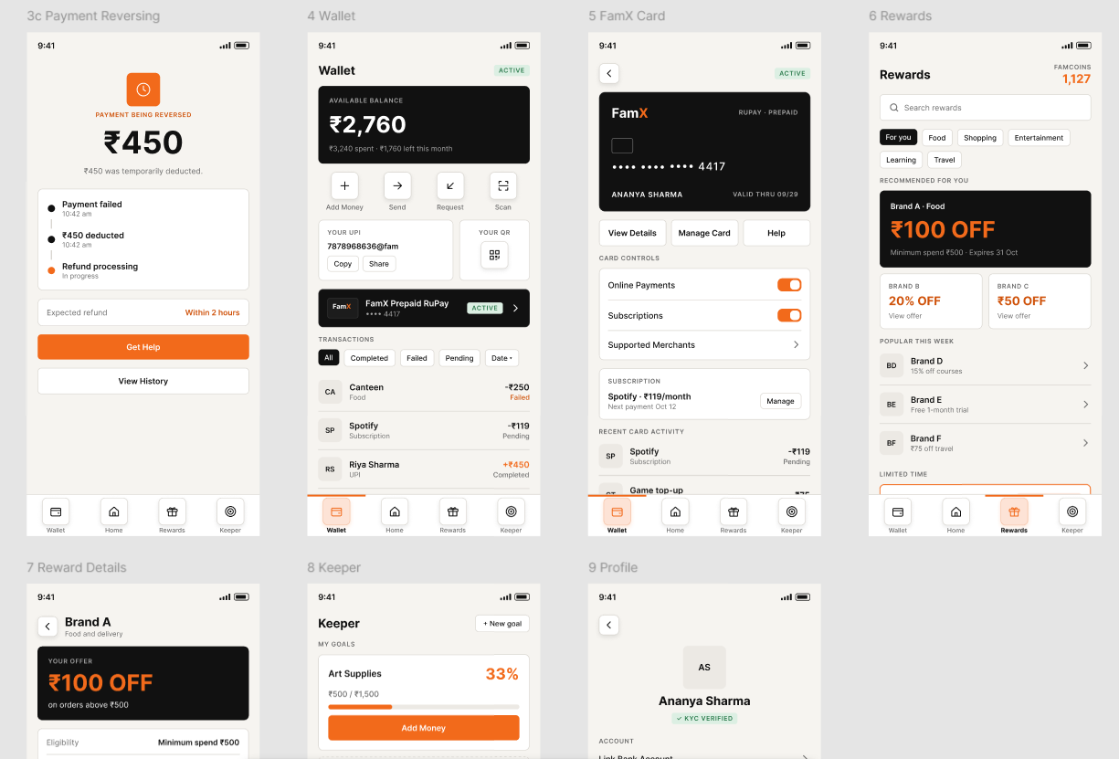
Screenshot 3: Reward Details, Keeper and Profile
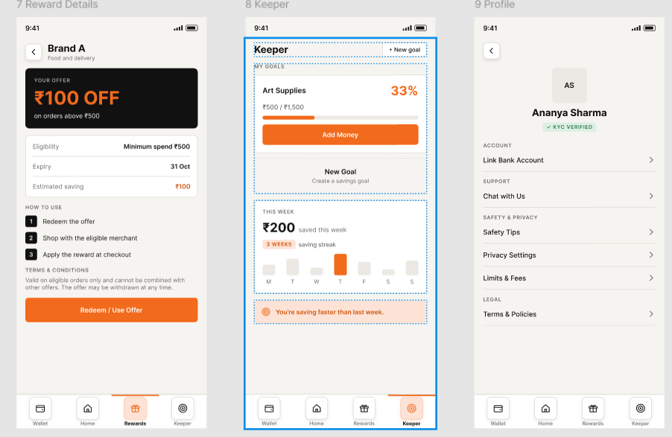
Screenshot 4: Scan QR, Confirm Recipient, Processing and Processing Fail
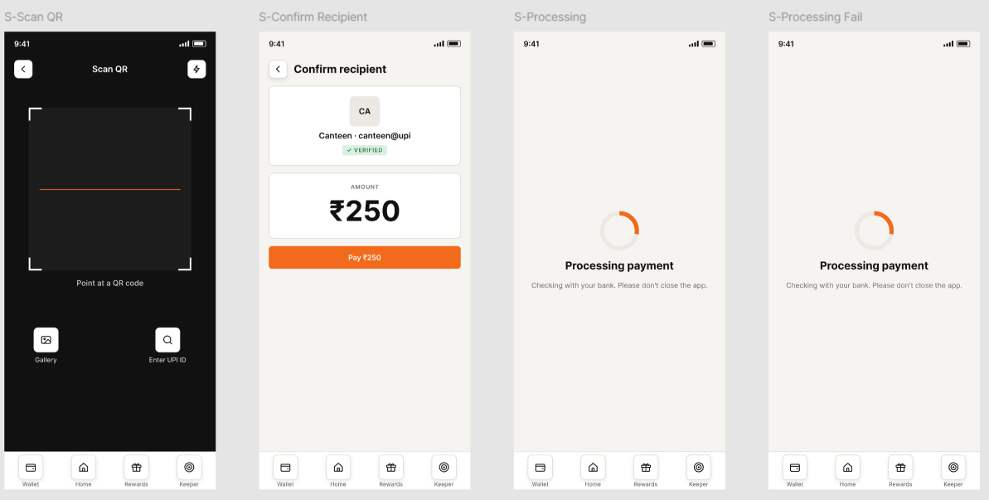
Screenshot 5: Search Contacts, All Transactions, Goal Details and New Goal
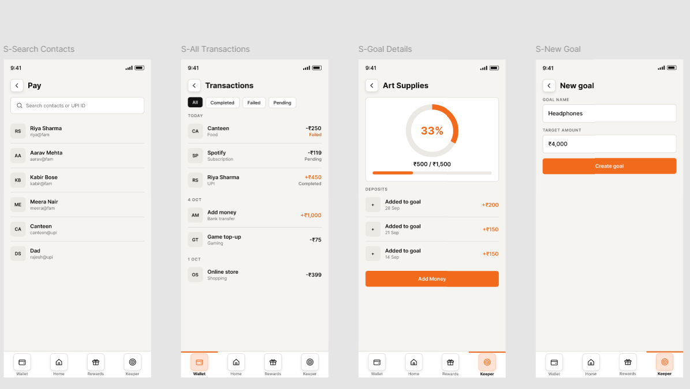
Screenshot 6: Link Bank Account, Chat with Us, Safety Tips and Confirm Payment
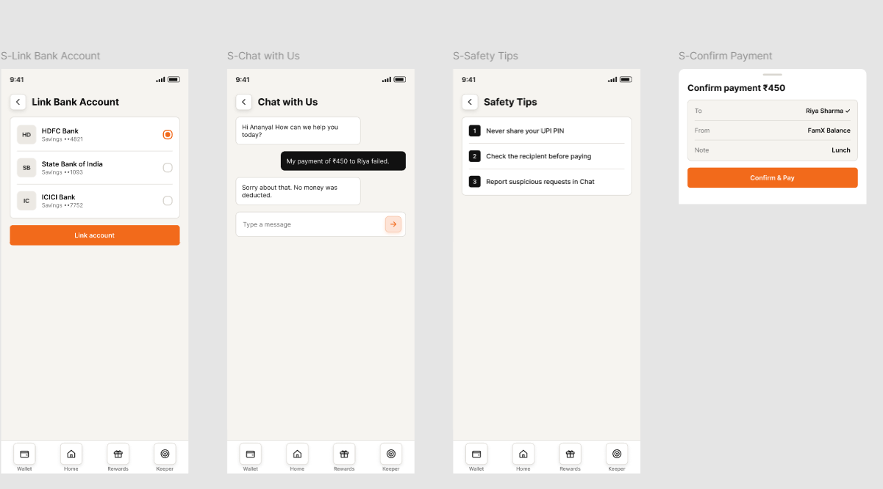
Screenshot 7: Confirm Payment, PIN, Add Money, Share Sheet, Split Bill, Your QR and Card Details sheets
