Slides. Maximum 20 slides

Make sure bring ruler

Q &A

One question, One answer, One person

Concise questions

Facts vs Insights

Judges looking for insights

FactrsL what u have read about the company

Insights: what u read between the lines about the case

What is meant for the business

Fact: Air NZ, different seat classes

Insight: Air NZ segments the market in order to extract more value from those customers who can afford to travel in luxury while satisfying the larger majority of customers.

Finance Tutorial:

1. Current valuation of Company
2. Value of each strategy arm -> how much impact per strategy it can make financially, how much is the implementation of a strategy is gonna cost
3. Other Key metrics: not just dollar amount
4. Time pressure during Preparation

Accounting Basics

1. Balance Sheet A-L = Equity
2. Income Statement (Income- Expenses)

Look at any key trends, look at contrasts

Strategy Valuation

Top Down

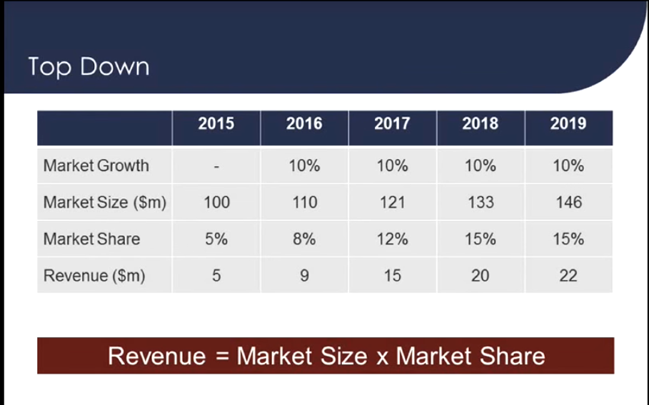

Can make reasonable Assumptions of Market Size

Bottom up

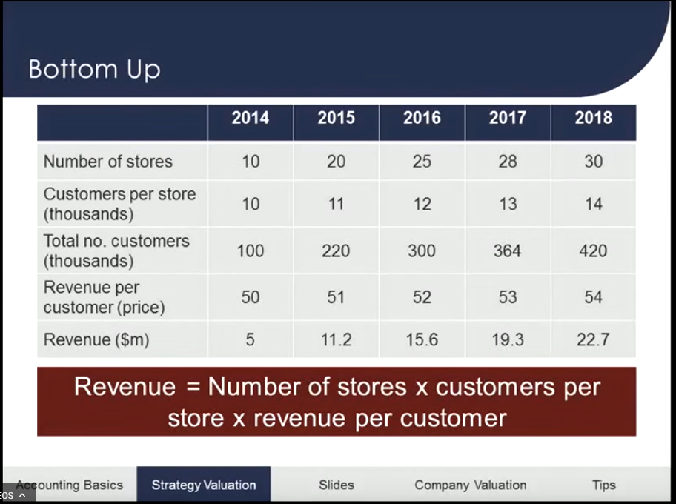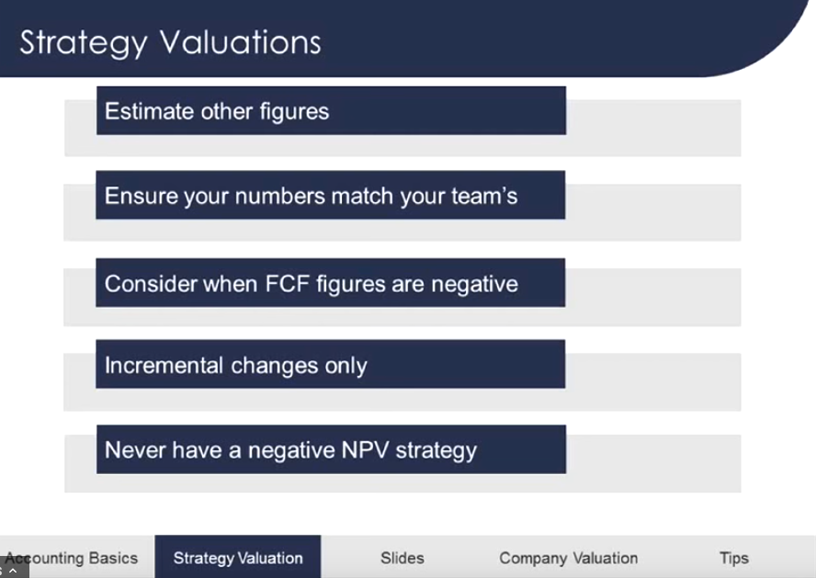

Make sure Future cash flows are positive, ie., costs>revenue

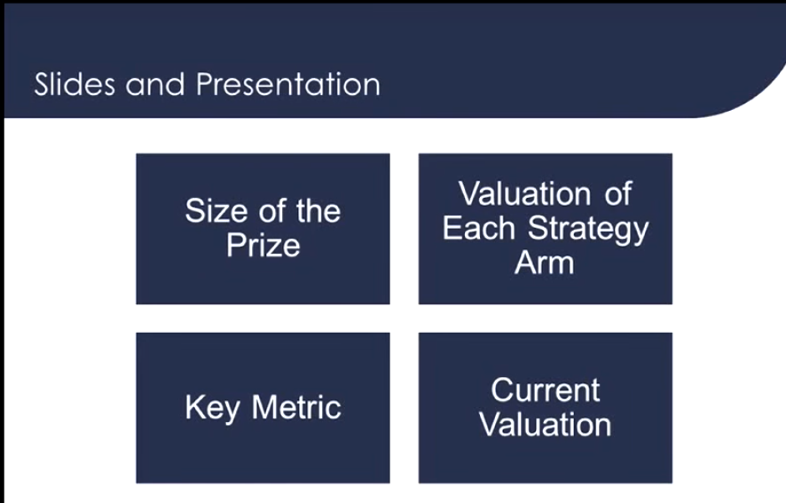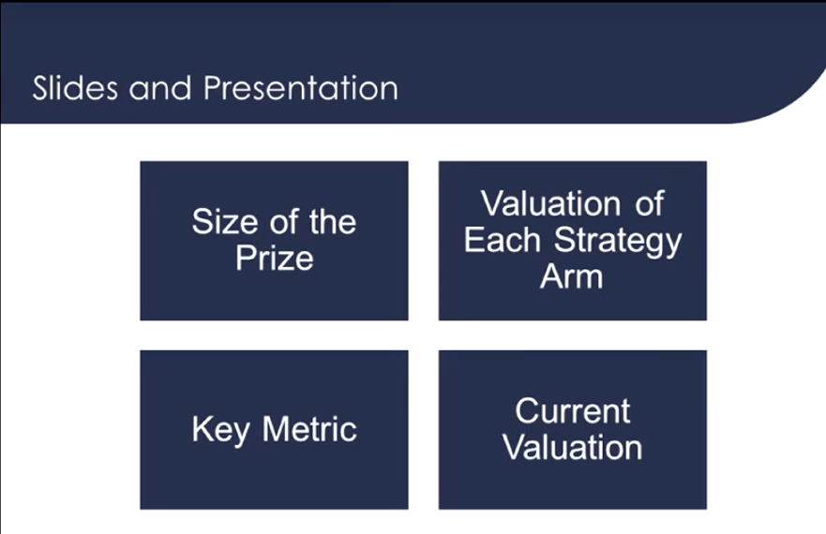

Size of the prize: increase your business to 1billion valuation, or NPV to whatever

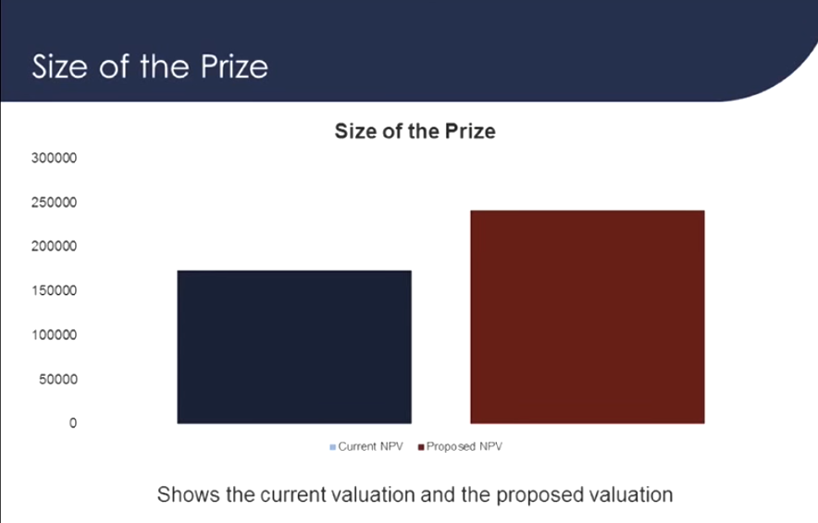

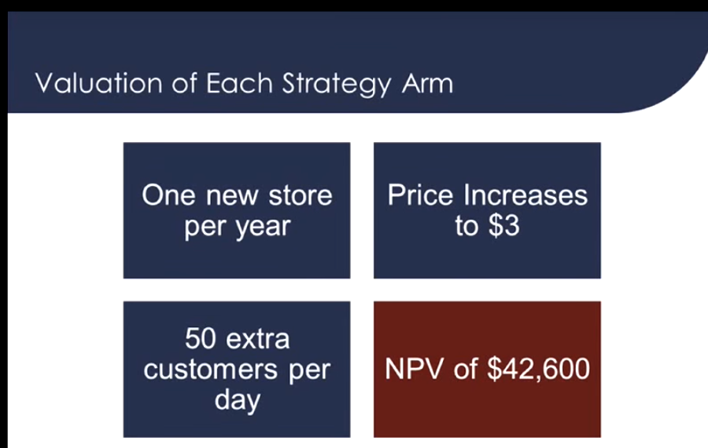

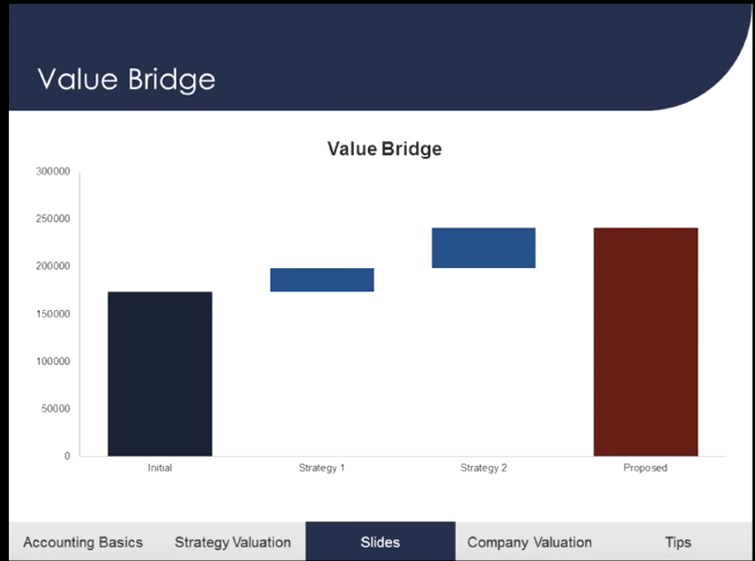

Don’t have to talk about the assumptions

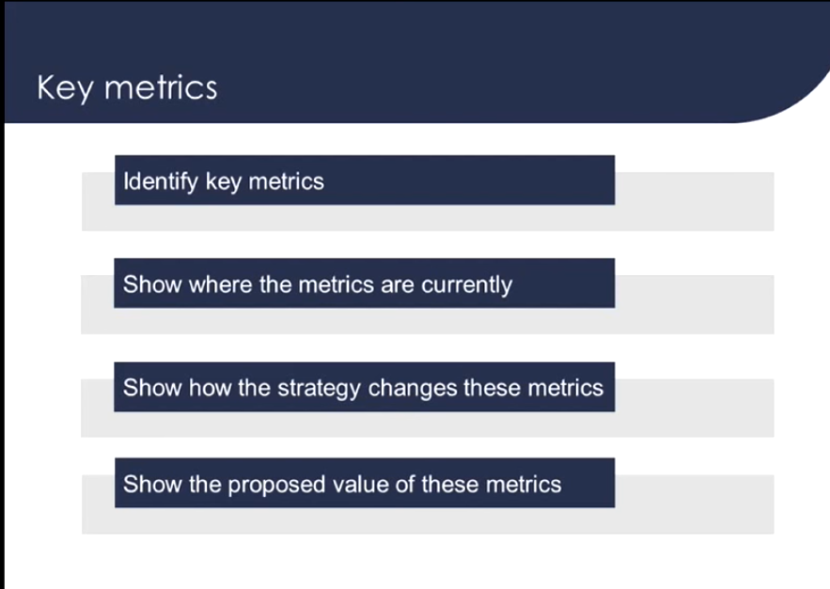

Key metric can be done for each strategy arm

