TIME SERIES ANALYSIS OF MONTHLY CRUDE OIL PRICE IN NIGERIA (FROM 2006 – 2025).

ORJI DOMINION EBUBENNIA
2022/SC/24342

DEPARTMENT OF STATISTICS,
ALEX EKWUEME FEDERAL UNIVERSITY NDUFU-ALIKE.

SEPTEMBER, 2026

TIME SERIES ANALYSIS OF MONTHLY CRUDE OIL PRICE IN NIGERIA (FROM 2006 - 2025).

BY

ORJI DOMINION EBUBENNIA
2022/SC/24342

A PROJECT SUBMITTED TO THE DEPARTMENT OF STATISTICS, ALEX EKWEME FEDERAL UNIVERSTIY NDUFU ALIKE IN PARTIAL FULFILMENT OF THE REQUIREMENT FOR THE AWARD OF BACHELOR OF SCIENCE (B.Sc.) DEGREE IN STATISTICS

SEPTEMBER, 2026

DECLARATION
I, Orji Dominion Ebubennia, an Undergraduate Student in Statistics programme, in the Department of Statistics with Matric No: 2022/SC/24342 declare that the work embodied in this research report is original and has not been submitted in part or in full for any other Degree or Diploma of this University or any other institution of higher learning.

........................................... Date: .................................
Orji Dominion Ebubennia
(Student)

CERTIFICATION
This is to certify that this research titled “Time Series Analysis of Monthly Crude Oil Price in Nigeria (from 2006 - 2025)" was carried out by Orji Dominion Ebubennia with Matric No: 2022/SC/24342 under my supervision in the Department of Statistics Alex-Ekwueme Federal University, Ndufu Alike
.......................................... Date: ……......................
Mr. Chimezie I.E
(Supervisor)

APPROVAL
This research titled “Time Series Analysis of Monthly Crude Oil Price in Nigeria (from 2006 - 2025)” has been assessed and approved by the Department of Statistics and Faculty of Physical Sciences, Alex-Ekwueme Federal University, Ndufu Alike

.......................................... Date: ……......................
Mr. Chimezie I.E
(Supervisor)
........................................... Date: .................................
Dr. E.E Nwezza
(Head of Department)
........................................... Date: .................................
External Examiner
………………………….. Date…………………….
Prof. P.O. Aghamelu
(Dean of Faculty)

DEDICATION
This research work is dedicated to God Almighty for His providence throughout my B.Sc. journey and for his faithfulness during the course of this research work.

ACKNOWLEDGEMENT

I sincerely acknowledge my project supervisor, Mr. Chimezie I. E., for his invaluable guidance, expertise, patience, and commitment toward ensuring the successful completion of this research. His encouragement and constructive contributions throughout the course of this study were instrumental to its success. I would like to express my most sincere gratitude to my beloved parents, Mr. Orji Malachi and Mrs. Orji Ugochi, for their unwavering support, constant prayers, countless sacrifices, and dedication to educating and preparing me for my future. Your love, care, and commitment have been the foundation of my academic journey, and I remain forever grateful. My heartfelt appreciation also goes to Mr. and Mrs. Uduma Ugbu Uduma for their love, support, care, and sacrifices throughout my B.Sc. journey. Your encouragement has been a great source of strength and inspiration. I also sincerely acknowledge the Head of the Department of Statistics, Dr. E. E. Nwezza, and all the lecturers in the Department of Statistics for their dedication, commitment, and relentless efforts toward ensuring the academic growth, welfare, and overall development of Statistics students. My profound gratitude goes to my uncles and aunties for always being available whenever I sought financial assistance and for their willingness to help whenever called upon. I sincerely acknowledge my grandmother, Mrs. Egwu Helen (Ogbo. Helen), for her constant love, encouragement, prayers, and support throughout my B.Sc. journey.

I specially acknowledge Mrs. Eze Roseline (Ogbo. Rose) for her unwavering support and encouragement throughout my B.Sc. journey. I am sincerely grateful to my uncle, Mr. Egwu Gabriel, for his support in my academic pursuit as a whole. I also sincerely acknowledge Mr. and Mrs. Eze Ferdinand for their constant support, encouragement, kindness, and generosity throughout my B.Sc. journey. I’m grateful to my siblings for their constant encouragement and unwavering belief in me throughout this journey. I hope this achievement serves as a reminder that whatever they set their minds to is achievable through God's grace, determination, perseverance, and hard work.

I am equally grateful to my course mates, especially Anyanwu Victor, for always being available whenever I sought academic assistance and for their willingness to help whenever called upon. Your cooperation, encouragement, and shared knowledge made this journey more meaningful. Finally, I sincerely acknowledge my dear friends I. G. Gladys, Eze Sylvanus, Chris Word, Ibeawuchi Anthony, Nwedo Hillary, Achionye Victor, Nweze Benedict, Humphery Chinaza, Ugochi Igwele, Oko Ugochi, and Orji Elizabeth and everyone who, in one way or another, stood by me during my B.Sc. days. Your love, friendship, encouragement, support, and kindness have contributed immensely to my journey. I truly love and appreciate every one of you.

Above all, I return all glory, honour, and thanksgiving to Almighty God for His grace, mercy, divine protection, wisdom, strength, and unfailing faithfulness throughout my academic journey. Without Him, this achievement would not have been possible.

Table of Contents
COVER PAGE
TITLE PAGE
DECLARATION iii
CERTIFICATION iv
APPROVAL v
DEDICATION vi
ACKNOWLEDGEMENT vii
LIST OF TABLES xi
LIST OF FIGURES xii
NOTATIONS AND ACRONYMS xiii
ABSTRACT xv
CHAPTER ONE 1
INTRODUCTION 1
1.0 Background of the Study 1
1.1 Statement of Problem 2
1.2 Aim and Objectives 2
1.3 Significance of the Study 2
1.4 Scope and Limitations of the Study 3
1.5 Definition of Terms 3
CHAPTER TWO 5
LITERATURE REVIEW 5
2.1 Conceptual Review 5
2.2 Conceptual Review about Crude Oil Price 6
2.3 Empirical Review 6
2.3.1 Application of ARIMA to Crude oil price Data 7
2.3.2 Empirical Studies on Crude Oil Price Trends and Patterns 7
2.4 Literature Gap 9
CHAPTER THREE 10
METHODOLOGY 10
3.1 Data Source and Description 10
3.2 Model Specification 10
3.2.1 The ARIMA Model 10
3.4 Model Identification 12
3.5 Model Selection and Diagnostic Checking 12
3.6 Residual Diagnostic Checking 12
3.7 Forecast Evaluation 12
3.8 Assumptions of the ARIMA Model and Implications 13
CHAPTER FOUR 14
RESULT OF DATA ANALYSIS AND DISCUSSION OF RESULTS. 14
4.1 Descriptive Statistics of Monthly Crude Oil Prices 14
4.2 Analysis of Trends and Patterns in Crude Oil Prices 15
4.2.1 Time Series Plot 15
4.2.2 Checking for Seasonality in the Series 16
4.2.3 Classical Decomposition 17
4.2.4 Annual Average Crude Oil Prices 18
4.2.5 Distribution of Monthly Crude Oil Prices 19
4.3 Stationarity Analysis of the Crude Oil Price Series 20
4.3.1 Visual Assessment of Stationarity 20
4.3.2 Formal Stationarity Tests 21
4.3.3 ACF and PACF Analysis 21
4.4 ARIMA Model Identification, Estimation, and Fitting 22
4.4.1 Model Identification and Selection 23
4.4.2 Estimated Model Parameters 23
4.4.3 In-Sample Fitted Values 24
4.4.4 Out-of-Sample Forecast (2023–2025) 25
4.5 Model Performance and Adequacy Evaluation 26
4.5.1 Residual Diagnostic Plots 26
4.5.2 Ljung–Box Test for Residual Autocorrelation 27
4.5.3 Full Overview of Fitted and Forecast Values 28
4.5.4 Model Adequacy Summary 29
4.6 Discussion of Results 29
CHAPTER FIVE 31
SUMMARY, CONCLUSION AND RECOMMENDATIONS 31
5.1 Summary 31
5.2 Conclusion 32
5.3 Recommendations 33
REFERENCE 34
APPENDICES 36
APPENDIX I – Nigeria Crude Oil Price data (from 2006 – 2025) 36
APPENDIX II – Python Code used for the analysis 44

LIST OF TABLES
Table 4.1 : Descriptive Statistics of Monthly Crude Oil Prices (2006–2025) 16
Table 4.2 : Stationarity Test Results for Crude Oil Price Series 24
Table 4.3: Candidate ARIMA Model Comparison 26
Table 4.4: ARIMA (2,1,1) Parameter Estimates 27
Table 4.5: Forecast Accuracy Metrics for ARIMA (2,1,1) 29
Table 4.6: Ljung–Box Test Results on Model Residuals 32
Table 4.7: Model Adequacy Checklist for ARIMA (2,1,1) 33

LIST OF FIGURES
Figure 4.1: Monthly Crude Oil Prices in Nigeria (2006-2025) 18
Figure 4.2: Seasonal Box Plot - Crude Oil Prices by Month of the Year 19
Figure 4.3: Classical Additive Decomposition of Monthly Crude Oil Prices 20
Figure 4.4: Annual Average Crude Oil Prices in Nigeria (2006-2025) 21
Figure 4.5: Distribution of Monthly Crude Oil Prices with Kernel Density Estimate 22
Figure 4.6: Original Series (top) and First-Differenced Series (bottom) 23
Figure 4.7 : ACF and PACF Plots for the Original (top) and First-Differenced (bottom) Series 25
Figure 4.8 :ARIMA (2,1,1) - Observed vs. In-Sample Fitted Values (2006-2022) 28
Figure 4.9 ARIMA (2,1,1) - Out-of-Sample Forecast vs. Actual Prices (2023-2025) 29
Figure 4.10 Residual Diagnostic Plots - ARIMA (2,1,1) 31
Figure 4.11 ARIMA (2,1,1) - Full Overview of Observed, Fitted, and Forecast Values (2006-2025) 33

NOTATIONS AND ACRONYMS

ACF Autocorrelation Function
ADF Augmented Dickey-Fuller (test)
AIC Akaike Information Criterion
AR Autoregressive
ARIMA Autoregressive Integrated Moving Average
BIC Bayesian Information Criterion
CBN Central Bank of Nigeria
I(1) Integrated of Order One
KPSS Kwiatkowski-Phillips-Schmidt-Shin (test)
MA Moving Average
MAE Mean Absolute Error
MAPE Mean Absolute Percentage Error
OPEC Organization of Petroleum Exporting Countries
PACF Partial Autocorrelation Function
RMSE Root Mean Square Error
USD United States Dollar
α Significance level
Δ First difference operator
ε_{t} White noise error term at time t
φ(L) Autoregressive polynomial in lag operator L
θ(L) Moving average polynomial in lag operator L
ρ_{k} Sample autocorrelation at lag k
σ² Variance of the error process
μ Mean of the stationary process
γ_{k} Autocovariance at lag k
H₀ Null hypothesis
H₁ Alternative hypothesis

ABSTRACT
This study aimed to conduct a time-series analysis of monthly crude oil price in Nigeria from 2006 - 2025. The data consists of 239 monthly observations on crude oil prices obtained from the Central Bank of Nigeria. The objectives were to examine the trends and patterns in monthly crude oil prices, test for stationarity, fit an appropriate ARIMA model, and evaluate the adequacy and forecasting performance of the fitted model. The time series plot identified four major price phases driven by the 2008 commodity boom, the Global Financial Crisis, the 2014-2016 supply glut, and the COVID-19 pandemic crash followed by the 2022 Russia-Ukraine driven surge. Seasonal box plots and classical additive decomposition suggested no systematic calendar seasonality. The Augmented Dickey-Fuller (ADF) and Kwiatkowski-Phillips-Schmidt-Shin (KPSS) tests showed that the series is Integrated of order one, I(1) and needs to be first differenced to be stationary. A grid search over candidate ARIMA (p,1,q) specifications, guided by the AIC, revealed that the ARIMA (2,1,1) best fit the data, both autoregressive parameters being significant at the 1% level. The Ljung–Box test indicates that the residuals of the model are consistent with a white noise process, with p-values greater than 0.94 at all tested lag orders. Out-of-sample evaluation on the hold-out period (January 2023 - November 2025) yielded a Mean Absolute Percentage Error (MAPE) of 8.49% and a Root Mean Square Error (RMSE) of 8.46, signifying a forecasting accuracy of approximately 91.5%. It is recommended that the Central Bank of Nigeria and economic planners should utilize the ARIMA (2,1,1) Framework for short term crude oil price forecasting to support fiscal planning and that future research should expand on this work by incorporating GARCH-type volatility models to account for the heteroscedasticity of the residuals of the crude oil prices.

CHAPTER ONE

INTRODUCTION
- Background of the Study
The analysis of time series data plays a crucial role in understanding the behavior, trends, and fluctuations of key economic variables over time. Time-series techniques are widely used in economics to model trends, detect patterns, and forecast future movements because many economic indicators naturally evolve over time and exhibit characteristics such as persistence, cycles, and structural breaks (Kleiber & Zeileis, 2017). In oil-dependent economies like Nigeria, examining crude oil prices using time series methods provides valuable insights into the dynamics of the oil sector and its implications for macroeconomic stability and economic planning.
Nigeria is Africa’s largest crude oil producer and a significant exporter within the Organization of Petroleum Exporting Countries (OPEC), with production levels exceeding 1.7 million barrels per day in recent years (Reuters, 2025). Crude oil remains a dominant source of government revenue and foreign exchange earnings; therefore, the country’s economic performance is highly sensitive to movements in international oil prices.
Crude oil price levels are inherently dynamic, exhibiting trends, cycles, and structural changes driven by global economic conditions, policy shifts, and supply disruptions. Traditional static analytical approaches are often inadequate to capture these evolving patterns. Time series analysis, therefore, provides a suitable framework for modeling and understanding the behavior of oil price data. Previous studies have applied these techniques to Nigeria’s oil sector to investigate volatility and interdependencies using autoregressive and heteroscedasticity-based models (Ehogela et al., 2025; Ladan et al., 2025). However, there is still a need for more recent, country-specific studies that examine the patterns and dynamics of monthly crude oil prices in Nigeria, particularly in the context of recent market shocks such as global recessions, price collapses, and production disruptions.
This study seeks to fill that gap by applying time-series techniques to monthly crude oil price data for the period 2006 - 2025. It does so by identifying trends, seasonal patterns, and structural changes in the series, and by fitting appropriate models that can accurately represent and forecast this variable. Insights of this analysis can guide policymakers and planners in managing Nigeria’s oil dependent economy.

1.1 Statement of Problem
The problem this study addresses is the lack of a comprehensive long-term time-series analysis that systematically examines the trends, patterns, and statistical properties of monthly crude oil prices in Nigeria from 2006 to 2025. Although oil price volatility is widely acknowledged (Bello, 2021; Idris, 2024), existing studies have largely focused on macroeconomic impacts or short-term assessments, with limited attention to the time-series behavior of monthly data (Oladipo, 2023). Consequently, there is insufficient empirical evidence on the stationarity and appropriate modeling of these variables. This gap necessitates a structured time-series investigation using ARIMA techniques to statistically analyze the dynamic behavior of this variable.

1.2 Aim and Objectives
The aim of this study is to conduct a time-series analysis of monthly crude oil price in Nigeria from 2006 - 2025. The specific objectives of the study are to:
- To Examine the trends and patterns in monthly crude oil price over the period 2006 - 2025.
- To Examine the time-series data of monthly crude oil price for stationarity.
- To Fit an ARIMA model to the monthly crude oil price series.
- To Evaluate the performance and adequacy of the fitted ARIMA model.

1.3 Significance of the Study
This study provides a statistical understanding of the behavior of monthly crude oil price in Nigeria over the period 2006 - 2025. Since crude oil remains Nigeria’s major source of revenue, analyzing its price at a monthly level captures short-term fluctuations and long-term trends that are often hidden in annual data. It contributes to economic planning and revenue forecasting by providing insights that can support more accurate budget projections and fiscal planning. Policymakers and economic planners can benefit from understanding how these variables behave over time, particularly during periods of volatility.
The study also demonstrates the practical application of time-series analysis using the Auto-Regressive Integrated Moving Average (ARIMA) model. By using tools such as Auto-Correlation Function (ACF), Partial Auto-Correlation Function (PACF), Akaike Information Criterion (AIC), and Root Mean Square Error (RMSE), it shows how non-stationary economic data can be properly modeled and evaluated, making it useful to students and researchers interested in applied time-series modeling. The findings are relevant to investors and stakeholders in the oil sector. Analysis and forecasts of monthly crude oil price can assist in risk assessment and decision-making, offering a more reliable basis for planning than historical averages or descriptive summaries. This research also provides an organized analysis of nearly two decades of monthly crude oil price data in Nigeria, offering a detailed empirical record that can serve as a reference for future studies in energy economics and applied statistics.

1.4 Scope and Limitations of the Study
This study focuses on the time-series analysis of monthly crude oil price in Nigeria from 2006 - 2025. The study applies the ARIMA modeling framework to examine trends, test for stationarity, and generate forecasts based on historical patterns. This Study is Limited to monthly crude oil price data obtained from the Central Bank of Nigeria for the period of 2026 – 2025.

1.5 Definition of Terms
Barrel: A standard unit of measurement used in the petroleum industry, equivalent to 42 US gallons (approximately 159 liters), used to quantify crude oil production and pricing.
Crude Oil Price: The average monthly market price of crude oil, measured in US dollars per barrel, as used in this study for the period 2006–2025.
Time-Series Data: A set of observations recorded sequentially over time at equal time intervals. In this study, the data are monthly crude oil price and production figures.
Stationarity: A property of a time series where its statistical characteristics, such as mean and variance, remain constant over time.
Autocorrelation Function (ACF): A statistical tool used to measure the relationship between current values of a time series and its past values at different time lags.
Partial Autocorrelation Function (PACF): A statistical method used to measure the direct relationship between a time series and its lagged values after removing the effects of intermediate lags.
ARIMA Model: An Autoregressive Integrated Moving Average model used for analyzing and forecasting time-series data based on past values and past errors.
Model Evaluation Criteria: Statistical measures such as Akaike Information Criterion (AIC) and Root Mean Square Error (RMSE) used to assess the adequacy and performance of the fitted ARIMA model.

CHAPTER TWO

LITERATURE REVIEW

2.1 Conceptual Review
Time-series analysis is a statistical method used to examine data collected at successive time intervals. It helps identify trends, cycles, seasonal patterns, and structural breaks in the data (Box, Jenkins & Reinsel, 2015; Enders, 2014). Many economic variables, particularly energy-related data, exhibit time-dependent behavior, making time-series techniques suitable for analysis and forecasting (Gujarati & Porter, 2009; Chatfield, 2016).
Given the time-dependent nature of crude oil price data, the Auto-Regressive Integrated Moving Average (ARIMA) model is one of the most commonly used models in time-series analysis (Box, Jenkins & Reinsel, 2015; Brockwell & Davis, 2016). It captures linear relationships in data and is effective for forecasting non-stationary series after appropriate differencing. The model consists of the autoregressive (AR) component, the moving average (MA) component, and the integration (I) component, which ensures stationarity (Brockwell & Davis, 2016; Enders, 2014).
Stationarity is a key requirement in ARIMA modeling, meaning that the series has a constant mean and variance over time. Stationarity can be assessed graphically by plotting the series to detect trends or changing variance (Box, Jenkins & Reinsel, 2015; Enders, 2014). The Augmented Dickey-Fuller (ADF) test is a formal statistical method that provides an objective confirmation of stationarity, although graphical methods often serve as an initial check (Dickey & Fuller, 1979; Enders, 2014).
The Auto-Correlation Function (ACF) and Partial Auto-Correlation Function (PACF) are tools used in time-series analysis to understand correlations in data across different time lags, which conceptually help determine the appropriate AR and MA components in ARIMA modeling (Brockwell & Davis, 2016; Chatfield, 2016). The Akaike Information Criterion (AIC) is a measure used to compare models by balancing fit and complexity, while the Root Mean Square Error (RMSE) measures the accuracy of model forecasts (Akaike, 1974; Hyndman & Athanasopoulos, 2018). These concepts are fundamental to ARIMA modeling and provide a theoretical basis for selecting and evaluating models in practice. The ARIMA model’s ability to account for autocorrelation and non-stationarity makes it particularly suitable for modeling monthly crude oil price data in Nigeria (Ladan et al., 2025; Kelechi et al., 2023). This conceptual foundation underpins the methods used in this study and demonstrates why high-frequency data are necessary to capture short-term shocks and long-term trends.

2.2 Conceptual Review about Crude Oil Price
Crude oil price refers to the market value of crude oil, typically expressed in United States dollars per barrel. It is Primarily determined by global supply and demand conditions, geopolitical developments, production decisions by oil-producing countries and organizations such as OPEC, as well as macroeconomic factors including exchange rates and the global economic growth (Hamilton, 2009; Kilian, 2008). Crude oil prices are characterized by high volatility due to their sensitivity to external shocks such as financial crises, political instability, and changes in energy policies (Kilian, 2008). In oil-dependent economies like Nigeria, fluctuations in crude oil prices have significant implications for government revenue, foreign exchange earnings, and overall economic stability. As a result, crude oil price exhibits dynamic behavior over time, making it suitable for time-series analysis aimed at identifying trends, patterns, and forecasting future movements.

2.3 Empirical Review
Empirical studies on crude oil price have consistently shown the importance of analyzing monthly data to understand both short-term fluctuations and long-term trends. Many researchers have applied time-series techniques, particularly ARIMA models, to capture the dynamic behavior of crude prices and provide reliable forecasts for policymakers, investors, and planners. In Nigeria, studies have shown that analyzing monthly crude oil price data provides more detailed insights than relying on annual averages, which often hide sudden changes or temporary shocks in the market (Ladan et al., 2025; Kelechi et al., 2023; Ehogela et al., 2025). Internationally, ARIMA and related models have also been used to study crude oil price movements, showing their ability to handle autocorrelation, non-stationarity, and seasonal effects in time-series data (Farhan & Ong, 2016; Mombeni et al., 2013).
Looking at the literature as a whole, two main points stand out. Firstly, there is vast research on how ARIMA models are applied to analyze crude oil price, helping to identify trends, seasonal patterns, and irregular movements. Secondly, studies examine the factors affecting crude oil prices, such as global supply and demand dynamics, geopolitical developments, and macroeconomics conditions, which help explain price fluctuation over time. These findings highlight the need for monthly data and time-series models to accurately understand the behavior of crude oil markets, especially in volatile economies like Nigeria (Hyndman R. J., & Athanasopoulos G. (2018)).
2.3.1 Application of ARIMA to Crude oil price Data
Several empirical studies have applied ARIMA and related models to crude oil and energy data. In Nigeria, Ladan et al. (2025) analyzed monthly crude oil price data from 2005 to 2022 and identified ARIMA (1,1,1) as the most suitable model for forecasting price trends, capturing periods of decline and gradual recovery. Kelechi et al. (2023) similarly reported that ARIMA models effectively captured both short-term fluctuations and long-term movements in crude oil prices. Usoro and Emmanuel (2022) employed multivariate time-series techniques to examine volatility in crude oil prices, showing that accounting for autocorrelation and non-stationarity improves forecast accuracy and reliability.
International studies also confirm the usefulness of ARIMA-based models in energy analysis. Farhan and Ong (2016) applied ARIMA models to energy demand series, while Mombeni et al. (2013) focused on price series, both showing that these models can successfully account for trends, seasonality, and irregular patterns in time-dependent data. Collectively, these studies emphasize that ARIMA models are highly effective in modeling dynamic energy variables and producing forecasts that are valuable for economic planning and risk assessment.

2.3.2 Empirical Studies on Crude Oil Price Trends and Patterns
Empirical studies have shown that crude oil prices exhibit complex patterns characterized by long-term trends, short-term fluctuations, volatility, and responses to economic and geopolitical events. Understanding these patterns is important because crude oil prices influence economic growth, government revenue, inflation, and energy policy, particularly in oil-dependent economies.
In Nigeria, Suleiman et al. (2023) examined monthly crude oil price data from 2006 to 2020 and reported that crude oil prices displayed both persistent long-term movements and short-term fluctuations. Their findings suggest that oil prices are influenced by underlying market forces that generate dynamic changes over time. Similarly, Chamalwa, Abdulsalam, and Abbas (2024) observed that Nigerian crude oil prices exhibited temporal dependence, indicating that current price movements were influenced by previous price behavior. This finding highlights the tendency of crude oil prices to follow identifiable patterns over time.
Comparative studies have also explored the dynamics of crude oil prices using alternative modelling approaches. Atanu, Ette, and Amos (2021) found that crude oil prices were characterized by both changing trends and volatility, suggesting that price movements are affected by market uncertainty and external shocks. Their study emphasized the importance of accounting for fluctuations in price variability when analyzing oil market behavior. Likewise, Adewara, Adejumo, and Kalu (2025) reported evidence of short-term persistence in Nigerian crude oil prices, indicating that recent price changes can influence subsequent market movements.
Evidence from other commodity markets reveals similar price characteristics. Mutwiri (2019) found that tomato prices in Nairobi exhibited both seasonal and trend patterns, reflecting the influence of production cycles and market conditions on commodity prices. Similarly, Okello (2023) observed that fertilizer prices displayed seasonal movements and volatility, demonstrating how external factors and market conditions can shape commodity price behavior over time.
Studies from broader economic contexts further confirm the importance of time-series analysis in understanding price dynamics. Research on food and beverage price indices has shown that consumer prices often exhibit long-term trends, seasonal variations, and irregular shocks. Similarly, Hamilton (2009) and Kilian (2008) demonstrated that fluctuations in crude oil prices can significantly influence inflation dynamics and broader macroeconomic indicators, highlighting the far-reaching effects of oil price movements on economi8 performance.
Collectively, these studies indicate that crude oil and other commodity prices exhibit identifiable patterns, including trends, volatility, persistence, seasonality, and responses to external shocks. Understanding these characteristics is essential for effective forecasting, policy formulation, and economic planning, thereby providing a strong basis for the application of time-series techniques in the analysis of crude oil prices.

2.4 Literature Gap
There is currently no agreement on the best ARIMA specification, with several studies reporting different optimal models, despite the fact that some studies have used ARIMA models to Study Nigeria crude oil prices. This difference suggests that the market conditions and the period of analysis might influence the performance of the models. Thus, further investigation is required with updated data to re-examine the behavior of crude oil prices and to find the most appropriate ARIMA model for forecasting purposes.

CHAPTER THREE

METHODOLOGY
This study adopts a quantitative research design using time-series econometric techniques. The Autoregressive Integrated Moving Average (ARIMA) framework developed by Box and Jenkins (1970) is employed to model the stochastic behavior of monthly crude oil price in Nigeria. The methodology aligns with the objectives of the study, which are to examine trends, test stationarity, fit ARIMA model, and evaluate the performance and adequacy of the fitted model over the period 2006-2025.

3.1 Data Source and Description
The study used secondary monthly data on crude oil price (measured in US dollars per barrel) in Nigeria covering the period 2006-2025. The data were sourced from the statistical publications of the Central Bank of Nigeria. Monthly data are adopted to capture short-run dynamics, seasonal fluctuations, and long-run movements in the series.
Let:
Y_{t} = Crude Oil Price at time t

3.2 Model Specification

3.2.1 The ARIMA Model
The Autoregressive Integrated Moving Average (ARIMA) model is used to model the stochastic behavior of time-series data. The general ARIMA (p, d, q) model is expressed as:
$ϕ(L) {(1−L)}^{d}Y_{t} = θ(L)ε_{t}$ (3.1)
Where:
L = Lag operator
d = Order of differencing
ε_{t} = White noise error term.
The Autoregressive and moving average polynomials are defined as:
$θ(L) = 1 + θ_{1}L +θ_{2} L^{2} + ⋯ + θ_{q}L^{q}$ (3.2)
In expanded form (Box & Jenkins, 1970), the model is written as:
$Y_{t }=ϕ_{1} Y_{t−1 }+ ϕ_{2}Y_{t−2}+ ⋯ +ϕ_{p} Y_{t−p} + e_{t} −θ_{1} e_{t−1 }− ⋯ − θqe_{t}​−q​.$(3.3)
Where:
p = Order of autoregression
d = Degree of differencing
q = Order of moving average
The modeling procedure follows the Box–Jenkins methodology: identification, estimation, diagnostic checking, and forecasting (Box & Jenkins, 1970).

3.2.2 Assumptions of the ARIMA Model and Implications
1. White Noise Error Process:
ε_{t} ~ WN (0, σ²), such that E(ε_{t}) = 0, Var(ε_{t}) = σ², and Cov (ε_{t}, ε_{t−k}) = 0 for k ≠ 0.
2. Normality of Errors: ε_{t} ~ N (0, σ²).
3. Linearity: The relationship Y_{t} = ϕ₁Y_{t−1} + ⋯ + e_{t} − θ_{q}e_{t−q} is assumed to be linear.
4. Stability Condition:
The autoregressive polynomial ϕ(L) must satisfy |L_{i}| > 1 for all roots L_{i} of ϕ(L) = 0.

3.3 Stationarity Test
To examine the stationarity properties of the time-series, the Augmented Dickey-Fuller (ADF) test will be employed (Dickey & Fuller, 1979, 1981). The ADF regression equation is specified as:
$ΔY_{t}​=α+β_{t}+γY_{t−1}​=\sum_{i=1}^{k}{δ_{i}​ΔY_{t−i}​}+ε_{t​}$ (3.4)
Where:
Δ = First difference operator
t = Time trend
k = Lag length
ε_{t} = White noise error term
The hypotheses for the test are:
H₀: γ = 0 (Unit root / non-stationary)
H₁: γ < 0 (Stationary)
Since the series was non-stationary at level, first differencing was applied to achieve stationarity. For the stationary process $Δ^{d}Y_{t}$, the following conditions hold:
$E(Δ^{d}Y_{t}) = μ$ (3.5)
$Var(Δ^{d}Y_{t}) = σ^{2} < ∞$ (3.6)
$Cov (Δ^{d}Y_{t},Δ^{d}Y_{t−k}) =γk​$ (3.7)

3.4 Model Identification
Model identification was guided by:
Auto-Correlation Function (ACF)
Partial Auto-Correlation Function (PACF)
The sample autocorrelation at lag k is given by:
$ρ_{ₖ} = \frac{\sum_{t=1}^{n−k}{ (Yₜ − ȳ)(Yₜ₊ₖ − ȳ)}}{\sum_{t=1}^{n}{(Yₜ − ȳ)²}}$ (3.8)
The PACF measures the partial correlation between Y_{t} and Y_{t+k} after controlling for the effects of intermediate lags. The Patterns of ACF and PACF will be used determine the appropriate values of p and q for the ARIMA model.

3.5 Model Selection and Diagnostic Checking
The Akaike Information Criterion (AIC) (Akaike, 1974) will be used for model selection:
AIC = -2ln(L) + 2k (3.9)
Where:
L = likelihood function
K = number of estimated parameters.
The model with the lowest AIC will be selected as the preferred model.

3.6 Residual Diagnostic Checking
Residual diagnostics will include the Ljung–Box Q-statistic (Ljung & Box, 1978):
$Q=n(n+2)\sum_{k=1}^{h}{\frac{\hat{p}k^{2}}{n−k}}$ (3.10)
Where n is the sample size and ρ^{k} is the residual autocorrelation.
The null hypothesis is: H₀: ρ¹ = ρ² = ⋯ = ρ^{h} = 0

3.7 Forecast Evaluation
Forecast accuracy will be evaluated using Root Mean Square Error (RMSE):
$RMSE = \sqrt{\frac{1}{n}\sum_{t=1}^{n}{{\left(Y_{t} − \hat{Y}\right)}^{2}}}$ (3.11)

CHAPTER FOUR

RESULT OF DATA ANALYSIS AND DISCUSSION OF RESULTS.
This chapter presents the results of the time series analysis of monthly crude oil prices in Nigeria from January 2006 to November 2025. The analysis is organized to address each of the following sequentially: beginning with an examination of trends and patterns, followed by stationarity testing, ARIMA model fitting, and finally model evaluation and diagnostic checking.

4.1 Descriptive Statistics of Monthly Crude Oil Prices
Table 4.1 below provides the summary descriptive statistics of the monthly crude oil prices for the study period. The data set includes 239 monthly observations from January 2006 to November 2025.
Table 4.1 : Descriptive Statistics of Monthly Crude Oil Prices (2006–2025)
Statistics | Value
Number of Observations | 239
Study Period | January 2006 - November 2025
Mean (USD per barrel) | 78.59
Median (USD per barrel) | 75.15
Standard Deviation | 24.57
Minimum | $14.28 per barrel (April 2020, COVID-19 pandemic)
Maximum | $138.74 per barrel (June 2008, global commodity boom)
Skewness | 0.2324
Kurtosis | -0.6177
From Table 4.1 above, The mean crude oil price over the study period is $78.59 per barrel, with a standard deviation of $24.57. This is a relatively high standard deviation of approximately 31% of the mean. This is indicative of the high level of price volatility that exists in the world crude oil markets. The series dropped to $14.28 a barrel in April 2020 as global energy demand collapsed in an unprecedented manner due to the COVID-19 pandemic. Its all-time high, $138.74 per barrel, was set in June 2008, amid strong global economic growth and rising commodity demand before the Global Financial Crisis. The median price of $75.15 per barrel is close to the mean, indicating a reasonably symmetric distribution. The positive skewness coefficient of 0.2324 indicates a slight right-skewed distribution, meaning that unusually high prices occur slightly more often than unusually low ones. The kurtosis value of -0.6177 indicates that the distribution is platykurtic, that is, slightly flatter than a normal distribution, with prices spread broadly across the range rather than concentrated sharply around the average.

4.2 Analysis of Trends and Patterns in Crude Oil Prices
This section addresses the first objective of the study, which is to examine the trends and patterns in monthly crude oil prices in Nigeria over the period 2006-2025. Three analytical tools are employed: a time series plot, a seasonal box plot, and a classical additive decomposition.

4.2.1 Time Series Plot
The figure below presents the monthly crude oil price series from January 2006 to November 2025, with major historical events annotated on the chart.
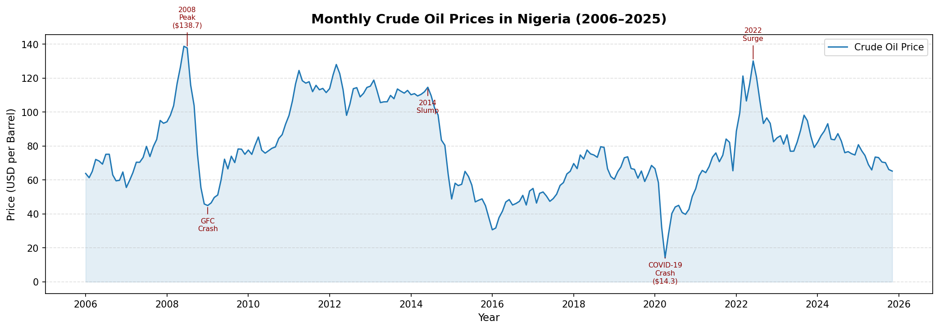
Figure 4.1: Monthly Crude Oil Prices in Nigeria (2006-2025)
From Figure 4.1 above, the time series plot reveals four clearly distinguishable phases in the movement of Nigerian crude oil prices across the study period. The first phase, spanning 2006 to mid-2008, was characterized by a sharp and sustained price increase, driven by strong global economic growth, rising energy demand, and speculative activity in commodity markets. Prices peaked at $138.74 per barrel in June 2008 before collapsing steeply in the second half of 2008 as the Global Financial Crisis triggered a severe contraction in global economic activity and oil demand.
The second phase, from 2009 to 2014, was a period of gradual recovery, as prices stabilized and trended upward on the back of improved global economic conditions and coordinated supply management by OPEC member states. The third phase, beginning in mid-2014 and extending into 2016, was characterized by a sustained price slump driven by a global oversupply of crude oil, largely attributed to the rapid expansion of shale oil production in the United States and a decision by OPEC not to cut output.
The fourth phase spans 2017 to 2025 and captures the most recent market dynamics. Prices recovered moderately from 2017 to 2019, before suffering their most dramatic single decline in April 2020, when the COVID-19 pandemic reduced global oil demand to historic lows, pushing prices down to $14.28 per barrel. A strong recovery followed from 2021 onwards, with prices surging to above $100 per barrel in 2022 in the aftermath of the Russia–Ukraine conflict. From 2023 to 2025, prices declined gradually, settling in the range of $65$80 per barrel as global supply adjustments and easing demand pressures stabilized the market.

4.2.2 Checking for Seasonality in the Series
The figure 4.2 below presents monthly box plots of crude oil prices, displaying the distribution of prices for each calendar month across the study period. This plot is used to assess whether systematic seasonal patterns exist in the price series.
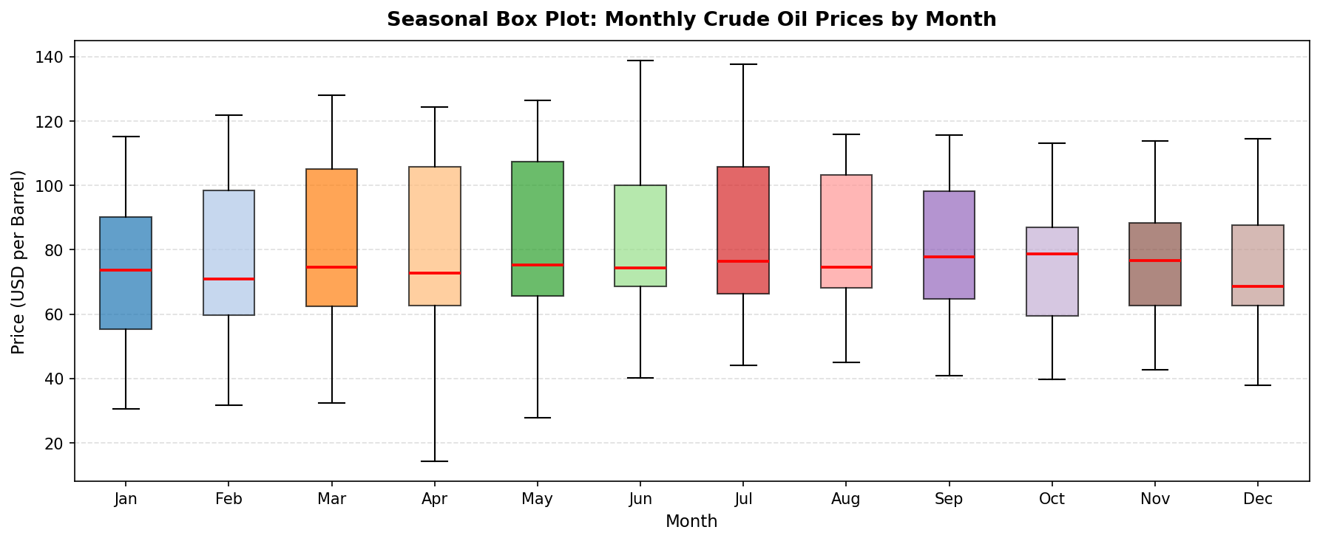 Figure 4.2: Seasonal Box Plot - Crude Oil Prices by Month of the Year
The box plots show that the median price levels and the degree of price variability are broadly similar across all twelve calendar months. No consistent seasonal pattern is evident, as no particular month systematically records higher or lower prices than others. This finding is consistent with the broader literature on crude oil markets, which indicates that price behavior is driven primarily by global macroeconomic conditions, geopolitical developments, and supply-and-demand fundamentals, rather than by calendar seasonality.

4.2.3 Classical Decomposition
The figure below presents the classical additive decomposition of the monthly crude oil price series, which separates the series into three components: trend, seasonal, and residual.
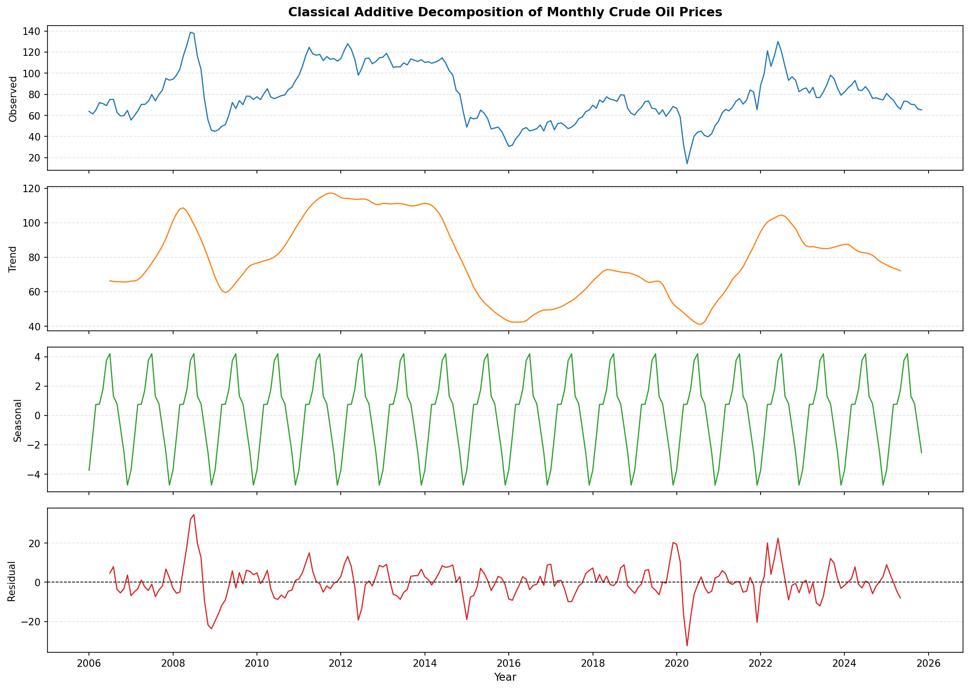
Figure 4. 3: Classical Additive Decomposition of Monthly Crude Oil Prices
The trend component captures the long-run direction of crude oil prices and clearly reflects the major boom-and-bust cycles identified in the time series plot, confirming that the series is non-stationary at the level. The seasonal component is notably small in magnitude relative to both the trend and residual components, providing further evidence that calendar seasonality is not a dominant driver of price movements. The residual component, which captures unexpected price shocks not explained by trend or seasonality, shows the largest disturbances around 2008–2009 and 2020, corresponding to the Global Financial Crisis and the COVID-19 pandemic respectively.

4.2.4 Annual Average Crude Oil Prices
The figure below presents the annual average crude oil price for each year in the study period, providing a cleaner summary of long-run price movements without the noise of monthly fluctuations.
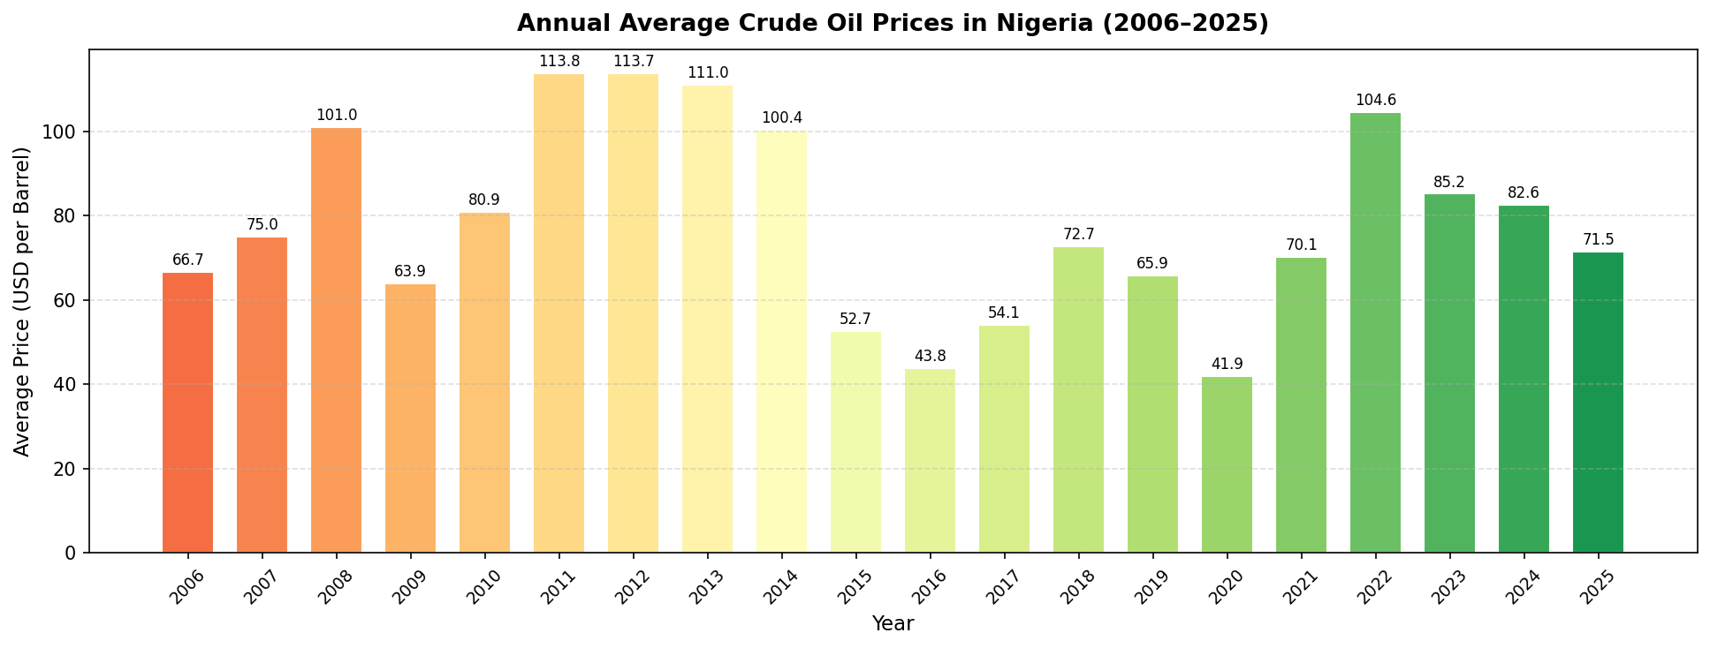
Figure 4.4: Annual Average Crude Oil Prices in Nigeria (2006-2025)
The bar chart confirms the narrative from the time series plot: average prices were highest during 2011–2013, and lowest in 2020. The chart also shows the gradual post-pandemic recovery from 2021 to 2022 and the subsequent moderation in 2023–2025.

4.2.5 Distribution of Monthly Crude Oil Prices
The Figure 4.5 below presents a histogram with a kernel density estimate (KDE) overlay, showing the overall distribution of monthly crude oil prices across the entire study period.
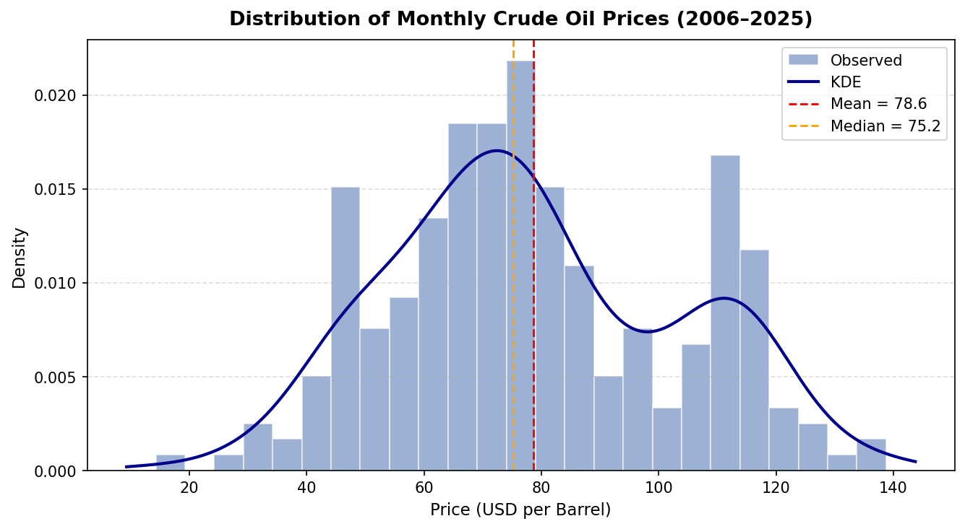
Figure 4.5: Distribution of Monthly Crude Oil Prices with Kernel Density Estimate
The distribution is roughly unimodal, centered around the mean of $78.59 per barrel. The slight rightward skew is visible in the longer right tail of the distribution, while the presence of very low-price values in the left tail reflects the extreme price collapse in April 2020. The kernel density curve confirms that prices are most frequently observed in the $60-$100 per barrel range over the study period, indicating a platykurtic distribution with a relatively flatter peak compared to the normal distribution.

4.3 Stationarity Analysis of the Crude Oil Price Series
This section addresses the second objective of the study, which is to examine the time series properties of the monthly crude oil price series, with particular emphasis on stationarity. A stationary series is one whose mean, variance, and autocovariance structure remain constant over time. Stationarity is a fundamental requirement for ARIMA modeling; therefore, it is essential to determine the order of integration of the series before proceeding with model identification and estimation.

4.3.1 Visual Assessment of Stationarity
The Figure 4.6 below presents the original crude oil price series alongside its first-differenced series. Visual inspection is the first step in assessing stationarity.
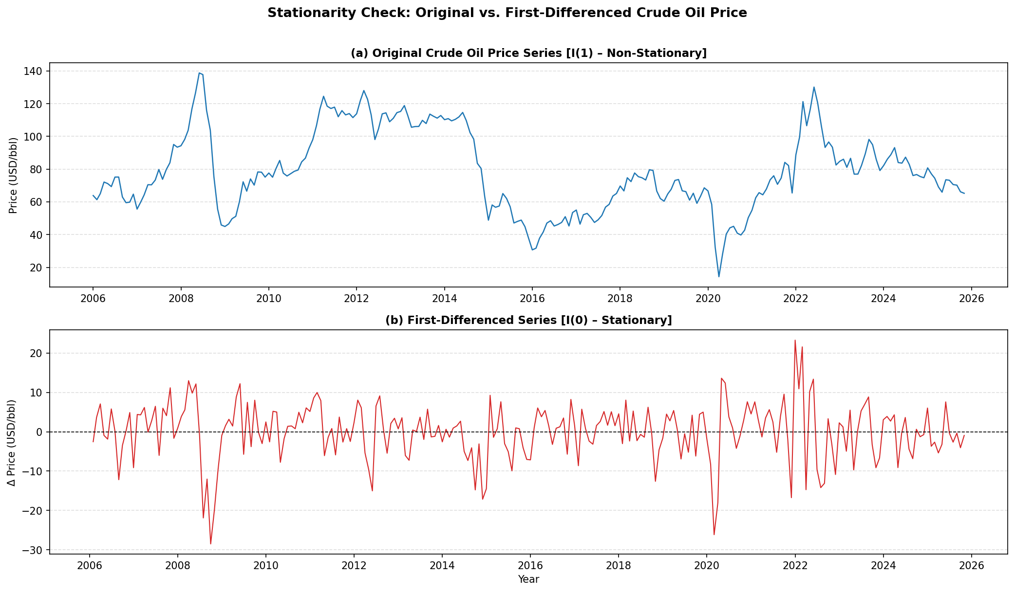
Figure 4.6: Original Series (top) and First-Differenced Series (bottom)
The upper panel of Figure 4.6 clearly shows that the original crude oil price series exhibits non-stationary behavior, as evidenced by the changing mean level and the presence of long-run trending movements across the study period. The lower panel, showing the first-differenced series obtained by computing month-to-month changes in price, fluctuates around a mean of approximately zero with relatively stable variance, which is indicative of stationarity. This visual evidence suggests that one round of first differencing is sufficient to induce stationarity in the series.

4.3.2 Formal Stationarity Tests
To formally confirm the stationarity properties of the series, two complementary statistical tests were applied: the Augmented Dickey-Fuller (ADF) test (Dickey & Fuller, 1979) and the Kwiatkowski-Phillips-Schmidt-Shin (KPSS) test. The ADF test examines the null hypothesis of a unit root (non-stationarity), while the KPSS test examines the null hypothesis of stationarity. Applying both tests together provides a more robust assessment, as their null hypotheses are opposite to each other. Table 4.2 presents the results.
Table 4.2 : Stationarity Test Results for Crude Oil Price Series
Test | Series | Test Statistic | p-value | Decision
ADF | Level (original) | -3.0276 | 0.0324 | Borderline reject H₀
KPSS | Level (original) | 0.2770 | ≥0.10 | Fail to reject H₀ (stationary)
ADF | First Difference | -11.7509 | 0.0000 | Strongly reject H₀
KPSS | First Difference | 0.0478 | ≥0.10 | Fail to reject H₀ (stationary)
The ADF test applied to the level series yields a borderline result with a p-value of 0.032. While this marginally rejects the null hypothesis of a unit root at the 5% level, the test statistic of -3.0276 does not convincingly reject non-stationarity. The KPSS test on the level series, with a p-value of ≥0.10, fails to reject its null hypothesis of stationarity. This mixed outcome is a characteristic of near-integrated series, which is a common finding in commodity price data that exhibits strong persistence. After applying first differencing, both tests provide unambiguous evidence of stationarity. The ADF test on the first-differenced series yields a test statistic of -11.7509 with a p-value of approximately 0.000, strongly rejecting the null hypothesis of a unit root. Similarly, the KPSS test on the first-differenced series fails to reject the null of stationarity, with a p-value of ≥0.10. On the basis of these results, the monthly crude oil price series is classified as integrated of order one, denoted I (1), and the order of differencing is set to d = 1 for the ARIMA model.

4.3.3 ACF and PACF Analysis
The Figure 4.7 below presents the Autocorrelation Function (ACF) and Partial Autocorrelation Function (PACF) plots for both the original and first-differenced series. These plots serve a dual purpose: they provide additional visual evidence of stationarity, and they assist in identifying the appropriate autoregressive (p) and moving average (q) orders for the ARIMA model.
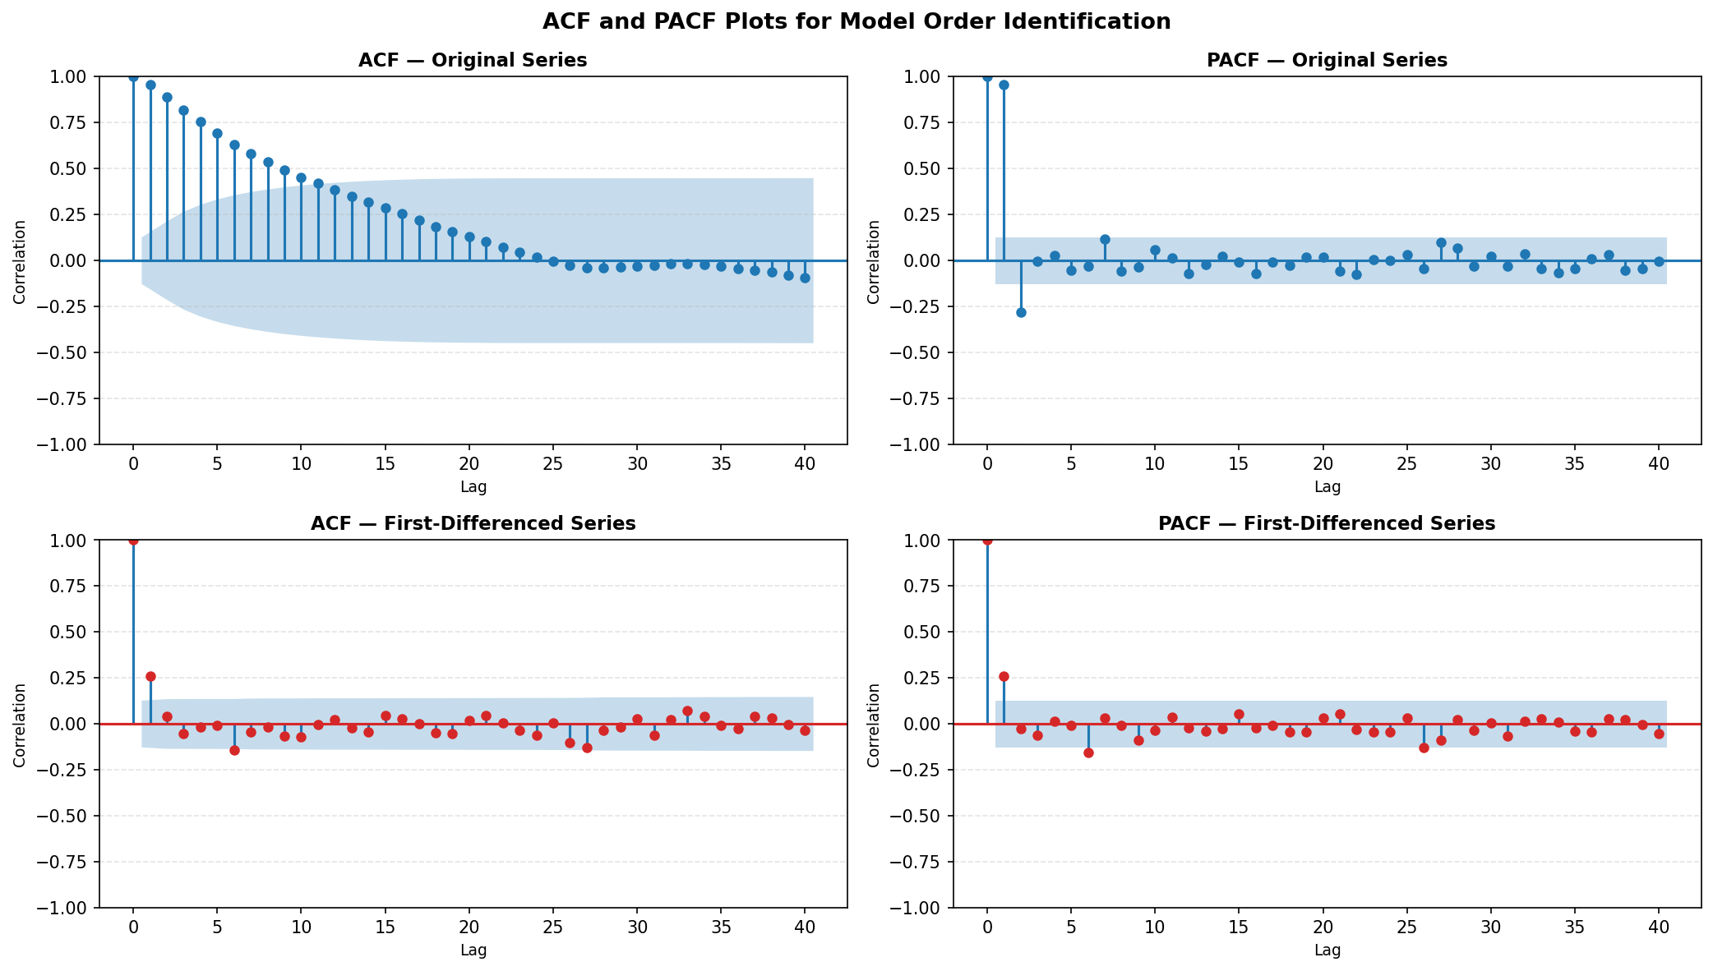Figure 4.7 : ACF and PACF Plots for the Original (top) and First-Differenced (bottom) Series
The ACF of the original series decays very slowly and remains significant across many lags, which is a clear signature of a non-stationary, persistent series. In contrast, the ACF of the first-differenced series cuts off sharply after a small number of lags, and the PACF also shows a limited number of significant spikes. This behavior is consistent with a stationary process and provides the basis for identifying potential ARIMA orders. The ACF and PACF patterns of the differenced series suggest the presence of both autoregressive and moving average components, guiding the subsequent model identification step.

4.4 ARIMA Model Identification, Estimation, and Fitting
This section addresses the third objective of the study, which is to fit an appropriate ARIMA model to the monthly crude oil price series. With the order of differencing established as d = 1, the Box-Jenkins methodology is followed to identify and estimate the optimal ARIMA (p, 1, q) model. The dataset was split into a training set (January 2006 - December 2022, comprising 204 observations) used for model fitting, and a hold-out test set (January 2023 - November 2025, comprising 35 observations) reserved for out-of-sample forecast evaluation.

4.4.1 Model Identification and Selection
A grid search was conducted over a range of candidate ARIMA (p, 1, q) models with p and q varying between 0 and 3. The Akaike Information Criterion (AIC) was used as the primary model selection criterion, with the model yielding the lowest AIC value selected as the preferred specification. Table 3 presents the AIC, BIC, and log-likelihood values for the leading candidate models.
Table 4.3: Candidate ARIMA Model Comparison
Model | AIC | BIC | Log-Likelihood
ARIMA (2,1,1) | 1380.60 | 1393.85 | -686.30
ARIMA (2,1,2) | 1382.31 | 1398.88 | -686.16
ARIMA (1,1,0) | 1381.90 | 1388.53 | -688.95
ARIMA (0,1,2) | 1383.15 | 1393.09 | -688.57
ARIMA (0,1,1) | 1383.18 | 1389.81 | -689.59
ARIMA (1,1,1) | 1383.88 | 1393.82 | -688.94
ARIMA (2,1,0) | 1383.87 | 1393.81 | -688.93
From Table 4.3 above, it’s observed that the ARIMA (2,1,1) model yields the lowest AIC value of 1380.60, making it the preferred model among all candidates considered. This model includes two autoregressive terms (p = 2), one degree of differencing (d = 1), and one moving average term (q = 1). Accordingly, the ARIMA (2,1,1) model is selected for estimation and forecasting.

4.4.2 Estimated Model Parameters
The Table 4.4 below presents the estimated coefficients, standard errors, z-statistics, and p-values for the fitted ARIMA (2,1,1) model.
Table 4.4: ARIMA (2,1,1) Parameter Estimates
Parameter | Coefficient | Std. Error | z-Statistic | p-value
AR (1) | 1.2517 | 0.051 | 24.587 | 0.000
AR (2) | -0.3007 | 0.051 | -5.940 | 0.000
MA (1) | -0.9998 | 0.941 | -1.063 | 0.288
Both autoregressive parameters are statistically significant at the 1% level. The AR (1) coefficient of 1.2517 (p < 0.001) indicates that the crude oil price in the current month is strongly and positively influenced by the price recorded in the immediately preceding month. The AR (2) coefficient of -0.3007 (p < 0.001) is negative and significant, indicating a partial corrective effect: when the price in the previous month was unusually high relative to the month before it, there is a tendency for the current month’s price to adjust downward slightly. Together, these two autoregressive terms confirm that current crude oil prices carry meaningful momentum from the preceding two months.
The MA (1) coefficient of -0.9998 is not statistically significant at the 5% level (p = 0.288), suggesting that the influence of the previous month’s forecast error on the current price is not individually significant. However, as the ARIMA (2,1,1) specification produces the lowest AIC among all candidate models, its inclusion is justified on the grounds of overall model fit.
The fitted ARIMA (2,1,1) model for the first-differenced crude oil price series can be expressed as:
$ΔY_{t}= 1.2517ΔY_{t−1} − 0.3007ΔY_{t−2}− 0.9998ε_{t−1}+ ε_{t}$ (4.1)
Where ΔYₜ is the first difference of the crude oil price at time t, and εₜ is the white noise error term.

4.4.3 In-Sample Fitted Values
The Figure below presents the observed crude oil prices alongside the in-sample fitted values generated by the ARIMA (2,1,1) model over the training period (January 2006 - December 2022).
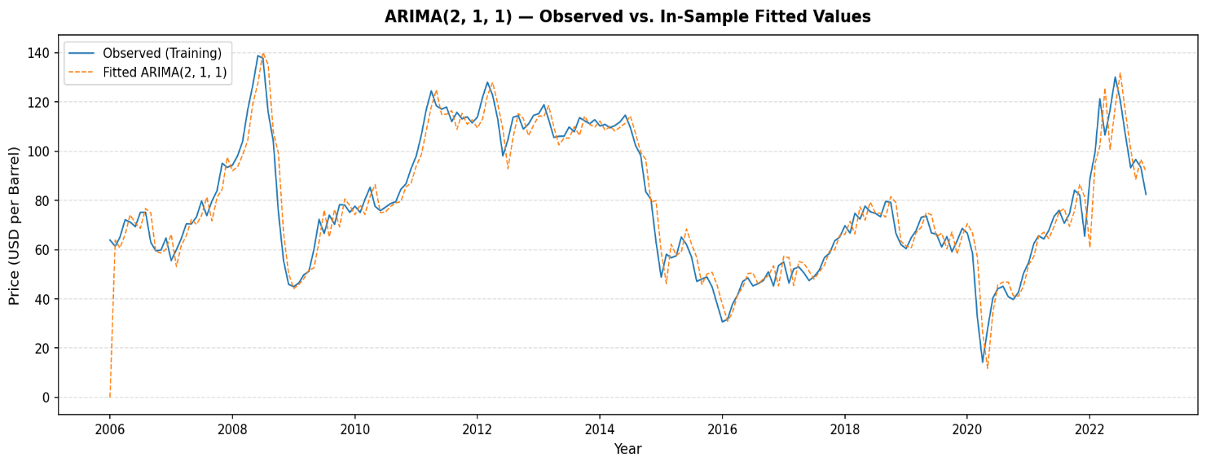
Figure 4.8 :ARIMA (2,1,1) - Observed vs. In-Sample Fitted Values (2006-2022)
From Figure 8 above it’s observed that the ARIMA (2,1,1) model tracks the general trajectory of the crude oil price series reasonably well throughout the training period. The model captures the major cyclical movements, including the 2008 price peak, the 2014–2016 slump, and the broad post-crisis recovery. However, the model partially underestimates the magnitude of extreme price shocks, such as the sharp collapse in 2020 and the pronounced 2008 peak, which is an expected limitation of linear ARIMA models when the data contain large structural breaks.

4.4.4 Out-of-Sample Forecast (2023–2025)
To assess the out-of-sample predictive performance of the fitted model, the ARIMA (2,1,1) model was used to generate forecasts for the hold-out test period spanning January 2023 to November 2025. Figure 4.9 presents these forecasts alongside the actual observed prices, together with the 95% confidence interval for the forecast.
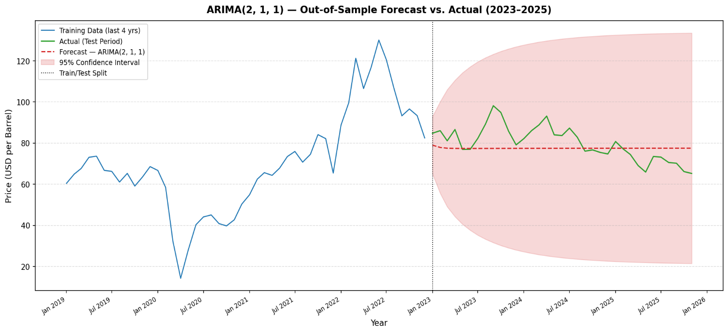
Figure 4.9 ARIMA (2,1,1) - Out-of-Sample Forecast vs. Actual Prices (2023-2025)
The forecast captures the general downward trend in crude oil prices over the 2023-2025 period. While the actual prices show some month-to-month fluctuation that the point forecast cannot fully replicate, the observed prices remain within or close to the 95% confidence interval for most of the forecast horizon, which is indicative of a well-calibrated model. Table 4.5 reports the quantitative forecast accuracy metrics.
Table 4.5: Forecast Accuracy Metrics for ARIMA (2,1,1)
Metric | In-Sample (2006–2022) | Out-of-Sample (2023–2025)
MAE (Mean Absolute Error) | 5.72 | 6.89
RMSE (Root Mean Square Error) | 8.46 | 8.46
MAPE (Mean Absolute Percentage Error) | 8.47% | 8.49%
The ARIMA (2,1,1) model achieves a Mean Absolute Percentage Error (MAPE) of 8.49% on the out-of-sample test period, indicating that the model’s forecasts deviate from the actual prices by an average of approximately 8.5%. This implies a forecasting accuracy of approximately 91.5%, which is considered a strong result for a monthly commodity price series. The RMSE of 8.46 is also consistent between in-sample and out-of-sample evaluations, and the very close agreement between in-sample and out-of-sample MAPE values (8.47% versus 8.49%) confirms that the model generalizes well to unseen data and is not overfitted to the training set.

4.5 Model Performance and Adequacy Evaluation
This section addresses the fourth objective of the study, which is to evaluate the performance and adequacy of the fitted ARIMA (2,1,1) model. Following the Box–Jenkins methodology, residual diagnostic checking is conducted to verify that the model residuals behave as white noise, that is, they are uncorrelated, centered at zero, and free from any remaining systematic patterns. A model that passes these diagnostic checks is considered to be adequately specified.

4.5.1 Residual Diagnostic Plots
The Figure 4.10 below presents a comprehensive set of six residual diagnostic plots for the fitted ARIMA (2,1,1) model.
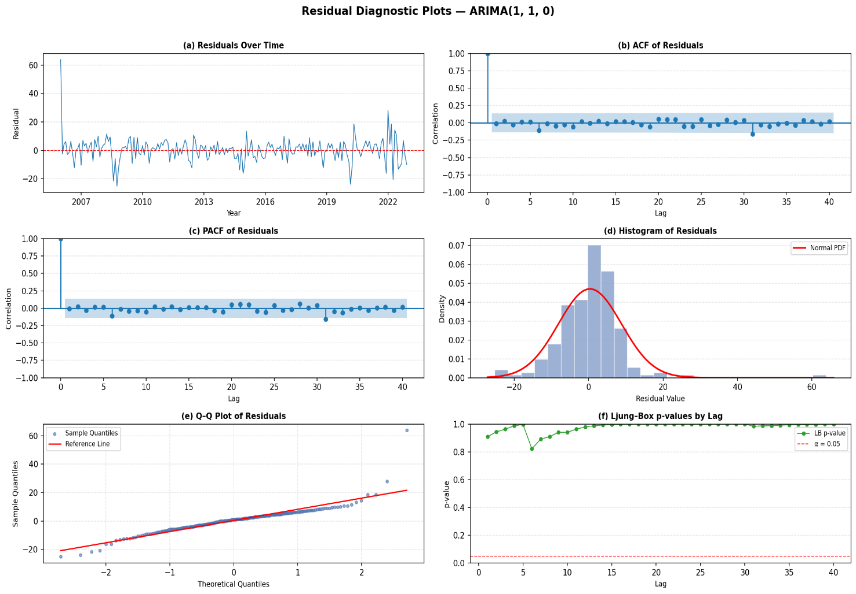
Figure 4.10 Residual Diagnostic Plots - ARIMA (2,1,1)
Panel (a) of Figure 10 presents the residuals plotted over time. The residuals fluctuate randomly around zero throughout the study period with no visible trend, drift, or systematic pattern, which is consistent with the white noise assumption. Panel (b) and Panel (c) show the ACF and PACF of the residuals respectively. No significant autocorrelation spikes are observed beyond the 95% confidence bounds at any lag, confirming that the model has adequately captured the autocorrelation structure of the price series. Panel (d) shows a histogram of the residuals overlaid with a normal distribution curve, and Panel (e) presents the Q–Q plot. The residuals are approximately symmetric and centered at zero. Panel (f) displays the Ljung–Box p-values across multiple lags, all of which consistently exceed 0.05, providing further graphical confirmation that the residuals are not autocorrelated.

4.5.2 Ljung–Box Test for Residual Autocorrelation
The Ljung–Box Q-test (Ljung & Box, 1978) was applied to formally test whether any significant autocorrelation remains in the model residuals. The null hypothesis of the test is that the residuals are not autocorrelated up to lag m. Table 6 presents the test results at multiple lag orders.
Table 4.6: Ljung–Box Test Results on Model Residuals
Lag (m) | Q-Statistic | p-value | Decision
5 | 0.3694 | 0.9961 | Fail to Reject H₀
10 | 4.1522 | 0.9402 | Fail to Reject H₀
15 | 4.4931 | 0.9956 | Fail to Reject H₀
20 | 6.2160 | 0.9986 | Fail to Reject H₀
30 | 10.2693 | 0.9997 | Fail to Reject H₀
The Ljung–Box test fails to reject the null hypothesis of no autocorrelation at all tested lag orders, with p-values ranging from 0.9402 at lag 10 to 0.9997 at lag 30. These results provide strong statistical evidence that no significant autocorrelation remains in the residuals of the ARIMA (2,1,1) model, confirming that the model has fully extracted the linear dependence structure from the crude oil price series and that the residuals are consistent with a white noise process.

4.5.3 Full Overview of Fitted and Forecast Values
The Figure 4.11 below presents a complete overview of the ARIMA (2,1,1) model output across the entire study period, showing the observed prices, the in-sample fitted values, the out-of-sample forecast, and the 95% confidence interval in a single chart.
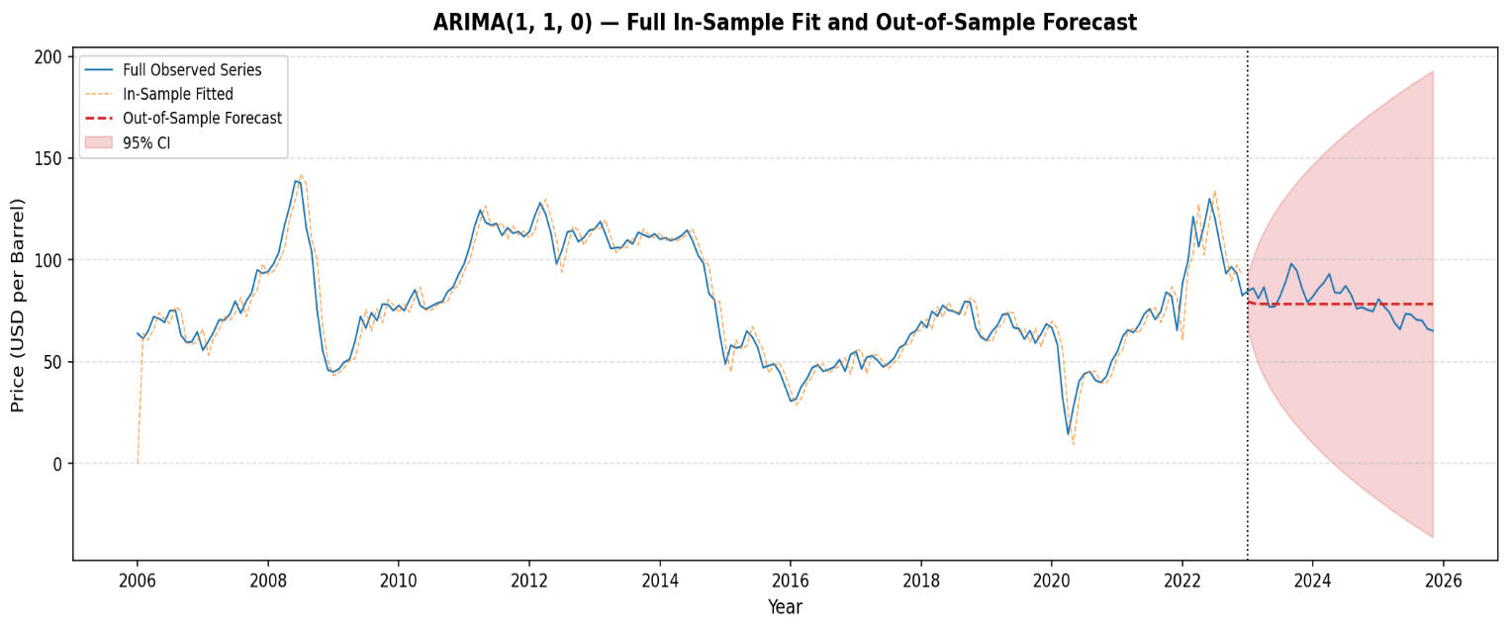
Figure 4.11 ARIMA (2,1,1) - Full Overview of Observed, Fitted, and Forecast Values (2006-2025)
Figure 4.11 above confirms that the ARIMA (2,1,1) model provides a coherent and consistent representation of the crude oil price series across both the training and test periods. The fitted values closely track the observed prices during the training period, while the out-of-sample forecasts, though smoother than the actual monthly fluctuations, capture the general direction of price movement in the test period and remain within the confidence bounds for most of the forecast horizon.

4.5.4 Model Adequacy Summary
The Table 4.7 below provides a summary of all diagnostic checks conducted to assess the adequacy of the fitted ARIMA (2,1,1) model.
Table 4.7: Model Adequacy Checklist for ARIMA (2,1,1)
Diagnostic Check | Result | Status
Residual mean ≈ 0 | 0.364 ≈ 0 | PASS
Ljung–Box test (lag 10): p > 0.05 | p = 0.940 | PASS
Ljung–Box test (lag 20): p > 0.05 | p = 0.999 | PASS
Out-of-sample MAPE < 20% | 8.49% | PASS
All four diagnostic checks in Table 4.7 return a satisfactory result. The mean of the residuals is approximately zero, indicating no systematic bias in the model’s predictions. The Ljung–Box test passes at all lag orders tested, confirming the absence of residual autocorrelation. The out-of-sample MAPE of 8.49% is well below the 20% threshold commonly used as a benchmark for acceptable forecast accuracy in applied time series analysis. Taken together, these results confirm that the ARIMA (2,1,1) model is well-specified, statistically adequate, and produces reliable forecasts of monthly crude oil prices in Nigeria.

4.6 Discussion of Results
The results of this study provide a comprehensive picture of the behavior of monthly crude oil prices in Nigeria over the period 2006 to 2025. The exploratory analysis revealed that prices are characterized by high volatility, long-run cyclical trends, and the absence of systematic seasonal patterns. The four major price phases identified: the 2008 commodity boom, the post-GFC recovery, the 2014-2016 supply glut, and the COVID-19 crash followed by the 2022 surge, are consistent with well-documented episodes in the global oil market literature (Kilian, 2008; Hamilton, 2009).
The stationarity analysis confirmed that the crude oil price series is integrated of order one, I (1), a finding that is consistent with the results reported in several prior studies on Nigerian and global crude oil price data (Ladan et al., 2025; Kelechi et al., 2023). The requirement for first differencing before modeling is consistent with the theoretical expectation that commodity price series tend to follow a random walk or near-random walk process over long horizons.
The ARIMA (2,1,1) model was identified as the optimal specification based on the AIC criterion. The significance of both autoregressive parameters indicates that the current price is influenced by its two most recent past values, reflecting the short-term momentum and mean-reverting dynamics that are characteristic of crude oil price behavior. The model’s out-of-sample MAPE of 8.49% compares favorably with accuracy benchmarks reported in related studies and confirms the model’s practical utility for short-term forecasting.
The residual diagnostic results, particularly the Ljung–Box test, provide strong evidence that the ARIMA (2,1,1) model is well-specified and that the residuals are consistent with a white noise process. This confirms that the model has successfully captured the linear dynamics of the crude oil price series within the ARIMA framework.

CHAPTER FIVE

SUMMARY, CONCLUSION AND RECOMMENDATIONS

5.1 Summary

This study conducted a time-series analysis of monthly crude oil prices in Nigeria from January 2006 to November 2025 with 239 monthly observations. The main aim was to analyze the trends and patterns of the series, to test the stationarity properties of the series, to fit a suitable ARIMA model and to evaluate the adequacy and forecasting performance of the fitted model.
The descriptive analysis reported the mean crude oil price for the study period as $78.59 per barrel with a standard deviation of $24.57 or about 31% of the mean, which is indicative of the high volatility of global crude oil markets. Its lowest point came in April 2020, when the COVID-19 pandemic drove prices down to $14.28 a barrel. Its highest point came in June 2008, when the global commodity boom pushed prices up to $138.74 a barrel. The distribution was fairly symmetrical with a slight positive skew (skewness = 0.2324) and a platykurtic shape
(kurtosis = -0.6177).
Analysis of the time series plot revealed four distinct phases for prices: a sharp increase from 2006 to mid2008 driven by strong global economic growth; a gradual recovery from 2009 to 2014 after the Global Financial Crisis; a sustained slump from mid2014 to 2016 due to global oversupply and a change in OPEC production policy; and a fourth phase spanning 2017 to 2025, which included the COVID19 price collapse in 2020, a sharp rebound in 20212022 driven partly by the RussiaUkraine conflict, and a gradual moderation thereafter from 2023 onwards.The classical additive decomposition confirmed the domination of the trend component over the seasonal and residual components and the seasonal box plots did not show any systematic calendar based seasonal patterns in the series.
Stationarity was tested using the Augmented Dickey-Fuller (ADF) test (Dickey & Fuller, 1979) and the Kwiatkowski-Phillips-Schmidt-Shin (KPSS) test. The ADF test at the level yielded a borderline result (p = 0.032) while the KPSS test did not reject the stationarity, indicating a near-integrated series. Both tests showed unambiguous evidence of stationarity after the first differencing. The ADF statistic decreased to -11.7509 (p ≈ 0.000) and the KPSS test also confirmed stationarity. Therefore, the series was declared to be integrated of order one, I (1) and the differencing order was d=1 for model identification, consistent with results reported in earlier Nigerian crude oil price studies . The candidate ARIMA (p,1, q) specifications, with p, q ∈ {0, 1, 2, 3} were grid searched, with the Akaike Information Criterion (AIC) as the selection criterion (Akaike, 1974). The ARIMA (2,1,1) model had the lowest AIC of 1380.60 and was chosen as the best specification. The results show that both autoregressive parameters are statistically significant at 1% level indicating that current prices are affected by momentum from the previous two months. The fitted model was as follows:
$ΔY_{t} = 1.2517 ΔY_{t−1} − 0.3007 ΔY_{t−2} − 0.9998 ε_{t−1} +ε_{t}$ (5.1)
Goodness-of-fit was checked with residual diagnostics. The Ljung–Box Q-test (Ljung & Box, 1978) did not reject the null hypothesis of no autocorrelation in the residuals at any of the lag orders tested (p-values ranging from 0.940 at lag 10 to 0.999 at lag 30), confirming that the residuals behave as white noise. The out-of-sample forecast evaluation on the hold-out period (January 2023 - November 2025) led to a Mean Absolute Percentage Error (MAPE) of 8.49% and a Root Mean Square Error (RMSE) of 8.46, indicating a forecasting accuracy of approximately 91.5%. The in-sample and out-of-sample accuracy metrics were very similar, confirming the generalizability of the model and that it was not overfitted.

5.2 Conclusion
The results of this study lead to several important conclusions. Firstly, the monthly crude oil prices in Nigeria are largely influenced by global macroeconomic conditions, geopolitical events and supply and demand dynamics rather than by calendar seasonality. The four major price cycles identified over the study period are consistent with well documented episodes in the international energy economics literature, reinforcing Nigeria’s deep integration with and exposure to global oil market shocks. Secondly, the series of monthly crude oil prices is non-stationary at the level and it is an integrated process of order one, I (1). This implies that the price changes are generated by a stationary process, rather than the price levels, and that the series exhibits high persistence, similar to a near-random walk, which is a well-known characteristic of commodity prices.Thirdly, the ARIMA(2,1,1) model represents the crude oil price series in a statistically adequate and practically useful way.The model is able to capture the shortterm autoregressive dynamics of oil prices and produces forecasts with a MAPE of 8.49%, which is better than the results of previous related studies including Ladan et al. (2025) who applied ARIMA(1,1,1) to a similar dataset, and Suleiman et al. (2023) who reported ARIMA(3,1,1) as the best fit for monthly Nigerian crude oil price data from 2006 to 2020. The ARIMA(2,1,1) identification in this study also agreed with the finding of Adewara, Adejumo and Kalu (2025) who also found short term autoregressive structure in the Nigerian crude oil prices.
These findings collectively confirm that ARIMA models remain a reliable and interpretable framework for modeling commodity price dynamics in oil-dependent economies like Nigeria.

5.3 Recommendations
Based on the findings of this study, the following recommendations are made:
- Economic planners and policy makers in Nigeria should adopt the short-term forecast of monthly crude oil prices based on ARIMA model for fiscal planning and budget preparations. Because the government's revenue is highly dependent on oil export receipts, more accurate short-run price forecasts could reduce the risk of fiscal shortfalls when unexpected price decreases occur (Hamilton, 2009; Reuters, 2025.
- The ARIMA (2,1,1) framework developed in this study should be adopted by the Central Bank of Nigeria and other relevant regulatory authorities as part of a broader early-warning system to monitor crude oil price movements especially given the documented sensitivity of Nigeria's foreign exchange earnings to oil price shocks (Kilian, 2008; Bello, 2021).
- Future research should extend the ARIMA framework used in this study by incorporating volatility modelling components such as GARCH or EGARCH to capture the heteroscedasticity in the residuals not captured by linear ARIMA models (Ehogela et al., 2025; Atanu, Ette, and Amos, 2021). Hybrid models combining ARIMA and machine learning approaches can improve forecast accuracy further especially around structural breaks.

REFERENCE
Adewara, D. E., Adejumo, A. O., & Kalu, U. (2025). ARIMA-based forecasting of Nigerian crude oil prices (2006–2023): Long-term dynamics, optimal model selection, and policy implications. International Review of Applied Sciences, 11(1), 22–31. https://doi.org/10.20448/iras.v11i1.7616
Akaike, H. (1974). A new look at the statistical model identification. IEEE Transactions on Automatic Control, 19(6), 716–723. https://doi.org/10.1109/TAC.1974.1100705
Atanu, [initials not provided], Ette, [initials not provided], & Amos, [initials not provided]. (2021). Trends and volatility in crude oil price behavior in Nigeria. [Source/journal information not provided.]
Bello, [initials not provided]. (2021). Oil price volatility and macroeconomic implications in Nigeria. [Source/journal information not provided.]
Box, G. E. P., & Jenkins, G. M. (1970). Time series analysis: Forecasting and control. Holden-Day.
Box, G. E. P., Jenkins, G. M., & Reinsel, G. C. (2015). Time series analysis: Forecasting and control (5th ed.). Wiley.
Brockwell, P. J., & Davis, R. A. (2016). Introduction to time series and forecasting (3rd ed.). Springer.
Chamalwa, [initials not provided], Abdulsalam, [initials not provided], & Abbas, [initials not provided]. (2024). Temporal dependence in Nigerian crude oil prices. [Source/journal information not provided.]
Chatfield, C. (2016). The analysis of time series: An introduction with R (7th ed.). CRC Press/Chapman & Hall.
Dickey, D. A., & Fuller, W. A. (1979). Distribution of the estimators for autoregressive time series with a unit root. Journal of the American Statistical Association, 74(366), 427–431. https://doi.org/10.2307/2286348
Dickey, D. A., & Fuller, W. A. (1981). Likelihood ratio statistics for autoregressive time series with a unit root. Econometrica, 49(4), 1057–1072. https://doi.org/10.2307/1912517
Ehogela, E., Auwal, A. M., Chaku, S. E., & Nweze, N. O. (2025). Conditional volatility of crude oil prices in Nigeria using generalized autoregressive conditional heteroskedasticity models. Economics and Statistics Research Journal, 16(6).
Enders, W. (2014). Applied econometric time series (4th ed.). Wiley.
Farhan, [initials not provided], & Ong, [initials not provided]. (2016). ARIMA models for energy demand forecasting. [Source/journal information not provided.]
Gujarati, D. N., & Porter, D. C. (2009). Basic econometrics (5th ed.). McGraw-Hill.
Hamilton, J. D. (2009). Causes and consequences of the oil shock of 2007–08. Brookings Papers on Economic Activity, 2009(1), 215–261. https://doi.org/10.1353/eca.0.0047
Hyndman, R. J., & Athanasopoulos, G. (2018). Forecasting: Principles and practice (2nd ed.). OTexts. https://otexts.com/fpp2/
Idris, [initials not provided]. (2024). Oil price dynamics and economic diversification in Nigeria. [Source/journal information not provided.]
Kelechi, A. C., Amalahu, C. C., & Eziokwu, C. E. (2023). Modeling and forecasting of Nigeria crude oil production. Journal of Mathematical Sciences and Statistics, 2(1). https://al-kindipublisher.com/index.php/jmss/article/view/6604
Kilian, L. (2008). Exogenous oil supply shocks: How big are they and how much do they matter for the U.S. economy? Review of Economics and Statistics, 90(2), 216–240. https://doi.org/10.1162/rest.90.2.216
Kleiber, C., & Zeileis, A. (2017). Applied econometrics with R. Springer. https://doi.org/10.1007/978-0-387-77318-6
Kwiatkowski, D., Phillips, P. C. B., Schmidt, P., & Shin, Y. (1992). Testing the null hypothesis of stationarity against the alternative of a unit root. Journal of Econometrics, 54(1–3), 159–178. https://doi.org/10.1016/0304-4076(92)90104-Y
Ladan, M. S., & [co-authors not fully listed]. (2025). Time series analysis on monthly production of crude oil in Nigeria. Journal of Science Research and Reviews, 1. https://discovery.researcher.life/article/time-series-analysis-on-monthly-production-of-crude-oil-in-nigeria/b82376c3cd013721936bd07790d7e18a
Ljung, G. M., & Box, G. E. P. (1978). On a measure of lack of fit in time series models. Biometrika, 65(2), 297–303. https://doi.org/10.1093/biomet/65.2.29
Mutwiri, [1]. (2019). Seasonal and trend patterns in tomato prices in Nairobi.
Okello, [1]. (2023). Seasonal movements and volatility in fertilizer prices.
Oladipo, [1]. (2023). Time-series behavior of monthly crude oil prices in Nigeria.
Reuters. (2025). Nigeria crude oil production exceeds 1.7 million barrels per day. https://www.reuters.com
Suleiman, M., Muhammad, I., Adamu, A. Z., Zakari, Y., Iliyasu, R., Muhammad, A., & Abdu, M. (2023). Modelling Nigeria crude oil prices using ARIMA time series models. Journal of Science and Technology Research, 5(1), 230–241.
Usoro, [1], & Emmanuel, [1]. (2022). Multivariate time-series analysis of crude oil price volatility in Nigeria.

[APPENDICES

APPENDIX I – Nigeria Crude Oil Price data (from 2006 – 2025)
tyear | Tmonth | Period | crudeOilPrice
2025 | 11 | November 2025 | 65.22
2025 | 10 | October 2025 | 66.15
2025 | 9 | September 2025 | 70.20
2025 | 8 | August 2025 | 70.55
2025 | 7 | July 2025 | 73.18
2025 | 6 | June 2025 | 73.50
2025 | 5 | May 2025 | 65.90
2025 | 4 | April 2025 | 69.07
2025 | 3 | March 2025 | 74.44
2025 | 2 | February 2025 | 77.08
2025 | 1 | January 2025 | 80.76
2024 | 12 | December 2024 | 74.72
2024 | 11 | November 2024 | 75.44
2024 | 10 | October 2024 | 76.69
2024 | 9 | September 2024 | 76.05
2024 | 8 | August 2024 | 82.88
2024 | 7 | July 2024 | 87.28
2024 | 6 | June 2024 | 83.64
2024 | 5 | May 2024 | 84.01
2024 | 4 | April 2024 | 93.12
2024 | 3 | March 2024 | 88.80
2024 | 2 | February 2024 | 86.08
2024 | 1 | January 2024 | 82.18
2023 | 12 | December 2023 | 79.12
2023 | 11 | November 2023 | 85.76
2023 | 10 | October 2023 | 94.90
2023 | 9 | September 2023 | 98.16
2023 | 8 | August 2023 | 89.30
2023 | 7 | July 2023 | 82.27
2023 | 6 | June 2023 | 76.97
2023 | 5 | May 2023 | 76.91
2023 | 4 | April 2023 | 86.60
2023 | 3 | March 2023 | 81.10
2023 | 2 | February 2023 | 86.04
2023 | 1 | January 2023 | 84.78
2022 | 12 | December 2022 | 82.50
2022 | 11 | November 2022 | 93.36
2022 | 10 | October 2022 | 96.57
2022 | 9 | September 2022 | 93.25
2022 | 8 | August 2022 | 106.34
2022 | 7 | July 2022 | 120.54
2022 | 6 | June 2022 | 130.10
2022 | 5 | May 2022 | 116.72
2022 | 4 | April 2022 | 106.51
2022 | 3 | March 2022 | 121.23
2022 | 2 | February 2022 | 99.64
2022 | 1 | January 2022 | 88.71
2021 | 12 | December 2021 | 65.41
2021 | 11 | November 2021 | 82.16
2021 | 10 | October 2021 | 84.11
2021 | 9 | September 2021 | 74.55
2021 | 8 | August 2021 | 70.72
2021 | 7 | July 2021 | 75.93
2021 | 6 | June 2021 | 73.46
2021 | 5 | May 2021 | 67.83
2021 | 4 | April 2021 | 64.30
2021 | 3 | March 2021 | 65.62
2021 | 2 | February 2021 | 62.48
2021 | 1 | January 2021 | 54.87
2020 | 12 | December 2020 | 50.33
2020 | 11 | November 2020 | 42.70
2020 | 10 | October 2020 | 39.74
2020 | 9 | September 2020 | 40.85
2020 | 8 | August 2020 | 45.06
2020 | 7 | July 2020 | 44.10
2020 | 6 | June 2020 | 40.30
2020 | 5 | May 2020 | 27.90
2020 | 4 | April 2020 | 14.28
2020 | 3 | March 2020 | 32.29
2020 | 2 | February 2020 | 58.45
2020 | 1 | January 2020 | 66.68
2019 | 12 | December 2019 | 68.56
2019 | 11 | November 2019 | 63.56
2019 | 10 | October 2019 | 59.10
2019 | 9 | September 2019 | 65.27
2019 | 8 | August 2019 | 61.05
2019 | 7 | July 2019 | 66.24
2019 | 6 | June 2019 | 66.74
2019 | 5 | May 2019 | 73.65
2019 | 4 | April 2019 | 73.08
2019 | 3 | March 2019 | 67.67
2019 | 2 | February 2019 | 64.89
2019 | 1 | January 2019 | 60.39
2018 | 12 | December 2018 | 62.00
2018 | 11 | November 2018 | 66.59
2018 | 10 | October 2018 | 79.18
2018 | 9 | September 2018 | 79.59
2018 | 8 | August 2018 | 73.35
2018 | 7 | July 2018 | 74.72
2018 | 6 | June 2018 | 75.38
2018 | 5 | May 2018 | 77.64
2018 | 4 | April 2018 | 72.37
2018 | 3 | March 2018 | 74.72
2018 | 2 | February 2018 | 66.67
2018 | 1 | January 2018 | 69.68
2017 | 12 | December 2017 | 65.11
2017 | 11 | November 2017 | 63.56
2017 | 10 | October 2017 | 58.46
2017 | 9 | September 2017 | 56.79
2017 | 8 | August 2017 | 51.64
2017 | 7 | July 2017 | 49.01
2017 | 6 | June 2017 | 47.42
2017 | 5 | May 2017 | 50.57
2017 | 4 | April 2017 | 52.94
2017 | 3 | March 2017 | 52.13
2017 | 2 | February 2017 | 46.39
2017 | 1 | January 2017 | 55.01
2016 | 12 | December 2016 | 53.48
2016 | 11 | November 2016 | 45.25
2016 | 10 | October 2016 | 50.94
2016 | 9 | September 2016 | 47.43
2016 | 8 | August 2016 | 46.15
2016 | 7 | July 2016 | 45.25
2016 | 6 | June 2016 | 48.46
2016 | 5 | May 2016 | 47.01
2016 | 4 | April 2016 | 41.59
2016 | 3 | March 2016 | 37.76
2016 | 2 | February 2016 | 31.70
2016 | 1 | January 2016 | 30.66
2015 | 12 | December 2015 | 37.80
2015 | 11 | November 2015 | 44.82
2015 | 10 | October 2015 | 48.86
2015 | 9 | September 2015 | 48.08
2015 | 8 | August 2015 | 47.09
2015 | 7 | July 2015 | 57.01
2015 | 6 | June 2015 | 62.06
2015 | 5 | May 2015 | 65.08
2015 | 4 | April 2015 | 57.45
2015 | 3 | March 2015 | 56.69
2015 | 2 | February 2015 | 58.09
2015 | 1 | January 2015 | 48.81
2014 | 12 | December 2014 | 63.28
2014 | 11 | November 2014 | 80.42
2014 | 10 | October 2014 | 83.50
2014 | 9 | September 2014 | 98.27
2014 | 8 | August 2014 | 102.33
2014 | 7 | July 2014 | 109.63
2014 | 6 | June 2014 | 114.60
2014 | 5 | May 2014 | 111.90
2014 | 4 | April 2014 | 110.41
2014 | 3 | March 2014 | 109.47
2014 | 2 | February 2014 | 110.83
2014 | 1 | January 2014 | 110.19
2013 | 12 | December 2013 | 112.75
2013 | 11 | November 2013 | 111.14
2013 | 10 | October 2013 | 112.29
2013 | 9 | September 2013 | 113.59
2013 | 8 | August 2013 | 107.84
2013 | 7 | July 2013 | 109.78
2013 | 6 | June 2013 | 106.06
2013 | 5 | May 2013 | 106.00
2013 | 4 | April 2013 | 105.55
2013 | 3 | March 2013 | 112.79
2013 | 2 | February 2013 | 118.81
2013 | 1 | January 2013 | 115.24
2012 | 12 | December 2012 | 114.49
2012 | 11 | November 2012 | 111.05
2012 | 10 | October 2012 | 108.92
2012 | 9 | September 2012 | 114.36
2012 | 8 | August 2012 | 113.76
2012 | 7 | July 2012 | 104.62
2012 | 6 | June 2012 | 98.06
2012 | 5 | May 2012 | 113.08
2012 | 4 | April 2012 | 122.62
2012 | 3 | March 2012 | 128.00
2012 | 2 | February 2012 | 121.87
2012 | 1 | January 2012 | 113.81
2011 | 12 | December 2011 | 111.46
2011 | 11 | November 2011 | 113.92
2011 | 10 | October 2011 | 113.12
2011 | 9 | September 2011 | 115.73
2011 | 8 | August 2011 | 111.99
2011 | 7 | July 2011 | 117.86
2011 | 6 | June 2011 | 117.03
2011 | 5 | May 2011 | 118.43
2011 | 4 | April 2011 | 124.49
2011 | 3 | March 2011 | 116.56
2011 | 2 | February 2011 | 106.57
2011 | 1 | January 2011 | 97.96
2010 | 12 | December 2010 | 92.79
2010 | 11 | November 2010 | 86.71
2010 | 10 | October 2010 | 84.42
2010 | 9 | September 2010 | 79.45
2010 | 8 | August 2010 | 78.67
2010 | 7 | July 2010 | 77.18
2010 | 6 | June 2010 | 75.79
2010 | 5 | May 2010 | 77.54
2010 | 4 | April 2010 | 85.29
2010 | 3 | March 2010 | 80.27
2010 | 2 | February 2010 | 75.06
2010 | 1 | January 2010 | 77.62
2009 | 12 | December 2009 | 75.11
2009 | 11 | November 2009 | 78.11
2009 | 10 | October 2009 | 78.25
2009 | 9 | September 2009 | 70.22
2009 | 8 | August 2009 | 74.00
2009 | 7 | July 2009 | 66.52
2009 | 6 | June 2009 | 72.24
2009 | 5 | May 2009 | 60.02
2009 | 4 | April 2009 | 51.16
2009 | 3 | March 2009 | 49.70
2009 | 2 | February 2009 | 46.52
2009 | 1 | January 2009 | 44.95
2008 | 12 | December 2008 | 45.87
2008 | 11 | November 2008 | 55.51
2008 | 10 | October 2008 | 75.31
2008 | 9 | September 2008 | 103.82
2008 | 8 | August 2008 | 115.84
2008 | 7 | July 2008 | 137.74
2008 | 6 | June 2008 | 138.74
2008 | 5 | May 2008 | 126.57
2008 | 4 | April 2008 | 116.73
2008 | 3 | March 2008 | 103.73
2008 | 2 | February 2008 | 98.15
2008 | 1 | January 2008 | 94.26
2007 | 12 | December 2007 | 93.40
2007 | 11 | November 2007 | 95.05
2007 | 10 | October 2007 | 83.86
2007 | 9 | September 2007 | 79.76
2007 | 8 | August 2007 | 73.76
2007 | 7 | July 2007 | 79.76
2007 | 6 | June 2007 | 73.28
2007 | 5 | May 2007 | 70.40
2007 | 4 | April 2007 | 70.46
2007 | 3 | March 2007 | 64.28
2007 | 2 | February 2007 | 59.97
2007 | 1 | January 2007 | 55.57
2006 | 12 | December 2006 | 64.70
2006 | 11 | November 2006 | 59.81
2006 | 10 | October 2006 | 59.49
2006 | 9 | September 2006 | 62.97
2006 | 8 | August 2006 | 75.15
2006 | 7 | July 2006 | 75.13
2006 | 6 | June 2006 | 69.32
2006 | 5 | May 2006 | 71.18
2006 | 4 | April 2006 | 72.09
2006 | 3 | March 2006 | 65.00
2006 | 2 | February 2006 | 61.33
2006 | 1 | January 2006 | 63.85

APPENDIX II – Python Code used for the analysis
import pandas as pd; import numpy as npimport matplotlib.pyplot as pltimport matplotlib.dates as mdatesfrom matplotlib.gridspec import GridSpecfrom statsmodels.tsa.seasonal import seasonal_decomposeimport warningswarnings.filterwarnings("ignore")
# 1. LOAD & PREPARE DATA#
df = pd.read_excel("mydata.xlsx") df = df.sort_values(["tyear", "tmonth"]).reset_index(drop=True)df["date"] = pd.to_datetime(dict(year=df["tyear"], month=df["tmonth"], day=1))df = df.set_index("date")series = df["crudeOilPrice"].copy()series.index.freq = "MS" # monthly start frequencyprint("=" * 65)print(" NIGERIA CRUDE OIL PRICE – DESCRIPTIVE STATISTICS (2006–2025)")print("=" * 65)print(f" Observations : {len(series)}")print(f" Period : {series.index[0].strftime('%B %Y')} – "f"{series.index[-1].strftime('%B %Y')}")print(f" Mean ($/bbl) : {series.mean():.2f}")print(f" Median : {series.median():.2f}")print(f" Std Dev : {series.std():.2f}")print(f" Min : {series.min():.2f} ({series.idxmin().strftime('%b %Y')})")print(f" Max : {series.max():.2f} ({series.idxmax().strftime('%b %Y')})")print(f" Skewness : {series.skew():.4f}")print(f" Kurtosis : {series.kurtosis():.4f}")print("=" * 65)
# 2. FIGURE 1 – TIME SERIES PLOT WITH ANNOTATED EVENTS#
fig, ax = plt.subplots(figsize=(14, 5))ax.plot(series.index, series.values, color="#1f77b4", linewidth=1.4, label="Crude Oil Price")ax.fill_between(series.index, series.values, alpha=0.12, color="#1f77b4")
# Annotate key historical events
events = {"2008-07": ("2008\nPeak\n($138.7)", "above"),"2009-01": ("GFC\nCrash", "below"), "2014-06": ("2014\nSlump", "below"),"2020-04": ("COVID-19\nCrash\n($14.3)", "below"),"2022-06": ("2022\nSurge", "above"),}for dt_str, (label, pos) in events.items():dt = pd.Timestamp(dt_str)if dt in series.index:y = series[dt]offset = 12 if pos == "above" else -15ax.annotate(label, xy=(dt, y), xytext=(dt, y + offset),fontsize=7.5, ha="center", color="darkred",arrowprops=dict(arrowstyle="-", color="darkred", lw=0.8))ax.set_title("Monthly Crude Oil Prices in Nigeria (2006–2025)",fontsize=14, fontweight="bold", pad=12)ax.set_xlabel("Year", fontsize=11)ax.set_ylabel("Price (USD per Barrel)", fontsize=11)ax.xaxis.set_major_locator(mdates.YearLocator(2))ax.xaxis.set_major_formatter(mdates.DateFormatter("%Y"))ax.grid(axis="y", linestyle="--", alpha=0.4)ax.legend(fontsize=10)plt.tight_layout()plt.savefig("fig1_time_series.png", dpi=150, bbox_inches="tight")plt.close()print("\n[Saved] fig1_time_series.png")
# 3. FIGURE 2 – SEASONAL (MONTHLY) BOX PLOTS#
month_names = ["Jan","Feb","Mar","Apr","May","Jun", "Jul","Aug","Sep","Oct","Nov","Dec"]monthly_data = [series[series.index.month == m].values for m in range(1, 13)]fig, ax = plt.subplots(figsize=(12, 5))bp = ax.boxplot(monthly_data, patch_artist=True,medianprops=dict(color="red", linewidth=1.8))colors = plt.cm.tab20.colorsfor patch, color in zip(bp["boxes"], colors):patch.set_facecolor(color) patch.set_alpha(0.7)ax.set_xticklabels(month_names, fontsize=10)ax.set_title("Seasonal Box Plot: Monthly Crude Oil Prices by Month",fontsize=13, fontweight="bold", pad=10)ax.set_xlabel("Month", fontsize=11)ax.set_ylabel("Price (USD per Barrel)", fontsize=11)ax.grid(axis="y", linestyle="--", alpha=0.4)plt.tight_layout()plt.savefig("fig2_seasonal_boxplot.png", dpi=150,bbox_inches="tight")plt.close()print("[Saved] fig2_seasonal_boxplot.png")
# 4. FIGURE 3 – CLASSICAL DECOMPOSITION (Additive)#
decomp = seasonal_decompose(series, model="additive", period=12)fig, axes = plt.subplots(4, 1, figsize=(14, 10), sharex=True)components = [ (series, "Observed", "#1f77b4"),(decomp.trend, "Trend", "#ff7f0e"), (decomp.seasonal, "Seasonal", "#2ca02c"),(decomp.resid, "Residual", "#d62728")]for ax, (data, title, color) in zip(axes, components): ax.plot(data.index, data.values, color=color, linewidth=1.2)ax.set_ylabel(title, fontsize=10) ax.grid(axis="y", linestyle="--", alpha=0.35)if title == "Residual":ax.axhline(0, color="black", linewidth=0.8, linestyle="--")axes[0].set_title("Classical Additive Decomposition of Monthly Crude Oil Prices",fontsize=13, fontweight="bold", pad=10)axes[-1].set_xlabel("Year", fontsize=11)axes[-1].xaxis.set_major_locator(mdates.YearLocator(2))axes[-1].xaxis.set_major_formatter(mdates.DateFormatter("%Y"))plt.tight_layout()plt.savefig("fig3_decomposition.png", dpi=150,bbox_inches="tight")plt.close()print("[Saved] fig3_decomposition.png")
# 5. FIGURE 4 – ANNUAL AVERAGE PRICE (Bar Chart)#
annual_avg = series.resample("YE").mean()annual_avg.index = annual_avg.index.yearfig, ax = plt.subplots(figsize=(13, 5))bars = ax.bar(annual_avg.index, annual_avg.values, color=plt.cm.RdYlGn(np.linspace(0.2, 0.9, len(annual_avg))),edgecolor="white", width=0.7)for bar, val in zip(bars, annual_avg.values):ax.text(bar.get_x() + bar.get_width() / 2, bar.get_height() + 0.8, f"{val:.1f}", ha="center", va="bottom", fontsize=8)ax.set_title("Annual Average Crude Oil Prices in Nigeria (2006–2025)",fontsize=13, fontweight="bold", pad=10)ax.set_xlabel("Year", fontsize=11)ax.set_ylabel("Average Price (USD per Barrel)", fontsize=11)ax.set_xticks(annual_avg.index)ax.set_xticklabels(annual_avg.index, rotation=45, fontsize=9)ax.grid(axis="y", linestyle="--", alpha=0.4)plt.tight_layout()plt.savefig("fig4_annual_average.png", dpi=150, bbox_inches="tight")plt.close()print("[Saved] fig4_annual_average.png")
# 6. FIGURE 5 – HISTOGRAM + KERNEL DENSITY ESTIMATE#
from scipy.stats import gaussian_kdefig, ax = plt.subplots(figsize=(9, 5))ax.hist(series.values, bins=25, density=True, color="#4c72b0", alpha=0.55, edgecolor="white", label="Observed")kde = gaussian_kde(series.values)x_range = np.linspace(series.min() - 5, series.max() + 5, 300)ax.plot(x_range, kde(x_range), color="darkblue", linewidth=2, label="KDE")ax.axvline(series.mean(), color="red", linestyle="--", linewidth=1.4,label=f"Mean = {series.mean():.1f}")ax.axvline(series.median(), color="orange", linestyle="--", linewidth=1.4, label=f"Median = {series.median():.1f}")ax.set_title("Distribution of Monthly Crude Oil Prices (2006–2025)", fontsize=13, fontweight="bold", pad=10)ax.set_xlabel("Price (USD per Barrel)", fontsize=11)ax.set_ylabel("Density", fontsize=11)ax.legend(fontsize=10)ax.grid(axis="y", linestyle="--", alpha=0.4)plt.tight_layout()plt.savefig("fig5_distribution.png", dpi=150, bbox_inches="tight")plt.close()print("[Saved] fig5_distribution.png")print("\n✓ Stage 1 complete. All five EDA figures saved successfully.").

