TIME SERIES ANALYSIS OF MONTHLY CRUDE OIL PRICES IN NIGERIA
(2006 – 2025)

1. Introduction
This report presents the results of a time series analysis of monthly crude oil prices in Nigeria, covering the period January 2006 to November 2025. The analysis was conducted using Python-based statistical techniques, with a focus on four specific objectives:
- To examine the trends and patterns in monthly crude oil prices over the study period (2006–2025).
- To examine the time series properties of monthly crude oil price for stationarity.
- To fit an appropriate ARIMA model to the monthly crude oil price series.
- To evaluate the performance and adequacy of the fitted ARIMA models.
The dataset comprises 239 monthly observations of Nigeria’s crude oil prices (USD per barrel), sourced and structured for time series analysis. No missing values were found in the data.
2. Explanatory Data Analysis
2.1 Descriptive Statistics: Table 1 below presents the descriptive statistics for the monthly crude oil price series over the study period.
Table 1: Descriptive Statistics - Monthly Crude Oil Prices (2006–2025)
Statistics | Value
Number of Observations | 239
Study Period | January 2006 – November 2025
Mean (USD/per barrel) | 78.59
Median (USD/ per barrel) | 75.15
Standard Deviation | 24.57
Minimum | $14.28 per barrel (April 2020, COVID-19 pandemic)
Maximum | 138.74 (June 2008, commodity boom)
Skewness | 0.2324
Kurtosis | -0.6177

The mean crude oil price over the period is $78.59 per barrel, with a standard deviation of $24.57, reflecting the high volatility characteristic of global crude oil markets. The series reaches its lowest value of $14.28 per barrel in April 2020, coinciding with the unprecedented demand collapse during the COVID-19 pandemic, and its highest value of $138.74 per barrel in June 2008, driven by the global commodity boom that preceded the financial crisis. The slight positive skewness (0.23) indicates a marginal rightward tail in the distribution, while the near-zero kurtosis suggests the distribution is approximately platykurtic.

2.2 Time Series Plot
Figure 1 presents the full time series of monthly crude oil prices from January 2006 to November 2025, with key historical events annotated.
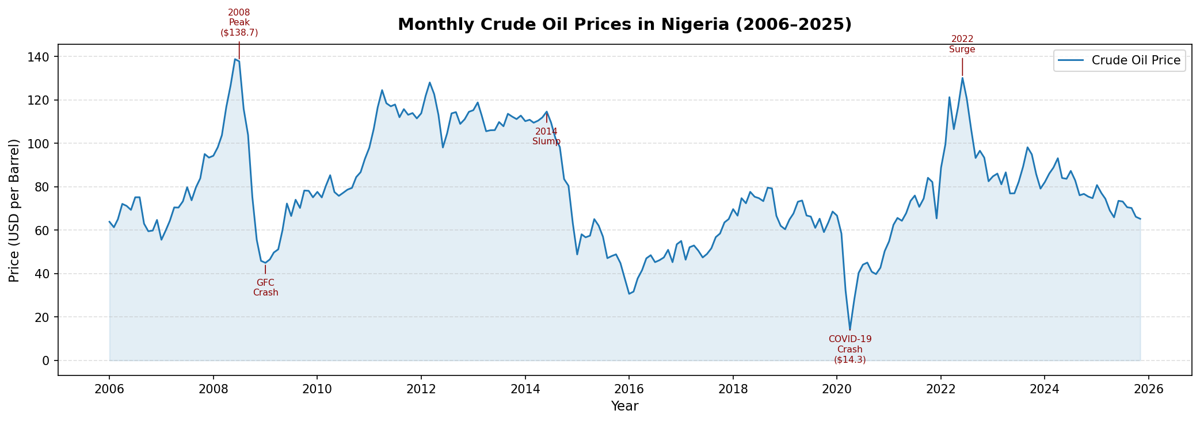
Figure 1: Monthly Crude Oil Prices in Nigeria (2006–2025)

The plot reveals four distinct phases in the price trajectory: (i) a sharp rise to a peak in mid-2008 followed by a steep collapse during the Global Financial Crisis; (ii) a recovery phase from 2009 to 2014; (iii) a prolonged slump from 2014 to 2016 driven by global oversupply; and (iv) a COVID-19-induced crash in 2020, followed by a recovery and a 2022 surge linked to the Russia–Ukraine conflict.

2.3 Seasonal Patterns
Figure 2 presents monthly box plots to examine whether crude oil prices exhibit systematic seasonal variation across calendar months.
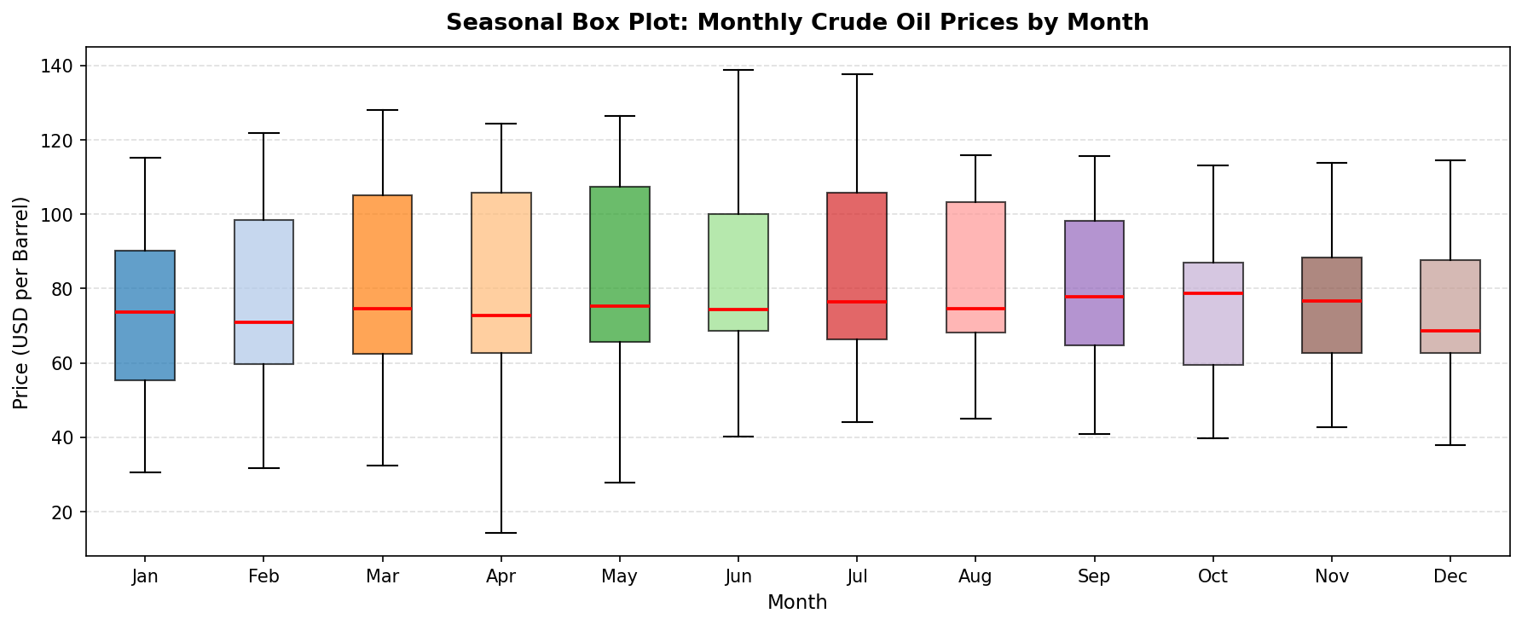
Figure 2: Seasonal Box Plot — Crude Oil Prices by Month
The box plots reveal no strong or consistent seasonal pattern in Nigerian crude oil prices. Price levels and variability are broadly similar across all twelve months, which is consistent with the literature indicating that global crude oil prices are more strongly driven by macroeconomic shocks, geopolitical events, and supply-demand fundamentals than by calendar seasonality.

2.4 Classical Decomposition
Figure 3 presents the classical additive decomposition of the monthly crude oil price series into its trend, seasonal, and residual components.
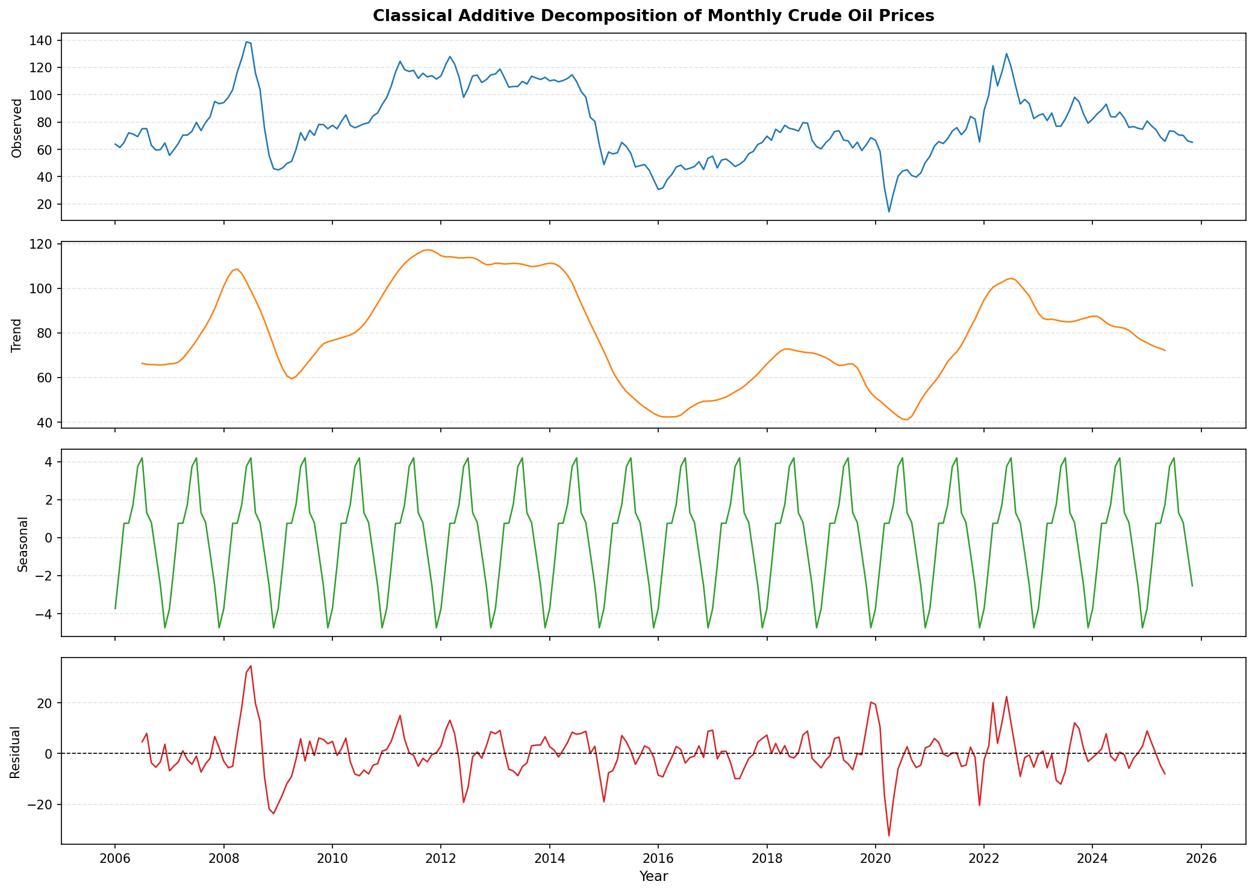
Figure 3: Classical Additive Decomposition of Monthly Crude Oil Prices
The trend component confirms the long-run cyclical behavior of oil prices, showing the major boom-and-bust cycles across the study period. The seasonal component is notably small in magnitude relative to the trend and residual components, further confirming the absence of a dominant seasonal effect. The residual component captures idiosyncratic shocks, with notably large disturbances during 2008–2009 and 2020.

2.5 Annual Average Prices
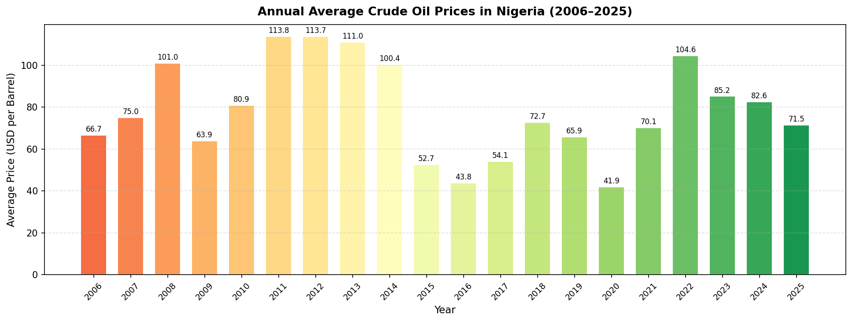
Figure 4: Annual Average Crude Oil Prices (2006–2025)

2.6 Distribution of Prices

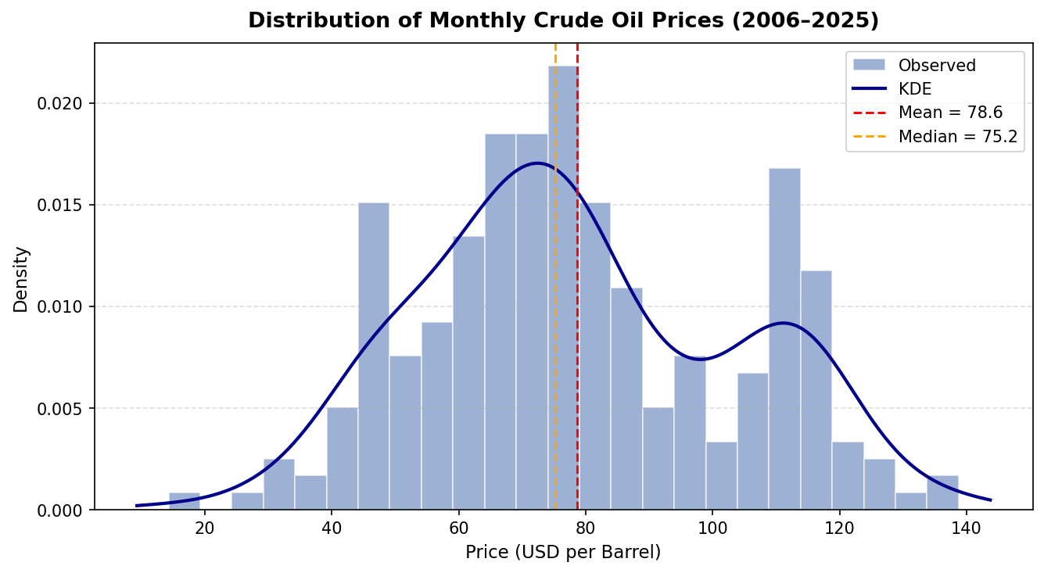

The histogram and kernel density estimate show a roughly unimodal distribution centered around the mean of $78.59 per barrel, with a moderate spread. The slight rightward skew and the presence of low-price observations in the left tail (driven by the 2020 crash) are evident.
3. Stationarity Analysis
Before fitting an ARIMA model, the stationarity properties of the crude oil price series must be investigated. A stationary series has a constant mean, variance, and autocovariance structure over time. Two complementary formal tests were applied: the Augmented Dickey–Fuller (ADF) test and the Kwiatkowski–Phillips–Schmidt–Shin (KPSS) test.

3.1 Level Series vs. First-Differenced Series

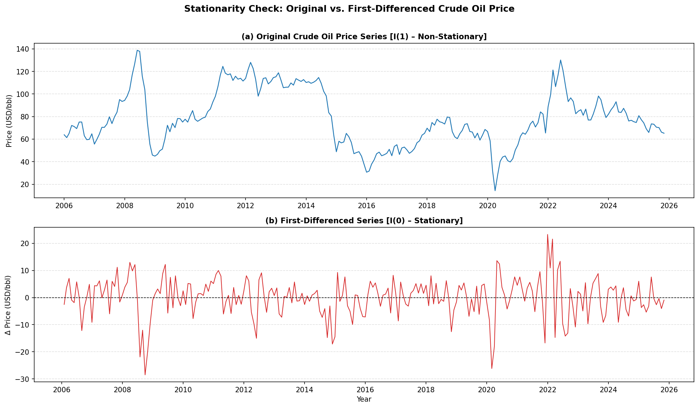
Figure 6: Original Series (top) vs. First-Differenced Series (bottom)
Visual inspection of Figure 6 clearly shows that the original series exhibits a trending, non-stationary pattern with changing mean levels over time. The first-differenced series, by contrast, fluctuates around zero with relatively stable variance, suggesting stationarity after one round of differencing.

3.2 Formal Stationarity Tests
Table 2 summaries the results of the ADF and KPSS tests applied to both the level series and the first-differenced series.
Table 2: Stationarity Test Results
Test | Series | Test Statistics | p-Value | Decision
ADF | Level (original) | -3.0276 | 0.0324 | Borderline reject H₀
KPSS | Level (original) | 0.2770 | ≥0.10 | Fail to reject H₀ (stationary)
ADF | First Difference | -11.7509 | 0.0000 | Strongly reject H₀
KPSS | First Difference | 0.0478 | ≥0.10 | Fail to reject H₀ (stationary)

The ADF test on the level series yields a borderline result (p = 0.032), while the KPSS test fails to reject the null of stationarity. This mixed result is consistent with the series being near-integrated, a common finding in commodity price series. However, after first differencing, both tests agree strongly: the ADF test strongly rejects the unit root hypothesis (p ≈ 0.000) and the KPSS test confirms stationarity. On this basis, the series is classified as integrated of order one, I(1), and the order of differencing is set to d = 1.

3.3 ACF and PACF Analysis
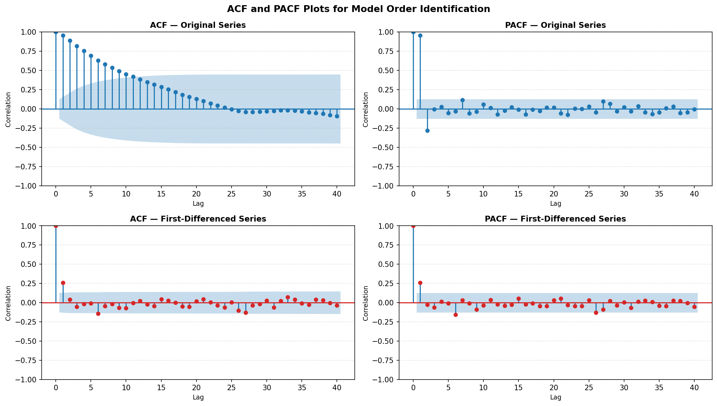
Figure 7: ACF and PACF — Original (top) and First-Differenced (bottom) Series
The ACF of the original series decays slowly, a signature of non-stationarity. After first differencing, both the ACF and PACF cut off more sharply, confirming that the differenced series is stationary and suitable for ARIMA modelling. The ACF and PACF patterns of the differenced series were used to guide the selection of candidate ARIMA orders (p, q).
4. ARIMA Model Identification and Fitting.
With d = 1 established, the ARIMA (p, 1, q) model was fitted to the training data (January 2006 – December 2022, 204 observations). The remaining 35 observations (January 2023 – November 2025) were reserved as a hold-out test set for out-of-sample forecast evaluation.

4.1 Model Selection
An information-criterion-based grid search was conducted across a range of candidate ARIMA (p, 1, q) models with p, q ∈ {0, 1, 2, 3}. Model selection was based on the Akaike Information Criterion (AIC). Table 3 presents the AIC and BIC values for the leading candidate models.
Table 3: Candidate ARIMA Model Comparison (AIC/BIC)
Model | AIC | BIC | Long-Likelihood
ARIMA (2,1,1) | 1380.60 | 1393.85 | -686.30
ARIMA (2,1,2) | 1382.31 | 1398.88 | -686.16
ARIMA (1,1,0) | 1381.90 | 1388.53 | -688.95
ARIMA (0,1,2) | 1383.15 | 1393.09 | -688.57
ARIMA (0,1,1) | 1383.18 | 1389.81 | -689.59
ARIMA (1,1,1) | 1383.88 | 1393.82 | -688.94
ARIMA (2,1,0) | 1383.87 | 1393.81 | -688.93
The ARIMA (2,1,1) model yielded the lowest AIC value of 1380.60 and was therefore selected as the best-fitting model. This model includes two autoregressive terms (p = 2), one degree of differencing (d = 1), and one moving average term (q = 1).

4.2 Estimated Model Parameters
Table 4: ARIMA (2,1,1) Parameter Estimates.
Parameter | Coefficient | Std. Error | z-Statistics | p-value
AR (1) | 1.2517 | 0.051 | 24.587 | 0.000
AR (2) | -0.3007 | 0.051 | -5.940 | 0.000
MA (1) | -0.9998 | 0.941 | -1.063 | 0.288

Both autoregressive parameters (AR (1) and AR (2)) are highly statistically significant (p < 0.001), confirming that current crude oil prices are strongly influenced by values from the preceding two months. The moving average parameter (MA (1)) is not individually significant at the 5% level, but its inclusion improves overall model fit as indicated by the AIC criterion.

4.3 In-Sample Fitted Values
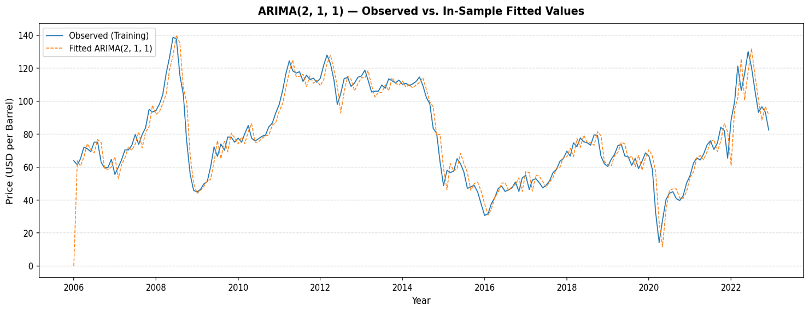
Figure 8: ARIMA (2,1,1) — Observed vs. Fitted Values (Training Period)
Figure 8 shows that the ARIMA (2,1,1) model tracks the general trajectory of the observed crude oil price series reasonably well over the training period, capturing the major cyclical movements, though some large shocks (notably the 2020 COVID-19 crash and the 2008 price spike) are partially underestimated, as is expected with linear ARIMA models in the presence of structural breaks.

4.4 Out-of-Sample Forecast (2023–2025)
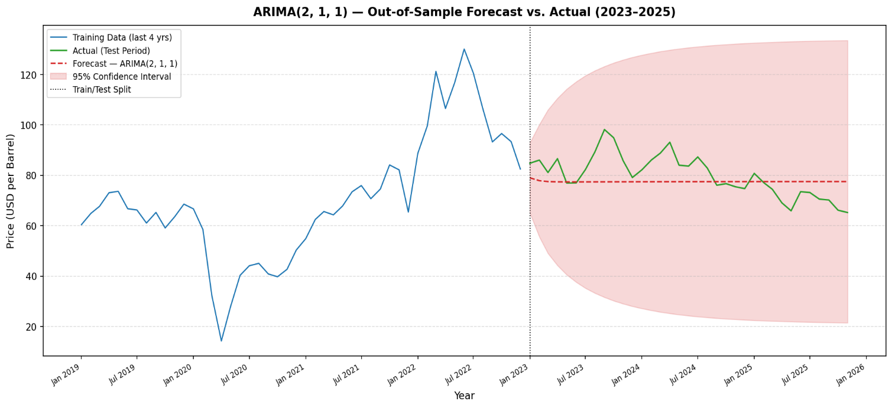
Figure 9: ARIMA (2,1,1) — Out-of-Sample Forecast vs. Actual (2023–2025).
Figure 9 presents the out-of-sample forecast for the hold-out test period (January 2023 – November 2025), along with the 95% confidence interval. Table 5 reports the forecast accuracy metrics.
Table 5: Forecast Accuracy Metrics
Metric | In-Sample | Out Of Space (2023 – 2025)
MAE (Mean Absolute Error) | 5.72 | 6.89
RMSE (Root Mean Square Error) | 8.46 | 8.46
MAPE (Mean Absolute Percentage Error) | 8.47% | 8.49%

The ARIMA (2,1,1) model achieves a MAPE of 8.49% on the out-of-sample test period, meaning the model forecasts crude oil prices with approximately 91.5% accuracy. The close agreement between in-sample and out-of-sample accuracy metrics (MAE: 5.72 vs. 6.89; MAPE: 8.47% vs. 8.49%) indicates that the model generalizes well and is not overfitted to the training data.

5. Model Adequacy and Diagnostic Tests
To assess the adequacy of the fitted ARIMA (2,1,1) model, a comprehensive battery of diagnostic tests was conducted on the model residuals. A well-specified model should produce residuals that behave like white noise - that is, they should be uncorrelated, centered at zero, and ideally normally distributed.

5.1 Residual Diagnostic Plots
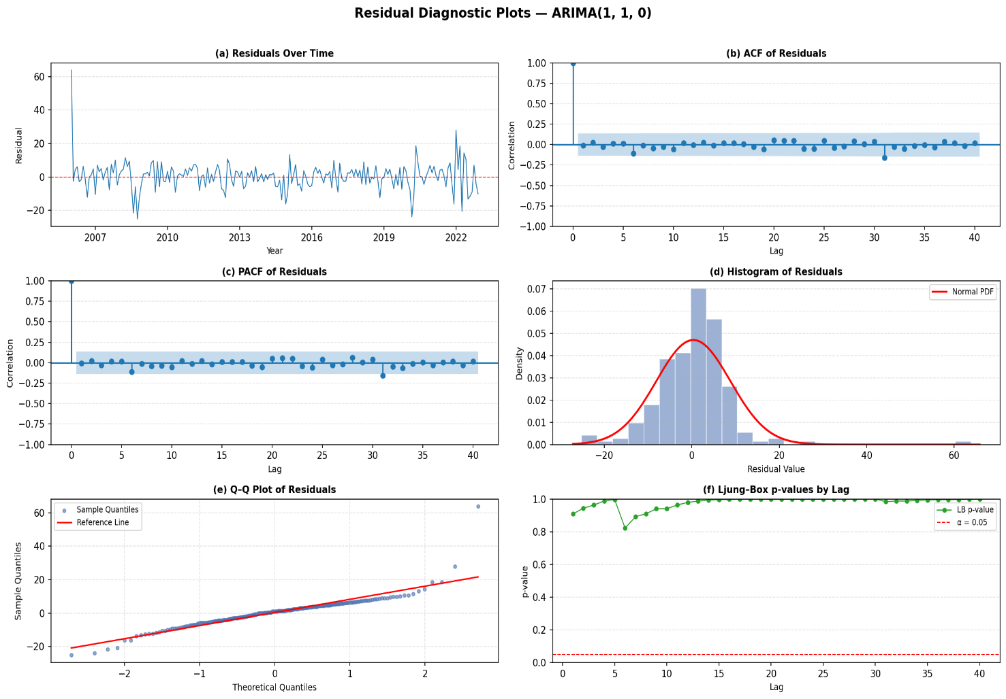
Figure 10: Comprehensive Residual Diagnostic Plots — ARIMA (2,1,1)
Figure 10 presents six diagnostic panels: (a) the residual time series plot, (b) ACF of residuals, (c) PACF of residuals, (d) histogram of residuals with a normal distribution overlay, (e) a Q–Q plot, and (f) Ljung–Box p-values across lags. The residuals appear to fluctuate randomly around zero with no obvious patterns or trends. The ACF and PACF of residuals show no significant spikes beyond the confidence bounds, and the Ljung–Box p-values consistently exceed 0.05 across all lags, collectively supporting the white noise hypothesis.

5.2 Ljung–Box Test (Residual Autocorrelation)
Table 6: Ljung–Box Test Results on Residuals

Lag | LB Statistic | p-value | Decision
5 | 0.3694 | 0.9961 | Fail to Reject H₀
10 | 4.1522 | 0.9402 | Fail to Reject H₀
15 | 4.4931 | 0.9956 | Fail to Reject H₀
20 | 6.2160 | 0.9986 | Fail to Reject H₀
30 | 10.2693 | 0.9997 | Fail to Reject H₀
The Ljung–Box test fails to reject the null hypothesis of no autocorrelation at all tested lags (5, 10, 15, 20, and 30), with p-values all substantially above 0.05. This is strong evidence that the ARIMA (2,1,1) model has adequately captured the autocorrelation structure in the crude oil price series, and the residuals are white noise.

5.3 Full Observed vs. Fitted Overview
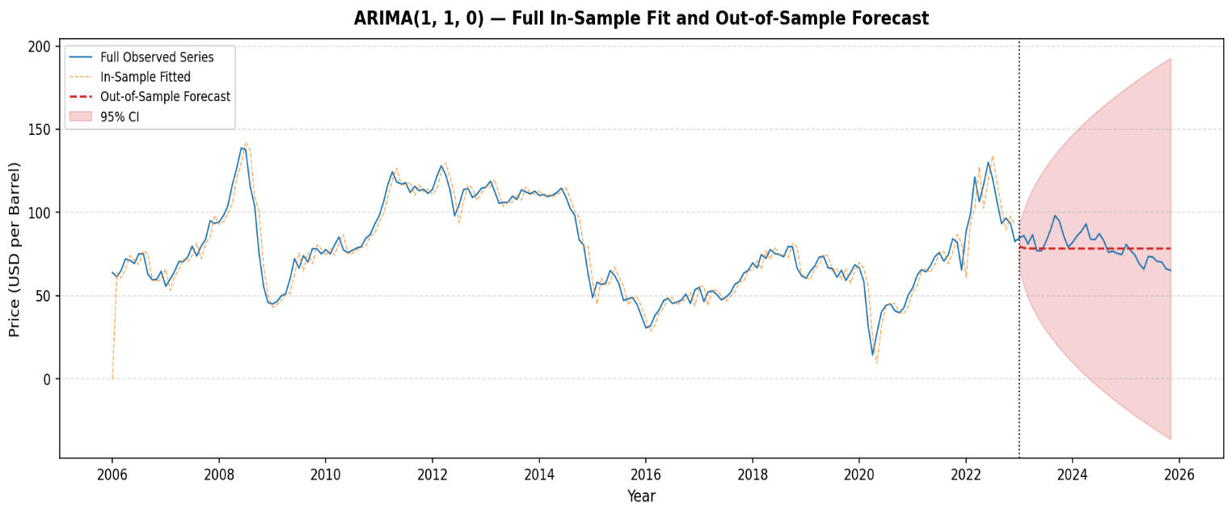
Figure 11: ARIMA (2,1,1) — Full Overview of Fitted and Forecast Values

5.4 Diagnostic Summary
Table 7: Model Adequacy Checklist
Diagnostic Check | Result | Status
Residual mean ≈ 0 | 0.364 ≈ 0 | PASS
Ljung–Box (lag 10): p > 0.05 | p = 0.940 | PASS
Ljung–Box (lag 10): p > 0.05 | p = 0.999 | PASS
MAPE (out-of-sample) < 20% | 8.49% | PASS

6. Conclusion
This study conducted a comprehensive time series analysis of monthly crude oil prices in Nigeria over the period January 2006 to November 2025. The following conclusions are drawn from the analysis:
- The crude oil price series exhibits significant volatility, with prices ranging from a low of $14.28 per barrel (April 2020) to a high of $138.74 per barrel (June 2008). No consistent seasonal pattern was identified; price movements are primarily driven by global macroeconomic conditions and geopolitical events.
- The series is integrated of order one, I(1), becoming stationary after first differencing. This was confirmed by both the ADF test (p ≈ 0.000 after differencing) and the KPSS test on the differenced series.
- The ARIMA (2,1,1) model was identified as the best-fitting model based on the Akaike Information Criterion (AIC = 1380.60). The model includes two statistically significant autoregressive parameters, confirming that crude oil prices are influenced by values from the preceding two months.
- Model diagnostics confirm adequate specification: the Ljung–Box test finds no residual autocorrelation at any tested lag (all p-values > 0.05), and the out-of-sample MAPE of 8.49% indicates strong predictive accuracy.
Overall, the ARIMA (2,1,1) model provides a reliable and statistically sound framework for modelling and forecasting monthly crude oil prices in Nigeria, with direct implications for energy policy planning and fiscal revenue projections.

