**IMS 257 (Web Interaction Programming)**

**Assignment#7 (20 pts):**

**Use jQuery Widgets in a Form**

In this exercise, you’ll modify a Reservation application by using Tabs, Datepicker, and Dialog widgets.

(**Before**)

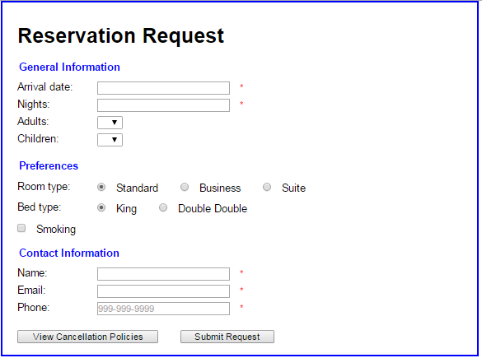

(**After**)

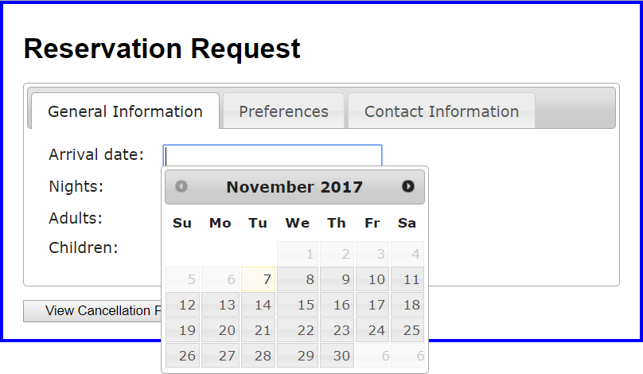

1. Go to **Canvas-Assignments-Assignment#7** and download and unzip **assignment7.zip** file. Then, run the **index.html** file to see what the user interface looks like.
2. Use Tabs widget (10pts):
   1. Modify the HTML so the contents of the three fieldset elements can be implemented as three tabs of a Tabs widget. When you do that, you should delete the fieldset and legend elements, and set the headings for the tabs to the content of the legend elements.
   2. Add the jQuery code that implements the tabs to <head> section of index.html.
3. Use Datepicker widget (10pts):

Add the jQuery code that implements the Datepicker widget for the arrival date. The available date to select can be restricted from the current date to next 90 days.

1. **(Bonus: 2 pts – Use Dialog widget)** Write jQuery code for the click event of the View Cancellation Policies button. It should then display the content of <div> element (Its id is “dialog”).

**Submission Guideline:**

You should complete **index.html** and **upload** to Canvas-Assignments-Assignment7 before the due date.