Benjamin Horn

Artificial Intelligence

Homework 2

PROBLEM 1

From Node A to Node J

Total Cost: 20

A:

Order Removed From Open List:

('A', 0, 14, 'n/a'), ('D', 8, 4, 'A'), ('B', 12, 5, 'D'), ('C', 17, 2, 'B'), ('F', 19, 1, 'C'), ('J', 20, 0, 'F')

B:

Open List when Goal Found:

[B, 19, 5, A] [F, 24, 1, B] [E, 19, 11, D] [E, 27, 11, C] [G, 28, 28, D]

Closed List when Goal Found:

('A', 0, 14, 'n/a'), ('D', 8, 4, 'A'), ('B', 12, 5, 'D'), ('C', 17, 2, 'B'), ('F', 19, 1, 'C'), ('J', 20, 0, 'F')

Total Nodes Added to Open List: 11

PROBLEM 2

From Node A to Node J

Total Cost: 20

A:

Without Bidirectional:

Path Length: 8

Number of Operations: 266

Nodes on Open List: 34

With Bidirectional:

Path Length: 8

Number of Operations: 81

Nodes on Open List: 21

Differences between the two:

While both searches give the same path length, the bidirectional requires less operations (almost half as many as without bidirectional). Because of this, the bidirectional search is faster and ends adds fewer states to the open and closed lists.

BIDIRECTIONAL EXAMPLE

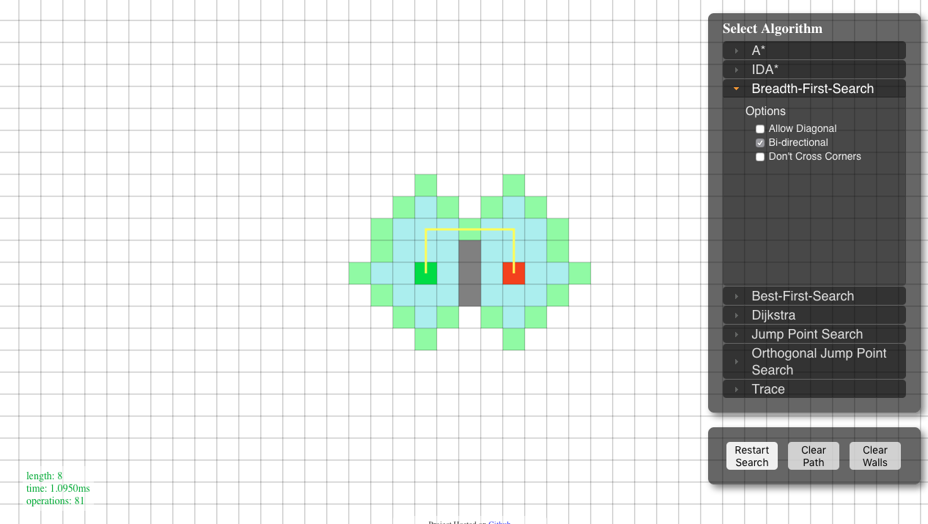

WITHOUT BIDIRECTIONAL EXAMPLE

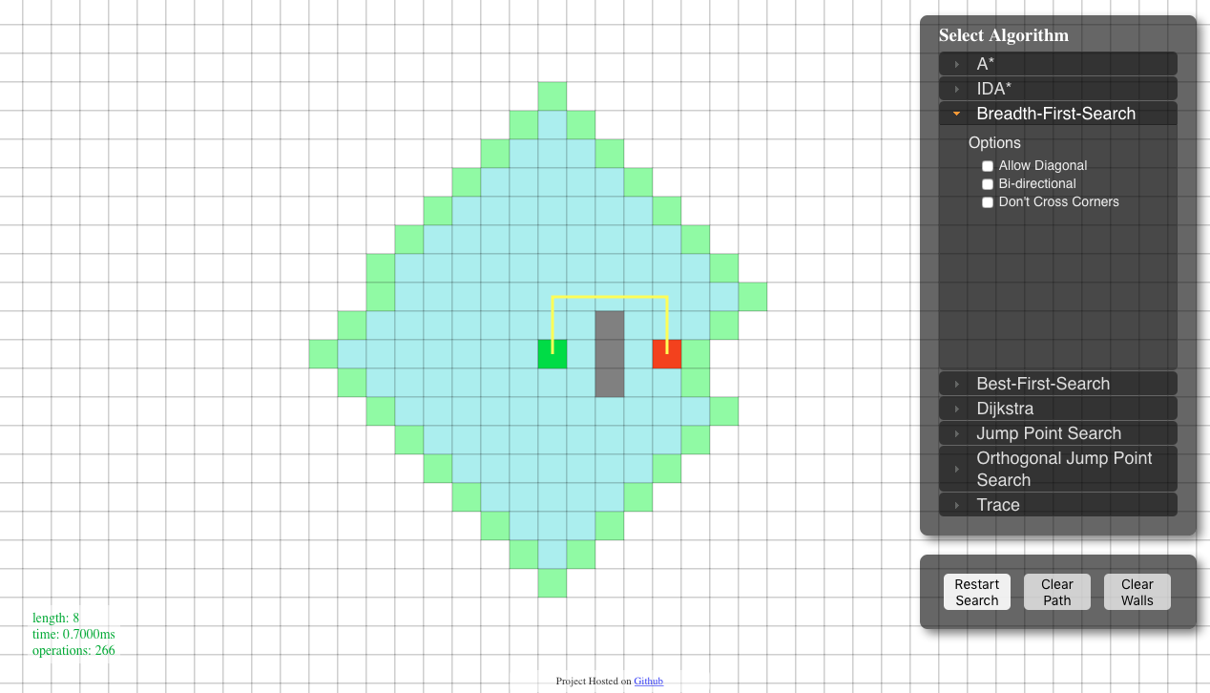

B:

Manhattan:

Path Length: 10

Number of Operations: 82

Nodes on Open List: 18

Euclidean:

Path Length: 10

Number of Operations: 96

Nodes on Open List: 20

Differences between the two:

Both heuristic estimations give the same path length, but the Manhattan does it in less operations. It adds less nodes to the open and closed list than the Euclidean does. However, even though the Manhattan has less operations, it seems to be slightly slower than the Euclidean at times.

MANHATTAN EXAMPLE:

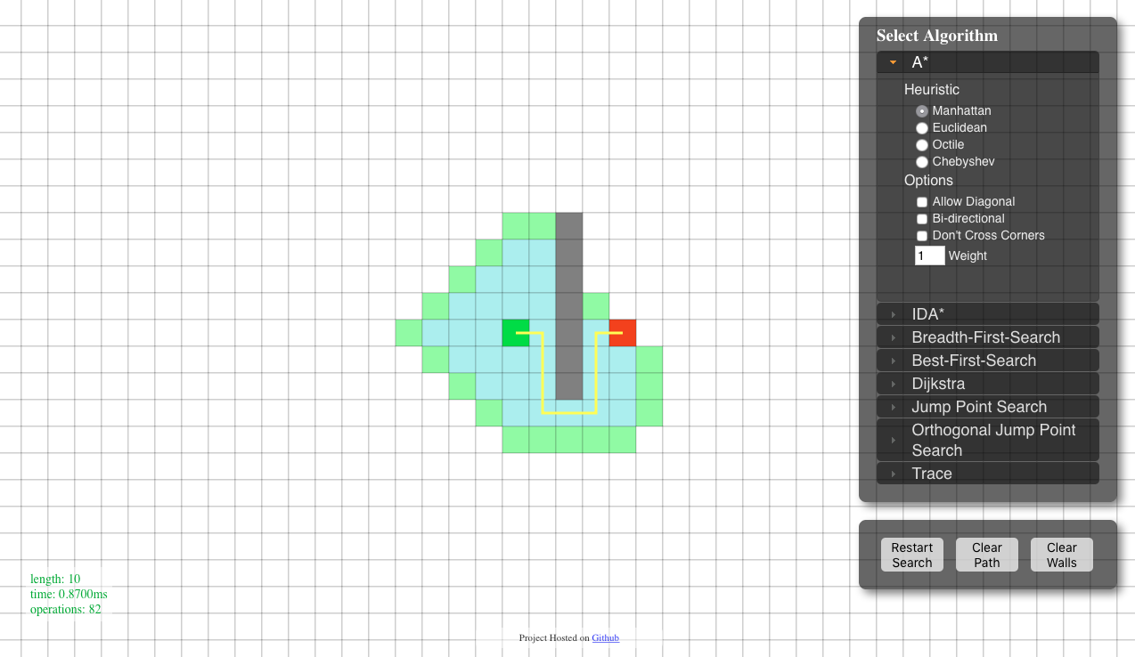

EUCLIDEAN EXAMPLE:

