FARM MASTER
INFORMATION ARCHITECTURE
Stage 2 — Sitemap & User Flow Diagrams
Prepared for: Farm Master Ghana Limited (Tema, Greater Accra Region)
Builds on: Farm_Master_PRD_Stage1.docx
Date: 2 September 2026 (Rev. 2 — confirmed by Emmanuel)
Status: CONFIRMED — proceeding to Stage 3

1. Purpose of This Document
This is the Stage 2 deliverable: every screen across the public site, the three portals, and Farm Master's internal operations, plus how they connect to one another; and the three core user journeys already named in the Business Concept Document, drawn as step-by-step flows. Nothing here is styled yet — Stage 4 handles visual design. The point of this stage is to catch structural and handoff mistakes while they're still cheap to fix.
Built on the confirmed Stage 1 pilot parameters (PRD Section 1.1): pilot region Tema (Greater Accra), single pilot crop maize, buyers and vendors onboarded through open public registration rather than pre-selected relationships, both Farm Master-owned and third-party vendors from day one, and a MoFA data-exchange touchpoint on the internal Control Centre — verified institutional buyer data coming in, a generic CSV/PDF compliance report (volume, quality grade, buyer, delivery date) going out.
Legend: Solid green = Phase 1 pilot must-have. Dashed grey = deferred to Phase 2+. Amber = MoFA data-exchange touchpoint (new this stage).

2. System Map
How the public site, three portals, internal Control Centre, Logistics & Fulfilment Module, Shared Services, and MoFA connect. Numbered arrows trace the core order-to-farm-to-buyer loop from the Business Concept Document (Section 3.2) — for the pilot, this loop runs on maize orders aggregated through the Tema fulfilment centre.
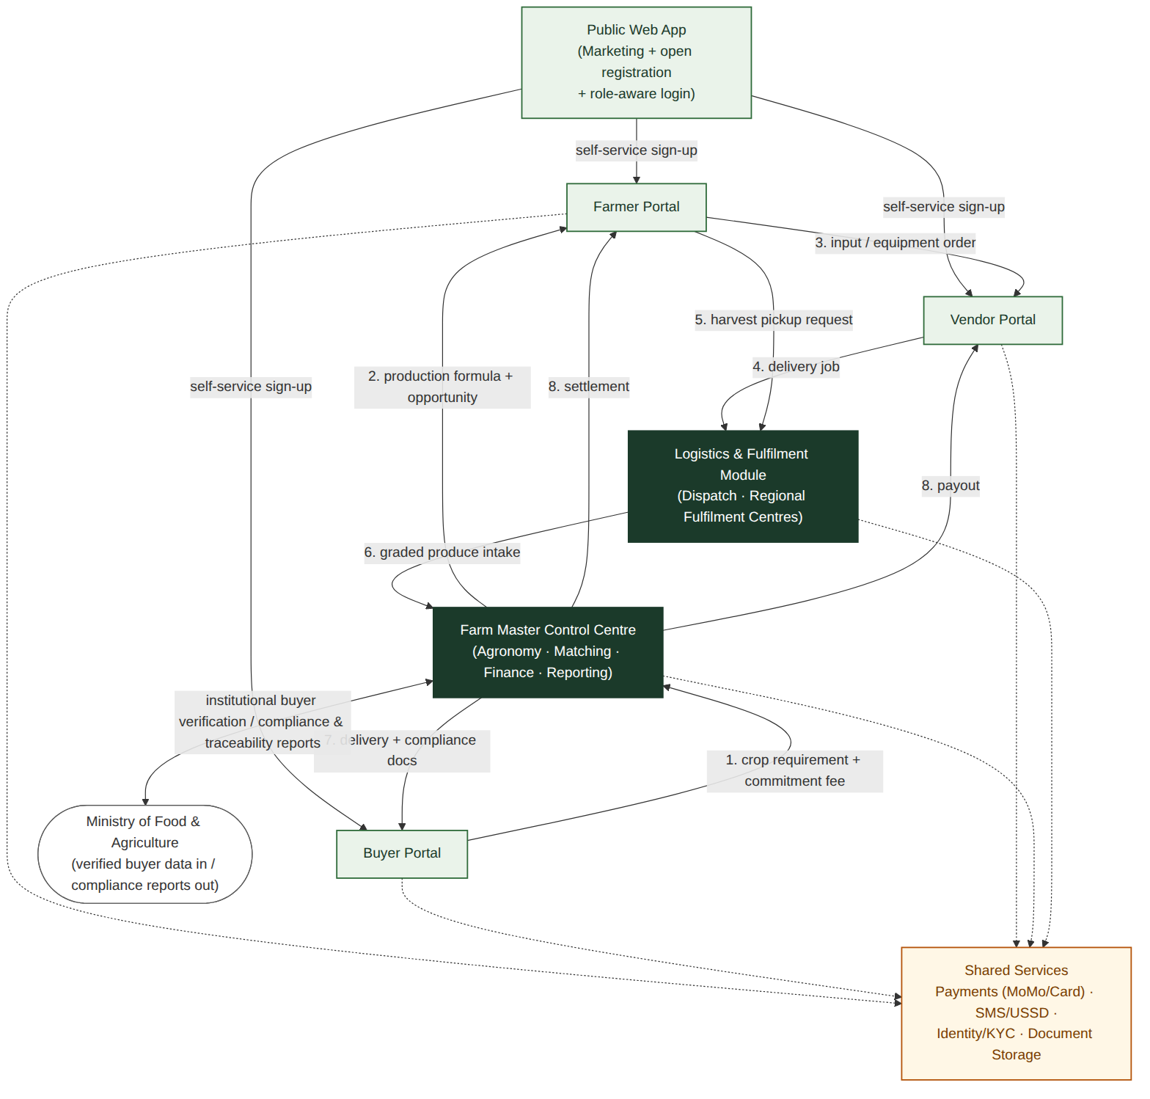
Figure 1 — Farm Master platform system map

3. Sitemap

3.1 Public / Marketing Site
The public entry point — open registration for all three roles, per your confirmation, rather than an invite-only pilot gate. This matters more than it might otherwise, since the pilot's 2–3 anchor buyers (including one MoFA-linked buyer) are being onboarded cold rather than from an existing relationship.
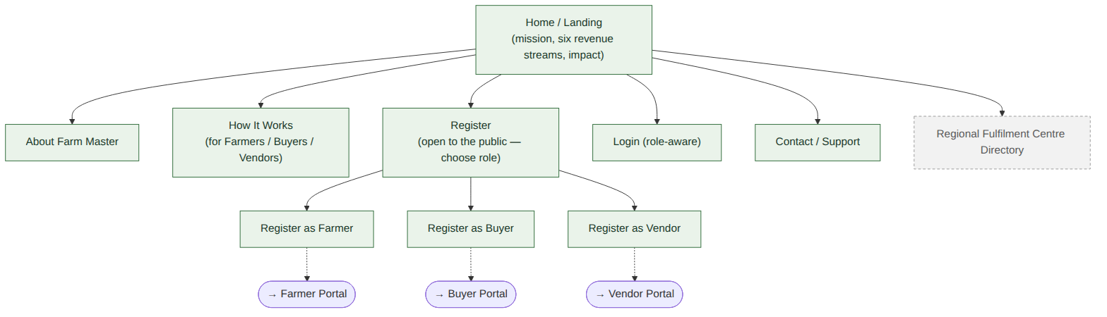
Figure 2 — Public site sitemap

3.2 Farmer Portal
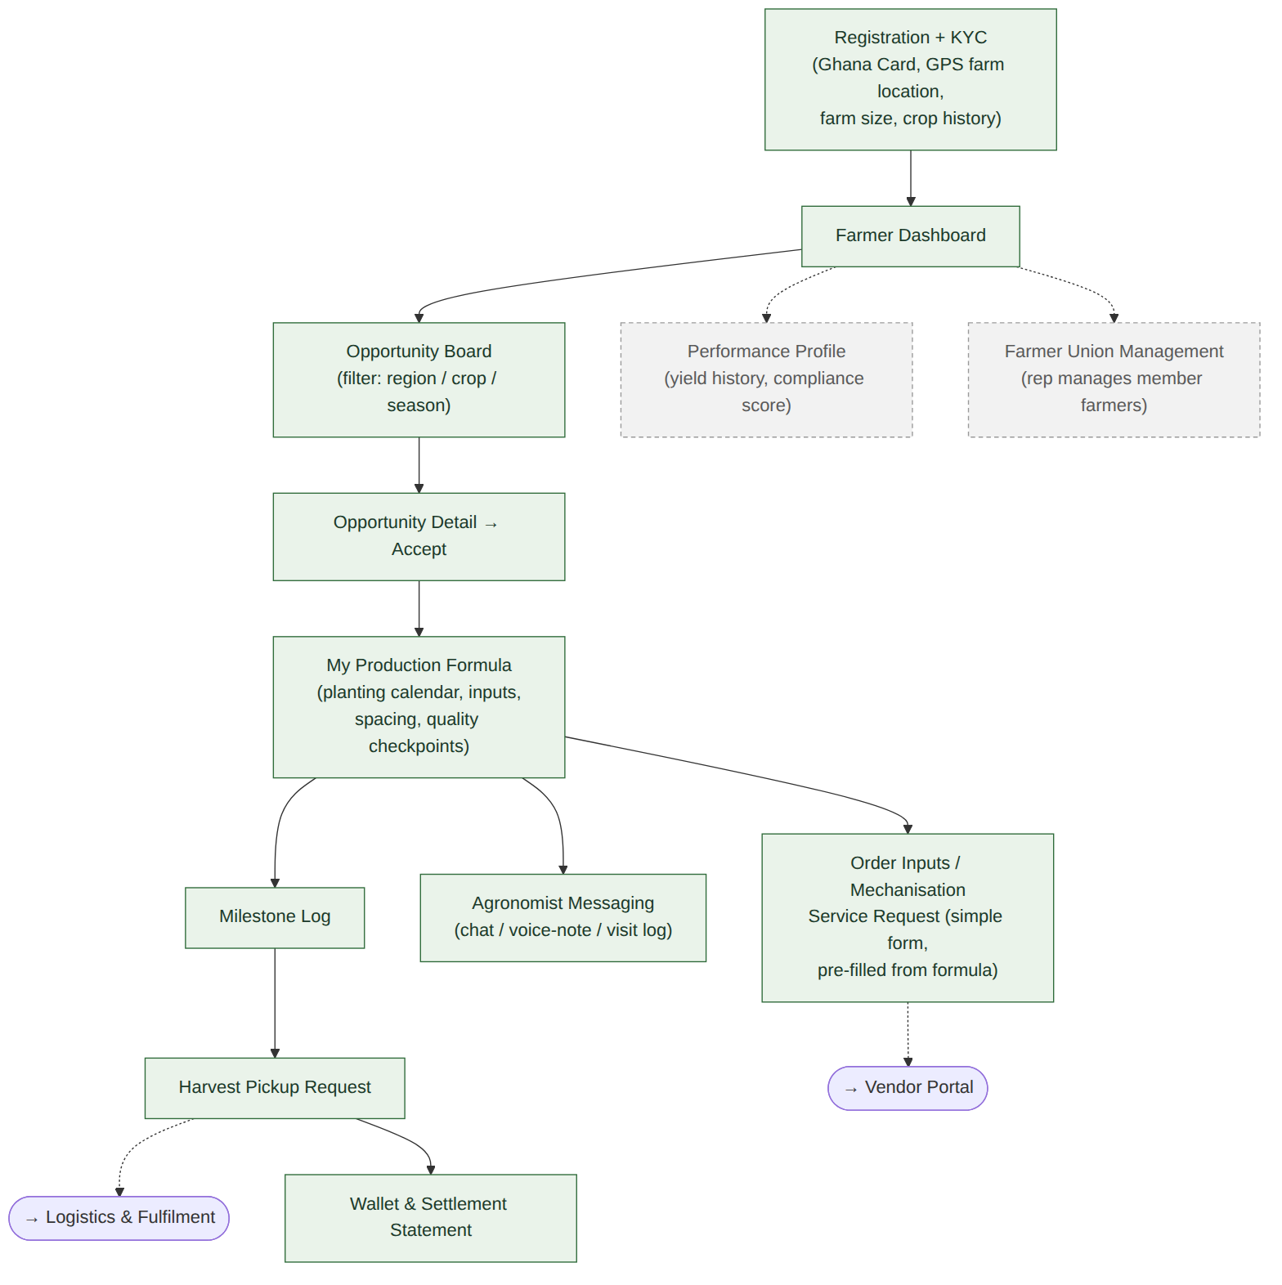
Figure 3 — Farmer Portal sitemap

3.3 Buyer Portal
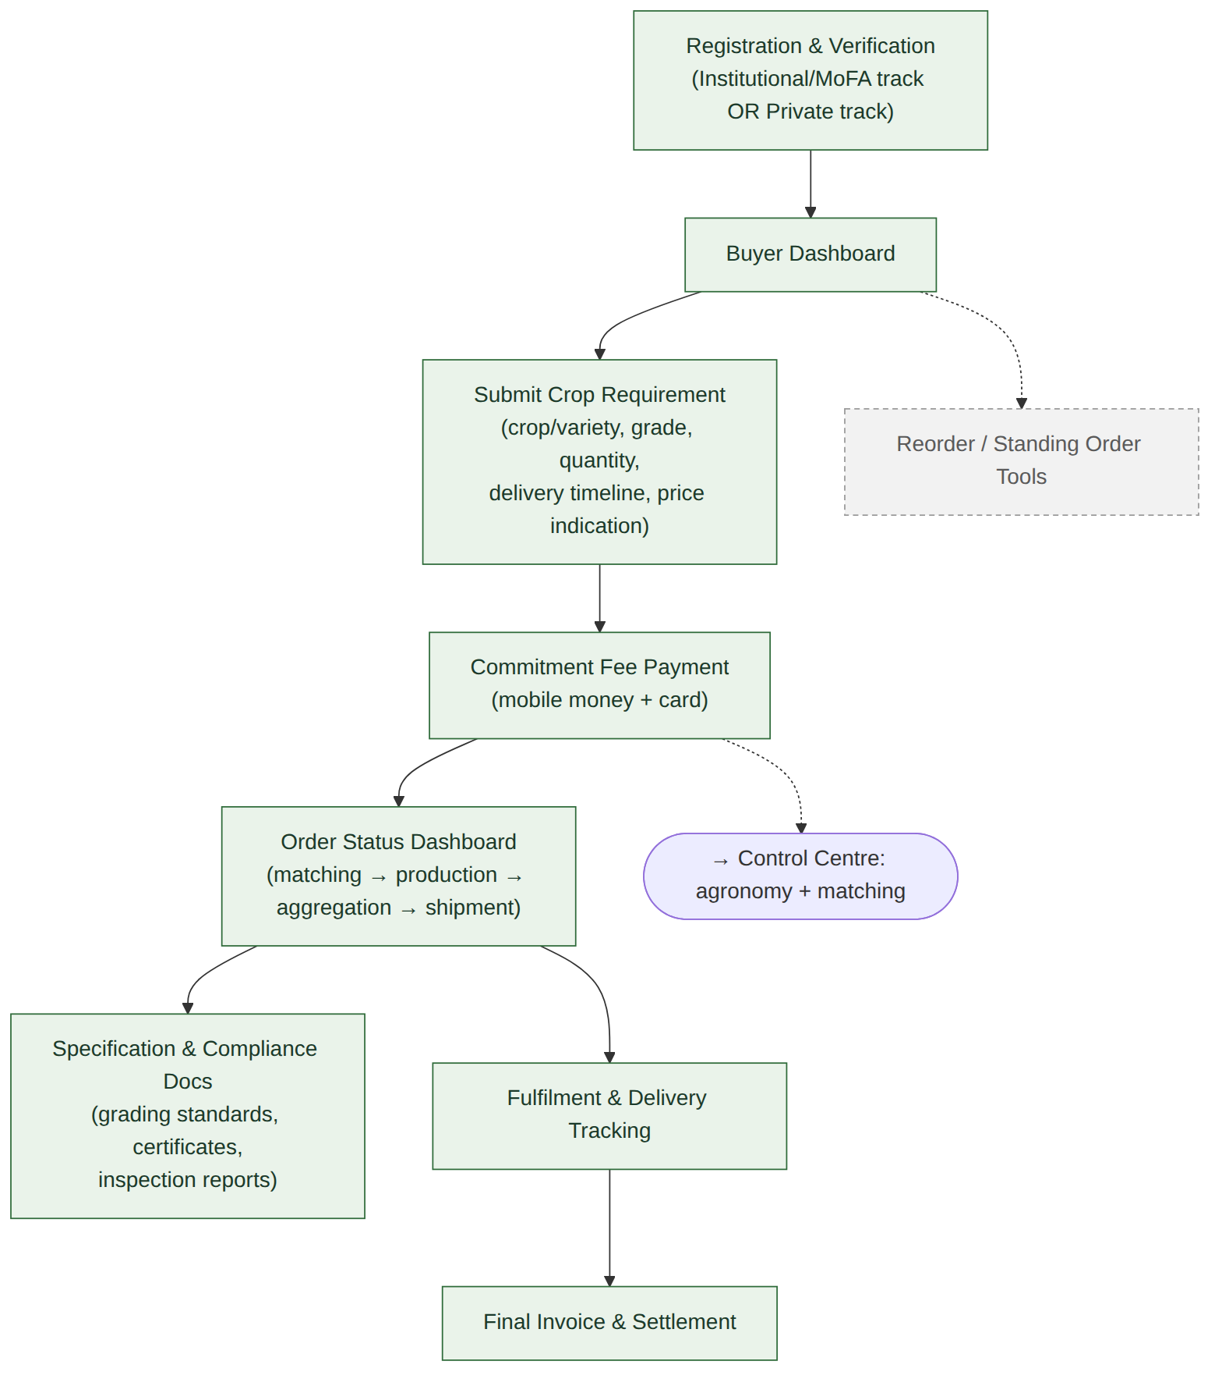
Figure 4 — Buyer Portal sitemap

3.4 Vendor Portal
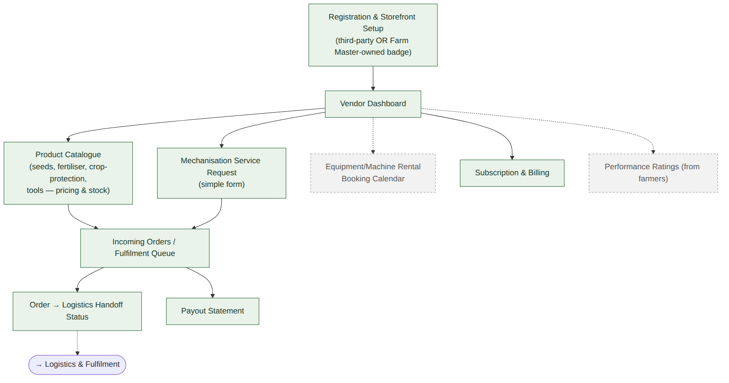
Figure 5 — Vendor Portal sitemap

3.5 Farm Master Internal Operations (Control Centre + Logistics & Fulfilment)
Kept as one combined map since these two layers are tightly coupled operationally, even though Logistics is rider/field-facing while the Control Centre is office-facing. The MoFA Data Exchange screen (amber) is new this stage, added in response to your confirmation that the platform needs MoFA data.
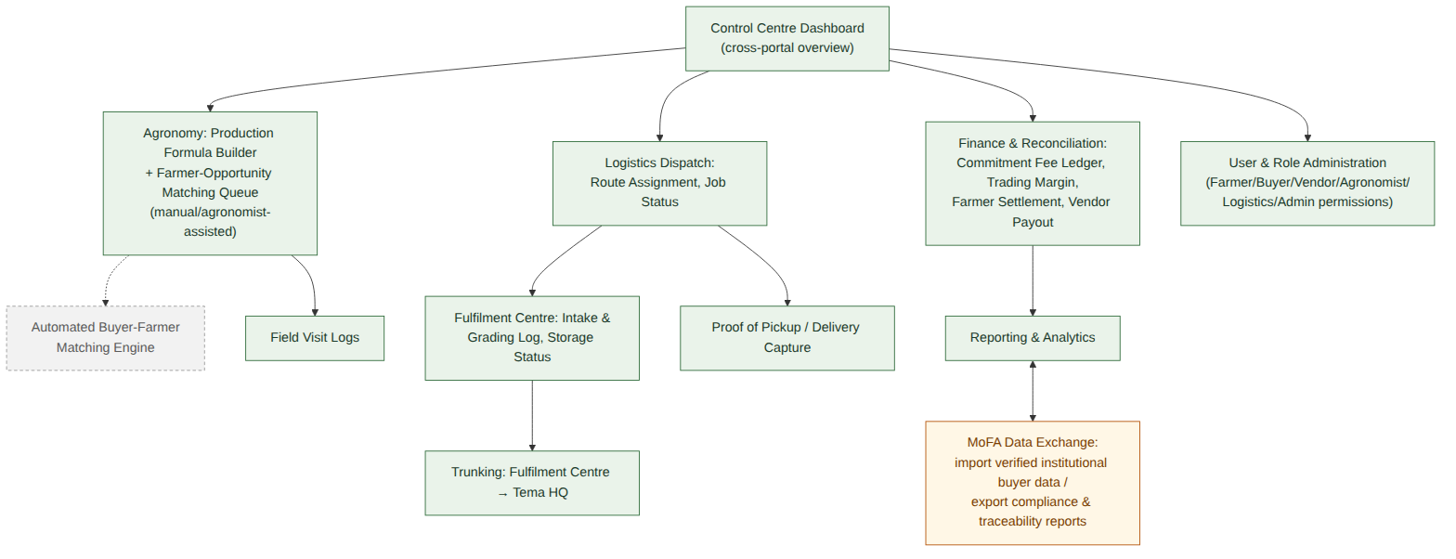
Figure 6 — Internal operations sitemap

4. User Flow Diagrams
The three core journeys named in the Business Concept Document (Sections 4.2, 5.2, 6.2), drawn as step-by-step flows with the decision points that matter most — payment success, opportunity acceptance, and specification compliance.

4.1 Buyer Journey
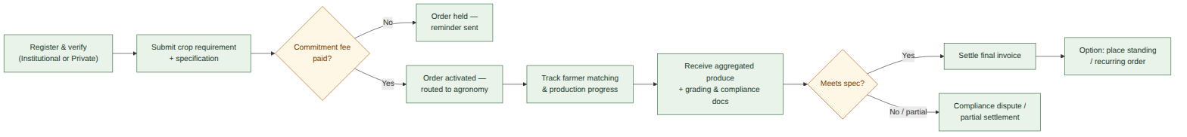
Figure 7 — Buyer journey: submit requirement → pay → track → receive → settle

4.2 Farmer Journey
Figure 8 — Farmer journey: register → accept opportunity → produce → harvest → settle

4.3 Vendor / Farmer Purchase Journey
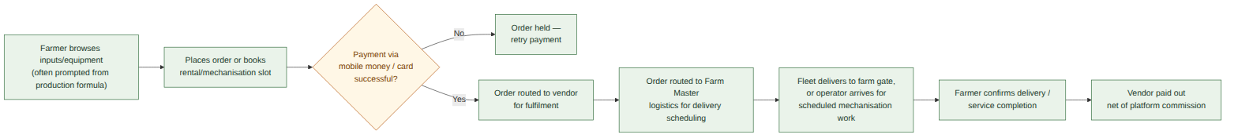
Figure 9 — Vendor/farmer purchase journey: browse → order → fulfil → deliver → payout

5. Cross-Portal Handoffs (Summary)
The dependencies that make this a genuine end-to-end system rather than three separate apps. These are the handoffs Stage 3's wireframes need to make visually obvious, since a break at any one of them stalls the whole order:
# | Handoff | From → To
1 | Crop requirement + commitment fee | Buyer Portal → Control Centre (Agronomy)
2 | Production formula + opportunity | Control Centre → Farmer Portal
3 | Input / equipment order | Farmer Portal → Vendor Portal
4 | Delivery job | Vendor Portal → Logistics & Fulfilment
5 | Harvest pickup request | Farmer Portal → Logistics & Fulfilment
6 | Graded produce intake | Logistics & Fulfilment → Control Centre
7 | Delivery + compliance docs | Control Centre → Buyer Portal
8 | Settlement / payout | Control Centre → Farmer Portal & Vendor Portal

6. Screen Inventory — Phase 1 Pilot vs. Deferred
Consolidated from the sitemaps above, matched against the must-have features locked in Stage 1 (PRD Section 6). Anything marked Deferred is deliberately excluded from Stage 3 wireframes unless you tell me otherwise.
Portal / Module | Phase 1 Pilot Screens | Deferred (Phase 2+)
Public Site | Home, About, How It Works, Register (Farmer/Buyer/Vendor), Login, Contact | Regional Fulfilment Centre directory
Farmer Portal | Registration/KYC, Dashboard, Opportunity Board, Opportunity Detail, Production Formula, Milestone Log, Agronomist Messaging, Order Inputs, Harvest Pickup Request, Wallet/Settlement | Performance Profile, Farmer Union Management (confirmed Phase 2 — PRD Section 3.1)
Buyer Portal | Registration & Verification, Dashboard, Submit Requirement, Commitment Fee Payment, Order Status, Compliance Docs, Delivery Tracking, Final Invoice | Reorder / Standing Order tools
Vendor Portal | Registration & Storefront, Dashboard, Product Catalogue, Mechanisation Service Request (simple form), Order Queue, Logistics Handoff Status, Subscription & Billing, Payout Statement | Equipment Rental Booking Calendar, Performance Ratings
Internal Operations | Control Centre Dashboard, Production Formula Builder, Matching Queue (manual), Field Visit Logs, Fulfilment Centre Intake/Grading, Logistics Dispatch, Proof of Pickup/Delivery, Trunking, Finance & Reconciliation, Reporting, MoFA Data Exchange, User & Role Admin | Automated Buyer-Farmer Matching Engine

7. What Changed From Stage 1
- Public registration confirmed. All three roles (Farmer, Buyer, Vendor) self-register from the public site rather than being onboarded only through hand-picked anchor relationships — consistent with the confirmed cold-onboarding approach for pilot buyers (PRD Section 1.1).
- MoFA Data Exchange screen added. Placed under Internal Operations (Section 3.5, Figure 6) as a two-way integration point: importing verified institutional buyer/accreditation data from MoFA, and exporting a generic CSV/PDF compliance report — volume, quality grade, buyer, and delivery date — per the confirmed MoFA reporting approach (PRD Section 1.1). The exact report template is expected to be refined once Emmanuel has an actual MoFA standard to design against.
- Farmer Union Management resolved. Confirmed deferred to Phase 2 (PRD Section 3.1) — every pilot registrant is an individual farmer profile, so this stays out of the Farmer Portal sitemap's pilot set (Section 6).
- Pilot crop and region threaded through. The system map, production-formula screen, and fulfilment-centre intake screen are all scoped to a single crop (maize) moving through a single fulfilment centre (Tema) for the pilot — this keeps Stage 3's wireframes concrete rather than generic.
- Agronomist Messaging confirmed in pilot scope. Stays as a Phase 1 pilot screen in the Farmer Portal sitemap (Figure 3) and the screen inventory (Section 6) — not simplified out.
- Equipment/input ordering label corrected. The Farmer Portal's input-ordering screen (Figure 3) and the Vendor Portal's mechanisation screen (Figure 5) were both relabelled to "...simple form" rather than implying a booking calendar — the calendar-based rental module stays correctly scoped as deferred (Figure 5, dashed grey), matching the Section 6 screen inventory.

8. Assumptions & Open Questions
- Agronomist Messaging is shown as a Phase 1 pilot screen (a chat/voice-note/visit-log channel), even though it wasn't in the Stage 1 five-item must-have list — the production formula alone is of limited use without a way to ask the assigned agronomist a question. If you'd rather keep this out of the pilot and route farmer questions through a phone number or SMS instead, tell me and I'll simplify it before Stage 3.
- Logistics fleet scale (placeholder 3–5 tricycles, per PRD Section 1.1) doesn't change this stage's sitemap, but will shape how much route-planning complexity the Logistics Dispatch screen needs in Stage 3 — worth your final number before wireframing that screen specifically.
Neither of these needs resolving before Stage 3 starts. I'll proceed to Stage 3 (low-fi wireframes) using what's marked Phase 1 pilot above, starting with the Buyer Portal or Farmer Portal — your call on which one to wireframe first, per the workflow guide's "start with whichever portal is most central to your pilot."

