1)

SELECT *

FROM bestellingen;

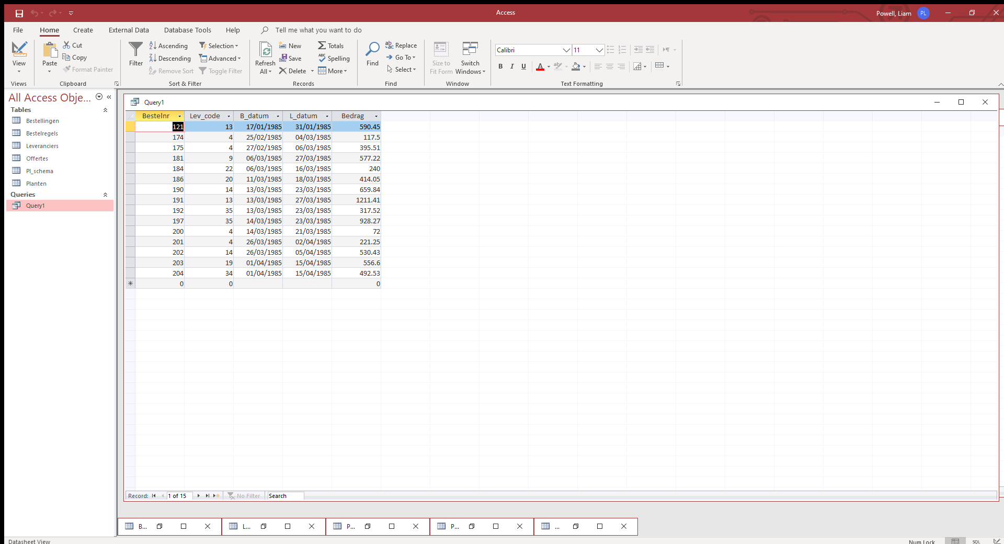

15

2)

SELECT Bestelnr

FROM bestellingen;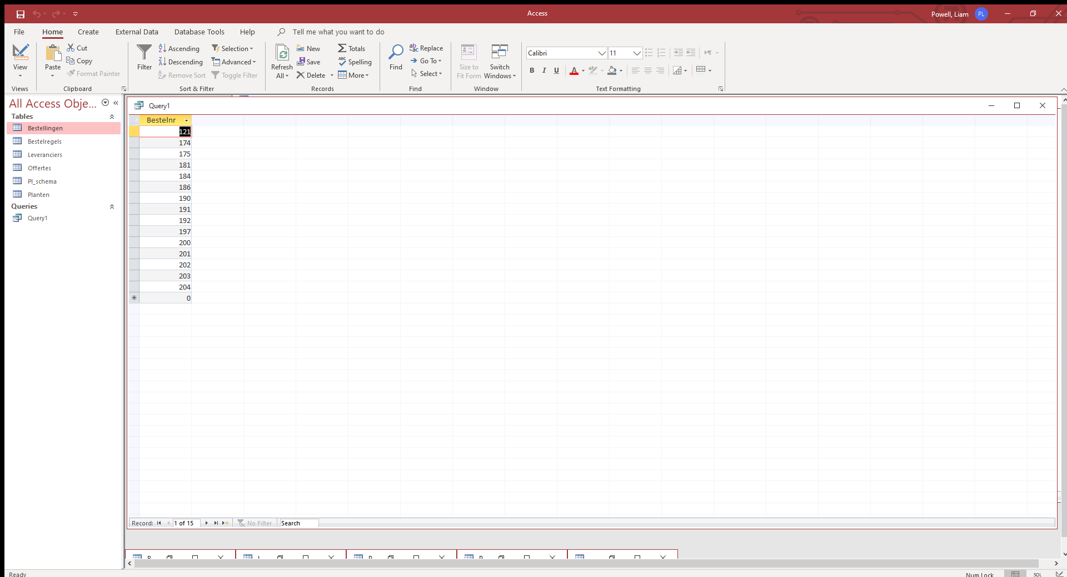

3)

SELECT Bedrag

FROM bestellingen;

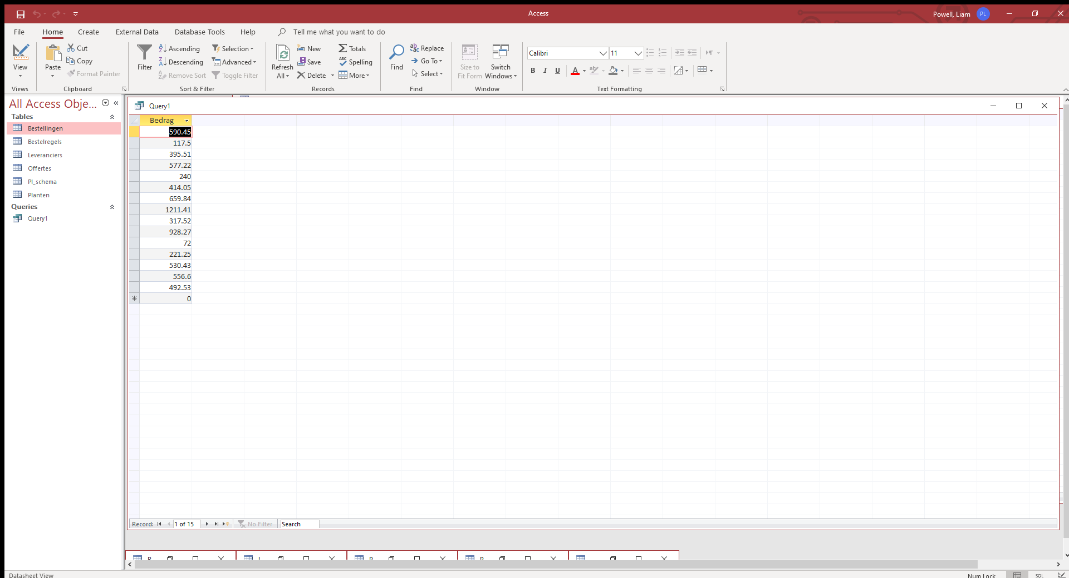

4)

SELECT Lev_code

FROM bestellingen;

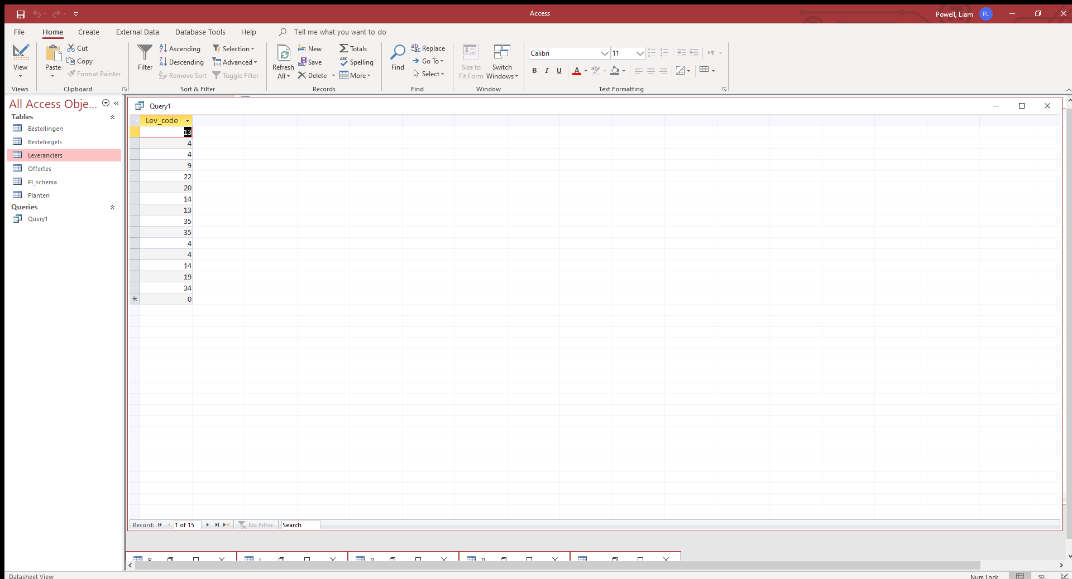

5)

SELECT *

FROM bestellingen

WHERE Lev_code

AND Bedrag > 10;

