%% HW2 for AMATH422

% @Author: Baihan Lin

% @Date: Nov 2016

clear all; close all; clc;

rng(1);

**%% I. Dwell time distributions: theory**

% ion channel with 4 open states and 2 closed states

% Mathematical arguement:

%

% Assume our Markov Matrix for this system, 6 X 6 matrix,

% is power-positive. Then, for any vector v,

% sum_i([A*v]) = sum_i(sum_k([a_ik * v_k])) = sum_k(v_k)

%

% For v, the dominant eigenvalue is:

% sum_i([A*v]) = sum_i(lamda*v_i) = lamda*sum_k(v_k)

% This implies lamda = 1, using sum_k(v_k) != 0

%

% Then, there exists, lamda as positive real number, and v > 0

% such that A*v = lamda*v, and |lamda| > |lamad_l| for all other

% eigenvalue lamda_l.

%

% Based on power positive stochastic 6 X 6 matrix A,

% lamda = 1 as dominant eigenvalue.

% p(k) -(k->inf)-> c_1*lamda^k * v = c_1 * v_1 = pi

% which is the equilibirium distribution for this Markov chain

%

% Since power-positive, lim (k->inf) (A^k * p(0)) = pi for any p(0)

% Thus, the answer to our question, the probability distribution for

% dwell time in open states, should be exponential in a certain type,

% but as a combination of four exponential function.

% [P1(k+1);P2(k+1);P3(k+1);P4(k+1);P5(k+1);P6(k+1);] as P(k+1)

% P(k+1) = A*P(k);

% If P1, P2, P3, P4 means open states.

% P_open(k+1) = P1(k+1)+P2(k+1)+P3(k+1)+P4(k+1)

% = sum_j(P(k)*(a1j+a2j+a3j+a4j))

% = sum_j(P(1)*(a1j+a2j+a3j+a4j)^(k-1))

% Q.E.D.!

**%% II. Simulating Markov Chains and dwell times**

% Markov Matrix

A = [0.98 0.1 0;

0.02 0.7 0.05;

0 0.2 0.95 ];

% across the entire time frame

Nstep = 10^7;

S = zeros(1,Nstep); % states

S(1) = 1; % from C1

% simulation of Markov Chains

for k=1:Nstep-1

rd=rand ;

if rd < A(1,S(k))

S(k+1) = 1; % S(k+1) = S1 (C1)

elseif rd < A(1,S(k))+A(2,S(k))

S(k+1) = 2; % S(k+1) = S2 (C2)

else

S(k+1) = 3; % S(k+1) = S3 (O)

end

end;

% plot the firstatet 1000 steps since 10^7 is too long

fig1 = figure

set(gca,'FontSize',18);

plot(1:1000,S(1:1000),'.','Markersize',20);

xlabel('Nstep','FontSize',16);

ylabel('States','FontSize',16);

title('Simulation of Markov Chain over Nstep = 1000');

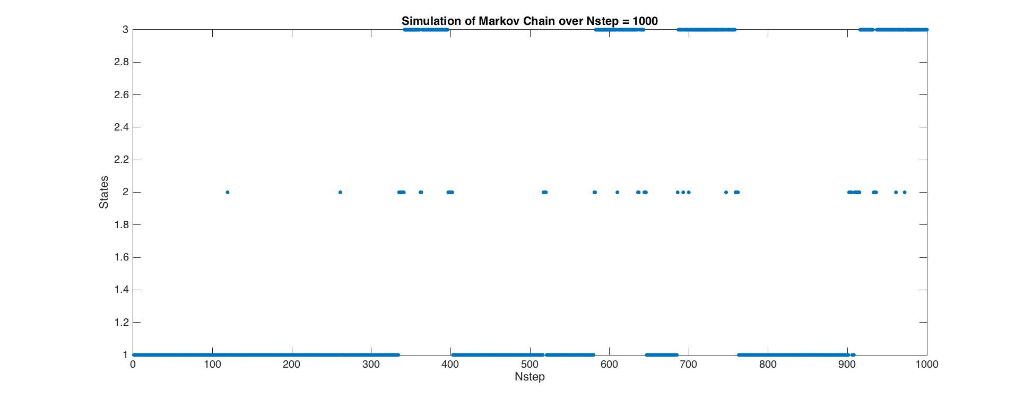

% Calculate dominant eigenvector

[V,D] = eig(A);

lamdas = diag(D);

jmax=find(abs(lamdas) == max(abs(lamdas))) ;

dom_eigenvec=V(:,jmax);

rescaled_dom_eigenvec = dom_eigenvec/sum(dom_eigenvec)

% Output of rescaled_dom_eigenvec:

% 0.5000

% 0.1000

% 0.4000

% fraction of time in each state with outputs:

S1 = length(find(S==1))/Nstep % 0.4999

S2 = length(find(S==2))/Nstep % 0.1000

S3 = length(find(S==3))/Nstep % 0.4001

% Here the fractions match with the rescaled dominant eigenvector.

% reduced states

rstate = S;

rstate(find(S == 2)) = 1; % reduction

% Find dwell times in the different reduced states.

dt_closed=[];

dt_open=[];

% Initial Condition

S_0 = rstate(1);

Nstep_0=1;

for k = 2:length(rstate)

if rstate(k) ~= S_0

dt = k- Nstep_0 + 1;

if S_0==1

dt_closed = [dt_closed dt];

else

dt_open = [dt_open dt];

end

S_0=rstate(k);

Nstep_0=k;

end

end

%plot histograms

fig2 = figure

subplot(211)

[Nc,xc]=hist(dt_closed,200);

bar(xc,Nc)

axis([0 max(xc)/4 -Inf Inf])

xlabel('dt')

ylabel('freq')

title('histogram of dt_ closed')

subplot(212)

bar(xc(1:50),log(Nc(1:50)))

xlabel('log(dt)')

ylabel('freq')

title('histogram of log(dt_ closed)')

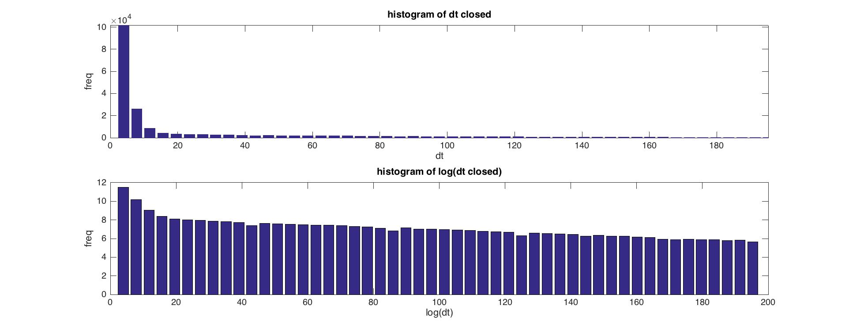

fig3 = figure

subplot(211)

[No,xo]=hist(dt_open,500);

bar(xo,No)

axis([0 max(xo)/4 -Inf Inf])

xlabel('dt')

ylabel('freq')

title('histogram of dt_ open')

subplot(212)

bar(xo(1:50),log(No(1:50)))

xlabel('log(dt)')

ylabel('freq')

title('histogram of log(dt_ open)')

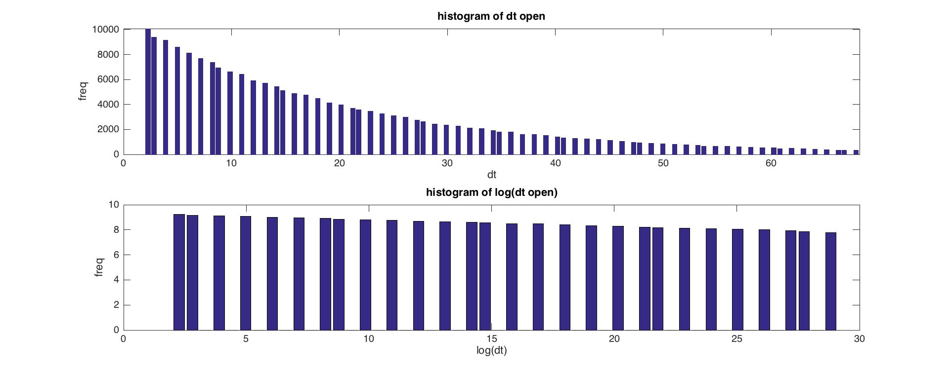

% Based on the hypothesis, here we fit it to a single exponential:

fig4 = figure;

plot(1:length(No),log(No)) %see what we're fitting

title('log(dt open) fitting to exponential')

parao = polyfit(1:50,log(No(1:50)),1) % -0.0666 8.7731

E_ajj = exp(parao(1)) % 0.9355

% Based on the hypothesis, here we fit it to a single exponential:

fig5 = figure;

plot(1:length(Nc),log(Nc)) %see what we're fitting

title('log(dt closed) fitting to exponential')

parac = polyfit(1:50,log(Nc(1:50)),1) % -0.0666 8.7731

E_ajj = exp(parac(1)) % 0.9355

% We see the distribution of dwell times for the open state

% fits exponential well (log graph almost linear). But the

% distribution for closed states is not, perhaps due to two

% different close states.

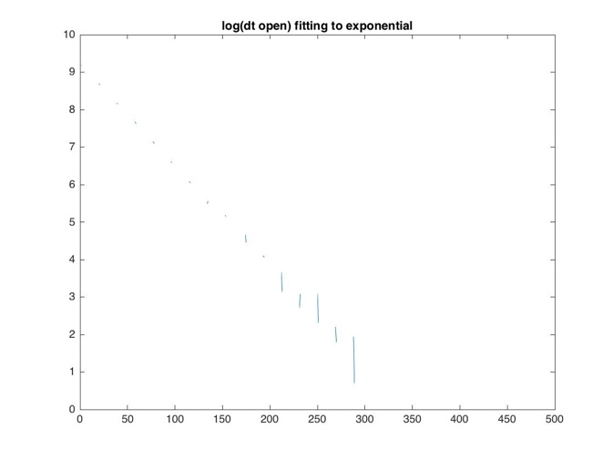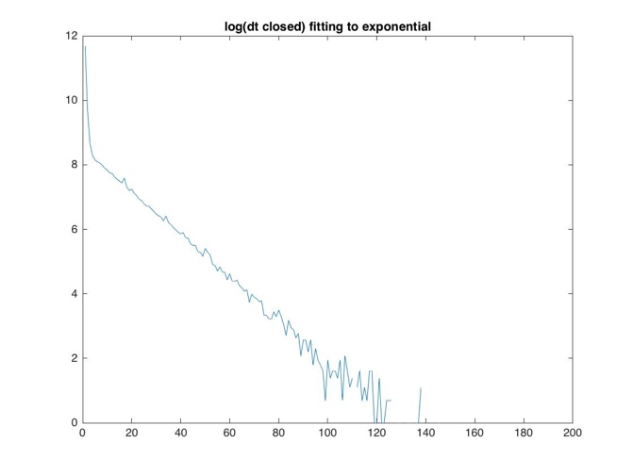

**%% III. Simulating Markov Chains and neural spiking**

Trial = 1000;

Nin = 10;

Nout = 5;

Snet = zeros(1, Trial);

% Markov Matrices

Ain = [0.98 0.1 0;

0.02 0.7 0.05;

0 0.2 0.95 ];

Aout = [0.9 0.1 0;

0.1 0.6 0.1;

0 0.3 0.9 ];

% across the entire time frame

Nstep = 10^6;

for t = 1:Trial

Sin = zeros(Nin,Nstep);

Sout = zeros(Nout,Nstep);

Sin(:,1) = 1;

Sout(:,1) = 1;

% simulation of Markov Chains

for k=1 : Nstep-1

% Get states of inward channels

for n = 1:Nin

rd=rand;

if rd < Ain(1,Sin(n,k))

Sin(n,k+1) = 1; % S(k+1) = S1 (C1)

elseif rd < Ain(1,Sin(n,k))+Ain(2,Sin(n,k))

Sin(n,k+1) = 2; % S(k+1) = S2 (C2)

else

Sin(n,k+1) = 3; % S(k+1) = S3 (O)

end

end

% Get states of outward channels

for m = 1:Nout

rd=rand;

if rd < Aout(1,Sout(m,k))

Sout(m,k+1) = 1; % S(k+1) = S1 (C1)

elseif rd < Aout(1,Sout(m,k))+Aout(2,Sout(m,k))

Sout(m,k+1) = 2; % S(k+1) = S2 (C2)

else

Sout(m,k+1) = 3; % S(k+1) = S3 (O)

end

end

end;

% Calculate dominant eigenvector of Ain

[Vin,Din] = eig(Ain);

lamdas_in = diag(Din);

jmax_in=find(abs(lamdas_in) == max(abs(lamdas_in))) ;

dom_eigenvec_in=Vin(:,jmax_in);

rescaled_dom_eigenvec_in = dom_eigenvec_in/sum(dom_eigenvec_in);

num_of_channels_S_in = Nin*rescaled_dom_eigenvec_in

% Output of num_of_channels_S_in:

% 5.0000

% 1.0000

% 4.0000

% double check with num of channels in each state with outputs:

N1in = length(find(Sin==1))/Nstep % 4.9968

N2in = length(find(Sin==2))/Nstep % 1.0014

N3in = length(find(Sin==3))/Nstep % 40.017

% Calculate dominant eigenvector of Aout

[Vout,Dout] = eig(Aout);

lamdas_out = diag(Dout);

jmax_out=find(abs(lamdas_out) == max(abs(lamdas_out))) ;

dom_eigenvec_out=Vout(:,jmax_out);

rescaled_dom_eigenvec_out = dom_eigenvec_out/sum(dom_eigenvec_out);

num_of_channels_S_out = Nout*rescaled_dom_eigenvec_out

% Output of num_of_channels_S_out:

% 1.0000

% 1.0000

% 3.0000

% double check with num of channels in each state with outputs:

N1out = length(find(Sout==1))/Nstep % 0.9992

N2out = length(find(Sout==2))/Nstep % 0.9989

N3out = length(find(Sout==3))/Nstep % 3.0019

% The equilibrium of the net current at t

Snet(t) = N3in-N3out

% Output of Snet:

% 1.0000

% Thus, it shows that the equilibrium would have 1 unit flows

end

% plot histograms

fig6 = figure

[Nt,xt]=hist(Snet,10);

bar(xt,Nt/Trial)

% axis([0 max(xt)/4 -Inf Inf])

xlabel('T')

ylabel('Probability')

title('histogram of probability on T for Nin = 10, Nout = 5')

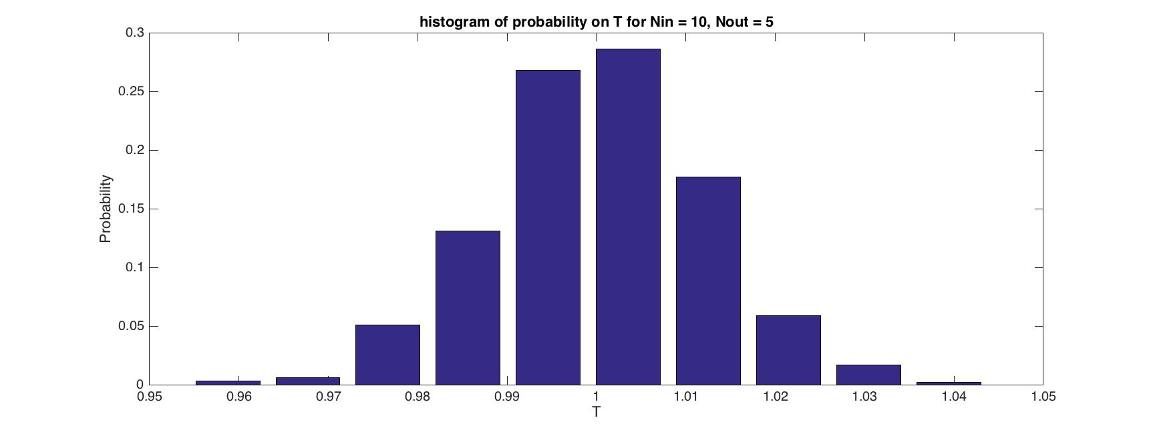

**%% For Nin = 1000, Nout = 500**

Trial = 100;

Nin = 1000;

Nout = 500;

Snet = zeros(1, Trial);

% Markov Matrices

Ain = [0.98 0.1 0;

0.02 0.7 0.05;

0 0.2 0.95 ];

Aout = [0.9 0.1 0;

0.1 0.6 0.1;

0 0.3 0.9 ];

% across the entire time frame

Nstep = 10^6;

for t = 1:Trial

Sin = zeros(Nin,Nstep);

Sout = zeros(Nout,Nstep);

Sin(:,1) = 1;

Sout(:,1) = 1;

% simulation of Markov Chains

for k=1 : Nstep-1

% Get states of inward channels

for n = 1:Nin

rd=rand;

if rd < Ain(1,Sin(n,k))

Sin(n,k+1) = 1; % S(k+1) = S1 (C1)

elseif rd < Ain(1,Sin(n,k))+Ain(2,Sin(n,k))

Sin(n,k+1) = 2; % S(k+1) = S2 (C2)

else

Sin(n,k+1) = 3; % S(k+1) = S3 (O)

end

end

% Get states of outward channels

for m = 1:Nout

rd=rand;

if rd < Aout(1,Sout(m,k))

Sout(m,k+1) = 1; % S(k+1) = S1 (C1)

elseif rd < Aout(1,Sout(m,k))+Aout(2,Sout(m,k))

Sout(m,k+1) = 2; % S(k+1) = S2 (C2)

else

Sout(m,k+1) = 3; % S(k+1) = S3 (O)

end

end

end;

% Calculate dominant eigenvector of Ain

[Vin,Din] = eig(Ain);

lamdas_in = diag(Din);

jmax_in=find(abs(lamdas_in) == max(abs(lamdas_in))) ;

dom_eigenvec_in=Vin(:,jmax_in);

rescaled_dom_eigenvec_in = dom_eigenvec_in/sum(dom_eigenvec_in);

num_of_channels_S_in = Nin*rescaled_dom_eigenvec_in

% Output of num_of_channels_S_in:

% 500

% 100

% 400

% double check with num of channels in each state with outputs:

N1in = length(find(Sin==1))/Nstep % 500

N2in = length(find(Sin==2))/Nstep % 100

N3in = length(find(Sin==3))/Nstep % 400

% Calculate dominant eigenvector of Aout

[Vout,Dout] = eig(Aout);

lamdas_out = diag(Dout);

jmax_out=find(abs(lamdas_out) == max(abs(lamdas_out))) ;

dom_eigenvec_out=Vout(:,jmax_out);

rescaled_dom_eigenvec_out = dom_eigenvec_out/sum(dom_eigenvec_out);

num_of_channels_S_out = Nout*rescaled_dom_eigenvec_out

% Output of num_of_channels_S_out:

% 100

% 100

% 300

% double check with num of channels in each state with outputs:

N1out = length(find(Sout==1))/Nstep % 100

N2out = length(find(Sout==2))/Nstep % 100

N3out = length(find(Sout==3))/Nstep % 300

% The equilibrium of the net current at t

Snet(t) = N3in-N3out

% Output of Snet:

% 100

% Thus, it shows that the equilibrium would have 1 unit flows

end

% plot histograms

fig7 = figure

[Nt,xt]=hist(Snet,10);

bar(xt,Nt/Trial)

% axis([0 max(xt)/4 -Inf Inf])

xlabel('T')

ylabel('Probability')

title('histogram of probability on T for Nin = 1000, Nout = 500')

