**1 (b) Figures**

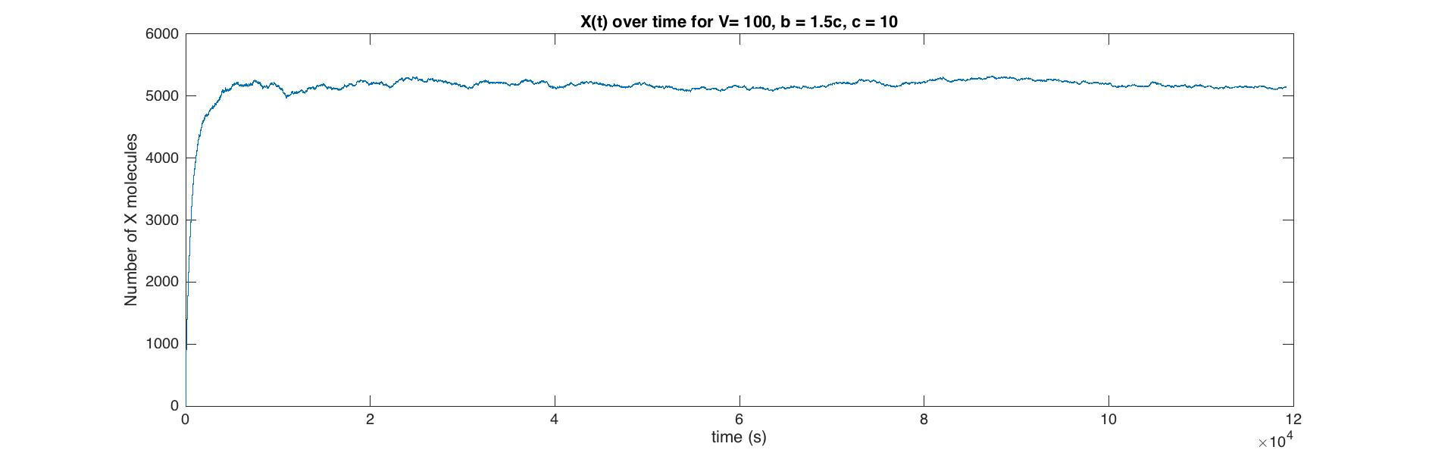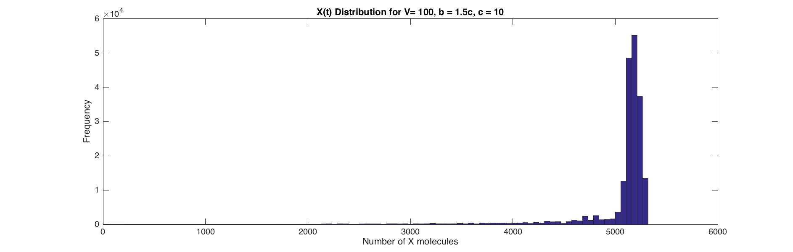

**1 (c) Figures**

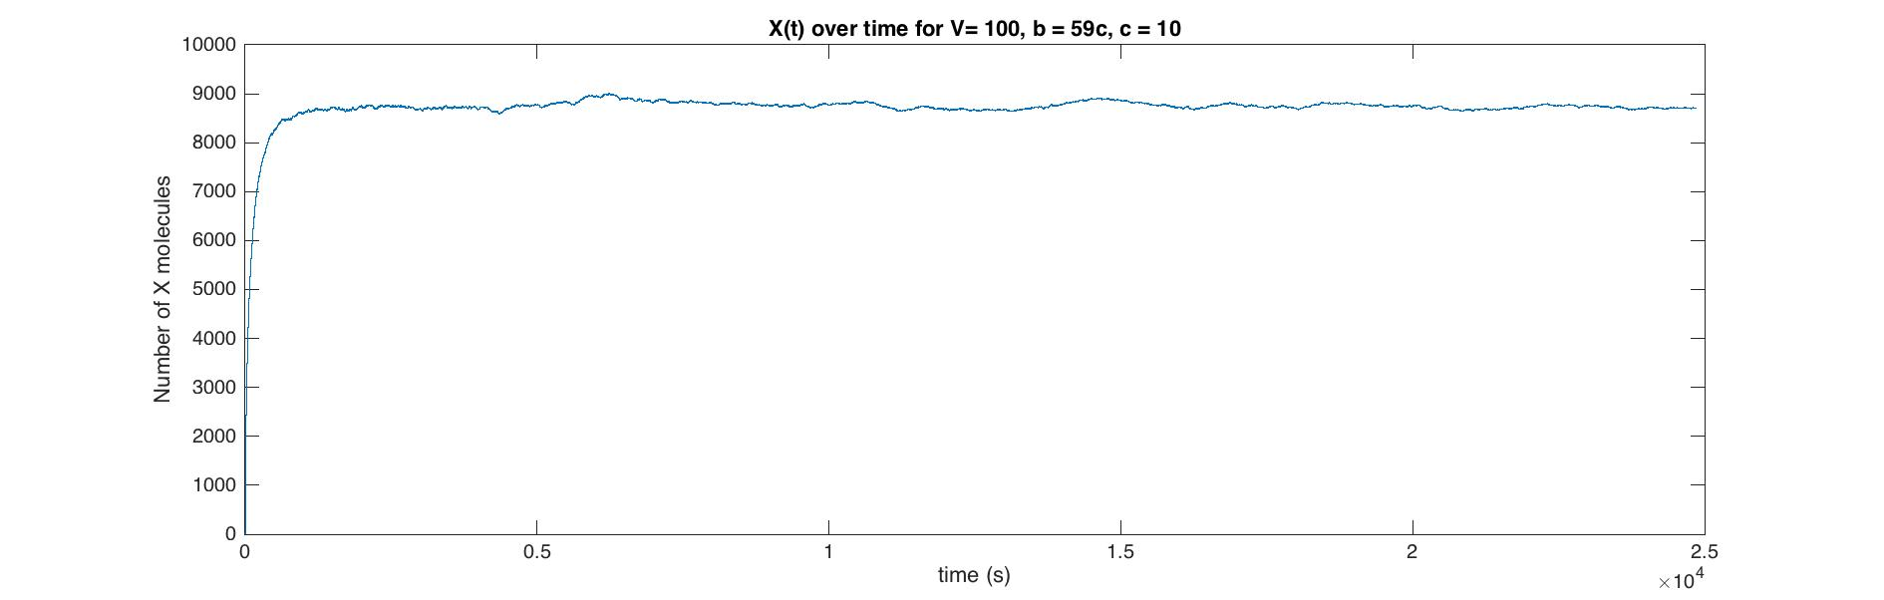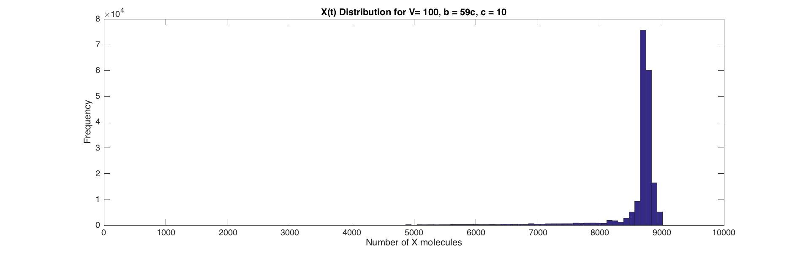

%% HW3 for MATH531

% @Author: Baihan Lin

% @Date: Oct 2016

clear all; close all; clc;

%% Question 1

% define rand seed and run time

rng(1);

Tmax = 200000;

alltime1 = 0;

alltime2 = 0;

% define variable

n1 = 0; % initial value

T1(1) = 0; % start at time 0

W1(1) = 0; % waiting time at time 0 is 0

X1(1) = n1; % at time 0, number of x molecule = n

n2 = 0;

T2(1) = 0;

W2(1) = 0;

X2(1) = n2;

% define concentration parameters

c = 10; % as an example

a = 1*c;

b1 = 1.5*c;

b2 = 59*c;

for t = 1:Tmax

% define model parameters

V = 100;

alpha = 3*c^(-2)*t^(-1);

beta = 0.6*c^(-2)*t^(-1);

lamda = 2.95*t^(-1);

delta = 0.25*t^(-1);

% define CME parameters

B1 = lamda*b1*V + alpha*a*n1*(n1-1)/V; % birth rate

D1 = delta*n1 + beta*n1*(n1-1)*(n1-2)/V^2; % death rate

% calculate Monte Carlo step

time_B1 = -log(rand)./B1; % waiting time for 1 birth

time_D1 = -log(rand)./D1; % waiting time for 1 death

time1 = min(time_B1, time_D1); % Inter-step times

if real(time_B1) < real(time_D1)

n1 = n1 + 1;

elseif real(time_B1) > real(time_D1)

n1 = n1 - 1;

end

alltime1 = alltime1 + time1;

X1(t) = n1;

T1(t) = alltime1;

W1(t) = time1;

% part c

B2 = lamda*b2*V + alpha*a*n2*(n2-1)/V;

D2 = delta*n2 + beta*n2*(n2-1)*(n2-2)/V^2;

time_B2 = -log(rand)./B2;

time_D2 = -log(rand)./D2;

time2 = min(time_B2, time_D2);

if real(time_B2) < real(time_D2)

n2 = n2 + 1;

elseif real(time_B2) > real(time_D2)

n2 = n2 - 1;

end

alltime2 = alltime2 + time2;

X2(t) = n2;

T2(t) = alltime2;

W2(t) = time2;

end

% part b)

fig1 = figure;

set(gca,'FontSize',20);

stairs(T1,X1);

xlabel('time (s)');

ylabel('Number of X molecules');

title('X(t) over time for V= 100, b = 1.5c, c = 10');

fig2 = figure;

set(gca,'FontSize',20);

hist(X1,100);

xlabel('Number of X molecules');

ylabel('Frequency');

title('X(t) Distribution for V= 100, b = 1.5c, c = 10');

% part c)

fig3 = figure;

set(gca,'FontSize',20);

stairs(T2,X2);

xlabel('time (s)');

ylabel('Number of X molecules');

title('X(t) over time for V= 100, b = 59c, c = 10');

fig4 = figure;

set(gca,'FontSize',20);

hist(X2,100);

xlabel('Number of X molecules');

ylabel('Frequency');

title('X(t) Distribution for V= 100, b = 59c, c = 10');

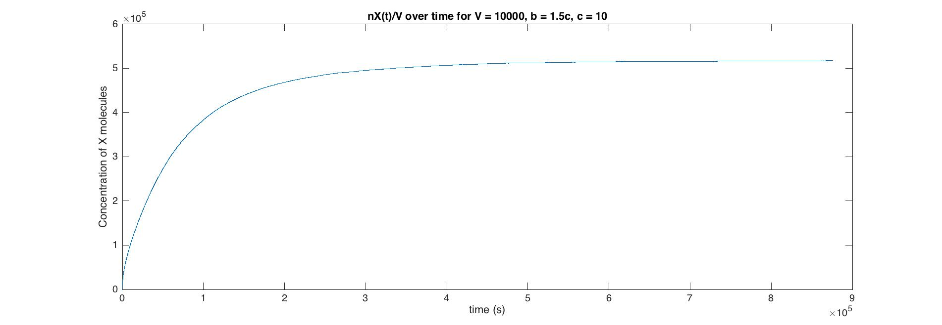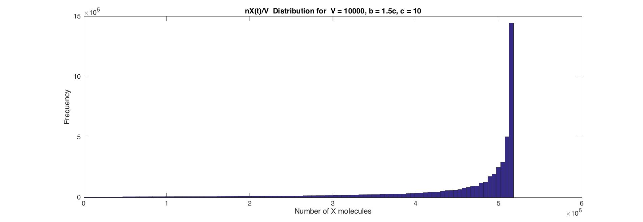

%% Question 3

% define rand seed and run time

rng(1);

Tmax = 5000000;

alltime = 0;

% define variable

n = 0; % initial value

T(1) = 0; % start at time 0

W(1) = 0; % waiting time at time 0 is 0

X(1) = n; % at time 0, number of x molecule = n

% define concentration parameters

c = 10; % as an example

a = 1*c;

b = 1.5*c;

for t = 1:Tmax

% define model parameters

V = 10000;

alpha = 3*c^(-2)*t^(-1);

beta = 0.6*c^(-2)*t^(-1);

lamda = 2.95*t^(-1);

delta = 0.25*t^(-1);

% define CME parameters

B = lamda*b*V + alpha*a*n*(n-1)/V; % birth rate

D = delta*n + beta*n*(n-1)*(n-2)/V^2; % death rate

% calculate Monte Carlo step

time_B = -log(rand)./B; % waiting time for 1 birth

time_D = -log(rand)./D; % waiting time for 1 death

time = min(time_B, time_D); % Inter-step times

if real(time_B) < real(time_D)

n = n + 1;

elseif real(time_B) > real(time_D)

n = n - 1;

end

alltime = alltime + time;

X(t) = n;

T(t) = alltime;

W(t) = time;

end

fig5 = figure;

set(gca,'FontSize',20);

stairs(T,X);

xlabel('time (s)');

ylabel('Concentration of X molecules');

title('nX(t)/V over time for V = 10000, b = 1.5c, c = 10');

fig6 = figure;

set(gca,'FontSize',20);

hist(X,100);

xlabel('Number of X molecules');

ylabel('Frequency');

title('nX(t)/V Distribution for V = 10000, b = 1.5c, c = 10');