**Question (a): Find the probability of needle crossing through simulation**

Here we are planning to find the probability of needle crossing four sides of a square with side length = 2a, or crossing the line y = 2a-2x inside the square.

To approach this question, inspired by Dr. Conroy’s hint in class, I decided to consider the issue as first droping the needle’s one side inside the square, then falling the other end in equal probability in all possible direction angle.

Thus here below in my code, you can see I first define a group of 3 random number for x1 coordinate, y1 coordinate and angle, then calculate x2 y2 based on triangular properties.

To determine whether it crosses or not, I first checked whether the (x2, y2) is outside the square, since (x1, y1) is defined inside. Then I checked whether (x1, y1) and (x2, y2) are in the same side of the square separated by the line y = 2a-2x. I did this by calculating the difference between, (the expected y values on the line y = 2a-2x in x1 and x2), and, (y1 and y2). If they have different signs, it means they are on different sides, i.e. they crossed the line.

I iterated the entire function through enough steps to see clear asymptotic behavior and add 1 when any cross found, and record the probability at that time.

So here is Figure 1: probability simulation of crossing needle versus number of trials

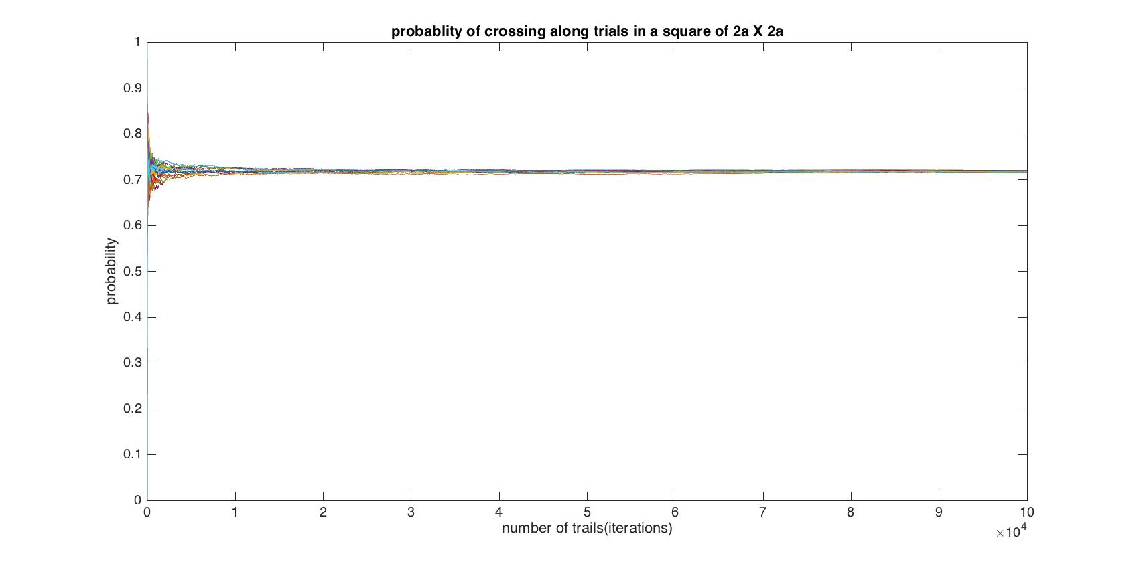

We can confidently say, experimentally speaking, shown from figure 1, the probability of needle crossing the lines is estimated within interval **0.71~0.72**. I feel this confidence because our Monte Carlos simulation shows a clear asymptotic behavior of error, and the probability in more trials are expected to be closer and closer to 0.71~0.72, which was even supported in different runs of simulations.

%% HW4 for MATH381

% @Author: Baihan Lin

% @Date: Nov 2016

clear all; close all; clc;

%% Question a: probability when needle length = 1a; and side of square = 2a

rng(1);

runs = 20; % runs of simulations

figure

for run = 1:runs

L = 1; % length of needle

N = 100000; % trials to run

n = 0; % number of crossed needles

p = zeros(1, N); % probability of crossing

r = rand(3,N); % random number for all steps

for k = 1:N

x1 = 2*L*r(1,k);

y1 = 2*L*r(2,k);

ang = 2*pi*r(3,k);

x2 = x1 + L*cos(ang); % coordinate of the other end

y2 = y1 + L*sin(ang); % coordinate of the other end

y1diff = y1 - (2*L-2*x1); % y1diff < 0 if left zone, > 0 right zone

y2diff = y2 - (2*L-2*x2); % y2diff < 0 if left zone, > 0 right zone

if x2 < 0 || y2 < 0 || x2 > 2*L || y2 > 2*L || y1diff*y2diff < 0

n = n+1;

end

p(k) = n/k;

end

plot(p); hold on

title('probablity of crossing along trials in a square of 2a X 2a')

xlabel('number of trails(iterations)'), ylabel('probability');

end

**Question (b): Find the length of needle having a crossing probability of 0.5**

Here we are planning to find the length of needle which has a crossing probability of 0.5 in a square with side length = 2a.

To approach this question, I decided to iterate through needle length from 0 to 2a (side length of the square), and showed the relationship between crossing probability with the needle length. The estimated probability was based on the method described in question (a) with great confidence described above.

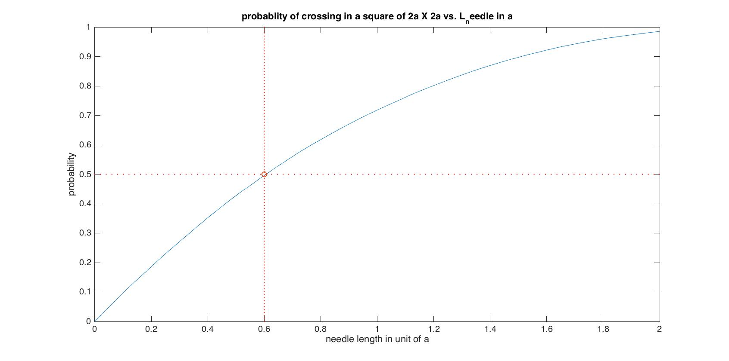

Here is Figure 2: probability of crossing needle vs. different needle length

As we can see from Figure 2, we can confidently say, experimentally speaking, the needle length with 0.5 probability of needle crossing the lines is estimated within interval **0.59a~0.61a.** I specified the red line of probability = 0.5, and needle length = 0.6a.

To double confirm it, I conducted similar simulation as question (a), but on needle length of 0.6a. Here shown in Figure 3, we can see, that the probability of needle crossing the lines is estimated within interval 0.49~0.51.

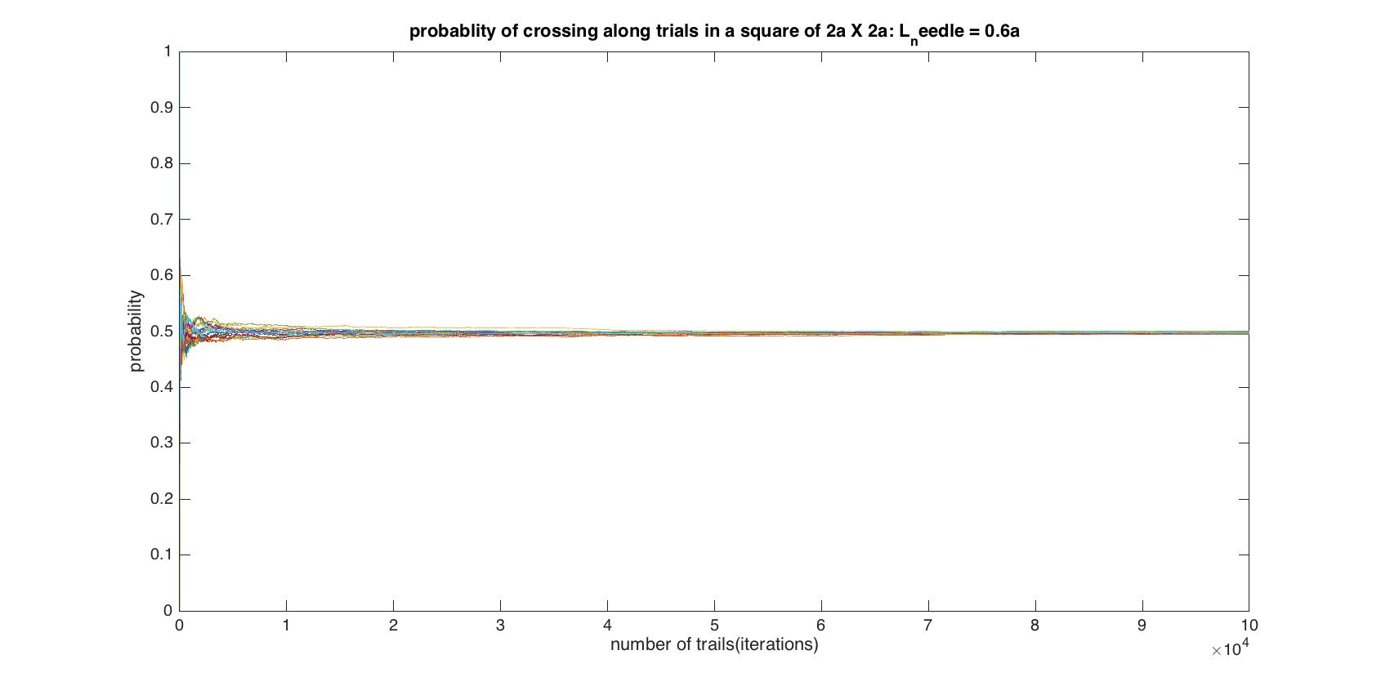

Figure 3: probability simulation of crossing needle vs. number of trials in L_needle = 0.6a

I feel this confidence because not only our Monte Carlos simulation across different needle length showed 0.6a as the one to yield 0.5 probability, but it is also confirmed by our Monte Carlos simulation under needle length 0.6a that shows a clear asymptotic behavior of error, and the probability in more trials are expected to be closer and closer to 0.49~0.51, which was even supported in different runs of simulations.

%% Quesiton b: probability based on different needle length in a when side of square = 2a

rng(1);

L = 1; % half length of the square side

targetP = 0.5; % target probability we want to reach

N = 100000; % trials to run

arange = linspace(0,2);

p_a = zeros(100, N); % probability of crossing

r = rand(3,N); % random number for all steps

for acount = 1:100

a = arange(acount);

n = 0; % number of crossed needles

for k = 1:N

x1 = 2*L*r(1,k);

y1 = 2*L*r(2,k);

ang = 2*pi*r(3,k);

x2 = x1 + a*cos(ang); % coordinate of the other end

y2 = y1 + a*sin(ang); % coordinate of the other end

y1diff = y1 - (2*L-2*x1); % y1diff < 0 if left zone, > 0 right zone

y2diff = y2 - (2*L-2*x2); % y2diff < 0 if left zone, > 0 right zone

if x2 < 0 || y2 < 0 || x2 > 2*L || y2 > 2*L || y1diff*y2diff < 0

n = n+1;

end

p_a(acount,k) = n/k;

end

end

figure

plot(arange, p_a(:,N)); hold on

plot(arange, 0.5*ones(1,100), '.r');

plot(0.6*ones(1,100), linspace(0,1), '.r');

plot(0.6,0.5,'o');

title('probablity of crossing in a square of 2a X 2a vs. L_needle in a');

xlabel('needle length in unit of a'), ylabel('probability');

%% Confirm needle length = 0.6a when side of square = 2a

rng(1);

runs = 20;

figure

for run = 1:runs

a = 0.6;

L = 1; % length of needle

N = 100000; % trials to run

n = 0; % number of crossed needles

p = zeros(1, N); % probability of crossing

r = rand(3,N); % random number for all steps

for k = 1:N

x1 = 2*L*r(1,k);

y1 = 2*L*r(2,k);

ang = 2*pi*r(3,k);

x2 = x1 + a*cos(ang);

y2 = y1 + a*sin(ang);

y1diff = y1 - (2*L-2*x1); % y1diff < 0 if left zone, > 0 right zone

y2diff = y2 - (2*L-2*x2); % y2diff < 0 if left zone, > 0 right zone

if x2 < 0 || y2 < 0 || x2 > 2*L || y2 > 2*L || y1diff*y2diff < 0

n = n+1;

end

p(k) = n/k;

end

plot(p); hold on

title('probablity of crossing along trials in a square of 2a X 2a: L_needle = 0.6a')

xlabel('number of trails(iterations)'), ylabel('probability');

end