Reference number: 2005-09-10343B.

Supplementary Information

1. Materials and procedures

Cell culturing and growth conditions
E.coli K12 (MG1655) cells with plasmid, pBR293.3, which confers ampicillin resistance and does not contain lacI binding sites, were cultured in M9 media supplemented with MEM amino acids solutions and MEM vitamins solutions (Invitrogen, CA) glucose (0.4%), and ampicillin (50μg/ml). Cells were grown in the experimental media overnight at 37ºC, diluted 1:100 into fresh medium and grown overnight and diluted again, then grown until they reach OD₆₀₀ 0.3-0.6 (mid-exponential growth) and used in the experiments. We verified that the expression level of β-gal does not change when cells are transformed with ampicillin resistance plasmid in bulk measurements.
Under the experimental conditions for real-time measurements (Fig. 2), E.coli cells can grow exponentially for at least 14 hours inside the microfluidics chamber (FigS1). The conditions for this measurement are: 300μM FDG, and laser power and illumination duty cycle similar to those used for all experiments presented. To determine cell growth, the total length of cells in the chamber was measured from DIC images taken during the run. Fig S1a-b shows that 100x100x10 μm chamber can sustain exponential growth for more than 14 hours. The red lines are exponential fits to the data, with a cell cycle of 150±11 min and 138±15 min for the chambers shown in Fig. S1a,b, respectively.
S. cerevisiae cells (yKT0032) used in the experiments express β-gal from the Gal1 promoter, carried on a low copy 2μm plasmid (pYES2-LacZ). Cells were cultured in SD glucose –ura medium (BD Bioscience, MA) at 30ºC overnight.
Mouse embryonic stem cells ES54A (Smo +/-, Rosa26 lacZ⁺) and ES17 (lacZ⁻) from 129SVJ background were grown on porcine gelatin (Sigma, MO) coated plates at 37ºC and in a defined medium to prevent differentiation. Single cell suspension is derived by adding trypsin to the cell culture and resuspending.

Sample preparation
E. coli cells were washed with fresh media, mixed with FDG and injected into the microfluidics chip. A concentration of 300μM FDG was used, as a compromise between improved membrane permeability and increased toxicity to the cells at increasing concentrations (Fig S5b,c). The microfluidics flow channels were incubated with BSA (20mg/ml) for 20 min prior to the experiments, to prevent adhesion of cells to the chamber walls. The sample was mounted on a Nikon TE-300 inverted microscope, and was temperature stabilized at 30°C (objective and mounting chamber temperature control, Bioptech Inc, PA). To measure the snapshot protein number distribution, E. coli cells were treated with 10% chloroform (v/v) before injection into the chip. Yeast cells were treated with 10% chloroform and 0.1% SDS (w/v).

Microfluidics chip fabrication
The master for the bottom channels is made by spin-coating positive photoresist (Shipley SPR 220-7, MicroChem, MA) onto a silicon wafer (University Wafer, MA) to a height of 7μm. After patterning with high resolution transparency mask (5400 dpi) (PageWorks, MA), the features are rounded by heating at 140ºC for 30 minutes,. The control layer master is patterned with negative photoresist at 40μm height. PDMS (10:1 Dow Corning Sylgard 184 A:B, Ellsworth Adhesives, MA), is spun onto the bottom master at 2000rpm for 1 minute and partially cured (70ºC 10 minutes). Control layer PDMS mold is also partially cured and baked at the thickness of 5mm. The top PDMS piece is aligned to the bottom wafer and cured overnight. The two-layer device is cut out, plasma oxidized for 3 minutes and bonded permanently to a round #1 coverslip. Figure S2 shows DIC (a,b) and fluorescence (c,d) images of the microfluidics chip, before (a,c) and after (b,d) actuation of the control channel. The flow channels are horizontal; the control channels are vertical and shaded in light blue. The boundaries of one closed chamber are boxed in blue.

Data analysis
The number of enzymes in the chamber was obtained by: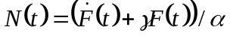, where N(t) is the number of enzymes in the chamber, F(t) is the fluorescent intensity as a function of time, 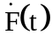is its time derivative, γ is the photobleaching rate (section 4), and α=30pM/min is the calibration factor, determined from the spacing between peaks in Figs. 1f and 3a and divided by the average permeability ratio of the cells (R=2, see main text). A median filter of length 11 was used to smooth F(t) and . With a sampling rate of once every 20s per chamber, the effective time resolution is about 4 min. We used the residual signal from chambers that contained no cells to compensate for multiplicative noise which is correlated in all the chambers, caused by small mechanical instabilities.
To calculate the reporter copy number distribution (Figs. 3b,c), only chambers that contained one cell were counted. Autohydrolysis background level was estimated from empty chambers, and was subtracted. The resulting copy number histogram was deconvolved with the measured histogram of hydrolysis rate in chambers containing zero cells on the same chip, using Matlab’s lsqnonneg function.

2. Efflux problem and attempted solutions
When we incubate cells expressing β-gal with FDG, we observe that majority of the cells have fluorescent intensities lower than that of the background (Fig. S3). While there are cells that are more fluorescent than the background (marked B in Figure S3), when followed under a time course, we do not observe these cells growing and dividing with time. The darker cells (marked A in Figure S3), divide for many generations. To isolate the problem to the efflux pumps, we observe the same result when cells are incubated only with the fluorescein. These results, which show a one-to-one correspondence between fluorescent cells and inability to divide, suggest to us that an active process which exists only in living cells is responsible for efflux of the fluorescent dyes out from the cells. Since cells are less fluorescent than the background when incubated with fluorescent product, live cells must contain an active and efficient efflux system. These results imply that most of the fluorescent products generated inside the cells are rapidly pumped out of the cell into the surrounding solution. However, because of the small volumetric ratio of the cells compared to the surrounding solution, the absolute number of the dye molecules in the cell is small compared to those in the surrounding solution, roughly proportional to the volume. Thus, the vast majority of the hydrolyzed fluorescent products are pumped into the surrounding with little remaining in the cells, supporting our assumption that fluorescent activity measured inside the microfluidics device accurately reflects enzymatic activity inside the cell.

The solutions we attempted in solving the efflux problem convince us of the robustness of the efflux system in E. coli and S. cerevisiae and of the significant effect on cellular vitality associated with disruption of the efflux systems. Our first attempt was to delete known efflux pumps and observe how these deletions affect the bacteria’s ability to retain the fluorescent products. Using a deletion library, we tested strains with single pump deletions and deletions of entire families of efflux pumps. We only observed a marginal improvement in retention of the fluorescent product when the outer membrane pump TolC is knocked out singly or in combination with other efflux pumps. Since TolC is a major efflux pump that interacts with many sub-family of so-called ABC pumps, its deletion renders E.coli much more sensitive to the growth environment. In fact, TolC deletion strains fail to grow in LB broth. Secondly, we employed efflux pump inhibitors, (verapmil, reserpine, valinomycine, CCCP, gramicidin, monesin, and nigercin), which produced no noticeable improvements. Neither does changing pH or temperature of incubation. Lastly, we tested out fluoregenic substrate containing long aliphatic tails that allows the hydrolyzed fluorescent product to be inserted into the membrane after hydrolysis. We sampled variants of these substrates with different length tail chains. However, none showed improvement over FDG in signal retention. After these trials and experimentation, we conclude that the efflux system is a set of overlapping nonspecific pumps that are essential to the survival of the cell. Inhibiting or deleting one or a small subset of these pumps do not improve the fluorescein retention, and knock outs of the essential TolC pump while modestly improves retention does so at a significant cost to the fitness of the cells.

3. Permeability of the cell membrane to the fluoregenic substrate
To evaluate the permeability of live growing cells to the fluoregenic substrate (FDG), ensemble hydrolysis rates were measured, using a fluorometer (Fluorolog 3, Jobin Yvon). Hydrolysis was first measured for live cells, and then cells’ membrane was permeablized with chloroform (10% v/v), after which the hydrolysis rate is measured again.
Wild-type E. coli cells show a 13-fold difference in hydrolysis rate before and after permeabilization (we denote this ratio R), as is shown in Fig. S4a. On the other hand, for cells containing the ampicillin resistant plasmid pBR293.3 and cultured in the presence of 50μg/ml of Ampicillin, we measure R = 2.0±0.3 (average and SD from 5 independent repeats), as shown in Fig S4b. FDG concentration of 300μM is used for both measurements.
The substrate concentration inside the cell is given by the following equation:

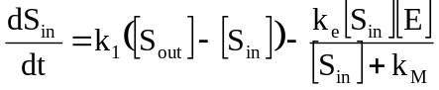, (S1)

where the first term describes diffusion of the substrate across the cell membrane, and the second term describes hydrolysis of the substrate by the enzyme. [S_{in/out}] is the substrate (FDG) concentration inside/outside the cell, respectively; k₁ is the diffusion rate of FDG across the cell membrane [s⁻¹]; [E]=(N/V) is the concentration of the enzyme (β-gal) inside the cell, with N: number of enzymes per cell, V: cell volume; k_{e} is the enzymatic turnover rate [s⁻¹]; and k_{M} is the binding constant of substrate for the enzyme β-gal [M], which was determined experimentally as k_{M} = 90 ± 20 μM (see Fig. S5a).At steady state, Eq. S1 can be solved analytically to find [S_{in}]. The ratio R is then given by:

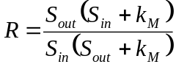 .

R decreases with increasing [S_{out}], as was validated experimentally (see Fig. S5b), and increases with increasing [E]. On the other hand, cell growth rate decreases at higher FDG concentrations (Fig. S5c).
With k_{M}=90μM, we choose [FDG_{out}]=300μm to saturate the enzyme, and decrease R. This substrate concentration is a compromise between the better permeability (lower R values, Fig. S5b) offered at higher concentrations, and the higher background levels due to increased autohydrolysis of the substrate as well as higher cell toxicity at higher FDG levels (Fig. S5c). Under these conditions, the real-time assay in live E. coli cells is limited to less than ~40 enzymes/cell. At higher enzyme levels, substrate is depleted by the enzymes faster than it can diffuse into the cell, leading to lower values of [S_{in}] and higher values of R, limiting the dynamic range. Note that the measurement of reporter number distribution is not limited by this effect, since it is performed with cells treated with chloroform, whose membrane is completely permeable.
Using the microfluidics chip, it is possible to measure membrane permeability also for individual cells. In this assay, cells were attached to the glass surface inside the microfluidic chambers, such that the enzymatic activity of the same cell can be measured before and after introduction of chloroform. We find the single-cell permeability R is uni-modally distributed with a mean of 1.8 and SD = 0.8 with sample size of 20 cells, eliminating the possibility of two heterogeneous population with distinct permeability. Hence, at low enzyme levels per cell the measured signal in live cells with an intact membrane will be proportional to the number of enzymes in the cell.
The agreement between the measured R values for the ensemble and single cell experiments is another indication that escape of enzymes from chloroform treated cells is negligible. Any escaping enzyme would be washed during the permeabilization step in the microfluidic chip, resulting in a decrease in the measured R value for single cells.
4. Characterization of the PDMS Microfluidic Chip
We evaluated errors in measuring fluorescence concentrations, by measuring fluorescence levels from 48 chambers in the same microfluidics chip filled with 100nM fluorescein. Figure S6a shows that the fluorescence detected within the chambers at that concentration of fluorescein differs only by 2%, demonstrating there is little systematic error introduced by our detection platform.

To evaluate how isolated the chambers are from each other and from the outside solution, we measured fluorescence recovery after photobleaching. 100nM fluorescein was injected into the microfluidic channels and the chambers were closed and fully bleached with 8 seconds exposure of 9mW laser illumination. While the outside channel has fluorescence level of 2000 counts/pixel, the closed chamber only recovers by 20 counts/pixel (1%) over a period of 12 hours. This indicates that little leakage of fluorescein occurs through either opening of the valves or diffusion through PDMS bulk during the course of the experiment.

As a control to the real-time live cell assay, in which jumps in enzyme levels were observed, we measured hydrolysis rates for purified enzymes for a similar time span. Dilute amounts of enzyme corresponding to 1 molecule per chamber on average and 300μm of FDG are loaded into the chambers and monitored for 8 hours. Fig S6b shows that a steady state is reached between enzymatic activity and photobleaching within 2 hours. No subsequent change in fluorescent intensities is observed in the next 6 hours. This contrasts with the chambers with dividing cells in which abrupt changes in hydrolysis rate are observed. The photobleaching half life, γ⁻¹, of the fluorescent dye under the experimental conditions (laser power, duration and repetition rate of the excitation, and chamber volume), is determined to be 60 min (see fit in Fig. S6b). This value is used in our compensation algorithm discussed in the section 1 in the supplementary text.

5. Measuring reporter levels in Mouse Embryonic Stem Cells
Mouse embryonic stem cells expressing β-gal from ROSA promoter (ES 54A, ref. S) were injected into the microfluidic channels together with 300μm FDG. The density of these cells in culture is much lower than that of E. coli and yeast cells, which may lead to high number of empty chambers. To increase the number of chambers containing cells, we partially close only one of the valves downstream to the flow. The cells cannot pass through underneath the valve while media can. This effectively concentrates cells at the site of the chamber. After this loading stage, both valves were closed, to form the enclosed chamber. The hydrolysis slopes are distributed with a mean of 470 enzymes per cell and with a standard deviation of 375. In chambers without cells, the hydrolysis rate corresponds to 100 enzymes, which is mainly due to lysis of cells during culturing or injection. There is a negligible contribution from endogenous enzymatic activity of the cells, as evidenced by measuring lacZ⁻ cells, which gives an average signal corresponding to 20 enzymes per cell.

6. Evaluating dynamic parameters of gene expression from protein copy-number distributions
For growing cells, the steady-state average number of protein molecules in the cell is determined by a steady state between protein production and protein degradation, or dilution due to cell growth, whichever is faster. Formally, the change in protein copy number, N, is given by:

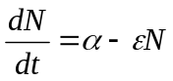, (S2)
with α the production rate, and ε the dilution (or degradation) rate. For a stable protein (like β-gal), dilution is dominant, and ε=ln2/T, with T the cell cycle time. The steady- state average protein number will then be proportional to the average number of proteins produced per cell cycle, as can be seen from the steady-state solution to Eq. S2:

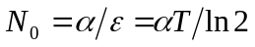. (S3)

We consider now the modification of Eq. S2 to the more realistic case, in which protein production occurs in bursts. If the number of proteins produced per burst is geometrically distributed and burst events are uncorrelated, the system can be described using two parameters: the average number of bursts per cell cycle, a, and the average number of proteins produced per burst, b. We note that the number of proteins per cell is given by the sum of a random variables drawn from an exponential distribution with a mean of b (here, we use an exponential distribution to describe burst size, which is the continuous analogue of the geometric distribution). This sum is given by the Gamma distribution,
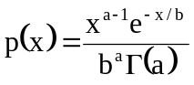, which is the convolution of exponential distributions. In fact, a and b uniquely describe the Gamma distribution and can be calculated directly from its first two moments: b = σ²/m (the Fano factor) and a = m²/σ². It has been previously shown that using the discrete, Geometric distribution to describe burst size gives rise to the Negative Binomial distribution for the steady state copy number distribution. This is consistent with our result since the Negative Binomial distribution is the discrete version of the Gamma distribution.

6.1 Intrinsic vs. Extrinsic Noise
The model described above assumes that burst events are uncorrelated in time, implicitly accounting only for the intrinsic noise of gene expression. The model can be extended to expression events correlated in time, or to include specific extrinsic contributions to stochasticity, such as repressor copy number fluctuations. However, in the regime of low expression level, intrinsic noise dominates. While we observe a burst roughly once every 10 cell cycles, the typical correlation time for extrinsic noise observed is about one cell cycle. Hence, this separation of time scales ensure that extrinsic noise is averaged out between bursts, without introducing significant correlations. The agreement between the a and b values measured directly from the real-time traces, and the extracted values from the copy number distribution, supports this conclusion.

6.2 The effect of random partitioning of proteins into daughter cells upon cell division on the protein number distribution
In the model described above, it is assumed that upon cell division proteins are divided equally among the two daughter cells. In reality, the partitioning is random, and is described by a binomial distribution. To evaluate how random partitioning may effect the parameters extracted from the distribution, we performed the following calculation: numbers were drawn from a Gamma distribution characterized by parameters a,b. Numbers were multiplied by 2 and rounded to the nearest integer, to represent the distribution of the number of protein molecules in cells just before cell division. For each value, a number was drawn using the binomial distribution, with p=0.5 (equal probability for each protein molecule to end up in either daughter cell). Then, we compared the distribution of these “after division” values with the original distribution. We present the results of this calculation for a=0.1, and b=5 (Fig S7a), and for a=3, and b=4 (Fig S7b). From the new distribution, we can estimate the parmeters a’, b’ (assuming it can be approximated by a Gamma distribution). The error introduced into the evaluation of the parameters is about 15% for a, and 17% for b. Note that the fraction of cells with zero copies of the protein in them can change by an order of magnitude due to the non-even partitioning, with the parameters of Fig. S7b . However, since our estimation uses the whole distribution and not a single value, the error is greatly reduced. Similar results were obtained also for other values of a,b, with the error decreasing with increasing a,b values.

6.3 Measured values of a, compared to ensemble measurements

The burst frequency a is measured to be 0.11±0.03 bursts per cell cycle from the real-time experiment, and evaluated as 0.16±0.05 bursts per cell cycle from a fit of the gamma distribution to the measured protein copy number distribution. Under our experimental conditions these correspond to a frequency of about 1e-5 s⁻¹. In vitro estimation for the dissociation rate of the LacI repressor from a short DNA oligo containing a single binding site are 20-200 times higher than the measured burst rate,, suggesting that DNA looping or transcription initiation by RNA polymerase may significantly reduce transcription rate.

7. The effect of using a tetramer as a reporter on evaluation of a and b from the steady-state copy number distributions
In our experiments the reporter, β-gal, is a tetramer, which is functional only in its tetrameric formError: Reference source not found. This can potentially lead to some inaccuracy in the evaluation of the transcription and translation parameters, which directly describe the production of monomers. To evaluate the effect of tetramerization on the reporter accuracy, we performed stochastic simulations of the gene expression process for a simple model involving transcription, translation, and reversible teramerization (Fig. S8a). Simulations were performed using Gillespie’s algorithm.
In an ideal tetrameric reporter system, tetramers are formed fast and irreversibly, such that monomer levels are minimal. Simulation results show that at low association rates (k_{T}) monomers rarely form tetramers, and the reporter system is bound to be inaccurate, as expected. At high association rates, tetramers are formed almost immediately as soon as four monomers are available, resulting in a reliable reporter.
Figure S8b shows the fraction of tetramers out of the total protein population, as a function of the association rate. With k_{T}~10⁻⁷, half of the proteins produced are in the form of tetramers. Next, we calculated tetramer copy-number distribution from the simulated data, and extracted the parameters a, b. Figure S8c,d shows the normalized values obtained for a and b, respectively, as a function of the tetramer association rate, k_{T}. It can be seen that at k_{T} ≥ 10⁻⁷ s, the errors in the estimation of a and b due to the non-perfect reporter are <40%, and <10%, respectively. Similar results were obtained also for other values of the parameters used. Since for β-gal the formation of tetramers is strongly favored,,, we estimate that the effect of reporter tetramerization on the evaluation of gene expression parameters is small.

8. Case of more than one mRNA produced per burst

So far, we have assumed that each transcription event leads to the production of one mRNA. Though we cannot rule out the possibility that multiple mRNAs are produced during one burst, it is unlikely in the case of the repressed lac operon, given the initiation rate of the polymerase (estimated as 50s) and the much faster association rate of the lac repressor to the operator (estimated as <1s ). However, if the number of mRNA produced per burst follows a geometric distribution and each mRNA is translated into a geometrically distributed number of proteins, then the resulting total copies of protein molecules produced per burst is still geometrically distributed. In the following derivation, we use the continuous version of the geometric distribution, the exponential distribution, to describe the protein copy number statistics. This enables us to use the formalism of Laplace transform, which facilitates the calculation of convolutions of distribution functions.

The probability of producing n proteins from one mRNA is given by an exponential distribution. According to the competition model, the probability density of having n protein molecules per burst, is 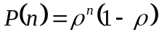 with ρ being the probability of ribosome binding on the mRNA, and 1− ρ being the probability of RNaseE binding. This distribution can be converted into the exponential form by redefining the burst size as b = 1/ln(1/ρ).

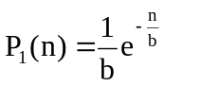 (S4)

and its Laplace transform is:

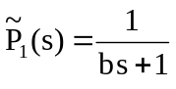 (S5)

The probability for producing n proteins from m copies of mRNA is given by a convolution of P₁, which can be expressed as products in Laplace space:

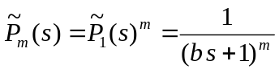 (S6)
If each transcriptional burst produces m copies of mRNA with probability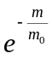, then the normalized total protein distribution is a weighted sum of 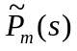:

(S7)

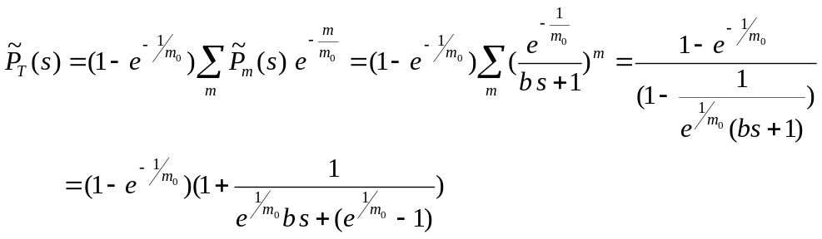

Inverse laplace transform of 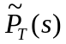 yields again an exponentially distributed amounts of protein per expression event:
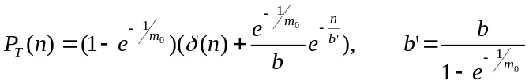 (S8)

Note that the δ function is experimentally unobservable, since we cannot observe events with zero protein produced.

9. Induction with IPTG
Shown in Fig S9, upon the addition of 1mM of IPTG to an exponential growing culture of k12+293.3 E.coli cells incubated with FDG, the hydrolysis rate drops to zero. This contradicts our expectation that IPTG induction should increase enzyme copy number and increase the hydrolysis rate. Upon the addition of 10% chloroform, which permeablize the cells, the hydrolysis rate recovers instantaneously and is dramatically higher than the pre-induced levels. This demonstrates that the enzyme is produced and accumulated inside the cell when induced, but the permeability reduces drastically. This leads us to conclude that IPTG competes with FDG for transport into the cell. We observe a similar decrease in permeability when inducing with lactose. We consider the possibility that IPTG competes for the enzyme catalytic site unlikely based on the structure and on the above experiment, although we cannot rule it out for lactose. This result prevents us from measuring the induced lac operon in real time.
We note that at high expression levels it is in general challenging to observe individual bursts using this assay, due to the higher background of enzymes in the cell and the shorter duration between bursts.

10. Calibration of fluorescence concentration and FDG autohydrolysis
We calibrate for the fluorescein concentration inside the microfluidics chambers under the experimental conditions, by measuring the fluorescence intensity of solutions of fluorescein with known concentrations determined from absorption measurements (Fig. S10). When we fitted the fluorescence vs. concentration with a linear fit, we obtained a good fit with the calibration factor of 35 counts equal to 1nM. We note that this calibration factor does not affect the calibration of the number of enzymes per chamber, because the distance between peaks in histogram in Fig. 1f and 3a serve as internal calibration.

The autohydrolysis of FDG is determined by injecting FDG without enzyme into the microfluidics device and measuring under the same experimental settings as the other experiments. In the histogram shown in Fig S11, the average hydrolysis rate is 23pM/min. The autohydrolysis rates fluctuate between 20-40pM/min among runs and are dependent on the particular batch of the substrate and the exact conditions of the solution. The variations in autohydrolysis rates only change the offset of the peaks shown in Figs. 1f and 3a and do not affect the spacing between the peaks, which is the enzymatic hydrolysis rate. Fig. S12 shows another histogram of hydrolysis rates, measured with E. coli cell treated with chloroform. Here, the average number of cells per chamber is higher than that of Fig. 3a, hence more peaks are observed. The spacing between peaks is similar to that of Figs. 1f and 3a.

a
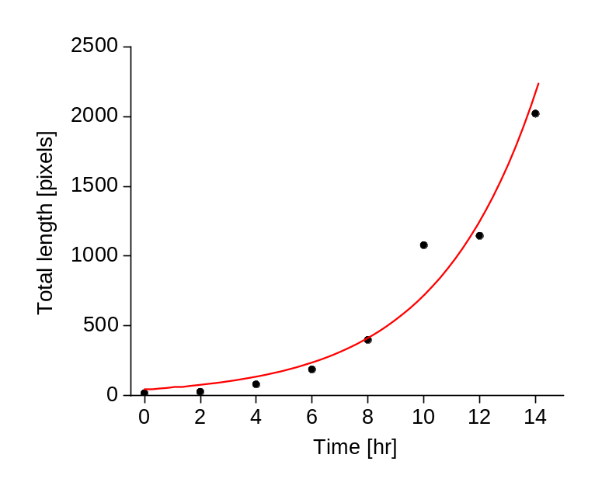
b
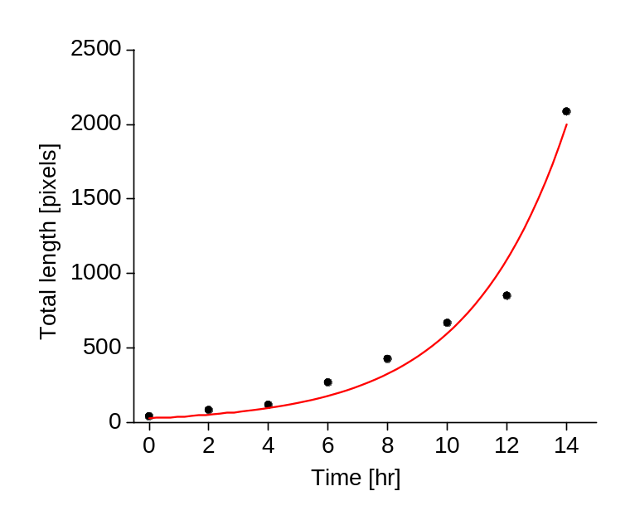
Figure S1: E. coli cells growing inside the microfluidic chamber, under the experimental conditions. Exponential growth in total length of cells in a chamber is observed. The red curves are exponential fits to the data, with time constants of: 150±11 min (a) and 138±15 min (b). The average cell length is 6 pixels.
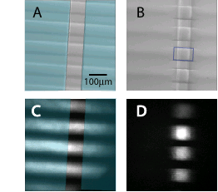
Figure S2: Images of the microfluidics chip. (a-b): DIC images of a chip before (a) and after (b) actuation of the control channel. The flow channels are horizontal; the control channels are vertical and shaded in light blue. The boundaries of one closed chamber are boxed in blue. (c-d) Fluorescence image of the same chip, before (c) and after (d) actuation of the control channel. The flow channels are filled with fluorescein for visualization.

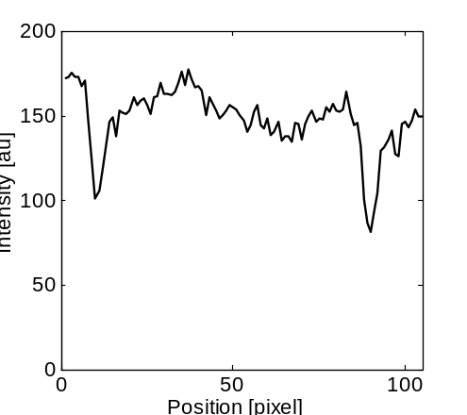
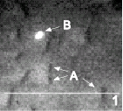

Figure S3: Fluorescence measurement of k12+293.3 cells incubated with fluorogenic substrate. Cells are immobilized under an agarose pad saturated with the substrate, while the measurement is taken with a total-internal reflection microscope to decrease background. Images taken with a confocal microscope yield the same results. Left: The rod-like shadows in the images (a) correspond to E.coli cells, thus showing that efflux system in E.coli actively pump out the fluorescent product. A cross section along the line marked “1” is shown on the right. A similar image is obtained when cells are incubated with just the fluorescent product. With the laser beam in the full upright (non-TIR) position, the background from the fluorescent product, which accumulates over time in the surrounding solution overwhelms our detector, showing that most of the hydrolyzed product is indeed pumped outside of the cells. A low fraction of the cells are extremely bright (b) Time-lapse microscopy shows that those bright cells neither grow nor divide, while the dark cells grow and divide normally.

a
b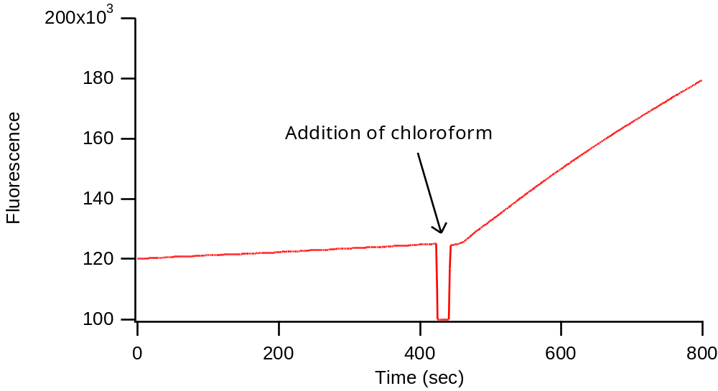
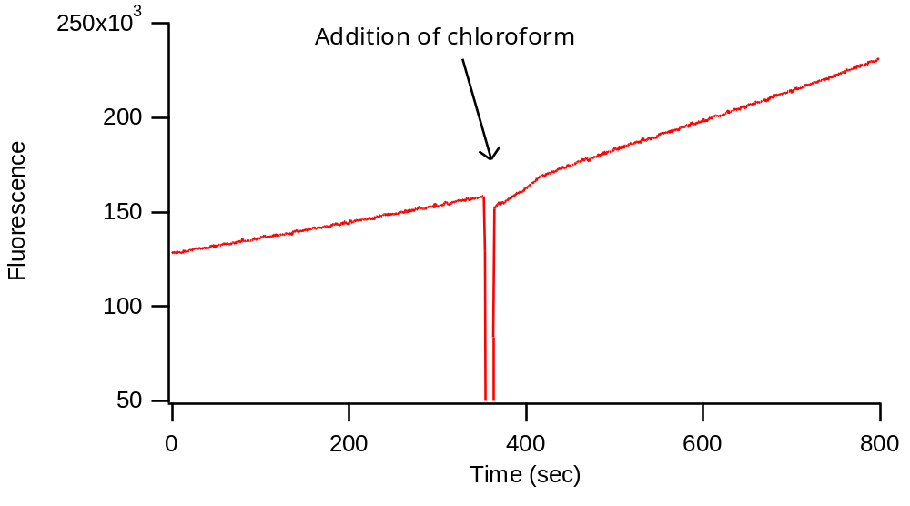
Fig S4: (a) E. coli K12 cells at OD₆₀₀ = 0.1 grown in supplemented M9 without the presence of Ampicillin, are incubated with 300μM FDG. After the addition of chloroform, the measured change in hydrolysis rate is determined to be R=13. (b) Same as (a), for E. coli K12 cells transformed with the plasmid pBR293.3 and grown in M9 with 50μg/ml of Ampicillin. The change in hydrolysis rate is determined to be R=2.1.

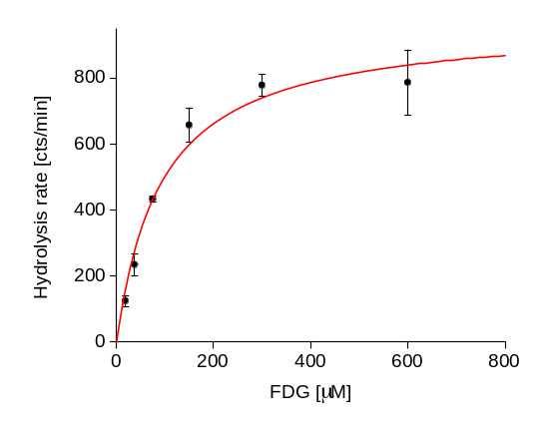
a

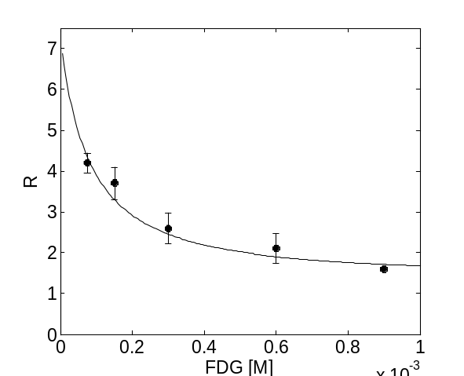
b

c
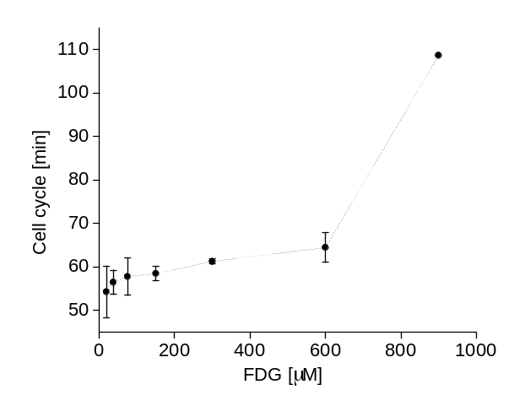
Figure S5: Dependence of permeability ratio R, and cell growth rate on FDG concentration. (a) Estimation of k_{M}, equilibrium constant of the enzymatic reaction. The graph shows hydrolysis rates measured for cells treated with chloroform, as a function of FDG concentration. The full curve is a best-fit Michaelis-Menten curve to the data, yielding k_{M} = 90±20 μM. (b) R decreases with increasing FDG concentration. The full curve is a fit to the data using solution to Eq. S1. The fit parameters are: k_{M} = 90 μM, k_{e} = 40 s⁻¹, and k₁ = 4e-4 s⁻¹. Since R values depends on the number of enzymes in the cell, especially for [FDG] < k_{M}, we took a weighted average of R over the cell population. The number of enzymes per cell, p(n) was taken from a Gamma distribution (see Eq. 1 in the main text), with a = 0.14, b = 5. Values of R were averaged over the cell population, with 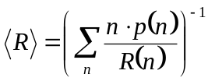. (c) Cell growth rate decreases with increasing FDG concentration. Measurements in (a-c) were done using a multiwell fluorescence plate reader (Victor 3, Perkin-Elmer), in triplicate.
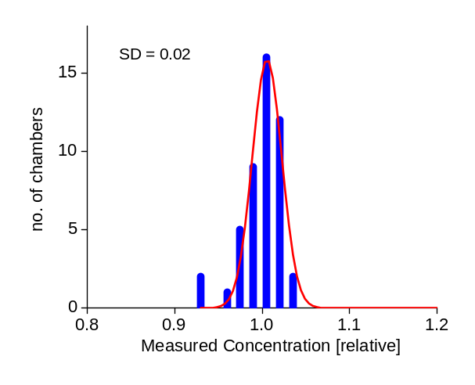
a
b
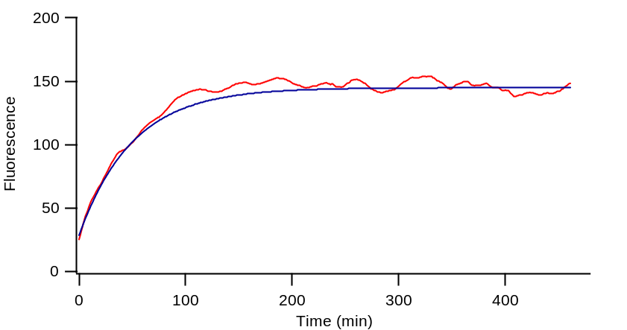

Figure S6: (a) Estimation of error in measuring dye concentration in the microfluidics chip. A chip with 48 chambers was loaded with 100nM of Fluorescein. The histogram shows distribution of the measured concentration, normalized by the average. The error is SD/mean = 0.02. (b) Dilute solution of enzyme is incubated with FDG in a chamber for 9 hours. Enzymatic hydrolysis and photobleaching reaches steady state within two hours. Blue curve: a fit to the data, with the equation: 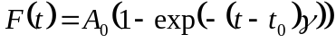, were A₀ is the steady-state fluorescence level, γ⁻¹ is the characteristic photobleaching time, determine to be 60 minutes from the fit, and t₀ is the actual time when substrate was added to the enzyme mixture.
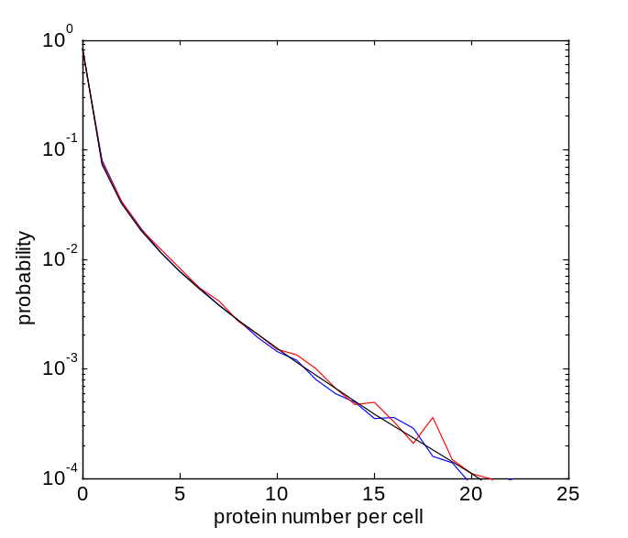
a
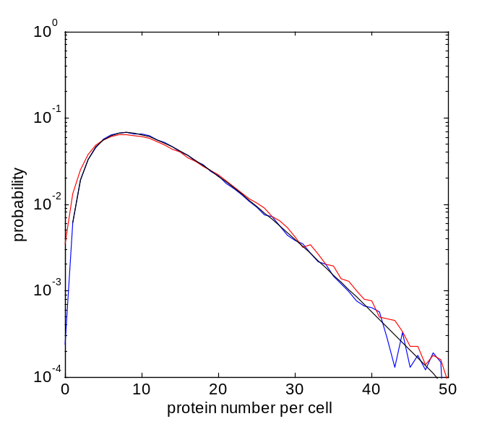
b

Figure S7: Effect of random partitioning of protein into daughter cells on the protein copy number distribution. Blue: histogram for 10⁵ numbers drawn from a Gamma distribution; Black: the calculated Gamma distribution given the a,b parameters; Red: histogram with addition of random portioning, as described above. (a) a=0.1, b=5. (b) a=3, b=4.
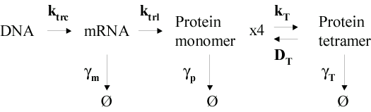
a

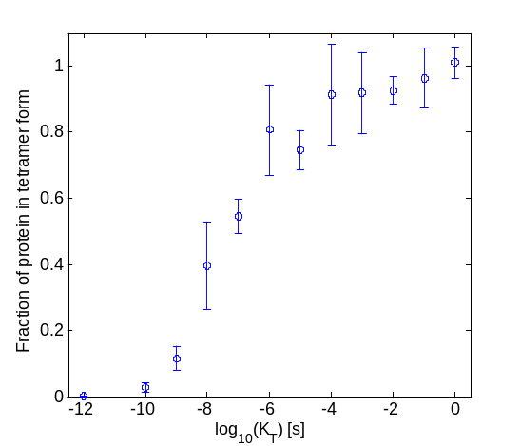
b

c

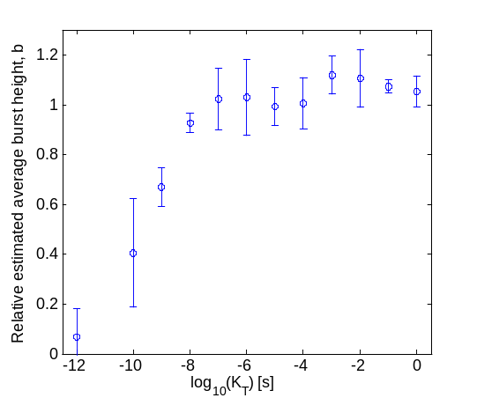
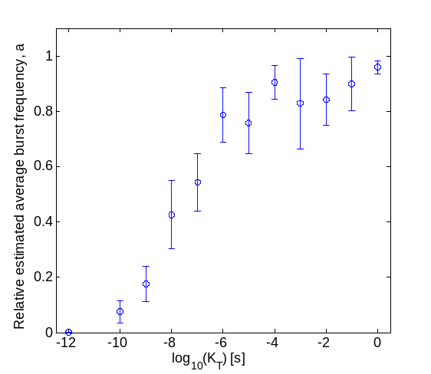
d

Figure S8: The effect of reporter tetramerization on evaluation of the parameters a, b. (a) A scheme representing the simulated model, for transcription, translation, and tetramerization. Typical parameters for low level gene expression, which are relevant to our real time experiment, were used: k_{trc}=10⁻⁴ s, k_{trl}=0.2 s, γ_{m}=10⁻² s, γ_{p}=5·10⁻⁴ s, D_{T}=4·10⁻⁵, and γ_{T}=γ_{p} (assuming that dilution is faster than degradation for both monomers and tetramers). Under these conditions, the parameters describing monomer production are a = k_{trc} / γ_{p} = 0.2, b = k_{trl} / γ_{T} = 20. (b) The fraction of proteins in the tetramer form, as a function of the tetramer association constant, k_{T}. (c-d) Estimation of the error in the extracted value for average burst-size (b), and for the average burst frequency (a), as a function of k_{T}.

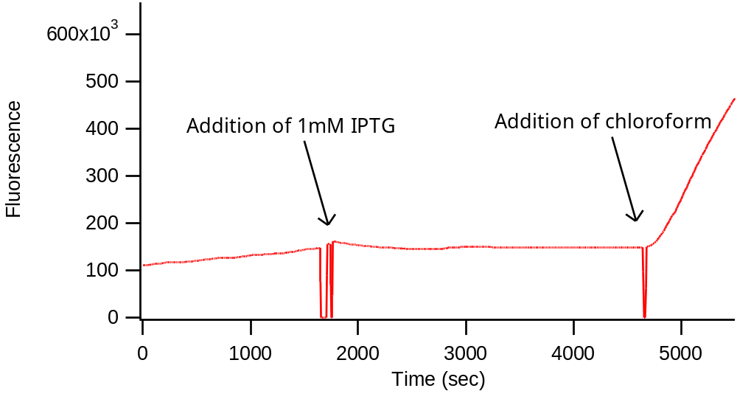

Figure S9. K12+293.3 E.coli cells in M9 incubated with 300μM FDG monitored in fluorometer. Upon addition of 1mM IPTG, the hydrolysis rate drops to zero, as shown by the constant fluorescence levels. However, when 10% chloroform is added, fluorescence increase is recovered and is dramatically increased over pre-induced levels, indicating actual induction of the enzyme.

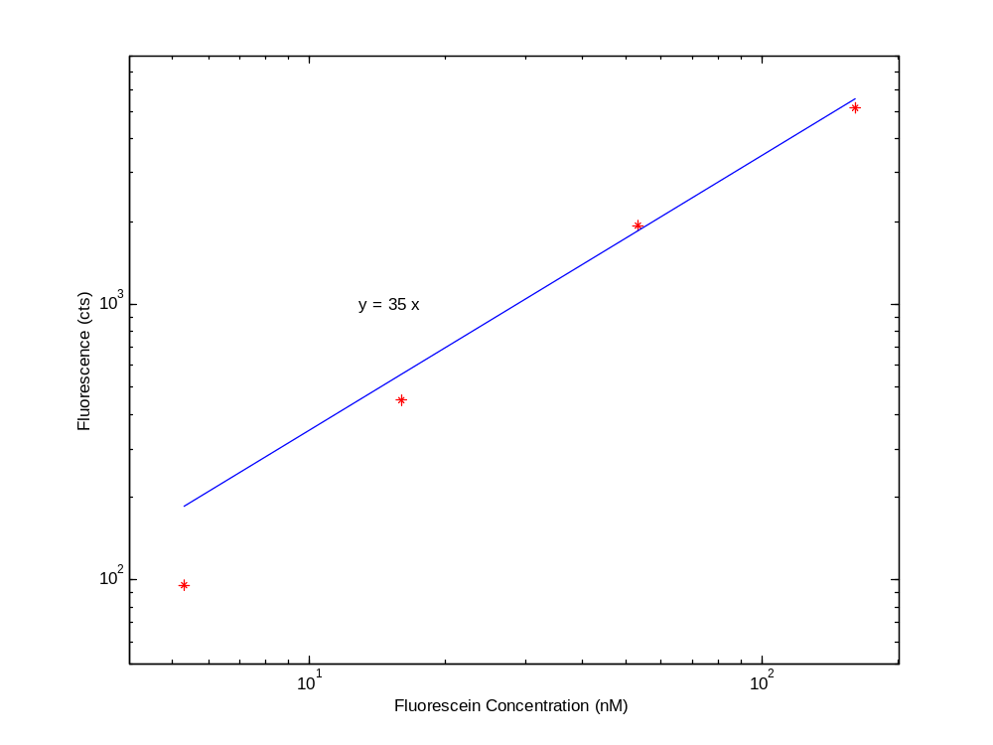
Figure S10. Calibration of fluorescein concentration. Fluorescein concentration is determined with absorption measurement at 490nM (Extinction coefficient =90000 cm⁻¹). Fluorescence on-chip measurements are taken at the same conditions as the other experiments. Plotted are the fluorescence intensity of 4 sequential dilutions each of factor of 3 from a stock solution of 160nM; the points shown on the log-log plot correspond to 5.6nM, 17nM, 53nM, 160nM.

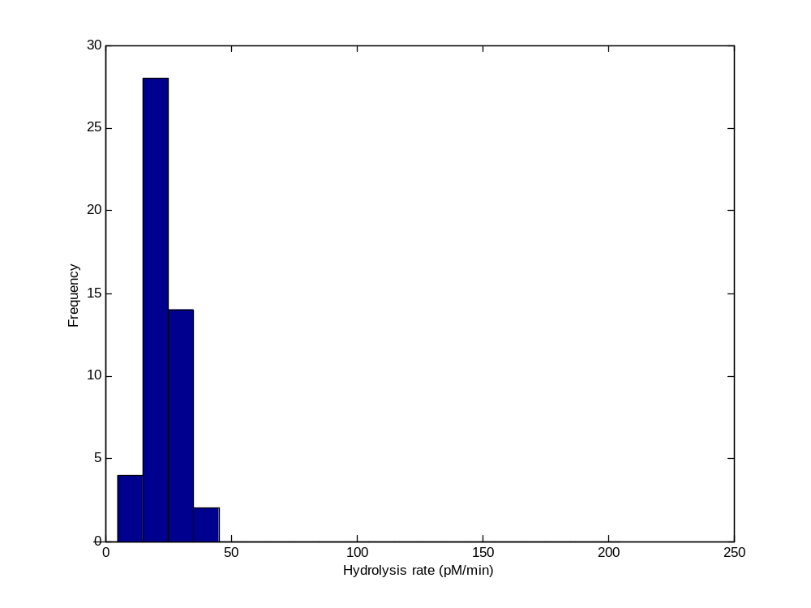
Figure S11: Autohydrolysis of FDG under the experimental conditions. The histogram shows autohydrolysis rates measured for 48 chambers in a microfluidics chip, filled with 300 μM FDG, and no enzyme or cells. The average autohydrolysis rates here is 23pM/min.

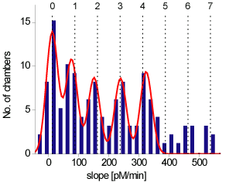

Figure S12: Hydrolysis rates measured for chambers containing E. coli cells that were treated with chloroform before the measurement. Similar to Fig. 3a in the main text, but here, the average number of cells/chamber is larger, hence the histogram shows more peaks. Red curve – a multi-peak Gaussian fit to the data. Distance between peaks is consistent with that in Figs. 1f and 3a.
References:

S? Broach, J.R., Volkert, F.C. Circular DNA Plasmid of yeasts. The Molecular and Cellular Biology of the Yeast Saccharomyces. 1 297-331 (1991).
S? Unger M. et al., Monolithic microfabricated valves and pumps by multilayer soft lithography. Science 288, 113-116 (2000).
S? Wu, H., Wheeler, A., Zare, R.N. Chemical cytometry on a picoliter-scale integrated microfluidic chip. Proc. Natl. Acad. Sci. U.S.A. 101, 12811-12813 (2004).
S?. Sulivak M.C. et. al., Antibiotic susceptibility profiles of Escherichia coli strains lacking multidrug efflux pump genes. Antimicrob Agents Chemother 45, 1126-36 (2001)
S?. Pages, J.M., Masi, M., Barbe, J. Inhibitors of efflux pumps in Gram-negative bacteria. Trends Mol Med. 11. 382-9 (2005).
S?. Miao, F., Todd, P., Kompala, D.k., A single-cell assay of β-galactosidase in recombinant Escherichia coli using flow cytometry. Biotechnology and Bioengineering 42, 708-715 (1993).
S?. Zambrowicz B.P. et. al., Disruption of overlapping transcripts in the ROSA beta geo 26 gene trap strain leads to widespread expression of beta-galactosidase in mouse embryos and hematopoietic cells. Proc. Natl. Acad. Sci. USA 94, 3789-3794 (1997).
S?. Paulsson, J., Berg, O.G., Ehrenberg, M. Stochastic focusing: fluctuation-enhanced sensitivity of intracellular regulation. Proc. Natl. Acad. Sci. U.S.A. 97, 7148-7153 (2000).
S?. Friedman, N. Cai, L. Xie, X.S. Phys. Rev. Lett, submitted.
S?. Elowitz, M.B., Levine, A.J., Siggia, E.D., Swain, P.S. Stochastic gene expression in a single cell. Science 297, 1183-1186 (2002).
S?. Rosenfeld, N., Young, J.W., Alon, U., Swain, P.S., Elowitz, M.B. Gene regulation at the single-cell level. Science 307, 1962-1965 (2005).
S?. Berg, O.G., A model for the statistical fluctuations of protein number in a microbial population. J Theor Biol. 71, 587-603 (1975).
S?. Bondeson, K., Frostell-Karlsson, A., Fagerstam, L., Magnusson, G. Lactose repressor-operator DNA interactions: kinetic analysis by a surface plasmon resonance biosensor. Anal Biochem. 214. 245-51 (1993).
S?. Goeddel, D.V., Yansura D.G., Caruthers, M.H., How lac repressor recognizes lac operator. Proc. Natl Acad. Sci. USA 74. 3292–3296(1977).
S?. Oehler S., Amouyal M., Kolkhof P., von Wilcken-Bergmann B., Muller-Hill B. Quality and position of the three lac operators of E. coli define efficiency of repression. EMBO J. 13, 3348-3355 (1994).
S?. Liu, M., Gupte, G., Roy, S., Bandwar, R.P., Patel, S.S., Garges, S. Kinetics of transcription initiation at lacP1. Multiple roles of cyclic AMP receptor protein. J Biol Chem.278. 39755-61 (2003).
S?. Nichtl, A., Buchner, J., Jaenicke, R., Rudolph, R., Scheibel, T., Folding and association of beta-Galactosidase. J. Mol. Biol. 282, 1083-1091 (1998).
S?. Gillespie,D. Exact stochastic simulations of coupled chemical reactions. J. Phys. Chem. 81, 2340-2361 (1977).
S?. Jacobson, R.H., Zhang, X.J., DuBose, R.F., Matthews, B.W., Three-dimensional structure of beta-galactosidase from E. coli. Nature 369, 761-766 (1994).
S?. Marchesi, S.L., Steers, E. Jr., Shifrin, S. Purification and characterization of the multiple forms of beta-galactosidase of Escherichia coli. Biochimica et Biophysica Acta 181, 20-34 (1969).
S?. Straney, S.B., Crothers, D.M., Kinetics of the stages of transcription initiation at the Escherichia coli lac UV5 promoter. Biochemistry. 26 5063-70 (1987).
S?. Goeddel, D.V., Yansura, D.G., Caruthers, M.H., How lac repressor recognizes lac operator. Proc. Natl Acad. Sci. USA 74 3292–3296 (1977).
S?. McAdams, H.H., Arkin, A., Stochastic mechanisms in gene expression. Proc. Natl. Acad. Sci. U.S.A. 94, 814-819 (1997).

