>> quantipatch_SD

e.g. /Users/DoerLBH/Dropbox/git/OLab_patch_processor_3.0/test

What is your folder?: /Users/DoerLBH/Dropbox/git/OLab_patch_processor_3.0/test

/Users/DoerLBH/Dropbox/git/OLab_patch_processor_3.0/test

09-Dec-2017

---------------------

file:/Users/DoerLBH/Dropbox/git/OLab_patch_processor_3.0/test/Ctrl-ODC-1-original-level-crop_average-1.tif

patch index (curve method): **0.011536** (rank 6)

patch index (sd method): **0.1295** (rank 6)



---------------------

file:/Users/DoerLBH/Dropbox/git/OLab_patch_processor_3.0/test/Ctrl-ODC-1-original_1_trim-grey.tif

patch index (curve method): **0.27542** (rank 5)

patch index (sd method): **7.6434** (rank 3)

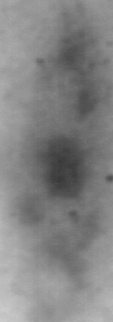

---------------------

file:/Users/DoerLBH/Dropbox/git/OLab_patch_processor_3.0/test/P20MDn-12-ipsi3,4-clean-trim-grey.tif

patch index (curve method): **0.65883** (rank 3)

patch index (sd method): **6.2879** (rank 5)



---------------------

file:/Users/DoerLBH/Dropbox/git/OLab_patch_processor_3.0/test/P20MDnd-73-ipsi13-scale-trim-grey.tif

patch index (curve method): **0.75417** (rank 2)

patch index (sd method): **6.7286** (rank 4)



---------------------

file:/Users/DoerLBH/Dropbox/git/OLab_patch_processor_3.0/test/P21MDd-100-ipsi5-scale-4pxOutlierRemoved-trim-grey.tif

patch index (curve method): **0.80021** (rank 1)

patch index (sd method): **9.762** (rank 1)



---------------------

file:/Users/DoerLBH/Dropbox/git/OLab_patch_processor_3.0/test/ctrl-ODC-4-section-2-original-trim-grey.tif

patch index (curve method): **0.55323** (rank 4)

patch index (sd method): **7.7509** (rank 2)

