StatR 101: Fall 2012

Homework 6

Rod Doe

Saturday, November 3, 2012

# Playing Cards

## How many possible poker hands?

The short answer to this is that it is possible to draw 2598960 combinations of 5 cards from a deck of 52.

> prod(1:52)/prod(1:5)/prod(1:47)

[1] 2598960

This was confirmed by the choose function.

> choose(52,5)

[1] 2598960

The combn function gives the correct result, but one must understand the result. Initially, I thought it was high by a factor of 5.

> h <- combn(1:52, 5)

> length(h)

[1] 12994800

> length(h) / choose(52,5)

[1] 5

Then I looked at the result, and realized that the factor of 5 came from the size of each combination. (Duh!)

h<-combn(1:52, 5)

> h[1:100]

[1] 1 2 3 4 5 1 2 3 4 6 1 2 3 4 7 1 2 3 4 8 1 2 3 4 9

[26] 1 2 3 4 10 1 2 3 4 11 1 2 3 4 12 1 2 3 4 13 1 2 3 4 14

[51] 1 2 3 4 15 1 2 3 4 16 1 2 3 4 17 1 2 3 4 18 1 2 3 4 19

[76] 1 2 3 4 20 1 2 3 4 21 1 2 3 4 22 1 2 3 4 23 1 2 3 4 24

## Deck

> Suit=c(rep("Clubs", 13), rep("Diamonds", 13), rep("Hearts", 13), rep("Spades", 13))

> Value = c(2:14, 2:14, 2:14, 2:14)

> SuitCode=c(rep(1, 13), rep(2, 13), rep(3, 13), rep(4, 13))

> Deck <- cbind(Suit, SuitCode, Value)

> Deck

Suit SuitCode Value

[1,] "Clubs" "1" "2"

[2,] "Clubs" "1" "3"

## IsFlush

IsFlush <- function(nCards) {

deck = c(rep(1, 13), rep(2, 13), rep(3, 13), rep(4, 13))

hand = sample(deck, nCards, replace = FALSE)

suit = hand[1]

result = prod(hand == suit)

}

I ran a single trial of 10000 samples:

for (j in 1:length(flushes)) { flushes[j] <- IsFlush(5) }

pFlush = 100 * sum(flushes)/length(flushes)

pFlush

[1] 0.17

I ran 100 trials of 10000 samples to get an idea of the range of the probability of getting a flush. My results indicate that the probability of getting a flush is around 1 in 500.

trials <- numeric(100)

flushes <- numeric(10000)

for (i in 1:length(trials)) {

for (j in 1:length(flushes)) { flushes[j] <- IsFlush(5) }

trials[i] = 100 * sum(flushes)/length(flushes)

}

summary(trials)

Min. 1st Qu. Median Mean 3rd Qu. Max.

0.0900 0.1700 0.1900 0.1964 0.2200 0.3300

hist(trials, prob=TRUE, main="Percentage of flush poker hands", xlab="")

lines(density(trials))

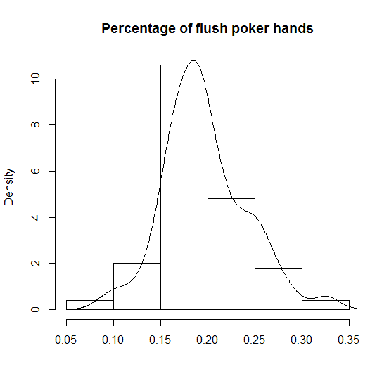

## IsStraight

IsStraight <- function(nCards) {

result = TRUE

deck = c(c(2:14), c(102:114), c(202:214), c(302:314))

hand = sample(deck, nCards, replace = FALSE)

numbers = sort(hand%%100)

for (i in 1:(nCards - 1)) {

if (numbers[i + 1] != (numbers[i] + 1)) {

result = FALSE

break

}

}

return(result)

}

I ran a single simulation of 10000 hands, and found that the probability of one will be dealt a straight roughly once in 263 hands.

> straights <- numeric(10000)

> for (j in 1:length(straights)) { straights[j] <- IsStraight(5) }

> pStraight = 100 * sum(straights)/length(straights)

> pStraight

[1] 0.38

> 100/pStraight

[1] 263.1579

I repeated 100 such simulations and found that my initial experiment was a little optimistic.

trials <- numeric(100)

> straights <- numeric(10000)

> for (i in 1:length(trials)) {

+ for (j in 1:length(straights)) { straights[j] <- IsStraight(5) }

+ trials[i] = 100*sum(straights)/length(straights)

+ }

> summary(trials)

Min. 1st Qu. Median Mean 3rd Qu. Max.

0.2200 0.3075 0.3450 0.3453 0.3800 0.5000

> hist(trials, prob=TRUE, main="Percentage of straight poker hands", xlab="")

> lines(density(trials))

> 100 / 0.3453

[1] 289.6032

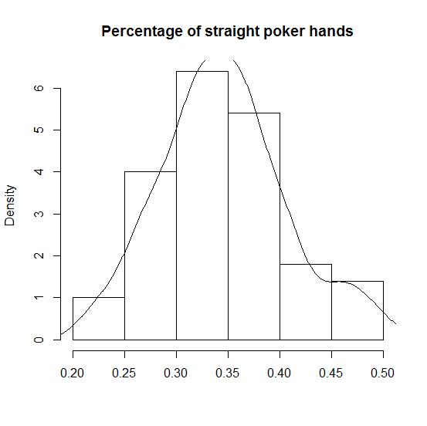

## In Summary

One is roughly twice more likely to be dealt a straight than a flush.

# Airplane function

## Binom simulation (single flight)

There are 100 critical path parts, each with 0.999 probability of successful operation.

rbinom(100, 1, 0.999)

[1] 1 1 1 1 1 1 1 1 1 1 1 1 1 1 1 1 1 1 1 1 1 1 1 1 1 1 1 1 1 1 1 1 1 1 1 1 1

[38] 1 1 1 1 1 1 1 1 1 1 1 1 1 1 1 1 1 1 1 1 1 1 1 1 1 1 1 1 1 1 1 1 1 1 1 1 1

[75] 1 1 1 1 1 1 1 1 1 1 1 1 1 1 1 1 1 1 1 1 1 1 1 1 1 1

This suggests that all parts operate without failure.

## Binom simulation (1000000 flights)

failures <- numeric(1000000)

for (i in 1:1000000) {

trial <-rbinom(100, 1, 0.999)

failures[i] = sum(trial == 0)

}

sum(failures > 0)

[1] 94559 # Yikes! Almost one in 10 has a failure

## Calculate exact probability of success

Success = all 100 components do not fail.

P = 0.999 (probability of success of a part)

Q = 1- P – 0.001 (probability of failure of a part)

N = 100 (number of parts)

Outcome of zero failures is the probability of interest.

choose(100, 0) * 0.999^100

[1] 0.9047921 # probability of success

## Would I fly Epsilon Airlines?

No – their equipment is susceptible to single points of failure. This is in contrast to Boeing designs, in which redundancy eliminates most single points of failures. For example, on a 747, there are four hydraulic pumps. Two are engine driven, and two are air-driven. As long as the airplane is moving through the air, hydraulic power is available from four different pumps. If all engines quit, as long as the airplane is moving, they still can operate flight controls and landing gear. The 787 has three flight control computers, running on two different processors, that are simultaneously processing identical input. If one fails, two more are available. They use two different processors in case a manufacturing defect is endemic to the processor.

# Elections

## Discrete probability distribution of the number of electoral votes

ala <- dbinom(x=0:100, size=100, prob=0.39, log = FALSE)

ind <- dbinom(x=0:100, size=100, prob=0.505, log = FALSE)

cal<- dbinom(x=0:100, size=100, prob=0.62, log = FALSE)

cols = c("red", "purple", "blue")

plot(ala, xlab="", ylab="", main="Binomial Distributions of State Election Results", col="red")

points(ind, col="purple")

points(cal, col="blue")

legend("topright", legend=c("Alaska", "Indiana", "California"), col=cols, pch=19)

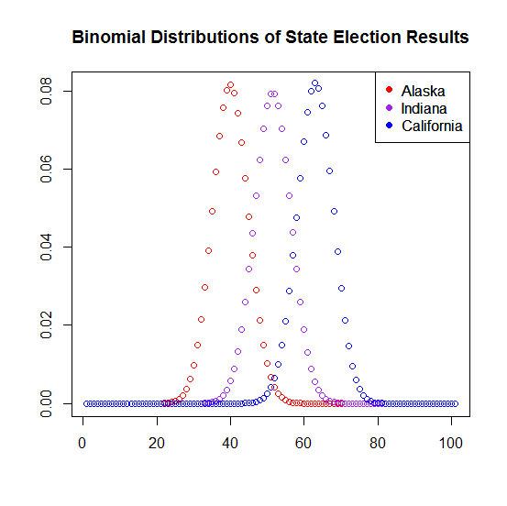

## Probability that McCain would have won Alaska

binom.test(x=501, n=1000, p=0.61, alternative="less")

Exact binomial test

data: 501 and 1000

number of successes = 501, number of trials = 1000, p-value = 1.827e-12

alternative hypothesis: true probability of success is less than 0.61

95 percent confidence interval:

1. 0.52748

## Probability that McCain would have won Indiana

binom.test(x=501, n=1000, p=0.495, alternative="less")

Exact binomial test

data: 501 and 1000

number of successes = 501, number of trials = 1000, p-value = 0.6595

alternative hypothesis: true probability of success is less than 0.495

95 percent confidence interval:

1. 0.52748

## Probability that McCain would have won California

binom.test(x=501, n=1000, p=0.38, alternative="less")

Exact binomial test

data: 501 and 1000

number of successes = 501, number of trials = 1000, p-value = 1

alternative hypothesis: true probability of success is less than 0.38

95 percent confidence interval:

0.00000 0.52748