# StatR 301: Spring 2013

Homework 03

Rod Doe

Thursday, May 9, 2013

# My First ggplot

head(ChickWeight)

# weight Time Chick Diet

# 1 42 0 1 1

# 2 51 2 1 1

# 3 59 4 1 1

# 4 64 6 1 1

# 5 76 8 1 1

# 6 93 10 1 1

# Assaf's example spaghetti plot.

library(lattice)

xyplot(weight~Time | Diet,data=ChickWeight,group=Chick,type='l',

scales=list(alternating=3),main="Chick Growth by Diet Type",xlab="Age (Days)")

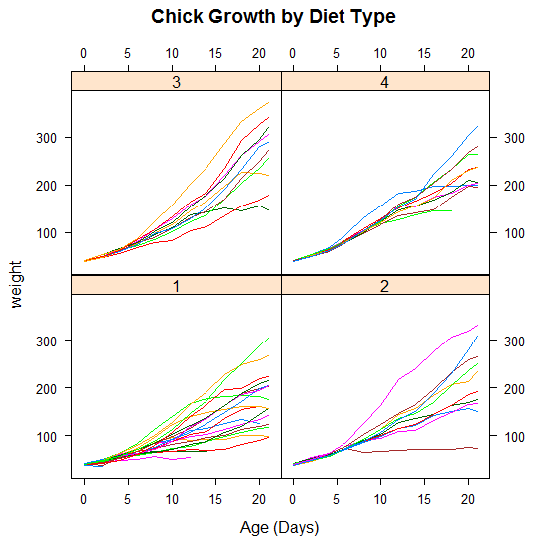

# Try to do the same thing with ggplot2

library(ggplot2)

qplot(x=Time, y=weight, data=ChickWeight, group=Chick, color=Diet, geom="line")

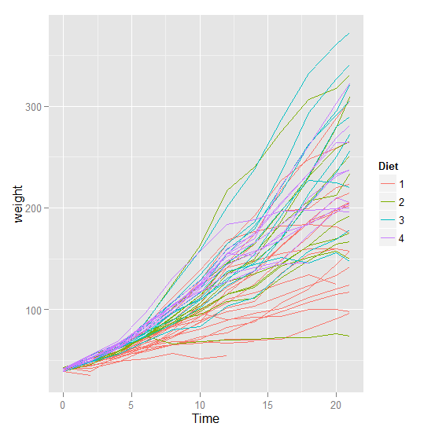

I could not find a way to split this into panes. The documentation of this function appeared to be written by somebody in a big hurry.

I started to play with the groupedData function, and found another way to render this with lattice.

library(lattice)

results <- groupedData(weight ~ Time |Chick, outer= ~ Diet, order.groups=TRUE, data=ChickWeight)

plot(results, outer=TRUE) # Useful and interesting. Shows that 3 has the most effect.

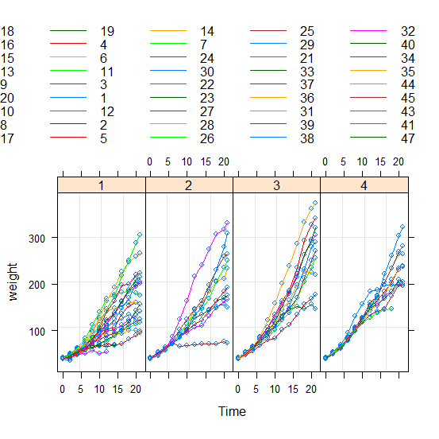

From a documentation standpoint, core R graphics beat lattice (Crawley’s ‘The R Book’ has decent coverage of lattice), and lattice beats ggplot, whose documentation appears to be its Achilles Heel. Oh, but there are books available to explain these is more detail. The powerful capabilities of ggplot are only as good as their documentation.

# Mixed Effects

Mixed effects include fixed effects and random effects. Fixed effects influence the mean of y, whereas random effects influence the variation of y.

# Mixed effect model for ChickWeight

library(nlme)

It’s probably not necessary/helpful to see information about each specific chick. Perhaps the data can be grouped differently to make this possible. I tried different things with this, and got R’s version of the PC LOAD LETTER, which I buried with a suppressWarnings call.

suppressWarnings( results <- groupedData(weight ~ Time | Diet, outer= ~ Chick, order.groups=TRUE, data=ChickWeight) )

suppressWarnings( plot(results) ) # Useful and interesting, shows that 3 has the most effect (steepest slope for group).

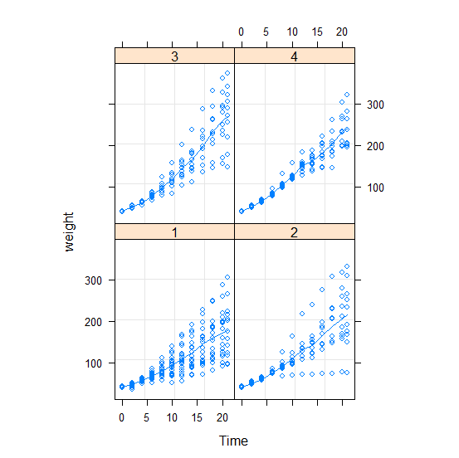

This is better. It is possible to see that diet 3 has the largest slope, and hence the most effect. I wish I new about this plot when I was using R in the semiconductor industry. To see the signal in the noise is nice.

Create a mixed-effects model using lme, and summarize:

model <- lme(weight~Diet, random= ~Time|Chick, data=ChickWeight)

summary(model)

> summary(model)

Linear mixed-effects model fit by REML

Data: ChickWeight

AIC BIC logLik

4909.447 4944.268 -2446.724

Random effects:

Formula: ~Time | Chick

Structure: General positive-definite, Log-Cholesky parametrization

StdDev Corr

(Intercept) 31.017008 (Intr)

Time 9.204751 -0.997

Residual 12.785139

Fixed effects: weight ~ Diet

Value Std.Error DF t-value p-value

(Intercept) 54.92402 1.389555 528 39.52633 0.0000

Diet2 2.85461 2.364553 46 1.20725 0.2335

Diet3 1.99684 2.364553 46 0.84449 0.4028

Diet4 9.27429 2.367623 46 3.91713 0.0003

Correlation:

(Intr) Diet2 Diet3

Diet2 -0.588

Diet3 -0.588 0.345

Diet4 -0.587 0.345 0.345

Standardized Within-Group Residuals:

Min Q1 Med Q3 Max

-2.72764450 -0.56576747 -0.03692424 0.47655985 3.47296794

Number of Observations: 578

Number of Groups: 50

>

### Model residuals

Residuals are not normally distributed:

## 

This is about as far as I got with this question.

## MPG with GAM – outlier removal

# Assaf's lecture code (adapted)

library(mgcv)

setwd("C:/Users/Rod/SkyDrive/R/301/Week05")

autos = read.csv("autoMPGtrain.csv", as.is = TRUE)

autos$continent = factor(autos$continent)

autos$name = tolower(autos$name)

autos$diesel = grepl("diesel", autos$name)

autos$diesel[autos$name == "mercedes-benz 240d"] = TRUE

autos$cylgroup = cut(autos$cyl, c(2, 5.5, 6.5, 9))

gam4=gam(mpg~continent+diesel+cylgroup+s(weight,by=cylgroup)+s(year,k=13)+s(accel)+s(hp),data=autos,select=TRUE)

plot(gam4,pages=1)

# Assaf used an rmse function. Implement it.

rmse <- function(predicted, observed) { err <- sqrt(mean((predicted - observed)^2)); err }

autest = read.csv("autoMPGtest.csv", as.is = TRUE)

autest$continent = factor(autest$continent)

autest$name = tolower(autest$name)

autest$diesel = grepl("diesel", autest$name)

autest$diesel[autest$name == "mercedes benz 300d"] = TRUE

autest$cylgroup = cut(autest$cyl, c(2, 5.5, 6.5, 9))

gampreds = predict(gam4, newdata = autest)

rmse(gampreds, autest$mpg)

[1] 2.440786

setwd("C:/Users/Rod/SkyDrive/R/301/Week05")

autos = read.csv("autoMPGtest.csv")

str(autos)

which(autos$mpg > 46)

> autos[which(autos$mpg > 46),]

name cyl volume hp weight accel year continent mpg

86 mazda glc 4 86 65 2110 17.9 80 3 46.6

Personal note: The outlier is the 86 Mazda GLC, which was sold the next year as the 323. I bought an 87 Mazda 323 for $8500, and it was a fantastic car. It was breathtakingly fast. It got rear-ended in an I-5 traffic jam when there were 666 miles ominously on the odometer. I got the car and my neck fixed and drove it for another 140,000. It only got about 35 mpg on the road, so I suspect that the 46 should have been a 36. Contrary to appearance, I am not a “car guy”, and currently drive a 17 year old Honda Civic with 256,000 miles on it.

Remove the outlier, which happens to be the only mileage greater than 46, and predict. Get the RMS error.

idx = which(autest$mpg < 46)

gampreds2 = predict(gam4, newdata = autest[idx,])

rmse(gampreds2, autest$mpg[idx])

[1] 2.198124

### More robust comparisons

abse <- function(predicted, observed) { err <- abs(predicted - observed); sum(err) }

>

> # Get vectors of absolute errors and do a summary to compare 75% percentile (3rd quartile).

> abserrs = abs(gampreds - autest$mpg)

> abserrs2 = abs(gampreds2 - autest$mpg[idx])

> summary(abserrs)

Min. 1st Qu. Median Mean 3rd Qu. Max.

0.04705 0.40680 1.37800 1.77800 2.66400 10.84000

> summary(abserrs2)

Min. 1st Qu. Median Mean 3rd Qu. Max.

0.04705 0.40670 1.36900 1.68600 2.65200 6.39300

>

> ( abse(gampreds,autest$mpg) )

[1] 177.7619

> ( abse(gampreds2, autest$mpg[idx]) )

[1] 166.9268

### Comparison of metrics

Now we have three metrics to compare models:

* RMS Error
* Absolute Error
* Comparison of third quartile of absolute errors.

Are these metrics really more robust? Well, as always in statistics, that depends. If the emphasis is to have less noise, then the 3rd quartile comparison metric appears reduces the effect of the outlier for the purpose of comparison. However, if I want less uncertainty in my prediction, that metric would be deceptive, and a low value on either of the other two metrics would be more meaningful.

### A New Metric – the Assafian (since Reynolds, Prandtl, and Mach shouldn’t get to have all the fun)

Assafian <- function(predicted, observed) {

# Get the difference in 3rd quartiles.

summaryPredicted = summary(predicted)

summaryObserved = summary(observed)

label = '3rd Qu.'

percentileDiff = abs(summaryPredicted[label] - summaryObserved[label])

# Get the absolute difference between predicted and observed.

absdiff <- sum(abs(predicted - observed));

# Take the mean of the two results.

assafian = mean(c(absdiff, percentileDiff))

assafian

}

# Tested

> (Assafian(gampreds,autest$mpg))

[1] 89.02096

> (Assafian(gampreds2, autest$mpg[idx]))

[1] 83.56839

Try my best parsimonious model from the dreaded homework 4:

> gam5 = gam(mpg ~ weight + year + continent + diesel, data=autos, select=TRUE)

> gampreds5 = predict(gam5, newdata = autest)

> (Assafian(gampreds5, autest$mpg))

[1] 123.908 (Well, that went in the wrong direction…)

gam6 = gam(mpg ~ cyl + volume + hp + weight + accel + year + continent + diesel + cylgroup, data=autos, select=TRUE)

> gampreds6 = predict(gam6, newdata=autest)

> (Assafian(gampreds6, autest$mpg))

[1] 121.3225 (headed in the right direction, but not fast enough)