Data Organisation & Analysis

# Data Organisation

|  |  |
| --- | --- |
| **Date:** | 18-01-22 |
| **Section worked on:** | Importing Data |
| **Work Completed:** |

We’ve been asked to import data from a **text** file into an excel spreadsheet. This file **will** have empty data, which we have been tasked to sort out. We will be:

* Making sure there are no duplicated records, unnecessary spaces or blank cells
* Making sure the mean (average) is the num. of hours spent taking part in outdoor activities **rounded to a whole number**
* The **PREFERENCES** column is identified in uppercase

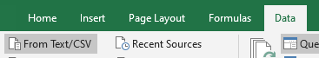

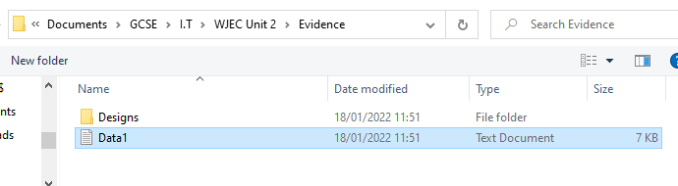

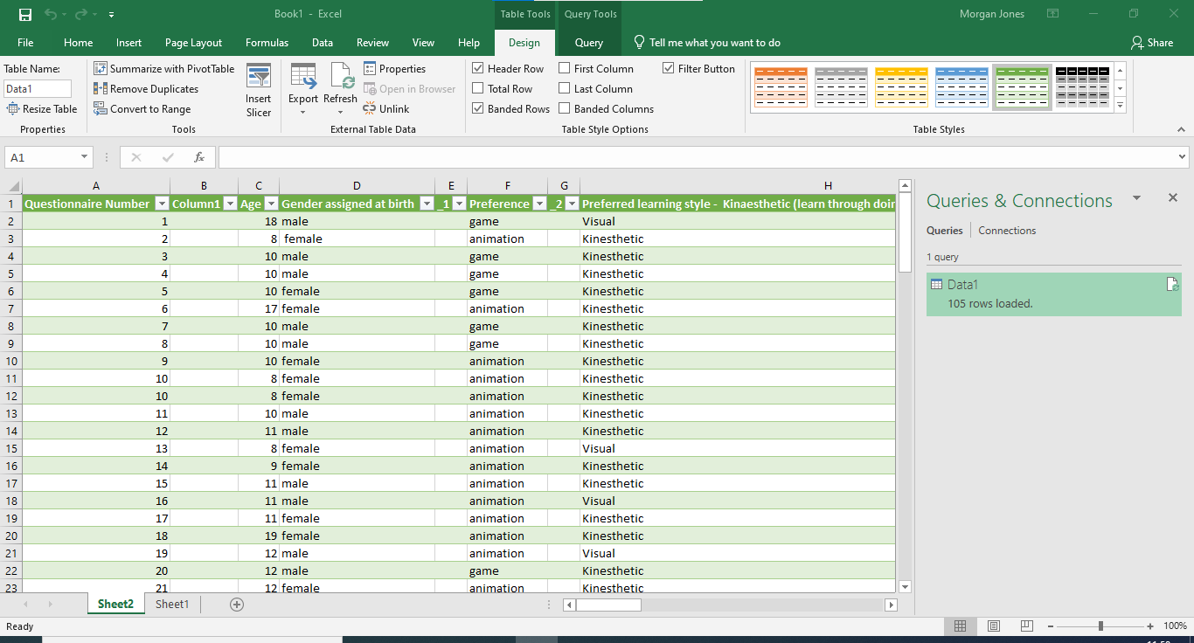

# Removing Blank Columns

To remove a column, right click at the top of it (Where it says A, B, C, etc.) and press delete.

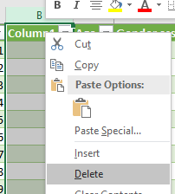

**Before:**

**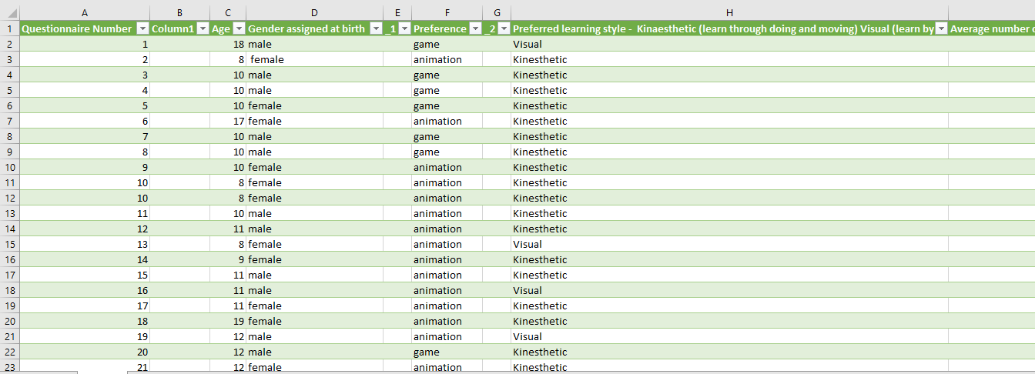  
After:**

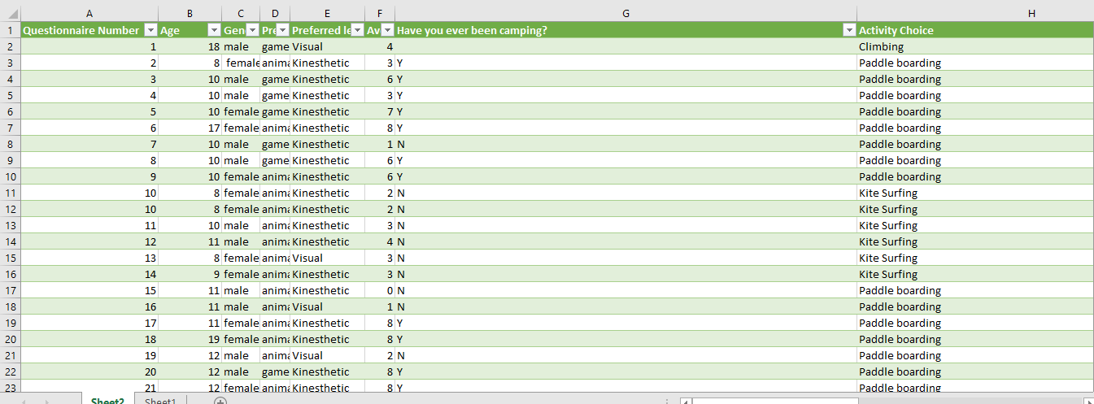

# Text Wrapping Titles

By text wrapping our titles, it allows us to increase the height of our titles and make them thinner so we don’t have to scroll horizontally across our spreadsheet.

First, we will select all of our titles in the first row



And press **Home > Wrap Text**:

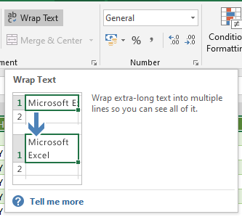

**After:**

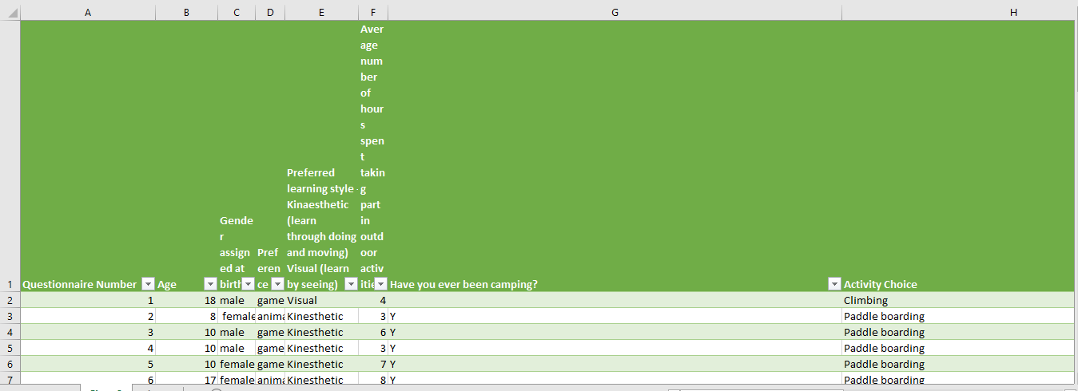

Obviously, this top row is too tall. The main culprit is column F. We will now change the width of all of these columns to make the spreadsheet titles more appropriate to the titles and the columns stored data.

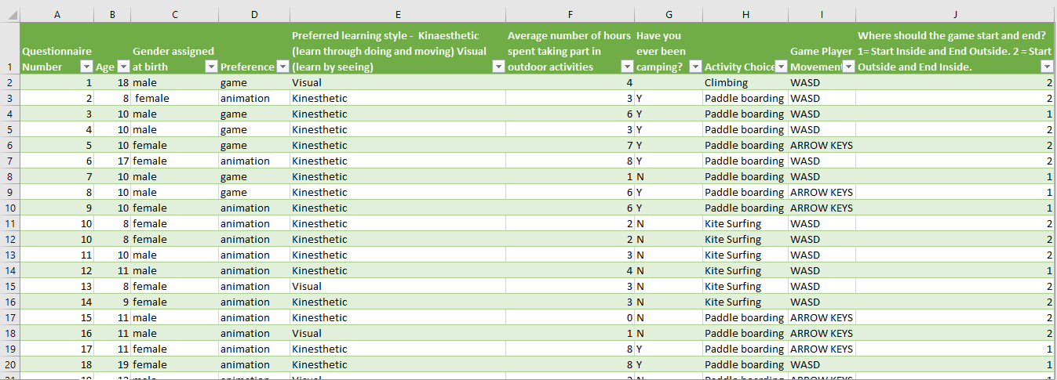

This is much better because now we can see all the columns in the spreadsheet without having to scroll.

# Removing Duplicates

Firstly, we will highlight every cell with **Ctrl + A**

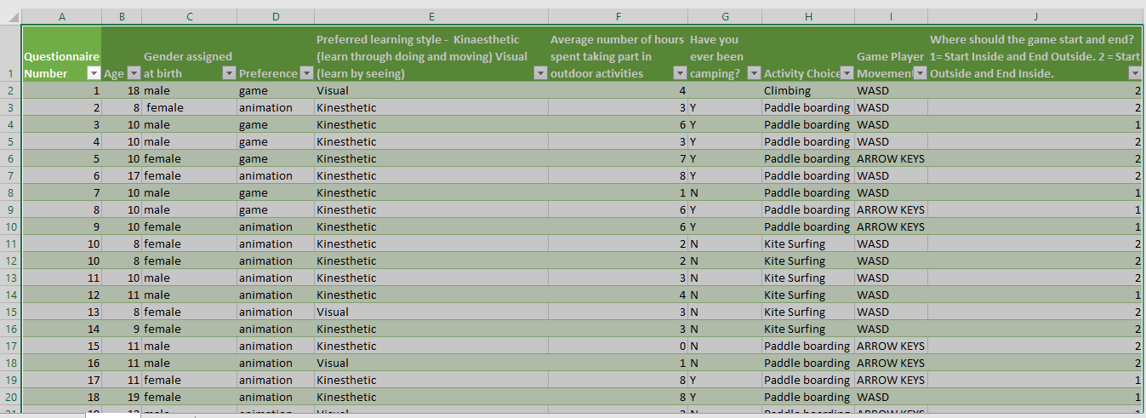

And then we go to **Data > Remove Duplicates** and press it

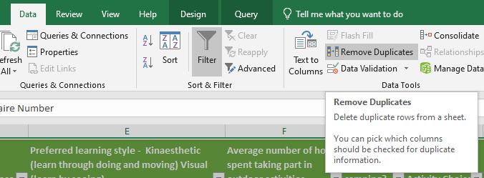

Press **OK** on the next two windows

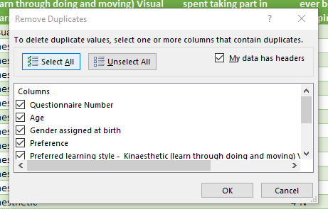

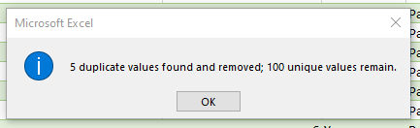

# Removing Blank Cells

Once again, highlight all the data with **Ctrl + A**

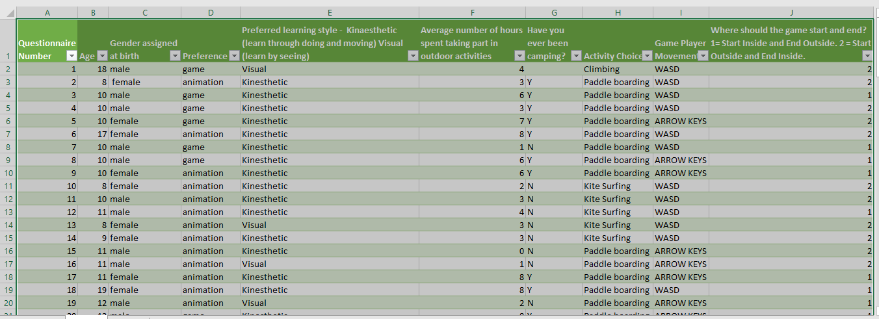

Then, we will click on **Home > Find & Select > Go To Special…**

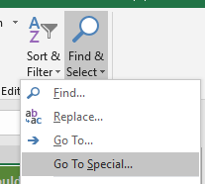

Select **Blanks** and click **OK**

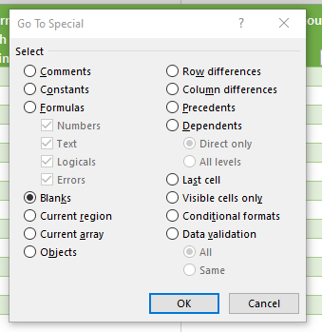

|  |  |
| --- | --- |
| **Date:** | 20-01-22 |
| **Section worked on:** | Roundup Mean Number & Changing Preferences to Upper Case |
| **Work Completed:** |

# Reducing decimals on the Average column

First, we will click on the column **letter** (F) to select the whole column

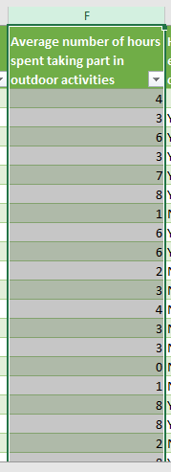

Then, under the Number section, press the expand button

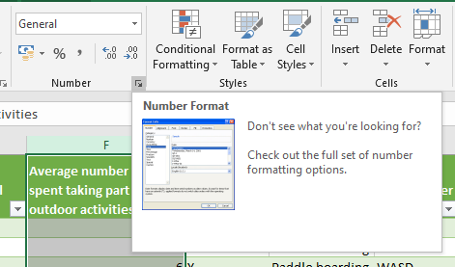

In the window that pops up, click on **Number** and set **Decimal places** to 0

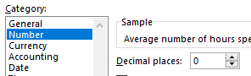

# Change the **Preferences** column to upper case

We select the column **K** and type **=upper(E2:E101)** in the formula field and press **Enter**

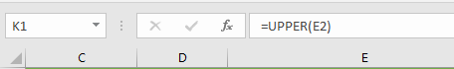

Our spreadsheet should now look something like this

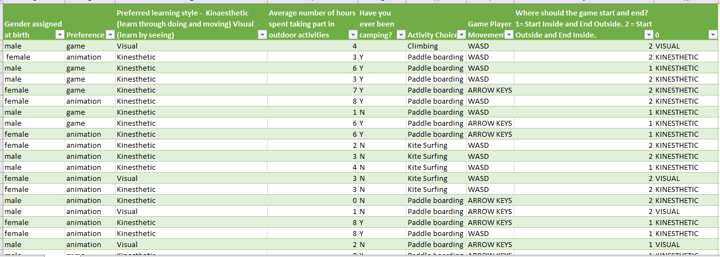

Now, we select from **K2** to **K101** and press **Ctrl+C**

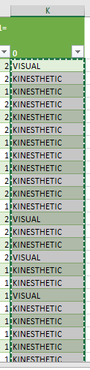

Then right click on **E2** and press **Paste Values**

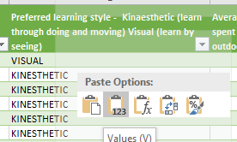

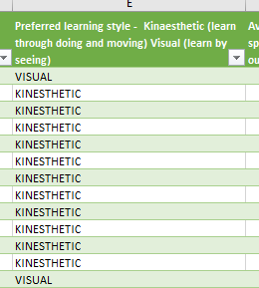

We can now right click on **column K** and press **Delete**

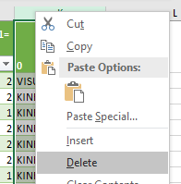

The spreadsheet now looks like this

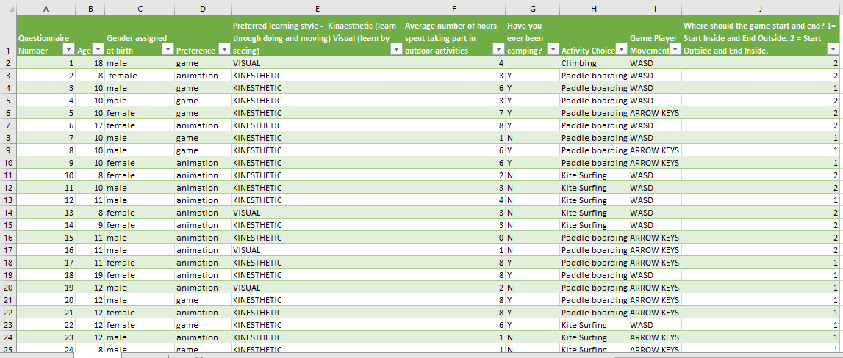

# Data Analysis

## 

|  |  |
| --- | --- |
| **Date:** | 27-01-22 |
| **Section worked on:** | Sorting by age |
| **Work Completed:** |

First, select the **Age** column



Then go to **Data > Sort**

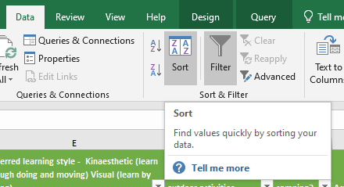

Press **OK**

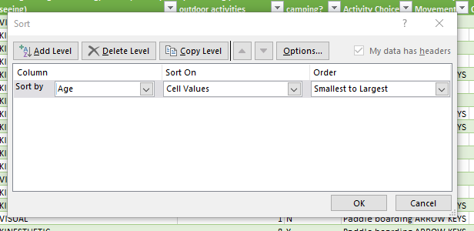

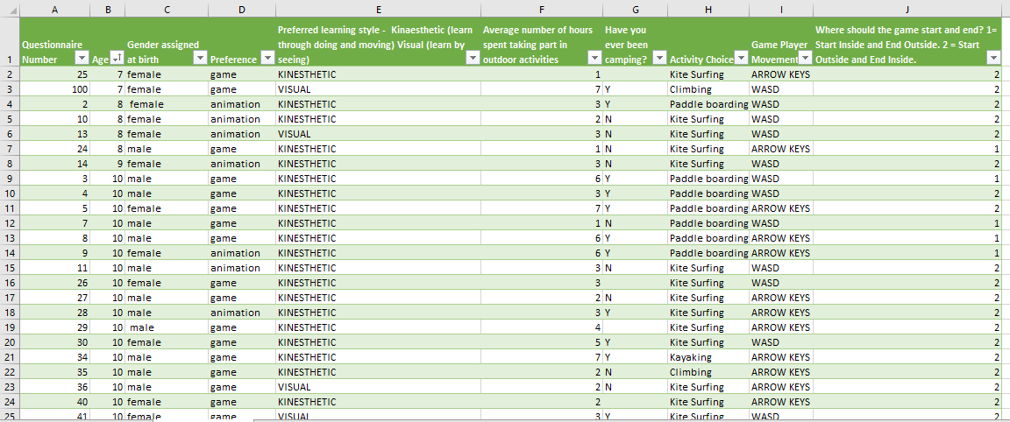

## Analysing ages

Starting from L2, we will create this table

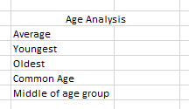

We then add in these formulae into the fields

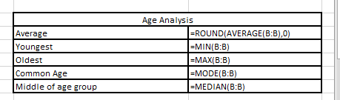

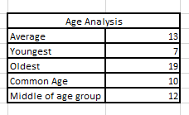

From this information I can tell that the average age of people that go to Adventure Cymru is 13, the youngest is 7, the oldest is 19, the most common age is 10 and the middle age is 12.

**=ROUND(x,y)** rounds the first argument to the decimal place of the second argument

**=MIN(B:B)** gets the smallest value from the cells or arguments

**=MAX(B:B)** get the biggest value from the cells or arguments

**=MODE(B:B)** gets the most used value from the cells or arguments

**=MEDIAN(B:B)** gets the middle-most value from the cells or arguments

# Analysing sex

To do this, we will create a table under the age table

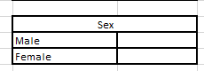

We will now use the **COUNTIF** function.

**=COUNTIF(xx:yx, z)** will look between the columns **xx** and **yx** and if the value of **z** is found in a cell, it will increment the count.

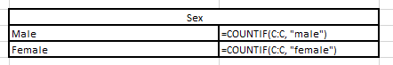

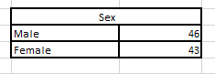

This information tells us that 46 males and 43 females are participating in Adventure Cymru.

# Showing how many people are doing each activity with a pivot table

To use this, we will use a **pivot table**

Click on **Insert > Pivot Table**

This window will pop up:

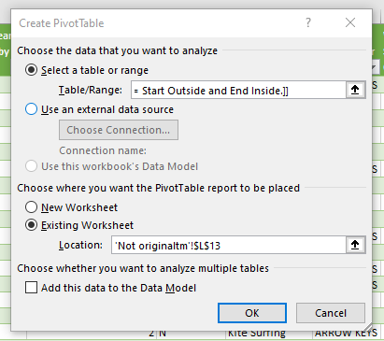

Click on the up arrow under **Select a table or range** and select the whole table including headings

Click on the up arrow under **Existing worksheet** and select a cell under the **Sex** table

Press **OK**

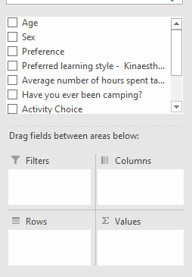

We can now drag these values down to create the pivot table

Example:

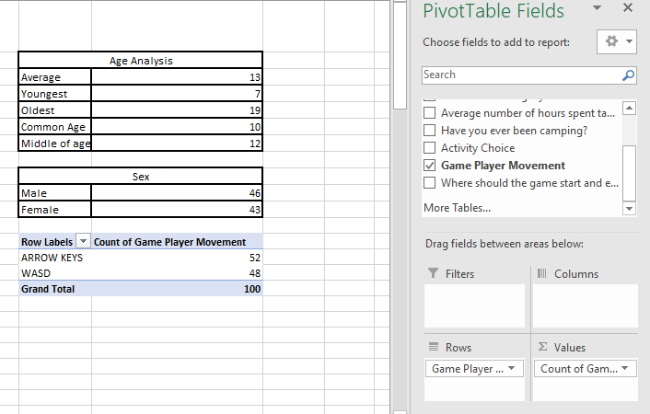

This tells us that 52 people prefer using the arrow keys and the other 48 prefer WASD

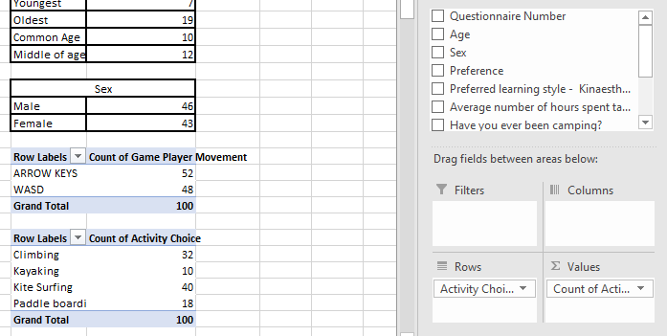

This shows us that 32 people enjoy climbing, 10 enjoy kayaking, 40 enjoy kite surfing and 18 enjoy paddle boarding

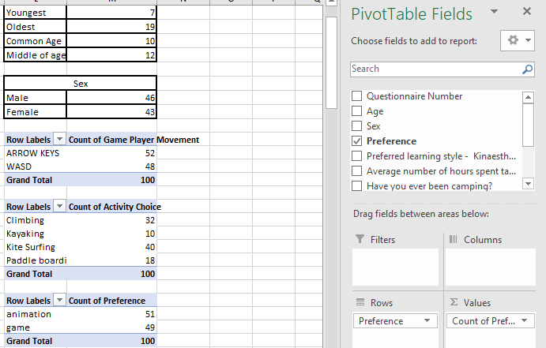

This shows us that 51 people prefer animation over the other 49 that prefer games.

# Conditional formatting

Conditional formatting is a non-numerical way of visualising information.

First, we select the whole of the last column of data (excluding the header)

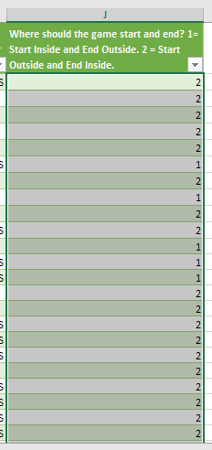

We then go to **Home > Conditional Formatting > Highlight Cell Rules > Equal To…**

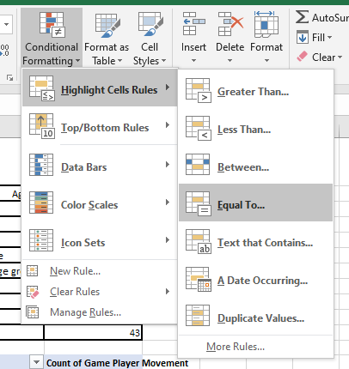

We will then enter 1 **OR** 2 into the left input field then choose our styling on the right.

We will make 1 = Orange and 2 = Yellow

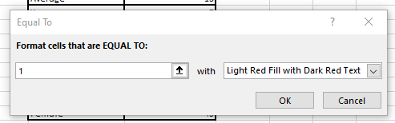

Press **OK**

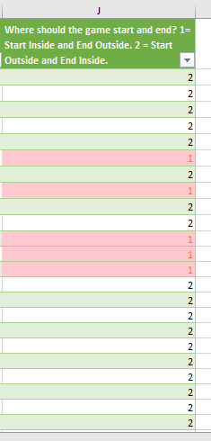

With the column still selected, press **Equal To…**, type in 2 and make the colour yellow

The column should now look like this (Red has been changed to orange)

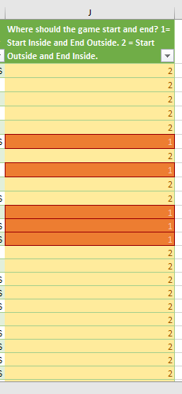

# Creating a Table of Activities

First, we will select **inside** the activity pivot table

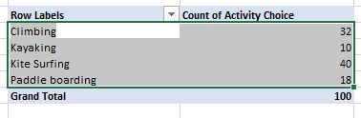

Then go to **Insert** and select a type of table

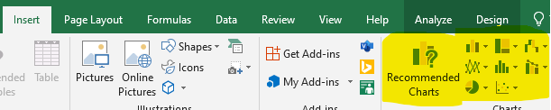

And voila! You have a table!

