Reward shaping:

Training this script gives a strange outcome:
- Reward shaping:
  - Reproduction rewards for all (4) types of agents are all set to 10.0.
  - All other rewards are set to zero with the exception of eating rewards which are set to 1.0 for both type_2 agents (type_2_predators and type_2_prey).
- However I get poor/no learning (after 300 iterations) of type_1_predators but on the other hand poor/no learning (after 300 iterations) of type_2_prey.

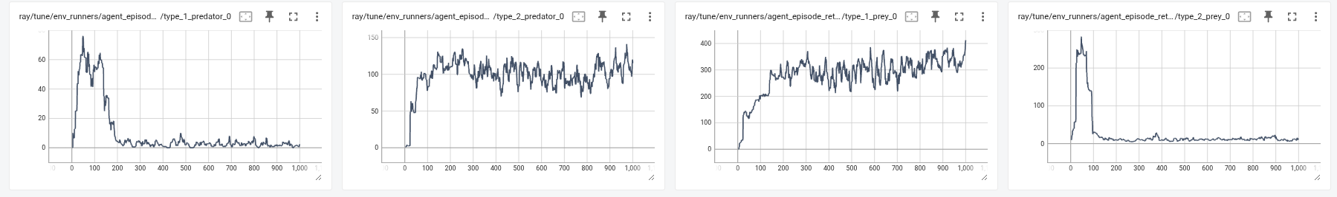
Tensorboard screenshot to display asymmetrical learning

QUESTION: Why this strange asymmetrical discrepancy?

COPILOT: Why type_1_predators stall but type_2_prey also stall
- Immediate vs sparse rewards
  - You give only type_2_predators a direct catch reward and only type_2_prey a direct grass-eating reward. Everyone gets a sparse reproduction reward (10).
  - For predators, this skews competition:
    - type_2_predators get immediate positive feedback each catch, so they quickly learn to hunt and monopolize prey.
    - type_1_predators only see sparse reproduction reward, which requires first catching prey to build energy. But with type_2_predators harvesting prey faster, type_1_predators rarely get catches, episodes end early, and their signal stays weak → poor learning.
- For prey, the shaping works against type_2_prey:
  - type_2_prey are positively reinforced to chase grass, which increases exposure in your walled map (openings are chokepoints), and with “respect_los_for_movement=True” they’re funneled through LOS-cleared paths. They get caught more, receive few reproduction rewards, and learn poorly.
  - type_1_prey have no eating bonus; they tend to roam/avoid more, survive longer, and eventually reach energy to reproduce (10) → they look “better” despite no eating reward.
- Episode termination amplifies it
  - In step, episodes end when either predators or prey go extinct: terminations["__all__"] = self.active_num_prey <= 0 or self.active_num_predators <= 0.
  - Faster prey wipeouts (driven by strong type_2_predators) shorten episodes, reducing the already-sparse reproduction signals for type_1_predators and type_2_prey.
- Walls + LOS increase asymmetry
  - With the manual inner-square walls and “respect_los_for_movement=True”, grass-seeking paths often pass chokepoints where predators camp or intercept. The extra eating drive (only for type_2_prey) pulls them into riskier routes more often than type_1_prey.

Net effect: your shaping makes one predator type overperform (type_2_predators) and one prey type overexposed (type_2_prey). The same shaping simultaneously starves type_1_predators of reward opportunities and deprives type_2_prey of survival/reproduction returns.

