**PRN212_Final Project**

1. **Introduction**
2. Overview

-When running the program, we must log in by entering the username and password to see which role it is

1. Account Role
2. Admin

-When entering the username and password as admin, we will enter the admin account. Admin will have the following functions:

+Product: admin can view, add, edit, and delete products

+Product Items: admin will select the product and select the option to view, add, edit, and delete the options of the selected product

+Category: admin can view, add, edit, and delete categories

+User: admin can view, add users as well as admin, edit, and delete users

+Supplier: admin can view, add, edit, and delete suppliers

+Order: admin can view orders as well as the current status of the order, and can change the order status from pending to approved or rejected

1. User

-When entering the username and password corresponding to the user, it will go to the home screen. When the user does not have an account, click the register button to create an account for the user. Users will have the following functions:

+ On the home screen, users will be able to view products

+ For each product, when the user clicks on View Product Detail, they will be able to view product information as well as choose options for the product to buy

+ When choosing the product options, the user will click the Buy button to buy the product

+ On the home screen, users can click the profile button to view account information

+ On the profile screen, users can select the profile button to view account information as well as edit

+ On the profile screen, users can select the View Order History button to view the current status of the order, as well as delete the Order if the current status is Pending

- When logging into the admin account or user, click the logout button to exit the account

- When the user purchases a product, it will be in pending status and the quantity of that product item will be deducted, when the user deletes the order (when the order status is pending), the quantity of that product item will be added back

1. **Use case**
2. Admin

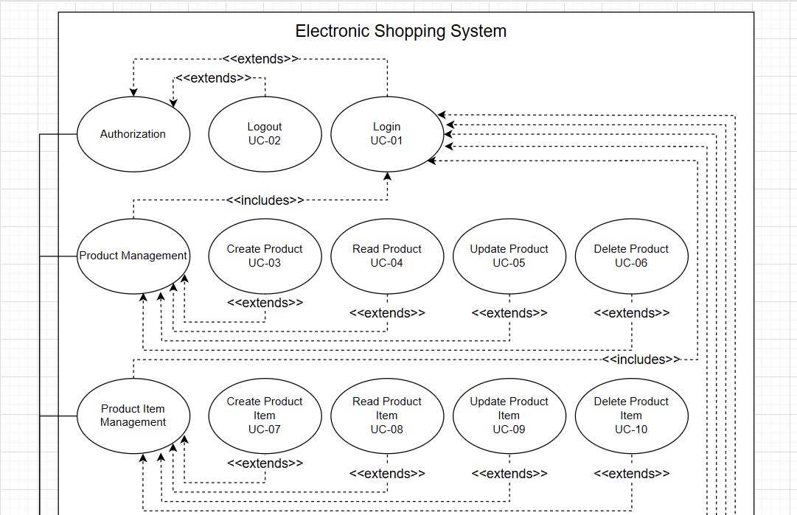

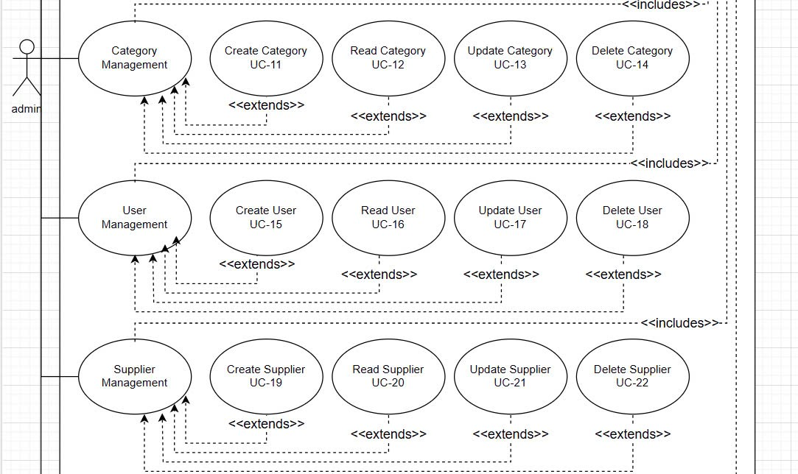

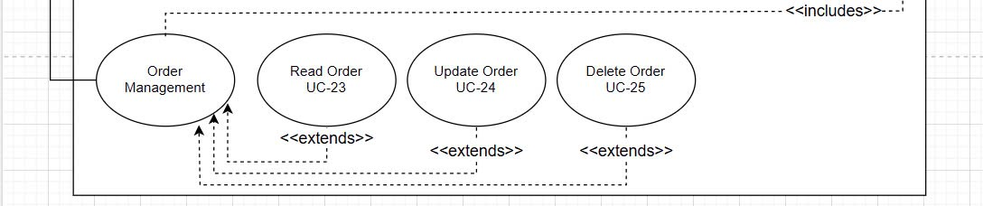

1. User

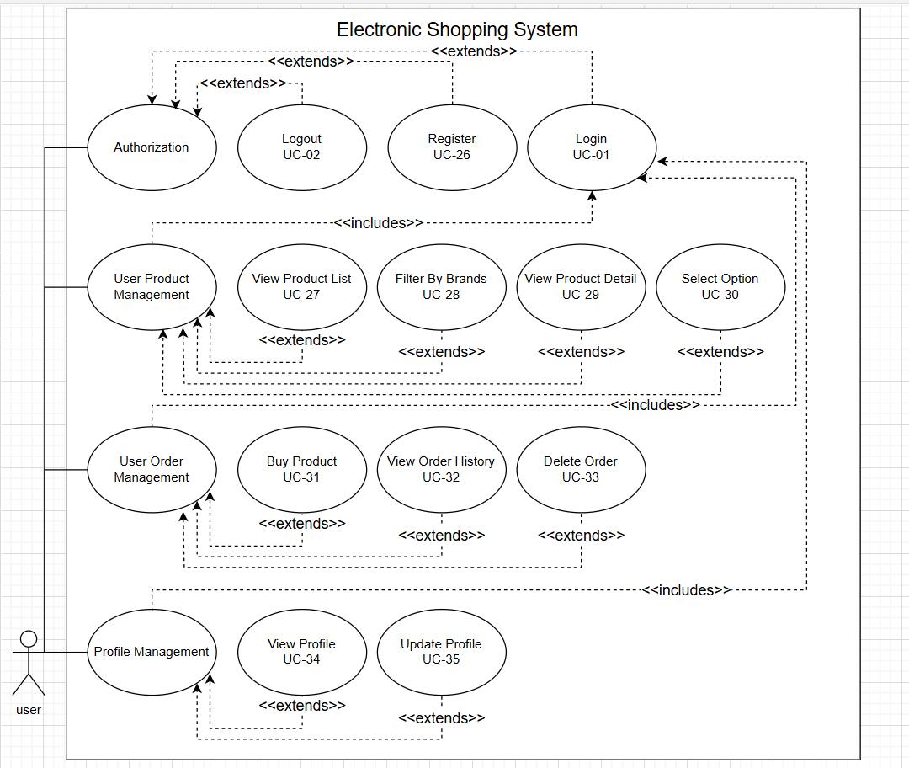

1. Description

|  |  |  |  |
| --- | --- | --- | --- |
| **ID** | **Feature** | **Use case** | **Use Case Description** |
| UC-01 | Authorization | Login | Users can log into their accounts using their credentials. |
| UC-02 | Authorization | Logout | User, Admin can log out their account |
| UC-03 | Product Management | Create Product | admin can add new products to the system.. |
| UC-04 | Product Management | View Product List | admin can view all products |
| UC-05 | Product Management | Update Product | admin can update product information |
| UC-06 | Product Management | Delete Product | admin can delete products from the system. |
| UC-07 | Product Item Management | Create Product Item | admin can add product items under a specific product |
| UC-08 | Product Item Management | View Product Item List | admin can view list of product item |
| UC-09 | Product Item Management | Update Product Item | admin can update a product item |
| UC-10 | Product Item Management | Delete Product Item | admin can delete product item |
| UC-11 | Category Management | Create Category | Admin can create new product categories |
| UC-12 | Category Management | View Category List | Admin can view category list |
| UC-13 | Category Management | Update Category | Admin can update category name |
| UC-14 | Category Management | Delete Category | Admin can delete a category |
| UC-15 | User Management | Create User | Admin can create a new user account |
| UC-16 | User Management | View User List | Admin can view list of users |
| UC-17 | User Management | Update User | Admin can update user information |
| UC-18 | User Management | Delete User | Admin can delete user account |
| UC-19 | Supplier  Management | Create Supplier | Admin can add new supplier |
| UC-20 | Supplier  Management | View Supplier list | Admin can view a list of supplier |
| UC-21 | Supplier  Management | Update Supplier | Admin can update supplier’s information |
| UC-22 | Supplier  Management | Delete supplier | Admin can delete a supplier |
| UC-23 | Order Management | Read Order | Admin can view a list of order |
| UC-24 | Order Management | Update order | Admin can update supplier’s state |
| UC-25 | Order Management | Delete order | Admin can delete order which state is pending |
| UC-26 | Authorization | Register | Guest can create a account |
| UC-27 | User Product Management | View Product List | Users and guests can view a list of available products |
| UC-29 | User Product Management | View Product Detail | Users and guests can view detailed information about a product |
| UC-28 | User Product Management | Filter Product by Brand | Users and guests can filter products by brand |
| UC-30 | User Product Management | Select Product Option | Users and guest can choose specific options, such as Ram and Storage |
| UC-31 | User Order Management | Buy Product | User can buy a product |
| UC-32 | User Order Management | View Order History | User can view his/her order history |
| UC-33 | User Order Management | Delete Order | User can delete his/her order history which state is pending |
| UC-34 | Profile Management | View Profile | User can view his/her profile information |
| UC-35 | Profile Management | Update Profile | User can update his/her profile information |