Posture-Robust In-Home Sleep Apnea Screening Using High-Dimensional Wi-Fi 6E Channel State Information
Jui-Hung Liu, Member, IEEE
Department of Smart Automation Engineering, National Chin-Yi University of Technology, Taichung, Taiwan
Email: jhliu@ncut.edu.tw
Abstract—Obstructive sleep apnea (OSA) affects close to one billion adults worldwide, yet most cases remain undiagnosed because the clinical reference standard—overnight polysomnography (PSG)—is costly, intrusive, and capacity-limited. Wi-Fi channel state information (CSI) enables a contactless, device-free, and privacy-preserving alternative for in-home respiratory screening, but two barriers have prevented clinical-grade deployment: poor cross-domain generalization and sensitivity to sleep-posture changes. This paper presents a posture-robust CSI sensing framework built on the high-dimensional CSI of IEEE 802.11ax (Wi-Fi 6E) hardware. Grounding the design in a multipath signal model, we derive a subcarrier-sensitivity criterion that explains why breathing appears only on a geometry-dependent subset of subcarriers, and use it to motivate four contributions: a systematic evaluation of the 256-subcarrier CSI of the Intel AX211 platform; a Posture-Aware Subcarrier Selection (PASS) mechanism that re-selects breathing-sensitive subcarriers after turn-over events; a lightweight dual-task network jointly regressing breathing rate and classifying apnea events with under one million parameters; and a layered site-calibration strategy that reconciles the accuracy of site-specific models with the robustness of generic ones. A physics-based synthetic digital twin, including explicit failure-mode modeling, supports pipeline development prior to hardware collection; in simulation, site-specific subcarrier calibration reduces breathing-rate error by roughly 4.5× at low SNR. The full evaluation protocol against synchronized PSG is presented; validation on real AX211 recordings is ongoing.
Index Terms—Wi-Fi sensing, channel state information, contactless vital signs, respiration, sleep apnea, IEEE 802.11ax, IEEE 802.11bf, domain generalization, subcarrier selection, digital twin.

I. Introduction
Obstructive sleep apnea (OSA) is a highly prevalent yet substantially under-diagnosed disorder in which repeated cessation of airflow during sleep fragments sleep architecture and is independently associated with hypertension, cardiovascular disease, and daytime impairment. The principal obstacle to diagnosis is the reference standard itself: overnight polysomnography (PSG) requires an attended sleep laboratory, a full montage of contact sensors, and expert scoring, making it expensive, uncomfortable, and severely capacity-constrained. These limitations have driven strong interest in contactless, in-home screening. Camera-based methods raise obvious bedroom-privacy concerns; dedicated radar achieves high accuracy at added hardware cost; and wearables depend on night-long user compliance. Wi-Fi channel state information (CSI) sensing is attractive because it reuses ubiquitous infrastructure, needs no worn device, and—recording only the perturbation of the wireless channel—is inherently anonymous with respect to identity while remaining sensitive to sub-centimeter thoracic motion. The ratification of the IEEE 802.11bf (WLAN Sensing) amendment in 2024 [2] signals that such sensing is moving from research prototypes toward standardized, commercially deployed services.
Despite a decade of progress, two barriers have kept CSI-based respiratory sensing from clinical utility. First, cross-domain generalization is poor: models trained in one environment degrade sharply elsewhere, a problem that recent large-scale surveys attribute primarily to the diversity and quantity of training data rather than to model capacity [3], [4], [5]. Second, and specific to sleep, posture changes are frequent throughout the night; because a turn-over alters the multipath geometry, it is effectively equivalent to a change of scene, yet no systematic mechanism exists to preserve accuracy across postures. This paper addresses both barriers by exploiting the high-dimensional CSI newly available on commodity IEEE 802.11ax (Wi-Fi 6E) hardware and by adopting a deployment philosophy grounded in site-specific calibration. Our contributions are:
- C1) a multipath-model-based subcarrier-sensitivity analysis that explains, and a systematic evaluation that quantifies, the vital-sign sensing gain of the 256-subcarrier CSI on the Intel AX211 platform relative to legacy and low-cost devices;
- C2) a Posture-Aware Subcarrier Selection (PASS) mechanism that detects turn-over events and dynamically re-selects the subcarriers most sensitive to respiration for the current posture;
- C3) a lightweight dual-task network jointly regressing breathing rate and classifying apnea events with fewer than one million parameters for edge deployment; and
- C4) a layered site-calibration strategy—generic base, site-specific calibration, and posture adaptation—with a change-triggered re-calibration mechanism, developed and stress-tested (including five failure modes) within a physics-based synthetic digital twin.
The remainder of this paper reviews related work (Section II), establishes the signal model and theoretical foundations (Section III), details the methodology (Section IV), describes the digital twin and experimental design (Section V), presents the evaluation framework and discussion (Section VI), and concludes (Section VII).

II. Related Work
Wi-Fi CSI sensing has matured rapidly, and several surveys now chart the field: foundational treatments of CSI-based sensing [1], the standardization landscape of IEEE 802.11bf [2], edge-oriented signal-processing challenges [3], and, most relevant here, the generalizability of sensing models across environments and devices [4], [5]. We position our work against three threads: respiratory vital-sign monitoring, cross-domain generalization and calibration, and the specific difficulties of the sleep setting.
For respiration and cardiac monitoring, early systems established that the fine-grained amplitude and phase of OFDM subcarriers can capture the sub-centimeter chest motion of breathing. BreatheSmart characterized performance and demonstrated robust respiratory-pattern extraction on commodity devices [6], while later work reached real-time operation with model-based formulations such as the concentric-circle model [7]. Cardiac sensing has likewise advanced, with amplitude-and-phase methods estimating heart rate from commodity CSI [8]. A recurring practical obstacle is the existence of Fresnel-zone “blind spots,” where the breathing signal on a given subcarrier or link nearly vanishes; a productive line of work mitigates this using the CSI ratio between two antennas, as in FarSense [9], and by exploiting signal and spatial diversity to extend range, as in DiverSense [10] and, more recently, RaliSense [11]. Complex-valued processing that treats the CSI as a coherent geometric object—for example ComplexBeat [12] and CSI-ratio trajectories on the I/Q plane—further improves weak-signal robustness. These systems, however, report their strongest numbers under controlled, single-posture conditions.
The generalization problem has been quantified at scale and surveyed comprehensively [4], [5]. Three families of remedies dominate. Domain generalization learns environment-invariant representations, exemplified by AirFi for gesture recognition across unseen rooms [16]. Few-shot and one-shot adaptation instead adapt quickly to a target domain from a handful of labeled samples, as in FewSense [18] and MetaFormer, which adapts from a single labeled target sample [17]; collaborative and incremental schemes such as AdaWiFi pursue cross-environment adaptation online [19]. A complementary and pragmatic view—which we adopt—fixes the environment through one-shot site enrollment, trading cross-domain ambition for accuracy; this connects directly to work on efficient subcarrier selection for fast CSI preprocessing [15] and to digital-twin models that pair a physical channel model with learning for patient respiration monitoring [14]. Our layered strategy unifies these: a generic base for robustness, site calibration for accuracy, and a re-calibration trigger for environmental change.
The sleep setting introduces difficulties that single-posture studies do not capture. Public datasets pairing CSI with respiratory-belt ground truth and labeled central and obstructive apnea events have begun to appear, including a low-cost ESP32 collection for older adults [13], and microcontroller platforms have been shown to track sleep respiratory rate in controlled environments [22]. Crucially, real sleep couples macroscopic motion (turning over) with microscopic motion (breathing): a turn-over changes the sleeping posture and therefore the multipath geometry, which is why systems that combine CSI-ratio amplitude and phase across complementary antenna pairs to sustain detection in different sleeping positions represent important progress toward posture robustness. The related challenge of multiple occupants—two people sharing a bed—has been approached through near-field channel variation, as in MUSE-Fi [20], and remains difficult; our failure-mode analysis treats it explicitly. Beyond healthcare, driving-environment respiration sensing [21] illustrates the breadth of the contactless-sensing agenda. Relative to this body of work, our contribution is the explicit exploitation of 802.11ax high-dimensional CSI for vital-sign sensing, a dedicated posture-robustness mechanism grounded in a subcarrier-sensitivity criterion, and a principled treatment of the accuracy–robustness trade-off.

III. Signal Model and Theoretical Foundations
For a MIMO-OFDM link, the frequency-domain received signal on subcarrier k is Y(f_{k}) = H(f_{k})X(f_{k}) + N(f_{k}), where the channel frequency response H(f_{k}) is the CSI reported per antenna pair. Modeling propagation as a sum of P paths with complex gain a_{p} and length d_{p}, the CSI is
H(f_{k}) = Σ_{p=1}^{P} a_{p} exp(−j2π f_{k} d_{p} / c) (1)
with c the speed of light. We split the channel into a static term (direct path, wall and furniture reflections) and a dynamic term produced by the person, H = H_{s} + H_{d}(t). Chest motion during breathing modulates the scattered path length as d_{r}(t) = d₀ + Δd sin(2π f_{b} t), where f_{b} is the breathing frequency and Δd the chest excursion (typically 2–6 mm). The induced CSI phase change on subcarrier k is
Δφ_{k} = 4π Δd / λ_{k} , λ_{k} = c / f_{k} (2)
the factor of 4π (rather than 2π) reflecting the round-trip geometry of the reflected path. At 2.4 GHz (λ ≈ 12.5 cm), Δd = 5 mm yields Δφ ≈ 0.5 rad—small, but recoverable by integrating over many respiratory cycles.
The observable is the amplitude |H(f_k)|. Writing the static and dynamic terms as phasors, the breathing-induced amplitude variation on subcarrier k depends on their phase alignment. Expanding to first order in the small dynamic term gives the per-subcarrier sensitivity
S_{k} ≈ |H_{d}(f_{k})| · |sin( ∠H_{s}(f_{k}) − ∠H_{d}(f_{k}) )| (3)
Equation (3) is the theoretical crux of this work. The sensitivity S_{k} is maximized when the static and dynamic phasors are in quadrature and vanishes when they are collinear—the analytic origin of the Fresnel “blind spots” reported empirically in [9]–[11]. Because ∠H_{s} and ∠H_{d} depend on the path lengths d_{p} and hence on room geometry and sensor placement, the set of breathing-sensitive subcarriers is environment-dependent. Two consequences follow. First, a larger subcarrier count K (256 on AX211 versus 30 or 56 on legacy and low-cost devices) increases the probability that some subcarriers fall near quadrature, improving robustness—motivating C1. Second, the optimal subset must be estimated per environment (site calibration, C4), and because a change of posture changes d_{r} and the scattering geometry, it must be re-estimated after turn-over (PASS, C2).
At low SNR the estimator benefits from fusing the M most sensitive subcarriers. If per-subcarrier noise is independent with variance σ², coherent combination of the breathing component across the selected set Ω yields an effective SNR
SNR_{eff} ∝ ( Σ_{k∈Ω} S_{k} )² / ( M σ² ) (4)
so that selecting the subcarriers with the largest S_{k} (the site-specific set Ω) rather than an arbitrary or cross-environment-averaged set materially improves low-SNR accuracy. This inequality is what the simulation study of Section VI quantifies.

IV. Proposed Methodology

A. Architecture and Preprocessing
The platform separates acquisition from analysis. CSI is captured from the AX211 radio (up to 256 subcarriers, two receive antennas) under a Linux live environment so that the host operating system is undisturbed; the complex CSI tensor is then transferred for offline preprocessing, training, and inference. Preprocessing applies phase sanitization to remove carrier- and sampling-frequency offsets, Hampel and wavelet denoising, and a band-pass stage retaining 0.1–2.5 Hz (covering respiration at 0.2–0.5 Hz and cardiac activity at 0.8–2.0 Hz). Candidate subcarriers are ranked by the variance of their low-pass-smoothed time series rather than raw variance, so that high-frequency noise does not corrupt the ranking—an estimator of the sensitivity S_k in (3).

B. Posture-Aware Subcarrier Selection (PASS)
PASS operationalizes the environment-dependence of S_{k} for the sleep setting. A turn-over is flagged when the sliding-window variance of CSI amplitude exceeds a dynamic threshold, Var_{w}(|H|) > η. A lightweight classifier then identifies the current posture from its sensitivity signature—each posture (supine, left/right lateral, prone) yields a distinct S_{k} profile because it changes d_{r} and the body’s scattering aspect. Finally the set Ω is re-ranked and the top-M subcarriers are re-selected per (4). The design target is that re-selection completes within 10 s of a turn-over with a change in breathing-rate error below 1 breath/min.

C. Lightweight Dual-Task Model
A single network with a shared bidirectional-LSTM backbone drives two heads: breathing-rate regression and binary apnea/normal classification. The composite objective balances a regression and an imbalanced-classification term,
L = α L_{reg} + β L_{cls} (5)
with the regression head trained under mean absolute error, L_{reg} = (1/N) Σ | BR̂ − BR |, and the classification head under focal loss, L_{cls} = − Σ (1−p_{t})^{γ} log p_{t}, which down-weights easy negatives and focuses learning on rare apnea events. The model is constrained to fewer than 10⁶ parameters for real-time embedded inference.

D. Layered Site-Specific Calibration
Because breathing rate is environment-invariant whereas the sensitive set Ω is not, fixing the background lets the model spend capacity on the foreground. A generic base uses the cross-environment-averaged ranking S̄_{k} = (1/R) Σ_{r} S_{k}(r) for robustness; a site-calibration layer performs few-shot adaptation at deployment, estimating Ω for the target room; and PASS maintains accuracy across postures within that room. Since the calibrated Ω is tied to the room fingerprint, the system monitors the static baseline H_{s} and triggers re-calibration when it shifts significantly (moved furniture or relocated sensor). This decomposes the intractable cross-domain problem into three tractable sub-problems.

V. Digital Twin and Experimental Design
To develop and stress-test the pipeline before hardware collection, we implemented a physics-based synthetic CSI generator that decomposes the channel as H = H_{s} + H_{d}(t) following (1). The static term (direct path, first- and second-order wall reflections via the image-source method, and furniture reflectors) is computed once per configuration, giving each room a distinct fingerprint; the dynamic term models the person as a point scatterer whose thoracic surface oscillates, modulating the scattered path length and hence the CSI through (2). Realistic impairments—additive noise to a target SNR, carrier- and sampling-frequency offsets, gain drift, and phase jitter—are layered on top and toggled across three severity levels, and two receive antennas are modeled at half-wavelength spacing to reproduce AX211 spatial diversity.
The twin additionally models five deployment failure modes that a clinically honest system must recognize: two co-sleeping persons (signal mixing), a bystander walking nearby (motion masking), electromagnetic interference (depressed SNR), an occupant outside the sensing zone (weak signal / false negative), and a rotating fan (a non-physiological periodic source). The detector reports an explicit failure flag with reduced confidence rather than forcing a spurious estimate—distinguishing, for instance, a genuine second respiratory fundamental from the harmonics of a single breather via (3), and rejecting periodic sources whose rate exceeds the plausible resting-respiration band.
[TO BE COMPLETED — Insert Fig. 1: four-panel visualization of the synthetic digital twin (CSI amplitude heat-map, clean-vs-noisy subcarrier time series, respiratory DFT spectrum, and apnea scenario with breath-hold segments). Asset available: csi_synth_demo.png.]
Scope statement. Synthetic CSI is used for pipeline development, algorithm validation, and analysis of the relative ordering of conditions only; no synthetic figure is reported as an experimental measurement, and all quantitative claims must be re-validated on real AX211 recordings.
Because a synthetic model is only useful if its idealizations are understood, we characterize the twin's optimism directly. Starting from an idealized configuration (a point scatterer breathing sinusoidally, purely specular multipath, and a static background), we progressively enable four realism factors—an extended multi-segment body (thorax, abdomen, limbs), a physiological respiration waveform with cycle-to-cycle variability, diffuse (Rician) scattering, and slow environmental micro-motion—and measure breathing-rate MAE under an identical estimator. As Fig. 2 shows, the idealized model is markedly more optimistic than the full-realism model (roughly 14× lower error at 20 dB SNR), with respiration variability and background micro-motion the dominant factors; the extended body is, interestingly, slightly easier because additional scattering centers add signal diversity. This ablation quantifies which simplifications matter, and by how much, without claiming to measure the true synthetic-to-real gap—which only real data can establish.
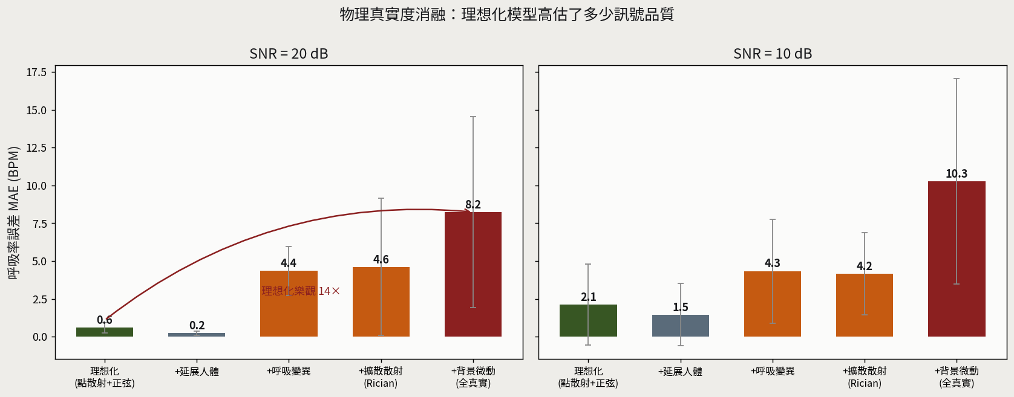
Fig. 2. Physics-realism ablation. Breathing-rate MAE as idealizations are progressively removed, at 20 dB (left) and 10 dB (right) SNR. The idealized model is ~14× more optimistic than full realism; respiration variability and background micro-motion dominate. Synthetic data; model characterization only.
The generator also supports non-convex room shapes, which matter because the image-source method underlying most synthetic CSI is only valid for convex rooms: in an L-shaped room it invents reflections through walls that do not exist. We therefore use a ray model that validates every first-order reflection (the reflection point must lie on a real wall segment and both legs must be unobstructed) and adds edge diffraction at reentrant corners via a simplified Uniform Theory of Diffraction coefficient. This reproduces the two phenomena a concave room introduces: line-of-sight occlusion between the two arms, and diffraction that carries a weak signal into the geometric shadow. Fig. 3 maps breathing-signal strength across a rectangular and an L-shaped room for a fixed link: the rectangle is covered almost uniformly (about 97% usable), whereas the L-room develops a shadow zone behind the reentrant corner where the direct scatter is occluded and only diffracted signal remains, reducing usable coverage to roughly 89%. This shows concretely where contactless screening would fail in a realistic home layout and reinforces the need for careful sensor placement and site calibration.
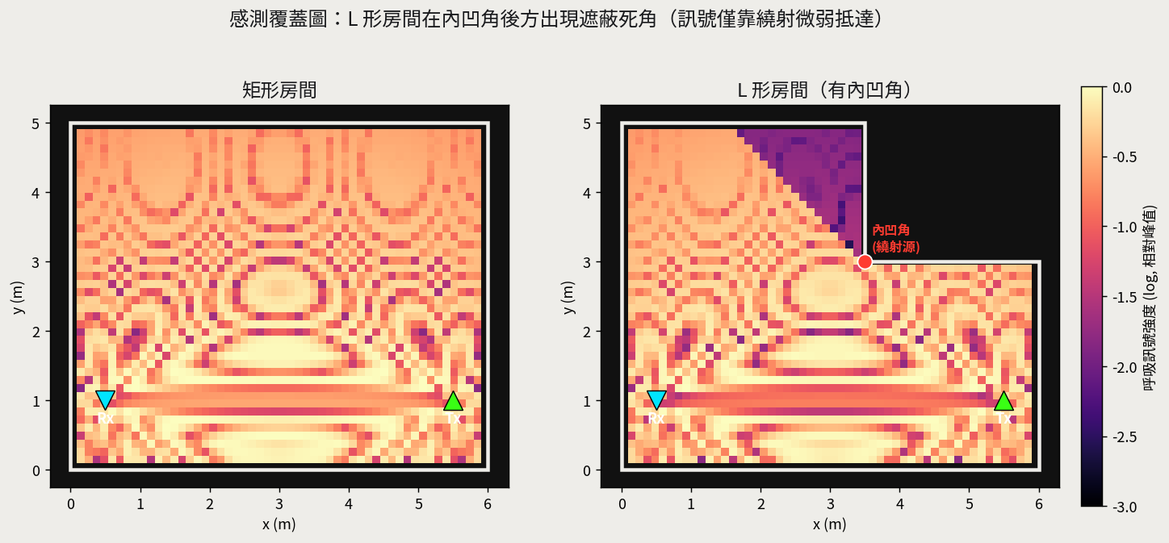
Fig. 3. Sensing-coverage maps (breathing-signal strength, log scale) for a rectangular (left) and an L-shaped (right) room with a fixed Tx/Rx link. The reentrant corner of the L-room (red) casts a shadow zone reached only by weak diffraction, reducing usable coverage from ~97% to ~89%. Physically-valid ray model; synthetic.
The same machinery lets us contrast two other common departures from a rectangular plan, which affect sensing in fundamentally different ways (Fig. 4). A free-standing interior partition (an inner wall with a doorway) is the more severe: with the Tx-Rx link straddling it, the direct person-scattered path is occluded almost everywhere, and usable coverage collapses—here from about 95% to roughly 3%—leaving signal only near the doorway or via diffraction around the partition's free edge. This is fundamentally a coverage problem, and it shows that sensor placement relative to interior walls is decisive. A slanted (trapezoidal but still convex) wall, by contrast, introduces no occlusion at all: coverage is essentially unchanged from the rectangular case. Its effect is instead on the fingerprint—the asymmetric reflection geometry shifts which subcarriers are breathing-sensitive (here about three of the top eight change relative to the rectangular room), so a model calibrated for one plan would select suboptimal subcarriers in the other. Partitions therefore stress signal reachability, whereas slanted walls stress calibration; the first reinforces the importance of placement, the second the need for site-specific calibration (Section IV-D).
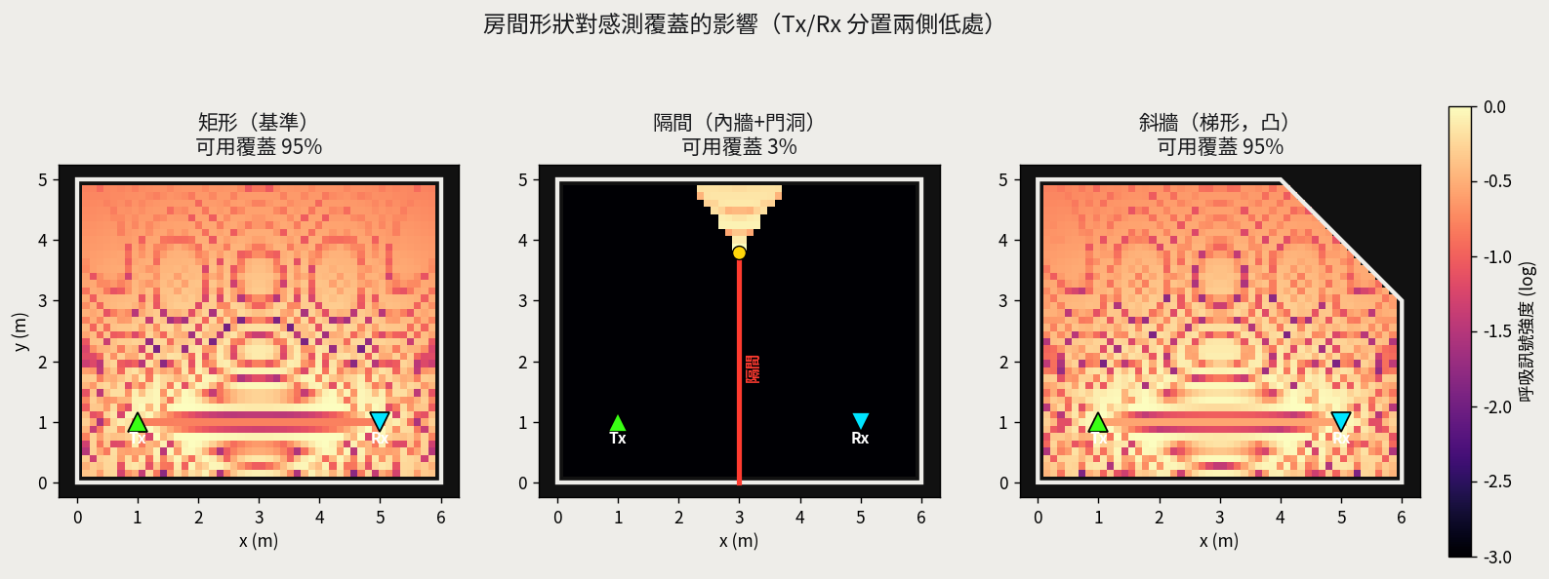
Fig. 4. Sensing coverage across room shapes with the Tx/Rx link straddling the room. A rectangular room (left) and a slanted-wall room (right) are covered almost uniformly (~95%), but an interior partition (centre) occludes nearly the whole room (~3% usable), signal reaching only near the doorway. Partitions stress reachability; slanted walls instead shift the sensitive-subcarrier set. Physically-valid ray model; synthetic.
Real CSI will be captured from an Intel AX211 in monitor mode under Linux, with a smartphone or access point as transmitter and ground-truth respiration/apnea labels from synchronized reference instrumentation, a subset validated against clinical PSG. The collection matrix mirrors the twin scenarios (empty baseline; normal supine respiration; four sleep postures; periodic turn-over; inserted apnea with per-sample masks). Breathing-rate estimation is scored by mean absolute error (MAE, breaths/min); apnea detection by sensitivity, specificity, and event-level F1; and posture robustness by the change in MAE across turn-over. Baselines include FFT peak-picking, a single-task LSTM, and a representative prior system [12]. Five experiments are defined: E1 high-dimensional CSI sensitivity (256 vs. 56 subcarriers; C1); E2 capture-tool signal-quality comparison; E3 PASS ablation across turn-over (C2); E4 dual-task model against baselines (C3); and E5 cross-domain generalization with the site-calibration ablation (C4).

VI. Results and Discussion
Prior to hardware collection, the site-calibration hypothesis of Section IV-D was examined within the digital twin. Four virtual rooms with distinct fingerprints were generated, with one as the target. The task was breathing-rate estimation at 6 dB SNR—the regime in which, by (4), subcarrier choice is decisive. A generic model selected subcarriers by averaging sensitivity across the non-target rooms; a site-specific model selected them from the target room itself. The simulation indicates a substantial benefit: MAE falls from 2.11 breaths/min (generic) to 0.47 (site-specific), approaching the oracle bound of 0.50, with few-shot calibration recovering most of the gain (0.70). The same analysis exposes the expected fragility: after a simulated sensor displacement the site-specific error rises to 1.68 before re-calibration restores it to 0.47 (Fig. 5). These synthetic results validate the relative ordering of conditions and motivate the layered design; they are not clinical measurements.
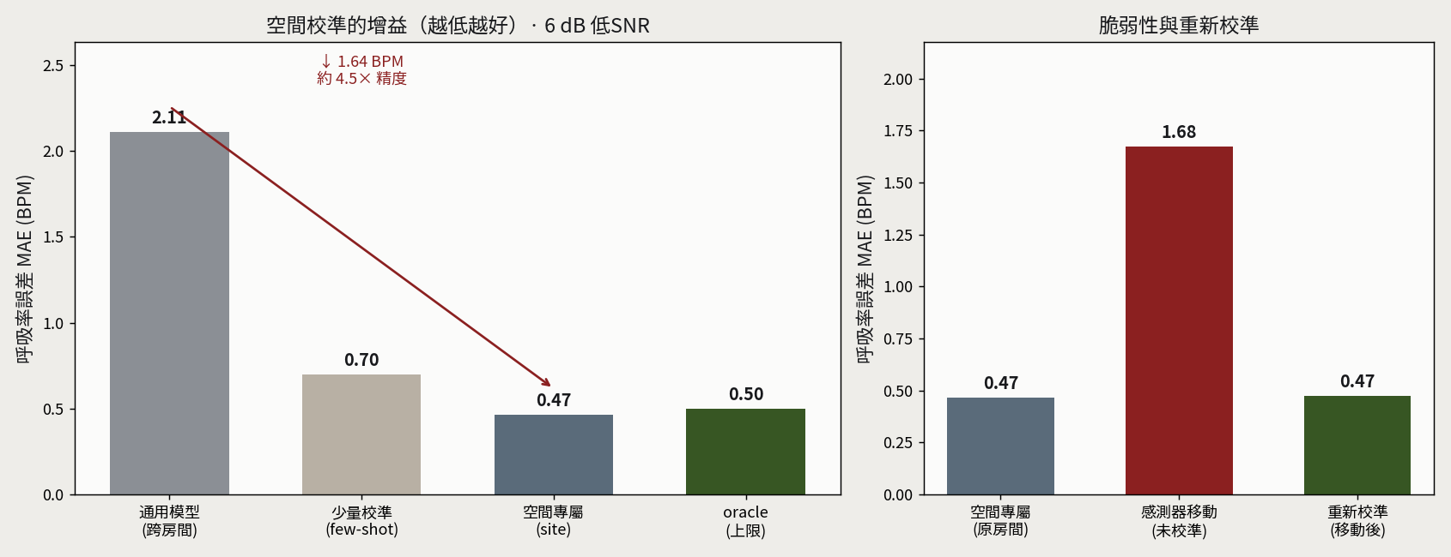
Fig. 5. Synthetic site-calibration analysis. Left: accuracy gain of site-specific over generic subcarrier selection at 6 dB SNR. Right: fragility to environmental change and recovery through re-calibration. Synthetic data; methodology validation only.
The twin also lets us examine why respiratory-event detection is clinically hard, using a two-channel effort model in which the thorax and abdomen are separate scatterers. This distinction matters because the two dominant event types present very differently: in central apnea, effort ceases and the respiratory motion genuinely vanishes, whereas in obstructive apnea the person strains against a blocked airway, so effort continues—indeed intensifies—with the thorax and abdomen moving paradoxically out of phase. A naive detector that flags an event when respiratory motion drops therefore behaves very differently across event types. Across five synthetic nights, such a detector caught central apnea reliably but missed obstructive apnea almost entirely, because the sustained effort keeps the motion envelope near its normal level (Fig. 6); hypopnea, a merely partial reduction, was likewise under-detected. Since obstructive events and hypopneas together account for the large majority of the Apnea-Hypopnea Index, this is a disqualifying failure for a motion-only approach, and it identifies the discriminating signal—thoraco-abdominal paradox—that a clinically useful model must exploit. This directly motivates the dual-task design (Section IV-C) and is the target of experiment E4.
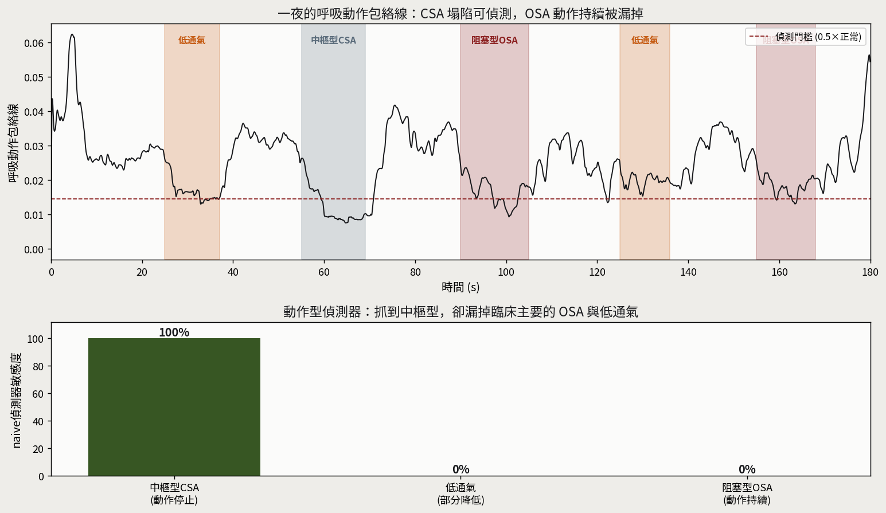
Fig. 6. Clinical-event detection with a naive motion-envelope detector across synthetic nights. Top: respiratory-motion envelope over one night; the envelope collapses during central apnea and (partially) hypopnea, but not during obstructive apnea, where effort continues. Bottom: per-event-type sensitivity—central apnea is caught while obstructive apnea and hypopnea are missed. Synthetic data; motivates a paradox-aware model.
The real-hardware evaluation will report E1–E5 in turn. Anticipated findings speak to three questions: whether the high-dimensional CSI of 802.11ax yields measurable gain in practice, particularly at low SNR where subcarrier diversity should matter most per (4); whether PASS restores accuracy quickly enough after turn-over to be clinically meaningful across a full night; and whether the accuracy–robustness trade-off observed in simulation holds on real hardware, with change-triggered re-calibration as a practical operating mode. The result tables below are reserved for measured data.
[TO BE COMPLETED — Insert Table I (E1): AX211 256- vs. low-cost 56-subcarrier breathing-rate MAE and detection range across SNR. Table II (E3): breathing-rate MAE before/after turn-over, with and without PASS; verify <1 BPM change and <10 s recovery. Table III (E4): joint breathing-rate MAE and apnea sensitivity/specificity/F1 vs. baselines, with parameter count and latency. Table IV (E5): zero-shot / few-shot / site-specific / post-change / re-calibrated MAE on real data, paralleling Fig. 5.]
Limitations to be discussed include the dependence of site calibration on a stable room configuration, the difficulty of multi-occupant scenarios [20], and the synthetic-to-real gap, which the digital twin is designed to help quantify rather than conceal.

VII. Conclusion
We presented a posture-robust framework for in-home sleep-apnea screening using the high-dimensional CSI of Wi-Fi 6E hardware. A multipath signal model yields a subcarrier-sensitivity criterion that explains Fresnel blind spots and grounds three design choices: exploiting 802.11ax's 256 subcarriers, re-selecting breathing-sensitive subcarriers after turn-over (PASS), and calibrating to the deployment site within a layered strategy that reconciles accuracy and robustness. A physics-based digital twin with explicit failure-mode modeling supports development, and simulation confirms that fixing the room fingerprint through site calibration substantially improves low-SNR accuracy, at the cost of a fragility that re-calibration resolves. Validation on real AX211 recordings against synchronized PSG is ongoing and will complete the evaluation defined here.

Acknowledgment
The author thanks collaborators at Taiwan Power Company and colleagues at DofLab, National Chin-Yi University of Technology.

References
[1] Y. Ma, G. Zhou, and S. Wang, “WiFi sensing with channel state information: A survey,” ACM Comput. Surv., vol. 52, no. 3, pp. 1–36, 2019.
[2] R. Du, H. Hua, H. Xie, et al., “An overview on IEEE 802.11bf: WLAN sensing,” IEEE Commun. Surveys Tuts., vol. 27, no. 1, pp. 184–217, 2024.
[3] S. M. Hernandez and E. Bulut, “Wi-Fi sensing on the edge: Signal processing techniques and challenges for real-world systems,” IEEE Commun. Surveys Tuts., 2023.
[4] F. Wang, T. Zhang, W. Xi, et al., “A survey on Wi-Fi sensing generalizability: Taxonomy, techniques, datasets, and future research prospects,” IEEE Commun. Surveys Tuts., 2025 (arXiv:2503.08008).
[5] C. Chen, G. Zhou, and Y. Lin, “Cross-domain WiFi sensing with channel state information: A survey,” ACM Comput. Surv., vol. 55, no. 11, pp. 1–37, 2023.
[6] S. Mosleh et al., “Monitoring respiratory motion with Wi-Fi CSI: Characterizing performance and the BreatheSmart algorithm,” IEEE Access, 2022.
[7] W. Xie, L. Gan, L. Huang, et al., “A real-time respiration monitoring system using WiFi sensing based on the concentric circle model,” IEEE Trans. Biomed. Circuits Syst., vol. 17, no. 2, pp. 157–168, 2023.
[8] J. Sun, X. Bian, and M. Li, “Non-contact heart rate monitoring method based on Wi-Fi CSI signal,” Sensors, vol. 24, no. 7, 2024.
[9] Y. Zeng, D. Wu, R. Gao, T. Gu, and D. Zhang, “FarSense: Pushing the range limit of WiFi-based respiration sensing with CSI ratio of two antennas,” Proc. ACM IMWUT, vol. 3, no. 3, pp. 1–26, 2019.
[10] Y. Li et al., “DiverSense: Maximizing Wi-Fi sensing range leveraging signal diversity,” Proc. ACM IMWUT, vol. 6, no. 2, pp. 1–28, 2022.
[11] H. Liu et al., “RaliSense: Extending WiFi respiratory detection range by rapid alignment of dynamic components,” IEEE Trans. Mobile Comput., vol. 24, no. 4, pp. 3421–3435, 2025.
[12] S. Li, A. T. Kristensen, A. Burg, and A. Balatsoukas-Stimming, “ComplexBeat: Breathing rate estimation from complex CSI,” in Proc. IEEE Workshop Signal Process. Syst. (SiPS), 2021, pp. 217–222.
[13] A. Alzaabi, T. Arslan, and N. Polydorides, “Wi-Fi CSI sensing for sleep disturbances in the care of older people,” IEEE Dataport, 2024, doi:10.21227/4rwc-1714.
[14] S. Khan, A. Alzaabi, Z. Iqbal, T. Ratnarajah, and T. Arslan, “A novel digital twin (DT) model based on WiFi CSI, signal processing and machine learning for patient respiration monitoring and decision-support,” IEEE Access, vol. 11, pp. 103554–103568, 2023.
[15] A. Corrêa et al., “Linear-complexity subcarrier selection strategy for fast preprocessing of CSI in passive Wi-Fi sensing classification tasks,” Electron. Lett., 2025, doi:10.1049/ell2.70237.
[16] D. Wang, J. Yang, W. Cui, L. Xie, and S. Sun, “AirFi: Empowering WiFi-based passive human gesture recognition to unseen environment via domain generalization,” IEEE Trans. Mobile Comput., vol. 23, no. 2, pp. 1156–1168, 2024.
[17] B. Sheng, R. Han, F. Xiao, Z. Guo, and L. Gui, “MetaFormer: Domain-adaptive WiFi sensing with only one labelled target sample,” Proc. ACM IMWUT, vol. 8, no. 1, 2024.
[18] G. Zhang et al., “FewSense: Towards a scalable and cross-domain Wi-Fi sensing system using few-shot learning,” IEEE Trans. Mobile Comput., vol. 22, no. 12, pp. 7052–7065, 2022.
[19] N. Zheng, Y. Li, S. Jiang, et al., “AdaWiFi: Collaborative WiFi sensing for cross-environment adaptation,” IEEE Trans. Mobile Comput., 2024.
[20] J. Hu, T. Zheng, Z. Chen, H. Wang, and J. Luo, “MUSE-Fi: Contactless multi-person sensing exploiting near-field Wi-Fi channel variation,” in Proc. ACM MobiCom, 2023.
[21] C. Yang, X. Wang, and S. Mao, “Respiration monitoring with RFID in driving environments,” IEEE J. Sel. Areas Commun., vol. 39, no. 2, pp. 500–512, 2021.
[22] “Monitoring the sleep respiratory rate with low-cost microcontroller Wi-Fi in a controlled environment,” Appl. Sci., vol. 14, no. 15, art. 6458, 2024.
—— Draft manuscript. Result tables (Section VI) await experimental data on the Intel AX211 platform. ——

