**ENGG 160 – Intro. To Engineering Design: Team 28 Official Project Charter**

**Luke Squire, Sergio Ara Del Olmo, Sam Epp**

**Table of Contents**

1 Charter Introduction 3

1.1 Document Change Control 3

**1.2** **Executive Summary** 4

2 Project Overview 5

2.1 Project Summary 5

2.1.1 Project Objectives 5

2.2 Project Scope 6

2.2.1 Key Activities 6

2.2.2 Key Requirements 7

2.2.3 Deliverables 8

2.3 Milestones 9

2.4 High-Level Project Plan 10

2.5 Project Risks, Assumptions, and Constraints 12

2.5.1 Risks 12

2.5.2 Constraints 12

3 Project Organization 13

3.1 Project Team Structure 13

4 Project References 14

5 Glossary and Acronyms 15

**Table of Figures**

Figure 1 High-level Project Timeline 11

Figure 2 Organization Chart for b1 T028 P03 15

**List of Tables**

Table 1 Document Revision Record 3

Table 2 Project Objectives 5

Table 3 Project Scope : key activities 6

Table 4 Project Scope : Key Requirements 7

Table 5 Project Scope : Key Deliverables 8

Table 6 Project Milestones 9

Table 7 Project Risks and Management Plans 12

Table 8 Project Constraints 12

Table 10 Project References 14

Table 11 Project Terms and Definitions 15

Table 12 Project Acronyms and Definitions 15

# Charter Introduction

## Document Change Control

This document’s revision control record is kept in Table 1.

Table 1 Document Revision Record

|  |  |  |  |
| --- | --- | --- | --- |
| Revision # | Date of Issue | Authors | Brief Description of Change |
| Initial Release | 2024-02-13 | Sergio Ara Del Olmo | Started filling out general information about group members and project |
| 2.0 | 2024-02-15 | Sergio Ara Del Olmo | Added information regarding the project |
| 3.0 | 2024-02-15 | Luke Squire | Revised sections 2.1 & 2.2 to fall in line with rubric |
| 4.0 | 2024-02-16 | Luke Squire | Revised, filled out, and finished key requirements, key activities, and project objectives.  Drafted and finalized “One Goal” statement, executive summary, constraints, risks, deliverables, project organization, project organization structure, acronyms, glossary, and references.  Github repository created and documents uploaded and properly referenced.  Updated all sections after reach out and clarifying with ENGG 160 instructional team |
| 5.0 | 2024-02-16 | Luke Squire  Sam Epp | Organized and formatted chart in preparation for final submission. |
| 6.0 | 2024-02-16 | Luke Squire | Gantt Chart Added |

## **Executive Summary**

This project charter outlines a proposal for the design and manufacture of a backpack accessory for the PuppyPi quadruped backpack [1]. With ever increasing interest and research into the robotics industry, it has become ever more important to find meaningful ways to integrate these technologies into our lives. Cutting edge companies like Boston Dynamics are among of number of pioneers in the industry developing science-fiction level technologies [2]. Despite being founded in the 1990’s, the everyday consumer has little to no interaction with advanced robotics in everyday life. Although this project was initiated by the Faculty of Engineering at the University of Alberta through the ENGG 160 “Introduction to Engineering Design” course, the appeal of quality robotics accessories spans far wider than the course instructor. Any open source and accessible technologies in the field can help push the industry forward, advancing the presences of robotics in our lives, and subsequently the interest of the general public.

Given a number of projects to choose from, our team, (π26), chose the PuppyPi backpack project. The backpack project seemed most within our capabilities out of all project options. We believe this project will best allow us to exercise our skills and capabilities to the furthest extent. Additionally, 3D printing, robotics, and compact design were among the interests of our team members, further motivating our decision. The project will be demonstrated during a design evaluation event at the end of the 2024 winter term. The main goal of this project is to design an extensible, functional, and aesthetically pleasing backpack for the PuppyPi robot, aimed at enhancing its ping pong ball transport capability in time for the Winter 2024 design evaluation event, and to further the robotics industry. Although this project is made specifically for the ENGG 160 course, provided it is successful, it may prove to be a quality accessory to any PuppyPi owner. The key objectives of this project, as outlined later on, include:

* Ability to successfully transport a payload
* A unique, original design
* Easily modifiable for use outside of PuppyPi
* Aesthetically pleasing

In order to complete our project and meet the requirements for the ENGG 160 course, we will need two main deliverables; a working prototype and video report. This should be done by the end of the Winter 2024 term.

Some key risks that may impact this project include the conceptual design going far beyond the weight limit, which is a major constraint, as well as the availability of university resources for manufacture of prototypes (ei. The Elko Garage 3D printers) [4]. Costs are not an issue and do not play a factor as the price of materials (3D printing filament) is inexpensive, and is all covered by the University within reason.

# Project Overview

## Project Summary

Design an extensible, functional and aesthetically pleasing backpack for the PuppyPi robot, aimed at enhancing its ping pong ball transport capability in time for the Winter 2024 design evaluation event, and to further the robotics industry.

### Project Objectives

A list of initial project objectives is provided in Table 2.

Table 2 Project Objectives

|  |  |
| --- | --- |
| Objectives | What is measurable |
| 1. Securely accept and transport payload | * The backpack will be functional as a backpack * Backpack will meet its functional requirements as described in the project outline |
| 1. Unique design | * The backpack design will have functional (non-aesthetic) design aspects not in utilization by other ENGG 160 groups. |
| 1. Widely applicable | * Backpack design will be elegant / not utilize complex manufacturing techniques making it extensible / modifiable for other robotics applications |
| 1. Aesthetically pleasing | * Backpack will have an aesthetically pleasing design. Aesthetics are subjective, but can be measured through average surveyed opinion. |

## Project Scope

In this section, the key activities, key requirements to be met, and deliverables for the project are defined.

### Key Activities

A list of the key activities for the project is provided in Table 3.

Table 3 Project Scope: key activities

|  |
| --- |
| Key Project Activities |
| 1. Collect initial ideas / solutions and initiate project hierarchy |
| 1. Finalize and submit project charter (Milestone 1) |
| 1. Access PuppyPi and formally analyze design specifications |
| 1. Generate possible designs organized into a report (Milestone 2) |
| 1. Screen and rank designs until a formal conceptual design is chosen (Milestone 3) |
| 1. Develop documentation / 3D model / artefacts for prototype (Milestone 4) |
| 1. Manufacture and test initial prototype (Milestone 5) |
| 1. Finalize documentation and manufacture final prototype after revisions (Milestone 6) |
| 1. Create and submit video report along with all required project materials (Milestone 8) |
| 1. Design evaluation event (Milestone 7) |

### Key Requirements

The key requirements for the system are listed in Table 4. Here the words “must” and “shall” mean the requirement is mandatory and the words “may” and “should” mean the requirement is desirable.

Table 4 Project Scope : Key Requirements

|  |
| --- |
| Key Project Requirements |
| 1. Shall not weigh more then 100 grams |
| 1. Shall not extend more then 20 mm beyond the robots back plate |
| 1. Shall not extend more then 120 mm perpendicularly above robots back plate |
| 1. Must be made from 3 different materials; each material should be used in a functional capacity |
| 1. Must be attachable and detachable within 10 seconds |
| 1. Must contain payload while in movement |
| 1. Must contain payload while robot is tilted forwards and backwards |
| 1. Must be open source with all key documentation publicly available online (hosted on GitHub) |
| 1. Must be able to contain 6 ping-pong balls |
| 1. Must prevent successfully obtain ping-pong balls dropped from a height of 0.75 m |

### Deliverables

The project’s key deliverables are listed in Table 5.

Table 5 Project Scope : Key Deliverables

|  |  |
| --- | --- |
| Project Deliverable 1 : Working Prototype & Demonstration | |
| Objective #s: | All |
| Deliverable Description: | Final prototype design to be demonstrated at the design evaluation event |
| Acceptance Criteria: | Demonstration, review and verification by ENGG 160 Instructional Team. Received grade. |
| Project Deliverable 2 : Video Report | |
| Objective #s: | All |
| Deliverable Description: | Final video report outlining project |
| Acceptance Criteria: | Review and verification by ENGG 160 Instructional Team. Grade received. |

## Milestones

The main project milestones are defined in Table 6.

Table 6 Project Milestones

|  |  |  |
| --- | --- | --- |
| Project Milestone | Description | Expected Date |
| 1. Project Charter | Finish final draft of project charter and submit | 2024-02-16 |
| 2. Design Candidate Report | Produce an organized report of all generated design ideas | 2024-03-03 |
| 3. Conceptual Design | Formally evaluate designs using decision matrix and go or no go screening | 2024-03-08 |
| 4. Draft Prototype Documentation | Generate formal documentation for our chosen design and initiate manufacturing phase | 2024-03-15 |
| 5. First Prototype | Manufacture and test the first prototype | 2024-03-24 |
| 6. Final Design | Manufacture and test the final backpack design | 2024-04-05 |
| 7. Design Evaluation | Test the backpack in the 2024 end of term design evaluation event | 2024-04-09 |
| 8. Video Report & Submission | Produce video report and submit it along with all other documentation and artefacts | 2024-04-12 |

*Conceptual Design Evaluation is March 22. Project is due in less then a month from then. It is our belief that we should have a design and begin prototyping before then, so the date is changed to be earlier then what is outlined in the syllabus

## High-Level Project Plan

A high-level project plan is shown in Figure 1. Task details are shown in Figure 2.

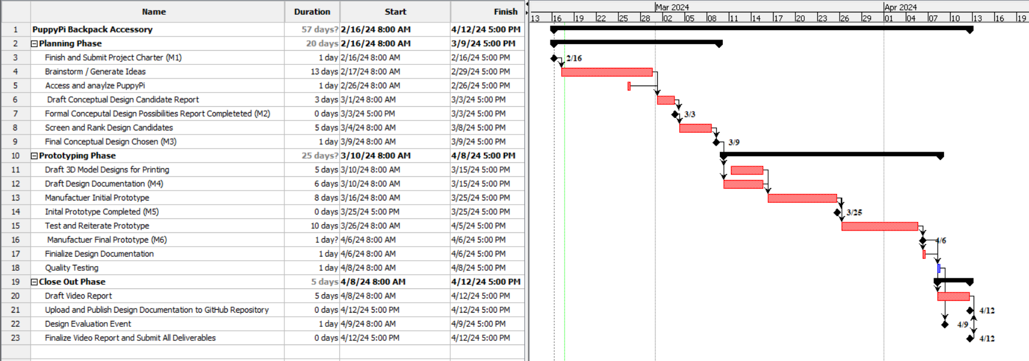

Figure 1 High-level Project Timeline

** Technical Difficulties with Project Libre were had. Dates *refused* to properly align even after changing to 7 day work week **

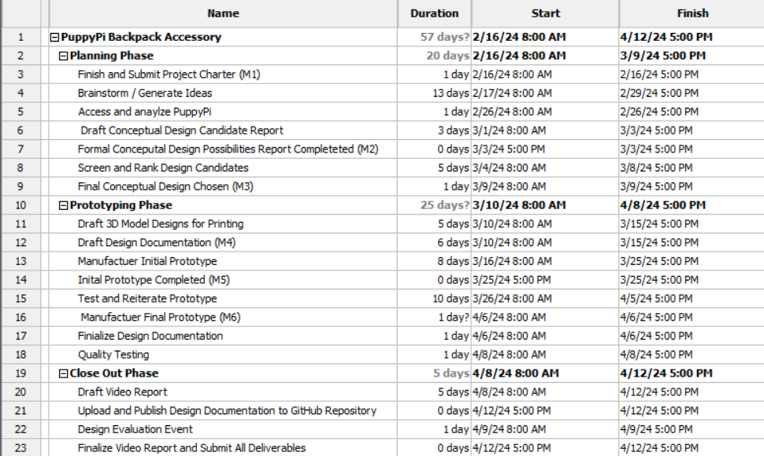

Figure 2 Project Plan Task Details

## Project Risks and Constraints

In this section, the main project risks and constraints known at the time of the Charter are identified. Where possible, mitigation strategies and plans are outlined.

### Risks

The main project risks and mitigation plans are defined in Table 7.

Table 7 Project Risks and Management Plans

|  |  |  |  |  |
| --- | --- | --- | --- | --- |
| No. | Risk Description | Probability (H/M/L) | Impact (H/M/L) | Risk Management Plan |
| 1 | **Design Incompatibility with Robot Movements** | (H) | (H) | Engage in early prototype testing to ensure the backpack is compatible with all robot movements. |
| 2 | **Technical Issues with 3D Printing Resources** | (M) | (H) | Schedule 3D printing tasks during off-peak hours, have backup printers available (local library), and consider outsourcing if necessary. |
| 3 | **Conceptual Design Beyond Weight Limit** | (H) | (H) | Research lightweight 3D printing techniques to minimize mass. |

### Constraints

The main project constraints are defined in Table 8.

Table 8 Project Constraints

|  |  |  |
| --- | --- | --- |
| No. | Category | Constraints |
| 1 | Time | ENGG 160 course is only a single term |
| 2 | Resources | Materials are limited to wood, cardboard, and plastic, and only that which is provided by the Elko Engineering garage |

# Project Organization

The project organization is defined in the “Team Charter for T028_P03” [2].

## Project Team Structure

The organization chart for T028_P03 is shown in Figure 2.

Figure 3 Organization Chart for T028_P03

# Project References

More information concerning this project can be found in the documents and sites listed in Table 10.

Table 9 Project References

|  |  |  |  |  |
| --- | --- | --- | --- | --- |
| Ref # | Document Title | Pub. Date | Author | Location (link or path) |
| 1 | ENGG 160 Project Proposal: PuppyPi Backpack | 2024 | ENGG 160 Instructional Team | https://github.com/dog-blood/ENGG160-Project/blob/8a94a6fe571e5c9d940073df464bab60bad44ad9/ENGG%20160%20P3%20-%20PuppyPi%20Backpack.pdf |
| 2 | Main Website | 2024 | Boston Dynamics | https://bostondynamics.com/ |
| 3 | Team Charter for T028 P03 | 2024-02-9 | Team π28 | https://github.com/dog-blood/ENGG160-Project/blob/d1a0690a72622604d9bbe8d63910c4744662a5dc/B1_28-P03-Team-Charter.docx |
| 4 | Main Website |  |  | https://confluence.garage.ualberta.ca/ |

# Glossary and Acronyms

Table 10 Project Terms and Definitions

|  |  |
| --- | --- |
| Term | Definition |
| PuppyPi | Controllable quadruped robot designed and manufactured by HiWonder |
| Quadruped | An animal or machine that has 4 legs to move around |
| Elko Garage | University run makerspace |
| Makerspace | General workshop with a focus on technical devices / tools / equipment |

Table 11 Project Acronyms and Definitions

|  |  |
| --- | --- |
| Acronyms | Name in Full |
| ENGG | Engineering |
| T028_P03 | Team 28 and Project 03 |
| $$π28$$ | “Pi” 28 (Team Name) |