Assignment 2: Agile Estimation, User Stories, and Reporting

# Task 1: Writing User Stories

**Project: College Library System**

1. As a student, I want to search for books, so that I can find the books I need easily.
2. As a librarian, I want to add new books to the system, so that students can borrow them.
3. As a student, I want to see due dates of borrowed books, so that I can return them on time.
4. As a librarian, I want to track overdue books, so that I can send reminders to students.
5. As a student, I want to renew a borrowed book online, so that I don’t have to go to the library.

**Acceptance Criteria:**

1. Student can type a keyword and see matching book titles with author names.

2. Student can click a 'renew' button and get a new due date if the book is renewable.

# Task 2: Agile Estimation

**Story Points using Fibonacci Series (1, 2, 3, 5, 8):**

- As a student, I want to search for books, so that ... : 3 points

- As a librarian, I want to add new books to the sys... : 5 points

- As a student, I want to see due dates of borrowed ... : 2 points

- As a librarian, I want to track overdue books, so ... : 5 points

- As a student, I want to renew a borrowed book onli... : 3 points

**Reasoning:**

- Searching books is simple but needs good filtering. (3 points)

- Adding books takes more steps and validation. (5 points)

- Seeing due dates is easy. (2 points)

- Tracking overdue books needs automation. (5 points)

- Renewing books is a common but useful task. (3 points)

**Tasks needing refinement:**

- Tracking overdue books may need to split into checking and notifying.

# Task 3: Agile Metrics and Reporting

**Burndown Chart:**

A burndown chart shows how much work is left in a sprint. It helps the team see progress and adjust if needed.

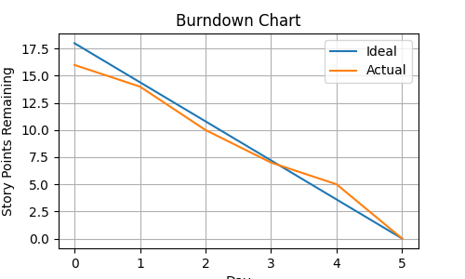

Day

**Other Agile Metrics:**

- Velocity: How many story points done in past sprints. Helps with planning.

- Cumulative Flow Diagram: Shows work in different stages. Helps find bottlenecks.