Specification and Design Report

Student's Name: Ismail Dogan
Student's Number: 200051668
Student's Email Address: I.Dogan2@liverpool.ac.uk

Project Title: Multi-Agents in Fintech Regulatory Compliance

Name of Dissertation Advisor (DA): Dr. Chunyan Mu

Name of Dissertation Instructor (DI): Dr. Kathleen Kelm

- The Specification
Project Context, Aims, Objectives, Ethical Considerations and Outcomes

The Context of the Research:
The research is situated within the dynamic and challenging field of Financial Technology (FinTech) regulatory compliance, specifically focusing on Anti-Money Laundering (AML). The contemporary financial landscape is characterized by increasingly sophisticated and coordinated illicit activities, which render traditional, static rule-based or monolithic machine learning models ineffective. Initial research and a survey of the literature (Bello, Ige and Ameyaw, 2024; Huang et al., 2025) have indicated a clear need for systems that are not only accurate but also adaptive and scalable. This has led to the selection of a Multi-Agent System (MAS) as the core architectural paradigm. A MAS approach allows for the modular development of specialized, independent agents that can collaborate to provide comprehensive compliance coverage, mirroring the structure of real-world financial investigation units.

The Problem Statement:
While the potential of AI in finance is vast, its practical adoption is hindered by several critical challenges. Monolithic systems struggle to scale effectively; adding new detection capabilities for emerging threats or changing regulations often requires redesigning the entire model. Furthermore, many advanced AI models operate as "black boxes," making it difficult for human users to understand, trust, and audit their decisions. This lack of transparency is a major barrier to regulatory acceptance (Černevičienė and Kabašinskas, 2024). The problem this research addresses is therefore multifaceted: how to build a compliance system that is not only effective at detecting financial crime but is also scalable, adaptable, robust, and, critically, explainable. The project aims to solve the tension between the need for complex systems to fight evolving threats and the absolute requirement for scalability, transparency, and human oversight in a regulated industry.

The Dissertation Question(s):
- RQ1 (Architecture): How can a Multi-Agent System (MAS) architecture be designed to effectively coordinate specialized, independent agents (e.g., a TransactionPatternAgent, CustomerRiskAgent, and NetworkAnalysisAgent) to achieve a holistic and robust Anti-Money Laundering (AML) detection capability?

- RQ2 (Adaptation): What specific Multi-Agent Reinforcement Learning (MARL) mechanisms, employing a periodic offline retraining cycle with newly observed, analyst-verified data, can enable the MAS to adapt its collective detection policies against novel and evolving money laundering typologies?

- RQ3 (Explainability & Collaboration): How can a dedicated XAI component generate post-hoc, causal explanations that synthesize findings from the multiple AML agents, with the primary goal of improving an analyst's trust calibration and enabling effective decision override feedback through a visual interface?

Ethical Implications:
As stated in the project proposal, formal ethics approval is not required for this research. The primary reason is that the IT artefact will be developed and tested using synthetically generated financial data. No real customer or sensitive financial information will be used at any stage of the project, thus eliminating data privacy risks. The evaluation phase will include a task-based user study to assess the explainability component. The participants for this study will be volunteers, and their involvement will be limited to interacting with the system's interface to evaluate non-sensitive, simulated AML alerts. They will be fully informed about the purpose of the study, and their feedback will be anonymized.

The Anticipated Outcomes:
The primary outcome of this research will be a novel, integrated framework that demonstrates how a Multi-Agent System can be engineered for both high-performance adaptation and regulatory-compliant explainability in AML. This contributes to the body of knowledge by bridging a critical gap identified in the literature between the theoretical application of MAS in finance and the practical, robust integration of adaptive MARL and collaborative XAI.

The IT artefact produced will be a prototype Multi-Agent System developed in Python. It will operate within a simulated digital banking environment featuring specialized agents for different compliance tasks. This artefact directly supports the anticipated outcomes by serving as tangible proof-of-concept. Its evaluation is designed to directly answer the dissertation questions:

- The system's detection accuracy and processing latency will be quantitatively measured to validate the architectural design (RQ1).
- Its ability to learn from new, unseen money laundering patterns through a Multi-Agent Reinforcement Learning (MARL) retraining cycle will be tested to assess its adaptation capabilities (RQ2).

- Finally, a user study will measure the impact of its XAI-generated explanations on an analyst's decision-making time and accuracy, thereby evaluating the effectiveness of the explainability and collaboration component (RQ3). This mixed-method evaluation approach ensures a rigorous assessment of the artefact's success.

Major Modifications:
There have been no major modifications to the project's aims, scope, or methodology since the submission and approval of the Project Proposal (Version 4).
Literature Survey:
This literature review synthesizes foundational and contemporary research across three core themes that underpin this project: the architectural justification for using Multi-Agent Systems (MAS) in FinTech, the mechanisms for enabling adaptation through Multi-Agent Reinforcement Learning (MARL), and the critical role of Explainable AI (XAI) in achieving regulatory trust and adoption.

1. The Case for Adaptive, Multi-Agent Systems in FinTech

The contemporary financial landscape is challenged by dynamic and coordinated illicit activities that render traditional, static models ineffective (Bello, Ige and Ameyaw, 2024). This necessitates a paradigm shift towards intelligent systems that are inherently scalable, modular, and collaborative. A Multi-Agent System (MAS) architecture is exceptionally well-suited to this challenge, as it allows for the development of specialized, independent agents that can cooperate to provide comprehensive compliance coverage, mirroring the distributed nature of real-world compliance departments (Huang et al., 2025; Hernes et al., 2023). However, the practical implementation of such systems is not without its challenges. The effectiveness of any AI-driven approach is fundamentally constrained by issues of data quality, particularly the problem of imbalanced datasets where fraudulent transactions are rare, which can significantly bias model performance (Bello et al., 2023). This project's design directly addresses this context by proposing a modular MAS architecture that can effectively manage specialized tasks while being trained on data specifically designed to mitigate imbalance issues.

2. Enabling Adaptation through Multi-Agent Reinforcement Learning (MARL)

To move beyond static detection, a MAS must be able to adapt its strategies to novel threats. Multi-Agent Reinforcement Learning (MARL) provides the theoretical framework for this adaptation. A primary obstacle in MARL is the problem of non-stationarity, where each agent's learning process is destabilized because its peers are simultaneously changing their own strategies. The prevailing and most effective solution to this is the paradigm of Centralized Training for Decentralized Execution (CTDE), where agents are trained with access to global information but can be deployed to act using only their local observations (Amato, 2024).

The Multi-Agent Deep Deterministic Policy Gradient (MADDPG) algorithm is a powerful and widely adopted implementation of the CTDE framework, allowing agents to learn complex, coordinated behaviors (Lowe et al., 2017). Recognizing that standard MADDPG can suffer from sample inefficiency in complex environments, this project will draw upon advancements such as the Mixed Experience (ME-MADDPG) approach. This enhanced framework uses techniques like experience replay with high-quality samples to accelerate learning and improve the stability of the trained agents, making the algorithm more robust for demanding, real-world applications like financial compliance (Wan et al., 2022).

3. The Critical Role of Explainable AI (XAI) for Trust and Adoption

For any advanced AI system to be successfully deployed in a highly regulated domain such as finance, its decisions must be transparent, auditable, and trustworthy. The "black box" nature of many complex models presents a significant barrier to adoption, as regulators and human analysts are unable to verify the reasoning behind an automated decision (Huang et al., 2025). As a systematic review by Černevičienė and Kabašinskas (2024) confirms, Explainable AI (XAI) is a critical field of research aimed at resolving this tension.

The integration of XAI is not merely a technical feature but a core requirement for regulatory compliance and human-computer collaboration. While some argue for the exclusive use of inherently interpretable models, the complexity of financial crime often necessitates more powerful, albeit less transparent, models (Rudin, 2019). This project addresses this by integrating post-hoc XAI techniques to generate clear, causal explanations for the MAS's collective decisions. However, the literature also acknowledges that XAI is not a panacea; challenges remain in standardizing metrics for explanation quality and ensuring data privacy is not compromised by the explanations themselves (Černevičienė and Kabašinskas, 2024; Hernández et al., 2019). This project's design accounts for these challenges by proposing a dedicated XAI component that synthesizes findings into a coherent narrative for the human analyst, focusing on utility and trustworthiness.

Conduct of the Project:
This project will be carried out following the Design Science Research (DSR) methodology, which is well-suited for creating and evaluating innovative IT artefacts to solve practical problems. The process is iterative and structured around the design, development, and evaluation of the proposed Multi-Agent System.

Background and Information Gathering: The initial phase involves a systematic literature review to build a strong theoretical foundation. This review, summarized in the preceding section, focuses on three core areas: Multi-Agent System architectures, adaptive mechanisms in Multi-Agent Reinforcement Learning (MARL), and the application of Explainable AI (XAI) in finance. This scholarly information is essential for understanding the current landscape and justifying the design choices for the IT artefact.

Data Requirements: The project will utilize the publicly available "Synthetic AML Transaction Monitoring Dataset (SAML-D)" from Kaggle. This dataset is ideal as it provides a rich source of labelled transaction data, including examples of specific money laundering typologies, while avoiding the ethical and privacy issues associated with real financial data. The training process for the agents will be conducted in two phases:

- Initial Supervised Training: All agents will first be trained on the SAML-D dataset using traditional supervised learning techniques. This provides each agent with a foundational, baseline model for identifying suspicious activities based on its specific area of focus (e.g., transaction patterns, network analysis).
- Adaptive MARL Training: Following the initial training, the agents will be deployed into the simulated environment. Here, Multi-Agent Reinforcement Learning (MARL) will be used to train them to cooperate effectively and adapt their collective policies over time. The MARL environment will be initialized with the patterns from the SAML-D dataset and will subsequently introduce novel, unseen threats to test and improve the system's adaptive capabilities.

Skills Acquisition: The project requires a combination of existing and newly acquired skills. Building on a foundation of Python programming and machine learning, specific skills in the following areas will be developed: advanced implementation of MARL algorithms like MADDPG, designing and managing event-driven microservices architectures with tools such as FastAPI and Kafka, and integrating XAI techniques like SHAP to generate model explanations. These skills will be acquired through a combination of academic literature, technical documentation, and hands-on implementation.

Software and Tools: The development will rely entirely on open-source software. The primary tools include:
- Programming Languages: Python for the AI agents; Java, using the Spring Boot framework, for the microservices that simulate the digital banking environment.
- Machine Learning Libraries: PyTorch or TensorFlow.
- Microservices and Communication: FastAPI for creating agent APIs, an event-driven messaging system (such as Apache Kafka, RabbitMQ, or other similar platforms) to serve as the communication backbone, and Docker for containerization.
- Data Storage: A hybrid model using Redis for real-time state management and PostgreSQL for persistent audit trails.

- The Design
This section outlines the design of the IT artefact, a Multi-Agent System (MAS) for AML compliance, following the Design Science Research (DSR) methodology. The design has been developed to be directly traceable to the dissertation questions and robust enough for implementation and evaluation.

- Link Between IT Artefact and Dissertation Questions: The production of the IT artefact is fundamentally linked to answering the project's dissertation questions.

- To answer RQ1 (Architecture), the artefact will be built as a modular, event-driven system with distinct, specialized agents. Its performance (e.g., detection accuracy, latency) will be measured to validate this architectural choice against a monolithic baseline.
- To answer RQ2 (Adaptation), the agents within the artefact will be equipped with a Multi-Agent Reinforcement Learning (MARL) mechanism. The system will be tested by introducing novel threat patterns to quantitatively measure its ability to adapt its detection policies.
- To answer RQ3 (Explainability & Collaboration), the artefact will include a dedicated Explainable AI (XAI) component that generates justifications for its collective decisions. This component will be the focus of a user study to evaluate its impact on human trust and decision-making.

- Evaluation of the IT Artefact: The artefact's success will be measured using the mixed-method evaluation strategy detailed in the project proposal. Quantitative experiments will assess system performance against objective metrics (Precision, Recall, F1-Score, Adaptation Time). Concurrently, a qualitative, task-based user study will assess the practical utility of the XAI component by measuring its effect on an analyst's task completion time and decision accuracy. This dual approach ensures that every aspect of the dissertation is rigorously evaluated.

System Components and Organisation: The system is designed as a decoupled, event-driven microservices architecture. A high-level diagram would show the following key components:

- Simulated Banking Environment: A set of microservices built in Java using the Spring Boot framework that generates a continuous stream of synthetic transaction data.
- Event Bus (Communication Backbone): A central messaging system (e.g., Apache Kafka) that handles the asynchronous communication between all components. Transactions are published as events to this bus.
- Specialised AI Agents: Three independent Python microservices, each containerized with Docker and exposing an API with FastAPI.
- TransactionPatternAgent: Analyses the characteristics of individual transactions.
- CustomerRiskAgent: Assesses the risk profiles of the sender and receiver.
- NetworkAnalysisAgent: Examines the relationships between accounts over time.
- Orchestration Service: A central service that consumes the findings from all agents for a given transaction and applies a final decision logic (e.g., Approve, Block, Escalate to Analyst).
- Data Storage: A hybrid system using Redis for caching real-time findings and PostgreSQL for the permanent storage of transaction outcomes and agent audit logs.
- Analyst User Interface: A simple web-based dashboard for human analysts to review escalated cases and the accompanying XAI explanations.

Commissioned Work: No commissioned work or external hardware is required for this project. All software will be developed by the researcher using open-source tools.

Data Structures: The primary data structures will be the JSON messages used for communication on the event bus. For example, a TransactionEvent will contain fields like transaction_id, sender_id, receiver_id, amount, and timestamp. Each AgentFinding message will contain the transaction_id, agent_name, a risk_score, and supporting evidence. The PostgreSQL database will have a transactions table to log the outcome and an agent_findings table to store the detailed analysis from each agent for audit purposes.

Algorithms: The core algorithms to be implemented are:
- Supervised Learning: A baseline model (e.g., a Gradient Boosting classifier) will be trained for each agent on the SAML-D dataset to establish initial detection capabilities.
- Multi-Agent Reinforcement Learning: The Multi-Agent Deep Deterministic Policy Gradient (MADDPG) algorithm will be implemented to enable the agents to learn cooperative and adaptive policies within the simulated environment.

Intended Interface Design: A simple, clean web interface will be designed for the human analyst. The dashboard will display a list of high-risk transactions escalated by the system. When a transaction is selected, the interface will show:
- The core details of the transaction.
- The individual risk scores and findings from each of the three agents.
- A final, synthesized explanation of why the transaction was flagged, generated by the XAI component.
- Simple buttons allowing the analyst to agree or disagree with the system's recommendation, providing the feedback necessary for the user study.

- Statement of Deliverables
Upon successful completion, this project will produce a collection of tangible outcomes that document the research process and present the final IT artefact. The key deliverables are as follows:

- The IT Artefact: The primary deliverable. It will be a functional software prototype of the Multi-Agent System for AML compliance, developed in Python and Java. The prototype will include the simulated banking environment, the specialized AI agents, the orchestration service, and the analyst user interface.
- Software and Research Designs: This deliverable includes the detailed architectural design for the event-driven MAS, the design of the controlled experiments for quantitative evaluation, and the survey and task design for the user study.
- Evaluation Results and Analysis: A comprehensive report presenting the findings from the evaluation phase. This will include the statistical analysis of the system's performance metrics (e.g., F1-Score, Adaptation Time) and a summary of the results from the user study on the XAI component's effectiveness.
- Source Code Documentation: The complete, commented source code for the entire IT artefact, including all microservices and agents. The code will be managed in a version-controlled repository (e.g., GitHub), serving as the primary technical documentation.
- Final Dissertation: The complete scholarly report that synthesizes all research activities, from the initial literature review and design to the implementation, evaluation, final conclusions, and recommendations for future work.

- Project Plan

The project plan is visualized in the Gantt chart below, which outlines the timeline for all major activities and milestones from the project's inception to its final submission.

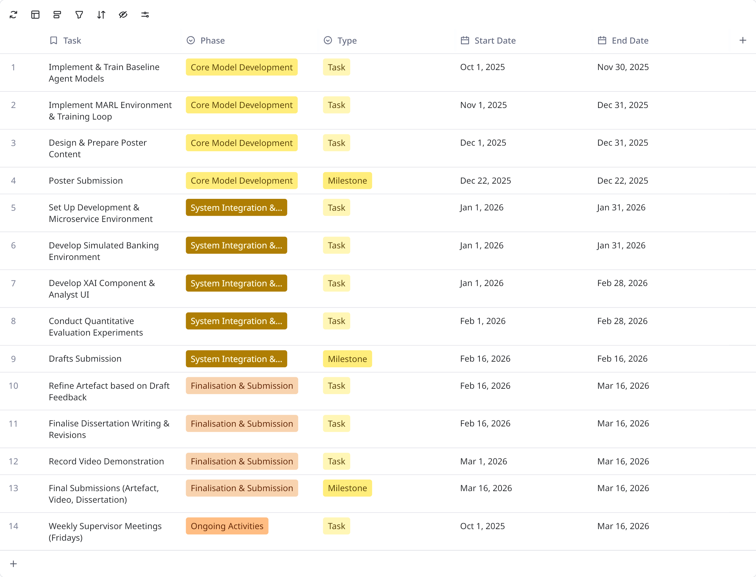
References

Amato, C. (2024) ‘An Introduction to Centralized Training for Decentralized Execution in Cooperative Multi-Agent Reinforcement Learning’. Available at: https://doi.org/10.48550/arxiv.2409.03052.

Bello, H.O., Ige, A.B. and Ameyaw, M.N. (2024) ‘Adaptive machine learning models: Concepts for real-time financial fraud prevention in dynamic environments’, World Journal of Advanced Engineering Technology and Sciences, 12(2), pp. 21–34. Available at: https://doi.org/10.30574/wjaets.2024.12.2.0266.

Bello, O.A., Ogundipe, A., Mohammed, D., Adebola, F. and Alonge, O.A. (2023) ‘AI-driven approaches for real-time fraud detection in US financial transactions: Challenges and opportunities’, European Journal of Computer Science and Information Technology, 11(6), pp. 84-102.

Černevičienė, J. and Kabašinskas, A. (2024) ‘Explainable artificial intelligence (XAI) in finance: a systematic literature review’, Artificial Intelligence Review, 57(8), p. 216.

Hernes, M., Nguyen, N.T. and Pham, H. (2023) ‘Application of Cognitive Architecture in Multi-Agent Financial Decision Support Systems’, in Springer Handbook of Engineering Statistics. 2nd edn. London: Springer Nature, pp. 1–1. Available at: https://doi.org/10.1007/978-1-4471-7503-2_49.

Hernández, E. et al. (2019) ‘Data Protection on Fintech Platforms’, in Highlights of Practical Applications of Survivable Agents and Multi-Agent Systems. The PAAMS Collection. Switzerland: Springer International Publishing AG, pp. 223–233. Available at: https://doi.org/10.1007/978-3-030-24299-2_19.

Huang, K. et al. (2025) ‘AI Agents in Banking’, in Agentic AI. Cham: Springer Nature Switzerland, pp. 237–277. Available at: https://doi.org/10.1007/978-3-031-90026-6_8.

Lowe, R., Wu, Y.I., Tamar, A., Harb, J., Abbeel, P. and Mordatch, I. (2017) ‘Multi-agent actor-critic for mixed cooperative-competitive environments’, Advances in neural information processing systems, 30.

Rudin, C. (2019) ‘Stop explaining black box machine learning models for high stakes decisions and use interpretable models instead’, Nature machine intelligence, 1(5), pp. 206–215. Available at: https://doi.org/10.1038/s42256-019-0048-x.

Wan, K., Wu, D., Li, B., Gao, X., Hu, Z. and Chen, D., 2022. ME‐MADDPG: An efficient learning‐based motion planning method for multiple agents in complex environments. International Journal of Intelligent Systems, 37(3), pp.2393-2427.

