Innovation Framework

Made by:
Doga Ege Ozden

Table of Contents
What is discovery? 2
What is innovation? 2
What are the differences between innovation and discovery? 2
Innovation Framework 3
Stage 1: Make a research, fallow the world, read news 3
Stage 2: Generate Idea 3
Stage 3: Develop Your Idea 3
Stage 4: Step to the market 4
References 4

What is discovery?
Discovery is the process of finding, examining, detecting or proving the existence of something new that hasn’t been identified yet.

What is innovation?
Innovation is improvement, development putting something on top of another thing.

What are the differences between innovation and discovery?
- A discovery is something that hasn’t been identified or recorded or it’s existence is didn’t proved before. People accept discoveries as things that is already exist in the universe, but we just didn’t identified them or proved the existence of them yet.
- Innovation can be any type of improvement or development on top of something that is already existed.

Innovation Framework

Stage 1: Make a research, fallow the world, read news
Found something that is just invented or discovered. You can fallow the magazines, news and etc.

Stage 2: Generate Idea
Find something that can be useful with the new invention or discovery. You can think about needs of the consumers, lack of convention of the new product for the consumers, a new feature for the new product and etc.

Ex1: Altair personal computer was so hard to use for regular people who doesn't know coding with windows operating system non-programmers become able to use it without programming knowledge
Ex2: Instagram and Instagram filters
Ex3: Instagram, Instagram insight apps(follow me app and etc)
Ex4: Car, self driving technology
Ex5: Benjamin Franklin discovered electricity but it was in-controllable or in-store-able so Alessandro Volta created the first battery

Note: If you see something that is never been identified, recorded or it’s existence proved before you can show can license it as well.

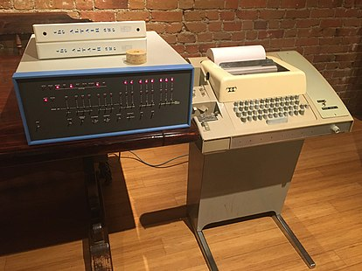

Stage 3: Develop Your Idea
Develop your idea by fallowing the fallowing steps:
1) Planning: Write the algorithm with set of instructions and rules.
2) Backup: Backup your plan’s copy in case a coffee accident.
3) Production: Start coding or creating physically.
4) Production Backup: Have a copy of your product in case it breaks.
5) Post Deployment: Do examination on your product before share with the world.
6) Deployment: Publish to the world by putting copyright notice. Notice should appear on every part. It should include the copyright symbol(©), year of publication, copyright owners name. Ex: © 2019-2021 by Doga Ege Ozden
7) Deployment Backup: Have copy of the your shared product so you can see in bad case if something you didn't done is there.

Stage 4: Step to the market
Get its patent rights. One differentiation, a differentiation is enough, it can be even design, if you can talk very very good in some cases such as music and art. You should show your self high educated, smart as they will think you can develop it make it better for the world. Use logical appeals, which means generate logical arguments to support your product, give examples plan your speech by writing scripts.

References
1. Redirect Notice. https://www.google.com/url?sa=i&url=https%3A%2F%2Fwww.wikizero.com%2Fen%2FMITS_Altair&psig=AOvVaw34j9WofvEzTEbBS1ntZO9k&ust=1614019799009000&source=images&cd=vfe&ved=0CAIQjRxqFwoTCJjk2LnS--4CFQAAAAAdAAAAABAI.
2. P-03: Using Copyright Notices?:: The UK Copyright Service. https://copyrightservice.co.uk/copyright/p03_copyright_notices.

