Smart Undergraduate Course Navigator
Intelligent Decision Support for Course Selection and Academic Performance Optimization at UMaT
Final Year Project - Streamlit Implementation
University of Mines and Technology (UMaT)
April 15, 2026
GitHub (placeholder): https://github.com/your-team/smart-course-navigator

Abstract
This artefact documents a Streamlit-based decision support system that couples cohort analytics with supervised machine learning to forecast pass probabilities, recommend semester loads, and classify academic risk. Three classifiers-logistic regression, decision trees, and random forests-are trained on a realistic synthetic engineering dataset (≥1000 rows) spanning mining, geological, electrical, and mechanical programs. The best-performing model is serialized with joblib and invoked from a multi-page Streamlit experience built entirely in Python.

Introduction
Engineering undergraduates must balance accreditation requirements, laboratory intensity, and individual preparedness. The navigator operationalizes historical signals into individualized guidance.

Problem Statement
Students lack transparent, quantitative aids when sequencing demanding courses, while administrators need reproducible pipelines for refreshing analytics.

Objectives
- Deliver Streamlit dashboards for analytics, prediction, recommendations, and model governance.
- Train and compare three ML models with accuracy, precision, recall, and F1-score.
- Expose reasoning strings aligned with cohort behaviour and modeled probabilities.

Literature Review
Decision support systems integrate data, models, and interfaces for semi-structured decisions (Power, Sharda, & Burstein, 2015). Educational data mining applies classification to academic traces (Romero & Ventura, 2013). Responsible deployment foregrounds transparency and student agency (Williamson, 2018).

Methodology
Synthetic data emulate registrar-style fields; preprocessing scales numerics and one-hot encodes categoricals; class imbalance is mitigated via class_weight within estimators; evaluation uses a stratified hold-out split.

System Design
The Streamlit runtime orchestrates UI, calls utility modules for analytics, recommendations, and risk analysis, and loads the persisted sklearn pipeline from disk.
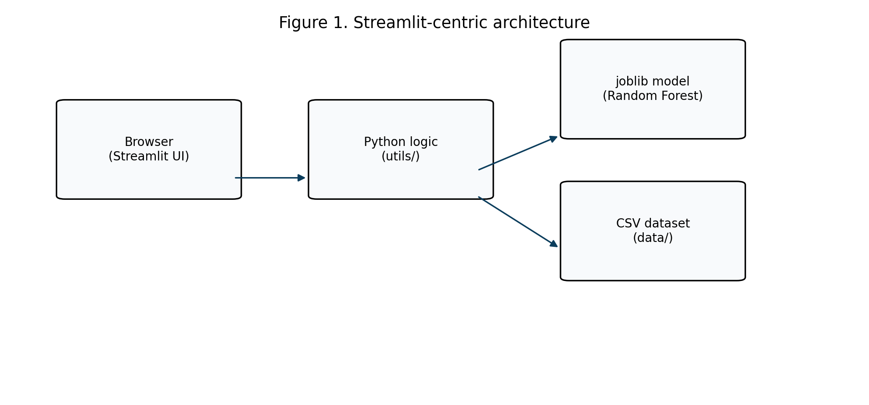
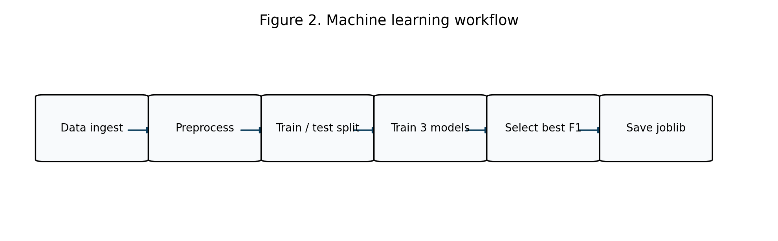

Dataset Description
Fields include student_id, program, GPA, course identifiers, difficulty, attempts, attendance, credit load, grade, and pass/fail labels for supervised learning.

Machine Learning Approach
Selected model: random_forest. Highest F1-score on stratified hold-out test set (imbalance handled via class_weight).
Model | Accuracy | Precision | Recall | F1
logistic_regression | 0.6507 | 0.851 | 0.639 | 0.7299
decision_tree | 0.6027 | 0.7883 | 0.6318 | 0.7014
random_forest | 0.712 | 0.8189 | 0.7834 | 0.8007
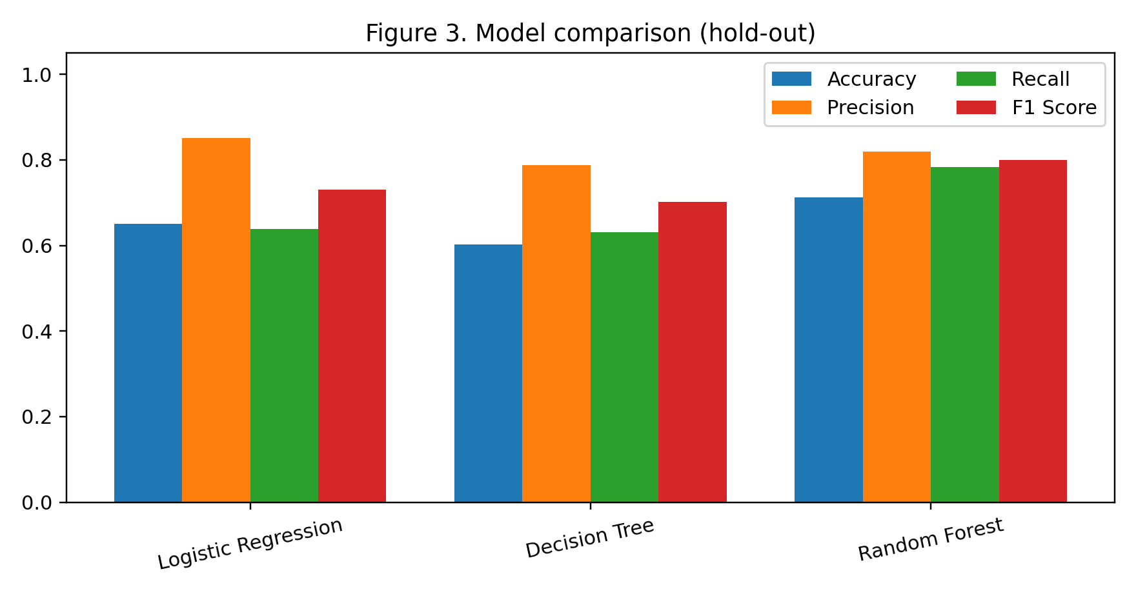
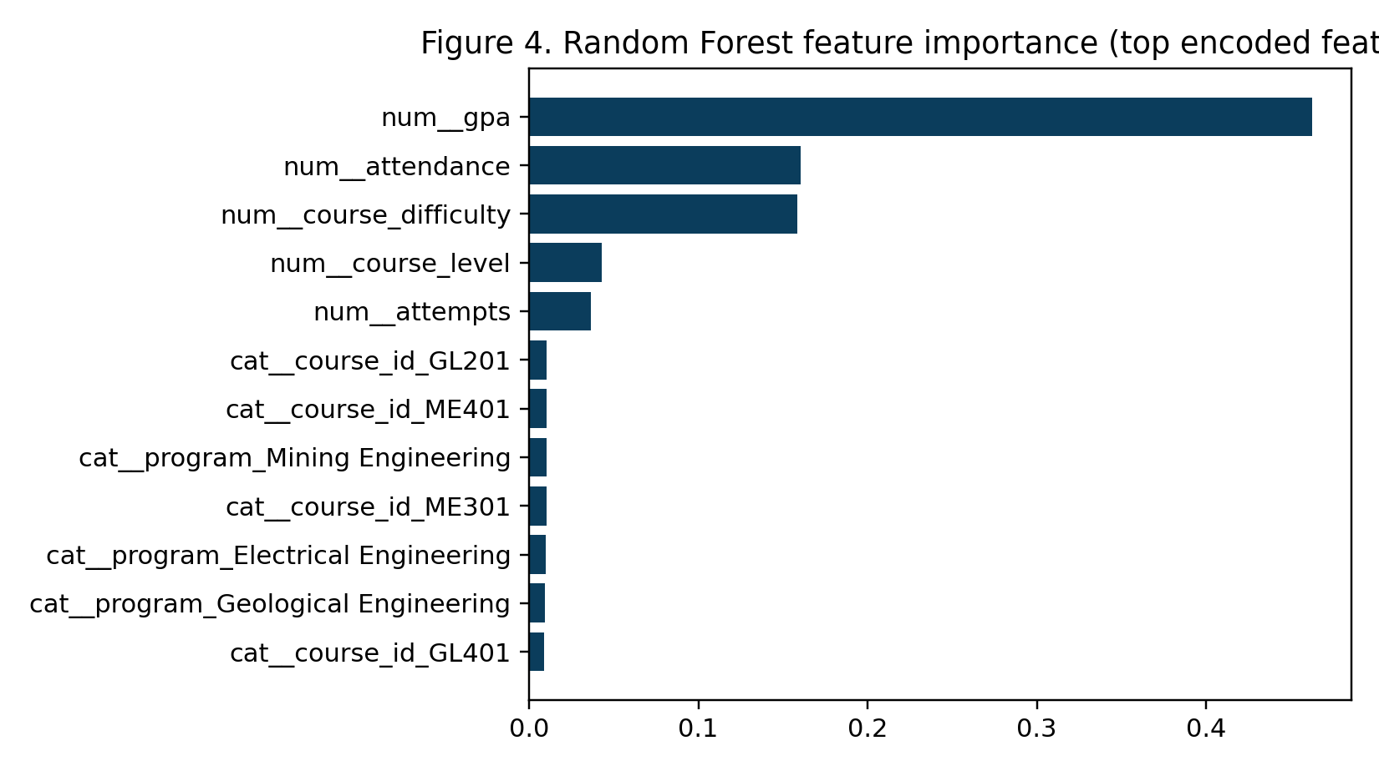

System Implementation (Streamlit)
The implementation follows the prescribed structure: app.py for the home page, pages/ for modular views, utils/ for preprocessing and ML services, and notebooks/training.ipynb for reproducible training.
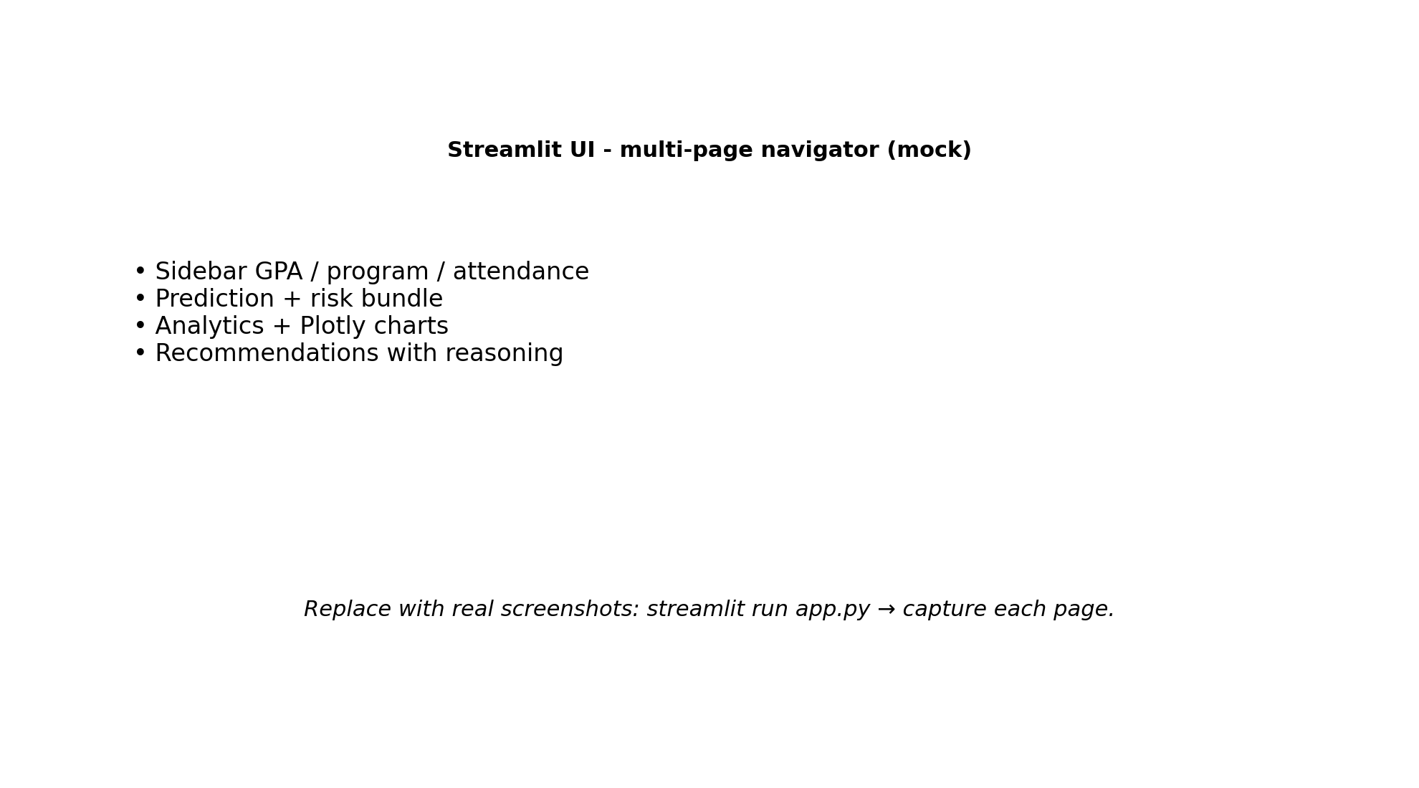

Results and Evaluation
Quantitative metrics are summarized in the performance dashboard and embedded figures. Qualitative review confirms that reasoning strings map to cohort statistics and individualized probabilities.

Discussion
Synthetic data enable safe academic demonstration; production deployment requires governed extracts, bias audits, and integration with official advising workflows.

Conclusion
The Streamlit navigator satisfies the functional brief: prediction, analytics, recommendations, risk tiers, and model transparency within a single Python codebase.

Recommendations
Adopt institutional authentication, connect to relational databases, and schedule quarterly model retraining with drift monitoring.

References (APA-style samples)
- Power, D. J., Sharda, R., & Burstein, F. (2015). Decision support systems (3rd ed.). Wiley.
- Romero, C., & Ventura, S. (2013). Data mining in education. Wiley Interdisciplinary Reviews.
- Pedregosa, F. et al. (2011). Scikit-learn: Machine learning in Python. Journal of Machine Learning Research, 12, 2825-2830.

Contributors
Wisdom Dogah - FCM.41.020.099.23
Faustian Nyamekye - FCM.41.020.146.23
Owusu Appiah Barimah Kofi Duodu - FCM.41.020.159.23
De-Graft Prince Kweku - F.C.M. 41.020.098.23
Cudjoe Jennifer Abena - FCM. 41.020.096.23
Danquah Joseph - FCM.41.020.097.23
Kelvin Kandibiga - FCM.41.020.118.23

Appendices
Appendix A: Directory tree (app.py, pages/, utils/, data/, models/). Appendix B: API-free architecture because Streamlit embeds server logic. Appendix C: evaluation_metrics.json stores raw metrics for audits.

