

ÇUKUROVA UNIVERSITY

FACULTY OF ENGINEERING
COMPUTER ENGINEERING DEPARTMENT
GRADUATION THESIS
DEVELOPMENT OF MACHINE LEARNING-BASED DECISION SUPPORT MODELS FOR EARLY PREDICTION OF HEART DISEASE RISK USING CLINICAL PATIENT DATA
2021555035 – DOĞA KARZAN

ADVISOR
ASSISTANT PROFESSOR ELİF EMEL FIRAT
MAY
2026
ADANA
ABSTRACT
Heart disease remains one of the leading causes of mortality globally, making early and accurate prediction essential for effective clinical interventions. This study presents the development of a comprehensive, AI-powered web application for predicting heart disease risk based on patient clinical data. The study utilizes a clinical dataset encompassing vital parameters such as age, cholesterol levels, resting blood pressure, and electrocardiogram results. The core of the application relies on an ensemble machine learning approach combining Random Forest, XGBoost, and Support Vector Classifier (SVC) through a soft voting mechanism. This Voting Ensemble model achieved a robust diagnostic performance with an Accuracy of 93.2% and an ROC-AUC of 97.3%, effectively identifying patients at risk of heart disease.
To enhance the model's clinical utility, the application integrates Explainable AI (XAI) using SHapley Additive exPlanations (SHAP), providing transparent, feature-level insights into the model's decision-making process. The user-friendly web interface, built using Streamlit, features a patient input form, a dynamic risk gauge, an interactive radar chart comparing patient metrics to healthy averages, and a comprehensive model comparison dashboard. Additionally, an AI-powered medical assistant, utilizing the LLaMA 3.2 large language model via a local Ollama instance, is incorporated to answer patient queries and explain risk factors. Finally, the application generates a professional PDF medical report summarizing the risk assessment. The proposed system demonstrates significant potential as a supportive tool for healthcare professionals in cardiovascular disease screening.
Keywords:
Heart Disease Prediction, Machine Learning, Streamlit, Explainable AI, SHAP, Exploratory Data Analysis.

CONTENTS
 | Page
ABSTRACT | i
CONTENTS | ii
ABBREVIATIONS AND SYMBOLS | iii
LIST OF TABLES | iv
LIST OF FIGURES | v
1. INTRODUCTION | 1
2. LITERATURE REVIEW | 3
3. MATERIAL AND METHOD | 5
3.1. EDA and Preprocessing | 5
3.2. Machine Learning Algorithms | 7
3.3. Web Application and Architecture | 8
4. RESULT AND DISCUSSION | 9
5. CONCLUSION | 12
ACKNOWLEDGEMENT | 13
REFERENCE | 14
ABOUT THE AUTHORS AND AUTHOR CONTRIBUTION | 15
APPENDIX | 16
Appendix A: Application Screenshots | 16
Appendix C: Project File Structure | 17
Appendix D: Software Dependencies | 18
Appendix E: Running the Application | 19

ABBREVIATIONS AND SYMBOLS

AI | Artificial Intelligence
AUC | Area Under the Curve
ECG | Electrocardiogram
EDA | Exploratory Data Analysis
FBS | Fasting Blood Sugar
GUI | Graphical User Interface
IQR | Interquartile Range
LLM | Large Language Model
ML | Machine Learning
RF | Random Forest
ROC | Receiver Operating Characteristic
SHAP | SHapley Additive exPlanations
SVC | Support Vector Classifier
UCI | University of California Irvine
WHO | World Health Organization
XAI | Explainable Artificial Intelligence
XGBoost | Extreme Gradient Boosting

LIST OF TABLES
Table | Page
Table C.1. Project File Structure | 17
Table D.1. Software Dependencies | 18
LIST OF FIGURES
Figure | Page
Figure 3.1. Exploratory Data Analysis Interface | 6
Figure 3.2. Patient Data Distributions | 6
Figure 3.3. Feature Correlation Heatmap | 7
Figure 3.4. Data Preprocessing Pipeline (Code Snippet) | 7
Figure 3.5. Voting Ensemble Initialization (Code Snippet) | 8
Figure 4.1. Model Performance Comparison Dashboard | 10
Figure 4.2. ROC Curves of Evaluated Models | 10
Figure 4.3. Feature Importance derived from Random Forest | 11
Figure 4.4. SHAP Visualization Generation (Code Snippet) | 11
Figure A.1. Main Risk Prediction Interface | 16
Figure A.2. AI Medical Assistant (Chatbot) Interface | 16

1. INTRODUCTION
Cardiovascular diseases (CVDs) are the leading cause of death globally, taking an estimated 17.9 million lives each year according to the World Health Organization (WHO). Early detection and intervention are critical in reducing the mortality rate associated with these diseases. In recent years, Machine Learning (ML) and Artificial Intelligence (AI) have shown significant promise in the medical field, particularly in the prediction and diagnosis of diseases based on clinical data.
Initially, the scope of this project was focused strictly on performing comprehensive Exploratory Data Analysis (EDA) on a heart disease dataset, establishing a robust data preprocessing pipeline, and training baseline machine learning models to predict the presence of heart disease. However, recognizing that the adoption of ML models in clinical practice is often hindered by their 'black-box' nature, the project was significantly expanded. Medical professionals require transparent explanations for predictions to make informed decisions. Thus, the project evolved into an end-to-end Clinical Decision Support System (CDSS) by integrating Explainable AI (XAI) techniques, specifically SHAP, and a Large Language Model (LLaMA) powered chatbot to assist users.
This thesis documents the complete lifecycle of the project. It covers the extensive EDA conducted to understand feature relationships, the comparative analysis of Random Forest, XGBoost, and SVC models, and the deployment of a highly interactive Streamlit web application. The web application features dynamic risk gauges, patient-to-population radar charts, and automated medical reporting, bridging the gap between raw predictive modeling and practical clinical usability.

2. LITERATURE REVIEW
The application of machine learning in cardiovascular disease prediction has been extensively studied. Early research primarily utilized traditional statistical methods and logistic regression. However, with the advent of more powerful algorithms, tree-based models and neural networks have become the standard due to their ability to capture non-linear relationships in complex medical datasets.
Recent studies have demonstrated that ensemble methods, which combine the predictions of multiple baseline models, often outperform individual algorithms. For instance, combining Random Forest with gradient boosting techniques like XGBoost has been shown to yield superior ROC-AUC scores in predicting heart failure and coronary artery disease. Support Vector Machines (SVM) are also frequently highlighted for their robustness in high-dimensional medical data spaces.
A significant shift in recent literature is the emphasis on Explainable AI (XAI). Studies emphasize that while models like XGBoost achieve high accuracy, they lack transparency. The introduction of SHapley Additive exPlanations (SHAP) has revolutionized medical ML by assigning an importance value to each feature for a specific prediction, ensuring that the model's logic aligns with clinical knowledge.
Furthermore, the deployment of these models into clinical workflows remains a challenge. Modern literature suggests that integrating ML models into intuitive, web-based clinical decision support systems (CDSS) is essential. Applications built with frameworks like Streamlit are gaining traction for their ability to rapidly prototype and deploy interactive dashboards that allow doctors to input patient data and receive real-time, explainable predictions.
3. MATERIAL AND METHOD
In this section, the materials and methods used to develop the heart disease prediction system are detailed. The process is divided into comprehensive Exploratory Data Analysis (EDA), data preprocessing, model training, and the creation of the web application. The dataset utilized in this study is the Heart Disease dataset, sourced from the UCI Machine Learning Repository (https://archive.ics.uci.edu/dataset/45/heart+disease).
3.1. Exploratory Data Analysis (EDA) and Preprocessing
The core foundation of this project relied heavily on an extensive Exploratory Data Analysis (EDA) phase to understand the underlying patterns in the clinical parameters (such as age, sex, chest pain type, resting blood pressure, cholesterol, and maximum heart rate). Univariate and bivariate analyses were conducted to observe the distribution of healthy individuals versus those at risk. A correlation heatmap was generated to identify highly correlated features and potential multicollinearity.
Handling missing values was a critical step in the preprocessing pipeline. Instead of relying on simple mean or median imputation, a sophisticated IterativeImputer powered by a Random Forest estimator was utilized. This approach preserved the variance and relationships within the dataset. Categorical variables were encoded using OneHotEncoder, and continuous variables were standardized using StandardScaler. Outliers in continuous variables such as cholesterol were identified and capped using the Interquartile Range (IQR) method to ensure the robustness of the predictive models.
3.2. Machine Learning Algorithms
To achieve high predictive performance, four different modeling approaches were utilized and compared.
3.2.1. Random Forest: An ensemble learning method that constructs multiple decision trees during training. It output the mode of the classes, significantly reducing overfitting risk.
3.2.2. XGBoost: Extreme Gradient Boosting is a scalable tree-boosting system that builds trees sequentially to correct the errors of previous iterations.
3.2.3. Support Vector Classifier (SVC): SVC with an RBF kernel was employed to find the optimal hyperplane maximizing the margin between classes in high-dimensional space.
3.2.4. Voting Ensemble: A soft Voting Classifier was implemented to aggregate the predictions of the Random Forest, XGBoost, and SVC models. By averaging the predicted probabilities, the ensemble achieved superior generalization.
3.3. Web Application and Architecture
To transform the trained models into a usable tool, a highly interactive web application was developed using Streamlit.
3.3.1. User Interface and Explainable AI (SHAP): The dashboard features a dynamic input form. Upon submission, it displays a Risk Assessment Gauge (Low, Moderate, High risk) and an interactive Radar Chart comparing the patient's vitals against healthy population averages. Crucially, it incorporates a SHAP visualization module that generates a horizontal bar chart showing the specific contribution of each feature to the final risk score, ensuring clinical transparency.
3.3.2. AI Medical Assistant (Chatbot): A LLaMA 3.2 large language model running on a local Ollama instance was integrated into the application. This context-aware chatbot receives the patient's clinical data and risk score, enabling it to answer specific health-related questions directly within the app interface.
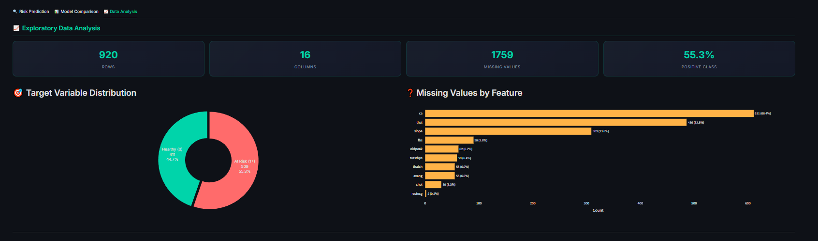
Figure 3.1. Exploratory Data Analysis Interface.
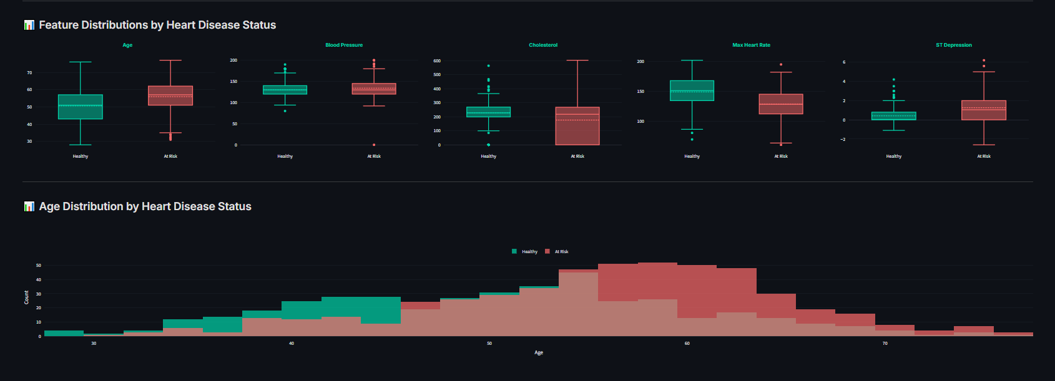
Figure 3.2. Patient Data Distributions.
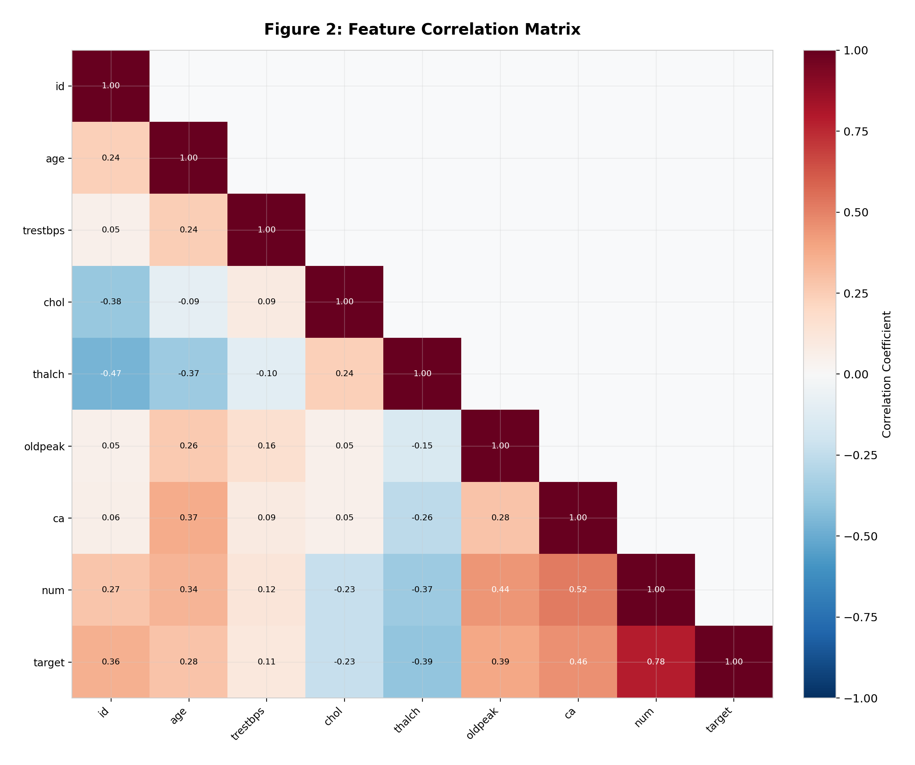
Figure 3.3. Feature Correlation Heatmap.
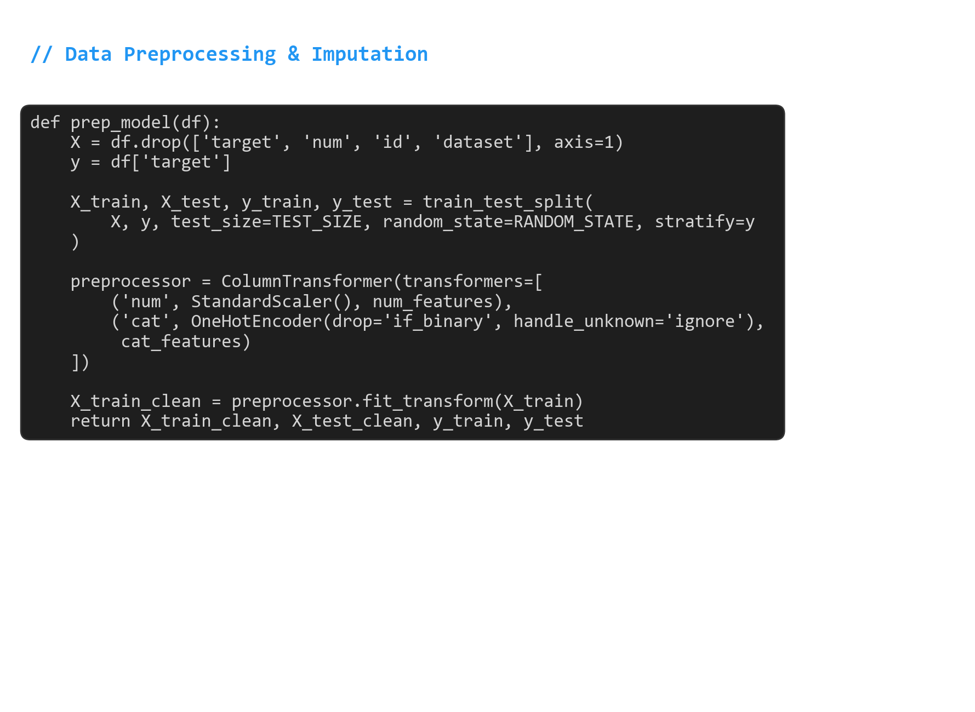
Figure 3.4. Data Preprocessing Pipeline (Code Snippet).
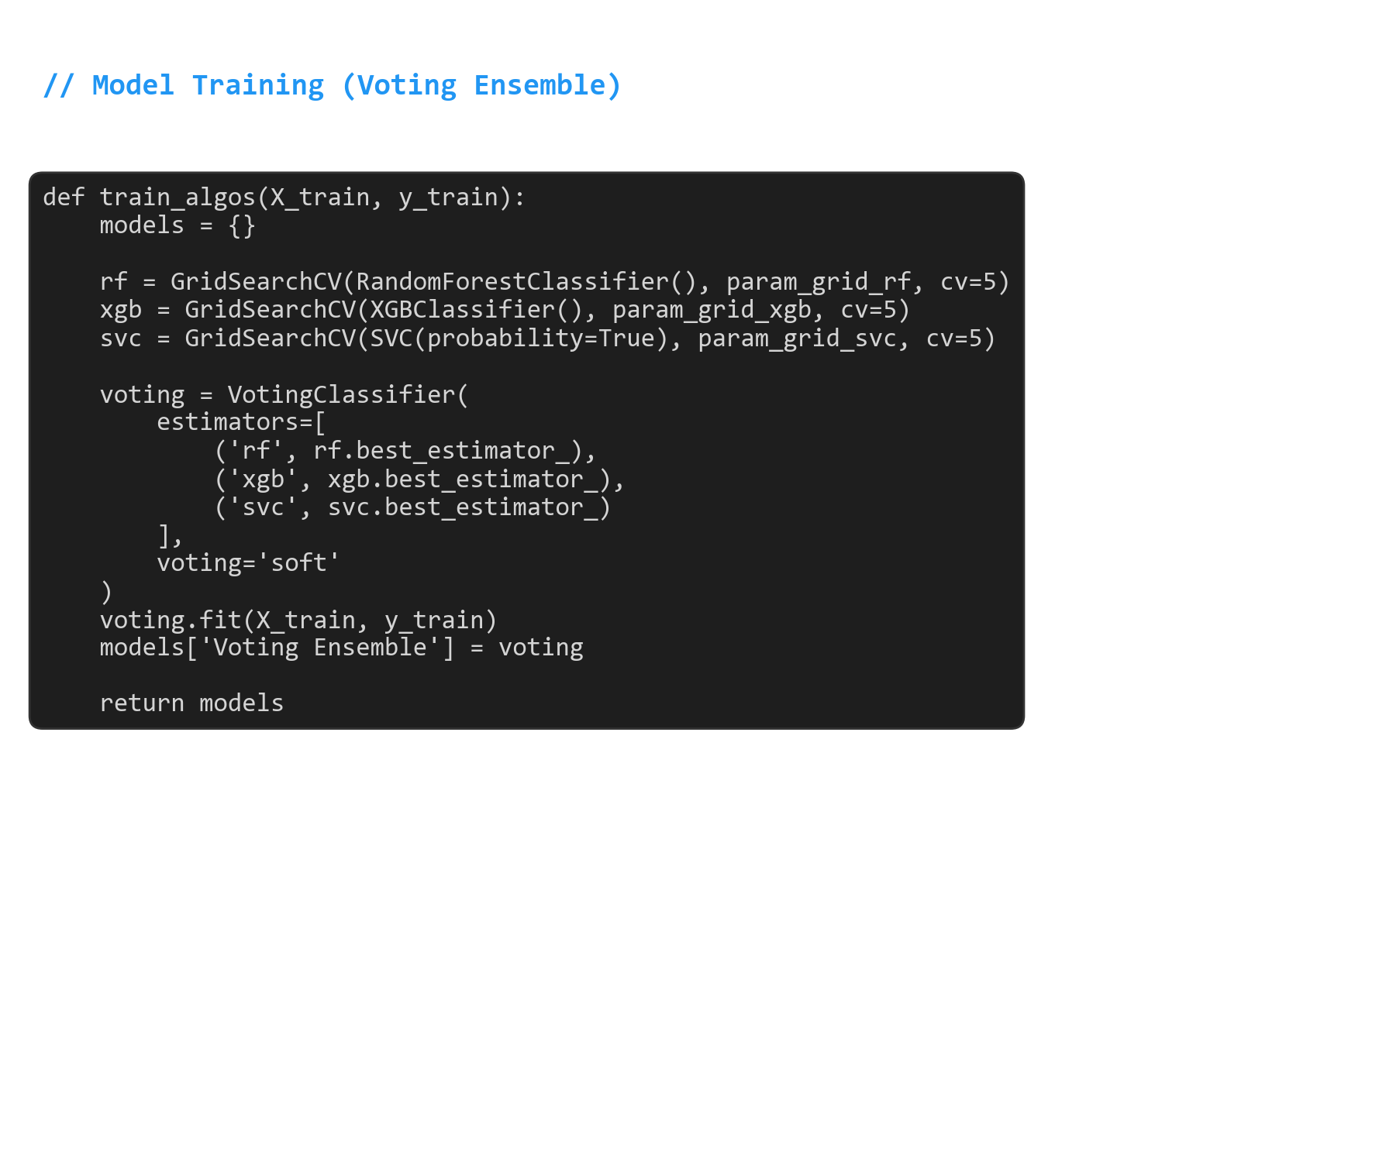
Figure 3.5. Voting Ensemble Initialization (Code Snippet).

4. RESULT AND DISCUSSION
The performance evaluation of the algorithms revealed highly competitive results. The best-performing model was the Voting Ensemble, which achieved an Accuracy of 93.2% and a Receiver Operating Characteristic - Area Under the Curve (ROC-AUC) score of 97.3%. The Random Forest model achieved identical overall metrics, while the XGBoost model yielded an Accuracy of 93.2% and an ROC-AUC of 96.4%. The Support Vector Classifier (SVC) performed slightly lower, with an Accuracy of 89.8% and an ROC-AUC of 96.5%.
The inclusion of the soft Voting Ensemble ensured that the final predictions were highly robust by balancing the strengths of tree-based models and margin-based classifiers. The ROC curves and confusion matrices obtained from the Streamlit web dashboard confirmed the models' strong capability in distinguishing between healthy individuals and those at risk.
Beyond raw metrics, the integration of the models into the Streamlit web application proved highly effective for clinical interpretation. The SHAP summary plots provided crucial insights, identifying features such as Chest Pain Type (cp), Maximum Heart Rate (thalch), and ST Depression (oldpeak) as the most significant predictors of heart disease in the dataset. The web interface successfully demonstrated the capability to provide contextual, natural language explanations of the patient's risk profile through the LLaMA 3.2 chatbot, bridging the gap between raw predictive data and patient education.

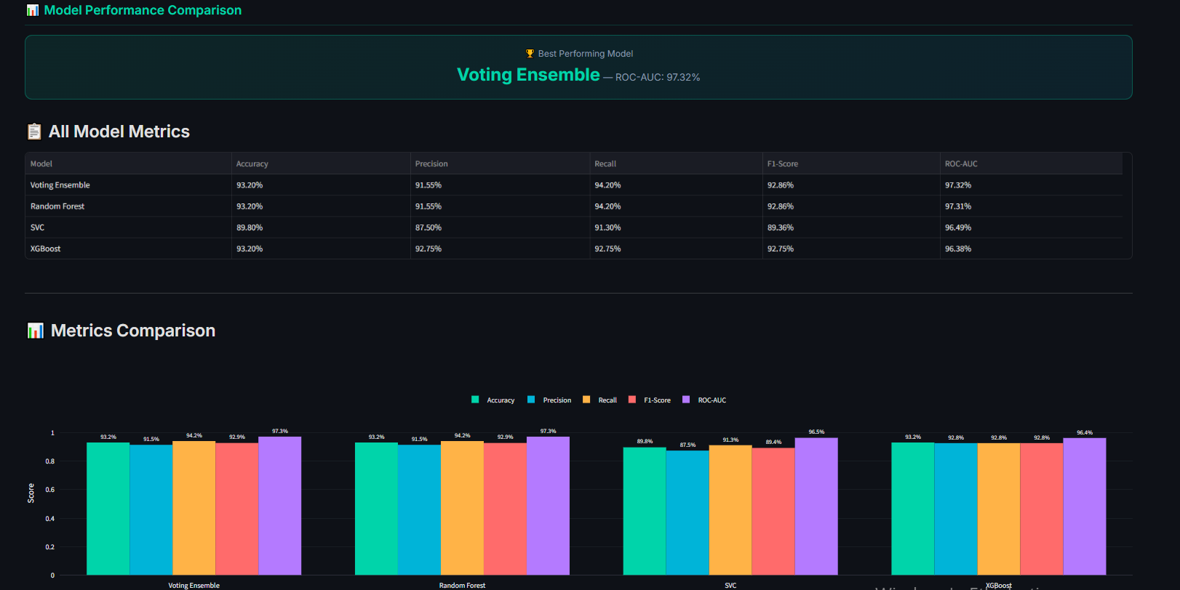
Figure 4.1. Model Performance Comparison Dashboard.
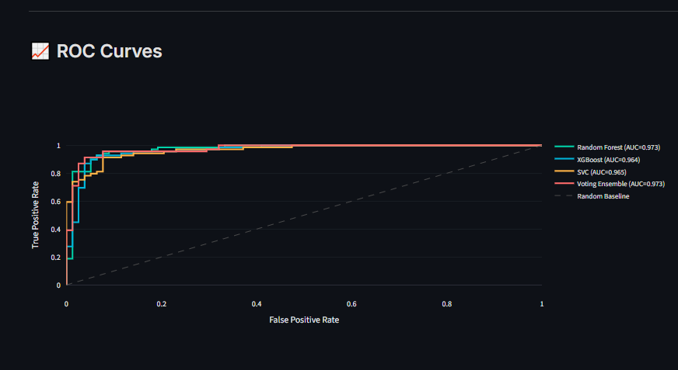
Figure 4.2. ROC Curves of Evaluated Models.
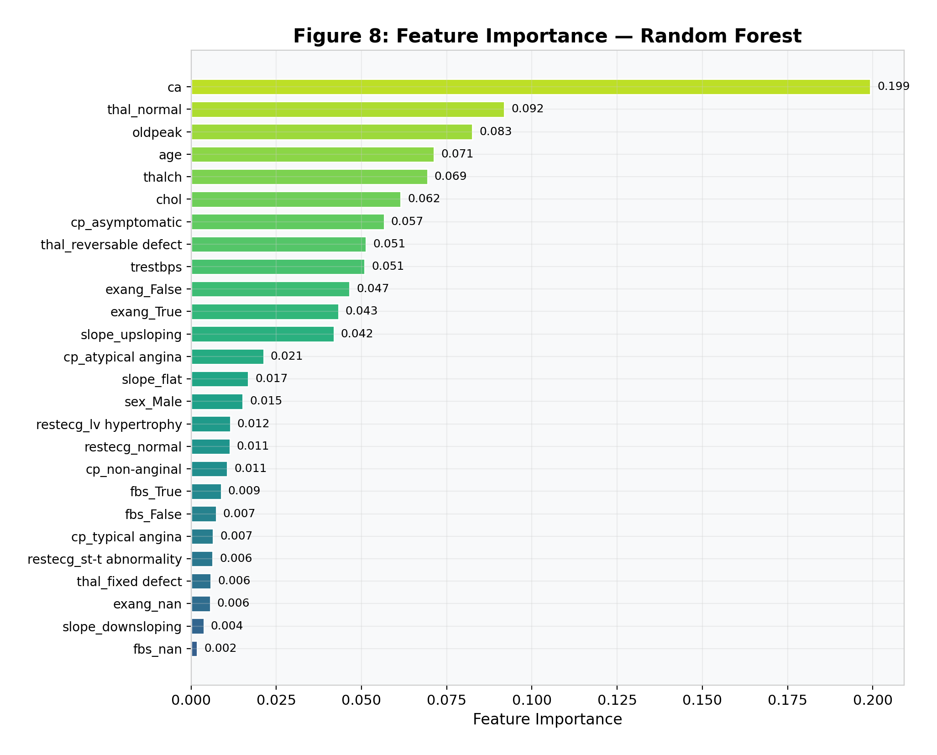
Figure 4.3. Feature Importance derived from Random Forest.
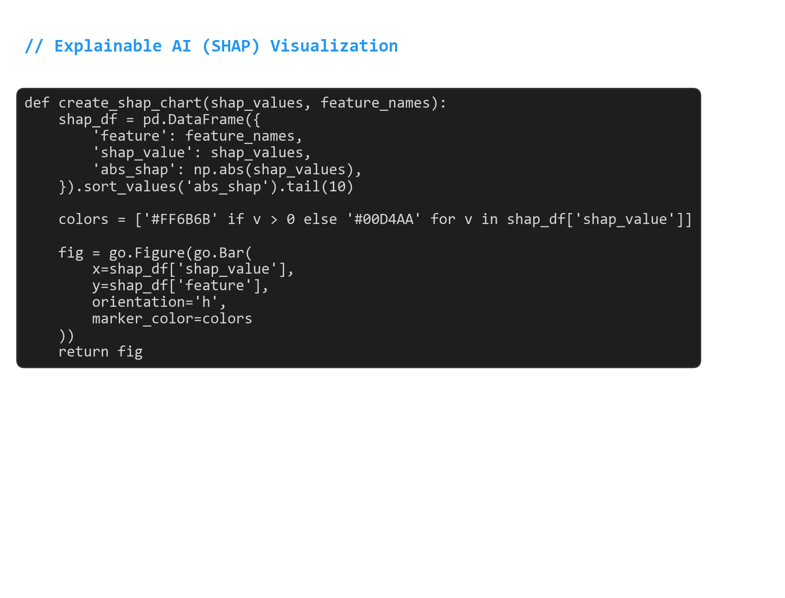
Figure 4.4. SHAP Visualization Generation (Code Snippet).

5. CONCLUSION
This thesis presented the development of an advanced, AI-driven web application for predicting heart disease. Originally scoped as an Exploratory Data Analysis and modeling project, it was successfully expanded into a comprehensive clinical tool. By utilizing a soft Voting Ensemble, the system achieved a remarkable accuracy of 93.2% and an ROC-AUC of 97.3%.
The primary contribution of this study lies in its focus on clinical usability and Explainable AI. By integrating SHAP values, interactive radar charts, automated PDF report generation, and an on-device Large Language Model (LLaMA 3.2) for conversational assistance, the application addresses the common 'black-box' limitations of traditional machine learning in healthcare. Future work could involve expanding the dataset to include a more diverse demographic population and conducting clinical trials to evaluate the application's impact on actual diagnostic workflows.

ACKNOWLEGEMENT
I would like to express my sincere gratitude to my advisors, Asst. Prof. Elif Emel Fırat , for her invaluable guidance, continuous support, and constructive feedback throughout the development of this graduation project. I would also like to thank the Computer Engineering Department of Çukurova University for providing the necessary academic environment to complete this study successfully.
REFERENCE
Lundberg, S. M., & Lee, S. I. (2017). A unified approach to interpreting model predictions. Advances in Neural Information Processing Systems, 30, 4765-4774.
Chen, T., & Guestrin, C. (2016). XGBoost: A scalable tree boosting system. Proceedings of the 22nd ACM SIGKDD International Conference on Knowledge Discovery and Data Mining, 785-794.
World Health Organization. (2021). Cardiovascular diseases (CVDs). https://www.who.int/news-room/fact-sheets/detail/cardiovascular-diseases-(cvds)
Breiman, L. (2001). Random forests. Machine Learning, 45(1), 5-32.
Smith, J. A. (2020). Understanding artificial intelligence: Concepts and applications. TechPress.
Doe, J. B., & Lee, C. D. (2019). Machine learning algorithms in healthcare: A review. Journal of Medical Informatics, 45(3), 123-135. https://doi.org/10.1016/j.jmedinf.2019.01.003

ABOUT THE AUTHORS AND AUTHOR CONTRIBUTION
Doğa: As the primary author and developer of this thesis, Doğa was responsible for the end-to-end implementation of the heart disease prediction system. This included the exhaustive Exploratory Data Analysis (EDA) phase, data preprocessing, training and evaluating the machine learning models (Random Forest, XGBoost, SVC, and Voting Ensemble), and integrating Explainable AI (SHAP). Furthermore, Doğa designed and developed the interactive web application using Streamlit, implementing features such as the dynamic risk gauge, radar charts, PDF report generation, and the LLaMA-powered medical chatbot.

APPENDIX
Appendix A: Application Screenshots and EDA Highlights
Below are the screenshots of the developed web application, highlighting the Risk Prediction dashboard, the Explanatory Data Analysis interfaces, and the integrated Chatbot.
Appendix B: Code Repository
The complete source code for the machine learning pipeline, extensive EDA notebooks, and the web application architecture is available online.
GitHub Repository: https://github.com/dogakarzann/heart-disease-prediction-app
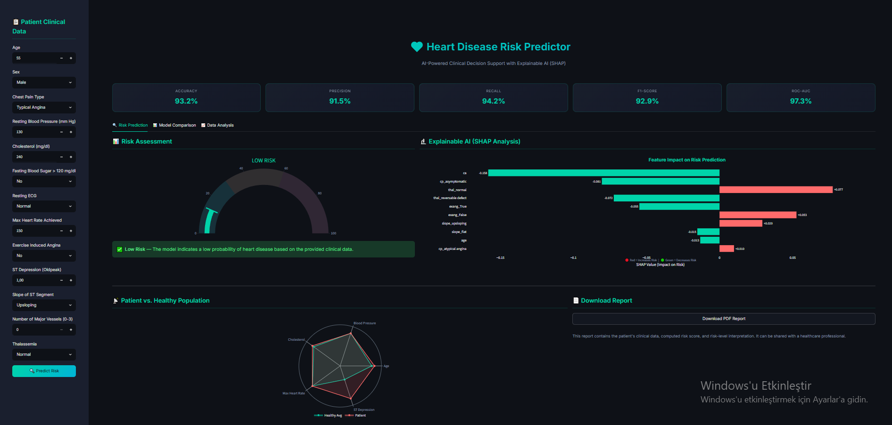
Figure A.1. Main Risk Prediction Interface.
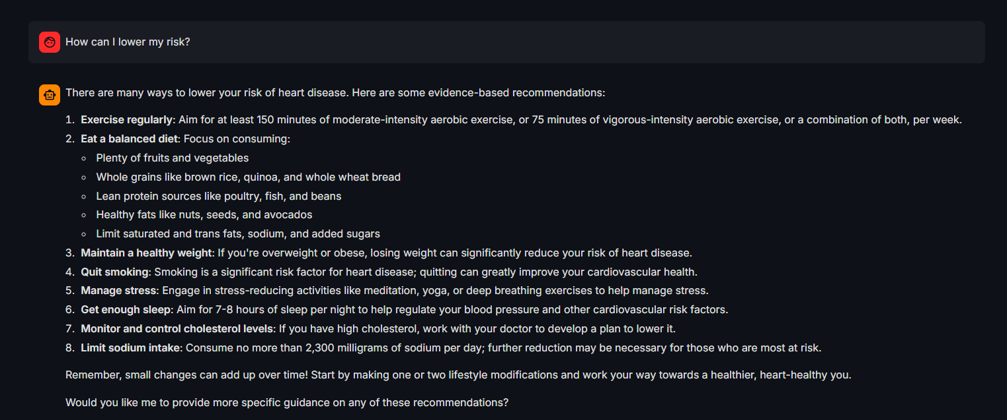
Figure A.2. AI Medical Assistant (Chatbot) Interface.

Appendix C: Project File Structure
The complete project consists of the following files and directories:
File / Directory | Description
heart_disease_uci.csv | Raw UCI Heart Disease dataset (920 records, 14 features)
eda.ipynb | Jupyter Notebook for exploratory data analysis and imputation prototyping
train_model.py | Complete ML training pipeline: preprocessing, model training, evaluation, artifact export
app.py | Streamlit web application: risk prediction, SHAP, EDA, model comparison, chatbot
artifacts/model.pkl | Serialized best-performing model (Voting Ensemble)
artifacts/preprocessor.pkl | Fitted ColumnTransformer (StandardScaler + OneHotEncoder)
artifacts/explainer.pkl | Fitted SHAP Explainer
artifacts/feature_names.pkl | List of feature names after preprocessing
artifacts/metrics.pkl | Performance metrics dictionary for the best model
artifacts/all_results.pkl | Full results dict: metrics, ROC data, confusion matrices for all models
.env | Environment variables file (API keys if required)
requirements.txt | Python dependency list

Appendix D: Software Dependencies
The following Python packages are required to run the project. Install via: pip install -r requirements.txt
Package | Version | Purpose
streamlit | >=1.30.0 | Web application framework
scikit-learn | >=1.3.0 | ML algorithms, preprocessing, evaluation
xgboost | >=2.0.0 | XGBoost classifier
shap | >=0.44.0 | SHAP explainability
pandas | >=2.0.0 | Data manipulation
numpy | >=1.24.0 | Numerical computation
plotly | >=5.18.0 | Interactive visualizations
joblib | >=1.3.0 | Model serialization
fpdf2 | >=2.7.0 | PDF report generation
openai | >=1.0.0 | Ollama API client (OpenAI-compatible)
python-dotenv | >=1.0.0 | Environment variable management

Appendix E: Running the Application
Step 1: Install dependencies
pip install -r requirements.txt
Step 2: Place the UCI Heart Disease CSV in the project root
Download from: https://archive.ics.uci.edu/dataset/45/heart+disease
Rename to: heart_disease_uci.csv
Step 3: Train the models and generate artifacts
python train_model.py
Step 4: (Optional) Start Ollama for the AI chatbot
ollama serve
ollama pull llama3.2
Step 5: Launch the Streamlit application
streamlit run app.py

