Doğa Özkaracaabatlıoğlu - 150301037 - CEN
TERM PROJECT
1- Requirements for facebook like social media system
Requirements
- Admin
- Review reported posts. Each reported post will have postID, userID (of the user who reported the post), typeID ( Description of why the post reported by user can be retrieved by using typeID).
- Remove reported posts.
- Give partial or full admin privileges to existing another user.
- Revoke admin privileges of another user.
- User
- Create an account. Each user which is not signed up yet, can add themselves into the system. Each user will have userID (generated auto-incremented value every time when a new user added), userName, userLastName, userBirthDate, userProfilePicURL, userEmail, userPassword.
- Adding or editing where the user lives information. Each userLocation contains state and city information which can be retrieved by using stateID and cityID.
- Adding or editing which university did or will user graduate from. Each university will have universityID, universityName, graduationDate
- Adding or editing which highschool did or will user graduate from. Each highschool will have highschoolID, highschoolName, graduationDate
- Add someone as friend or remove from friends.
- Post something to user’s timeline or group. Each post will have postID, userID, groupID(null if not posted to any group), postText (can be null if an image file shared instead), postDate.
- User receives notifications. Each notification will have affected_userID, interactionBy_userID, interacted_postID (the notification is referenced to), interactionTypeID (like, dislike ,comment interaction types), notificationDate
- Create a group. Each group will have groupName, createdBy_userID, groupProfilePicURL.
- Add member(s) into a group.
- Comment to a post. Each comment will have postID, userID, commentDateTime, userComment
- Like a post
- Dislike a post.

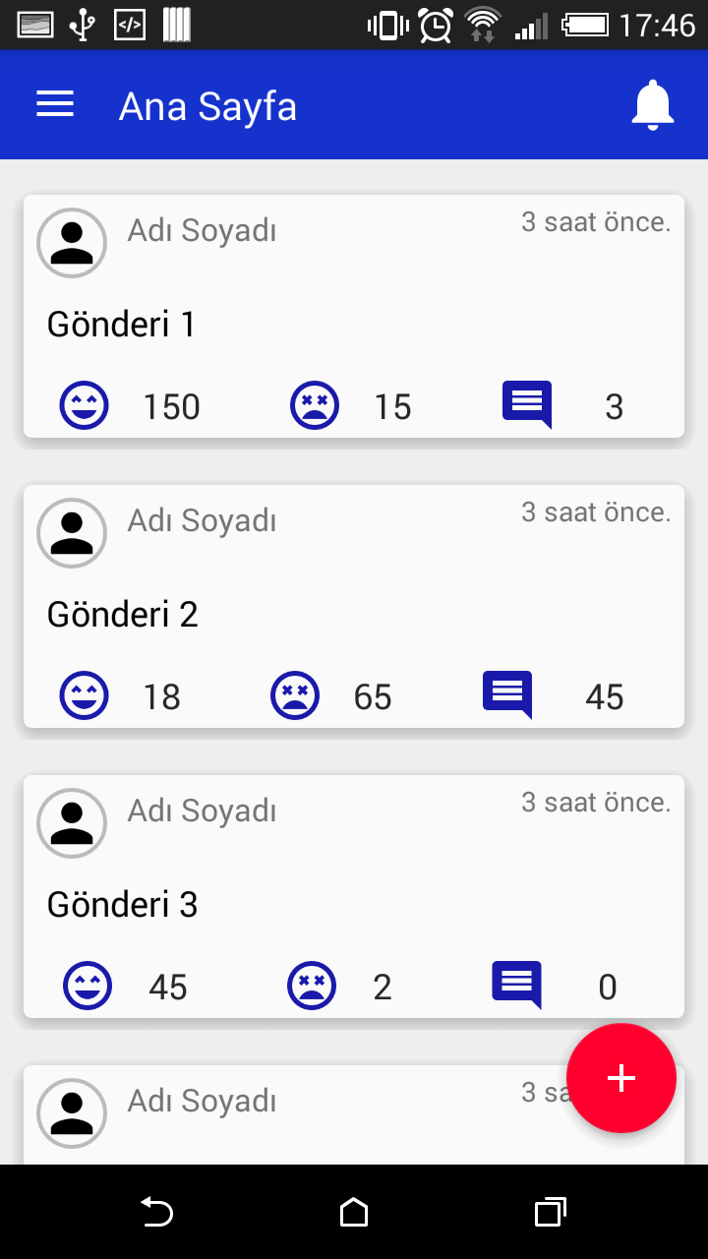
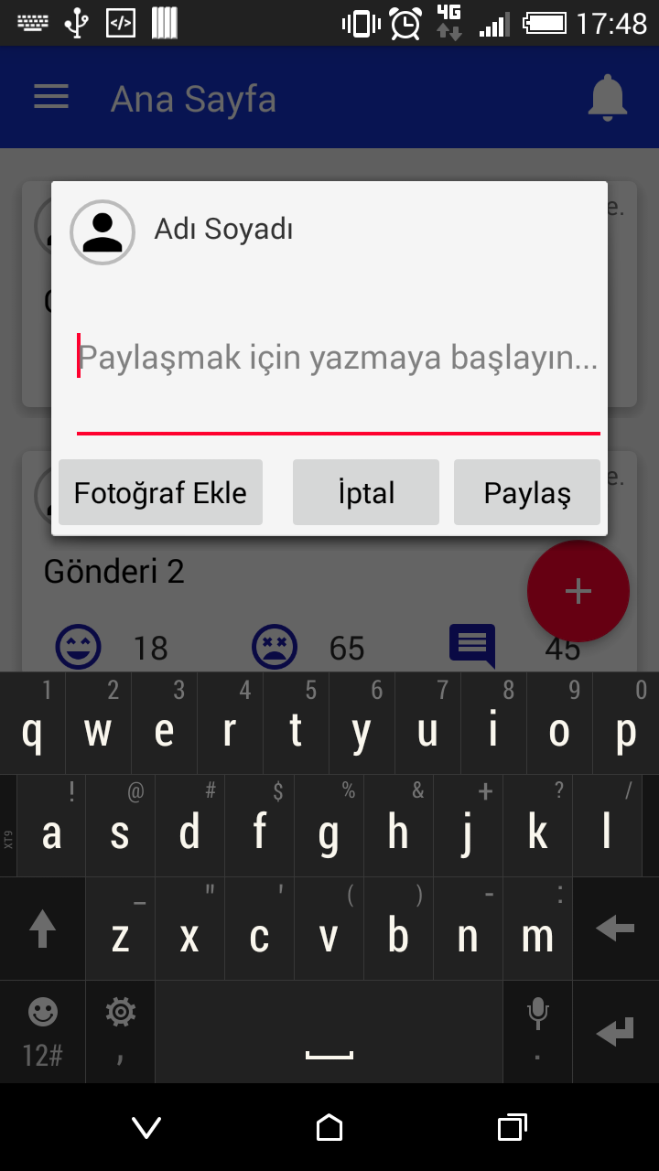
2- Mockups (P.S. Admin Panel button is only shown to users that have admin privileges.)
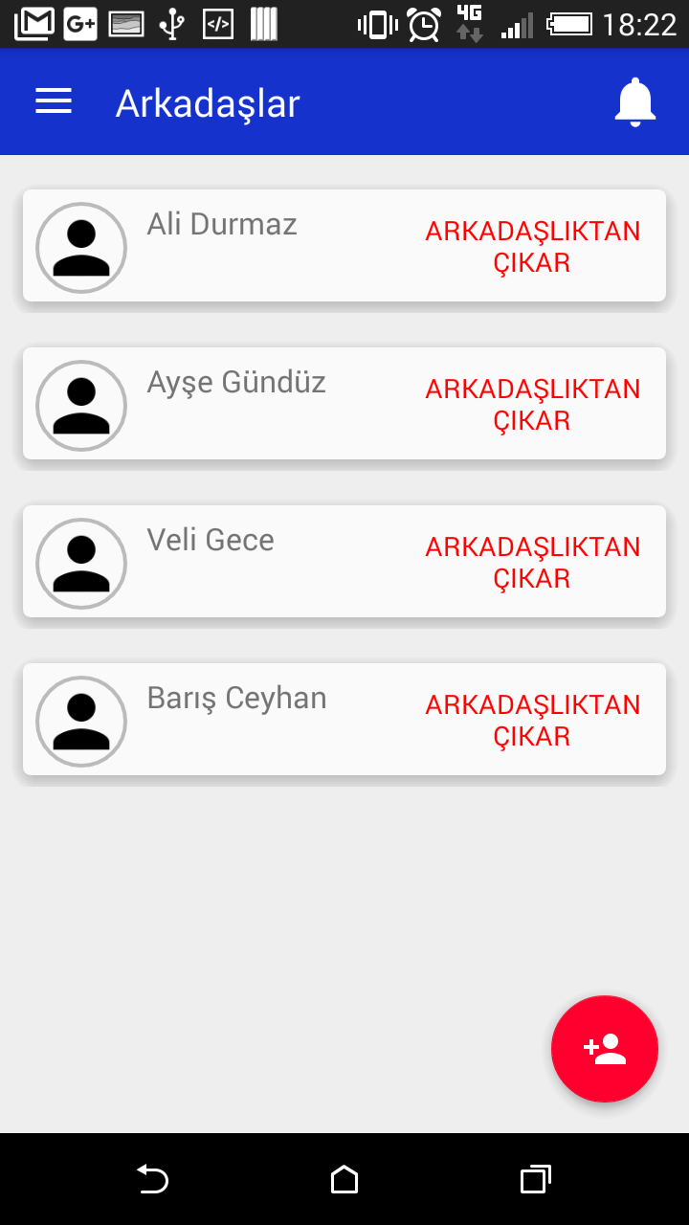

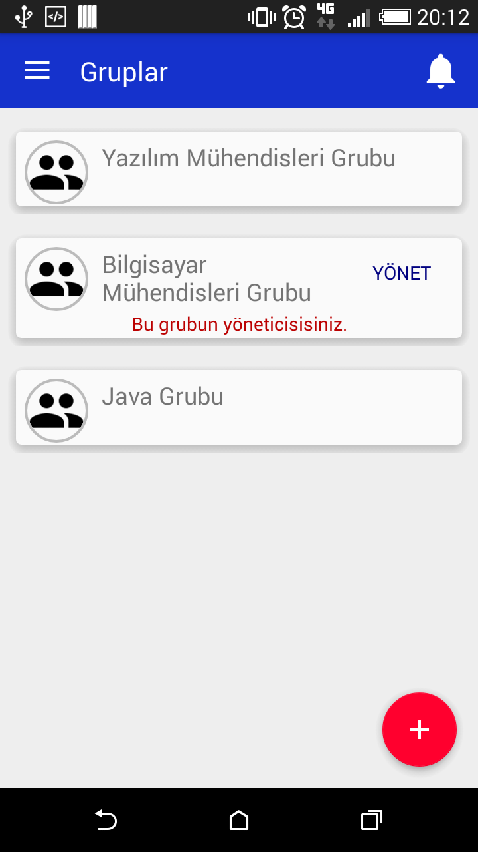
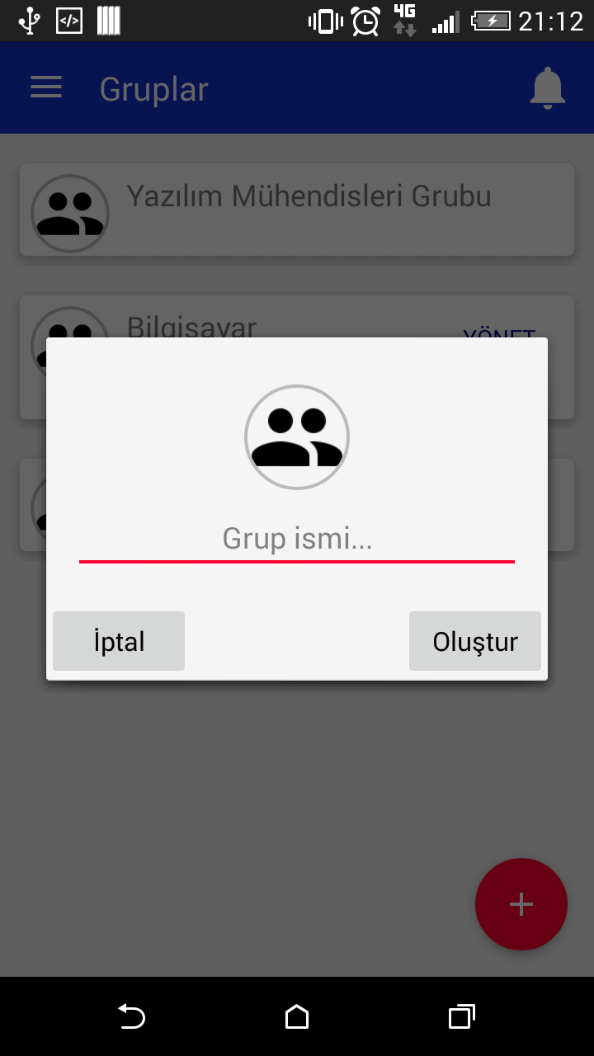
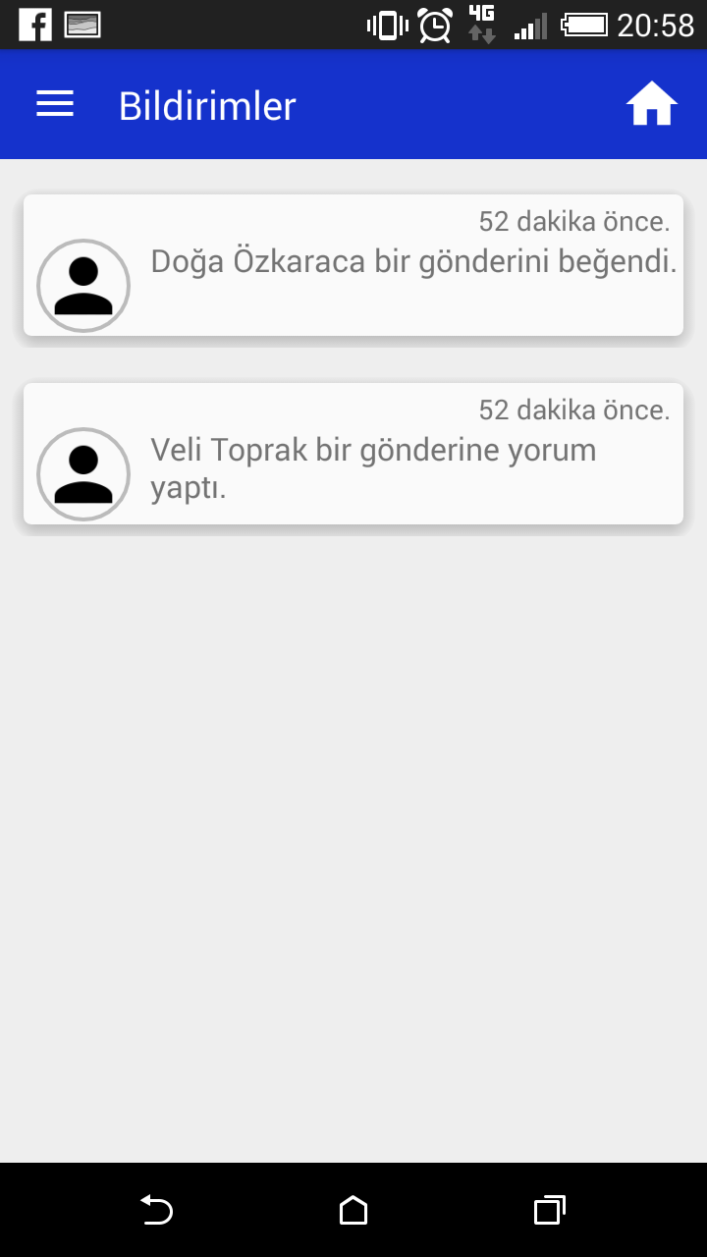
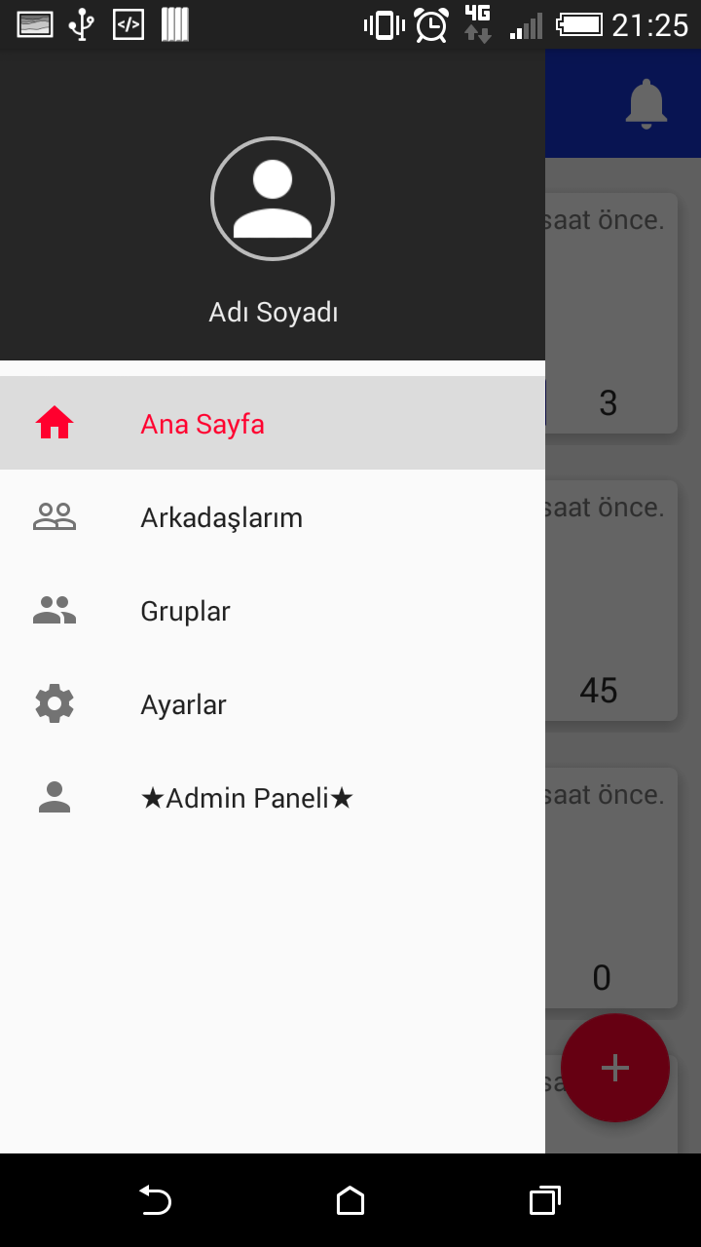
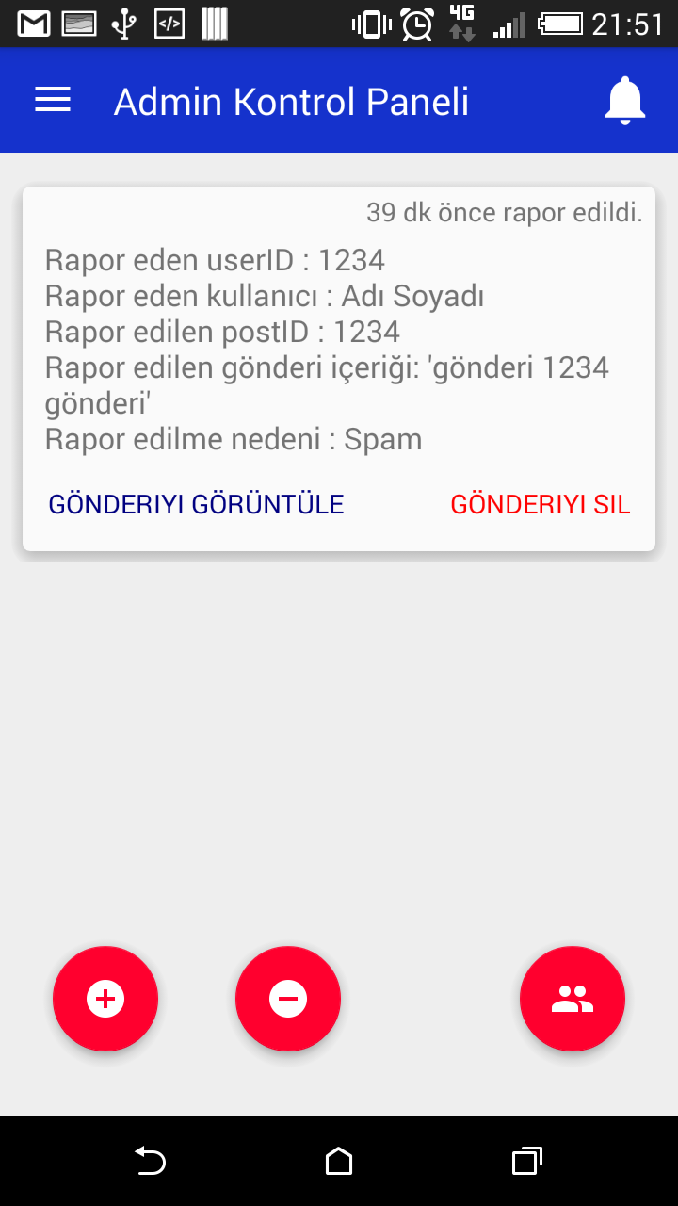
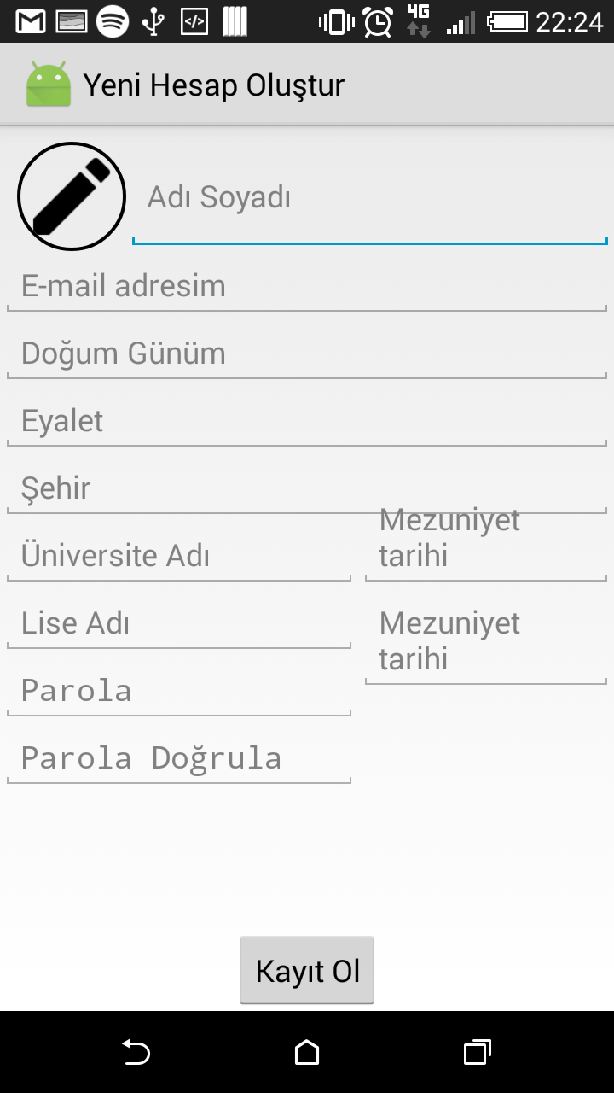

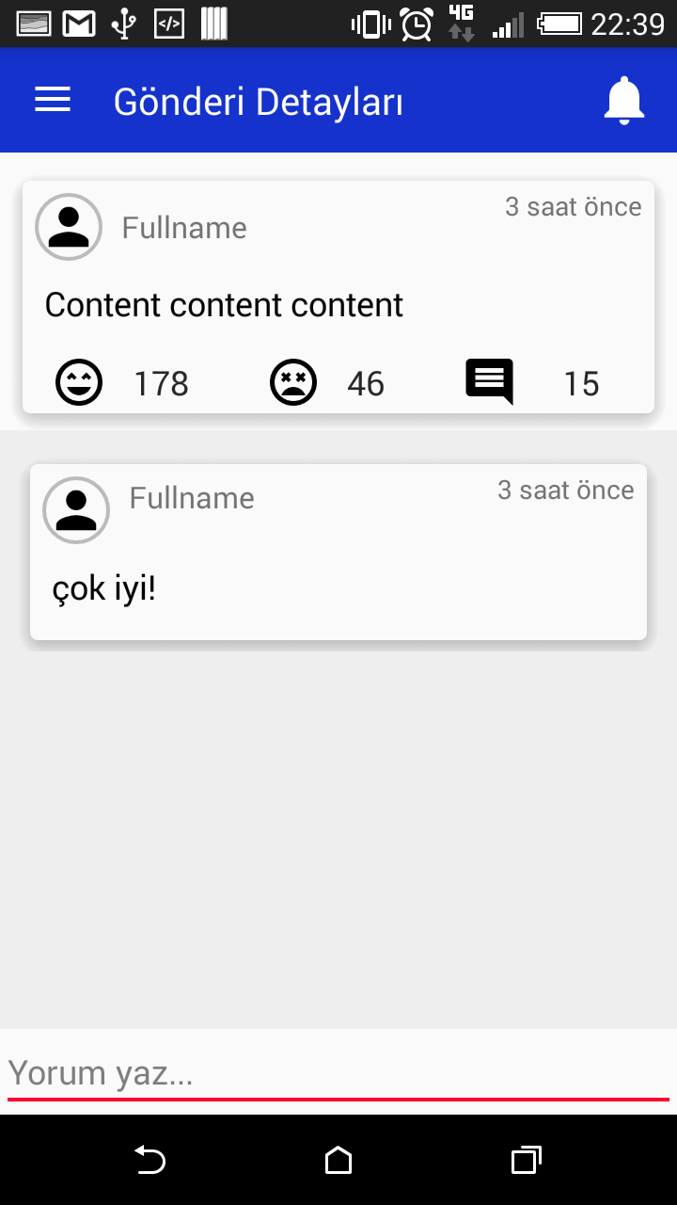
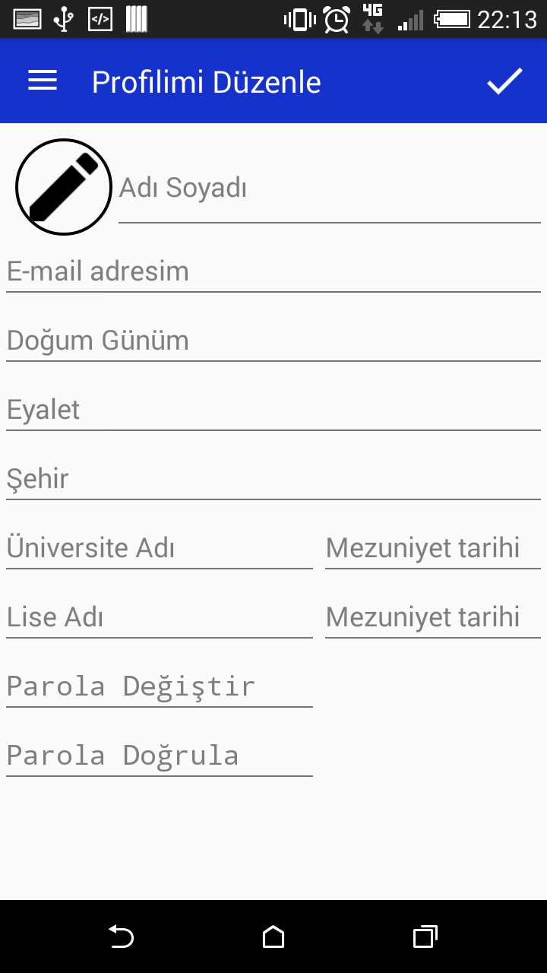
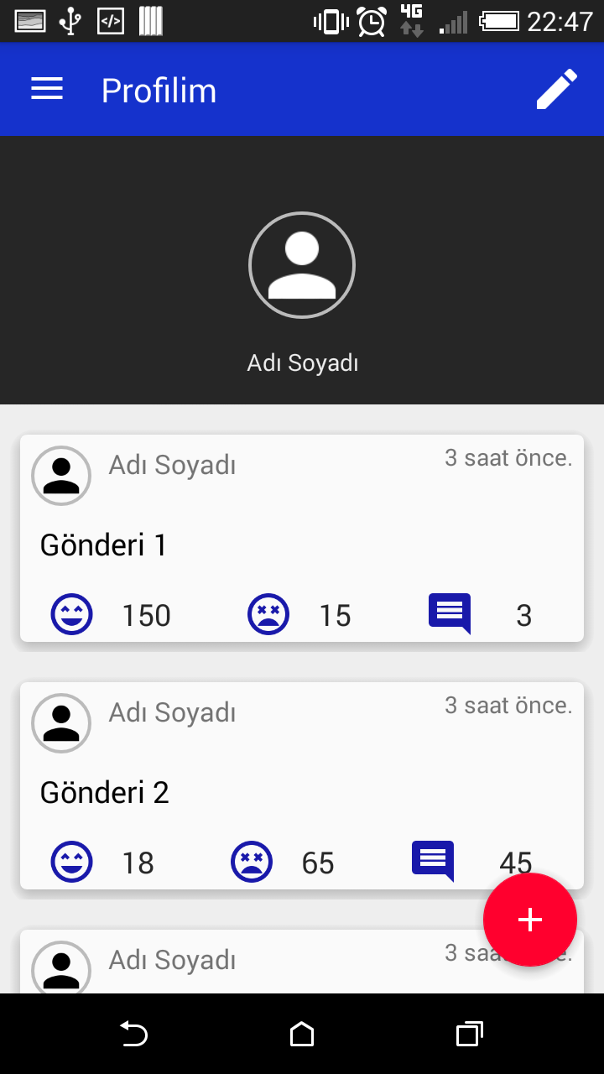
3 - Conceptual Diagram
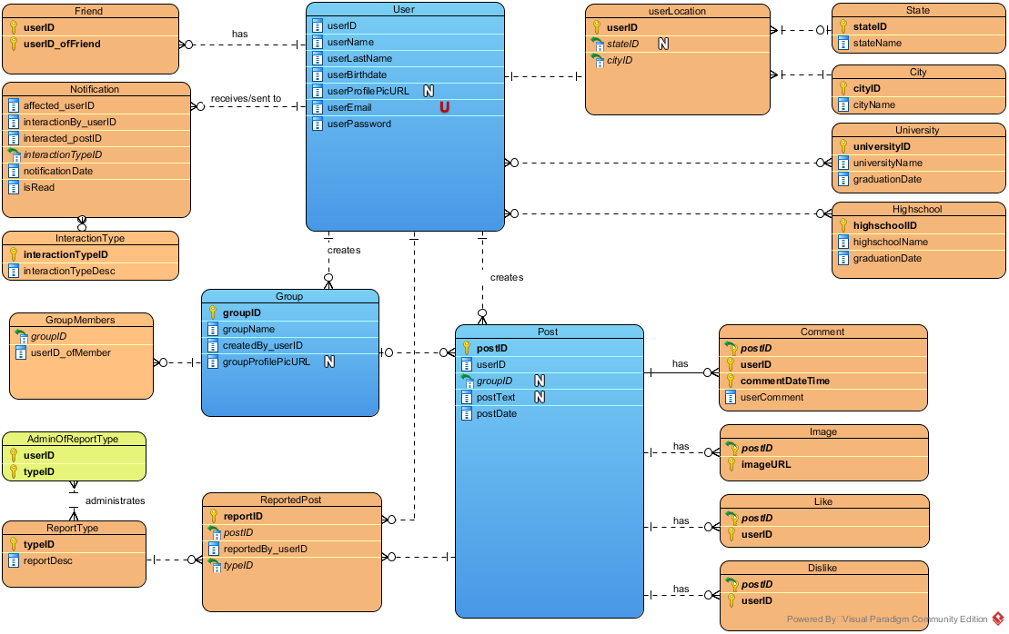
3.1 - Physical Diagram
