Lab Report 3: Path Planning

In the first lab, we designed a heading controller that adjusts the turn radius of the steering on each clock cycle to minimize the difference between the current compass heading and the desired heading. In the second lab we, needed to use the same controller to follow a course that was defined by the list of points of latitude and longitude.

In this lab, we refined things further by giving ERTS the ability to plan its path in a better way than just using GPS. By adding “synthetic” waypoints as ERTS travels the track and a “leaning point” before and after the actual waypoints, it is better guided around the corners by forcing it to lean toward the edge of the corridor and make a much wider turn. The synthetic points were defined as follows:

x1=(self.course[(self.waypoint+1)%len(self.course)][1]+7\*(self.course[(self.waypoint)%len(self.course)][1]))/8  
y1=(self.course[(self.waypoint+1)%len(self.course)][2]+7\*(self.course[(self.waypoint)%len(self.course)][2]))/8

x2=(self.course[(self.waypoint+1)%len(self.course)][1]+3\*(self.course[(self.waypoint)%len(self.course)][1]))/4  
y2=(self.course[(self.waypoint+1)%len(self.course)][2]+3\*(self.course[(self.waypoint)%len(self.course)][2]))/4

x3=(self.course[(self.waypoint)%len(self.course)][1]+(self.course[(self.waypoint+1)%len(self.course)][1]))/2  
y3=(self.course[(self.waypoint)%len(self.course)][2]+(self.course[(self.waypoint+1)%len(self.course)][2]))/2

Self.course is the array containing the track information including latitude and longitude of waypoints, waypoint radius, and maximum speed ***<\*double check to be sure\*>***. Self.waypoint is the most recent waypoint passed. Len(self.course) is the length of the corridor that ERTS is in at the time calculated using the distance formula from the coordinates from the array in self.course.

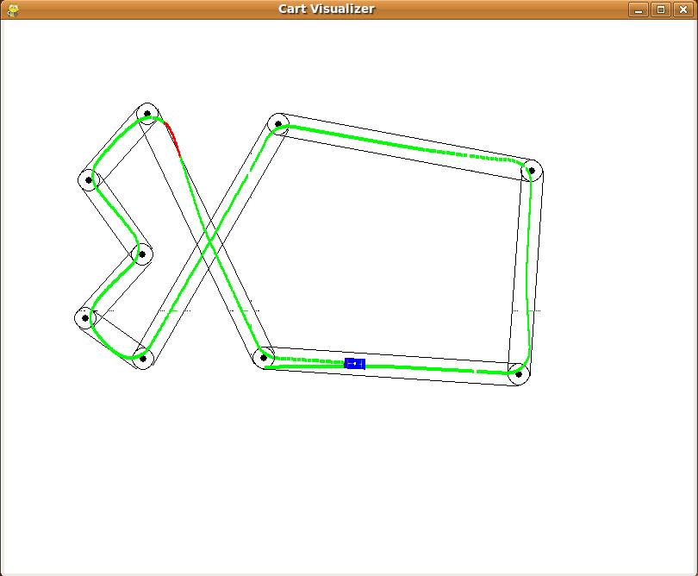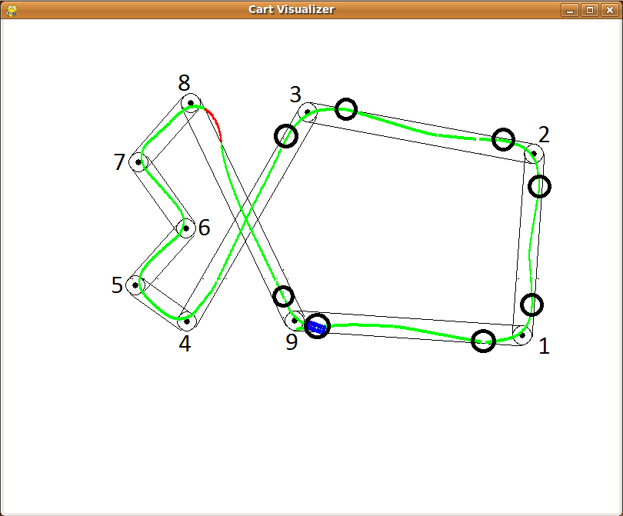

Figure 1: First run without leaning point Figure 2: Final run with leaning point

Starting from ERTS starting point on the course and following that, set 1 corresponds to turn 1, set 2 to turn 2, and set 3 to turn 3. A fourth set of synthetic points (x4 and y4) are placed at turn 9 (the final turn) using the same formula as x1 and y1. Turns 1, 2, 3, and 9 were the only turns used due to these being longer corridors with a length greater than 20 metres. It would looks as if turn 8 would need a synthetic point as well, since the corridor between turns 8 and 9 is greater than 20 metres long, but after several tries, we determined the angle of turn 8 is too acute and the turn would not be sharp enough and would send ERTS too far off track.