R_Homework5

Stacey Elmore

11/16/2021

setwd("C:/Users/elmor/OneDrive/Documents/R_HW5")  
library(readr)  
homicide <- read_csv("data/homicide-data.csv")  
#View(homicide)

* Choice 1

1. Pick one city in the data.
2. Create a map showing the locations of the homicides in that city, using the sf framework.
3. Use tigris to download boundaries for some sub-city geography (e.g., tracts, block groups, county subdivisions) to show as a layer underneath the points showing homicides.
4. Use different facets for solved versus unsolved homicides and different colors to show the three race groups with the highest number of homicides for that city (you may find the fct_lump function from forcats useful for this).

library(tidyverse)  
library(tigris)  
library(sf)  
options(tigris_class = "sf")  
options(tigris_use_cache = TRUE)  
  
  
### filter to Chicago homicides  
homicide <- homicide %>%  
 filter(city == "Chicago")   
   
homicide <- homicide %>%   
 mutate(disposition = recode(disposition,  
 'Closed by arrest' = "Solved Cases",  
 'Closed without arrest' = "Unsolved Cases",  
 'Open/No arrest' = "Unsolved Cases"))  
  
### make homocide a sf file (add spatial coordinates using NAD83)  
chi_hom <- st_as_sf(homicide, coords = c("lon", "lat")) %>%   
 st_set_crs(4269)  
  
###add chicago city boundaries  
cb <- core_based_statistical_areas(cb = TRUE)  
places <-places(state = "IL", cb = TRUE)  
chi_bound2 <-filter(places, NAME == "Chicago")  
  
road <- roads("IL", "Cook") %>%   
 filter(FULLNAME == "N Marshfield Ave")  
  
##add water and census tracts  
water <- area_water("IL", "Cook", class = "sf") %>%   
 filter(FULLNAME == "Chicago River N Br")  
water2 <- area_water("IL", "Cook", class = "sf") %>%   
 filter(FULLNAME == "Chicago River South Br")  
water3 <- area_water("IL", "Cook", class = "sf") %>%   
 filter(FULLNAME == "Chicago River North Br")  
  
##group homicide victims into race groups  
hom_groups <- fct_lump_n(chi_hom$victim_race, n = 3)   
  
ggplot() +   
 geom_sf(data = chi_bound2, color = "black", fill = NA) +  
 geom_sf(data = road, color = "darkmagenta") +  
 geom_sf(data = water, color = "darkblue") +  
 geom_sf(data = water2, color = "darkblue") +  
 geom_sf(data = water3, color = "darkblue") +  
 geom_sf(data = chi_hom, aes(color = hom_groups), alpha = .3) +  
 labs(color = "Race of Victim")+  
 facet_grid(~disposition) +  
 ggtitle("Solved and Unsolved Homicides in Chicago, Illinois")

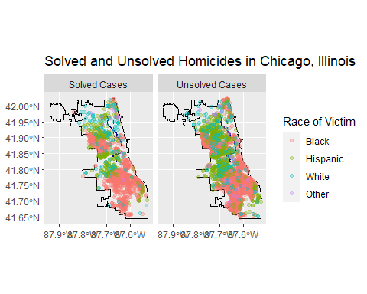

Choice 2: