**MODELO MER-E NORMALIZADO NOTACIÓN BARKER**

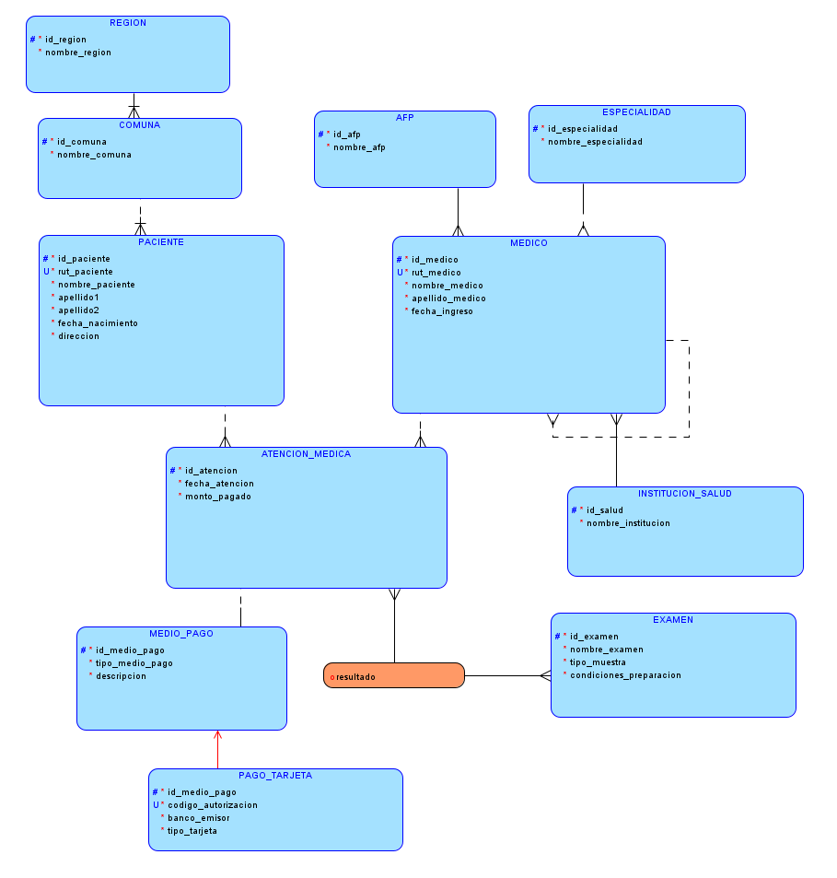

**MODELO RELACIONAL NORMALIZADO**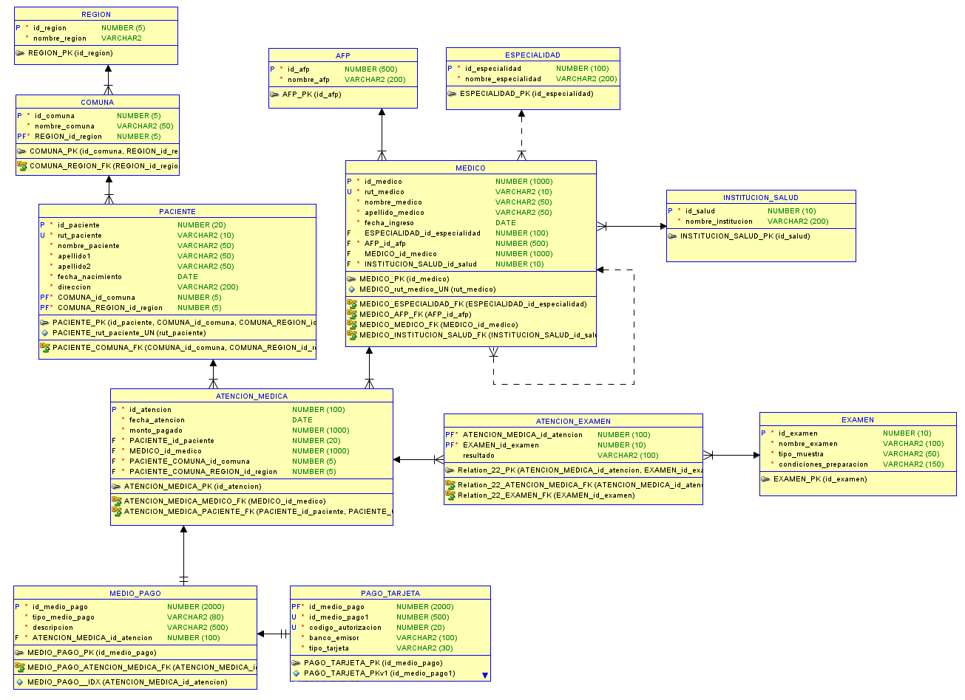

**SCRIPT DDL**

**-- Generated by Oracle SQL Developer Data Modeler 24.3.1.351.0831**

**-- at: 2025-09-10 22:22:52 CLST**

**-- site: Oracle Database 11g**

**-- type: Oracle Database 11g**

**-- predefined type, no DDL - MDSYS.SDO_GEOMETRY**

**-- predefined type, no DDL - XMLTYPE**

**CREATE TABLE AFP**

**(**

**id_afp NUMBER (500) NOT NULL ,**

**nombre_afp VARCHAR2 (200) NOT NULL**

**)**

**;**

**ALTER TABLE AFP**

**ADD CONSTRAINT AFP_PK PRIMARY KEY ( id_afp ) ;**

**CREATE TABLE ATENCION_EXAMEN**

**(**

**ATENCION_MEDICA_id_atencion NUMBER (100) NOT NULL ,**

**EXAMEN_id_examen NUMBER (10) NOT NULL ,**

**resultado VARCHAR2 (100)**

**)**

**;**

**ALTER TABLE ATENCION_EXAMEN**

**ADD CONSTRAINT Relation_22_PK PRIMARY KEY ( ATENCION_MEDICA_id_atencion, EXAMEN_id_examen ) ;**

**CREATE TABLE ATENCION_MEDICA**

**(**

**id_atencion NUMBER (100) NOT NULL ,**

**fecha_atencion DATE NOT NULL ,**

**monto_pagado NUMBER (1000) NOT NULL ,**

**PACIENTE_id_paciente NUMBER (20) NOT NULL ,**

**MEDICO_id_medico NUMBER (1000) NOT NULL ,**

**PACIENTE_COMUNA_id_comuna NUMBER (5) NOT NULL ,**

**-- ERROR: Column name length exceeds maximum allowed length(30)**

**PACIENTE_COMUNA_REGION_id_region NUMBER (5) NOT NULL**

**)**

**;**

**ALTER TABLE ATENCION_MEDICA**

**ADD CONSTRAINT ATENCION_MEDICA_PK PRIMARY KEY ( id_atencion ) ;**

**CREATE TABLE COMUNA**

**(**

**id_comuna NUMBER (5) NOT NULL ,**

**nombre_comuna VARCHAR2 (50) NOT NULL ,**

**REGION_id_region NUMBER (5) NOT NULL**

**)**

**;**

**ALTER TABLE COMUNA**

**ADD CONSTRAINT COMUNA_PK PRIMARY KEY ( id_comuna, REGION_id_region ) ;**

**CREATE TABLE ESPECIALIDAD**

**(**

**id_especialidad NUMBER (100) NOT NULL ,**

**nombre_especialidad VARCHAR2 (200) NOT NULL**

**)**

**;**

**ALTER TABLE ESPECIALIDAD**

**ADD CONSTRAINT ESPECIALIDAD_PK PRIMARY KEY ( id_especialidad ) ;**

**CREATE TABLE EXAMEN**

**(**

**id_examen NUMBER (10) NOT NULL ,**

**nombre_examen VARCHAR2 (100) NOT NULL ,**

**tipo_muestra VARCHAR2 (50) NOT NULL ,**

**condiciones_preparacion VARCHAR2 (150) NOT NULL**

**)**

**;**

**ALTER TABLE EXAMEN**

**ADD CONSTRAINT EXAMEN_PK PRIMARY KEY ( id_examen ) ;**

**CREATE TABLE INSTITUCION_SALUD**

**(**

**id_salud NUMBER (10) NOT NULL ,**

**nombre_institucion VARCHAR2 (200) NOT NULL**

**)**

**;**

**ALTER TABLE INSTITUCION_SALUD**

**ADD CONSTRAINT INSTITUCION_SALUD_PK PRIMARY KEY ( id_salud ) ;**

**CREATE TABLE MEDICO**

**(**

**id_medico NUMBER (1000) NOT NULL ,**

**rut_medico VARCHAR2 (10) NOT NULL ,**

**nombre_medico VARCHAR2 (50) NOT NULL ,**

**apellido_medico VARCHAR2 (50) NOT NULL ,**

**fecha_ingreso DATE NOT NULL ,**

**ESPECIALIDAD_id_especialidad NUMBER (100) ,**

**AFP_id_afp NUMBER (500) NOT NULL ,**

**MEDICO_id_medico NUMBER (1000) ,**

**INSTITUCION_SALUD_id_salud NUMBER (10) NOT NULL**

**)**

**;**

**ALTER TABLE MEDICO**

**ADD CONSTRAINT MEDICO_PK PRIMARY KEY ( id_medico ) ;**

**ALTER TABLE MEDICO**

**ADD CONSTRAINT MEDICO_rut_medico_UN UNIQUE ( rut_medico ) ;**

**CREATE TABLE MEDIO_PAGO**

**(**

**id_medio_pago NUMBER (2000) NOT NULL ,**

**tipo_medio_pago VARCHAR2 (80) NOT NULL ,**

**descripcion VARCHAR2 (500) NOT NULL ,**

**ATENCION_MEDICA_id_atencion NUMBER (100) NOT NULL**

**)**

**;**

**CREATE UNIQUE INDEX MEDIO_PAGO__IDX ON MEDIO_PAGO**

**(**

**ATENCION_MEDICA_id_atencion ASC**

**)**

**;**

**ALTER TABLE MEDIO_PAGO**

**ADD CONSTRAINT MEDIO_PAGO_PK PRIMARY KEY ( id_medio_pago ) ;**

**CREATE TABLE PACIENTE**

**(**

**id_paciente NUMBER (20) NOT NULL ,**

**rut_paciente VARCHAR2 (10) NOT NULL ,**

**nombre_paciente VARCHAR2 (50) NOT NULL ,**

**apellido1 VARCHAR2 (50) NOT NULL ,**

**apellido2 VARCHAR2 (50) NOT NULL ,**

**fecha_nacimiento DATE NOT NULL ,**

**direccion VARCHAR2 (200) NOT NULL ,**

**COMUNA_id_comuna NUMBER (5) NOT NULL ,**

**COMUNA_REGION_id_region NUMBER (5) NOT NULL**

**)**

**;**

**ALTER TABLE PACIENTE**

**ADD CONSTRAINT PACIENTE_PK PRIMARY KEY ( id_paciente, COMUNA_id_comuna, COMUNA_REGION_id_region ) ;**

**ALTER TABLE PACIENTE**

**ADD CONSTRAINT PACIENTE_rut_paciente_UN UNIQUE ( rut_paciente ) ;**

**CREATE TABLE PAGO_TARJETA**

**(**

**id_medio_pago NUMBER (2000) NOT NULL ,**

**id_medio_pago1 NUMBER (500) NOT NULL ,**

**codigo_autorizacion NUMBER (20) NOT NULL ,**

**banco_emisor VARCHAR2 (100) NOT NULL ,**

**tipo_tarjeta VARCHAR2 (30) NOT NULL**

**)**

**;**

**ALTER TABLE PAGO_TARJETA**

**ADD CONSTRAINT PAGO_TARJETA_PK PRIMARY KEY ( id_medio_pago ) ;**

**ALTER TABLE PAGO_TARJETA**

**ADD CONSTRAINT PAGO_TARJETA_PKv1 UNIQUE ( id_medio_pago1 ) ;**

**-- ERROR: UK name length exceeds maximum allowed length(30)**

**ALTER TABLE PAGO_TARJETA**

**ADD CONSTRAINT PAGO_TARJETA_codigo_autorizacion_UN UNIQUE ( codigo_autorizacion ) ;**

**CREATE TABLE REGION**

**(**

**id_region NUMBER (5) NOT NULL ,**

**nombre_region VARCHAR2**

**-- ERROR: VARCHAR2 size not specified**

**NOT NULL**

**)**

**;**

**ALTER TABLE REGION**

**ADD CONSTRAINT REGION_PK PRIMARY KEY ( id_region ) ;**

**ALTER TABLE ATENCION_MEDICA**

**ADD CONSTRAINT ATENCION_MEDICA_MEDICO_FK FOREIGN KEY**

**(**

**MEDICO_id_medico**

**)**

**REFERENCES MEDICO**

**(**

**id_medico**

**)**

**;**

**ALTER TABLE ATENCION_MEDICA**

**ADD CONSTRAINT ATENCION_MEDICA_PACIENTE_FK FOREIGN KEY**

**(**

**PACIENTE_id_paciente,**

**PACIENTE_COMUNA_id_comuna,**

**PACIENTE_COMUNA_REGION_id_region**

**)**

**REFERENCES PACIENTE**

**(**

**id_paciente,**

**COMUNA_id_comuna,**

**COMUNA_REGION_id_region**

**)**

**;**

**ALTER TABLE COMUNA**

**ADD CONSTRAINT COMUNA_REGION_FK FOREIGN KEY**

**(**

**REGION_id_region**

**)**

**REFERENCES REGION**

**(**

**id_region**

**)**

**;**

**ALTER TABLE MEDICO**

**ADD CONSTRAINT MEDICO_AFP_FK FOREIGN KEY**

**(**

**AFP_id_afp**

**)**

**REFERENCES AFP**

**(**

**id_afp**

**)**

**;**

**ALTER TABLE MEDICO**

**ADD CONSTRAINT MEDICO_ESPECIALIDAD_FK FOREIGN KEY**

**(**

**ESPECIALIDAD_id_especialidad**

**)**

**REFERENCES ESPECIALIDAD**

**(**

**id_especialidad**

**)**

**;**

**ALTER TABLE MEDICO**

**ADD CONSTRAINT MEDICO_INSTITUCION_SALUD_FK FOREIGN KEY**

**(**

**INSTITUCION_SALUD_id_salud**

**)**

**REFERENCES INSTITUCION_SALUD**

**(**

**id_salud**

**)**

**;**

**ALTER TABLE MEDICO**

**ADD CONSTRAINT MEDICO_MEDICO_FK FOREIGN KEY**

**(**

**MEDICO_id_medico**

**)**

**REFERENCES MEDICO**

**(**

**id_medico**

**)**

**;**

**ALTER TABLE MEDIO_PAGO**

**ADD CONSTRAINT MEDIO_PAGO_ATENCION_MEDICA_FK FOREIGN KEY**

**(**

**ATENCION_MEDICA_id_atencion**

**)**

**REFERENCES ATENCION_MEDICA**

**(**

**id_atencion**

**)**

**;**

**ALTER TABLE PACIENTE**

**ADD CONSTRAINT PACIENTE_COMUNA_FK FOREIGN KEY**

**(**

**COMUNA_id_comuna,**

**COMUNA_REGION_id_region**

**)**

**REFERENCES COMUNA**

**(**

**id_comuna,**

**REGION_id_region**

**)**

**;**

**ALTER TABLE PAGO_TARJETA**

**ADD CONSTRAINT PAGO_TARJETA_MEDIO_PAGO_FK FOREIGN KEY**

**(**

**id_medio_pago**

**)**

**REFERENCES MEDIO_PAGO**

**(**

**id_medio_pago**

**)**

**;**

**ALTER TABLE ATENCION_EXAMEN**

**ADD CONSTRAINT Relation_22_ATENCION_MEDICA_FK FOREIGN KEY**

**(**

**ATENCION_MEDICA_id_atencion**

**)**

**REFERENCES ATENCION_MEDICA**

**(**

**id_atencion**

**)**

**;**

**ALTER TABLE ATENCION_EXAMEN**

**ADD CONSTRAINT Relation_22_EXAMEN_FK FOREIGN KEY**

**(**

**EXAMEN_id_examen**

**)**

**REFERENCES EXAMEN**

**(**

**id_examen**

**)**

**;**

**-- Oracle SQL Developer Data Modeler Summary Report:**

**--**

**-- CREATE TABLE 12**

**-- CREATE INDEX 1**

**-- ALTER TABLE 28**

**-- CREATE VIEW 0**

**-- ALTER VIEW 0**

**-- CREATE PACKAGE 0**

**-- CREATE PACKAGE BODY 0**

**-- CREATE PROCEDURE 0**

**-- CREATE FUNCTION 0**

**-- CREATE TRIGGER 0**

**-- ALTER TRIGGER 0**

**-- CREATE COLLECTION TYPE 0**

**-- CREATE STRUCTURED TYPE 0**

**-- CREATE STRUCTURED TYPE BODY 0**

**-- CREATE CLUSTER 0**

**-- CREATE CONTEXT 0**

**-- CREATE DATABASE 0**

**-- CREATE DIMENSION 0**

**-- CREATE DIRECTORY 0**

**-- CREATE DISK GROUP 0**

**-- CREATE ROLE 0**

**-- CREATE ROLLBACK SEGMENT 0**

**-- CREATE SEQUENCE 0**

**-- CREATE MATERIALIZED VIEW 0**

**-- CREATE MATERIALIZED VIEW LOG 0**

**-- CREATE SYNONYM 0**

**-- CREATE TABLESPACE 0**

**-- CREATE USER 0**

**--**

**-- DROP TABLESPACE 0**

**-- DROP DATABASE 0**

**--**

**-- REDACTION POLICY 0**

**--**

**-- ORDS DROP SCHEMA 0**

**-- ORDS ENABLE SCHEMA 0**

**-- ORDS ENABLE OBJECT 0**

**--**

**-- ERRORS 3**

**-- WARNINGS 0**