**Students: Names (please update)**

*Instructions: Update this file (or recreate a similar one, e.g. in Latex) to prepare your answers to the questions. Feel free to add text, equations and figures as needed. Hand-written notes, e.g. for the development of equations, can also be included e.g. as pictures (from your cell phone or from a scanner). Please submit both the source file (*.doc) and a pdf of your document, as well as all the used and updated Matlab functions in a single zipped file called lab4_name1_name2_name3.zip where namei are the team member last names. This should be submitted on Moodle by* ***Monday April 10, midnight****. Please submit* ***only one report per team****!*

**Question 6: Modeling the lamprey CPG with phase oscillators**

**6.a** Implement a chain of N phase oscillators. Verify that the analytical approach presented in Lecture 5 correctly finds the conditions for phase locking when the chain has a gradient of different intrinsic frequencies from head to tail. See and modify chain_phase_oscil.m

Show that the analytical predictions are correct with several simulations with different parameters (for instance different number of oscillators, different gradients of frequencies, different coupling strengths). Make sure to report all the different parameters in your report.

**6.b** Investigate situations where the difference of intrinsic frequency is not constant along the spinal cord (i.e. something else than a linear decrease of frequencies in oscillators from head to tail segments). Check in particular, the intrinsic frequencies of oscillators at the extremities. Can you find other interesting behaviors in this chain of oscillators? Please illustrate and describe them.

**6.c** Let’s assume the tail of the lamprey is manually moved with a frequency of ωmech , and that the last oscillator (i.e. oscillator N) receives input from a sensory neuron (e.g. a stretch receptor) with a coupling strength of asens, as in the following equation. Investigate the behavior of the chain of oscillators (e.g. its phase lags and resulting frequencies) depending on the sensory coupling strength and the frequency of the mechanical movement. Also discuss what interesting information about the organization of motor circuits this type of experiment can help investigating when it is performed on the real animal.



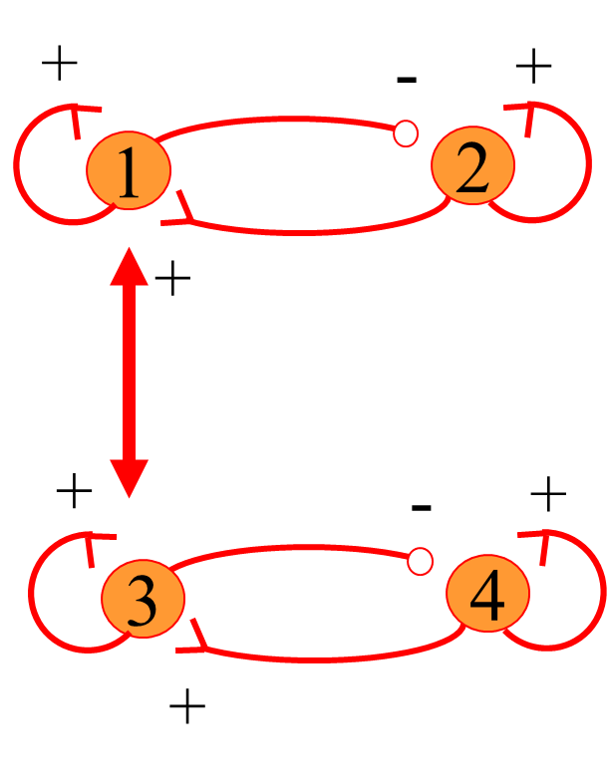**Question 7: Comparing neuronal oscillators and phase oscillators**

**7.a** Compare the synchronization mechanisms of neuronal and phase oscillators. Systems to compare: two coupled neural oscillators made of leaky-integrators (see the figure to the right, and two_neural_oscillators.m), and two coupled phase oscillators (chain_phase_oscil.m with Noscils=2). Things to compare and discuss: general behavior (for instance signal shape, phase evolution, resulting frequency, ...) and conditions for synchronization in terms of different intrinsic frequencies and coupling strengths (hint: perform multiple experiments). The intrinsic frequencies can be modified with the tau parameters of the neurons.

Discuss similarities and differences between the two types of coupled oscillators. Try to be as detailed as possible. Remarks: (1) inhibitory couplings work better than excitatory couplings; (2) do not hesitate to add inputs and outputs to the function two_neural_oscillators.m to facilitate multiple tests. (3) Feel also free to test couplings between other neurons (no obligation).

**7.b** Apply a periodic sensory input to one of the neurons (e.g. Neuron 1) such as to represent a forcing term coming from a periodic mechanical manipulation of the body (like for question 6.c). Find out and discuss the effect of such an input on the behavior of the two neural oscillators. In particular, look at resulting frequencies, and the influences of the sensory coupling and the frequency of the forcing term. Compare to what you obtained with the phase oscillators (question 6.c). If possible (**bonus**), try to make an Arnold tongue figure (see slide 81 Lecture 5), i.e. a figure showing which parameter combinations (difference of frequencies between the forcing term and the neural oscillators + strength of the sensory coupling) lead to synchronized behavior.