1. run sbt compile,package command as below:

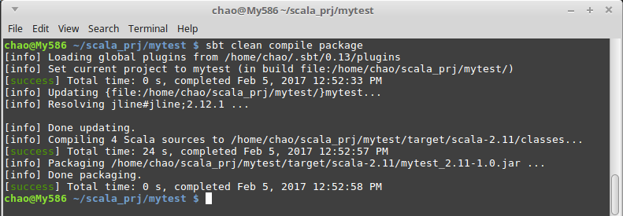
2. sbt command for running this application:
sbt run /home/chao/scala_prj/mytest/target/scala-2.11/mytest_2.11-1.0.jar testRun

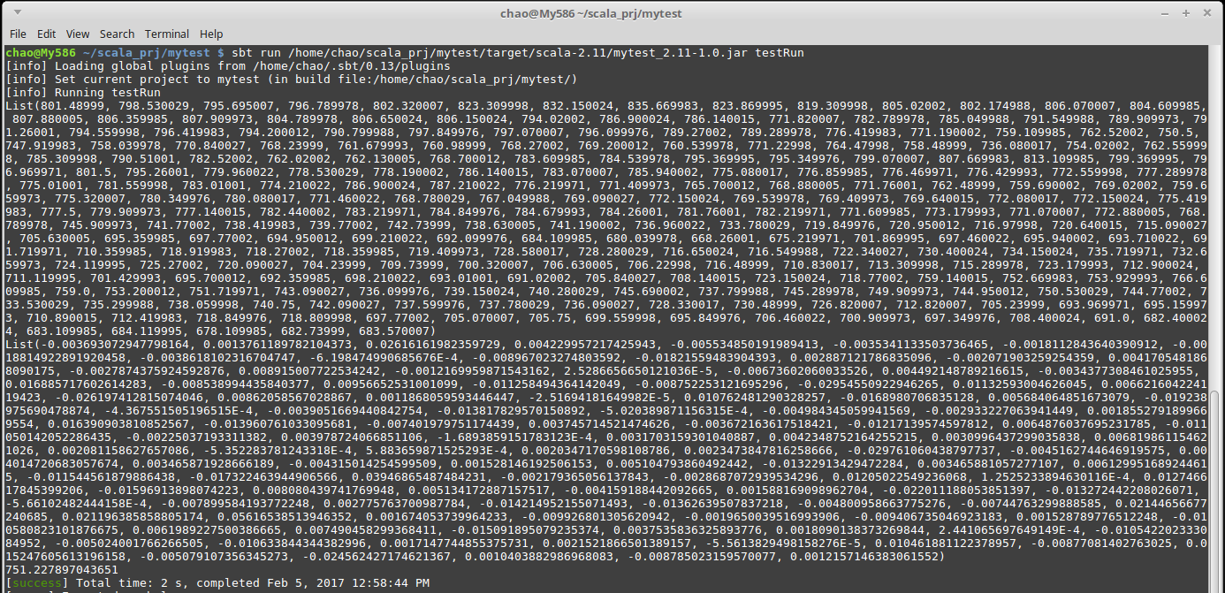
3. Github URL:

https://github.com/doglasfc/Markit-Scala-Test

