MARITIME MISSION SUPPORT SYSTEM

Technical Proposal
Prepared for:
NorthStar Maritime Services
Portfolio Project
Fictional Technical Proposal & Bid Documentation

Prepared by:
Dimple Dogra
Date:
October 2026
Field | Value
Document ID | MMSS-PROP-001
Version | 1.0
Status | Portfolio Draft
Classification | Portfolio Project

DOCUMENT CONTROL
This document is maintained as a portfolio demonstration of technical proposal development, document control, review, and technical communication practices. The proposal represents a fictional solution and does not contain customer-confidential or classified information.
Field | Value
Document Title | MMSS Technical Proposal
Document ID | MMSS-PROP-001
Version | 0.1
Status | Portfolio Draft
Author | Dimple Dogra
Project | Maritime Mission Support System
Client Scenario | NorthStar Maritime Services — Fictional

REVISION HISTORY

Version | Date | Description | Author
0.1 | October 2026 | Initial portfolio proposal draft | Dimple Dogra
Document Status: Portfolio Draft
This document is intended for portfolio demonstration purposes only.

TABLE OF CONTENTS

Table of Contents
1. Executive Summary 4
2. Proposed Technical Solution 5
2.1 Solution Overview 5
2.2 High-Level System Architecture 5
2.3 User Roles 7
2.4 Security and Access Controls 7
2.5 Operational Monitoring 7
2.6 Reporting 8
2.7 Documentation Deliverables 8
2.8 Solution Benefits 8
3 Customer Requirements 9
3.1 Requirements Response 9
4. Compliance Matrix 12
4.1 Compliance Assessment 12
4.2 Compliance Review Process 12
5. Requirements Traceability 13
5.1 Traceability Controls 13
5.2 Change Impact Assessment 13
5.3 Traceability Lifecycle 13
6. Implementation Plan 14
6.1 Implementation Phases 14
6.2 Stakeholder & SME Engagement 14
6.3 Review & Approval 15
6.4 Change Management 16
6.5 Implementation Success Criteria 16
7. Deliverables 16
8. Risks and Assumptions 17
8.2 Risks 18
9. Documentation and Training 19
9.1 Documentation Strategy 19
9.2 Documentation Audiences 19
9.3 Training Approach 19
9.4 Documentation Quality and Review 20
9.5 Maintenance and Lifecycle 20

1. Executive Summary
NorthStar Maritime Services requires a reliable and centralized solution for monitoring maritime operations, coordinating missions, and providing authorized personnel with timely operational information.
The proposed Maritime Mission Support System (MMSS) is designed to address these requirements through a centralized operational platform that brings together vessel status, mission information, secure communications, reporting, and operational monitoring.
The proposed solution provides role-based access to operational information, enabling personnel to access information according to their responsibilities. A centralized dashboard provides an overview of active vessels and mission activities, while reporting capabilities support operational analysis and decision-making.
MMSS also incorporates audit logging and monitoring capabilities to support accountability, system oversight, and operational maintenance. Supporting documentation, including user guidance, operational procedures, and system documentation, will be developed as part of the proposed solution.
The implementation approach emphasizes controlled deployment, user readiness, documentation, and ongoing support. The proposed solution is intended to provide NorthStar Maritime Services with a structured and maintainable platform that supports operational visibility while establishing clear processes for system use, monitoring, and maintenance.

2. Proposed Technical Solution

2.1 Solution Overview
The proposed Maritime Mission Support System (MMSS) will provide NorthStar Maritime Services with a centralized platform for monitoring maritime operations, coordinating mission activities, and providing authorized personnel with timely operational information.
The solution will consolidate key operational information into a centralized dashboard and provide controlled access to vessel status, mission information, communications, reporting, and system activity. The platform will use role-based access controls to ensure that users can access functions and information appropriate to their responsibilities.
The proposed solution will provide the following primary capabilities:
- Operational Dashboard — Provides a centralized view of active vessels, mission status, and operational information.
- Vessel Monitoring — Displays vessel location, status, and other relevant operational information.
- Mission Coordination — Supports the organization and monitoring of active mission activities.
- Secure Communications — Enables authorized users to exchange operational information through controlled communication channels.
- Role-Based Access Control — Restricts system functions and information according to defined user roles.
- Audit Logging — Records significant system activities to support accountability and operational review.
- Reporting — Provides operational summaries and reports to support monitoring and decision-making.
- System Monitoring — Supports monitoring of system health and operational status.
- Documentation and User Guidance — Provides procedures, user guidance, and technical documentation to support system operation and maintenance.

2.2 High-Level System Architecture
The proposed architecture will use a centralized application platform connected to operational data sources and supporting services.
At a high level, the solution will consist of the following components:
- User Access Layer — Authorized personnel access the system through approved user interfaces.
- Application Layer — The MMSS application processes user requests and provides operational functions.
- Data Layer — Operational information is stored and managed within controlled data repositories.
- Communication Services — Secure communication services support authorized operational communications.
- Monitoring and Audit Services — System activity and operational events are monitored and recorded.
- Reporting Services — Operational data is used to generate reports and summaries.
A detailed architecture diagram will be developed as part of the technical proposal to illustrate the relationship between these components.
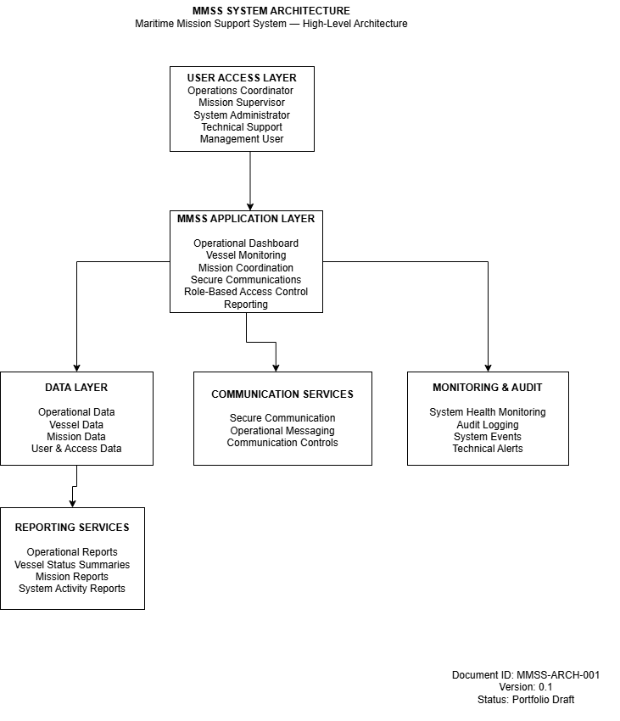
Figure 1. MMSS System Architecture — High-Level Architecture

2.3 User Roles
The system will support role-based access to ensure that users receive only the functions and information required for their responsibilities.

User Role | Primary Responsibilities
Operations Coordinator | Monitor active missions and coordinate operational activities
Mission Supervisor | Review mission status, operational information, and reports
System Administrator | Manage system configuration, users, permissions, and maintenance
Technical Support | Monitor system health and investigate technical issues
Management User | Review operational summaries and reports

2.4 Security and Access Controls
Security will be incorporated into the solution through controlled authentication, role-based authorization, audit logging, and defined administrative procedures.
Access permissions will be assigned according to established user roles. Significant system activities will be recorded in audit logs to support accountability, troubleshooting, and operational review.
Administrative procedures will define processes for user provisioning, access changes, account removal, system maintenance, and review of system activity.

2.5 Operational Monitoring
The MMSS solution will provide monitoring capabilities to support system availability and operational awareness.
Monitoring activities will include:
- System availability monitoring
- Application health monitoring
- Identification of operational errors
- Review of significant system events
- Maintenance status tracking
- Escalation of identified technical issues
Monitoring procedures will define the expected response when an issue is identified and will provide technical support personnel with a consistent troubleshooting and escalation process.

2.6 Reporting
The reporting capability will provide authorized personnel with operational information in a structured format.
Reports may include:
- Active mission summaries
- Vessel status summaries
- Operational activity reports
- System activity and audit reports
- Maintenance and system-health reports
Reporting requirements will be reviewed during implementation to determine the appropriate report formats, data sources, frequency, and access permissions.

2.7 Documentation Deliverables
Documentation will be developed alongside the technical solution rather than after implementation.
The documentation set will include:
- User Guide
- System Administration Guide
- Technical/System Documentation
- Operational Procedures
- Troubleshooting Guide
- Maintenance Procedures
- Quick Reference Guide
- Release and Change Documentation
Documentation will follow standardized templates and controlled revision practices to improve consistency, traceability, and maintainability.

2.8 Solution Benefits
The proposed MMSS solution is intended to provide the following benefits:
- Centralized access to operational information
- Improved visibility of active maritime activities
- Controlled access to system information and functions
- Improved consistency in operational procedures
- Better traceability through audit logging
- Structured reporting for operational decision-making
- Clear documentation for users and technical personnel
- Repeatable monitoring and maintenance processes
- A maintainable documentation framework that can evolve with future system changes

3 Customer Requirements
NorthStar Maritime Services has identified a set of operational and technical requirements for the proposed Maritime Mission Support System. The following requirements provide the basis for the proposed solution and establish the criteria used to evaluate solution capabilities, implementation activities, and supporting documentation.

Requirement ID | Requirement | Priority | Acceptance Criteria
MMSS-001 | Centralized operational dashboard | High | Authorized users can view current operational information from a centralized dashboard.
MMSS-002 | Vessel monitoring | High | Authorized users can view vessel status and relevant operational information.
MMSS-003 | Mission coordination | High | Users can monitor and coordinate active mission activities.
MMSS-004 | Secure communications | High | Authorized users can exchange operational information through controlled communication channels.
MMSS-005 | Role-based access control | High | User access is restricted according to assigned roles and permissions.
MMSS-006 | Audit logging | Medium | Significant system activities are recorded and available for authorized review.
MMSS-007 | Operational reporting | Medium | Authorized users can generate or access required operational reports and summaries.
MMSS-008 | System monitoring | Medium | System health and significant technical events can be monitored and reported.

3.1 Requirements Response
The proposed MMSS solution has been designed to address the identified operational requirements through a combination of application capabilities, controlled access, monitoring, reporting, and supporting documentation. The following sections describe how the proposed solution responds to each requirement.
MMSS-001 — Centralized Operational Dashboard
Proposed Response: The MMSS operational dashboard will provide authorized users with a centralized view of active vessels, mission status, and relevant operational information.
Acceptance: The dashboard will be reviewed during validation to confirm that authorized users can access the required operational information from a centralized interface.

MMSS-002 — Vessel Monitoring
Proposed Response: The vessel monitoring capability will provide authorized users with vessel status and relevant operational information to support operational awareness and decision-making.
Acceptance: Validation will confirm that authorized users can access the required vessel information and status indicators.

MMSS-003 — Mission Coordination
Proposed Response: The mission coordination capability will support the organization and monitoring of active mission activities, providing authorized users with a structured view of mission status and related operational information.
Acceptance: Validation will confirm that authorized users can monitor active missions and access the information required to support coordination activities.

MMSS-004 — Secure Communications
Proposed Response: The secure communications capability will enable authorized users to exchange operational information through controlled communication channels.
Acceptance: Validation will confirm that authorized users can access the approved communication functions and that communication controls operate as defined.

MMSS-005 — Role-Based Access Control
Proposed Response: Role-based access controls will restrict system functions and information according to defined user roles and responsibilities.
Acceptance: Validation will confirm that users can access only the functions and information permitted by their assigned roles.

MMSS-006 — Audit Logging
Proposed Response: The MMSS solution will record significant system activities through audit logging to support accountability, troubleshooting, security review, and operational oversight.
Acceptance: Validation will confirm that defined system activities are recorded and available for authorized review.

MMSS-007 — Operational Reporting
Proposed Response: The reporting capability will provide authorized users with structured operational summaries and reports to support monitoring, analysis, and decision-making.
Acceptance: Validation will confirm that authorized users can access the required operational reports and that report access follows defined permissions.

MMSS-008 — System Monitoring
Proposed Response: System monitoring capabilities will support monitoring of application health, system availability, significant technical events, and identified operational issues.
Acceptance: Validation will confirm that defined system-health indicators and significant technical events can be monitored and that identified issues can be escalated according to established procedures.

4. Compliance Matrix
The compliance matrix provides a structured assessment of the proposed MMSS solution against the identified customer requirements. Each requirement is mapped to the corresponding solution response and a proposed verification method. The matrix is intended to support review, evaluation, and traceability throughout the proposal and implementation lifecycle.

Requirement ID | Customer Requirement | Compliance Status | Proposal Reference | Verification Method
MMSS-001 | Centralized operational dashboard | Compliant | Section 2.1 | Demonstration and validation
MMSS-002 | Vessel monitoring | Compliant | Section 2.1 | Functional validation
MMSS-003 | Mission coordination | Compliant | Section 2.1 | Scenario-based testing
MMSS-004 | Secure communications | Compliant | Section 2.1 | Functional and security validation
MMSS-005 | Role-based access control | Compliant | Section 2.4 | Access-control testing
MMSS-006 | Audit logging | Compliant | Section 2.4 | Log review and validation
MMSS-007 | Operational reporting | Compliant | Section 2.6 | Report validation
MMSS-008 | System monitoring | Compliant | Section 2.5 | Monitoring validation

4.1 Compliance Assessment
The proposed MMSS solution addresses all identified customer requirements within the scope of this portfolio proposal. Compliance is based on the proposed capabilities and documented solution approach described in this document. Final compliance would be confirmed through detailed requirements validation, testing, customer review, and formal acceptance during implementation.

4.2 Compliance Review Process
Compliance will be reviewed throughout the proposal and implementation lifecycle. Requirements will be reviewed during solution design, verified during testing and validation, and confirmed through customer review and acceptance. Any requirement changes identified during the lifecycle will be assessed for impact and incorporated into the requirements traceability and change-control process.

5. Requirements Traceability
Requirements traceability provides a structured relationship between customer requirements, proposed solution components, documentation deliverables, and verification activities. The traceability approach supports controlled review and helps ensure that requirements remain visible throughout the solution lifecycle.

Requirement ID | Customer Requirement | Solution Component | Deliverable | Verification Method
MMSS-001 | Centralized operational dashboard | Operational Dashboard | User Guide | Demonstration
MMSS-002 | Vessel monitoring | Vessel Monitoring | User Guide | Functional Testing
MMSS-003 | Mission coordination | Mission Coordination | Operational Procedures | Scenario Testing
MMSS-004 | Secure communications | Communication Services | System Documentation | Security Validation
MMSS-005 | Role-based access control | Access Control | Administration Guide | Access-Control Testing
MMSS-006 | Audit logging | Monitoring and Audit Services | Technical Documentation | Log Review
MMSS-007 | Operational reporting | Reporting Services | Reporting Guide | Report Validation
MMSS-008 | System monitoring | Monitoring and Audit Services | Troubleshooting Guide | Monitoring Validation

5.1 Traceability Controls
Requirements will be assigned unique identifiers and maintained throughout the proposal and implementation lifecycle. Each requirement will be linked to the relevant solution component, documentation deliverable, and verification activity. Changes to requirements will be reviewed for potential impact on design, documentation, testing, schedule, and acceptance.

5.2 Change Impact Assessment
Proposed changes to customer requirements will be evaluated before implementation. The assessment will consider affected solution components, documentation, testing activities, implementation activities, dependencies, and delivery timelines. Approved changes will be incorporated into the appropriate controlled project documentation.

5.3 Traceability Lifecycle
Requirements traceability will be maintained from initial requirements definition through solution design, implementation, testing, documentation, customer review, and final acceptance. This approach provides visibility into requirement status and supports controlled change management throughout the project lifecycle.

6. Implementation Plan
The proposed implementation approach uses a phased delivery model designed to support controlled planning, solution development, validation, documentation, training, deployment, and transition to ongoing support. Each phase includes defined activities, review points, and deliverables to support visibility and controlled progression through the implementation lifecycle.

6.1 Implementation Phases

Phase | Primary Activities | Key Deliverables | Review / Exit Criteria
1. Initiation & Requirements | Confirm scope, stakeholders, requirements, assumptions, and constraints | Project initiation documentation; confirmed requirements | Requirements reviewed and approved
2. Solution Design | Develop solution architecture, workflows, security approach, and detailed design | Architecture documentation; design specifications | Design reviewed and accepted
3. Configuration & Development | Configure and develop solution capabilities | Configured application components | Development objectives completed
4. Testing & Validation | Conduct functional, security, integration, and user validation | Test results; issue records | Test objectives achieved
5. Documentation & Training | Develop user, technical, operational, and training materials | Documentation set; training materials | Documentation reviewed and approved
6. Deployment & Readiness | Prepare production environment, users, procedures, and support processes | Deployment package; readiness checklist | Deployment readiness confirmed
7. Transition & Support | Transition to operational support and monitor initial operation | Support procedures; transition records | Operational transition completed

6.2 Stakeholder & SME Engagement
Implementation activities will involve collaboration with customer representatives, technical SMEs, operational users, project stakeholders, and documentation reviewers. SME engagement will be used to validate requirements, confirm technical information, review documentation, identify gaps, and support acceptance activities.
Review responsibilities will be defined for each major deliverable to ensure that technical accuracy, operational suitability, documentation quality, and customer expectations are addressed before approval.

6.3 Review & Approval
Project documentation will follow a controlled review and approval process. Documents will progress through drafting, technical review, SME review, editorial and quality review, customer review, formal approval, and controlled release.
Review comments and requested changes will be tracked and incorporated before final approval. Approved documents will be issued through the applicable document-control process.

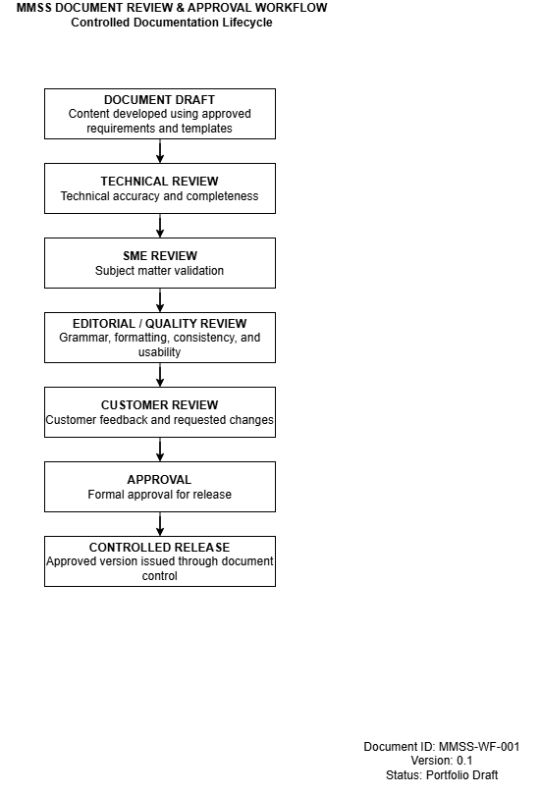
Figure 2. MMSS Document Review & Approval Workflow

6.4 Change Management
Changes to approved requirements, solution components, documentation, or implementation activities will be assessed through a controlled change-management process. Each proposed change will be reviewed for impact on scope, schedule, dependencies, testing, documentation, and acceptance.
Approved changes will be incorporated into the appropriate project documentation and communicated to affected stakeholders.

6.5 Implementation Success Criteria
Implementation success will be evaluated based on completion of approved requirements, successful validation and testing, completion and approval of required documentation, user readiness, deployment readiness, and successful transition to ongoing operational support.

7. Deliverables
The proposed MMSS deliverables include technical, operational, project, training, and supporting documentation required to support implementation, validation, deployment, and ongoing system use. Each deliverable will be subject to the applicable review, approval, and document-control processes.

Deliverable ID | Deliverable | Category | Primary Audience | Review / Approval
DOC-001 | Project Initiation Documentation | Project | Customer / Project Team | Customer Review
DOC-002 | Requirements Documentation | Requirements | Customer / SMEs | Requirements Approval
DOC-003 | System Architecture Documentation | Technical | Technical SMEs / Support | Technical Review
DOC-004 | Solution Design Documentation | Technical | Technical SMEs | Design Review
DOC-005 | User Guide | User Documentation | Operational Users | SME / Customer Review
DOC-006 | Administration Guide | Technical Documentation | System Administrators | Technical Review
DOC-007 | Operational Procedures | Operational Documentation | Operations Staff | SME / Customer Review
DOC-008 | Technical Documentation | Technical Documentation | Technical Support | Technical Review
DOC-009 | API Documentation | Technical Documentation | Developers / Technical Support | Technical Review
DOC-010 | Troubleshooting Guide | Support Documentation | Technical Support | Technical Review
DOC-011 | Test Documentation | Validation | Project / QA Team | Test Review
DOC-012 | Training Materials | Training | End Users / Administrators | SME Review
DOC-013 | Deployment & Readiness Checklist | Deployment | Project / Operations | Readiness Approval
DOC-014 | Support Procedures | Support | Technical Support | Support Review
DOC-015 | Release Documentation | Release | Customer / Project Team | Release Approval
DOC-016 | Document Control Register | Document Control | Project / Document Control | Document Control Review

8. Risks and Assumptions
Successful implementation of the MMSS solution depends on defined assumptions, managed risks, stakeholder participation, and timely resolution of issues. The following risks and assumptions provide a structured basis for planning, monitoring, and decision-making throughout the implementation lifecycle.

Assumption ID | Assumption | Impact if Not Met
ASM-001 | Customer stakeholders will be available to participate in requirements and review activities. | Requirements or approvals may be delayed.
ASM-002 | Required technical and operational information will be available to the project team. | Solution design and documentation may be affected.
ASM-003 | Required infrastructure and system environments will be available according to the implementation schedule. | Development, testing, or deployment may be delayed.
ASM-004 | Subject matter experts will provide timely technical and operational validation. | Documentation or solution decisions may remain unresolved.
ASM-005 | Users will participate in training and readiness activities. | User adoption and operational readiness may be affected.
ASM-006 | Approved requirements will remain sufficiently stable during implementation. | Changes may affect scope, schedule, testing, and documentation.
ASM-007 | Required security and access-control decisions will be available before deployment. | Deployment or authorization activities may be delayed.

8.2 Risks

Risk ID | Risk | Likelihood | Impact | Mitigation
RSK-001 | Requirements may change during implementation. | Medium | High | Apply controlled requirements and change management.
RSK-002 | SME availability may be limited. | Medium | Medium | Schedule reviews in advance and identify alternate reviewers.
RSK-003 | Technical dependencies may affect implementation activities. | Medium | High | Identify dependencies early and monitor them throughout delivery.
RSK-004 | Integration or configuration issues may delay testing. | Medium | High | Conduct incremental testing and track issues through resolution.
RSK-005 | Documentation may require additional review cycles. | Medium | Medium | Use defined review stages and maintain review comments and actions.
RSK-006 | User readiness may not meet deployment expectations. | Low | High | Provide training, user guidance, and readiness checks before deployment.
RSK-007 | Security or access-control requirements may change. | Low | High | Review security requirements throughout design, testing, and deployment.
RSK-008 | Deployment activities may be affected by environmental constraints. | Low | Medium | Confirm deployment prerequisites and maintain a readiness checklist.

9. Documentation and Training
Documentation and training will be developed as an integrated part of the MMSS implementation. The documentation strategy is intended to provide users, administrators, technical support personnel, and other stakeholders with accurate and accessible information throughout the system lifecycle.

9.1 Documentation Strategy
Documentation will be developed according to the needs of each audience and the activities required throughout the implementation lifecycle. Content will be structured to support task completion, system administration, troubleshooting, technical maintenance, and operational understanding.
Documentation will be reviewed by appropriate subject matter experts and stakeholders before approval and controlled release. Approved documentation will be maintained through the applicable document-control process.

9.2 Documentation Audiences

Audience | Documentation Needs | Example Deliverables
Operational Users | Task procedures, system use, operational workflows | User Guide, Operational Procedures
Mission Supervisors | Operational information, reporting, mission workflows | User Guide, Reporting Guide
System Administrators | Configuration, user management, access controls | Administration Guide
Technical Support | Troubleshooting, system behaviour, technical procedures | Technical Documentation, Troubleshooting Guide
Developers / Technical SMEs | APIs, interfaces, technical architecture | API Documentation, System Documentation
Management | Operational summaries and system-level information | Reports, System Documentation

9.3 Training Approach
Training will be aligned with user responsibilities and system access. Operational users will receive task-focused training covering common workflows and system functions. Administrators and technical support personnel will receive additional training covering configuration, access management, troubleshooting, monitoring, and support procedures.
Training materials will be developed using approved documentation and validated with appropriate subject matter experts before delivery.

9.4 Documentation Quality and Review
Documentation will be reviewed for technical accuracy, completeness, clarity, consistency, usability, formatting, and alignment with approved requirements. Review comments will be tracked and resolved before formal approval.
Documentation quality activities will include technical review, SME validation, editorial review, customer review, and controlled release. Changes to approved documentation will be managed through the applicable change-control process.

9.5 Maintenance and Lifecycle
Documentation will be maintained throughout the operational lifecycle of the solution. Updates may be required when system capabilities, procedures, security controls, user responsibilities, or operational requirements change.
Documentation updates will follow the applicable review, approval, version-control, and release processes to ensure that users have access to current and approved information.

