UAS Safety & Risk Assessment
SORA 2.5 Assignment

Step 1: Proposed Operation / Concept of Operations (ConOps)
What is the operation trying to achieve?
Bison monitoring.
Where will you operate? Define the intended Flight Geography.
Operation will take place at Ditlevsdal Bison Farm, Tokkerodvej 24, 5462 Morud, Denmark, over the bison-monitoring area.
What is the maximum operating height?
Maximum Operational Volume height is assumed to be 120 m AGL.
Which UAS will you use?
An EagleNXT eBee X drone equipped with a camera.

SORA semantic model map
Show the Flight Geography, Contingency Volume, Ground Risk Buffer and Adjacent Area. Add the main height limit as a note.
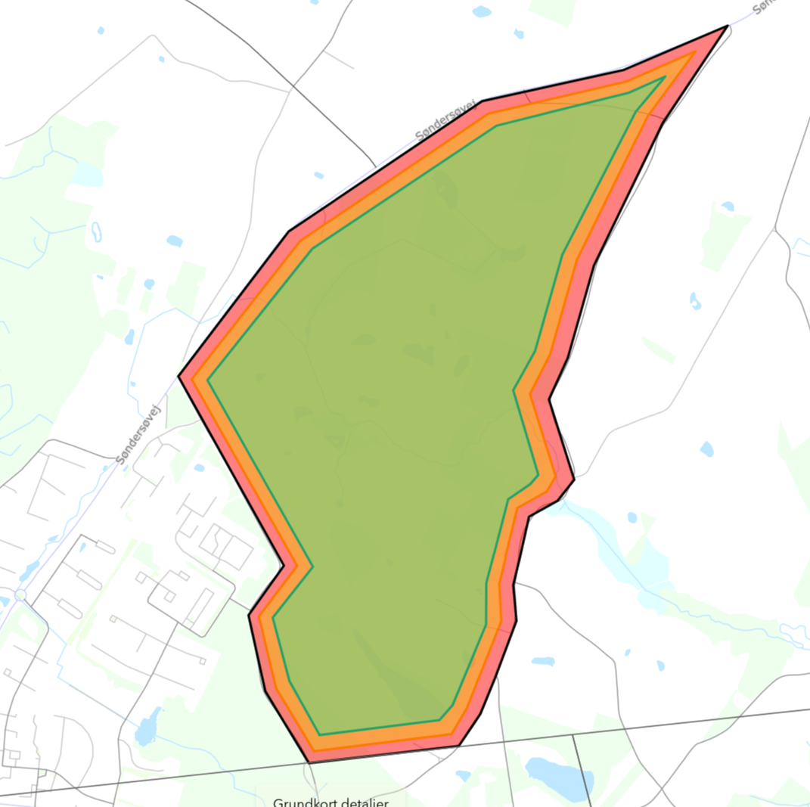
Ground risk buffer is 50m, contingency volume is 70m witch together gives us 120m. Main max height limit is 120m AGL
Step 2: Intrinsic Ground Risk Class (iGRC)
What is the highest population density within the iGRC footprint?
Assumed highest population from obtained data in the iGRC footprint is: <500 people/km².
What is the maximum speed of the UAS?
Assumed maximum commanded airspeed: 30 m/s, using the upper published cruise speed.
What is the maximum characteristic dimension of the UAS?
Maximum characteristic dimension: wingspan 1.16 m.
What is the resulting iGRC?
iGRC = 5, using the 3 m / 35 m/s and <500 people/km² .

Step 3: Final Ground Risk Class (GRC)
Which ground-risk mitigations are genuinely applicable? Add a short justification or supporting evidence.
Mitigation | Applicable? | Why / supporting evidence?
M1(A)  Strategic mitigation - sheltering | 0 | Not claimed
M1(B)  Strategic mitigation - operational restrictions | 0 | Not claimed
M1(C)  Tactical mitigation - ground observation | 0 | Not claimed
M2  Reduced effects of UA impact dynamics | -2 | Based on the eBee X EASA Design Verification Report.
For this exercise, you can state your assumed robustness rather than working through Annex B in detail. Apply any claimed credits in the sequence given in SORA Table 5.
What is the final GRC after the applicable mitigations?
GRC = 5 − 0 − 0 − 0 − 2 = 3

Step 4: Initial Air Risk Class (iARC)
Which initial ARC applies to the Operational Volume, and why?
ARC-c: Because operation space is located in controled airspace.
Are there any relevant NOTAMs, temporary restrictions or special airspace constraints?
Location is under controled airspace by airport by EKR25 so ewery aery operations needs to be discussed with airport.
Step 5: Strategic Mitigations and Residual ARC
Which strategic mitigation(s) could reduce the air encounter rate?
Limit the Operational Volume to 120 m AGL and the defined area. Obtain required coordination/permission from the responsible authorities.
What is the residual ARC after those mitigations?
ARC-b.

Step 6: Tactical Mitigation Performance Requirement (TMPR)
What TMPR level and robustness follow from your residual ARC?
Residual ARC-b: Low TMPR, Low robustness.
ARC-a | ARC-b | ARC-c | ARC-d
No requirement | Low | Medium | High
In one or two sentences, what would you use to detect and respond to manned traffic during the BVLOS flight?
Assume trained airspace observers with suitable coverage and direct pilot communication, supplemented by ADS-B/traffic information.
Step 7: Specific Assurance and Integrity Level (SAIL)
Final GRC:
3
Residual ARC:
ARC-b
Resulting SAIL:
II

Step 8: Containment Requirements
What is the lateral size of the Adjacent Area?
30 m/s × 180 s = 5,400 m = 5.4 km outward from the Operational Volume, using the assumed maximum speed.
What population / assembly-of-people limits are relevant in the Adjacent Area?
Average density <5,000 people/km² between the ground risk buffer and adjacent-area outer boundary.
What containment robustness is required?
LOW for SAIL II

Step 9: Operational Safety Objectives (OSOs)
Use SORA Table 14 to enter the required level (NR / L / M / H). For each OSO that is required, give one short example of how you would implement it or what evidence you would keep. A few words are enough. Basis: SAIL II from Step 7; examples below describe proposed evidence.
OSO | Short description | Level | Implementation / evidence example
#01 | Operator competence / proven organisation | L | Documented responsibilities, operating procedures and operator declaration of competence.
#02 | UAS manufactured by competent/proven entity | NR | Not required at SAIL II.
#03 | UAS maintained by competent/proven entity | L | Maintenance instructions, personnel training and maintenance records.
#04 | Safety-essential components designed to an ADS | NR | Not required at SAIL II.
#05 | System safety and reliability considered in the design | NR | Not required at SAIL II; review Annex E guidance if novel or complex design features apply.
#06 | C3 link characteristics appropriate for the operation | L | Link coverage assessment and lost-link procedure
#07 | Conformity check of the UAS configuration | L | Documented aircraft/configuration conformity checks and records.
#08 | Operational procedures defined, validated and followed | M | Normal, contingency and emergency procedures; validation through representative flight tests or simulation, with results recorded.
#09 | Remote crew trained and current | L | Training syllabus, competency assessments and currency records.
#13 | External services adequate for the operation | L | Service performance requirements, provider evidence and outage procedures.
#16 | Multi-crew coordination | L | Defined crew roles, communication procedures and coordination training records.
#17 | Remote crew fit to operate | L | Documented fitness policy, crew declarations and preflight fitness checks.
#18 | Automatic flight-envelope protection from human error | NR | Not required at SAIL II.
#19 | Safe recovery from human error | NR | Not required at SAIL II.
#20 | Human factors / HMI evaluation | L | Manufacturer HMI evaluation covering interface, alerts and workload for the intended operation.
#23 | Environmental limits defined, measurable and followed | L | Documented weather limits, measurement methods and recorded go/no-go checks.
#24 | UAS qualified for adverse environmental conditions | NR | Not required at SAIL II.

Step 10: Comprehensive Safety Portfolio (CSP)
In 4-6 bullets, what would you include in the final CSP?

- Final ConOps, maps, aircraft configuration and operating limits.
- confirmation from airport for operation.
- Ground/air-risk assessments, mitigation claims and their claimed robustness.
- Supporting evidence: manuals, procedures, training, maintenance and validation records.

