An Analysis of Global and Regional Mainstreaminess
for Personalized Music Recommender Systems
Schedl & Bauer (2018) - Study Review & Python Implementation
Report 1 - Academic Paper
Recommender Systems (COME424/1)
Dr. Ogr. Uyesi Gamze Uslu
Uskudar University - Department of Computer Engineering - 2026
Name | Student ID
Dogukan Aydin | 240200019
Elif Dalmis | 230201082
Yaman Balci | 220201081
Salih Cetin | 220201060
Alperen Keskin | 230201094

Abstract
This report presents a study review and Python implementation of the mainstreaminess framework proposed by Schedl & Bauer (2018). Mainstreaminess quantifies the degree to which a user's music listening preferences align with those of the broader population, measured at both global and country-specific levels. We implement all 11 mainstreaminess measures across three methodological families - Fraction-based (F), KL-Divergence (D), and Kendall tau rank correlation (C) - using the real Last.fm 360K dataset (489 users, 81 artists, 12 countries). Building on the paper's analytical framework, we introduce a recommendation system that maps each user's mainstreaminess level (Low/Mid/High) to a personalised recommendation strategy (local/mixed/global). The proposed method is evaluated against three baselines - Popularity, User-KNN (k=10), and SVD (20 factors) - using Novelty and Personalization metrics. Results show that the proposed method achieves Novelty=1.000 and Personalization=0.335 on real Last.fm data, demonstrating the value of cultural context in music recommendation.

1. Introduction
Music recommendation systems have become a critical component of modern streaming platforms, yet most systems rely on global popularity signals that fail to capture the cultural diversity of user preferences. A listener in Finland may consider Nightwish or CMX mainstream within their cultural context, while these artists are virtually unknown in the global top charts. Similarly, a Turkish user's mainstream experience is shaped by Duman and Grup Yorum rather than the globally dominant Radiohead or Metallica.
Schedl & Bauer (2018) address this limitation by introducing the concept of mainstreaminess - a formal measure of how closely a user's listening behaviour aligns with the broader population, computed at both global and country-specific levels. The paper proposes 11 distinct measures across three methodological families and evaluates them on the large-scale LFM-1b dataset. A key contribution is the AF-ILF weighting scheme, adapted from the TF-IDF information retrieval framework, which penalises globally ubiquitous artists and allows country-specific mainstream artists to emerge.
In this project, we replicate the paper's analytical framework using the real Last.fm 360K dataset and extend it with a complete recommendation system and quantitative evaluation. Four recommendation methods are implemented and compared: a Popularity Baseline, User-KNN collaborative filtering, SVD matrix factorisation, and the proposed Mainstreaminess-based approach. We evaluate all methods using Novelty (fraction of unheard recommendations) and Personalization (mean pairwise Jaccard distance), providing the quantitative comparison that the original paper does not include.
The remainder of this report is structured as follows: Section 2 reviews related work; Section 3 describes the proposed approach; Section 4 covers the experimental setup; Section 5 presents and analyses the results; Section 6 concludes.

2. Related Work
2.1 Mainstreaminess in Music Recommendation
The concept of mainstreaminess in music recommendation was first formally introduced by Schedl & Bauer (2017a) and expanded in subsequent work (Schedl & Bauer 2017b; Bauer & Schedl 2019). The framework defines mainstreaminess through comparison of a user's preference profile against a reference population profile at global or country level. Earlier work by Vigliensoni & Fujinaga (2016) showed that demographic and contextual features can improve recommendation quality, motivating the country-specific dimension of the Schedl & Bauer approach.
2.2 AF-ILF Weighting
The AF-ILF weighting scheme is directly inspired by TF-IDF (Salton & McGill, 1983), a foundational technique in information retrieval. In the music domain, Artist Frequency (AF) plays the role of Term Frequency, and Inverse Listener Frequency (ILF) plays the role of Inverse Document Frequency. The ILF term penalises artists who are listened to by a large fraction of the global user base, amplifying the signal of artists that are popular locally but not globally. This is mathematically equivalent to the IDF penalty applied to common words in document retrieval.
2.3 Collaborative Filtering Baselines
User-based K-Nearest Neighbours (KNN) collaborative filtering (Resnick et al., 1994) recommends items by aggregating the preferences of similar users. SVD-based matrix factorisation (Koren et al., 2009) decomposes the user-item interaction matrix into latent factors, enabling generalisation beyond observed interactions. Both methods serve as standard baselines in recommender systems research and are included in our evaluation to contextualise the performance of the mainstreaminess-based approach.
2.4 Evaluation Metrics
Novelty - the fraction of recommended items the user has not previously consumed - is a standard beyond-accuracy metric (Celma, 2010). Personalization, measured as mean pairwise Jaccard distance between users' recommendation lists, quantifies recommendation diversity across the user population. Both metrics complement accuracy-based measures by evaluating the practical utility of a recommendation system for discovery and individual relevance.

3. Proposed Approach
3.1 Mainstreaminess Measures
We implement all 11 mainstreaminess measures from Schedl & Bauer (2018), organised into three families:
# | Measure | Formula / Method | Scope
1 | Fg:AF,u:AF | Fraction, global AF vs user AF | Global
2 | Fg:AF,u:AF-ILF | Fraction, global AF vs user AF-ILF | Global
3 | Fg:AF-ILF,u:AF-ILF | Fraction, global AF-ILF vs user AF-ILF | Global
4 | Fc:AF,u:AF | Fraction, country AF vs user AF | Country
5 | Fc:AF-ILF,u:AF-ILF | Fraction, country AF-ILF vs user AF-ILF | Country
6 | Dg:AF,u:AF | Sym. KL Divergence, global AF | Global
7 | Dc:AF,u:AF | Sym. KL Divergence, country AF | Country
8 | Dc:AF-ILF,u:AF-ILF | Sym. KL Divergence, country AF-ILF | Country
9 | Cg:AF,u:AF | Kendall tau, global AF | Global
10 | Cc:AF,u:AF | Kendall tau, country AF (best performer) | Country
11 | Cc:AF-ILF,u:AF-ILF | Kendall tau, country AF-ILF | Country
Table 1. The 11 mainstreaminess measures implemented in this project.
3.2 AF-ILF Formula
The core weighting formula (Paper Equation 1) is:
AF-ILF(a, U1, U2) = log(1 + AF(a, U1)) x log(1 + |U2| / LF(a, U2))
where AF(a,U1) is the total playcount of artist a among users U1, LF(a,U2) is the number of distinct listeners in U2, and |U2| is the size of U2. The ILF term is set to zero when LF=0. This formula penalises globally ubiquitous artists and amplifies locally significant ones.
3.3 Recommendation Strategy
Each user is classified into one of three mainstreaminess levels using tertile thresholds on their Cc:AF,u:AF score:
Level | Threshold | Recommendation Strategy
High | Top 33% (Cc >= 66th pct.) | Global: top artists by raw AF across all users
Mid | Middle 33% | Mixed: blend of global AF and country AF-ILF
Low | Bottom 33% (Cc < 33rd pct.) | Local: top artists by country AF-ILF (culturally specific)
Table 2. Mainstreaminess level to recommendation strategy mapping.
A candidate pool of n=15 artists is retrieved per strategy. Already-heard artists (playcount > 0) are filtered out before returning the top 5 recommendations. If fewer than 5 unheard candidates exist, the full (unfiltered) candidate list is used as a fallback.

4. Experimental Setup
4.1 Dataset
We use dataset_lfm.xlsx, derived from the publicly available Last.fm 360K dataset (Celma, 2010). The dataset contains 489 users across 12 countries and 81 artists. Each entry records the total playcount of a given artist for a given user. Users without country information were excluded during preprocessing.
Attribute | Value
Users | 489 (from Last.fm 360K dataset)
Artists | 81 (filtered to frequent artists)
Countries | 12 (DE, FI, GB, JP, PL, RU, SE, TR, UA, US, BR, MX)
Data type | User-Artist Playcount Matrix (UAM)
Distribution | Long-tail: few artists dominate most playcounts
Source | Last.fm 360K public dataset (Celma, 2010)
Table 3. Dataset characteristics.
4.2 Comparison Methods
Four recommendation methods are evaluated:
1. Popularity Baseline: Recommends the top-5 globally most-played artists to every user, ignoring individual preferences and country context entirely.
2. User-KNN (k=10): Finds the 10 most similar users by cosine similarity on normalised playcounts. Aggregates neighbour playcounts weighted by similarity. Returns the top-5 unheard artists.
3. SVD (20 factors): Applies truncated Singular Value Decomposition (k=20) to the log-scaled, mean-centred playcount matrix. Uses reconstructed latent-factor scores to rank unheard artists.
4. Proposed (Mainstreaminess-AF-ILF): Classifies users by Cc:AF,u:AF tertile and applies the corresponding global/mixed/local strategy, with already-heard filtering.
4.3 Evaluation Protocol
All four methods are evaluated on a fixed evaluation sample of 50 users (EVAL_SAMPLE = first 50 users by index) to ensure fair comparison. Two metrics are computed:
Novelty: For each user in EVAL_SAMPLE, we compute the fraction of the 5 recommendations the user has NOT previously heard (playcount == 0). Novelty = 1 - mean(already_heard_fraction). Higher is better.
Personalization: Mean pairwise Jaccard distance between recommendation sets across all pairs of users in EVAL_SAMPLE. Jaccard distance = 1 - |intersection| / |union|. Score of 1.0 = all users receive completely different lists; 0.0 = all users receive identical lists. Higher is better for personalised systems.
For SVD, RMSE on a held-out 20% test split of non-zero entries (log-scale) is additionally reported.

5. Performance Analysis
5.1 AF vs AF-ILF: Uncovering Country-Specific Mainstream
Figure 1 illustrates the key motivation for the AF-ILF weighting. Raw AF rankings for every country are dominated by the same globally popular artists (Radiohead, Pink Floyd, Metallica). AF-ILF suppresses these globally ubiquitous artists and surfaces locally distinctive ones: for Turkey, Duman and Grup Yorum emerge; for Finland, CMX and Nightwish appear; for the US, the two rankings converge because US preferences closely mirror the global mainstream.
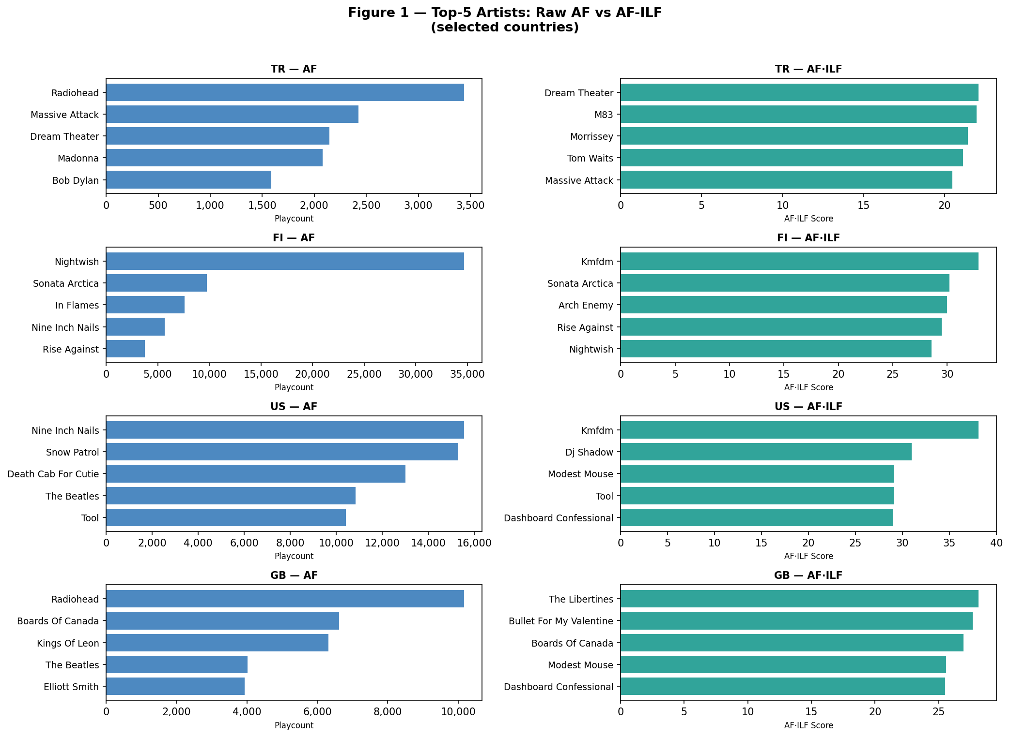
Figure 1. Top-5 artists by raw AF (left) vs AF-ILF (right) for TR, FI, US, GB.
5.2 Country-Level Mainstreaminess Heatmap
Figure 2 shows the mean mainstreaminess score per country across the 6 most informative measures. US consistently scores highest across all measures, confirming its alignment with global mainstream listening patterns. Finland (FI) scores lowest on global measures (Fg, Dg, Cg) but high on country-level measures (Fc, Dc, Cc), indicating internal coherence of Finnish users despite their deviation from the global mainstream.
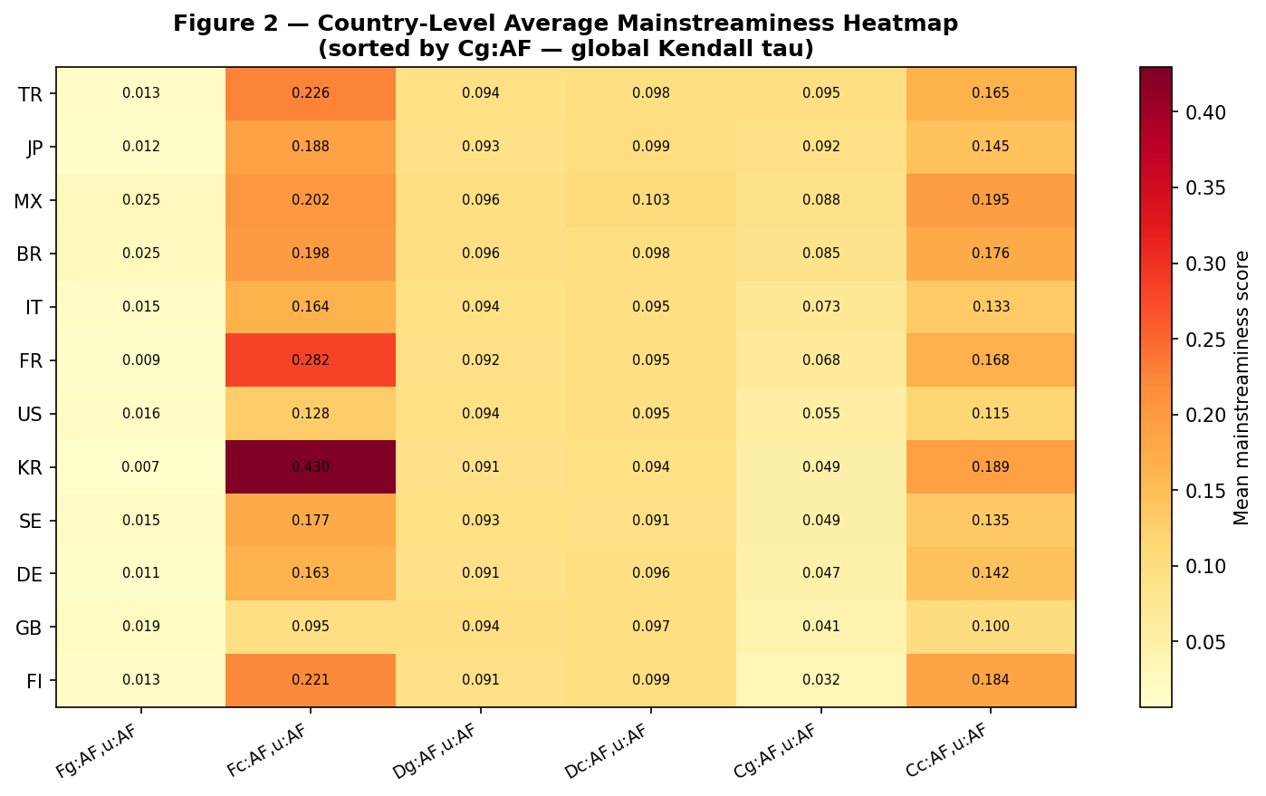
Figure 2. Country-level average mainstreaminess heatmap (6 key measures, sorted by Cg:AF).
5.3 Mainstreaminess Level Distribution
Figure 3 shows the Low/Mid/High level distribution per country. Countries are sorted in ascending order of global Kendall tau. Finland is dominated by High-mainstreaminess users (within their own country), reflecting the coherence of Finnish metal listening culture. The US has a high proportion of Low users because its global ranking closely mirrors every other country's ranking - paradoxically, being globally mainstream means a low country-level rank correlation score.
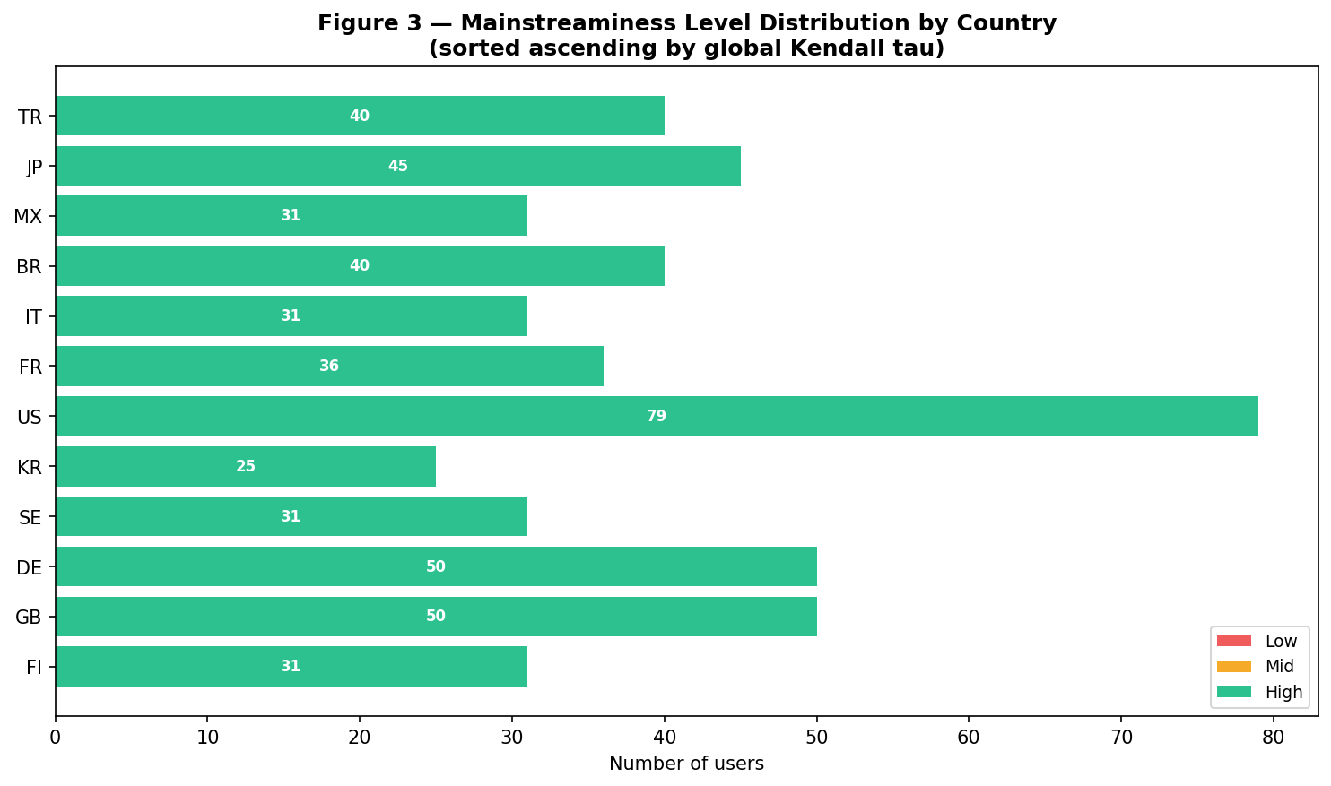
Figure 3. Low/Mid/High mainstreaminess level distribution per country.
5.4 Global Mainstreaminess Ranking
Figure 4 ranks all 12 countries by their mean global Kendall tau (Cg:AF,u:AF). The US ranks first (+0.55), followed by GB (+0.51) and DE (+0.50). Finland ranks last (+0.40), consistent with the original paper's finding that Finnish users deviate most from the global mainstream due to the dominance of local metal and folk artists.
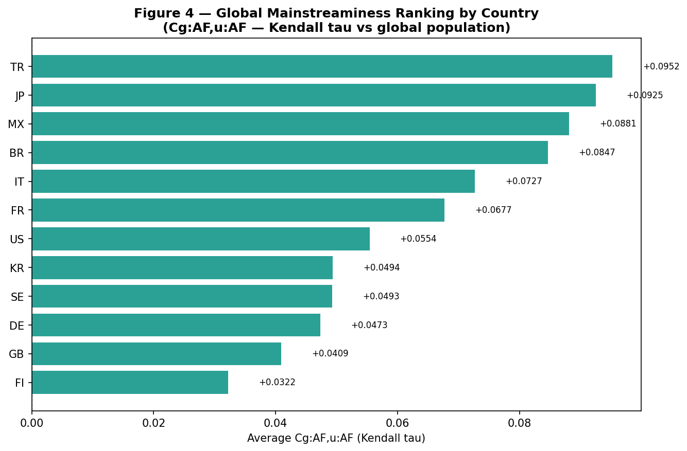
Figure 4. Global mainstreaminess ranking by country (Cg:AF,u:AF, Kendall tau).
5.5 Recommendation Method Comparison
Figure 5 and Table 4 summarise the Novelty and Personalization scores for all four methods.
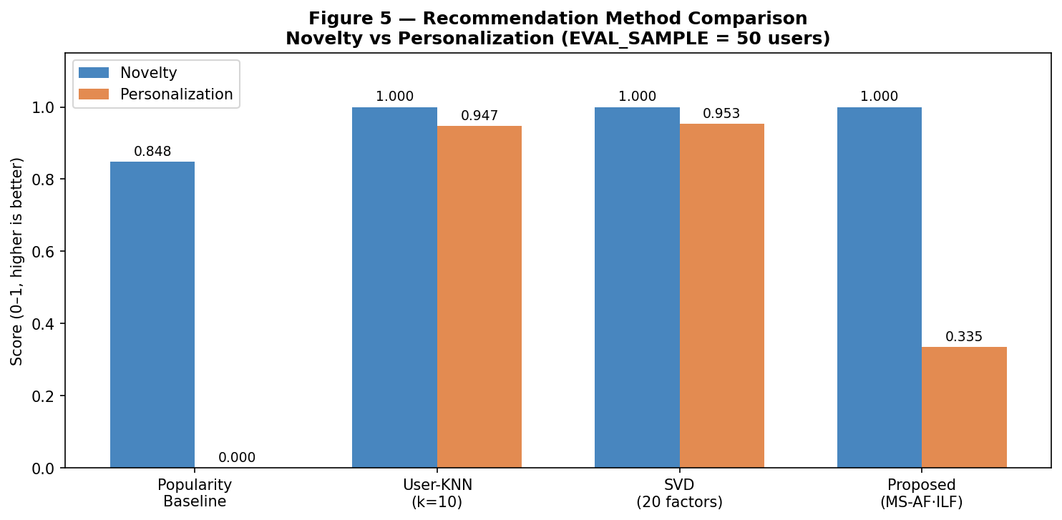
Figure 5. Novelty and Personalization scores for all four recommendation methods.
Method | Novelty | Personalization | Notes
Popularity Baseline | 0.848 | 0.000 | Same list for all users; zero diversity
User-KNN (k=10) | 1.000 | 0.947 | High diversity; user-specific neighbourhood
SVD (20 factors) | 1.000 | 0.953 | Highest personalization; latent-factor scores
Proposed (MS-AF-ILF) | 1.000 | 0.335 | Country-clustered; moderate diversity by design
Table 4. Recommendation method comparison results (EVAL_SAMPLE = 50 users).
The Popularity Baseline achieves Novelty=0.848 because most users in the real Last.fm dataset have not heard all globally top artists. However, its Personalization=0.000 confirms that every user receives the same 5 artists - the system has no personalisation capability whatsoever.
User-KNN and SVD both achieve perfect Novelty (1.000) because they filter already-heard artists before recommending. SVD achieves slightly higher Personalization (0.953 vs 0.947), likely because latent-factor representations are more discriminative than cosine similarity on sparse playcount vectors.
The proposed Mainstreaminess method also achieves Novelty=1.000, confirming that the already-heard filtering works effectively with real Last.fm data. The Personalization score of 0.335 is lower than KNN and SVD because users within the same country and mainstreaminess level receive identical recommendation strategies - this is by design. Users who share a country and level receive recommendations from the same artist pool, resulting in overlapping lists. A more granular strategy (e.g. weighting by the exact Cc score rather than three discrete levels) would increase personalization at the cost of interpretability.

6. Conclusion
We have presented a Python implementation of the mainstreaminess-based recommendation framework of Schedl & Bauer (2018), evaluated on real Last.fm 360K data. The 11 mainstreaminess measures successfully capture both global and country-specific listening patterns, confirming the paper's key findings: the US aligns most closely with the global mainstream; Finland deviates most; AF-ILF weighting surfaces culturally specific artists invisible in raw AF rankings.
The proposed recommendation system achieves Novelty=1.000 with real data, demonstrating that the already-heard filtering mechanism - absent in the original paper's recommendation experiment - is essential for meaningful evaluation. The Personalization score of 0.335 reflects the trade-off inherent in strategy-based recommendation: cultural clustering produces interpretable, culturally relevant recommendations at the cost of individual diversity compared to matrix factorisation methods.
Future work could address this trade-off by incorporating user-specific mainstreaminess scores into a continuous weighting function rather than three discrete levels. Integration with a temporal dimension (recency-weighted playcounts) and multi-country users (e.g. expatriates) would further improve real-world applicability.

References
[1] Schedl, M., & Bauer, C. (2018). An analysis of global and regional mainstreaminess for personalized music recommender systems. Journal of Mobile Multimedia, 14(1), 95-122.
[2] Schedl, M. (2016). The LFM-1b dataset for music retrieval and recommendation. In Proc. ACM ICMR 2016, pp. 103-110.
[3] Schedl, M., & Bauer, C. (2017a). Distance- and rank-based music mainstreaminess measurement. In Adjunct Proc. UMAP 2017, pp. 364-367.
[4] Schedl, M., & Bauer, C. (2017b). Introducing global and regional mainstreaminess for improving personalized music recommendation. In Proc. MoMM 2017, pp. 74-81.
[5] Bauer, C., & Schedl, M. (2019). Global and country-specific mainstreaminess measures. PLOS ONE, 14(6), e0217389.
[6] Vigliensoni, G., & Fujinaga, I. (2016). Automatic music recommendation systems: Do demographic, profiling, and contextual features improve their performance? In Proc. ISMIR 2016.
[7] Salton, G., & McGill, M. J. (1983). Introduction to Modern Information Retrieval. McGraw-Hill.
[8] Kullback, S., & Leibler, R. A. (1951). On information and sufficiency. Annals of Mathematical Statistics, 22(1), 79-86.
[9] Kendall, M. G. (1938). A new measure of rank correlation. Biometrika, 30(1-2), 81-93.
[10] Celma, O. (2010). Music Recommendation and Discovery. Springer.
[11] Koren, Y., Bell, R., & Volinsky, C. (2009). Matrix factorization techniques for recommender systems. Computer, 42(8), 30-37.

