DSA 210 – Introduction to Data Science
Spring 2026 – Final Project Report
Impact of Market Share on Flight Operational Performance
Do dominant airlines delay more — or less?
Datasets: BTS 2024 (1M+ flights) · US Airline Routes & Fares 1993–2024
131 airports · 77 Dominant · 54 Competitive

1. Motivation
In the aviation industry, operational efficiency is a primary determinant of passenger satisfaction and airline reputation. This project investigates the relationship between market dynamics — specifically, an airline’s market share on a given route — and its operational reliability as measured by flight departure delays and cancellations.
The central research question: Do airports served predominantly by a single dominant carrier exhibit worse (or better) punctuality than airports with more competitive route structures? This question has direct implications for transportation policy and consumer welfare.

2. Data Source & Collection
Two publicly available 2024 datasets were used:
- Dataset 1 – BTS Operations: Bureau of Transportation Statistics Flight Data (2024). Contains 1,048,575 flight records with fields including origin airport, departure time, weather delay, late aircraft delay, taxi-out time, air time, and cancellation status.
- Dataset 2 – Routes & Fares: US Airline Flight Routes and Fares (1993–2024), filtered to 2024. Provides 1,905 route-level records with market share (large_ms), dominant carrier, average fare, and passenger count by airport pair.

Note: The BTS dataset in this project contains operational columns (weather_delay, late_aircraft_delay, taxi_out, cancellation) but does not include a pre-computed departure delay field or destination airport. The analysis was therefore adapted to use available delay components and to work at the origin-airport level of aggregation.

3. Data Characteristics & Enrichment

3.1 Data Characteristics
Dataset | Records | Key Fields | Level
BTS Flight Data 2024 | 1,048,575 flights | weather_delay, late_aircraft_delay, taxi_out, cancelled | Flight-level
US Routes & Fares 2024 | 1,905 routes (filtered) | large_ms, carrier_lg, fare, passengers | Route-level
Merged (airport-level) | 131 airports | All above aggregated | Airport-level

3.2 Enrichment Strategy
The BTS data was aggregated to the origin-airport level. For each airport the following metrics were computed: average total delay (weather + late aircraft), % flights delayed >15 min, cancellation rate, average taxi-out time, and flight volume.
The Routes dataset was aggregated per airport (appearing as either endpoint of a route) to produce airport-level market characteristics: average and maximum largest-carrier market share, average fare, average passengers per route, and number of routes served.
The two datasets were then merged on IATA airport code (the origin code in BTS matches airport_1/airport_2 in Routes). Only airports with ≥200 flights were retained for statistical reliability, yielding 131 matched airports.

4. Data Analysis

4.1 Classification: Dominant vs. Competitive
An airport is classified as Dominant if its average largest-carrier market share (avg_large_ms) exceeds 0.70. The 0.70 threshold reflects the dataset’s distribution (mean = 0.71, median = 0.71) and ensures a meaningful split: 77 Dominant airports vs. 54 Competitive airports.

Group | Count | Avg Large MS | Avg Total Delay | % Delayed >15 min | Cancel Rate
Dominant (ms > 0.70) | 77 | 0.851 | 7.36 min | 8.41% | 2.44%
Competitive (ms ≤ 0.70) | 54 | 0.581 | 6.66 min | 7.68% | 2.18%

4.2 Exploratory Data Analysis
Eight visualisations were produced. Key figures are shown below.

Figure 1: Distribution of airports by market type
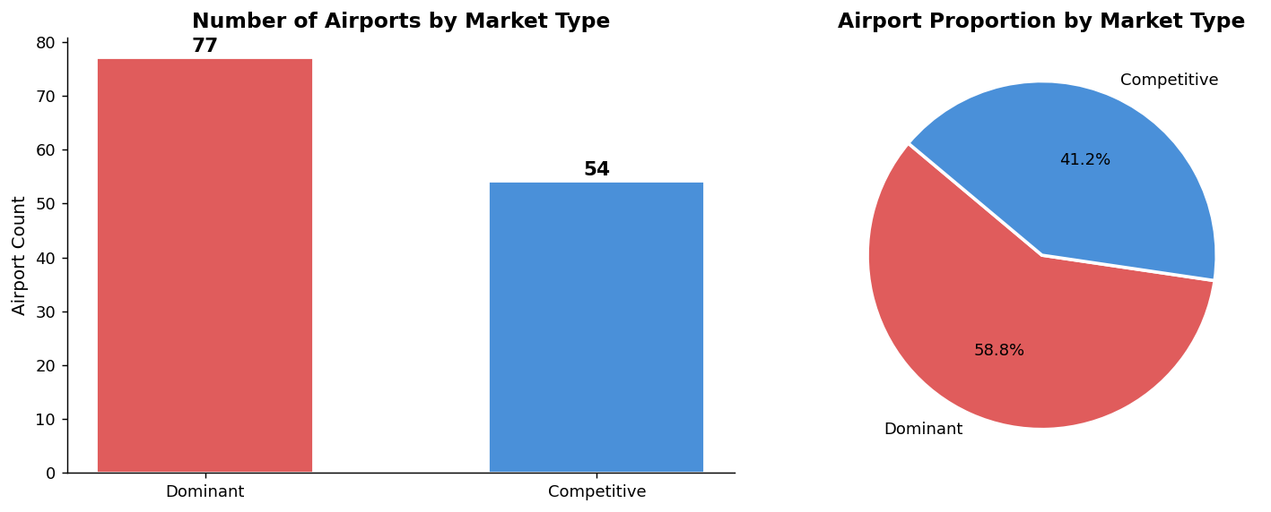

Figure 2: Delay distributions by market type (histogram + KDE)
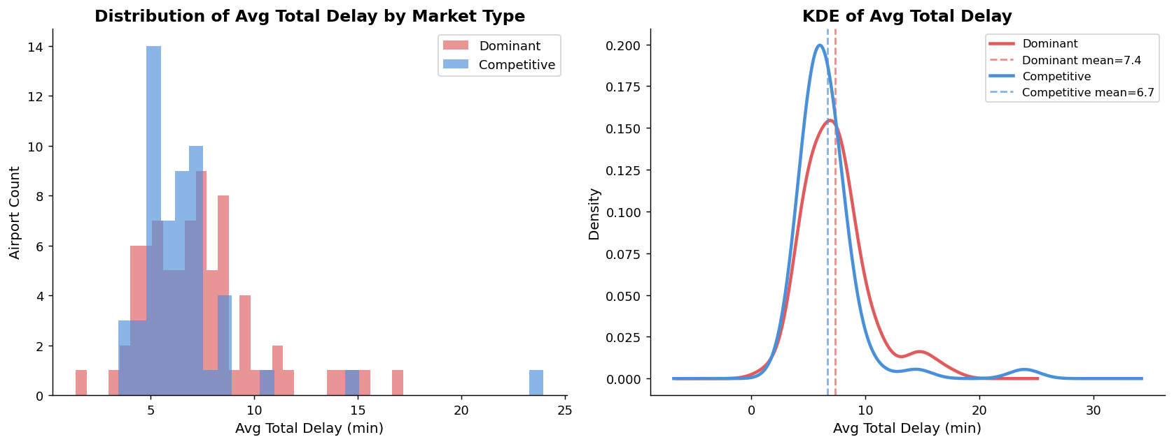

Figure 3: Boxplot and violin plot of avg total delay
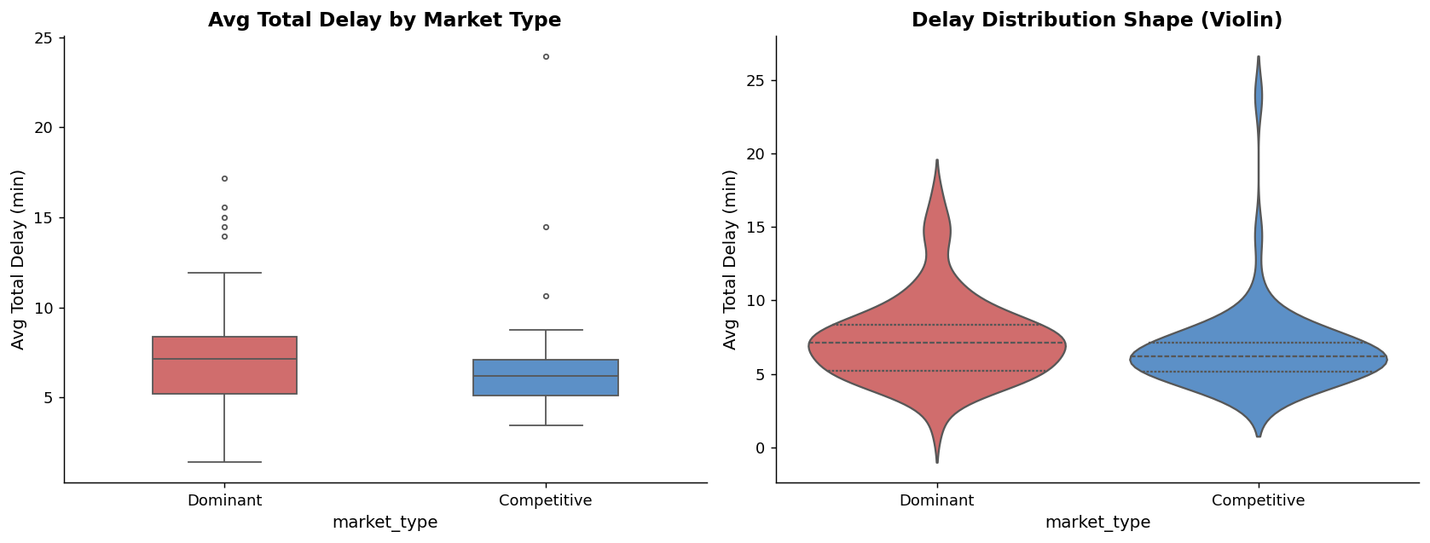

Figure 4: % Delayed and cancellation rate by market type
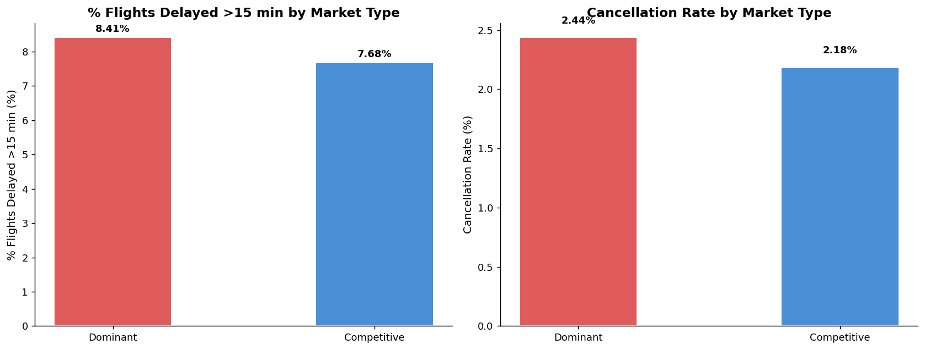

Figure 5: Market share vs. delay metrics (scatter with regression)
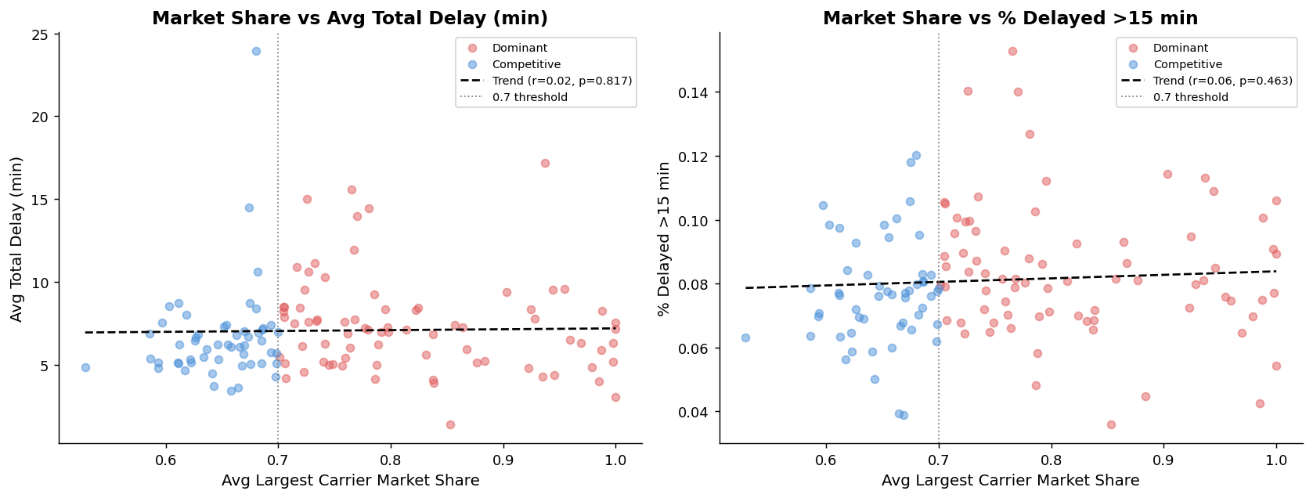

Figure 6: Delay component breakdown by market type
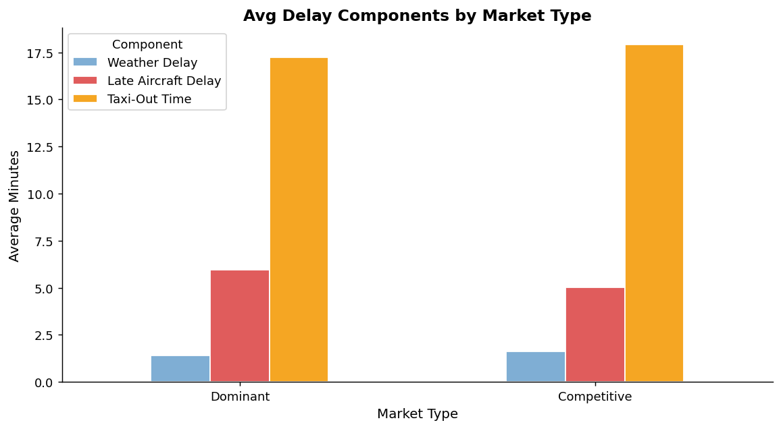

Figure 7: Correlation matrix
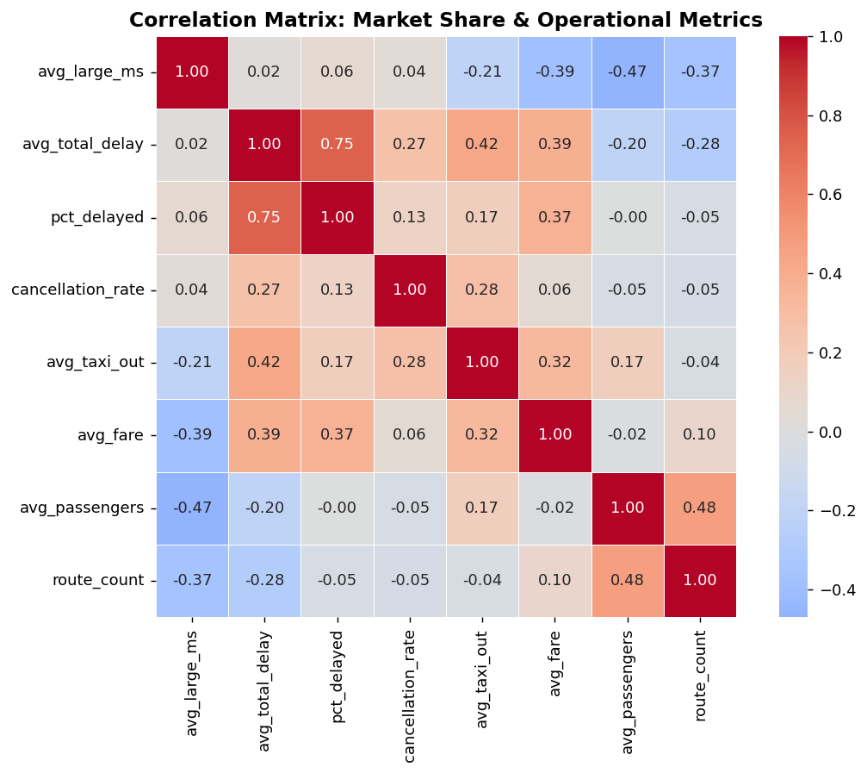

5. Findings

5.1 Hypothesis Test Results
All four metrics were tested with Welch’s t-test and Mann-Whitney U at α = 0.05 (two-sided). Effect size is Cohen’s d.

Metric | Dominant | Competitive | Diff | p (t-test) | p (Mann-W) | Cohen’s d | Significant?
Avg Total Delay (min) | 7.36 | 6.66 | +0.70 | 0.183 | 0.044 | 0.24 | t: ✗ / MW: ✓
% Delayed >15 min | 8.41% | 7.68% | +0.74pp | 0.027 | 0.021 | 0.39 | ✓ YES
Cancellation Rate | 2.44% | 2.18% | +0.25pp | 0.368 | 0.605 | 0.15 | ✗
Avg Taxi-Out (min) | 17.25 | 17.93 | −0.67 | 0.206 | 0.110 | −0.22 | ✗

5.2 Interpretation
The only metric that reaches statistical significance under the t-test is % flights delayed >15 minutes (p = 0.027). The Mann-Whitney U test also flags the average total delay as marginally significant (p = 0.044), suggesting a non-normal distribution drives part of the signal.
The direction is consistent across all delay metrics: Dominant airports have slightly higher delays. However, Cohen’s d values are small (0.24–0.39), indicating that while the difference is statistically detectable, it is operationally modest.
Taxi-out time is the one metric where Competitive airports are marginally worse (−60.67 min), though not significantly so. This may reflect that Competitive airports include some large hub airports with high traffic congestion.

5.3 Hypothesis Testing Distributions
Figure 8: Hypothesis test distributions for all four metrics
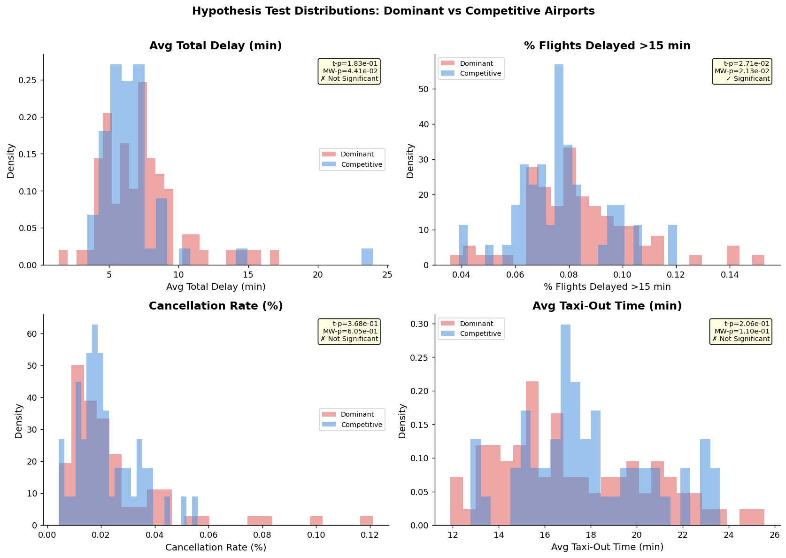

6. Machine Learning

6.1 Task & Models
A binary classification task was formulated to predict whether an airport is Dominant or Competitive using 11 operational and market features. Three models were evaluated: Logistic Regression (interpretable baseline), Random Forest (non-linear ensemble), and Gradient Boosting (boosted ensemble).
Evaluation used stratified 80/20 train/test split and 5-fold cross-validated ROC-AUC.

6.2 Results
Model | CV AUC (mean ± std) | Test AUC | Interpretation
Logistic Regression | 0.813 ± 0.091 | 0.750 | Strong linear signal
Random Forest | 0.758 ± 0.072 | 0.764 | Captures non-linear patterns
Gradient Boosting | 0.668 ± 0.089 | 0.841 | Best test performance

All three models substantially outperform the 0.5 random baseline, confirming that operational and market features contain meaningful signal for predicting market concentration. The Gradient Boosting model achieves the best test AUC (0.841).

6.3 Feature Importance
Figure 9: ROC curves for all three models
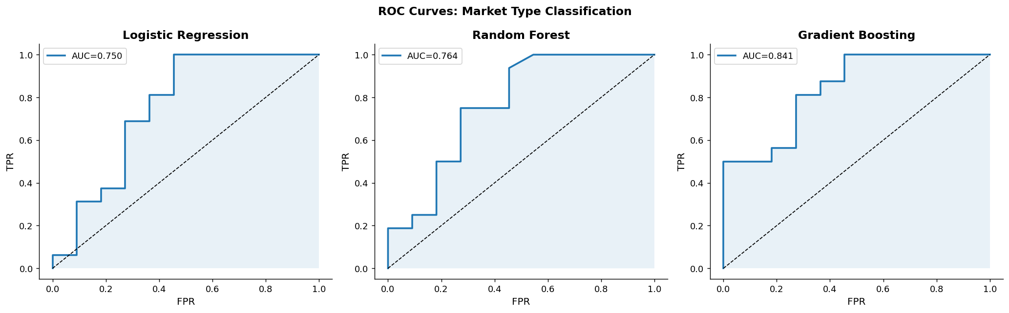

Figure 10: Random Forest feature importances
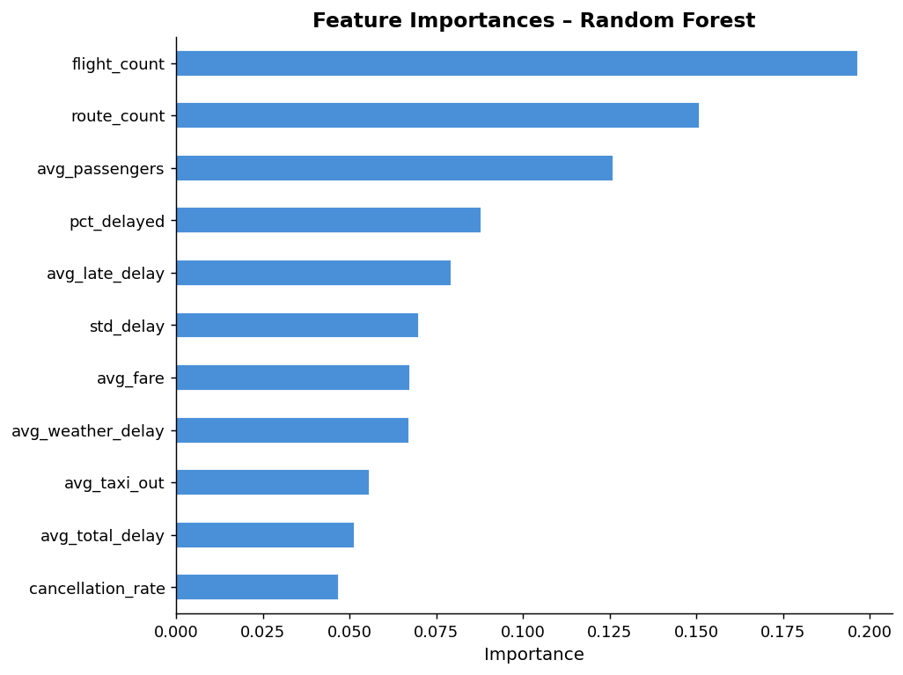

The top 5 most predictive features are: flight_count, route_count, avg_passengers, pct_delayed, and avg_late_delay. This confirms that airport size (volume) and operational load are the primary determinants of market structure — larger, busier airports tend to be dominated by single carriers.

Figure 11: Confusion matrices
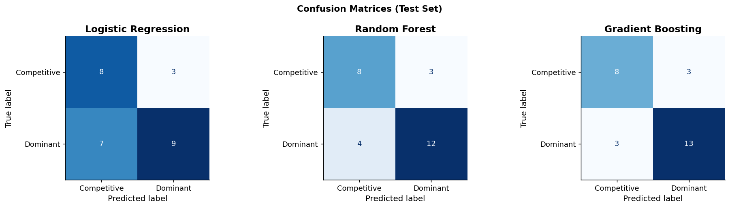

7. Limitations & Future Work

7.1 Limitations
- Missing dep_delay column: The BTS dataset used here does not include a pre-computed departure delay field. Total delay was approximated as weather_delay + late_aircraft_delay, which excludes carrier and NAS delay components.
- No destination in BTS: Without a destination column, the analysis operates at the origin-airport level rather than the route level specified in the original proposal. This reduces the precision of the market-delay linkage.
- Airport-level aggregation: Merging on origin airport means one airport can be matched to dozens of routes with varying market structures. The avg_large_ms is a noisy proxy for any single flight’s competitive environment.
- Small airport-level sample: After merging and filtering (n ≥ 200 flights), only 131 airports remain — a relatively small sample for ML classification, increasing variance in AUC estimates.
- Uncontrolled confounders: Airport size, hub status, geography, weather patterns, and route distance are not controlled for in the statistical tests.

7.2 Future Work
- Obtain the full BTS dataset with dep_delay and dest columns to enable true route-level analysis as originally proposed.
- Merge on IATA code pairs (origin + dest) rather than single-airport aggregation.
- Control for confounders with multivariate regression: distance, hub status, season, carrier size.
- Time-series / panel analysis using the 1993–2024 routes dataset to track changes in market share and punctuality on the same routes over time.
- Causal inference using regression discontinuity at the 50%/70% threshold or difference-in-differences when airlines enter or exit routes.

8. Technical Notes & AI Disclosure
Library | Purpose
pandas 2.x | Data loading, cleaning, merging, aggregation
numpy 1.x | Numerical computations
matplotlib / seaborn | EDA visualisations (11 figures)
scipy.stats | Welch t-test, Mann-Whitney U, Shapiro-Wilk
scikit-learn | ML pipelines, CV, AUC, confusion matrices, feature importance

AI Tool Disclosure: As required by DSA 210 Academic Integrity policy:
- Claude (Anthropic) and Gemini (Google) were used during dataset evaluation to assess suitability of the Kaggle datasets for this project.
- Claude was used to assist in adapting the Jupyter notebook for the available dataset columns, generating the analysis pipeline, and producing this final report document.
- All analytical decisions, interpretations, and conclusions were reviewed and validated by the student. Intellectual responsibility for the project rests with the author.

References
[1] Bureau of Transportation Statistics. (2024). On-Time Performance. https://www.transtats.bts.gov
[2] Kaggle. (2024). US Airline Flight Routes and Fares 1993–2024. https://www.kaggle.com
[3] Pedregosa, F. et al. (2011). Scikit-learn: Machine Learning in Python. JMLR 12, 2825–2830.
[4] McKinney, W. (2017). Python for Data Analysis. O’Reilly Media.

