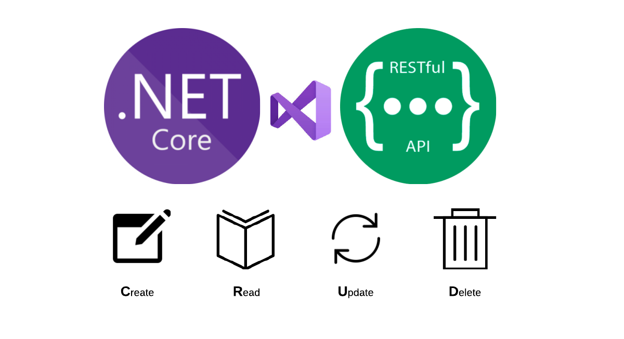

SERTOM TECHNICAL TASK DOCUMENTATİON

API Evaluation and Notification

DOĞUKAN CANERLER - Junior Backend Developer

# Abstract

It is a RestFul WebAPI that I have prepared according to the document instructions I have received from you. In this API, .Net 5.0, C#, MSQQL, EntityFramework, Autofac, Jwt, xUnit as well as principles and architectural patterns such as Solid Principles and Layered Architecture has been made. . Don't think I'm not using Net Core. Net 5.0 and the new version of net core have only a naming difference.Please evaluate me by considering that I am a Junior developer, my desire to improve myself, my effort and work. I think it is a very simple and useful WebAPI as in the directive. I hope you will be satisfied.I hope I will get a good result and I will have the opportunity to develop good projects with you.

## Api's Mechanics

The API works with the routing and data scheme I have specified below. I used the Data Validation Structure under .Net for data validation. I am using a JWT based authentication system that I have created for user authentication. In order to make any request on the API, you must first be registered in the system, log in to the system and get an access token. Otherwise, you cannot do anything on the system. Since the api has controller returns according to the situations, you need to be prepared for this on the frontend. Api Controllers give json-based output and receive json-based data, so you need to pay attention to CRUD operations in this regard.

**API REQUESTS**

The basic url sequence you should use for basic Api requests is:

127.0.0.1:port/api/controller/action?parameter

**AuthController Requests:**

api/login(paramaters: UserForLoginDto userForLoginDto)

api/register(parameters:RegisterForLoginDto registerForLoginDto)

**ClinicsController Request:**

api/getClinicById?id= int id

api/getClinicList

api/getEquipmentsByClinic?id=int id

api/getEquipmentsByClinicDetail?id = int id

api/add paramaters: Clinics clinics

api/update parameters : Clinics clinics

api/delete parameters : Clinics clinics

**EquipmentController Requests:**

api/getEquipmentById?id = int id

api/getEquipmentsListByOrd?ordType = bool ordType

api/getEquipmentsListForPage?int takeCount & int pageCount

api/GetListByClinic?clinicId= int clinicId

api/GetListByClinicDetail?clinicId = int clinicId

api/GetListByBuyDate?date = DateTime date

api/GetListByBetweenDates?DateTime start & DateTime finish

api/add paramaters: Equipment equipment

api/delete Equipment equipment

api/update Equipment equipment

API SCHEMAS

