|  |  |  |  |  |
| --- | --- | --- | --- | --- |
| **Group: 2** | | **Date:13.05.2019** | | |
| **Time:14.15** | | |
| **TOPIC:** **Crystal Oscillators** | | | | |
| **TASK:** | | | | |
| **No.** | **Name** | | **Grade** | |
| 1. | Cem Arslan | |  |  |
| 2. | Kadir Kocak | |  |  |

ELECTRONIC CIRCUITS

LABORATORY

Wroclaw University of Technology

Faculty of Electronics

Course: Electronic Circuits

**1.Introduction**

This exercise is discusses about the basic structures of crystal generators, also in addition we get familiar with surface mount techniques such as Surface Mount Technology(SMT) or Surface Mounting Technology(SMD) and we tested three simplest and most popular system structure BJT bipolar transistor, TTL gates, CMOS inventers. For this experiment we have not needed to calculations before laboratory.

**2.Procedures**

In this experiment we didn’t need to calculate anything. We obtained the values of our circuit from instruction and added new components up to task.

Firstly we took screenshot of 4.2 task called as Quartz Oscillator Implemented Using TTL Digital IC. We set generator voltage as 5 V. Below you can see our screenshot;

**4.2 Quartz oscillator implemented using TTL digital IC**

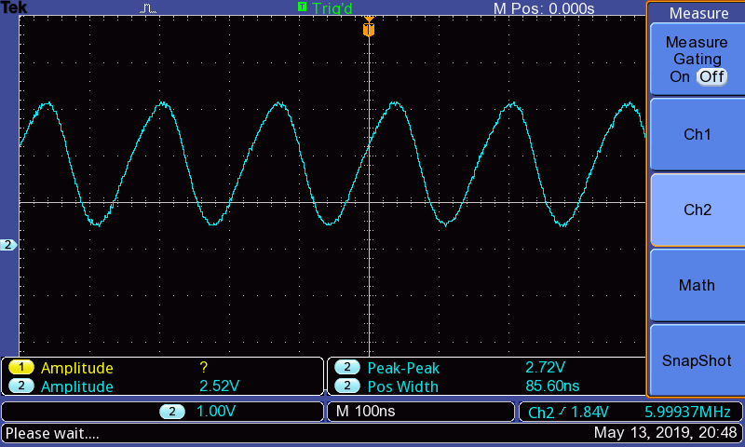

**4.1 Colpittsa-Pierce oscillator with BJT**

After that we soldered more passive components and some SDM according to fig.8 from instruction.Than we were obtaining Amplitude results from oscillator while changing Vcc 0 to 15 V.

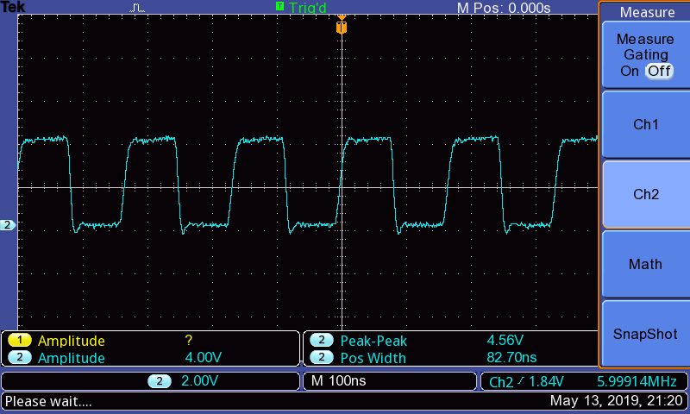

|  |  |
| --- | --- |
| BJT | |
| **Vcc[V]** | **Amp[V]** |
| **0** | **0** |
| **1** | **0,12** |
| **2** | **0,12** |
| **3** | **0,76** |
| **4** | **1,72** |
| **5** | **2,52** |
| **6** | **3,32** |
| **7** | **4,16** |
| **8** | **4,96** |
| **9** | **5,12** |
| **10** | **4,96** |
| **11** | **4,76** |
| **12** | **4,68** |
| **13** | **4,52** |
| **14** | **4,32** |
| **15** | **4,16** |

**4.3 Quartz oscillator implemented using CMOS digital IC**

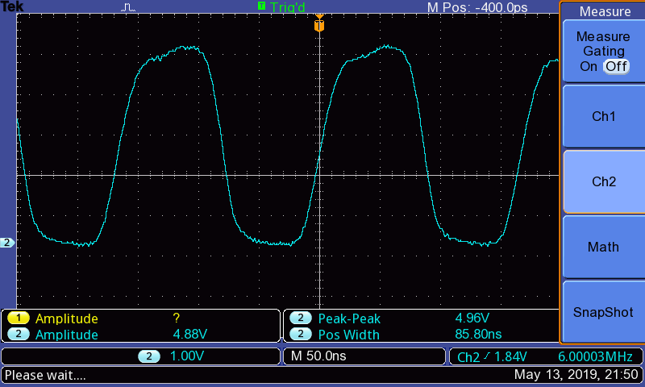

|  |  |
| --- | --- |
| CMOS | |
| **Vcc[V]** | **Amp[V]** |
| **0** | **0** |
| **1** | **0** |
| **2** | **0,12** |
| **3** | **2,08** |
| **4** | **4,12** |
| **5** | **5,52** |
| **6** | **6,32** |
| **7** | **7,28** |
| **8** | **8,24** |
| **9** | **9,44** |
| **10** | **10,3** |
| **11** | **10,7** |
| **12** | **11,7** |
| **13** | **12,6** |
| **14** | **13,6** |
| **15** | **14,6** |

We noticed that comparing between BJT and CMOS graphs that voltage is effecting positively and faster to circuit for CMOS . BJT was growing than linear and falled around middle of voltage drop but CMOS was all the time increasing on graph.

**3.Conclusion**

During the experiment firstly we supply the oscillator system with 5V (Vcc TTL)

And we connect the our circuit to the oscilloscope for observe the frequency and amplitude. And we took the screenshot. Next we were dealing with BJT also we set the supplier with 5V and at the oscillator output we observe the shape and frequency of the waveform also amplitude and we set the our supplier up to 15V and each voltage we noted down Amplitude. Finally we carry out same process with CMOS and we noted down amplitude read rom oscillator up to 15V.